ONLINE PARKING PLACE RESERVATION SYSTEM

Dr.M.V.subramanyam¹,B.v.Lakshmi Prasanna²,K.Sumasree³,S.Apsana⁴,V.Pallavi⁵
^{1,2,3,4,5}(ElectronicsandCommunicationEngineering,SanthiramEngineeringCollegeNandyal
Email:lakshmiprasanna1101@gmail.com

ABSTRACT
The Online Parking Place Reservation System is a digital solution aimed at streamlining the process of reserving parking spots in crowded urban areas. This system allows users to conveniently book parking spaces in advance through an online platform, reducing the hassle of searching for parking upon arrival. The key features of this system include real-time availability updates, secure payment options, and customizable reservation settings. By leveraging technology, this system enhances the efficiency of parking management and improves the overall parking experience for users.

Keywords:Parking Reservation,Digital Solution,Urban Mobility

INTRODUCTION
Intoday'sfast-pacedurban environments, finding parking canbe a major source offrustration andwasted time. The Online Parking Place Reservation System addresses this challenge by offering a user-friendlydigitalsolution.Thissystemrevolutionizesthewayindividualssecureparkingspacesincrowded city areas. By enabling users to reserve parking spots in advance through an online platform, iteliminates the stress of searching for parking upon arrival. Key features such as real-time availabilityupdates, secure payment options, and customizable reservation settings enhance user convenience andsatisfaction.Moreover,thissystemcontributestoimprovingurbanmobility byoptimizingparkingmanagement processes.By leveraging technology,it notonly streamlines the reservation processbutalsoenhancesoverallefficiency,makingparkingmoreaccessibleandmanageableforurbanresidentsandvisitorsalike.WithParkingReservation,DigitalSolution,andUrbanMobilityasitscorepillars,thisprojectaimstotransformtheparkingexperience inurbansettings.

LITERATURE SURVEY

RelatedWork:

- 2020-Shrestha&Sharma,AReviewonParkingReservationSystemUsingInternetofThings(IoT)
Summary:ShresthaandSharmaconductedacomprehensivereviewfocusingontheintegrationofInternet of Things (IoT) technology in parking reservation systems. They explore various IoT-basedapproachesaimedatenhancingparkingmanagementefficiency,includingsensor-basedmonitoring,real-time data processing, and smart decision-making algorithms. The review discusses the potentialbenefits of IoT-enabled parking systems, such as improved resource utilization, reduced congestion, andenhanceduserexperience.Additionally,theauthorshighlightchallengesandfutureresearchdirectionsin this field, emphasizing the importance of scalability, interoperability, and data privacy in IoT-drivenparkingsolutions.

2.2019-Loureiro,Teixeira,&MartinsTitle:AReviewonSmartParkingSolutionsforSmartCities

Summary:Loureiro,Teixeira,andMartinsprovideacomprehensiveoverviewofsmartparkingsolutions tailored for smart cities. They discuss various technologies and strategies, including sensornetworks,dataanalytics,andmobileapplications,aimedatoptimizingparkingmanagementandenhancingurbanmobility.Thereviewexaminescasestudiesandimplementationchallenges,emphasizingtheimportanceofinteroperability,scalability,anduseracceptanceinsmartparkingdeployments. The authors also discuss the potential impact of smart parking on traffic flow, air quality,andoverallurbansustainability,highlighting itsroleinshaping futureurbanlandscapes.

3.2018-Zhang,Liu,Guo,&Tian,SmartParkingSolutionsintheEraofIoT:ASurvey

Summary:Zhangetal.presentacomprehensivesurveyofsmartparkingsolutionsleveragingInternetofThings(IoT)technologies.TheyreviewvariousIoT-basedapproaches,suchassensornetworks,dataanalytics,andcloudcomputing,aimedat improving parkingavailabilityandefficiency.
The survey discusses key challenges, including sensor deployment, data privacy, and integration withexisting infrastructure, while also highlighting emerging trends and future research directions in IoT-driven parkingsystems.

2017-Nasri&BenMessaoud,ASurveyonSmartParking:TechnologiesandApplications

Summary:NasriandBenMessaoudprovideasurveyonsmartparkingtechnologiesandtheirapplications. They discuss various sensor-based systems, wireless communication protocols, and dataanalyticstechniquesemployedinsmartparkingsolutions.Thesurveyexploreschallengessuchassensoraccuracy,scalability,andcost-effectiveness,whilealsohighlightingthepotentialbenefitsofsmart parking in terms of reducing traffic congestion, enhancing user experience, and improving urbansustainability.

2016-Bhagat,Khamitkar,Sutar,&Malunjkar,SmartParkingSystem:AReview

Summary:Bhagat et al. present a review focusing on smart parking systems and their functionalities.Theydiscussvarioustechnologies,includingsensornetworks,mobileapplications,andcloudcomputing, used in smart parking deployments. The review examines the benefits of smart parkingsystems in terms of reducing parking search time, optimizing space utilization, and improving overallurbanmobility.Additionally,theauthorsdiscusschallengessuchascost,scalability,andinteroperability,alongwithpotentialsolutionsandfutureresearchdirectionsinthisdomain.

3.PROPOSEDSYSTEM
TheproposedOnlineParkingPlaceReservationSystemisdesignedtorevolutionizetheparkingexperience in crowded urban areas. It offers users the ability to reserve parking spots convenientlythroughanonlineplatform,therebyreducingthestressandtimespentsearchingforparkinguponarrival. Key features of the system include real-time availability updates, secure payment options, andcustomizable reservation settings, providing users with flexibility and peace of mind. By leveragingtechnology, this system aims to enhance parking management efficiency and improve overall urbanmobility.

4.RESULTS

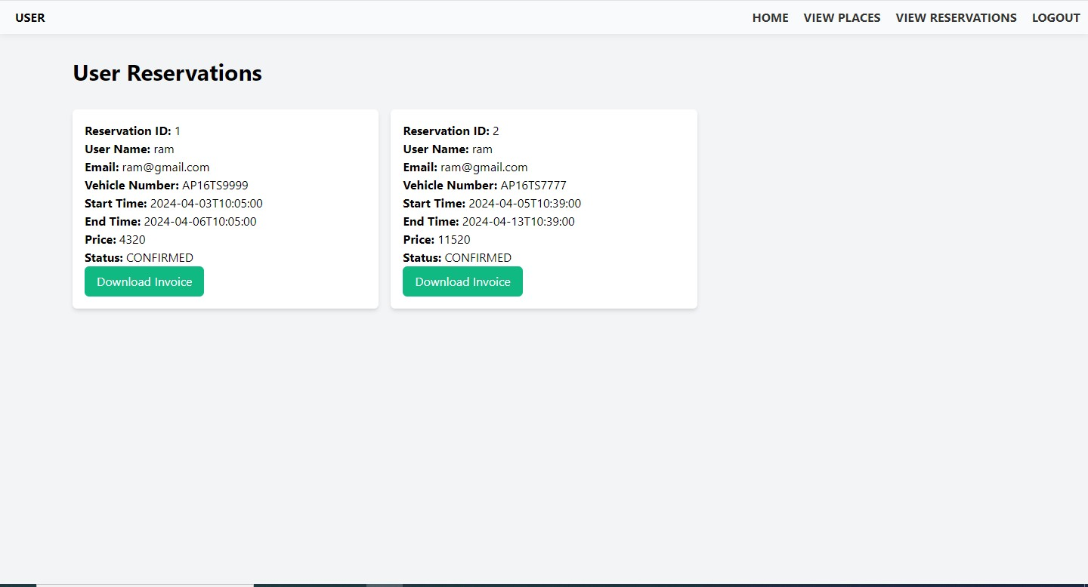

5.CONCLUSION

The Online Parking Place Reservation System offers a timely solution to the challenges of parking incrowdedurbanareas.Byintegratingadvancedtechnologyanduser-friendlyfeatures,itenhancesconvenience, efficiency, and overall urban mobility. This system represents a significant step towardstransformingtheparkingexperience,makingitmoreaccessible,manageable,andstress-freeforresidents and visitors alike.

6.FUTURE ENHACEMENT
FutureenhancementsfortheOnlineParkingPlaceReservationSystemcouldincludeintegrationwithIoTsensorsforreal-timeparkingspacemonitoring,implementationofAIalgorithmsforpredictive parking availability analysis, and expansion of the platform to include additional featuressuchasnavigationassistancetothereservedparkingspot.Theseadvancementswouldfurtheroptimizeuserexperienceandcontributetomoreefficienturbanparkingmanagement.

7.REFERENCES

- http://www.face-rec.org
- ShemiPM,AliMA,APrincipalComponentAnalysisMethodforRecognitionofHumanFaces:EigenfacesApproach,InternationalJournalofElectronicsCommunicationandComputerTechnology(IJECCT),Volume2Issue 3(May2012).
- M. Turk, A. Pentland: Face Recognition using Eigenfaces, Conference on Computer Vision and PatternRecognition,3–6June1991,Maui, HI,USA, pp. 586–591.

- Zhao,R.Chellappa,P.J.Phillips,andA.Rosenfeld,“Facerecognition:Aliteraturesurvey,”ACMComput.Surv.,vol. 35, pp. 399–458,Dec. 2003.
- R.Fergus,B.Singh,A.Hertzmann,S.T.Roweis,andW.T.Freeman,“Removingcamerashakefromasinglephotograph,”ACM Trans. Graph.,vol. 25, pp.787–794,July2006.
- Q.Shan,J.Jia,andA.Agarwala,“High-qualitymotiondeblurringfromasingleimage,”ACMTrans.Graph.,vol. 27, pp. 73:1–73:10, Aug. 2008.
- A.Levin,Y.Weiss,F.Durand,andW.T.Freeman,“Understandingblinddeconvolutionalgorithms,”PatternAnalysisandMachineIntelligence,IEEETransactionson,vol.33,pp.2354–2367,Dec.2011.
- D.LAKSHMAIAH, DR.M.SUBRAMANYAM, DR.K.SATYA PRASAD,” DESIGN OF LOW POWER 4- BIT CMOS BRAUN MULTIPLIER BASED ON THRESHOLD VOLTAGE TECHNIQUES”, GLOBAL JOURNAL OF RESEARCH IN ENGINEERING, VOL.14(9),PP.1125-1131,2014.
- R SUMALATHA, DR.M.SUBRAMANYAM, “IMAGE DENOISING USING SPATIAL ADAPTIVE MASK FILTER”, IEEE INTERNATIONAL CONFERENCE ON ELECTRICAL, ELECTRONICS, SIGNALS, COMMUNICATION &AMP; OPTIMIZATION (EESCO-2015), ORGANIZED BYVIGNANS INSTITUTE OF INFORMATION TECHNOLOGY, VISHAKAPATNAM, 24 TH TO 26TH JANUARY 2015. (SCOPUS INDEXED)
- P.BALAMURALI KRISHNA, DR.M.V.SUBRAMANYAM, DR.K.SATYA PRASAD, “HYBRID GENETIC OPTIMIZATION TO MITIGATE STARVATION IN WIRELESS MESH NETWORKS”, INDIAN JOURNAL OF SCIENCE AND TECHNOLOGY,VOL.8,NO.23,2015. (SCOPUS INDEXED)
- Y.MURALI MOHAN BABU, DR.M.V.SUBRAMANYAM,M.N. GIRI PRASAD,” FUSION AND TEXURE BASED CLASSIFICATION OF INDIAN MICROWAVE DATA – A COMPARATIVE STUDY”, INTERNATIONAL JOURNAL OF APPLIED ENGINEERING RESEARCH, VOL.10 NO.1, PP. 1003-1009, 2015. (SCOPUS INDEXED)
- A.V.R.MAYURI, M.V.SURBRAMANYAM,” NEIGHBOR CONDUCT SENSITIVE QOS VARIANCE AWARE SPECTRUM SENSING AND ALLOCATION”, INTERNATIONAL JOURNAL OF ADVANCED RESEARCH IN COMPUTER AND COMMUNICATION ENGINEERING,VOL.4,NO.3,PP.344-351,2015.
- A.V.R.MAYURI, M.V.SURBRAMANYAM,” QOS VARIANCE AWARE SPECTRUM SENSING AND ALLOCATION STRATEGY FOR COGNITIVE RADIO WIRELESS MESH NETWORKS”, GLOBAL JOURNAL OF COMPUTER SCIENCE AND TECHNOLOGY:E NETWORK.WEB AND SECURITY, VOL.15,NO.2,PP.1-6,2015.
- B.KRISHNA NAGA DEEPTHI, DR.M.V.SUBRAMANYAM,” ANALYSIS AND OPTIMIZATION OF POWER AND AREA OF DOMINO FULL ADDER AND ITS APPLICATIONS”, IOSR JOURNAL OF ELECTRONICS AND COMMUNICATION ENGINEERING, VOL.10,NO.3,PP.55-63,2015.
- Y.MURALI MOHAN BABU, DR.M.V.SUBRAMANYAM,M.N. GIRI PRASAD,” A NEW APPROACH FOR SAR IMAGE DENOISING”, INTERNATIONAL JOURNAL OF ELECTRICAL AND COMPUTER ENGINEERING, VOL.5,NO.5,PP.984-991,2015. (SCOPUS INDEXED)
- CH.NAGARAJU, DR.ANIL KUMAR SHARMA, DR.M.V.SUBRAMANYAM,” A REVIEW ON BER PERFORMANCE ANALYSIS AND PAPR MITIGATION IN MIMO OFDM SYSTEMS”, INTERNATIONAL JOURNAL OF ENGINEERING TECHNOLOGY AND COMPUTER RESEARCH, VOL.3,NO.3,PP.237-238, JUNE, 2015.
- S.L.PRATHAPA REDDY, DR.M.V.SUBRAMANYAM AND DR.K.SATYAPRASAD,” A HYBRID GENETIC FUZZY APPROACH FOR POWER CONTROL CROSS LAYER MAC PROTOCOL IN WIRELESS NETWORK”, ICCICCT, NOORUL ISLAM UNIVERSITY,NAGARKOILE, TAMILNADU,PP. 195-200, 7/7/2015. (SCOPUS INDEXED)
- BALAMURALIKRISHNAPOTTI, DR.M.V.SUBRAMANYAM,DR.K.SATYA PRASAD,” GENETIC ALGORITHMIC APPROACH TO MITIGATE STARVATION IN WIRELESS MESH NETWORKS”INTERNATIONAL CONFERENCE ON COMPUTER AND COMMUNICATION TECHNOLOGIES-2015, CMR TECHNICAL CAMPUS, HYDERABAD, 489,24TH - 26TH JULY, 2015, PP.479-489, 2016.
- R SUMALATHA, DR.M.SUBRAMANYAM,” HIERARCHICAL LOSSLESS IMAGE COMPRESSION FOR TELEMEDICINE APPLICATIONS”, PROCEEDIA COMPUTER SCIENCE, VOL.54,PP. 838-848,2015. (SCOPUS INDEXED)
- K.MALLIKARJUNA, DR.K.SATYA PRASAD, DR.M.V.SUBRAMANYAM,” COMPRESSION OF NOISY IMAGES BASED ON SPARSIFICATION USING DISCRETE RAJAN TRANSFORM”, INTERNATIONAL JOURNAL OF COMPUTER APPLICATIONS, VOL.132,NO.12,PP.37-43,2015.
- K.MALLIKARJUNA, DR.K.SATYA PRASAD, DR.M.V.SUBRAMANYAM,” SPARSE REPRESENTATION BASED IMAGE COMPRESSION USING DISCREATERAJAN TRANSFORM”, INTERNATIONAL JOURNAL OF APPLIED ENGINEERING RESEARCH, VOL.10,PP.13, PP.33424-33429,2015. (SCOPUS INDEXED)
- P.V.GOPI KRISHNA RAO, DR.M.V.SUBRAMANYAM,DR.K.SATYA PRASAD,” ROBUST DESIGN OF PID CONTROLLER USING IMC TECHNIQUE FOR INTEGRATING PROCESS BASED ON MAXIMUM SENSITIVITY”, JOURNAL OF CONTROL, AUTOMATION AND ELECTRICAL SYSTEMS, VOL. 26, NO.5,PP. 466–475,2015. (EMERGING SOURCES CITATION INDEX AND SCOPUS INDEXED)

