**TESTING THE STRENGTH AND DURABILITY OF STEEL FIBER CONCRETE AT HIGH HEAT**

**MEHWISH JAVID1, Er. REKHA DEVI2**

**1** M.Tech Scholar,Desh Bhagat University Gobindgarh Punjab,India

*Bhatm212@gmail.com*

2 Assistant Professor, Desh Bhagat University Gobindgarh Punjab,India

*Katwalrekha7@gmail.com*

## **ABSTRACT**

Concrete, being the most often used construction material globally, is extensively used. However, it has a vulnerability in stress because of its intrinsically fragile characteristics. In order to deal with this issue, the integration of SF into concrete has emerged as a feasible technique to improve its ability to deform without breaking. Investigating the effect of heat on concrete with SF reinforcing is of great interest due to the widespread use of concrete and its exposure to high heat caused by fire accidents and other reasons. Despite the existence of several investigate on this topic, there has been little focus on examining the impact of the aspect ratio of SF in concrete. So the primary objective of this investigate is to examine the effectiveness of integrating SF with varying aspect ratios into the concrete using experimental techniques. The goal is to assess the improvement in performance of concrete components when exposed to both low and high heat.

The experimental review was done in numerous phases. In the first phase, various tests were performed at room heat, including assessments of workability, strength in compression, and split strength in tensile. The objective was to examine the reaction of concrete and identify the most effective amount of fibres for aspect ratios of 65 and 55, ranging from 0% to 1.50% with increments of 0.25%. The next phase included assessing the mechanical characteristics of the samples using the established optimal fibre doses. This assessment was carried out at high heat of 125°C, 250°C, and 375°C. The conducted mechanical tests included strength in compression, split strength in tensile, and flexural strength evaluations. The findings demonstrated that the addition of SF with different concentrations and aspect ratios had a considerable consequence on the mechanical characteristics of concrete.

The concrete's workability was shown to diminish as the aspect ratio of the fibres increased. The 65 and 55 aspect ratio mixes had a maximum drop of 39% and 36%, respectively, associated to the control mix. Nevertheless, the adding of SF caused in a notable enhancement in the strength in compression, ranging from about 13% to 38%, as well as an improvement in the split strength in tensile, ranging from 7% to 65%, under normal heat conditions. The findings indicate that the ideal fibre volume percentages for generating the greatest improvements in compressive and split strength in tensile are 0.75% for an aspect ratio of 65 and 0.50% for an aspect ratio of 55.   
Upon subjecting the samples to increased heat for a duration of 3 hours, ranging from 125°C to 375°C, a decrease in weight was noted. The weight loss may be due to the volatilisation of water content from

the concrete at elevated heat. Additionally, the samples subjected to a heat of 375°C exhibited minor fractures on their surface as a result of water loss and the development of tensions at elevated heat. The strength in compression of the FRC exhibited an upward trend as heat climbed, although at a reduced pace. Nevertheless, the split strength in tensile and flexural strength shown an initial rise until reaching 250°C, after which they declined at elevated heat.

In addition, a mathematical model was created to forecast the remaining strength of steel FRC for any combination of ingredients at higher heat. The model included variables such as heat, fibre volume, and fibre content. The correlation between these characteristics and the remaining strength was compared to the empirical findings. The review demonstrated that the created mathematical model accurately predicted the residual strength of steel FRC at high heat, as it closely matched the experimental results.

1. **Key Words**: High Heat, Fire Resistance, Mechanical Properties, Thermal Performance, Degradation, Heat Exposure

# INTRODUCTION

Concrete is a highly adaptable and extensively used construction material that offers several benefits. Concrete is a mixture of substances composed of cement, water, and aggregates (such as sand, gravel, or crushed stone). It has the ability to be shaped into many forms and sizes before hardening into a solid mass. Concrete has a long history of usage spanning centuries, and it is renowned for its exceptional durability and cost-effectiveness as a construction material. One of the main benefits of concrete is its strength and durability. It is a substance that can support a great deal of weight and pressure without breaking or collapsing. Concrete constructions are renowned for their durability and toughness, making them perfect for various uses, including buildings, bridges, roads, and pavements.

Concrete is also a highly versatile material that can be customized to meet specific requirements. It can be colored, stamped, or textured to create a variety of finishes and styles. This makes it popular for adorning applications such as flooring, countertops, and walls. Concrete also has the benefit of being fire-resistant and capable of offering excellent fire protection. Additionally, because it is an excellent insulator, it may help keep buildings warm in the winter and cool in the summer, lowering energy expenses. Overall, concrete is a reliable and cost-effective material that has numerous benefits. Its robustness, longevity, adaptability, and flame retardancy make it a widely favoured option for building endeavours of all scales and categories.

**STEEL FIBER REINFORCED CONCRETE**

The collaboration of steel SFRC dates back to the early 1900s, whereby SF were used to boost the mechanical characteristics of concrete. Nevertheless, it was only in the 1960s that notable progress was achieved in the improvement of SFRC, resulting in its widespread use in the field of building. In the 1960s, researchers began investigating the use of SF for the purpose of strengthening concrete. SF with a straight and smooth shape were initially used as a reinforcing material in 1963 to enhance the flexural strength of concrete. Over the subsequent years, a range of SF with distinct mechanical characteristics were created, such as hooked, crimped, and twisted fibres, which could be customised to suit particular uses. Furthermore, there were notable improvements in the manufacturing and dissemination of SF, resulting in their heightened accessibility and cost-effectiveness. The SFRC composite material was developed in the 1970s, with the purpose of enhancing the strength in tensile and flexibility of concrete by the incorporation of fibres. During the 1980s, SFRC became extensively used in the construction industry and found many applications, including bridge decks, airport runways, and industrial floors. Over the years, SFRC underwent continuous development, including new fibre types and manufacturing technologies to further improve its performance qualities. Currently, SFRC is generally acknowledged as a diverse and efficient substance for Enhancing the mechanical strength and stability characteristics of concrete buildings. However, the narrative of SF does not conclude at that point. Scientists and technicians persist in expanding the limits of what can be achieved with this exceptional substance, investigating novel methods to enhance its characteristics and enhance its efficiency in various uses.

SFRC is a compound material comprising cement, aggregates, and separate SF. SFimprove the mechanical characteristics of concrete, including ductility, toughness, and fracture resistance. SF function as a reinforcement in concrete by connecting small fractures that emerge when the material is subjected to pressure, so enhancing its performance and longevity. The use of Steel FRC (SFRC) has seen a surge in popularity in current years owing to its higher benefits associated to conventional reinforcing techniques, including enhanced longevity, heightened resistance to cracking, and decreased expenses associated with maintenance. Moreover, SFRC has shown exceptional performance in challenging environmental circumstances, making it a highly sought-after material for infrastructure projects in regions susceptible to corrosion. To get the intended outcome.

When considering the performance characteristics of SFRC it is crucial to meticulously plan and balance the mixture to get the best possible distribution and bonding of the fibres. In addition, the usage of low alkali cement may reduce the likelihood of alkali-silica reaction, which can lead to the formation of cracks in concrete. In summary, the usage of SFRC is a pragmatic approach to enhance the mechanical and durability Characteristics of concrete, while simultaneously decreasing the need for traditional reinforcement methods.

Nevertheless, its advantages extend beyond only ambient heat conditions. SFRC has shown efficacy in delivering superior mechanical strength and thermal stability at high heat. SF augment the malleability, resilience, and abilities to absorb energy of SFRC hence enhancing its capability to withstand fracturing and swelling. under high-heat conditions. This is attributed to the capacity of SF to retain their structural integrity and strength in tensile even at elevated heat, in contrast to typical reinforcing materials like steel bars. Moreover, the thermal conductivity of SF in SFRC facilitates rapid and effective dissipation of heat, hence reducing excessive heating and potential harm to the concrete. This feature is very advantageous for high-heat applications such as furnace linings, blast furnace shells, and chimneys. Ultimately, the use of steel FRC at elevated heat provides a range of benefits, such as enhanced structural integrity, increased resilience to heat, and reduced likelihood of cracking and spalling. The material's ductility and hardness, together with its good heat dissipation, make it a dependable and efficient choice for high-heat applications in construction.

**TYPES OF FIBER**

There are various types of fiber available some of the different types of fibers used in construction:

* + 1. **Synthetic Fibers:** These fibers are made from materials such as polypropylene, nylon, and polyester. Synthetic fibers are the best choice for use in concrete constructions exposed to hostile conditions because of their great resistance to chemicals, UV radiation, and moisture.
    2. **Natural Fibers**: Natural fibers are derived from plants such as coconut, jute, and hemp. These fibers are environmentally friendly and have good strength in tensile, but they are less durable than synthetic fibers and are therefore typically used in non- structural applications.
    3. **Glass Fibers:** Glass fibers are made from fine strands of glass and are commonly used to reinforce concrete structures that require high resistance to impact and abrasion. Glass fibers offer high dimensional stability and are resistant to chemicals.
    4. **Carbon Fibers:** Carbon fibers are composed of carbon atoms bonded together in a crystalline structure. These fibers are perfect for reinforcing constructions that need high strength-to-weight ratios, such as bridges and aircraft parts since they have extraordinarily high strengths and stiffness.
    5. **Steel Fibers:** Steel fibers are made from thin, flexible steel strands and offer excellent resistance to impact and fatigue. They are commonly used in industrial flooring, tunnel linings, and precast concrete products. These fibers come in various shapes and sizes, each with its unique benefits and limitations. Here are some of the unlike types of steel fibers used in construction:
       1. **Hooked Steel Fibers:** These fibers have a hooked shape, which helps them bond more effectively with the concrete matrix. Hooked steel fibers are often used in precast concrete panels, industrial flooring, and shotcrete applications.
       2. **Straight Steel Fibers:** Because they are smooth and straight, straight steel fibers are perfect for reinforcing concrete in high-traffic locations like airport runways, bridge decks, and commercial floors.
       3. **Crimped Steel Fibers**: Crimped steel fibers have a wavy shape, providing increased surface area for bonding with the concrete. These fibers are frequently utilized in precast concrete goods, shotcrete applications, and tunnel linings.
       4. **Deformed Steel Fibers:** Deformed steel fibers have a twisted shape that creates more friction between the fibers and the concrete. Higher bond strength and enhanced toughness are the results of this increased friction.
       5. **Micro Steel Fibers:** Micro steel fibers are extremely small fibers that are often added to concrete to improve its durability and resistance to cracking. These fibers are employed in high-performance concrete applications and generally have a diameter of less than 0.3 mm.

# OBJECTIVES

The chief purposes of the review are:

* To investigate the mechanical Characteristics of steel FRC with different aspect ratios.
* To assess the effect of elevated heat on the mechanical Characteristics of the concrete embedded with steel fiber.
* To perform a regression analysis aimed at establishing a connection for residual mechanical Characteristics.

# LITERATURE REVIEW

**Ranj Baran et al (2018)** observed the cyclic presentation of steel fiber added reinforced concrete beams. The outcomes showed that the maximum strength and ultimate displacement improved with the accumulation of steel fibers, up to a maximum of 2% fiber volume percentage. Steel fibers also improved damping, energy absorption, and stiffness preservation Characteristics. These findings show that steel fibers have the ability to improve the cyclic performance of reinforced concrete beams. Higher fiber fractions and implications for long-term durability in this context can be explored in further review.

**Wasim et al (2018)** determined that the addition of steel fibers can lower the brittleness and low strength in tensile of concrete. Superior performance is provided by SFRC, which exhibits great toughness, improves ductility and residual strength and prevents crack propagation. The mechanical characteristics of concrete were examined in this review in relation to various steel fiber lengths, diameters, and volume fractions. Significant improvements were found, including a 10–25% rise in strength in compression, a 3–47% increase in direct strength in tensile, and a rise of up to 140% in flexural strength. With good agreement to experimental findings, a mathematical framework for strain and stress connections in FRC was suggested.

**Li et al (2017)** To enhance the performance of PC in shear keys of submerged tunnels, a review was conducted to optimize the fiber composition in HFRC. We found that adding steel and basalt fibers greatly boosted toughness, shear strength and residual load via extensive tests, including direct shear, flexure, tensile, compression, and breaking tests. The strongest and toughest group was C2, which had 4.5 kg/m3 basalt fibers and 180 kg/m3 steel fibers.

**Dahak and Charkha (2016)** explored the effects of various steel fiber kinds on various concrete strength levels. The experimental review consistently used 2.5% of cement weight for various fibers. Strength in compression and flexural strength were among the strengths that were investigated. The findings from numerous studies and their experimental comparisons showed that mixing steel fiber to concrete significantly improved its compressive and flexural strengths. These enhancements were noted with various aspect ratios, constant volume fractions, and different kinds of steel fibers.

**Gupta et al (2016)** investigated how steel fiber effect the property of concrete. Their experimental examination revealed that the functioning of concrete in terms of strength in tensile and strength in bending is greatly improved by the inclusion of steel fibers. Steel fibers added to concrete increase its ductility and energy absorption capabilities, making it more resilient to failure and cracking under different loading scenarios. The review also emphasises how important fiber quantity and aspect ratio are in enhancing the mechanical characteristics of mix.

**Xu et al (2009)** evaluated the practicability of previously shown empirical connections for mechanical Characteristics in regular concrete, PFRC, and GFRC to SFRC. The connections between the mechanical characteristics of SFRC were examined after extensive experimental data had been gathered from published literature. The findings showed that the stated empirical connections did not apply to SFRC. With coefficients of determination of

0.94 and 0.90, accordingly, regression analysis produced novel power relations.

**Thomas et al (2005)** constructed models using a regression analysis of 60 test data points to estimate the impression of fiber addition on the mechanical characteristics of concrete. Split strength in tensile, Strength in compression, modulus of rupture, modulus of elasticity, post-cracking performance, Poisson's ratio, and peak compressive stress-strain were among the attributes that the models correctly predicted. The work cast doubt on previously accepted theories centred around the law of mixtures by highlighting the major role that fiber-matrix contact plays in increasing mechanical characteristics.

**Khaliq et al (2011)** investigated how heat affected the thermal and mechanical Characteristics of both SCC and FRSCC. Gathered knowledge on the behaviour of these materials by measuring thermal conductivity, thermal expansion, specific heat, strength in compression, strength in tensile, and elastic modulus between 20 and 800 °C. Four different SCC combinations, including plain SCC, SF reinforced SCC, polypropylene fibre reinforced SCC, and hybrid fibre reinforced SCC, were examined. Mechanical testing showed that adding SF significantly improved SCC's splitting strength in tensile and elastic modulus at high heat. Additionally, results showed that in the 20–1000 °C heat range, FRSCC shown somewhat greater thermal expansion than SCC. These empirical data made it possible to develop straightforward connections that depict the thermal and mechanical characteristics of SCC and FRSCC in response to heat.

# METHODOLOGY

The methodology employed in this review encompasses a systematic and well- structured approach to investigate and analyze the subject matter. This section outlines the steps undertaken to achieve the objectives of the research, ensuring the reliability, validity, and accuracy of the findings.

By examining existing scholarly works, research articles, and relevant sources, a solid understanding of the current state of knowledge is established. This process not only allows for the identification of existing research gaps but also provides valuable insights and establishes a contextual framework for the subsequent stages. Upon recognizing these research gaps, the next phase involves procuring the necessary materials and resources for experimentation. Rigorous attention is paid to selecting suitable materials that align with the objectives of the review, ensuring their availability and compatibility with the research design.

Testing performs a vital function in assessing the Characteristics and characteristics of the selected materials. Through a series of well-defined and meticulously conducted tests, the performance, durability, and mechanical Characteristics of the materials are thoroughly evaluated. These tests provide valuable data and insights, forming the basis for subsequent decision- making processes. The subsequent step revolves around mix design, specifically focusing on achieving the desired concrete strength and durability. Meticulous calculations, evaluations, and adjustments are made to regulate the optimal proportions of various components, aiming to achieve the desired characteristics and performance of the concrete mixture. Once the mix design is finalized, concrete samples are carefully cast and allowed to cure over a specified period, typically 28 days. This period enables concrete to attain its maximum strength and stability. Following the curing process, the samples undergo a battery of tests to evaluate their mechanical Characteristics, including strength in compression, strength in tensile, and other relevant factors.

To explore the impact of heat on the optimized concrete mixture, additional samples are cast and subjected to controlled heat conditions. These heat experiments simulate real-world scenarios and provide insights into the action and performance of the concrete under varying thermal conditions. The final phase entails a comprehensive analysis of the collected data, where statistical techniques and analytical tools are employed to derive meaningful conclusions. The results obtained from the tests and experiments are scrutinized, compared, and interpreted to shed light on the performance and action of the concrete mixture.

**MATERIAL TESTING**

Material characterization is crucial for assessing the absence of harmful elements and ensuring compliance with performance standards. Thorough testing and adherence to specifications outlined in IS codes play a pivotal role in evaluating material Characteristics. Here, we present an overview of the conducted tests and associated specifications.

**CEMENT**

The experimental investigation exclusively utilized 53-grade OPC conforming to IS: 12269 2013, consistently following the prescribed guidelines outlined in as per IS: 4031 (Part 4) 1988, the standard consistency of the cement was found as per IS: 4031 (Part 5) 1988, the setting time (initial and final) of cement was found. As per IS: 4031 (Part 6) 1988, the strength in compression of cement was tested (IS 4031- Part IV, 1988; IS 4031- Part V, 1988; IS 4031- Part 6, 1988). For casting all the samples, the cement was purchased from the same source. The specific gravity of the cement was 3. 15. The obtained test results showcasing the Characteristics are shown in the following Table 4.1

**Table 4. 1 Physical Characteristics of OPC**

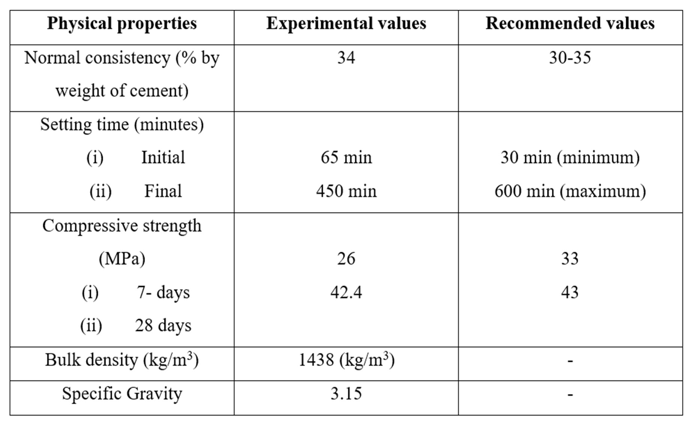

* 1. **FINE AGGREGATE**

The experimental investigation utilized locally sourced manufactured sand, also known as M-sand, as the fine aggregate. This M-sand adhered to the specifications outlined in IS: 383:2016 (IS 383, 2016). Its specific gravity was determined to be 2.65, indicating its density relative to water. A sieve analysis confirmed that the M-sand fell under the classification of grade Zone II. To assess its specific gravity, the fine aggregate was subjected to testing in accordance with IS: 2386(PIII)-1963 (IS:2386 (PART III)-1963, 2002). The results indicated that the quality of the M-sand used was deemed satisfactory. For a comprehensive overview of the fine aggregate’s characteristics, refer to Table 4.2 and Table 4.3.

**Table 4. 2 Sieve analysis of fine aggregate**

|  |  |  |  |  |  |
| --- | --- | --- | --- | --- | --- |
| **S. No.** | **Wt. Retained (g)** | **Cumulative wt. retained (g)** | **% of cumulative wt. retained** | **%**  **Passing** | **Recommended values by IS Code for zone**  **2** |
| 10 mm | 0 | 0 | 0 | 100 | 100 |
| 4.75  mm | 0 | 0 | 0 | 100 | 90-100 |
| 2.36  mm | 110 | 110 | 10.14 | 89.86 | 75-100 |
| 1.18  mm | 175 | 285 | 26.27 | 73.37 | 55-90 |
| 600 µ | 265 | 550 | 50.69 | 49.31 | 35-59 |
| 300 µ | 140 | 690 | 63.59 | 36.40 | 8-30 |
| 150 µ | 170 | 860 | 79.26 | 20.73 | 0-10/20 |

**Table 4. 3 Physical Characteristics of fine aggregate**

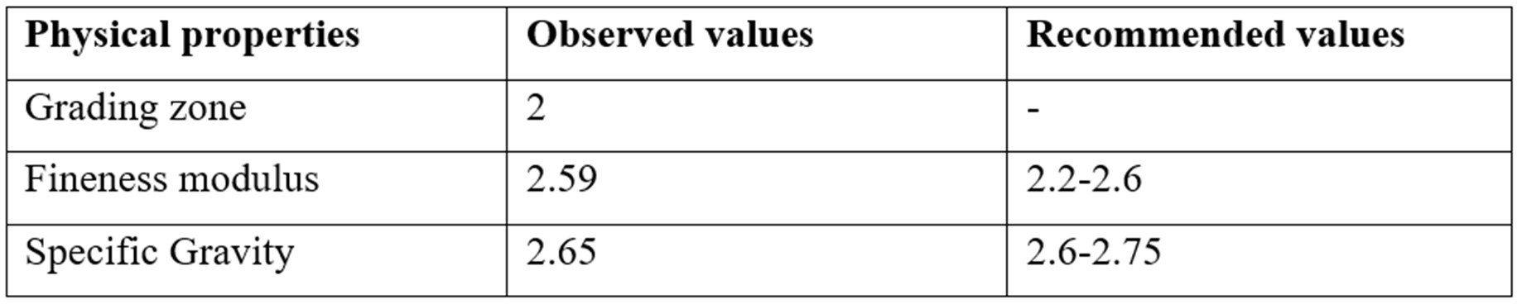

**COARSE AGGREGATE**

Our fiber concrete mixes incorporated two distinct single-sized uniformly graded crushed stone aggregates. These aggregates spanned a range of 20 mm to 12.5 mm, commonly referred to as 13 mm aggregate, and 12.5 mm to 10 mm, known as 10 mm aggregate. These aggregates were readily available in the market and primarily composed of granite. For a comprehensive understanding of the coarse aggregates, including their physical Characteristics, consult Table 4.4.

**Table 4. 4 Physical Characteristics of coarse aggregate**

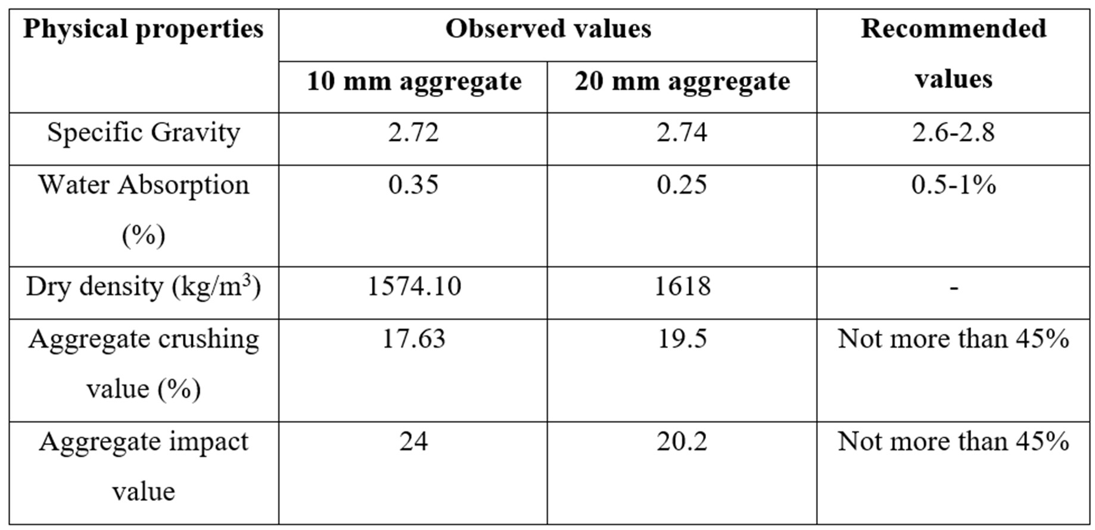

**WATER**

We employed standard potable water for both the casting and curing processes of our samples. Water, a crucial component in concrete development, fulfills a vital role by acting as a cohesive paste that binds all the aggregates together. Its quality, conforming to the stipulations set forth by IS 456:2000 (Bureau of Indian Standard (BIS), 2000), was carefully ensured throughout the review. The significance of water in the concrete mixture cannot be overstated, as it interacts with the other constituents to create a robust and durable final product. Rest assured, our utilization of high-quality water contributes to the integrity and longevity of our research findings.

**SUPERPLASTICIZER**

Superplasticizers, an advanced evolution of plasticizers, belong to a distinctive and relatively recent category. Chemically distinct from conventional plasticizers, superplasticizers offer remarkable benefits. One notable advantage is their ability to reduce water content by up to 30% while maintaining optimal workability, surpassing the potential water reduction of only 15% achievable with regular plasticizers. For this particular review, we employed the SikaPlast-5061 NS2 superplasticizer, which boasts a modified polycarboxylate chemical base. This cutting-edge formulation exhibits a density of 1.08 kg/l, contributing to its excellent performance. Additionally, the pH level of this superplasticizer

hovers around 6, ensuring compatibility with various concrete compositions and enhancing its overall effectiveness. Through the implementation of SikaPlast-5061 NS2, we aimed to harness the full potential of superplasticizers to optimize our experimental outcomes.

1. **RESULT**

**MECHANICAL CHARACTERISTICS OF FRC AT AMBIENT HEAT**

The mechanical characteristics of FRC are determined by measuring its strength in compression and split strength in tensile. This analysis will provide a comprehensive examination of the impact of the aspect ratio of SF on the Characteristics and performance of concrete.

**WORKABILITY TEST**

The measured slump values for each concrete mixture, indicating the degree of subsidence observed in millimeters (mm) are mentioned in Table 5.1. These measurements serve as indicators of the fluidity and cohesiveness of the fresh concrete. A higher slump value typically signifies increased workability, facilitating easier placement and compaction during construction processes. Moreover, the table demonstrates the varying quantities of steel fibers employed in each concrete mixture. The inclusion of steel fibers allows for assessing their impact on the slump characteristics of the concrete, thereby gauging their influence on workability.

**Table 5. 1 Slump Values**

|  |  |  |
| --- | --- | --- |
| **Fiber Dose**  **(%)** | **Slump value for 65 AR Fiber**  **(mm)** | **Slump value for 65 AR Fiber**  **(mm)** |
| 0 | 100 | 100 |
| 0.25 | 93 | 95 |
| 0.50 | 89 | 90 |
| 0.75 | 82 | 84 |
| 1.00 | 76 | 79 |
| 1.25 | 69 | 72 |
| 1.50 | 61 | 64 |

By incorporating fiber into the concrete mix, Figure 4.1 demonstrates the impact on the workability of fresh concrete. The workability of concrete is influenced by the aspect ratio of fibers used in the mix. When considering a 65-aspect ratio and a 55-aspect ratio, the workability is found to be 39% and 36% lower, respectively, compared to the control mix. This indicates that the addition of fibers with a 65-aspect ratio at a rate of 1.5% by volume of concrete results in a maximum decline in concrete workability, which is approximately 3% less than the decline observed with fibers of a 55-aspect ratio. It is experimental that fibers with higher aspect ratios have a greater impact on reducing concrete workability for a given volume fraction. The addition of fibers to concrete can introduce a network structure that hinders the flow and segregation of the mixture. Due to their significant content and wide surface area, fibers tend to absorb more cement paste and form a wrapping effect. The increased viscosity of the mixture, caused by the absorption of cement paste by the fibers, leads to a decrease in the slump of the concrete.

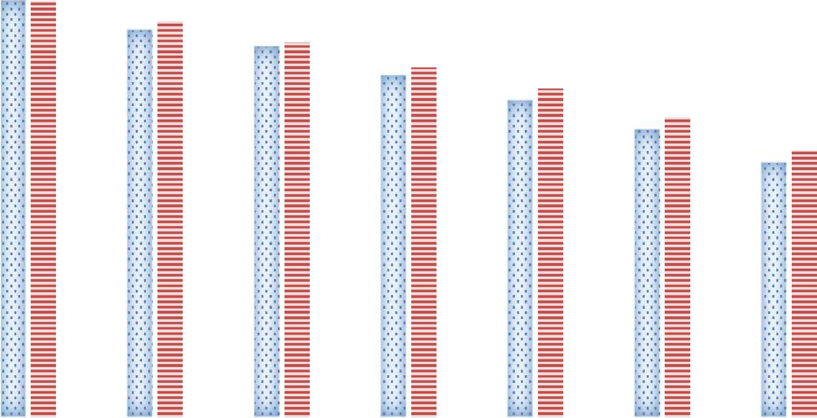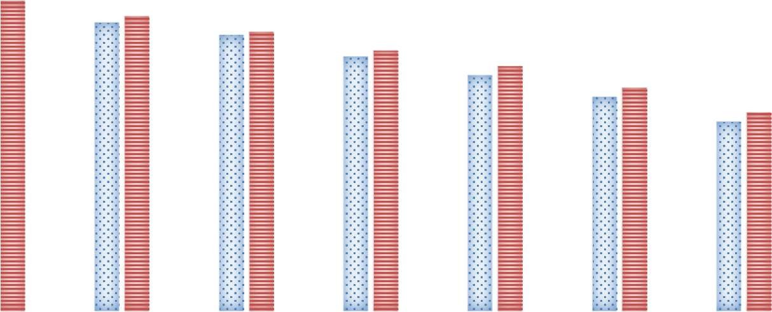

65 aspect ratio

55 aspect ratio

120

100

80

60

40

20

0

0

0.25

0.5

0.75

**Fiber (%)**

1

1.25

1.5

**SLUMP VALUE (mm)**

**Figure 5. 1 Workability of Concrete on Adding Different Fibers.**

**STRENGTH IN COMPRESSION OF FRC CUBES**

The average strength in compression results obtained from three samples of different concrete mixtures with varying fiber contents at a testing period of 28 days are shown in Table 5.2, Table 5.3, and Figure 5.2. The measurements were performed using a compression testing machine (CTM) and a Rebound hammer. The inclusion of fibers in the concrete mixture improved strength in compression, as evident from the data. The maximum strength in compression recorded for cubes tested with a CTM, containing fibers with an aspect

**Table 5 2 Strength in compression by CTM**

|  |  |  |  |  |
| --- | --- | --- | --- | --- |
| **Fiber Dose (%)** | **65 AR (MPa)** | **% Increment** | **55 AR (MPa)** | **% Increment** |
| **0** | 45.76 | - | 45.76 | - |
| **0.25** | 54.93 | 20.04 | 51.77 | 13.13 |
| **0.50** | 61.26 | 33.87 | 62.12 | 35.75 |
| **0.75** | 63.29 | 38.31 | 61.43 | 31.60 |
| **1.00** | 62.07 | 35.64 | 60.22 | 31.6 |
| **1.25** | 60.50 | 32.21 | 58.19 | 27.16 |
| **1.50** | 58.71 | 28.30 | 56.67 | 23.84 |

**Table 5. 3 Strength in compression by Rebound Hammer**

|  |  |  |
| --- | --- | --- |
| **Fiber Dose (%)** | **65 AR (MPa)** | **55 AR (MPa)** |
| **0** | 47 | 47 |
| **0.25** | 51.9 | 50.37 |
| **0.50** | 54.3 | 52.18 |
| **0.75** | 54.79 | 50.07 |
| **1.00** | 49.6 | 49.77 |
| **1.25** | 48 | 48 |
| **1.50** | 48.3 | 48.65 |

ratio of 65, was 63.29 MPa. Similarly, cubes with fibers having an aspect ratio of 55 achieved a strength in compression of 62.12 MPa when the fiber dosage was 0.75% and 0.5%, respectively. This indicates an overall variation in strength in compression ranging from 20% to 38.3% for cubes containing fibers with a 65-aspect ratio and 13.13% to 35.75% for cubes with fibers having a 55-aspect ratio. Conversely, when the Rebound Hammer was employed, the measured strength values were 54.79 MPa and 52.18 MPa for cubes with fiber aspect ratios of 65 and 55, respectively. These figures exhibited an overall variation of 3% to 16% and 3% to 11% for the two respective fiber aspect ratios. The increase in strength in compression resulting from the addition of fibers can be attributed to the enhanced bond between the steel fibers and the concrete matrix, which effectively halted the propagation of cracks.

The higher aspect ratios of the fibers contributed to more efficient prevention of fracture formation, thereby increasing strength in compression.

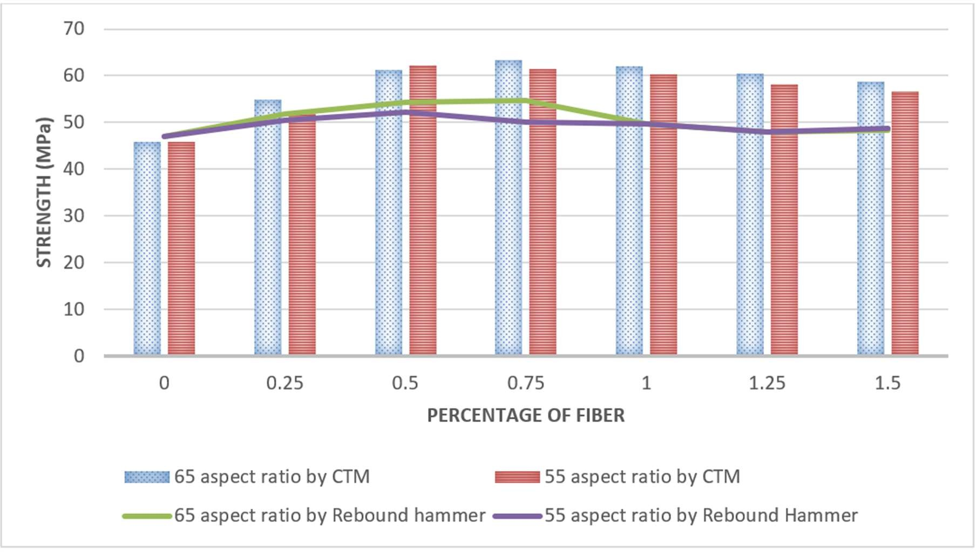

1. **CONCLUSION**

The following findings have been derived from the comprehensive analysis and experimental exploration conducted on plain concrete and FRC samples exposed to elevated heat:

* + - The experimental findings unequivocally demonstrate a discernible inverse connection between workability and fiber content, where an increase in fiber concentration corresponds to a noticeable decrease in workability. Intriguingly, an intriguing observation emerges from the review, revealing a more pronounced reduction in workability for mixtures featuring larger aspect ratio steel fibers. This phenomenon can be elucidated by the propensity of longer fibers to engage in heightened inter-fiber interactions, engendering augmented frictional forces among neighbouring fibers. Consequently, this augmented friction impedes the facile separation and reorientation of fibers during processing, thereby exerting an adverse influence on the overall workability of the material.
    - The strength of Fiber Reinforced Concrete increases significantly as fiber volume increases until a certain threshold. However, beyond this point, inadequate bonding between fibers and the matrix material hampers load transfer, reducing the overall effectiveness of the fibers in enhancing strength.
    - In the review, cubes incorporating fibers with different aspect ratios showed promising results for strength in compression. Cubes with a higher aspect ratio of 65 achieved maximum strengths of 63.29 MPa (CTM) and 54.79 MPa (rebound hammer), while cubes with a slightly lower aspect ratio of 55 reached strengths of 62.17 MPa (CTM) and 52.18 MPa (rebound hammer).
    - The maximum split strength in tensile after 28 days was observed to be 6.70 MPa for cylinders with a 65-aspect ratio fiber mixed at a volume of 1.25%. This represents an impressive 65.43% increase compared to normal concrete cylinders. Similarly, cylinders with a 55-aspect ratio fiber at a volume of 1.25% exhibited a split strength in tensile of 6.10 MPa, showing a remarkable 50.62% improvement over normal concrete cylinders.
    - The higher aspect ratio steel fiber exhibits greater strength at room heat as well as when subjected to an elevated heat due to its increased surface area, which enhances bonding and stress transfer with the surrounding matrix material, resulting in improved resistance against cracking and failure.
    - Visual inspection of concrete structures considers crucial parameters such as color changes and surface cracking to determine the extent of heat exposure. Extensive literature confirms that there are no discernible variations in color when concrete is subjected to heat up to 300°C for a duration of 2 hours. However, experimental investigations have demonstrated a noticeable change in color when concrete is exposed to 250°C for a duration of 3 hours. These findings highlight the significant influence of exposure duration on the assessment of structures subjected to elevated heat. Thus, careful consideration of exposure time is essential in accurately evaluating the impact of high heat on structural integrity.

1. **REFERENCES**
2. Abbass, W., Khan, M. I., & Mourad, S. (2018). Evaluation of mechanical Characteristics of steel fiber reinforced concrete with different strengths of concrete. Construction and Building Materials, 168, 556–569.
3. Abdallah, S., Fan, M., & Cashell, K. A. (2017). Pull-out behaviour of straight and hooked- end SF under elevated heat. Cement and Concrete Research, 95, 132.
4. Ahmed, T., & Siva Chidambaram, R. (2022). Shear strength of steel fiber reinforced concrete beam– A review. Materials Today: Proceedings, 64, 1087–
5. Cao, K., Liu, G., Li, H., & Huang, Z. (2022). Mechanical Characteristics and microstructures of Steel-basalt hybrid fibers reinforced Cement-based composites exposed to high heat. Construction and Building Materials, 341.
6. De Figueiredo, A. D., & Ceccato, M. R. (2015). Workability analysis of steel fiber reinforced concrete using slump and ve-be test. Materials Research, 18(6), 1284.
7. Effect of Steel Fibers on Strength of Concrete. (2016).
8. Kavya Sameera, V., & Keshav, L. (2022). Characteristics and performance of steel fiber reinforced concrete beam structure – Review. Materials Today: Proceedings, 66, 916– 919.
9. Mehdipour, I., Libre, N. A., Shekarchi, M., & Khanjani, M. (2013). Effect of workability characteristics on the hardened performance of FRSCCMs. Construction and Building Materials, 40, 611–621.
10. Li, Z. X., Li, C. H., Shi, Y. D., & Zhou, X. J. (2017). Experimental investigation on mechanical Characteristics of Hybrid FRC. Construction and Building Materials, 157, 930–942.