**Development of Hydroponics System and Data Monitoring Using Internet of Things**

**Hithyashini V, Kavya G, R Muskan Zehra, Anjuma B N**

1 Computer Science Engineering, Sambhram Institute of Technology, Bengaluru, Karnataka, India

2 Computer Science Engineering, Sambhram Institute of Technology, Bengaluru, Karnataka, India

3 Computer Science Engineering, Sambhram Institute of Technology, Bengaluru, Karnataka, India

4 Computer Science Engineering, Sambhram Institute of Technology, Bengaluru, Karnataka, India

**ABSTRACT**

**Hydroponic farming is gaining international attention due to its successful stockpiling of water and the development of high-quality foods. Formerly, majority of gardeners and farmers employed manual techniques and work. This has give impact on present and future food demand since the traditional farming system will not be able to meet due to urbanization, natural disasters, and climate change, among other factors. Therefore, the goal of this project is to design and develop the prototype of the hydroponics system and data monitoring in real time via IoT as well as to test the performance by collecting real-time data. The project used Arduino-Uno to control the system and to receive the readings from all of the sensors, such as pH, temperature, EC and water level. The WiFi module will transmit the data wirelessly to ThingSpeak and Spreadsheet, allowing the farmer to monitor the plant performance through the use of an Internet of Things. Results show that the parameters fulfill the requirement by the proper guideline. Thus, the farmers could monitor the temperature and lighting schedules based on the sensors data, which will boost plant productivity and address other agricultural issues.**

**Keywords:** hydroponic farming, Agriculture, Internet of Things, Microcontroller, ThingSpeak, Spreadsheet.

1. **INTRODUCTION**

Due to a variety of man-made factors, including industrialization, urbanization, natural disasters, climate change, and the unrestricted use of chemicals in agriculture, soil-based agriculture is currently experiencing difficulties. Hydroponics, also known as **soilless agriculture**, is a brand new alternative method of crop production. Plants can be grown hydroponically by being submerged in a **nutrient-rich solution of water**. Numerous plants, crops, or vegetables can be grown with hydroponics. In general, hydroponically grown produce has superior nutritional value, flavor, and yield quality than naturally grown produce on soil. Therefore, hydroponics would be a superior approach to produce various fruits, vegetables, and livestock feed as well as to meet the future demand for world nutrition.

1. **METHODOLOGY**

This system is developed using related theory and system design concepts to suit the requirements of farmer. The following approaches were used in the research.

**2.1 Hardware**

The Arduino Uno is used as a microcontroller in this particular project. All of the coding will be combined, and due to the Arduino standard, it will be able to read and write all of the data, as well as to ensure that all of the sensors are functioning as intended. In this project, the Arduino ESP 8266 is used as a Wi-Fi module. The ESP 8266 could transmit the sensor data to the ThingSpeak and Spreadsheets. Due to the general specifications, this module could deliver all the data from each of sensors through Wi-Fi. The DHT22 is a simple digital temperature and humidity sensor. This sensor uses a powerful moisture sensor and a thermistor to test the ambient air and delivers a digital signal on the data pin. This project uses the DHT22 humidity sensor to detect whether the relative humidity. The DS18B20 temperature sensor measures the liquid temperature. DS18b20 sensor is chose due to its robustness and could withstand immersion in concentrated water solutions at low or high temperatures in a hydroponics system. An EC sensor measures water conductivity. This sensor may also measure water directly. The probe used to generate a voltage between electrodes in water or solution. The voltage drop represents the water's resistance, which is converted to conductivity. Water Detection Regulator Analog PH Sensor Kit Board Probe Shield is used for this project. The probe is submerged in water as a solution to determine the pH value. This project uses Module Detection Liquid Surface Depth Height T1592 as its water level sensors. In a compact, enclosed location, water level sensors are used to monitor and control liquid concentration.

**2.2 Software**

The Arduino Uno board and the ESP8266 Wi-Fi module are programmed using the Arduino IDE. The pH sensor, water level sensor, and other sensors will all work with this software package's source code. The serial monitor output includes additional data such as the attention value. ThingSpeak will visualize all data in this project using gauges and graphs. Agriculturalists or users could monitor the plant growth based on the displayed data of pH, EC, water level, temperature, and humidity.

1. **MODELING AND ANALYSIS**

The following figure illustrates the block diagram of the system consists all required sensors for the design of prototype and to be used in the experiments.

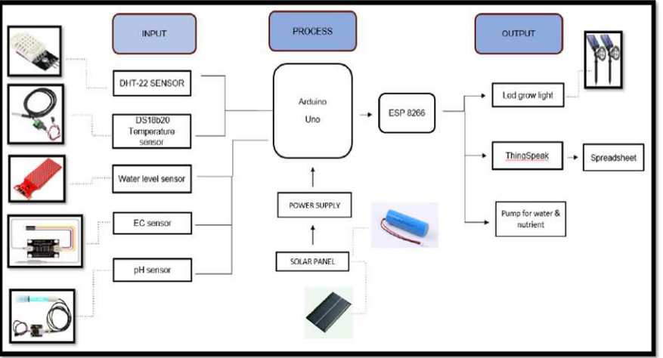

**Figure 1:** Bloch Diagram of Procedure

1. **RESULTS AND DISCUSSION**

This project involves the development of a prototype that could measure pH, water level, temperature, humidity, and EC in real time using ThingSpeak and a spreadsheet. The data will be presented in Thingspeak and will be stored in a Spreadsheet. In order to analyze the factors that could give impact to the plant growth and to determine whether the growth is compliance with the characteristics of Pak Choi, all data for each parameters will be graphed.The parameter value for pH is 7.5, which is within the range of the characteristic of Pak Choi. Field 2 is the EC value in real time data. The EC reading is 1.9 which is within the permitted range of EC value. According to Pak Choi's characteristic, the EC values should be in between 1.5 and 2.5. However, if it is higher than the recommended range, the plant's growth would be stunted. In the worst scenario, the plant will wither due to over-fertilization. The ThingSpeak parameter value for water level is 3, indicating the tank's maximum capacity of 10 litres. However, if the indicator displays as 1, the tank has less than 2 litres of water. EC and pH values will be too high if the water level is less than 8-10 litres due to the concentration of liquid. Humidity is displayed as field number 4. The plant could only absorb a specific amount of humidity and as a result, it produces less evaporation of water than most plants. If the plant loses too much water, the stomata will be closed and halting of photosynthesis. The current humidity level is 100% due to the plants could not evaporate any water, Figure 8 depicts water at 28°C. The experiment was held and tested in a room, thus, the water temperature is between 25°C and 28°C. The suitable temperature for Pak Choi is between 12.78°C to 29.44°C.

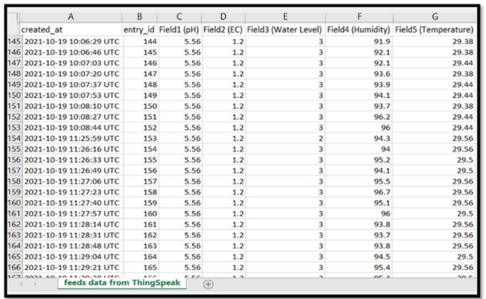

**Figure 1**: Result in Spreadsheet

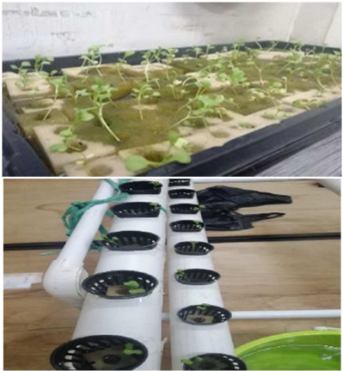

**Figure 2:** The sow seeds, the prototype and the Pak Choi plant during the monitoring process

1. **CONCLUSION**

the hydroponics system was successfully developed using ThingSpeak and Spreadsheet real-time data via the Internet of Things. The technology automatically controls the level of nutrition and offers a graphical user interface for simple maintenance and control. The hydroponics prototype can be developed with this project. In this study, data including pH, EC, and water temperature have been examined and validated to ensure they fit the criteria for Pak Choi's features. The testing method produced satisfactory findings, and the application is practical, which leads to an increase in production. Data mining techniques will be applied to evaluate and forecast data regarding the amount and quality of the plant as part of a future study that will expand the system to incorporate more beneficial and adaptable linked devices.

1. **REFERENCES**

[1] S. Jan et al., “Hydroponics – A Review,” Int. J. Curr. Microbiol. Appl. Sci., vol. 9, no. 8, pp. 1779–1787, 2020.

[2] K. Kularbphettong, U. Ampant, and N. Kongrodj, “An Automated Hydroponics System Based on Mobile Application,” Int. J. Inf. Educ. Technol., vol. 9, no. 8, pp. 548–552, 2019.

[3] J. Pitakphongmetha, N. Boonnam, S. Wongkoon, T. Horanont, D. Somkiadcharoen, and J. Prapakornpilai, “Internet of things for planting in smart farm hydroponics style,” 20th Int. Comput. Sci. Eng. Conf. Smart Ubiquitos Comput. Knowledge, ICSEC 2016, 2017.

[4] M. Fuangthong and P. Pramokchon, “Automatic control of electrical conductivity and PH using fuzzy logic for hydroponics system,” 3rd Int. Conf. Digit. Arts, Media Technol. ICDAMT 2018, pp. 65–70, 2018.

[5] T. Nishimura, Y. Okuyama, A. Matsushita, H. Ikeda, and A. Satoh, “A compact hardware design of a sensor module for hydroponics,” 2017 IEEE 6th Glob. Conf. Consum. Electron. GCCE 2017, vol. 2017-Janua, no. Gcce, pp. 1–4, 2017.

[6] D. Saraswathi, P. Manibharathy, R. Gokulnath, E. Sureshkumar, and K. Karthikeyan, “Automation of Hydroponics Green House Farming using IOT,” 2018 IEEE Int. Conf. Syst. Comput. Autom. Networking, ICSCA 2018.