**REVIEW ON A POWER QUALITY ISSUES OF A DISTRIBUTION TRANSFORMER WITH CONNECTED LOAD**

Shrinath Yadav1, Prakash Narayan Tiwari2

1M. Tech Scholar, Department of Electrical & Electronics Engineering, Rabindranath Tagore University, Bhopal (India)

2Assistant Professor, Department of Electrical & Electronics Engineering, Rabindranath Tagore University, Bhopal (India)

**ABSTRACT**

In this paper a Voltage control system for power distribution which can solve the power quality problem in distribution. the proposed system consists of a frequency transformer connected to a power transformer receiving connection from both sides. this automatic connection is achieved using high or medium frequency transformers. The input of the converter is single-phase alternating current and the output is single-phase alternating current with different voltage amplitudes. the output voltage is stabilized by a closed-loop controller that controls the voltage at one level. The proposed system meets the smart distribution in terms of improved ability, protection of equipment and efficiency.

**Keywords:** Single-phase AC, Distributed Transformer, Sine PWM, THD, MATLAB.

**1. INTRODUCTION**

Electricity has become an indispensable part of contemporary life. Without electricity, it is impossible to conceive of modern life. It is also important that the electricity provided be of high quality and reliable for the end user's devices to work properly. Power quality and reliability are particularly important for commercial and industrial users. Therefore, it is critical that the quality be preserved [4].

If the voltage and frequency values being delivered are off in any way, the power quality will suffer. The efficiency and durability of consumer devices are negatively impacted. Whereas power outages and other issues in the grid threaten the reliability of the electricity supply. Thus, the switchgear of the power system should be built to function without any time lag in order to ensure the Continuity of the power being provided by clearing faults at a quicker pace If the voltage and frequency values being delivered are off in any way, the power quality will suffer. The efficiency and durability of consumer devices are negatively impacted. Whereas power outages and other issues in the grid threaten the reliability of the electricity supply. Thus, the switchgear of the power system should be built to function without any time lag in order to ensure the continuity of the power being provided by clearing faults at a quicker pace.

The typical distribution transformer may be cheap, efficient, and dependable, but it cannot ensure the safety of loads against transients such voltage drops and spikes. Many industrial customers in power distribution networks now see voltage dips and spikes as one of the most serious problems with power quality. Customers' loads are becoming increasingly sensitive to voltage disturbances like sags and swells as the sophistication of electronics used in industrial applications increases. voltage sags and swells can be described by two essential characteristics: magnitude and duration. Power quality Problems: The reliability of our electrical supply may be compromised in a number of ways. These kinds of disruptions are almost inevitable with the electricity grid's interconnected infrastructure. Therefore, proper care must be made to keep the appropriate equipment running in order to avoid the repercussions of these issues and preserve the quality of the power supply [2]. A variety of power quality issues, along with their origins and effects, are discussed here.

### 1.1 Voltage Sag

When the voltage drops by 10% to 90% for a half cycle or longer, this is known as a voltage sag. Figure displays the voltage signal with a drop.

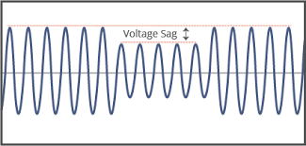

Figure 1. Voltage sag

Causes: The causes of voltage sag are-

* High current consumption during motor starting.
* Difficulties with the electricity grid
* An unexpected rise in the system's load

Consequences:

* Failure of contactors and switchgear
* Malfunction of Adjustable Speed Drives (ASD’s)

### Voltage Swell

A voltage swell occurs when the voltage increases by 10% to 80% over the typical value for a half cycle or longer. Fig. displays the voltage signal during an increase. originally referred to as surges were similar to sags, except that the voltage exceeded a user-defined high limit an increase to between 1.1 pu and 1.8 pu in rms voltage or current at the power frequency durations from 0.5 to 1 minute. Swells are treated under a single category. A common underlying cause of sags and swells in all three areas is a sudden change of current flow through the source impedance. A swell can occur due to a single line-to- ground fault on the system, which can also result in a temporary voltage rise on the undaunted phases sag as a decrease in rms voltage to between 0.1 and 0.9 pu for durations 1 min the IEC is much less prescriptive with respect to the magnitude of voltage and duration that apply to voltage sags, specifying a voltage dip (sag) as a “temporary reduction of the voltage magnitude at a point in the [electrical system](https://www.sciencedirect.com/topics/engineering/electrical-system) below a threshold.

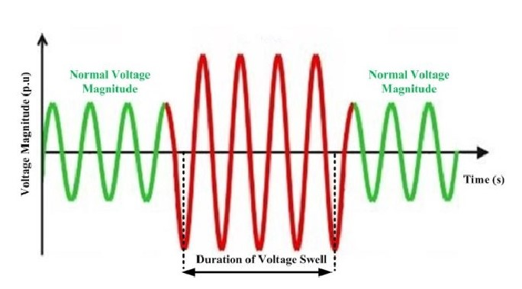

Figure 2. Voltage swell

Causes:

* Disconnection of major load
* Capacitor bank activation
* Electrical electricity being cut off suddenly
* Phases with no grounding undergo a shift in ground reference

**2. LITERATURE REVIEW**

(Patel, 2021) [1] This research presents an inverter-based analysis of the effects of harmonic content in 3-phase induction motor (IM) current generated by sinusoidal pulse-width modulated (SPWM) and space vector pulse-width modulated (SVPWM) drives the IM drive's topology and circuit are introduced, followed by its operational basics and the waveform it produces. The load-control process, including the 3-phase IM model fed from the grid, is also covered in detail, as are the characteristics of its operation. This thesis makes use of the MATLAB/Simulink simulation software package to model the operation of a three-phase IM connected to a pulse-width-modulated (PWM) inverter. The IM stator current is monitored while switching between SPWM and SVPWM inverters at different modulation indices in order to compare their performances. The Fast Fourier transform is used to do a spectral analysis of the IM current and reveal its harmonic content.

(Carreno et al., 2021) [2] There is a lot of strain on distribution systems because of the wide range of possible operating circumstances, which puts distribution transformers and lines at risk and reduces the quality of service provided to customers. The quality of service may be impacted when fluctuating loads cause voltage profiles to go beyond the ranges specified by grid regulations. On the other hand, nonlinear loads like diode bridge rectifiers without power factor correction devices provide nonlinear currents that disrupt the distribution transformer's functioning and shorten its lifespan. The unpredictable use of household appliances is a major cause of variable loads at residential levels; nevertheless, electric car charging stations have lately contributed to this phenomenon as well. As a result, the distribution transformer cannot function reliably under such situations, necessitating the use of backup infrastructure. Hybrid transformers, which combine the functions of a traditional transformer with a power converter, are one promising approach to addressing a variety of power quality issues. For anyone interested in learning more about hybrid distribution transformers, this article serves as a literature overview.

(Qureshi, 2020) [3] The quality of the electricity supplied to them is a major factor influencing the performance of modern technological gadgets. Power quality issues, such as non-sinusoidal voltage and frequency of current, are common and occur often, causing failure of end-use equipment. Voltage fluctuations during drops and spikes are the primary issue. Custom power devices may be utilised to solve these problems. These issues are solvable, at least to some degree. Ideally, power grids provide consumers with a steady stream of energy that exhibits sinusoidal voltage of narrow magnitude and frequency. In comparison to small and medium enterprise systems and uninterruptible power supplies, DVRs have a greater capacity for power. When compared to the DSTATCOM and other bespoke power devices, the DVR is more compact and affordable. The DVR is quick, adaptable, and effective. DVR has the additional feature of correcting for harmonics in addition to compensating for power dips and surges. When abnormal conditions arise in the distribution system, voltage sag/swell and power quality issues are eliminated or at least lessened thanks to DVR.

(Tajne, 2020) [4] Most distribution systems' primary worry is a voltage issue related to power quality. Thus far, the under-voltage (voltage sag) situation brought on by a short circuit or fault has been the primary source of the voltage issue. Today, power quality in the distribution system is the most pressing concern for all types of modern infrastructure. Under-voltage (voltage sag) conditions induced by short circuits or faults in the distribution system are often thought to be the root of the voltage issue. In this study, a series voltage regulator for distribution transformers is introduced to address the problem of voltage drop/rise on the secondary side of the transformer. The secondary side of a transformer is connected to a series voltage regulator based on hysteresis. gating signal production is handled by the hysteresis controller, whereas reference voltage generation is handled by the Phase lock loop. Every part of the system is created in MATLAB. In order to enhance power quality disturbances, the system is tested under a variety of conditions.

(Dandoussou & Kamta, 2020) [5] The study's goal is to analyse clearly by identifying and describing each disturbance. The primary goals are to examine the causes of unexpected faults on wires that provide loads and to conduct a survey of the adverse effects resulting from the load, in particular typical loads utilised in industrial settings. The effects of these disruptions on a Distribution Line network were analyzed through simulation, and the findings were given.

(Karaman et al., 2020) [6] With each passing day, the issue of poor electricity quality becomes more pressing. The primary elements affecting power quality are harmonic current and reactive power. Harmonic current and reactive power are used by the induction motors from the mains supply. Transmission line efficiency and heat loss are both negatively impacted by reactive power and harmonic current. These issues have been addressed using passive and active filter applications. Passive filters have a few limitations. Examples of these limitations are the system's large physical size and its resonance with load. Since Active Power Filters (APFs) may be used in conjunction with harmonic and reactive power compensation as suitable control approaches, their potential application domains are expanding quickly. Using a three-phase Parallel Active Power Filter, this research suggests simulating the process of power factor correction and reactive power compensation for a Three-phase induction motor in MATLAB/Simulink. The Sine Multiplication Technique (SMT)” is used to produce the reference currents used by PAPF. We show simulation experiments to evaluate the motor's functionality in a variety of real-world circumstances. “Using a hysteresis controller-based PAPF filter, the reactive power of a three-phase induction motor may be compensated, bringing the power factor up to 1.”

(Wang & Cao, 2019) [7] Power Line Communications (PLC) have a significant challenge from impedance mismatch, which reduces signal power transfer and may disrupt transmissions. Power line modems and power line networks have an inherent impedance mismatch; however, this may be efficiently compensated for by using impedance matching methods tailored to a particular frequency or frequency range. in this research, we explore the complexities involved in finding the right balance between competing goals in impedance-matching network design. We also present a helpful taxonomy of the many existing state-of-the-art PLC impedance matching approaches and conduct a thorough examination of their respective histories. We conclude with a discussion of key problems (concerns) and recommendations for future study that warrants more investigation. in order to develop an efficient impedance matching coupler for PLC applications, this paper offers a helpful reference for researchers and manufacturers to rapidly comprehend impedance matching concepts.

(Hren & Mihalič, 2018) [8] Total Harmonic Distortion (THD) and DC link usage are two important factors to keep in mind while designing a single-phase inverter system (grid-connected, UPS, or motor drive). over-modulation allows for the output voltage to be kept constant within a certain range even when the providing DC voltage is decreased. the inverter's output voltage suffers from the force of higher-order harmonics (the third is dominant), which are correlated to the fundamental frequency. A single-phase inverter operating in the over-modulation domain is analyzed in detail, including a full spectrum analysis of the three levels of output voltage. based on the analytical findings of a frequency spectrum assessment, the third harmonic component in the output voltage is almost nullified due to the opposite third harmonic component in the modulator unit. This component is formed by triangular “Sinusoidal Pulse-Width Modulation (SPWM).” A smaller filter will have an easier time dampening the remaining higher harmonics. With this technique, the inverter's THD is guaranteed to be reduced over its entire usable bandwidth, despite the fact that the voltage gains of the fundamental harmonic component decreases with increasing over-modulation. Experimental evidence supported the suggested SPWM method.

(Sur et al., 2018) [9] The Reduction of Transmission-System Harmonics is the subject of this paper. Since harmonic frequencies are a common source of power quality issues, this study focuses on methods for removing harmonic content from the system using a variety of Active and passive Filter configurations, each of which is managed by an Active Damper Controller. The non-linear load is the primary generator of harmonics since it uses discontinuous current and injects harmonics, both of which result in transmission losses. The simulation work is also carried out in MATLAB to evaluate the outcome without or with hybrid filter, demonstrating that the active damper may become a potential solution to stabilize the future power electronics-based power systems.

(Naderi et al., 2018) [10] As both the sensitivity of loads and the prevalence of nonlinear loads grow in the electrical distribution network, it is clear that power quality has become an essential feature of modern systems. It is clear that distributed power quality improvement (PQI) is required when dealing with harmonic loads, which are spread out over a network. Researchers have been working on different filters and devices to improve power quality for years, but the distribution system's nature has changed, making power electronic based DGs more crucial. In this study, we conduct a comprehensive literature review of power quality improvement devices, focusing on the auxiliary services of flexible DGs. The literature on the concept of microgrids, testbeds, and associated control approaches is also reviewed. In spite of the fact that DGs were used in several PQI-related contexts, these usages did not constitute the defining characteristics of multi-functional DGs. Several strategies of control are examined and classified based on their treatment in the academic literature. Finally, a few detailed comparisons are made between the various methods, taking into account their nature, capabilities, benefits, and implementation costs.

(Senapati et al., 2018) [11] The study discusses the use of a shunt active filter to improve power quality in a PV-battery-fuel-cell hybrid energy system that is linked to the grid. An application of the Sinusoidal Current Control Strategy is used to regulate the shunt active filter. To reduce the impact of the harmonic current component and make up for the imaginary or reactive power generated by the hybrid system's precise and careless operation, a shunt active power filter is included. Sinusoidal current is retrieved from its origin using a sinusoidal current management approach. We use MATLAB R2016a to analyse the effectiveness of a sinusoidal current control strategy applied to a shunt active power filter operating under passive load circumstances with a non-linear load. The power filter system's ability to reduce harmonics was verified using MATLAB simulation, and the control method was also checked for plausibility. The viability of a controller developed for SHAPF to provide harmonic separation of passive loads is established by the total harmonic distortion (THD) of voltage and current.

(Singh et al., 2018) [12] Overcoming problems with current harmonics and reactive power compensation using a shunt active power filter (SAPF) has become a well-known advanced technology in recent years. This paper presents a technical overview of several SAPF control mechanisms for operation. Various control mechanisms, including the development of reference current in the time domain, frequency domain, and through soft computing, the regulation of dc link voltage, and the generation of switching patterns for a voltage source inverter, have been studied. The purpose of this work is to offer a comprehensive introduction to SAPFs for use in a wide range of scientific and technical disciplines.

## 3.DISTRIBUTION TRANSFORMERS

The concept of a distribution transformer, a common kind of isolation transformer, is also presented. This transformer's primary use is in transforming very high voltage into more manageable levels, such as 240 or 120 volts, for use in power grids. Single-phase and three-phase transformers, pad-mounted transformers, underground transformers, and distribution transformers installed on poles are only some of the options in the distribution system.[29]

Service transformer is another name for a distribution equipment. The last voltage transformer in the electricity grid, it reduces the output used in the distribution lines to the users' rating.

Therefore, a constant supply of high-quality power is essential for a smart grid. The distribution transformer, seen in Figure, is an important component of the system for delivering clean power to the final user, whether it a business, factory, or home.

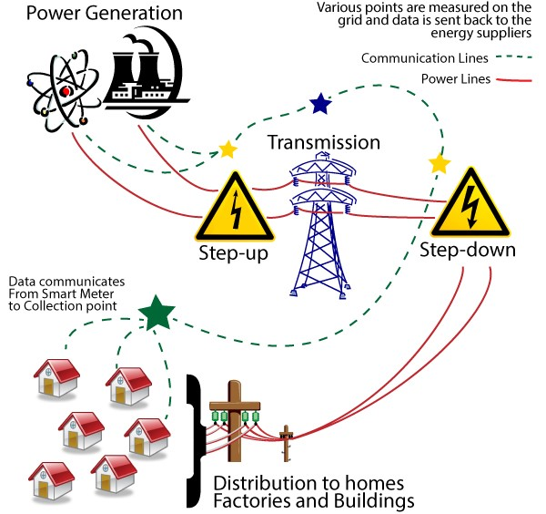

Figure 3. Concept of Functionality of Distribution Transformers in Electric Grid

Distribution transformers may be found in a wide range of sizes and efficiencies to accommodate a wide variety of applications and end-user budgets. There are a number of different transformer types used in the distribution system, all of which include secondary terminals that provide electricity to the end user at a usage voltage level. One common kind of distribution transformer used in the USA to power single-phase appliances is the single-phase distribution transformer.

# 4. PROPOSED METHODOLOGY

Existing LFT is connected to an auto-connected PEs module on the secondary side to smooth out voltage dips and spikes; this is the suggested solution. As a result of this auto connection, a compensator with a shunt input and series output may be constructed, with no capacitive energy storage required. Thus, the suggested system is distinct from the typical series compensator, such as a DVR, in both its structure and its operation.

To produce the compensating voltage Vc, the suggested system takes use of the Vin at the input. Rather of relying on a battery to control the voltage, this is a tap changer transformer, which uses the source voltage to modify the turns ratio of the transformer, thereby regulating the load voltage. As a result of how the PEs module is built, we may use its partial power processing capacity to decrease the suggested system's rating. In addition, the system's overall efficiency may be improved when in bypass mode. The output voltage delivered to the load may be controlled by the PEs module, which does so by generating a compensating voltage that is vector-added to the grid voltage.

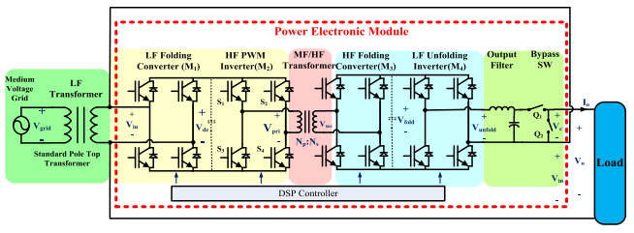

Figure 4. Detailed power electronics module in the proposed distribution transformer

Medium Voltage Grid: "Electrical grid" or "power grid" refers to the system that links "generation," "transmission," and "distribution" facilities. It is used to transport electricity from a power plant to a power distribution centre. Power is transferred at 220kV or greater from the producing station to the load centre. A super grid is the network formed by these high voltage cables. The sub-transmission network, which operates at 132kV or less, is fed by the super grid.

The medium-voltage range encompasses systems operating between 1 kV and 36 kV. Level 7. The low-voltage level is defined as voltages below 1 kilovolt (kV). This is the level at which electricity enters residential connections.

## 4.1 Control Technique

Controlling the power switches in the right order to minimise switching loss and maximise efficiency is the goal of Space Vector Modulation (SVM).

The output voltage and input current are modulated via a space vector pulse width modulator. The method's benefit lies in the fact that the switching vector used to regulate the input current and the output voltage may be selected arbitrarily. When the scales are tipped in one direction, this strategy may be advantageous. Vectors in space are used to represent the three phase variables. In order to ensure that each PWM cycle has the correct gate drive waveform, this module creates that waveform automatically.

Because of this, the inverter may merge many switching states into a single one (number of switching states depends on levels). For each of these states, the SVPWM calculates a different switching time. This method is compatible with all types of multilevel inverters and may be simply adapted for use with greater voltages (cascaded, capacitor clamped, diode clamped). The required voltage vector Vref may be calculated from the duty cycle time of each of the three input vectors that compose a triangle. [43] The SVPWM vector chart is shown in the figure:

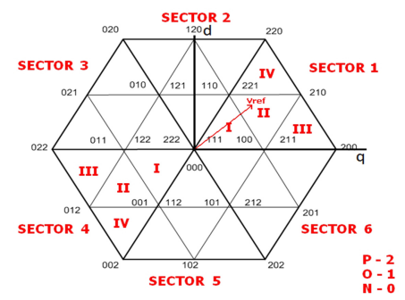

Figure 5. SVPWM Chart

Waveforms are a specific example of the triangulation approach with a modified reference waveform, as illustrated in figure, which is generated by adding an essentially triangular, third harmonic distortion waveform to the required sinusoidal component. “Due to the inherent additive third harmonic triangle waveform, the characteristics of the space vector PWM waveforms are very similar to those obtained through the addition of third harmonic sinusoidal distortion to a triangulation modulator although, as will be shown later, the space vector generation technique presented in this has many advantages over the traditional triangulation method - in particular it is more amenable to microprocessor implementation.” [4]

## 5. CONCLUSION

There is a growing problem in the industrial sector and among consumers due to the increased demand for reliable power. Among them, voltage imbalance is regarded as the most significant factor that reduces the efficiency of electrical devices. The need for reliable electricity has grown in importance in the industrial sector and among consumers. Among them, voltage imbalance is regarded as the most significant impacting factor that causes electrical equipment to function poorly.

# References

[1] A. Patel, “Electrical Power Engineering and Mechatronics the Impact Analysis of Motors Current Gain On High Frequency Harmonics Fed from Inverter,” 2021.

[2] A. Carreno, M. Perez, C. Baier, A. Huang, S. Rajendran, and M. Malinowski, “Configurations, power topologies and applications of hybrid distribution transformers,” Energies, vol. 14, no. 5, pp. 1–35, 2021, doi: 10.3390/en14051215.

[3] A. Qureshi, “Analysis of DVR in Distribution during Voltage Sags & Voltage Swells Analysis of DVR in Distribution during Voltage Sags & Voltage Swells Submitted in partial fulfillment of the requirement for the award of Degree of Master of Technology in Power System.,” no. March, 2020.

[4] D. Tajne, “Voltage Sag and Swell Compensator for Distribution Transformer Using Series Voltage Regulator,” vol. 8, no. 5, pp. 3459–3465, 2020.

[5] A. Dandoussou and M. Kamta, “Journal of electrical engineering and electronics technology Analysis of Electrical Power Disturbances in Distribution and,” vol. 9, no. September, pp. 4–11, 2020, doi: 10.37532/jeeet.2020.9(4) e.176.

[6] Ö. A. Karaman, A. Gündoğdu, and M. CEBECİ, “Performing reactive power compensation of three-phase induction motor by using parallel active power filter,” Int. Adv. Res. Eng. J., vol. 4, no. 3, pp. 239–248, 2020, doi: 10.35860/iarej.731187.

[7] B. Wang and Z. Cao, “A review of impedance matching techniques in power line communications,” Electron., vol. 8, no. 9, pp. 1–25, 2019, doi: 10.3390/electronics8091022.

[8] A. Hren and F. Mihalič, “An improved SPWM-based control with over-modulation strategy of the third harmonic elimination for a single-phase inverter,” Energies, vol. 11, no. 4, 2018, doi: 10.3390/en11040881.

[9] K. Sur, B. Dhabale, and N. Khobragade, “Performance Analysis of a Hybrid Filter Composed of Passive and Active Filter with Active Damper Controller,” vol. 4, no. 3, pp. 32–38, 2018.

[10] Y. Naderi, S. H. Hosseini, S. Ghassem Zadeh, B. Mohammadi-Ivatloo, J. C. Vasquez, and J. M. Guerrero, “An overview of power quality enhancement techniques applied to distributed generation in electrical distribution networks,” Renew. Sustain. Energy Rev., vol. 93, pp. 201–214, 2018, doi: 10.1016/j.rser.2018.05.013.

[11] R. Senapati, R. N. Senapati, and M. K. Maharana, “Study and analysis of performance of 3-phase shunt active filter in grid-tied PV-Fuel Cell system employing Sinusoidal Current Control Strategy,” Int. J. Renew. Energy Res., vol. 8, no. 1, pp. 67–81, 2018, doi: 10.20508/ijrer. v8i1. 6571.g7282.

[12] H. Singh, M. Kour, D. V. Thanki, and P. Kumar, “A review on Shunt active power filter control strategies,” Int. J. Eng. Technol., vol. 7, no. 4, pp. 121–125, 2018, doi: 10.14419/ijet. v7i4.5.20026.

[13] W. U. K. Tareen and S. Mekhielf, “Three-Phase Transformer Less Shunt Active Power Filter with Reduced Switch Count for Harmonic Compensation in Grid-Connected Applications,” IEEE Trans. Power Electron., vol. 33, no. 6, pp. 4868–4881, 2018, doi: 10.1109/TPEL.2017.2728602.

[14] B. R. Madhu, M. N. Dinesh, and B. M. Ravitheja, “Design of shunt hybrid active power filter to reduce harmonics on AC side due to non-linear loads,” Int. J. Power Electron. Drive Syst., vol. 9, no. 4, pp. 1926–1936, 2018, doi: 10.11591/ijpeds. v9n4.pp1926-1936.

[15] D. S. M. K.V. Pradeep Kumar Reddy, “Mitigating of Voltage Sag / Swell by Series Voltage Regulator for A Distribution,” vol. 5, no. 4, pp. 69–73, 2018.

[16] G. Devadasu, “Voltage Sag and Swell Identification Using FFT Analysis and Mitigation with DVR,” IOSR J. Electr. Electron. Eng., vol. 12, no. 2, pp. 30–40, 2017, doi: 10.9790/1676-1202013040.

[17] S. Biricik, O. C. Ozerdem, S. Redif, and M. S. Dincer, “New hybrid active power filter for harmonic current suppression and reactive power compensation,” Int. J. Electron., vol. 103, no. 8, pp. 1397–1414, 2016, doi: 10.1080/00207217.2015.1116113.

[18] I. Ali, V. Sharma, and P. Chhawchharia, “Control Techniques for Active Power Filter for Harmonic Elimination & Power Quality Improvement,” Int. J. Electr. Electron. Data Common., vol. 4, no. 10, pp. 25–36, 2016.

[19] V. Meenakshi, G. D. Anbarasi Jebaselvi, and S. Paramasivam, “Space vector modulation technique applied to doubly fed induction generator,” Indian J. Sci. Technol., vol. 8, no. 33, 2015, doi: 10.17485/ijst/2015/v8i33/60766.

[20] A. Ponder, S. Member, I. L. Pham, and S. Member, “Space Vector Pulse Width Modulation in Wind Turbines’ Generator Control,” IEEE Res. Pap., pp. 1–6, 2014.

[21] A. Sandeep, “study of hybrid active power filter for power quality improvement master of technology study of hybrid active power filter for power quality master of technology,” Dep. Electr. Eng. Natl. Inst. Technol. rourkela, 2014.

[22] B. S. Kumar, I. I. V Oltage, and D. I. P. S. A. Nd, “Compensation of Voltage Sags and Swells during Abnormal Conditions in Distribution Systems by Dynamic Voltage Restorer (DVR),” vol. 4, no. 4, pp. 62–68, 2014.

[23] P. Kaur and S. Gupta, “Mitigation Technique for Voltage Sag & Swell by Using Dynamic Voltage Restorer,” Int. J. Innov. Res. Electr., vol. 2, no. 1, pp. 2321–5526, 2014, [Online]. Available: www.ijireeice.com

[24] M. Islam, N. Raju, and A. Ahmed, “Sinusoidal PWM Signal Generation Technique for Three Phase Voltage Source Inverter with Analog Circuit & Simulation of PWM Inverter for Standalone Load & Micro,” Int. J. Renew. Energy Res., vol. 3, no. 3, pp. 647–658, 2013, [Online]. Available: http://www.ijrer.net/index.php/ijrer/article/view/771

[25] K. Sandhya, “Design of Unified Power Quality Conditioner (UPQC) for Power Quality Improvement in Distribution System,” IOSR J. Electr. Electron. Eng., vol. 4, no. 2, pp. 52–57, 2013, doi: 10.9790/1676-0425257.

[26] M. Kubeitari, A. Alhusayn, and M. Alnahar, “Space Vector PWM Simulation for Three Phase DC/AC Inverter,” Int. J. Electr. Comput. Eng., vol. 6, no. 12, pp. 1402–1407, 2012.

[27] M. Elamin and E. Ahmed, “Design of a Distribution Transformer Monitoring System using Global System Mobile Technology,” 2017.

[28] Long Xian, Lizhen Wu, Xiaoying Zhang., “Improving fault ride‐through capability for doubly‐fed induction generator based on improved system structure and corresponding control scheme. IET Energy Syst. Integr. 6:73–85. March 2023.

[29] [P.Bhardwaj](https://onlinelibrary.wiley.com/authored-by/Bhardwaj/Prashant), [Anuj Verma](https://onlinelibrary.wiley.com/authored-by/Verma/Anuj),.,Synchronized Control Strategy of UPQC to Mitigate the Sag and Swell of Voltage., Macromolecular Symposia 407(1)DOI:[10.1002/masy.202200059](http://dx.doi.org/10.1002/masy.202200059)., February 2023.