IOT BASED BLACK BOX FOR TRUCKS USING LABVIEW

Mr. R Satheesh, M.E.,

Assistant Professor

Department of Instrumentation and Control Engineering Saranathan College of Engineering, Tiruchirappalli-12, India.

Santhosh R

Instrumentation and control engineering

Saranathan college of engineering

Tiruchirappalli, India.

santhoshrathinam232@gmail.com

Chandru V

Instrumentation and control engineering

Saranathan college of engineering

Tiruchirappalli, India.

ksvmchandru14@gmail.com

Keerthi Vasan K

Instrumentation and control engineering

Saranathan college of engineering

Tiruchirappalli, India.

vasanraja749@gmail.com

**Abstract—** **Every day, there is an increase in traffic in our country. People are not adhering to traffic laws very well in many areas. Accidents are mostly caused by drivers who are careless and drive too quickly. Many, especially in the areas surrounding schools and colleges, are unwilling to slow down completely. The purpose of this embedded project is to give the driver control over the car and warn them when they are traveling too fast. This is constructed via wireless transmission. We make use of a MyRio microcontroller. We have an interfaced temperature sensor that can detect excessive temperatures and alert the driver by sounding an alarm in order to check the tire temperature. The location of the accident will be communicated to the owner of the car, a family member, or a nearby hospital via the GPS-based accident information system. If the impact is minor, the driver can use the reset button and go back behind the wheel. When a tire's air pressure isn't right, the pressure sensor examines it and notifies the driver. If the brake wire is connected correctly, the brake failure sensor will show it. The accelerator and the steering position sensor indicate the brake clutch and accelerator positions, respectively. The sensors will be monitored continuously using IOT.**

Keywords—Myrio, black box, truck, GPS, Labview, IOT.

1. Introduction

The primary goal of the paper is to create a black box prototype system for the truck, called BBS-Truck, that can be put in vehicles all around the world. As few circuits as feasible can be used in the design of this prototype. In order to lower the fatality rate, this can help with a number of issues including bettering road conditions, assisting insurance companies with their truck crash investigations, assisting in the development of safer automobiles, and enhancing the care provided to collision victims. The World Health Organization estimates that every year, over a million people worldwide pass away in accidents involving transportation. The black box system reacts to this circumstance by initiating the first step in fixing the issue, which transcends national borders and puts everyone's health and safety in danger. Black box technology gained off in 1999 when it was initially made available to a segment of the US market. In the latter instance, though, the technology was built inside the car. Therefore, the main goal of this study is to develop a black box system that can be put in vehicles worldwide. In order to reduce the fatality rate, it also attempts to construct safer automobiles, support insurance companies in their vehicle accident investigations, and enhance the care given to crash victims and the state of the roads. "Black box" technology, like flight data recorders in airplanes, is playing a more and bigger role in truck crash investigations. Nowadays, a significant portion of automobiles on the road are equipped with electronic devices that capture data in the case of an accident. Recorders that objectively capture events within the automobile before to, during, and following an accident are critical because they complement the subjective information often gleaned from victims, eyewitnesses, and police accounts. Most road accidents have uncertain causes, which means that many police cases are still pending. Black boxes, which are designed to analyze the condition of the truck during a collision, are meant to prevent these issues. A black box is an electrical device that is digitized and used to collect and monitor vehicle data, including real-time truck speed. It makes it easier to identify the cause of an accident, evaluate its seriousness, and settle a variety of vehicle-related issues, including insurance claims and collision lawsuits. It may be used by automakers, the government, and hospitals to enhance emergency medical services, as well as the designs of cars and roads. It can be used by police and insurance professionals to piece together what happened before an accident. To handle each of the aforementioned issues, an integrated system is needed.

1. EXISTING SYSTEM

In the existing system, there are no specialist vehicles. Moreover, four-wheelers are the main focus of many of the systems developed, such MVEDR (Motor Vehicle Event Device Recorder). This records the events that happened before the collision and then reconstructs the pre-collision occurrences. Before a collision, vital actions including braking, acceleration, and speed are recorded by the car's black box.

(Motor Vehicle Event Device Recorder), primarily focus on four-wheelers. which reconstructs the pre-collision events by recording the events prior to the collision. The vehicle's black box records critical activities such as braking, acceleration, and speed before to a collision.

1. need for this project

Real-time monitoring, straightforward control of several variables, and quick fault detection and repair are critical in today's market. The system will ease the process of investigation after the accident. Also, prevent from the accident by the rapid analysis.

1. Proposed System

In addition to other vehicle data, the gadget examines the temperature and pressure of the truck and saves the results for further examination in a small memory. Our proposed design aims to deliver a vehicle analysis system that is both cost-effective and high-performing. Our recommended solution is a black box for real-time monitoring that is affordable, tiny, and engineered to last. Our built black box uses an accident sensor to interact with a controller named MYRIO in order to detect whether or not an event happened. When an accident happens, accident sensors identify it and alert the public with a sounding alarm. This enables quick aid to be given, perhaps saving lives. The location of the accident will be sent to a nearby hospital or the automobile owner's family member via a GPS module in the accident information system. The reset switch prevents incorrect information from being provided, allowing the driver to resume driving in the unlikely case of a minor collision. Inadequate vehicle maintenance is the leading cause of accidents. Our technology evaluates the state of the car using sensors and alerts the driver to any anomalies. The temperature of the tire is detected by the temperature sensor, and the condition of the brake wire is shown by the brake failure sensor. The tire's required air pressure will also be confirmed by the temperature sensor. The accelerator and brake clutch sensors, respectively, show the location of the accelerator and brake clutch.

1. Methodology

The device analyses the truck temperature, pressure among other vehicle data, and stores the results in a brief memory for later analysis. The primary goal of our suggested design is to provide an efficient and reasonably priced vehicle analysis system. A small, reasonably priced, and real-time monitoring black box is designed for our suggested solution. Our designed black box makes use of a controller called MYRIO, to which an accident sensor is interfaced to determine whether an incident occurred or not. Accident sensors detect when an accident occurs and sound an alarm to notify the public. As a result, prompt assistance can be provided, saving lives. Using a GPS module, the accident information system will notify a local hospital or a relative of the car owner about the accident's location. In the event that the accident is minimal, the driver can drive normally by pressing the reset switch, which stops erroneous information from being delivered. The primary cause of accidents is inadequate maintenance for vehicles. Using sensors, our system assesses the vehicle's condition and notifies the driver of any abnormalities. The temperature sensor is used to measure the tire's temperature, and the brake failure sensor will tell whether or not the brake wire is connected correctly. The temperature sensor will also verify that the tire has the necessary air pressure. The position of the accelerator and brake clutch is indicated by the accelerator and brake clutch sensors, respectively.

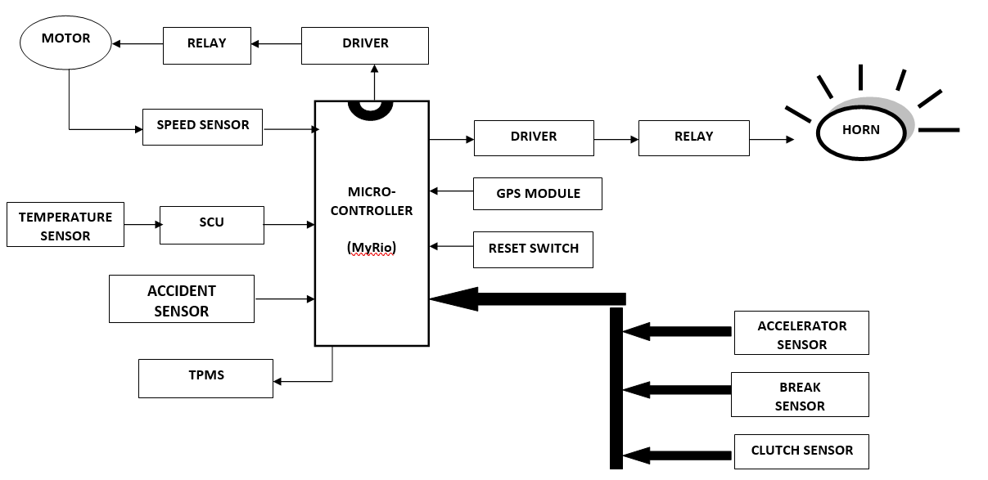

**Fig.1. Block Diagram of the system**

The sensors output will be monitored in the IOT which enables the system as a real-time monitoring process. The different sensors data will be stored in the excel sheet for the future purposes.

1. Hardware Description
2. Speed Sensor

Every object that is heated above absolute zero releases heat energy in the form of infrared radiation, which is the fundamental theory behind how an IR (infrared) sensor works. These sensors convert the radiations into a form that may be measured or comprehended once they have been detected. The infrared sensor's emitter is an IR LED (Light Emitting Diode). When the IR LED is powered on, it emits infrared light. The detector's component is the infrared photodiode. At the same wavelength as the infrared LED, it responds to infrared light. How much infrared light the photodiode gets directly affects its resistances and output voltages.

1. Tire Pressure Measurement

TPMS stands for Tire Pressure Monitoring System. Modern technology makes it possible to continuously monitor the air pressure in pneumatic tires on a range of vehicles, including trucks. TPMS's primary objectives are to track tire pressure and alert drivers to possible tire failures. Truck TPMS sensors typically measure tire pressure directly using internal sensors, or indirectly by estimating tire pressure using wheel speed and rotation data.

1. Accelerator, Brake, Clutch sensors

After a collision, these sensors are utilized to gather data on clutch, brake, and acceleration. Only after the collision will these be activated. This facilitates the quick analysis of the issues utilizing the recovered data.

1. Horn (Buzzer)

Electrical signaling devices, such as buzzers or beepers, are frequently seen in automobiles, home appliances, and competitive settings. It usually comprises of a number of switches or sensors that are linked to a control unit that determines if a predefined length of time has elapsed and which button was pressed. After then, it usually activates a light at the appropriate button or control panel and sounds a warning, which may sound like a beeping or buzzing sound and may happen continuously or sometimes.

1. Global Positioning System (GPS)

The Global Positioning System (GPS) is a weather-independent satellite-based global navigation system that provides precise location and timing information anytime and anywhere there is an unobstructed line of sight to four or more GPS satellites. It is publicly accessible to anybody with a GPS receiver and is kept up to date by the US government. In addition to GPS, several technologies are being developed or are already in use. The Russian Geodetic Navigation Satellite System, or GLONASS, is utilized by the Russian military.   
There are also the planned Chinese Compass navigation system and the European Union's (EU) Galileo positioning system. GPS was created and put into use by the US Department of Defense (DOD), and it was first run by 24 satellites. Its creation dates back to 1973.

1. Temperature Sensor (LM35)

The LM35 integrated circuit sensor is a helpful instrument for measuring temperature since it produces an electrical output proportional to the temperature (measured in degrees Celsius). Since the LM35 generates a higher output voltage than thermocouples, an amplifier may not be necessary.

1. Microcontroller

MyRIO, or my Reconfigurable I/O, is an embedded hardware device designed by National Instruments (NI). It provides a flexible foundation for study, education, and useful system design. The following are some crucial myRIO details

1. Goal and Characteristics:

• Educational Tool: Teachers and students were the focus of myRIO's creation.   
• Embedded Solution: It offers an embedded, WiFi-enabled solution for capstone projects,mechatronics,andlearningcontrols.   
• customizable I/O: Students may explore a range of engineering principles using a single device thanks to myRIO's customizable I/O.   
  
• Analog and Digital Interfaces: Having both analog and digital interfaces makes it suitable for high-speed control applications.

1. Specifications for Hardware:

• CPU: Dual-core ARM Cortex-A9 CPU with real-time operating system (OS) based on it.   
• FPGA: A configurable FPGA with 28,000 programmable logic cells. Analog I/O consists of ten analog inputs and six analog outputs.   
• Digital I/O: Up to 40 lines of digital input/output (DIO) are possible.  
  
• Additional Features: audio I/O channels, push button, LEDs, WiFi, built-in accelerometer, and more.

1. Software Description
2. LABVIEW

It is possible to build programs using icons instead of text lines by using the graphical programming language LabVIEW. Unlike text-based programming languages, which use instructions to determine the order of execution, LabVIEW uses data flow programming. Code and functions may be found in block diagrams that are part of a VI, and the sequence in which operations are carried out is determined by the data flow across nodes. In other words, after a node has received all of its inputs, it will execute and produce output data, which will then be transmitted to the node that comes after it in the data flow route.   
The VI (Virtual Instrument) that LabVIEW generates is a block diagram containing the source code. But it also features a graphical user interface, or front panel, that lets you

1. Internet of Things

The term "Internet of Things" (IoT) describes a network of actual physical objects, including cars, appliances, and other items, that have sensors, software, and network connectivity built into them. These systems continuously monitor temperature levels by utilizing real-time sensors that are integrated inside the surroundings.  
Cloud computing is used to transmit the data that these sensors have gathered to a centralized monitoring platform. In this paper, the ThingSpeak Online IOT website is used as an IOT module. This module will be interfaced with the LABVIEW software to acquire the sensor data. Later, this website helps for the real-time monitoring system in the process.

1. Results
2. Sensor Outputs in Labview

The GPS module in this system will help locate the accident scene and expedite rescue operations. It is possible to enhance the present system to analyze other data, including tire pressure, accelerator, and brake clutch position of the car.Many more significant parameters can be read from and saved in the memory. The suggested approach would be a helpful source of information in the event of an accident. Automobile black boxes provide the data required to compile accident reports and explain why accidents occur when they do. An intuitive program for assessing accident data is provided in this article.This created black box technology is compatible with any automobile. This system begins collecting information from each sensor as soon as possible.

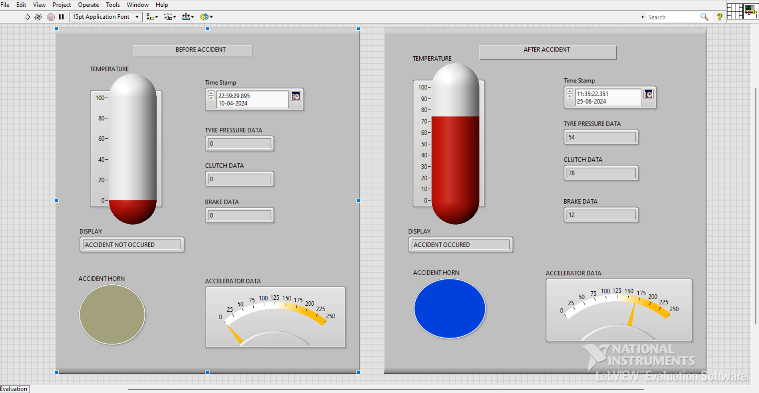

**Fig. 2. Output of the system (LABVIEW)**

1. Sensor Output in IOT
2. SPEED

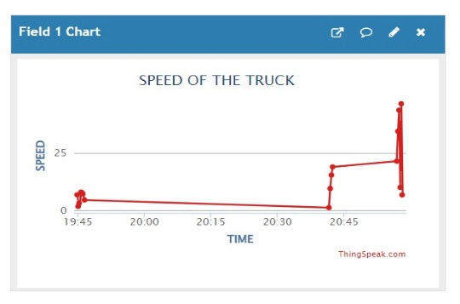

1. TPMS

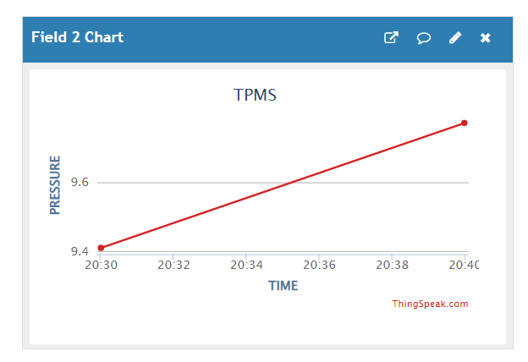

1. ACCELERATOR

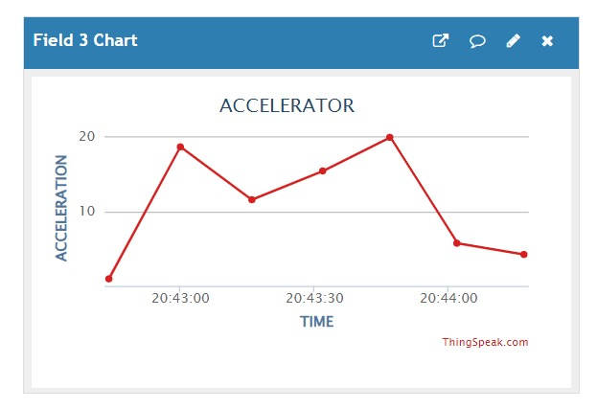

1. BRAKE

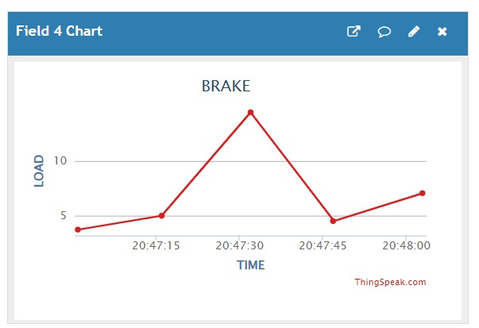

1. CLUTCH

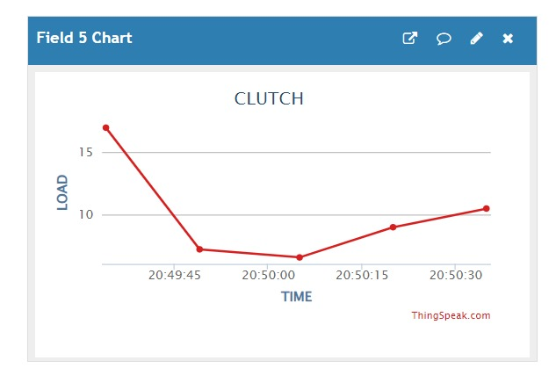

1. TEMPERATURE

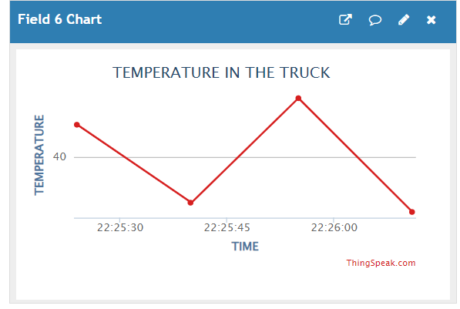

1. Conclusion

The Black Box Analysis System for Vehicles prototype was created and successfully put into use. GPS, an accelerator sensor, a brake sensor, a clutch sensor, a speed sensor, a TPMS, and a motor drive are all parts of the intended system that were installed in and around the prototype model. After testing, every sensor produced the expected results. The MyRio controller received a communication from these outputs. The controllers successfully control the sensors by communicating with one another. The information obtained from the sensors is successfully retained and is completely retrievable upon request.

The presence of IOT module will help to the real-time monitoring in the entire process. Additionally, the device has an emergency assistance module that notifies the family automatically of any accidents at the place.

References

[1] M. Corno, G. Panzani, and S. M. Savaresi, “Single-track vehicle dynamics control: state of the art and perspective,” IEEE/ASME Transactions on Mechatronics, vol. 20, no. 4, pp. 1521–1532, 2015.

[2] P. Gasp ´ ar, Z. Szabo, and J. Bokor, “A grey-box identification of an ´ lpv vehicle model for observer-based side slip angle estimation,” in American Control Conference, 2007. ACC’07. IEEE, 2007, pp. 2961– 2966.

[3] D. Piyabongkarn, R. Rajamani, J. A. Grogg, and J. Y. Lew, “Development and experimental evaluation of a slip angle estimator for vehicle stability control,” IEEE Transactions on Control Systems Technology, vol. 17, no. 1, pp. 78–88, 2009.

[4] V. Cerone, D. Piga, and D. Regruto, “Set-membership lpv model identification of vehicle lateral dynamics,” Automatica, vol. 47, no. 8, pp. 1794–1799, 2011.

[5] D. Selmanaj, M. Corno, G. Panzani, and S. M. Savaresi, “Vehicle sideslip estimation: A kinematic based approach,” Control Engineering Practice, vol. 67, pp. 1–12, 2017. [6] A. Teerhuis and S. Jansen, “Motorcycle state estimation for lateral dynamics,” Vehicle System Dynamics, vol. 50, no. 8, pp. 1261–1276, 2012.

[7] B. van Daal, “Design and automatic tuning of a motorcycle state estimator,” Ph.D. dissertation, Eindhoven University of Technology, 2009.

[8] M. E.-H. Dabladji, D. Ichalal, H. Arioui, and S. Mammar, “Unknowninput observer design for motorcycle lateral dynamics: Ts approach,” Control Engineering Practice, vol. 54, pp. 12–26, 2016.

[9] W. Wei, B. Shaoyi, Z. Lanchun, Z. Kai, W. Yongzhi, and H. Weixing, “Vehicle sideslip angle estimation based on general regression neural network,” Mathematical Problems in Engineering, vol. 2016, 2016. [10] H. Pacejka, Tire and vehicle dynamics. Elsevier, 2005.

[10] Amitava Choudhury, Alok Negi, “A New Zone Based Algorithm for Detection of License Plate from Indian Vehicle”, PDGC conf. , pp. 370- 374, Dec 2016.