SMART THERMOREGULATION BASED ON

FUZZY- PID SYSTEM WITH WEB OF THINGS

Dr. K. Gaayathry

Assistant Professor

Department of Instrumentation and Control Engineering Saranathan College of Engineering, Tiruchirappalli-12, India.

Hari Varshini S

Instrumentation and control engineering

Saranathan college of engineering

Tiruchirappalli, India.

Boomika S

Instrumentation and control engineering

Saranathan college of engineering

Tiruchirappalli, India.

Sherene Amalia G

Instrumentation and control engineering

Saranathan college of engineering

Tiruchirappalli, India.

Leena R

Instrumentation and control engineering

Saranathan college of engineering

Tiruchirappalli, India.

**Abstract— This paper describes the use of Internet of Things (IoT) technology to control temperature using a fuzzy-PID controller. Although it is commonly employed in temperature control systems, the traditional PID controller is not very good at handling nonlinearities and uncertainties. An adaptable and flexible control system that can successfully manage these difficulties is offered by fuzzy logic. Real-time temperature monitoring and control can be accomplished remotely by combining the fuzzy logic with the PID controller and making use of IoT technologies. A temperature control system is used to design, implement, and test the suggested Fuzzy-PID controller. The Fuzzy-PID controller works better than the traditional PID controller in terms of accuracy, stability, and disturbance rejection, according to experimental results. Convenience and efficiency are afforded by the IoT integration, which makes remote monitoring and control of the temperature system possible.**

Keywords—MyRio, Fuzzy-PID, Temperature Controller, Labview, IOT.

1. Introduction

Process control systems are collections of electrical apparatus and gadgets that provide accuracy and stability while removing hazardous transition states from the production process.   
Process control is widely used in industry to enable continuous processes to be produced in large quantities. Temperature control is the process of keeping an eye on temperature variations and modifying the quantity of heat energy entering or leaving water to obtain a desired temperature. It is essential for both domestic and industrial uses since it provides a necessary ingredient for chemical reactions, distillation, drying, calcinations, fermentation, and other processes. Inadequate temperature control can lead to major problems with security, quality, and productivity. During the early industrial revolution, especially in the 1960s and 1970s, relays were used to power mechanical machines. Cables that were located inside control panels connected them. Consequently, the control gets more and more complex. Processes are automated using an industrial computer known as a programmable logic controller. More complex process control systems made it more difficult to quickly identify a system issue. Because these panels were so rigid, there was an immediate need for a robust and dependable controller, which sparked the creation of new hardware and software.

1. EXISTING SYSTEM
2. Controller

An RTD or thermocouple require significant user intervention to adjust process temperature correctly; a temperature control system comprises a controller that obtains data from temperature sensors to accomplish this. After comparing the set point—also referred to as the planned control temperature—and the actual temperature, it provides an output to a control element.   
Consider the following aspects while selecting a controller:

* The intended output type, which could be an electromechanical relay, SSR, or analog output.
* The kind and temperature range of the input sensor.
* PID, on/off, or proportional control algorithms must be used.
* The type and amount of outputs (cold, hot, limit, and alarm).
* After the model is built, control techniques are needed to maintain a process's steady state.

1. need for this project

Real-time monitoring, straightforward control over several factors, and quick problem detection and rectification are critical in today's market. The system must be accelerated because the cooling process requires time.

1. Proposed System

This project establishes temperature monitoring and control with the use of the MyRio controller, fuzzy controller, PID controller, LabVIEW software, and water in the tank. By attempting to alter the difference between the measured temperature and the anticipated set point, this technique seeks to provide effective temperature management. The Internet of Things (IOT) will be used to monitor the entire process.

1. Methodology

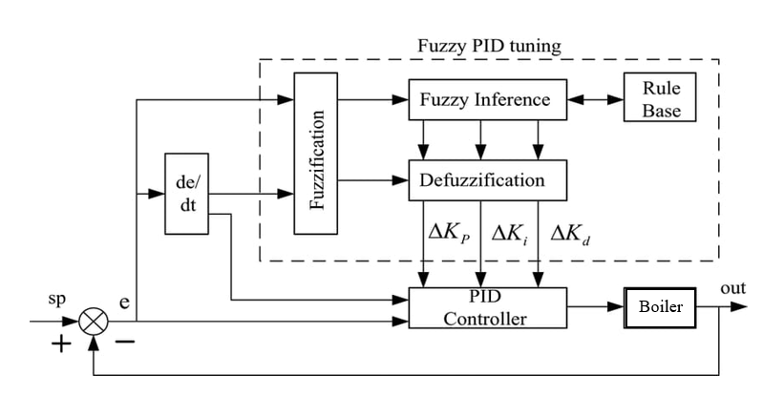

**Fig.1. Block Diagram of Fuzzy-PID controller**

The process of measuring or detecting changes in water temperature, as well as adjusting the quantity of heat energy entering or leaving the water to achieve the target temperature, is known as water temperature control. The process's temperature is managed via the ON-OFF mechanism. When controlling a fuzzy system according to preset rules, the fuzzy controller takes into account the error rate, temperature error, and current values of the input variables. In this case, the membership function's triangular and trapezoidal forms are used. Based on the proportional, integral, and derivative terms, the PID controller continually determines the error value and applies corrections. Its objective is to reduce the error over time by carefully modifying the control variable. Using LabVIEW software, which has enhanced features that enable continuous process monitoring even after the process variable hits the set point, is one aspect of this method. The parameters automatically adjust to the new circumstances when the process variable changes, producing the intended outcome. For the aim of real-time monitoring, the microcontroller and IOT module will be attached.

1. Design of MISO

The MISO temperature control system is designed and implemented using a fuzzy controller with LabVIEW coding. Fuzzy logic, a rule-based decision-making methodology, and the PID controller are used in process control.

1. Fuzzy Logic System

Rules, membership functions, and linguistic variables are a fuzzy system's three main parts. The basic steps involved in developing fuzzy logic control are as follows:

* Figuring out the variables that are input and output.
* Giving each fuzzy subset produced by dividing the time between each input and output a linguistic label.
* Determining the fuzzy subsets' membership functions.
* Calculating how fuzzy the "input fuzzy subsets" and "output fuzzy subsets," which together comprise the Rule Base,.
* You can understand the rules by using operators like fuzzy "AND" and "OR."
* In fuzzy systems, many rules may function concurrently, albeit to varying degrees of intensity.
* Transforming processed, imprecise data into accurate data suitable for instantaneous applications.

1. Proportional Integral Derivative System

Proportional–Integral–Derivative controllers, or PID controllers for short, are a common mechanism in industrial control systems and other applications requiring constantly modulated control. Let's dissect its basic functioning:

1. Proportional (P) Term: The present error between a measured process variable (PV) and a desired setpoint (SP) determines the P term. A gain factor Kp is used by the control output to react proportionately when the error is large.
2. Integrated (I) Term: Throughout time, the I term accumulates the cumulative mistake.   
   By modifying the control variable (e.g., opening a control valve) in accordance with the integral of the error, it helps avoid steady-state errors. The integral term is crucial to preserving precision and stability in the control loop.
3. Derivative (D) Term: This term takes the error's rate of change into account. It assists in preventing oscillations and overshoot by projecting future error trends. The controller enhances responsiveness by modifying the control variable in accordance with the derivative of the error.
4. Combined Action: Using the proportional, integral, and derivative terms as a basis for correction, the PID controller continually determines the error value. Its objective is to reduce the error over time by carefully modifying the control variable.
5. Temperature Sensor

Resistance temperature detectors work by establishing a connection between the RTD element's resistance and temperature. The resistance of the pure material used to create the RTD element has been tested and recorded at different temperatures. A material's temperature is determined by the expected change in resistance that it experiences as a function of temperature. This time, the material is platinum. A platinum resistance temperature detector (RTD) Pt100's resistance is normally 100 Ω at 0°C. Resistance has a positive slope that increases with temperature (resistance increases as temperature increases).

1. RTD Signal Conditioning Circuit

Signal conditioning is the process of modifying an analog signal to ascertain what is required for the subsequent processing stage. For instance, the output of an electronic temperature sensor is likely too low in voltage to be processed directly by an analog-to-digital converter (ADC). In this case, signal conditioning and amplification are needed to raise the voltage level to the point where an ADC requires it. Signal conditioning, in its broadest sense, refers to any necessary processing, such as conversion, amplification, or any other activity to prepare sensor output for conversion to a digital format.

1. Closed loop temperature control

Temperature (ºC) is the process variable, or system parameter, that has to be regulated. When water continuously seeps out of the tank, the process is hampered. A sensor gives the control system feedback by measuring the process variable. The process variable's desired or reference value is known as the set point. The compensator algorithm of the control system uses the difference between the process variable and the set point at any given time to determine the appropriate actuator output to drive the system (plant). The control algorithm will designate the actuator output to activate a heater, for example, if the expected temperature set point is 50 ºC and the observed temperature process variable is 40 ºC. When an actuator signal is used to drive a heater, the system warms up and the temperature process variable rises; when an actuator signal is used to drive a pump, the system lowers temperature more effectively. The reason this kind of control system is named a closed loop control system is that it uses a preset loop rate to continually calculate the desired actuator output and read sensors to offer continuous feedback.

1. Internet of Things

An real physical network of objects, such as vehicles, appliances, and other goods, with sensors, software, and network connectivity integrated into them is referred to as the "Internet of Things" (IoT). These devices use real-time sensors incorporated into their environment to continuously monitor temperature levels.   
The data collected by these sensors is sent to a centralized monitoring platform via cloud computing.

1. IoT Components for Temperature Control Systems:

* The temperature is monitored using a fuzzy logic system called ThingSpeak.
* The MyRio and IOT module are connected to provide the data.

1. How It Functions:

* Set a temperature setpoint and hysteresis to ensure a consistent temperature range.
* Create a LABVIEW VI and add components to read palette data from ThingSpeak.
* Enter the channel ID and API key to configure the ThingSpeak connection.
* Attach the IOT device's output data to the VI's input.
* After executing the VI, the application will receive the data to be monitored.

1. Multiple Input Single Output Process
2. MISO

Combining many manipulated variables and one control variable, a many Input Single Output (MISO) system is a control mechanism. For instance, the temperature of the reactor feed can be evaluated, and the coolant flow rate can be changed (a disturbance). The temperature of the reactor is affected by these two.

1. Procedure Configuration

The procedure is setup with a single water tank that has an inbuilt heater. Initially, water is added and taken out at a set flow rate. A Resistance Temperature Detector (RTD) is used to keep an eye on the setup's temperature.   
After being conditioned, this signal is transferred to the DAQ's analog input module, which subsequently feeds it to LabVIEW. The RTD's output, which is measured in ohms, is converted to volts (0–5V) using signal conditioning. After comparing the digital signal produced by LabVIEW to the set point, it is sent to the DAQ's analog output module. Through SSR and SCR, the output of this module is connected to the pump and heater control unit. The proportionate SSR and SCR regulate the current flows to and from the heater and pump, respectively.

1. Implementation of fuzzy rules

Sets of variables linked by fuzzily defined logic make up a fuzzy system. A fuzzy controller makes use of pre-established rules to govern a fuzzy system according to the input variables' current values. Three primary components comprise a fuzzy system: rules, membership functions, and linguistic variables. Terminologies and Variables in Language The terms used to represent the input and output variables of the system that requires regulation are known as linguistic variables. There are often an odd number of linguistic terms in linguistic variables, with a middle term and symmetric terms at either end. There is a predicted value range for each linguistic variable. The words "cold," "moderate," and "hot" may be included in the variables for both the expected and actual temperatures. It is possible to find the terms "off," "low," and "high" in the linguistic variable heater setting. For Membership Intentions Numerical functions known as membership functions are used to represent linguistic notions. The level of membership of linguistic variables within their linguistic terms is represented by a membership function. The membership degree is a continuous scale where 0 represents 0% membership and 1 represents 100% membership. The Ϋ-type (triangular shape), Π-type (trapezoidal shape), singleton-type (vertical line form), Sigmoid-type (wave shape), and Gaussian-type (bell shape) membership functions are among the various varieties that are available.

1. Inputs and Outputs Of Fuzzy System

Uncertain Input and Output In our project, two inputs are used, and the output is created by combining the two inputs. Each of these inputs consists of seven subsets.

Input 1: Temperature Error

Input 2: Temperature Error Rate

Output : Fuzzy output to Heating rod or Pump Subsets

1. Inputs

Input 1(Temperature Error) : Positive Big, Positive Medium, Positive Small, Zero, Negative Small, Negative Medium, Negative Big.

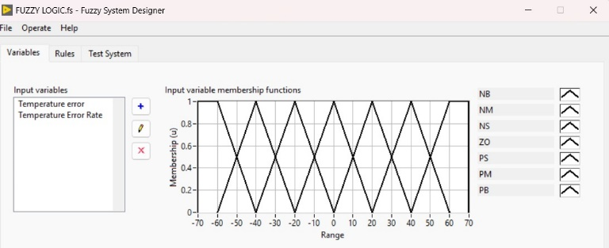

**Fig.2. Table of Input 1**

Input 2(Temperature Error Rate) : Positive Big, Positive Medium, Positive Small, Zero, Negative Small, Negative Medium, Negative Big

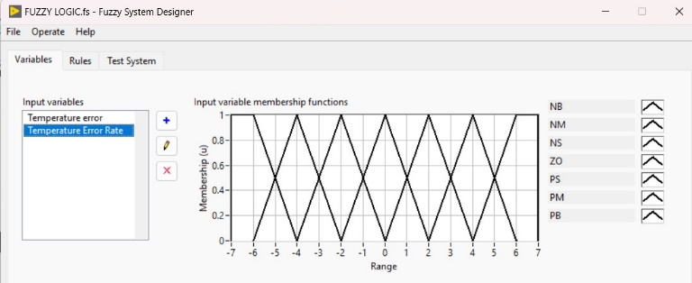

**Fig. 3. Table of Input 2**

1. Outputs

Positive Big, Positive Medium, Positive Small, Zero, Negative Small, Negative Medium, Negative Big

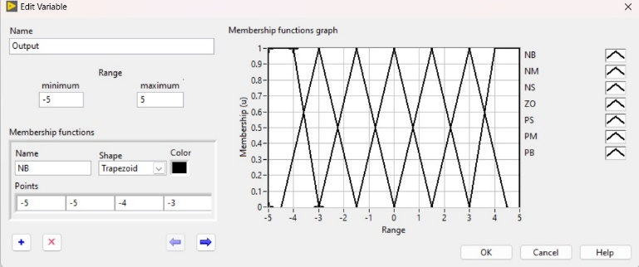

**Fig. 4. Table of Outputs**

1. Rule Description

The Table of Basic Rules Based on their linguistic language, rules convert the relationships between the linguistic variables in the input and output into words. The following formula defines the total number N of feasible rules for a fuzzy system: N is equal to p1 × p2 ×. For the input linguistic variable n, the number of linguistic phrases is represented by × pn. The following equation defines the total number N of feasible rules if all input linguistic variables have the same number of linguistic terms: N is equal to p^m, where m is the total number of input linguistic variables and p is the number of linguistic phrases for each input linguistic variable. It could be helpful to plot a rule base as a matrix in order to spot inconsistencies, such as conflicting rules. On the other hand, relatively modest rule bases get the greatest results when matrix plotting a rule basis. It is challenging to find discrepancies in large rule bases. By using cascaded fuzzy systems, large rule bases in fuzzy systems with many controller inputs can be avoided.

1. Rules Table

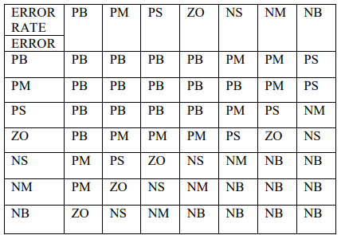

1. Developing Fuzzy Logic Controller With PID Controller
2. Objective of the fuzzy and PID in our Paper

For the most part, traditional control methods need you to have a mathematical model of the system you want to regulate. However, many physical systems are difficult or impossible to model mathematically. In addition, many processes are too complicated or nonlinear to be handled by traditional techniques. If a control strategy can be qualitatively characterized, fuzzy logic can be used to create a fuzzy controller that approximates a heuristic rule-of-thumb method. The fuzzy controller uses the matching input linguistic words and rule base to decide the consequent linguistic terms of the output linguistic variables after fuzzifying the input values of a fuzzy system. The process is given stability and quick responsiveness via the PID controller. It also contributes to lowering energy costs.

In conjunction with a PID controller, a fuzzy controller, Linguistic rules and contextual data are provided by the fuzzy controller. With this data, the PID controller may dynamically modify its parameters. The behavior of the system can be used by the fuzzy controller to adjust the PID gains. Precise control is guaranteed around the setpoint by the PID controller. The fuzzy controller facilitates the handling of nonlinearities and condition adaptation.

1. Steps in designing the fuzzy logic

* Determining the variables that are input and output.
* Giving linguistic names to every fuzzy subset that is produced for every input and output time period.
* Establishing a fuzzy subset's membership function.
* Determining the relationships between the "input fuzzy subsets" and "output fuzzy sets," which collectively comprise the Rule-Base.
* Applying fuzzy "AND" and "OR" operators to interpret the rules. Multiple rules may fire simultaneously in fuzzy systems, but at different intensities.
* Converting the processed, hazy data into clear data appropriate for practical application.

1. Steps in designing the PID

* Outlining the process's performance requirements.
* Being aware of the parameter's system dynamics.
* Selecting Proportional, Integral, and Derivative Gain as the PID Parameters.
* The crucial stage in the procedure is fine-tuning the PID controller.
* The next step will be to implement the PID Controller. Discretize the continuous-time PID controller in digital systems. To determine the control signal at each time step, use the difference equation.
* Applying the intended PID controller to the real temperature control system in order to test and validate the system. Examine the reaction and contrast it with the intended outcome. Adjust the profits as needed.

1. Sensor Integration

Take into consideration LabVIEW's data collecting features to obtain temperature readings from the attached sensors. If necessary, apply suitable signal processing techniques to guarantee precise measurement.

1. Actuator Control

To create control signals and communicate with the actuators attached to your system, use LabVIEW. To maintain the appropriate temperature, this may entail producing analog or digital control signals that operate the actuators.

1. Fuzzy Inference and PID control Implementation

Use LabVIEW to implement the PID control method and fuzzy inference mechanism. Determine the proper control actions depending on the target setpoint and the current temperature measurement by applying the fuzzy rules that were previously created. To create the final control signal, combine the PID control output and the fuzzy logic output.

1. Result

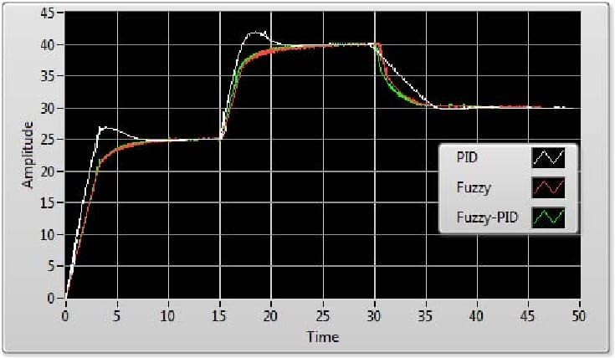

**Fig. 5. Output of the fuzzy rules in graph**

1. Implementation in IOT

With LabVIEW, evaluate the fuzzy-PID controller with simulated or actual temperature data. Check to make sure the control system performs as anticipated and achieves the intended control goals. To enhance performance, change the PID gains, fuzzy logic, or other parameters as needed. Install the LabVIEW program on the chosen platform or system. Make sure the system can interact with the IoT platform and is correctly connected to the IoT devices. Keep an eye on the temperature control system and adjust as needed based on practical use.

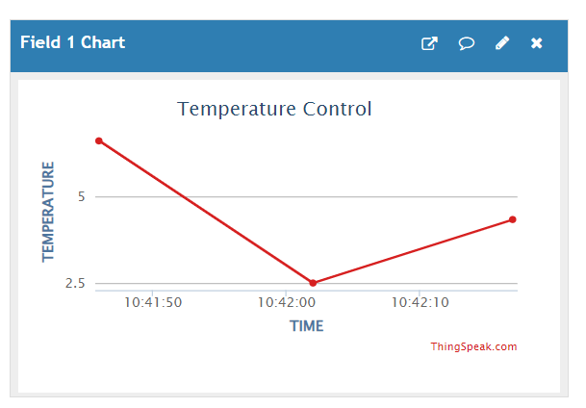

**Fig.6. Real-Time monitoring in IOT**

1. Conclusion

In the purposes of this research, we have effectively used Internet of Things technology to manage temperature with a fuzzy-PID controller. We have created a reliable and adaptive control mechanism that can successfully manage nonlinearities and uncertainties in the temperature control system by integrating the benefits of fuzzy logic with PID control. According to the experimental findings, the accuracy, stability, and disturbance rejection of the Fuzzy-PID controller are better than those of the traditional PID controller. Users may now conveniently and efficiently monitor and control the temperature system in real time from remote places thanks to the incorporation of IoT technology. All things considered, there is a lot of promise for the fuzzy-PID controller for temperature management via IoT in a variety of settings, including residences, businesses, and other establishments where accurate temperature control is crucial.

References

1. Sameh F. Desouky Howard M. Schwartz A Novel Technique to Design a Fuzzy Logic Controller Using Q learning and Genetic Algorithms in The on Systems, Man, and PursuitEvasion game IEEE International Conference Cybernetics San Antonio, TX, USA October 2009.
2. S. Nithya, Abhay Singh Gour, N. Sivakumaran, T. K Radhakrishnanand N. Shell and Tube Heat Anantharaman, Model Based Controller Design for Exchanger, Sensors and Transducers Journal, Vol. 84, Issue 10, pp. 1677-1686, October 2007.
3. D. Rathikarani, D. Sivakumar and S. Anita Janet Mary. Genetic algorithm based optimization of controller tuning for processes with dead time, Proceedings of the International conference on Advances in control and optimization of dynamical systems (ACDOS), 2007,
4. Psong-Wook Shin, Young-Joo Song, Tae-Bong Lee and Hong- KyooChoi, Genetic algorithm for identification of time delay systems from step responses, International Journal of Control, Automation, and Systems, Vol. 5, No. 1, Feb 2007, pp. 79-85.
5. M. V. Sadasivarao and M. Chidambaram, PID controller tuning of cascade control systems using genetic algorithm, Journal of Indian Institute of Science, 86, July-Aug 2006, pp. 343-354.
6. D. Rathikarani, D. Sivakumar and S. Anita Janet Mary, Genetic algorithm based optimization of controller tuning for processes with dead time, Proceedings of the International conference on Advances in control and optimization of dynamical systems (ACDOS), 2007.
7. LabVIEW based Fuzzy Logic Controller for PLC

Dr.Dereje Shiferaw, Addisalem Hailegnaw, Alemie Assefa, Daniel Abebe, Eyob Dagne and Getsh Fekadie

2019 International Conference on Computer, Control, Electrical, and Electronics Engineering (IEEE)

1. Design and Implementation of Fuzzy Logic Controller for Boiler Temperature Control using LabView

2023 International Conference on Computer Communication and Informatics (IEEE ), Jan. 23 – 25, 2023, Coimbatore, INDIA

1. LabVIEW based Fuzzy Logic Controller for PLC

Dr.Dereje Shiferaw, Addisalem Hailegnaw, Alemie Assefa, Daniel Abebe, Eyob Dagne and Getsh Fekadie

2019 International Conference on Computer, Control, Electrical, and Electronics Engineering (IEEE)

1. [4] N.Nithyarani. Advanced process Analysis on LabVIEW, International Journal of Advanced Research in Electrical and Electronics Engineering. Vol.1, No.I Nov 2013.

[5] B. Wayne Bequette "Process Control Modeling, Design, and Simulation" by Prentice-Hall, Inc. 2003.