**NEUROSCIENCE PERSPECTIVES**

**EEG ANALYSIS OF EYE BLINKING ACTIVITY**

**Dimpi Dewangana, Raghavendra Prasadb\***

**a, b Amity University Chhattisgarh**

**Abstract**

The purpose of this study is to investigate how eye blink artifacts interact with electroencephalogram (EEG) signals and develop reliable detection and removal techniques. Eye blinking introduces significant noise into the EEG recordings, which can interfere with neurophysiological analysis.(Ahammed & Ahmed, 2020) The ability to identify and reduce these artifacts is essential for enhancing the reliability of the EEG-based studies. Eye blink artifact detection plays an important role in EG analysis and neurodegenerative disorders, particularly with the frontal epilepsy discharges.(Wang et al., 2021) EEG signals are sometimes tainted by artifacts and have a frequency range of 0-100 Hz. Technical artifacts such as electric power source noise and amplitude artifacts, as well as biological artifacts including ocular, ECG, and EMG artifacts, are all present in the EEG. One of the primary artifacts in the EEG data is the blink of the eye. The identification of eye blinks utilizing kurtosis and amplitude analysis of EEG signals is the main topic of this research.(Chambayil et al., 2010)

A technology called a brain computer interface (BCI) enables communication between people without the use of their hands or mouths. The subject's intention is encoded into his electroencephalogram (EEG), which is a scalp recording obtained from his brain. Artefacts are noises that are added to the EEG signal by sources of electric fields both inside and outside the human body that do not involve the central nervous system (CNS). The artifacts should be appropriately managed as they obstruct the signal analysis. Electrooculographic (EOG) artefacts are the most prevalent and distinctive type, particularly those that are eye-blinking.(Manoilov, 2007) To improve classification accuracy and further the development of the brain-computer interface (BCI), it is imperative to remove these artifacts from EEG data as efficiently as possible. In this paper, we used a hybrid EEG and eye tracker system to identify and remove ocular artifacts from EEG data by proposing an automatic methodology based on independent component analysis (ICA) and system identification. The suggested algorithm's performance is demonstrated with both conventional and experimental EEG datasets. The suggested technique maintains the neural activity associated EEG signals in the non-artifactual zone while simultaneously eliminating the ocular artifacts from the artifactual zone. The suggested algorithm performs noticeably better than the two cutting-edge methods, ADJUST based ICA and REGICA, when it comes to eliminating eye movement and blink artifacts from EEG data.(Mannan et al., 2016)

**Key Words**

Eye blinking, EEG, Signal, Eye movement, Data, Matlab.

**Introduction**

The electrical activity of comparatively large neuronal populations that may be recorded from the scalp makes up the electroencephalogram, or EEG. The amplitudes and frequency of these signals vary in healthy adults depending on the human's state, such as awake vs sleep. As people age, so do the wave properties.(Hagemann & Naumann, 2001) Five main brain waves can be distinguished from one another by their varying frequency ranges. These frequency ranges are designated as delta (δ), theta (θ), alpha (α), beta (β), and gamma (γ), in that order Patient-related (physiological) and system-related artifacts comprise the majority of EEG artifacts. Sweating, bodily movement, EMG, ECG (including pulsation), EOG, and BMI are examples of patient-related or internal artifacts. System artifacts include unbalanced impedances of the transistors, 50/60 Hz power supply interference, impedance fluctuations, cable flaws, and electrical noise from the electronic components.(Singla et al., 2011) Many scientists view the human brain as a mystery. Most of the mechanisms underlying the brain's operation remain unknown, despite our ability to describe and explain some events. Blood flow and the measurement of electrochemical signals are two methods that may be used to quantify brain activity. Computations. The interpretation of these relationships is much more difficult to generalize because individual differences exist in brain activity. In this study, we report our results on the detection of one test subject's eye blinks and show a correlation between the frequency of eye blinks and the experienced stress level. We also report our research on the impact of mental computations on brain activity when eyes are open and closed. The scientific community may find great value in this field. If it were possible to detect erratic or rapid eye blinks, which could be a sign of fatigue or stress, human tasks like operating a car could be made safer.(Haak et al., 2009)

The voice face and finger print are currently considered traditional biometric features. These characteristics have the drawback of not being private or secret to a person (less secure). One of the most often used biometrics, for instance, is the finger print, which is simple to get and useful for real-time applications.(Abo-Zahhad et al., 2015a) To improve classification accuracy and further the development of the brain-computer interface (BCI), it is imperative to remove these artifacts from EEG data as efficiently as possible. In this paper, we used a hybrid EEG and eye tracker system to identify and remove ocular artifacts from EEG data by proposing an automatic methodology based on independent component analysis (ICA) and system identification. The suggested algorithm's performance is demonstrated with both conventional and experimental EEG datasets.

In addition to eliminating ocular artifacts from the artifactual zone, the suggested algorithm maintains neural activity. This is problematic for ICA since blinks nearly invariably coincide with event-related potentials (ERP). We merged single-trial ERP data with an additional spontaneous blink data set. Based on our findings(Li & Principe, 2006) The electroencephalogram (EEG) signal's eye events—eye blink, eye close, and eye open—are typically regarded as biological artifacts. With the right training, one may control how their eyes blink, which makes them suitable for use as a control signal in Brain Computer Interface (BCI) applications. The most effective categorization technology in recent years has been support vector machines (SVM). Results from comparing SVM and Artificial Neural Networks (ANN) are consistently positive.(Singla et al., 2011)

Brain signal-grounded emotion discovery holds significant pledge in revolutionizing the opinion and operation of colorful medical conditions. Traditional styles of emotion identification, similar as facial expressions, may encounter challenges with limited triggers, emotional disguises, or conditions like alexithymia.(Chambayil et al., 2010) This study explores the eventuality of exercising electroencephalogram(EEG) data to crack emotional countries by assaying constant brainwaves, furnishing perceptivity into feelings that individualities might struggle to articulate verbally.(Tyagi, 2012) The exploration focuses on assaying time data from EEG detector channels and conducting relative assessments of colorful machine literacy ways. The study evaluates machine literacy algorithms, including Support Vector Machine( SVM), K- nearest Neighbor, Linear Discriminant Analysis, Logistic Regression, and Decision Trees.(Abo-Zahhad et al., 2015b) Both with and without top element analysis( PCA) for dimensionality reduction, these ways are tested. To optimize the models, grid hunt and hyperactive- parameter tuning are enforced, using a Spark cluster to reduce prosecution time. The DEAP Dataset, a multimodal dataset designed for probing mortal affective countries, is employed for this disquisition.(Tyagi, 2012)

**Eye blink characteristics**

Amplitude: The frontal and prefrontal brain regions will have a preponderance of impulses relating to the eyes. A downward peak in the negative region of the prefrontal lobe, such as the electrode pairs FP1-F3 or FP2-F4, indicates an eyes-open event, and a positive peak indicates an eyes-close event. In addition, these peaks' amplitudes will be noticeably larger than the brain's rhythmic activity.(Chambayil et al., 2010)

Kurtosis: Since the EEG signal is stochastic, realizations or sample functions (x(t)) are the terms used to describe each collection of samples. First-order central momentum is defined as the expectance (µ), which is the mean of the realizations. The realizations' variance represents the second-order central momentum.(Chambayil et al., 2010)

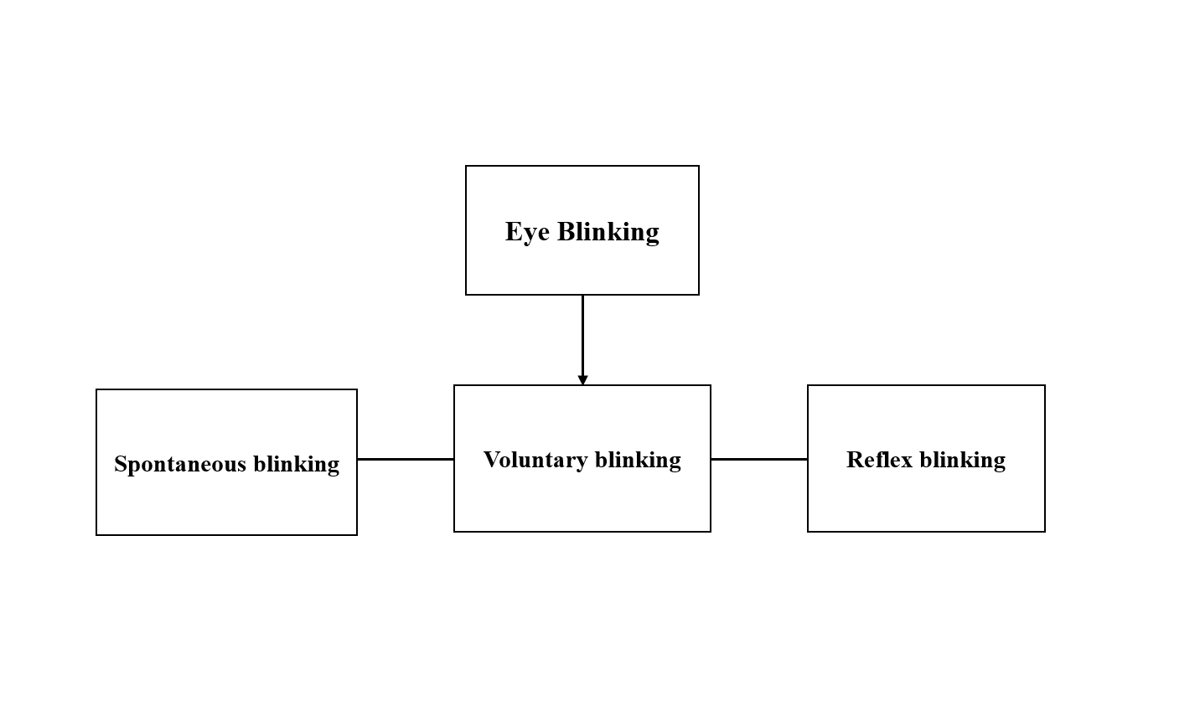

Fig no. 1.1 (Types of Eye blinking)

**Literature review**

Signal Processing and point birth ways: Accurate emotion discovery relies heavily on precise signal processing and effective point birth from EEG signals. colorfull styles have been employed to prize meaningful information from a specific number of EEG channels. One notable advancement is the preface of a novel and adaptive channel selection strategy. Feting that brain exertion exhibits unique patterns that vary among individualities and emotional countries, this strategy aims to enhance the capability of emotion recognition.(Ihc et al., 2013)

Also, the identification of ages, the moments when excitation is at its peak during an emotion, is pivotal for system delicacy. To achieve this, experimenters propose the birth of immediate spectral information using the numerator group- detention function with the zero- time windowing system. This approach allows for the precise identification of ages in each emotional state, contributing to the overall delicacy of the emotion discovery system.(Motamedi-Fakhr et al., 2014)

Experimental confirmation Using EEG Brainwave Database To validate the proposed styles, experimenters conducted trials using the EEG Brainwave Database. They employed colorful categorization schemes, including Quadratic Discriminant Classifier ( QDC) and intermittent Neural Network( RNN). The experimental findings demonstrated that the suggested system surpassed earlier exploration onmulti-class emotion identification. This competitiveness highlights the effectiveness of the new channel selection strategy and time identification in perfecting emotion recognition delicacy.(Jebelli et al., 2018)

Comparison of Traditional Machine Learning styles The exploration ideal extends to the comparison of traditional machine literacy styles, assessing their performance grounded on p- value, minimal error, delicacy, perfection, and f- score. This relative analysis aims to identify the most effective approach for emotion discovery, considering the unique challenges posed by EEG signals. Traditional machine literacy styles were named for their established performance criteria and interpretability. (Jebelli et al., 2018)

Dimensionality Reduction and Information Discovery To enhance performance and discover retired information, the exploration explores the use of dimensionality reduction ways. The analysis includes a comparison of artificial neural networks( ANN) and deep neural networks( DNN) against traditional machine literacy styles. In certain scripts, ANNs and DNNs have demonstrated superior performance, attributed to their capability to capture intricate patterns within high- dimensional datasets.(Schalk et al., 2010)

Experimental Design and Data Preprocessing The degree of each sample was reduced by grading feelings into three distinct groups positive, neutral, and negative. This categorization eased a more focused analysis, allowing experimenters to claw into the specific nuances associated with each emotional state. Data preprocessing played a pivotal part in preparing the EEG signals for analysis, icing the junking of noise and vestiges that could intrude with accurate emotion discovery.(Khosla et al., 2020)

Conclusion and unborn Directions In conclusion, emotion discovery using EEG signals has witnessed significant advancements in signal processing, point birth, and categorization schemes. The proposed novel channel selection strategy and time identification system demonstrated remarkable competitiveness inmulti-class emotion identification. The comparison of traditional machine literacy styles, along with the disquisition of dimensionality reduction ways, provides precious perceptivity into optimizing emotion discovery systems.(Khosla et al., 2020)

Unborn exploration directions may involve the integration of real- time emotion discovery operations, considering the practical counteraccusations of planting similar systems in different settings. Also, exploring the eventuality of transfer literacy and nonstop literacy models could contribute to the rigidity and robustness of EEG- grounded emotion discovery systems.(Costin et al., 2012) As technology continues to evolve, the field holds pledge for further advancements, ultimately enhancing our understanding of mortal passions and their neural supplements.(Khosla et al., 2020) Pre-processed datasets blended into one new big dataset.

Workflow fashion is easily normal.

Determining the ideal categorization algorithm to be used to each emotion.

The perfection of every EEG data type model.

Data segmenting by time produces better features for classifiers.

EEG Brainwave dataset" emotion analysis using EEG, physiological and video signals" analysis and visualisations.(Rampil, 1998)

**Overview of Eye Blinking**

Because it causes alterations in electrical conductivity and related muscular abnormalities, eye blinking presents difficulties for EEG recordings.(Abo-Zahhad et al., 2015b) Facial muscle contractions during blinking can introduce electromyographic aberrations that may cause EEG readings to become distorted.(Tyagi, 2012) These noise sources can appear as low-frequency elements, especially in the delta and theta bands, where they may obscure real brain activity. When an eye blinks, adjacent electrodes may be impacted, resulting in both vertical and horizontal distortions. Researchers use a variety of preprocessing methods to solve these issues. (R. N. Roy et al., 2014) Low-frequency components are eliminated via high-pass filtering, and blink-related aberrations can be effectively separated from EEG signals using Independent Component Analysis (ICA). While electrode selection, reference techniques, and sophisticated interpolation methods help to minimize the influence of eye blink artifacts, epoch and thresholding procedures help to identify and reject contaminated segments.(Chambayil et al., 2010) Accurate EEG analysis requires an understanding of and mitigation of these aberrations, especially in applications such as Brain-Computer Interfaces (BCIs) where accurate brain signal interpretation is critical.(A. Roy et al., 2014)

## EEG signals

The EEG signal is a type of bioelectrical signal that represents the overall response of the activity of many neurons in the cerebral cortex or the surface layer of the scalp and is rich in physiological and pathological data. Studies that are pertinent demonstrate that EEG signals can provide crucial information on human emotional states by being collected, analysed, and their emotional aspects extracted. The physiological and psychological state of human bodies can be assessed using dynamic features.(McFarland et al., 1997)

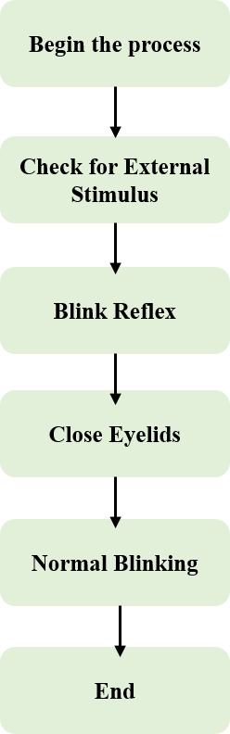

## Fig 1.2(flow Chart of eye blinking)

## 

**EEG signal acquisition**

The general form of the EEG signal can transition between induced and spontaneous modes. Human cerebral cortex brain cells' spontaneous physiological activity is referred to as spontaneous EEG. Face expressions are used by experimenters to directly identify emotions. Through the experimenter's neural pathway, the evoked type externally stimulates brain cells with particular visual or auditory stimulus to produce EEG signals with the associated properties.(Asif et al., 2019) In actuality, the researchers stimulated patients' electrical impulses by using evoked expressions. Collecting EEG signals may be invasive or non-invasive. Due to its portability and safety, non- invasive EEG signal is used in brain-computer interface research due to the significant danger of invasive acquisition on the human body. As a result, scientists use non-invasive EEG signal capture.(Khosla et al., 2020)

## Problem formulation: The major objective is to understand how neurophysiological systems might cause someone to feel emotion and to identify the brain regions that store information about various emotions.(Nunez et al., 2016)

## Classification of EEG signals

EEG signals can be classified according to frequency as Delta wave, Theta wave, Alpha wave, Beta wave, and Gamma wave. Different brain activity states and EEG signals in a certain frequency band have a high association. In Table 1, EEG signal categorization is provided.(Chambayil et al., 2010)

**Frequencies of Brain waves**

Delta wave (0.1–3.1 HZ): Delta waves are used to measure sleep depth, and a rise in their power is linked to improved performance on internal working memory tasks.

Theta wave (3.1–7.1 HZ): Theta waves are linked to a variety of cognitive processes, including the encoding and recall of memories. Increased tiredness is another effect of theta.

Alpha wave (7.1–13.1 HZ): The conscious and subconscious minds can communicate with one another because to alpha waves. People's consciousness is awake and their bodies are comfortable when their individual brain frequencies are in the alpha range. Physical and mental energy use are quite low in this state. Valence and the alpha wave were closely related.

Beta wave (13.1–30 HZ): When people are focused, alert, or engaging in other types of active brain thinking, beta waves frequently arise, and their frequency increases. When the body was physically active, there were noticeably greater beta wave frequencies in the brain. High correlation exists between the beta wave and the excitation state of brain neurons.

Gamma wave (>30 HZ): Multimodal sensory processing is related to gamma waves. According to studies, the Gamma wave symbolises focused attention. Rapid eye movement is linked to gamma waves. The Gamma band was shown to be the best emotional band for the majority of problems when they used visual stimuli to elicit the feelings of the individuals, showing the crucial function of the Gamma band in emotion identification studies.

The distinctive frequencies of various brain waves.

|  |  |
| --- | --- |
| Types | Characters |
| Delta wave (0.1–3.1 HZ) | In humans, delta waves are found in the temporal and parietal lobes and are linked to restful sleep and deep relaxation. |
| Theta wave (3.1–7.1 HZ) | When someone is hypnotised or in a trance, theta waves are frequently present. Theta wave activity is most optimal in this state. |
| Alpha wave (7.1–13.1 HZ) | Occipital and posterior parietal lobes produce alpha waves. The wave amplitude appears as a shuttle pattern from large to tiny and again from small to large when a person is awake, silent, and wearing closed eyes. |
| Beta wave (13.1–30 HZ) | The most prevalent high-frequency waves during awake are beta waves, which primarily develop on the left and right sides of the brain. |
| Gamma wave (>30HZ) | Gamma waves combine sensory processing skills for new information processing and are crucial for learning, memory, and processing. |

Table no.1.1 (Frequencies of various brain waves)

**EEG Channels**

|  |  |
| --- | --- |
| CHANNEL LABLE | BRAIN REGION |
| Fp1 | Frontopolar |
| Fp2 | Frontopolar |
| F3 | Frontal |
| F4 | Frontal |
| C3 | Central |
| C4 | Central |
| P3 | Parietal |
| P4 | Parietal |
| O1 | Occipital |
| O2 | Occipital |
| F7 | Frontotemporal |
| F8 | Frontotemporal |
| T3 | Temporal |
| T4 | Temporal |
| T5 | Parietotemporal |
| T6 | Parietotemporal |
| Fz | Frontocentral Middle |
| Cz | Central Middle |
| Pz | Parietal Middle |
| Oz | Occipital Middle |

Table no 1.2 (EEG Channels)

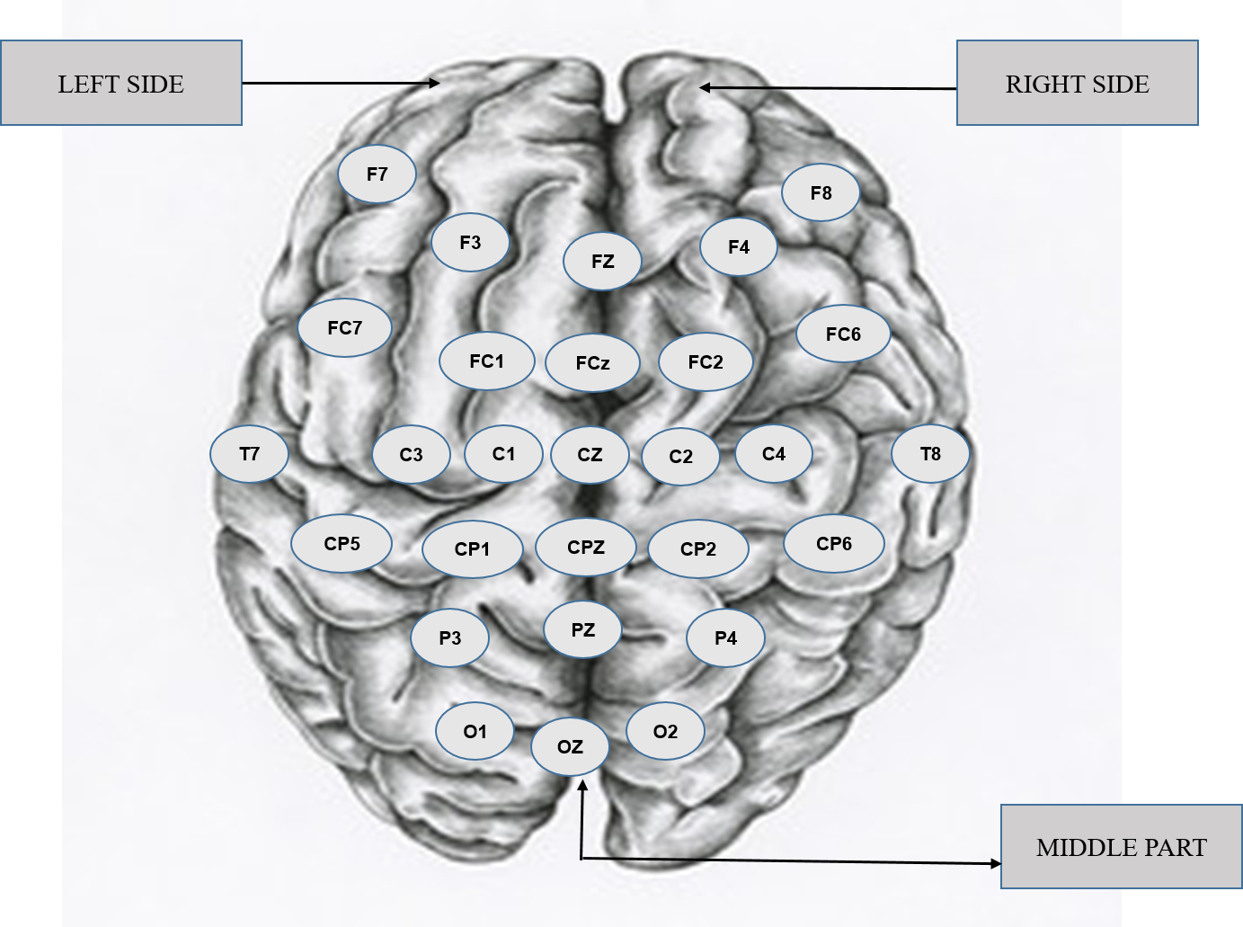

Fig no.1.3 (Brain Channels)

## Signal data pre-processing

EEG signals are low frequency, 5-100 v bioelectrical brain signals. After the signal has been amplified by an amplifier, it can be shown and processed. EEG signals are extremely sensitive, making it simple to interfere with them as they are being acquired.(Ihc et al., 2013) As a result, the EEG signal that is recorded is weak, and the results of its analysis are frequently inadequate. It makes it extremely difficult to analyse EEG signals. Acquisition and processing of EEG signals are impacted by these interference disturbances. EEG signal pre-processing eliminates several additional noise signals from the EEG data, including electromagnetic interference, power frequency interference, electro cutaneous response (GSR), and EOG, EMG, and ECG abnormalities. EOG and EMG are capable of spatial and adaptive noise filtering.(Singla et al., 2011)

Proposed system: Any biometric authentication system consists of four primary modules; data acquisition, pre-processing, feature extraction and classifier module. The implemented algorithms for these modules are detailed in this section.(Glisson & Chowdhury, 2002)

Data Acquisition: In Electroencephalography, or EEG, data acquisition is the procedure of gathering and logging electrical impulses produced by the brain. Electrodes are applied to the scalp to assess brain electrical activity using EEG, a non-invasive neuroimaging procedure.(Abo-Zahhad et al., 2015a)

Pre-processing Stage: Preprocessing EEG data for eye blinking usually entails a number of processes to reduce artifacts related to eye movements and blinks and clean up the signal. (Ishimaru et al., 2014)

Classification Stage: The process of creating models and algorithms to automatically identify and categorize eye blink events from EEG signals is known as the classification stage of EEG eye blink research. Applications like brain-computer interfaces (BCIs), human-computer interaction, and the comprehension of neurological illnesses depend on this mechanism.(Rampil, 1998)

Feature Extraction Stage : An essential stage in the analysis of EEG signals for the identification of eye blinking is feature extraction. The objective is to convert the unprocessed EEG data into a set of discriminative and pertinent features that can be applied to further categorization.(Iwasaki et al., 2005)

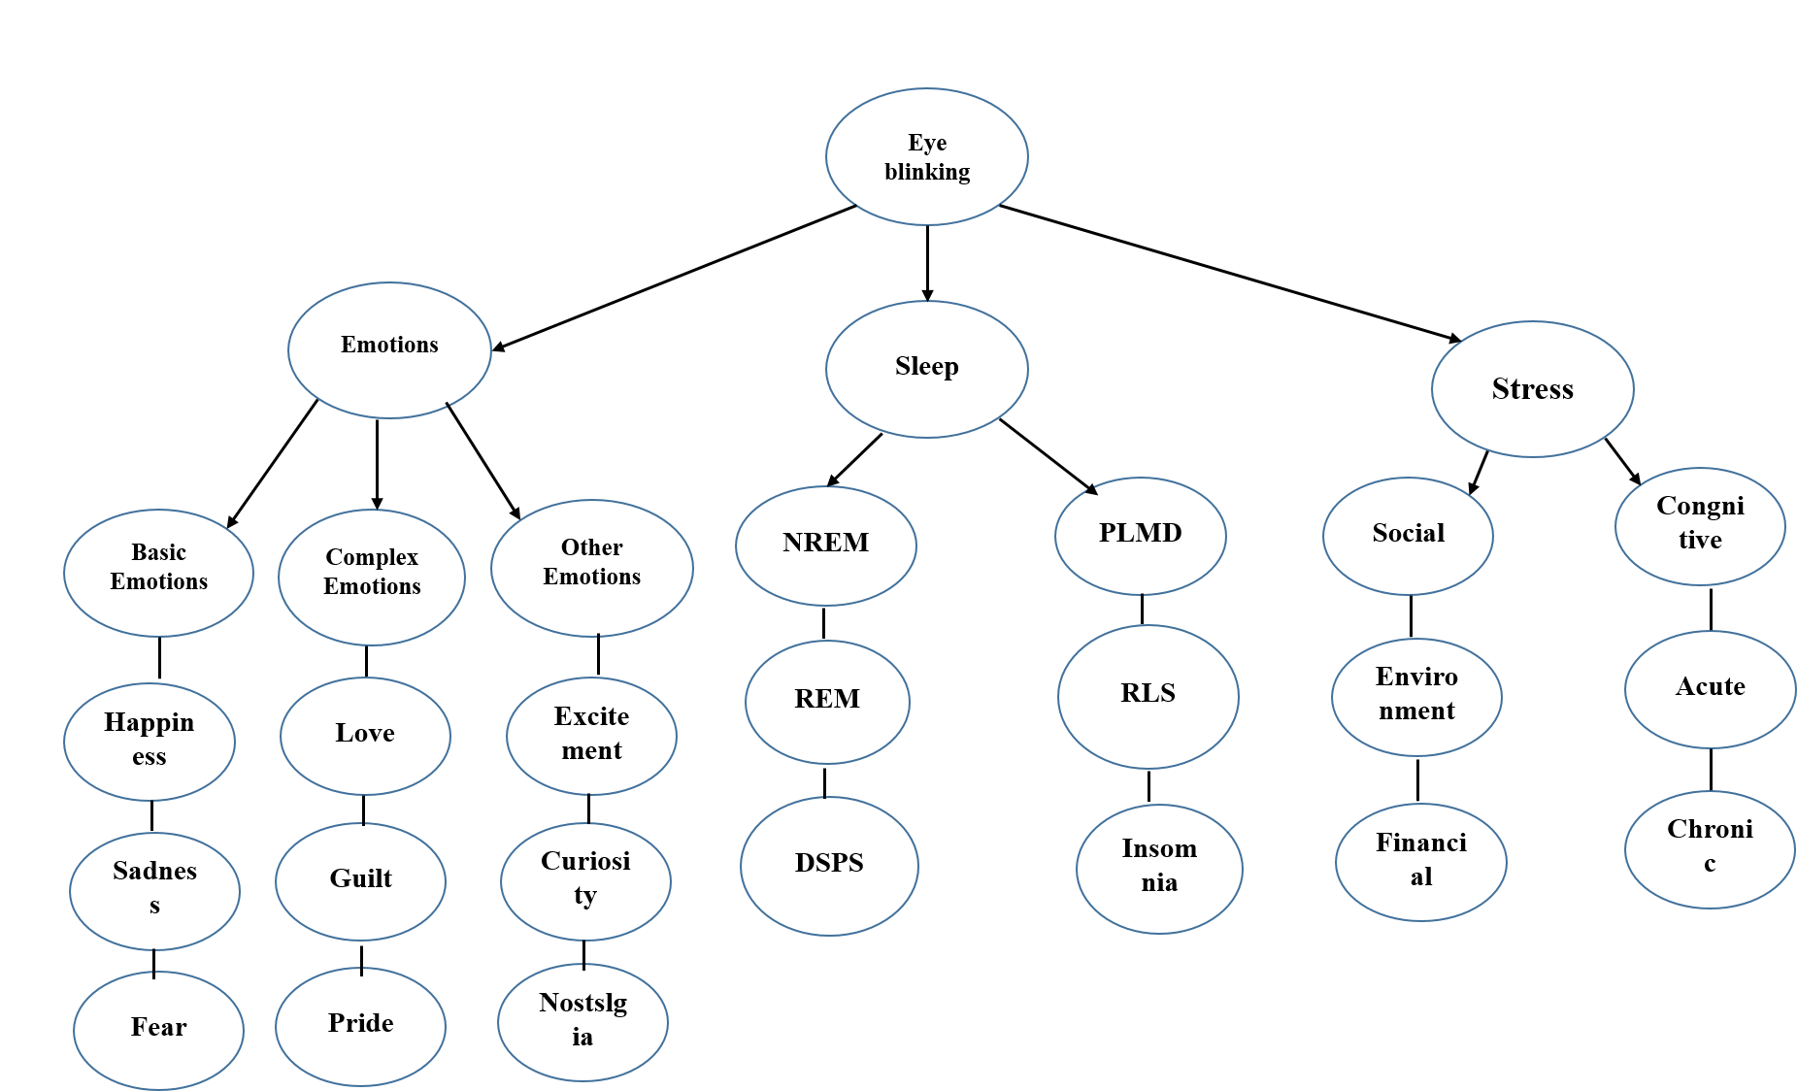

Fig no.1.4 (Classification of Eye blinking)

**Implementation**

Electroencephalography, or EEG, is a neuroimaging technique that is used to track and examine the electrical activity of the brain in relation to different phases of eye blinking. By illuminating the brain correlations and patterns linked to various eye blink patterns, EEG offers important insights into cognitive and neurological processes. First to record the electrical signals produced by the brain, EEG electrodes are carefully positioned on the scalp. By detecting voltage fluctuations brought on by neural activity, these electrodes make it possible to measure brainwave patterns. To record signals associated with the eye blink response, certain electrodes may be placed around the eye and forehead regions. Individual variations in EEG signals during blinking are indicative of the neurophysiological components of the blinking process. For instance, the brain displays distinct patterns when blinking in response to external stimuli, on purpose, or spontaneously. By analyzing EEG data using sophisticated signal processing techniques, researchers can discover markers linked to various blink types and investigate the temporal dynamics of brain responses.

**Future Scope**

The field of EEG-based stress detection has enormous promise for revolutionary developments in both theory and real-world applications. We believe that as technology develops further, more complex algorithms that are able to identify individualised and nuanced patterns in EEG data will be refined and developed, improving the precision and dependability of stress identification. Connectivity with wearable technology and smartphone apps may open the door to real-time tracking and prompt feedback, enabling people to take charge of their stress management. Furthermore, there are a lot of intriguing opportunities for immersive and customised stress intervention techniques at the nexus of EEG and other cutting-edge technologies like virtual reality and artificial intelligence. Beyond stress detection, EEG's future applications could include neuro feedback and insights into a range of cognitive and emotional states including brain-computer connections and training. The combination of neuroscience, engineering, and data science is set to spark revolutionary breakthroughs and usher in a new era of comprehending and improving human cognition and well-being as multidisciplinary collaboration blossoms.

The potential applications of EEG in eye blinking are intriguing in a number of fields. Electroencephalography (EEG) and eye blinking data integration has the potential to progress cognitive research, health monitoring, and brain-computer interfaces (BCI). This integration could improve communication for those with motor limitations in the context of BCIs. Understanding the relationship between EEG and eye blinking patterns and cognitive tasks, decision-making, and emotional reactions will be useful for cognitive research. The combined information may also be a useful tool for health monitoring, providing non-invasive markers of mental and neurological illnesses. Moreover, it is probable that applications in the fields of neurofeedback, virtual/augmented reality, and human-computer interaction will surface, influencing the development of more immersive and responsive user interfaces. The synergistic potential of EEG and eye blinking data is positioned to greatly contribute to a wide range of industries and applications as technology and neuroscience advance.

**Computation:** When processing and analyzing the electrical activity of the brain that has been recorded,an electroencephalogram (EEG) calculation usually consists of multiple phases.

**Machine Learning :** In order to convert raw EEG signals into features appropriate for training and assessing machine learning models, a sequence of procedures must be followed during the computation of EEG in machine learning.(Peng et al., 2013) The first preprocessing processes are normalization for uniform scaling, filtering to identify particular frequency bands, and eliminating artifacts like eye blinks with techniques like Independent Component Analysis (ICA).(Mcguire, n.d.) Next, elements including time domain statistics, frequency domain characteristics, and time-frequency representations are retrieved from the EEG data, which has been divided into epochs centered around consequential events.(Arsalan et al., 2019) After feature extraction, pertinent features are chosen for additional analysis using dimensionality reduction techniques like principal component analysis (PCA).(Giannakakis et al., 2015) Training and testing sets are made easier by labeling EEG epochs according to experimental circumstances.(Zhang et al., 2020) AUC-ROC, accuracy, precision, recall, and other metrics are measured when machine learning models—which can range from Support Vector Machines to Neural Networks—are chosen, trained on the labeled EEG data, and then assessed using cross-validation procedures.(Agrawal et al., 2021)

**Artificial Intelligence:** Artificial intelligence computation of EEG data requires advanced processing methods to extract the complex patterns from brain signals. First, preprocessing techniques like filtering are used to concentrate on particular frequency ranges,(Greene et al., 2016) and techniques for removing artifacts like Independent Component Analysis (ICA) guarantee the extraction of real brain signals.(Liu et al., 2016) The EEG data is further standardized by normalization to ensure uniform feature scaling. By dividing the EEG signals into distinct epochs, pertinent temporal events may be isolated, which facilitates the process of feature extraction. The dynamic aspect of brain activity is captured by time-frequency representations, frequency domain features derived from Fourier or wavelet transforms, and time domain statistics combined.(Geetha et al., 2022) Principal component analysis and other dimensionality reduction techniques can be used to simplify the dataset after feature extraction.(Shon et al., 2018)

**Image processing:** Electroencephalogram signals are converted into visually comprehensible representations during the EEG computation process in image processing, which makes it easier to retrieve relevant data regarding brain activity.(Costin et al., 2012) The first preprocessing processes include filtering to separate out pertinent frequency bands and eliminating artifacts, like those from twitches of the eyes or contractions of the muscles.(Asif et al., 2019) Following processing, these EEG signals are transformed into structures that resemble images and are frequently referred to as spectrograms or time-frequency representations.(Purnamasari & Fernandya, 2019) Electroencephalogram signals are converted into visually comprehensible representations during the EEG computation process in image processing, which makes it easier to retrieve relevant data regarding brain activity.(Parunak et al., 2012) The first preprocessing processes include filtering to separate out pertinent frequency bands and eliminating artifacts, like those from twitches of the eyes or contractions of the muscles. Following processing, these EEG signals are transformed into structures that resemble images and are frequently referred to as spectrograms or time-frequency representations.(Ardila et al., 2016)

**Discussion**

EEG eye blink research and discussion center on overcoming the difficulties caused by artifacts in electroencephalogram recordings. Eye blinking causes electrical conductivity changes and muscle artifacts that make it more difficult to discern true brain impulses from noise. Methodologically, to isolate and reduce the influence of eye blink artifacts, researchers use preprocessing techniques including filtering and Independent Component Analysis (ICA). Important factors to take into account in this procedure are the selection of reference electrodes, electrode positioning, and the insertion of extra recordings such as electrooculogram (EOG) channels. It is crucial to handle eye blink artifacts accurately in cognitive neuroscience, as exact temporal dynamics are crucial for understanding cognitive processes. This is just as important in clinical settings, where neurological disorder diagnosis and monitoring rely heavily on EEG analysis. Moreover, the consequences encompass pragmatic implementations, specifically in the advancement of Brain-Computer Interfaces (BCIs). For brain-computer interfaces (BCIs) to reliably convert users' neural signals into control commands and improve communication and interaction for those with motor disabilities, accurate artifact removal is essential. In the future, standardizing artifact removal protocols throughout studies, utilizing machine learning techniques, and investigating more sophisticated preprocessing methods could all be part of EEG eye blink research. As EEG technology and processing techniques continue to progress, eye blink artifacts will be handled more skillfully, guaranteeing more precise insights into brain function in a variety of applications. The conversation concludes by highlighting the importance of careful artifact management in EEG research and advancing our knowledge of brain activity and its uses in a variety of domains.

**Conclusion**

Eye blinking introduces aberrations into EEG recordings that can make it difficult to accurately interpret brain activity. As such, it presents major hurdles to EEG recordings. Electromyographic artifacts, which can distort EEG readings, are produced by the contraction of muscles and the alterations in electrical conductivity that accompany eye blinks. Preprocessing methods including filtering, epoch analysis, and Independent Component Analysis (ICA) are used by researchers to overcome these issues and improve the accuracy of EEG data. Methods like as electrode selection, interpolation, and reference can reduce the effect of blink artifacts in the eye. For EEG analyses to be considered genuine, it is imperative to comprehend and manage these artifacts. This is particularly important in applications such as Brain-Computer Interfaces (BCIs), where accurate brain signal interpretation is critical. To fully utilize EEG in neuroscience and related fields, ongoing work to improve techniques for reducing eye blink artifacts will be essential as EEG research develops. Continuous efforts to improve approaches for managing these artifacts are crucial to improving the accuracy of EEG-based applications as the technology develops, from basic neuroscience studies to clinical diagnostics and the creation of Brain-Computer Interfaces (BCIs). Recognizing and resolving the intricacies brought about by eye blink artifacts enhances EEG analysis over time and expands the range of information obtained from this potent neuroimaging instrument.

**Reference**

Abo-Zahhad, M., Ahmed, S. M., & Abbas, S. N. (2015a). A New EEG Acquisition Protocol for Biometric Identification Using Eye Blinking Signals. *International Journal of Intelligent Systems and Applications*, *7*(6), 48–54. https://doi.org/10.5815/ijisa.2015.06.05

Abo-Zahhad, M., Ahmed, S. M., & Abbas, S. N. (2015b). A novel biometric approach for human identification and verification using eye blinking signal. *IEEE Signal Processing Letters*, *22*(7), 876–880. https://doi.org/10.1109/LSP.2014.2374338

Agrawal, J., Gupta, M., & Garg, H. (2021). Early Stress Detection and Analysis using EEG signals in Machine Learning Framework. *IOP Conference Series: Materials Science and Engineering*, *1116*(1), 012134. https://doi.org/10.1088/1757-899x/1116/1/012134

Ahammed, K., & Ahmed, M. U. (2020). QUANTIFICATION of MENTAL STRESS USING COMPLEXITY ANALYSIS of EEG SIGNALS. *Biomedical Engineering - Applications, Basis and Communications*, *32*(2), 1–7. https://doi.org/10.4015/S1016237220500118

Ardila, A., Bernal, B., & Rosselli, M. (2016). How Localized are Language Brain Areas? A Review of Brodmann Areas Involvement in Oral Language. *Archives of Clinical Neuropsychology*, *31*(1), 112–122. https://doi.org/10.1093/arclin/acv081

Arsalan, A., Majid, M., Butt, A. R., & Anwar, S. M. (2019). Classification of Perceived Mental Stress Using A Commercially Available EEG Headband. *IEEE Journal of Biomedical and Health Informatics*, *23*(6), 2257–2264. https://doi.org/10.1109/JBHI.2019.2926407

Asif, A., Majid, M., & Anwar, S. M. (2019). Human stress classification using EEG signals in response to music tracks. *Computers in Biology and Medicine*, *107*(August 2018), 182–196. https://doi.org/10.1016/j.compbiomed.2019.02.015

Chambayil, B., Singla, R., & Jha, R. (2010). EEG eye blink classification using neural network. *WCE 2010 - World Congress on Engineering 2010*, *1*(June), 63–66.

Costin, R., Rotariu, C., & Pasarica, A. (2012). Mental stress detection using heart rate variability and morphologic variability of EeG signals. *EPE 2012 - Proceedings of the 2012 International Conference and Exposition on Electrical and Power Engineering*, *Epe*, 591–596. https://doi.org/10.1109/ICEPE.2012.6463870

Geetha, A., Bharathi, S. S., Bernard, A. R., Teja, R. Y., & Pradeep, K. (2022). Emotional Recognition System Using EEG and Psycho Physiological Signals. *Lecture Notes in Networks and Systems*, *356*, 327–335. https://doi.org/10.1007/978-981-16-7952-0_30

Giannakakis, G., Grigoriadis, D., & Tsiknakis, M. (2015). Detection of stress/anxiety state from EEG features during video watching. *Proceedings of the Annual International Conference of the IEEE Engineering in Medicine and Biology Society, EMBS*, *2015*-*November*, 6034–6037. https://doi.org/10.1109/EMBC.2015.7319767

Glisson, W. B., & Chowdhury, G. G. (2002). Design of a digital dissertation information management system. *Program*, *36*(3), 152–165. https://doi.org/10.1108/00330330210440449

Greene, S., Thapliyal, H., & Caban-Holt, A. (2016). A Survey of Affective Computing for Stress Detection. *IEEE Consumer Electronics Magazine*, *5*(October), 44–56.

Haak, M., Bos, S., Panic, S., & Rothkrantz, L. J. M. (2009). Detecting stress using eye blinks during game playing. *10th International Conference on Intelligent Games and Simulation, GAME-ON 2009*, *January*, 75–82.

Hagemann, D., & Naumann, E. (2001). The effects of ocular artifacts on (lateralized) broadband power in the EEG. *Clinical Neurophysiology*, *112*(2), 215–231. https://doi.org/10.1016/S1388-2457(00)00541-1

Ihc, F., Deshmukh, M. D., & Kamble, S. (2013). *International Journal of Advanced Research in Survey on Hierarchical Document Clustering Techniques*. *3*(7), 157–161.

Ishimaru, S., Kunze, K., Kise, K., Weppner, J., Dengel, A., Lukowicz, P., & Bulling, A. (2014). In the blink of an eye - Combining head motion and eye blink frequency for activity recognition with google glass. *ACM International Conference Proceeding Series*. https://doi.org/10.1145/2582051.2582066

Iwasaki, M., Kellinghaus, C., Alexopoulos, A. V., Burgess, R. C., Kumar, A. N., Han, Y. H., Lüders, H. O., & Leigh, R. J. (2005). Effects of eyelid closure, blinks, and eye movements on the electroencephalogram. *Clinical Neurophysiology*, *116*(4), 878–885. https://doi.org/10.1016/j.clinph.2004.11.001

Jebelli, H., Hwang, S., & Lee, S. (2018). EEG Signal-Processing Framework to Obtain High-Quality Brain Waves from an Off-the-Shelf Wearable EEG Device. *Journal of Computing in Civil Engineering*, *32*(1). https://doi.org/10.1061/(asce)cp.1943-5487.0000719

Khosla, A., Khandnor, P., & Chand, T. (2020). A comparative analysis of signal processing and classification methods for different applications based on EEG signals. *Biocybernetics and Biomedical Engineering*, *40*(2), 649–690. https://doi.org/10.1016/j.bbe.2020.02.002

Li, R., & Principe, J. C. (2006). Blinking artifact removal in cognitive EEG data using ICA. *Annual International Conference of the IEEE Engineering in Medicine and Biology - Proceedings*, *3*, 5273–5276. https://doi.org/10.1109/IEMBS.2006.260605

Liu, J., Meng, H., Nandi, A., & Li, M. (2016). Emotion detection from EEG recordings. *2016 12th International Conference on Natural Computation, Fuzzy Systems and Knowledge Discovery, ICNC-FSKD 2016*, 1722–1727. https://doi.org/10.1109/FSKD.2016.7603437

Mannan, M. M. N., Kim, S., Jeong, M. Y., & Kamran, M. A. (2016). Hybrid EEG--Eye Tracker: Automatic Identification and Removal of Eye Movement and Blink Artifacts from Electroencephalographic Signal. *Sensors (Basel, Switzerland)*, *16*(2), 241. https://doi.org/10.3390/s16020241

Manoilov, P. (2007). Eye-blinking Artefacts analysis. *ACM International Conference Proceeding Series*, *285*, 1–6. https://doi.org/10.1145/1330598.1330654

McFarland, D. J., Todd Lefkowicz, A., & Wolpaw, J. R. (1997). Design and operation of an EEG-based brain-computer interface with digital signal processing technology. *Behavior Research Methods, Instruments, and Computers*, *29*(3), 337–345. https://doi.org/10.3758/BF03200585

Mcguire, D. (n.d.). *Computational Biology Modeling and Analysis*.

Motamedi-Fakhr, S., Moshrefi-Torbati, M., Hill, M., Hill, C. M., & White, P. R. (2014). Signal processing techniques applied to human sleep EEG signals - A review. *Biomedical Signal Processing and Control*, *10*(1), 21–33. https://doi.org/10.1016/j.bspc.2013.12.003

Nunez, P., Nunez, M., & Srinivasan, R. (2016). *Chapter 7 Electroencephalography (EEG): Neurophysics, experimental methods, and signal processing*. https://doi.org/10.13140/rg.2.2.12706.63687

Parunak, H. V. D., Brooks, S. H., Brueckner, S., & Gupta, R. (2012). Apoptotic stigmergic agents for real-time swarming simulation. *AAAI Fall Symposium - Technical Report*, *FS*-*12*-*04*, 59–64.

Peng, H., Hu, B., Zheng, F., Fan, D., Zhao, W., Chen, X., Yang, Y., & Cai, Q. (2013). A method of identifying chronic stress by EEG. *Personal and Ubiquitous Computing*, *17*(7), 1341–1347. https://doi.org/10.1007/s00779-012-0593-3

Purnamasari, P. D., & Fernandya, A. (2019). Real time EEG-based stress detection and meditation application with K-nearest neighbor. *IEEE Region 10 Humanitarian Technology Conference, R10-HTC*, *2019*-*November*, 49–54. https://doi.org/10.1109/R10-HTC47129.2019.9042488

Rampil, I. J. (1998). A primer for EEG signal processing in anesthesia. *Anesthesiology*, *89*(4), 980–1002. https://doi.org/10.1097/00000542-199810000-00023

Roy, A., Baxter, B., & He, B. (2014). High-definition transcranial direct current stimulation induces both acute and persistent changes in broadband cortical synchronization: A simultaneous tDCS-EEG study. *IEEE Transactions on Biomedical Engineering*, *61*(7), 1967–1978. https://doi.org/10.1109/TBME.2014.2311071

Roy, R. N., Charbonnier, S., & Bonnet, S. (2014). Eye blink characterization from frontal EEG electrodes using source separation and pattern recognition algorithms. *Biomedical Signal Processing and Control*, *14*, 256–264. https://doi.org/10.1016/j.bspc.2014.08.007

Schalk, G., Mellinger, J., & Roman-Gonzalez, A. (2010). EEG Signal Processing for BCI Applications Avid Roman-Gonzalez To cite this version : *… Practical Guide to Brain–Computer Interfacing with …*, 9–36. http://link.springer.com/chapter/10.1007/978-1-84996-092-2_2

Shon, D., Im, K., Park, J. H., Lim, D. S., Jang, B., & Kim, J. M. (2018). Emotional stress state detection using genetic algorithm-based feature selection on EEG signals. *International Journal of Environmental Research and Public Health*, *15*(11). https://doi.org/10.3390/ijerph15112461

Singla, R., Chambayil, B., Khosla, A., & Santosh, J. (2011). Comparison of SVM and ANN for classification of eye events in EEG. *Journal of Biomedical Science and Engineering*, *04*(01), 62–69. https://doi.org/10.4236/jbise.2011.41008

Tyagi, A. (2012). A Review of Eeg Sensors used for Data Acquisition. *Electronics and Instrumentation*, *Ncfaaiia*, 13–18.

Wang, J., Cao, J., Hu, D., Jiang, T., & Gao, F. (2021). Eye Blink Artifact Detection with Novel Optimized Multi-Dimensional Electroencephalogram Features. *IEEE Transactions on Neural Systems and Rehabilitation Engineering*, *29*, 1494–1503. https://doi.org/10.1109/TNSRE.2021.3099232

Zhang, Y., Wang, Q., Chin, Z. Y., & Keng Ang, K. (2020). Investigating different stress-relief methods using Electroencephalogram (EEG). *Proceedings of the Annual International Conference of the IEEE Engineering in Medicine and Biology Society, EMBS*, *2020*-*July*, 2999–3002. https://doi.org/10.1109/EMBC44109.2020.9175900