**RENEWABLE ENERGY INTEGRATION INTO CLOUD AND IOT BASED SMART AGRICULTURE**

**Dr.K.Rajasekhar Reddy*1, S.Arshiya*2, S.Lakshmi Surabhi*3, M.Subhashini*4, V.Manasa*5, K.Haripriya*6**

*1Associate professor, Dept.of EEE, Santhiram Engineering College, Nandyal, A.P, India

*2 *3 *4*5*6 UG Students Scholar, Dept.of EEE, Santhiram Engineering College, Nandyal, A.P, India

**ABSTRACT**

Water scarcity is becoming increasingly prevalent due to unregulated water table pumping for irrigation, exacerbated by the extensive use of energy-intensive methods, contributing to global warming and land degradation. With rapid population growth and the consequent rise in food demand, efficient management of water resources and energy is imperative for sustainable agriculture. Smart Agriculture (SA) emerges as a promising solution, utilizing Information and Communication Technology (ICT) to optimize farming practices and boost crop yields. This paper introduces a comprehensive SA approach focusing on cost-effectiveness, crucial for accessibility by small and medium-scale growers. The solution encompasses three main components: Smart Water Metering for real-time monitoring and conservation of groundwater, Renewable Energy integration to reduce reliance on fossil fuels in pumping, and Smart Irrigation to enhance crop quality and yield while preserving soil and groundwater ecosystems. Tested in a real-world Smart Farm setting, the SA system demonstrated significant water savings compared to traditional irrigation methods, up to 71.8%. Moreover, its open-source nature facilitates widespread adoption and adaptation, particularly beneficial for water-stressed regions like sub-Saharan Africa.

**Keywords:** Renewable Energy; Integration; Cloud-based; IoT (Internet of Things); Smart Agriculture (SA); Energy Efficiency.

**I.INTRODUCTION**

The integration of sustainable power, distributed computing, and IoT is revolutionizing agriculture, offering a path towards a more sustainable, efficient, and data-driven future in food production. [1] As the global population grows, the agricultural sector faces the challenge of meeting rising food needs in a sustainable and efficient manner. In response, the incorporation of renewable energy sources into cloud and IoT-based smart agriculture has emerged as a dynamic solution. This shift not only enhances traditional farming practices but also ensures environmental sustainability and resource optimization. This presentation explores the complex landscape of Sustainable Power Integration into Cloud and IoT-Based Smart Farming, focusing on critical components such as soil sensors, water level monitoring, rechargeable batteries, signals, LCD displays, and power bank modules. Traditional farming encounters numerous challenges, including resource depletion such as over-pumping of groundwater for irrigation and reliance on non-renewable energy sources for machinery and irrigation pumps. These practices can lead to environmental degradation, including greenhouse gas emissions and water pollution. Moreover, conventional farming methods often lack precision, resulting in wasted resources and lower crop yields. The foundation of smart agriculture lies in precise control over soil conditions. Real-time data, collected by precisely positioned sensors, enables informed decision-making. Integrated into an IoT network, these sensors monitor variables such as moisture, nutrients, and temperature, empowering farmers to optimize irrigation, fertilization, and crop selection.[3] By incorporating renewable energy, the system ensures continuous sensor operation for seamless data collection and analysis, leading to superior yield management. Additionally, efficient water management is crucial for sustainable agriculture.

Water level monitoring systems, seamlessly integrated with IoT platforms, provide farmers with an accurate understanding of their water resources. Combining cloud computing with real-time water level data allows for enhanced irrigation plans, preventing water waste and addressing water scarcity challenges.[12] Furthermore, integrating renewable energy sources ensures the reliability of these monitoring systems, even in remote or off-grid locations. Rechargeable batteries serve as the backbone of smart agriculture, ensuring continuous and reliable operation. Renewable energy sources, such as solar or wind power, fuel these batteries, providing a sustainable solution for powering the field's IoT devices and sensors. This minimizes environmental impact and grants the system independence from traditional grids.[5] For timely response to environmental changes or potential crop threats, the system offers real-time alerts. Integrated signal alerts act as an audible notification system, powered by renewable energy, signaling extreme weather events, pest infestations, or abnormal soil conditions, allowing farmers to respond promptly and mitigate risks.[11] User-friendly interface points are crucial for farmers to gain insights and control. LCD displays, powered by renewable energy, present real-time data visualizations collected from various sensors, enabling farmers to make informed decisions about soil health, weather forecasts, and irrigation plans. An additional layer of resilience comes from power bank modules, charged by sustainable sources, ensuring continued operation of critical devices, sensors, and communication modules during power fluctuations or outages, strengthening the overall reliability of the smart agriculture system.[6]

Finally, cloud computing provides a centralized platform for data storage, analysis, and management. Accessible remotely, farmers can collaborate with experts and leverage advanced analytics for informed decision-making. Integrating renewable energy ensures the sustainability of this cloud infrastructure, aligning perfectly with environmentally conscious farming practices. Embracing sustainable power in cloud and IoT-based smart agriculture represents a bold shift towards environmental stewardship, reducing the carbon footprint of agricultural operations and aligning with global efforts to combat climate change. [7]This ongoing journey of integrating renewable energy holds tremendous promise, driving continuous optimization of resource utilization, increased yields, and a more secure food supply for our growing global population. [9]In summary, integrating sustainable power into smart farming signifies a historic development in agriculture, empowering farmers with precision control over their operations while minimizing environmental impact and paving the way for a sustainable future of farming.[10]

**BLOCK DIAGRAM:**

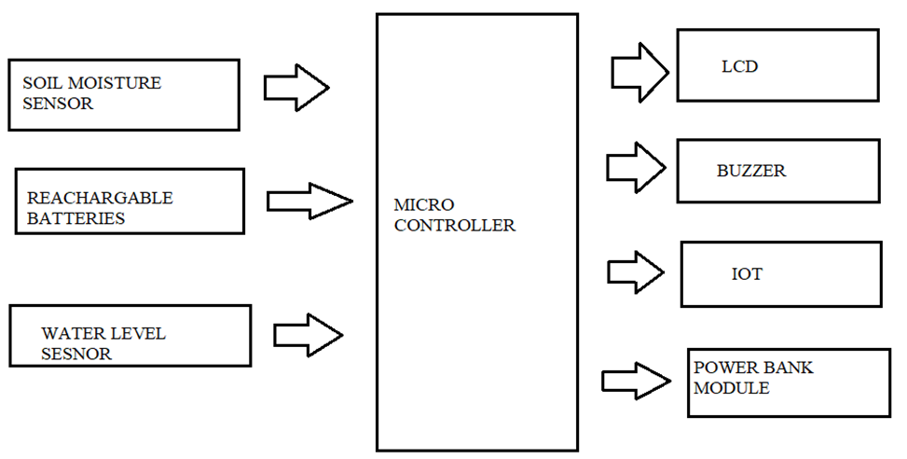

**II.METHODOLOGY**

**Writing Survey**: Lead a complete audit of existing writing on sustainable power combination, cloud-based frameworks, IoT applications in horticulture, and energy effectiveness procedures. This will give a strong comprehension of the present status of-the-craftsmanship advances and systems in the field.

**Distinguish Environmentally friendly power Sources**: Assess different environmentally friendly power sources, for example, sun based, wind, and hydroelectric power that are appropriate for controlling shrewd farming frameworks. Survey the accessibility, unwavering quality, and cost-viability of these energy sources in the objective horticultural region.

**Energy Needs Appraisal**: Decide the energy prerequisites of the IoT gadgets, sensors, and cloud-based foundation utilized in savvy agribusiness. This incorporates assessing the power utilization of every part and distinguishing top energy requests.

**Combination Arranging:** Foster a complete joining plan for integrating sustainable power into the cloud and IoT-based shrewd horticulture framework. Characterize the engineering and plan contemplations for coordinating environmentally friendly power sources with existing foundation.

**Cloud-Based Foundation:** Set up a cloud-based stage for information capacity, handling, and investigation. Pick a dependable cloud specialist organization and design the framework to guarantee versatility, security, and consistent coordination with IoT gadgets.

**IoT Gadget Choice and Sending:** Select proper IoT gadgets and sensors for checking soil conditions, weather conditions, crop wellbeing, and water utilization. Send these gadgets in the field and guarantee they are viable with the cloud-based stage.

**Energy-Effective IoT Conventions:** Execute energy-proficient correspondence conventions, for example, MQTT or Co AP to limit the power utilization of IoT gadgets. Advance information transmission and handling to lessen energy utilization while keeping up with constant checking capacities.

**Sustainable** **power Collecting:** Introduce environmentally friendly power gathering frameworks, for example, sunlight based chargers or wind turbines to create power for IoT gadgets and cloud foundation. Improve the situation and arrangement of these energy reaping frameworks to amplify energy yield.

**Energy Capacity Arrangements:** Execute energy capacity arrangements, for example, batteries or capacitors to store abundance energy created by sustainable sources. Plan a strong energy the executive’s framework to manage energy stream and guarantee nonstop activity of the brilliant farming framework.

**Checking and Streamlining:** Foster observing and control components to follow energy utilization, framework execution, and ecological circumstances continuously. Use information examination strategies to recognize energy shortcomings and streamline framework activity for greatest energy effectiveness.

**Approval and Testing:** Lead broad testing and approval of the coordinated sustainable power framework in a genuine shrewd farming climate. Assess the exhibition, dependability, and energy effectiveness of the framework under different working circumstances.

**Nonstop Improvement:** Consistently screen and assess the presentation of the sustainable power joining framework. Distinguish regions for development and carry out iterative improvements to enhance energy proficiency and generally speaking framework adequacy.[15]

**III.MODELING AND ANALYSIS**

**1. PV SYSTEM:**

A PV (photovoltaic) framework is an innovation that produces power from daylight. It comprises of sunlight based chargers, which are made out of numerous sun oriented cells produced using semiconductor materials like silicon. At the point when daylight hits these sunlight based cells, it makes an electric field across the layers of the material, producing direct flow (DC) power. This power can be utilized right away, put away in batteries for sometime in the future, or changed over into exchanging flow (AC) power involving inverters for framework associated frameworks or to drive AC apparatuses.[2,4]

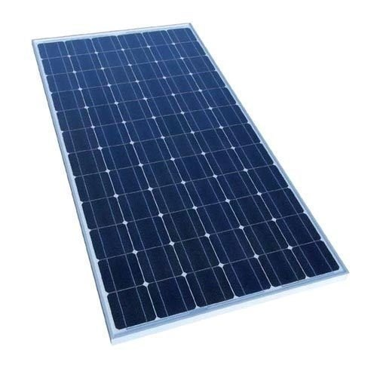

**Fig 1: Solar PV Panel**

**1.1 WORKING OF PV SYSTEM:**

The operation of a photovoltaic (PV) gadget entails numerous key components and tactics that work together to convert sunlight into usable electrical power. Here's a top level view of the way a PV system typically works:

**Sun Panels (PV Modules):**

Solar panels, additionally called PV modules, encompass multiple photovoltaic cells fabricated from semiconductor substances like silicon. When daylight strikes those cells, they generate an immediate contemporary (DC) electric current due to the photovoltaic effect.

**Inverter:**

The DC electricity produced through the sun panels is sent to an inverter. The inverter converts the DC energy into alternating modern-day (AC), that is the sort of power utilized in maximum houses and companies.

**Electrical Panel (or Breaker container):**

The AC power from the inverter is then sent to the electric panel or breaker container of the building. From there, it can be used to strength electrical loads within the building or fed back into the electric grid.

**Electrical masses:**

The AC power produced through the PV system can energy various electrical hundreds, inclusive of lighting fixtures,home equipment, electronics, and equipment, within the building.

If the energy generated exceeds the instant demand of the constructing, the extra energy may be exported to the grid.

**Grid Connection (for Grid-Tied structures):**

In grid-tied PV systems, there's a connection to the electric grid. When the PV machine generates greater strength than the building consumes, the excess power is fed again into the grid thru a bi-directional meter. Conversely, while the PV system isn't producing sufficient energy to meet the building's demand, electricity is drawn from the grid.

**Monitoring and control:**

PV structures regularly include monitoring and control structures to tune the performance of the machine, display power production, and optimize operation. This could involve sensors, meters, and software program that provide real-time facts on power manufacturing, machine performance, and capability issues.

**Mounting and Racking:**

Solar panels are normally established on racks or systems that function them at an gold standard angle and orientation to maximize daylight exposure. Mounting systems additionally offer stability and guide for the panels, making sure they stay securely in area, even in harsh climate conditions.

**Wiring and electrical components:**

Various electrical additives, which include wiring, circuit breakers, fuses, and disconnect switches, are used to securely join the PV gadget additives and distribute electricity in the device.

Standard, a PV machine works with the aid of harnessing daylight through solar panels, changing it into usable power, and distributing that energy to power electric hundreds or feed it back into the electrical grid. The efficiency and overall performance of the machine depend upon factors consisting of the nice of the components, machine layout, orientation of the panels, and local environmental conditions.

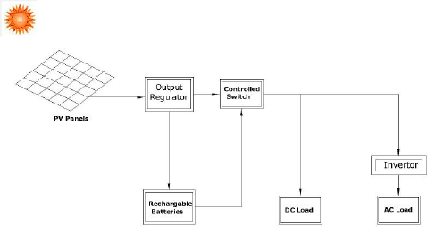

**Fig 2: Block Diagram of PV System**

**Mathematical Analysis:**

Generally, diode current describes as follows,

$I_{dll}= I_{ds}\left[e^{\frac{QV_{pv}}{nKT}}-1\right]$ (1)

Where, *Q* = electron charge = 1.6022 x 10-19C, *K* = Boltzmann’s constant = 1.3807 x 10-23JK-1, *n* = Quality factor of diode, *T* = Working temperature of cell’s in Kelvin, *Ids* = Saturation current.

It includes the effect of series resistance, then diode current becomes,

$I_{dll}= I_{ds}\left[e^{A(V_{pv}+I_{pv}R_{se})}-1\right]$ (2)

Where,

*A* = Constant = $\frac{Q}{nKT}$

The current in shunt branch resistance, $I_{sh}$, as per OHM’s law is,

$I_{sh}= \frac{V_{dp}}{R_{sh}}= \frac{V_{pv}+I_{pv}R_{se}}{R_{sh}}$ (3)

Therefore, the output current *Ipv* is given by substituting Eqns. (2), and (3) in (1)

$I_{pv}= I_{LG}-I_{ds}\left[e^{A\left(V_{pv}+I_{pv}R_{se}\right)}-1\right]-\frac{V_{pv}+I_{pv}R_{se}}{R_{sh}}$ (4)

Eqn. (3) is valid for a single cell; But a PV array contains a matrix of several cells in practice. By seeing the array of *Ns* number of cells for one module or one panel Eqn.(3.6) can be written as

$I_{pv}= I_{LG}-I_{ds}\left[e^{A\left(\frac{V_{pv}+I_{pv}R_{se}}{N_{s}}\right)}-1\right]-\frac{V_{pv}+I_{pv}R_{se}}{R_{sh}}$ (5)

To meet the high voltage demand number of PV cells are added in series, $N_{sl}$, and to meet the high current demand number of cells are connected in parallel, $N_{ll}$, So, Eqn. (4) can be written as,

$I_{pv}= N_{ll}I_{LG}-{N_{ll}I}_{ds}\left[e^{A\left(\frac{V_{pv}}{N_{s}N_{sl}}+\frac{I_{pv}R_{se}}{N_{s}N_{ll}}\right)}-1\right]-\left[\frac{{N_{ll}^{2}V}_{pv}+N_{ll}N_{sl}(I_{pv}R_{se})}{N_{ll}N_{sl}R_{sh}}\right]$ (6)

The light-induced current produced by the PV cell depends on solar irradiation and by the temperature according to the following equation

$I_{LG}= \left[I_{sc}+k_{i}(T-T_{*})\right]\frac{G}{G^{*}}$ (7)

Here, *Isc* (A) is the short circuit current, generally, at 250C and 1000 W/m2, is short circuit current temperature coefficient. *T* (K) and *T\** are actual or operating temperatures, and reference temperature (250C or 298K), *G* (W/m2) is the solar irradiation or insolation, and *G\** is the reference irradiation (1000 W/m2).

The diode saturation current *Ids* is expressed as:

$I_{ds}= I_{rs}{\left[\frac{T}{T_{*}}\right]}^{3} exp\left[\frac{QE_{gb}}{nK}(\frac{1}{T}-\frac{1}{T_{*}})\right]$ (8)

Where,*Egb* is the semiconductor band gap energy typically $≈$ 1.12eV for polycrystalline Si at 250C, and is the reverse saturation current at the reference temperature.

Therefore, reverse saturation current is,

$I_{rs}= \frac{I_{sc}}{exp \left[\frac{A.V_{oc}}{N_{s}}\right]-1}$ (9)

Where, $V_{oc}$ is the open circuit voltage, the following expressions will now be used to enhance the PV model.

$I_{ds}= \frac{I_{sc}+k_{i}∆_{T}}{exp\left[\frac{A\left(V_{oc}+k_{v}∆_{T}\right)}{N_{s}}\right]-1}$ (10)

Where $, ∆_{T}=T-T_{*}$, *kv* = Voltage temperature coefficient

**2. BUZZER:**

A buzzer or beeper is an audio signaling device, which may be mechanical, electromechanical, or piezoelectric. Typical uses of buzzers and beepers include alarm devices, timers, train and confirmation of user input such as a mouse click or key stroke.

An audio signaling device like a beeper or buzzer may be electromechanical or piezoelectric or mechanical type. The main function of this is to convert the signal from audio to sound. Generally, it is powered through DC voltage and used in timers, alarm devices, printers, alarms, computers, etc.

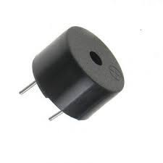

**Fig: 3 Buzzer**

**3. DHT11-TEMPERATURE AND HUMIDITY SENSOR**

DHT11 is a low-cost digital sensor for sensing temperature and humidity. This sensor can be easily interfaced with any micro-controller such as Arduino, Raspberry Pi etc.… to measure humidity and temperature instantaneously.

Differences: DHT11 vs DHT22. Temperature range: With respect to the temperature range, for DHT11, it falls within -20 – 60℃, while for DHT22, it falls within -40 – 80℃.

Humidity Range: the humidity range for DHT11 falls between 5 – 95% RH, while that of DHT22 falls within 0 – 100%RH.DHT11 is a single wire digital humidity and temperature sensor, which gives relative humidity in percentage and temperature in degree Celsius.

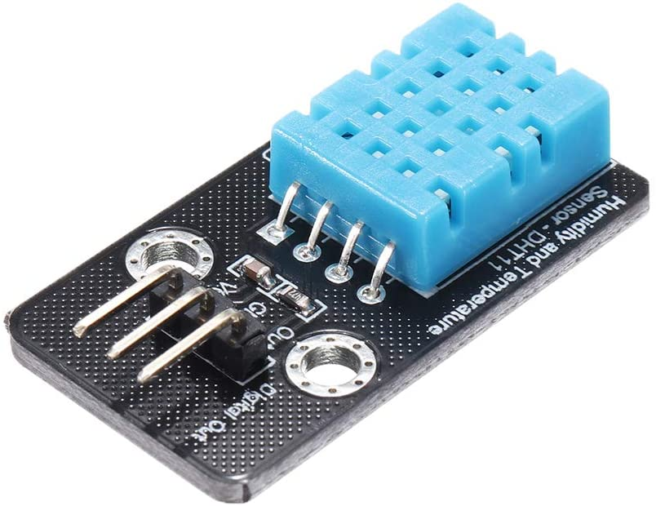

**Fig: 4 Temperatures and Humidity Sensor**

**4. RECHARGEABLE BATTERY**

A rechargeable battery, storage battery, or secondary cell, is a type of electrical battery which can be charged, discharged into a load, and recharged many times, as opposed to a disposable or primary battery, which is supplied fully charged and discarded after use. It is composed of one or more electrochemical cells. The term "accumulator" is used as it accumulates and stores energy through a reversible electrochemical reaction. Rechargeable batteries are produced in many different shapes and sizes, ranging from button cells to megawatt systems connected to stabilize an electrical distribution network. Several different combinations of electrode materials and electrolytes are used, including lead–acid, zinc–air, nickel–cadmium (NiCd), nickel–metal hydride (NiMH), lithium-ion (Li-ion), lithium iron phosphate (LiFePO4), and lithium-ion polymer (Li-ion polymer).

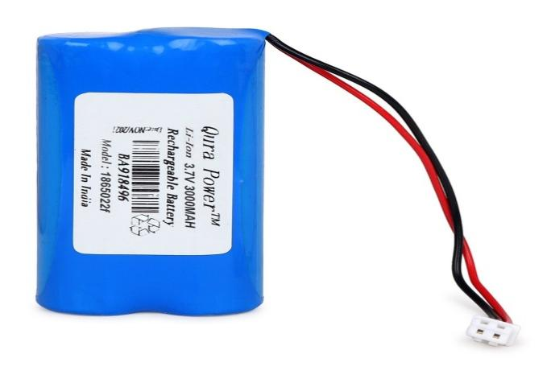

**Fig: 5. Rechargeable batteries**

**5. LIQUID CRYSTAL DISPLAY (LCD)**

LCD stands for Liquid Crystal Display, a technology used in screens and displays for a wide range of electronic devices, including televisions, computer monitors, smartphones, digital watches, calculators.

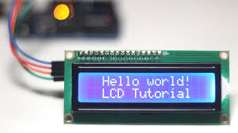

**Fig 6: LCD Display**

**IV.RESULTS AND DISCUSSION**

Sustainable power reconciliation into cloud-based shrewd horticulture alludes to the utilization of sustainable power sources, for example, sun oriented or wind power, to help the tasks of cloud-based frameworks in the agrarian area. These frameworks can incorporate different advances like sensors, information investigation, and computerization to streamline cultivating processes. By utilizing environmentally friendly power, ranchers can decrease their carbon impression and make agribusiness more manageable.[14]

Sustainable power sources like sunlight based chargers or wind turbines are utilized to produce power. This perfect energy is then used to drive the cloud framework, which incorporates servers, capacity frameworks, and server farms. These cloud-based frameworks empower ranchers to gather and examine information from different sources, for example, weather patterns, soil dampness levels, and yield development designs. With this data, ranchers can settle on additional educated conclusions about irrigation, preparation, and vermin control, at last further developing their harvest yield and decreasing asset squander.

To assess our framework, constant information was consistently gathered remotely through the settled WSN more than five days in July 2020. Gathered information incorporate soil dampness, temperature, water system span, water level, sun powered chargers energy creation, and the energy utilization of water siphon

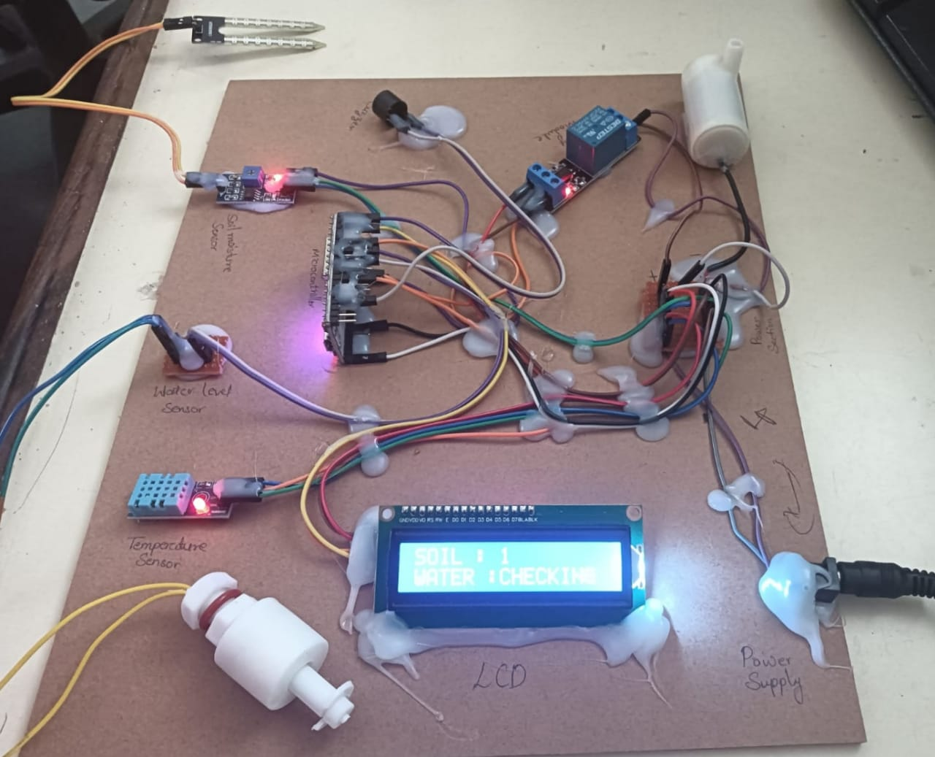 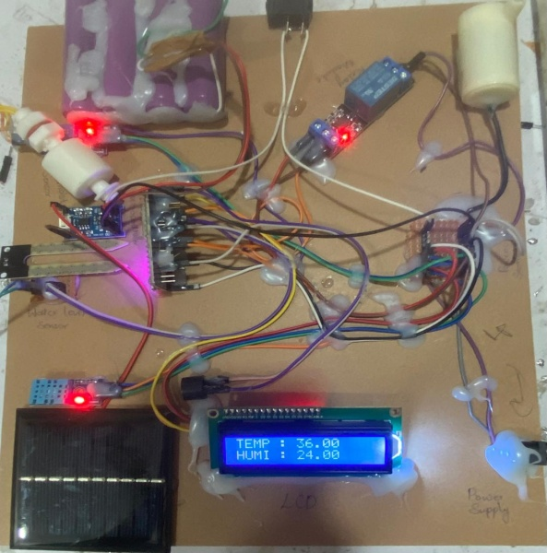

Fig 7: Hardware kit without solar Fig 8: Hardware Kit with the solar

**BLYNK APPLICATION:**

Blynk is a Web of Things (IoT) stage that empowers designers to rapidly and effectively construct associated equipment projects. It gives an intuitive connection point for making custom portable applications to control different IoT gadgets and sensors. Blynk offers a cloud-based framework to work with correspondence between the equipment and versatile application, permitting clients to screen and control their IoT gadgets over the web from a distance. It upholds a large number of equipment stages and correspondence conventions, making it flexible for various IoT applications. By and large, Blynk improves on the method involved with making IoT projects by giving an easy to understand interface and strong backend framework.[13]

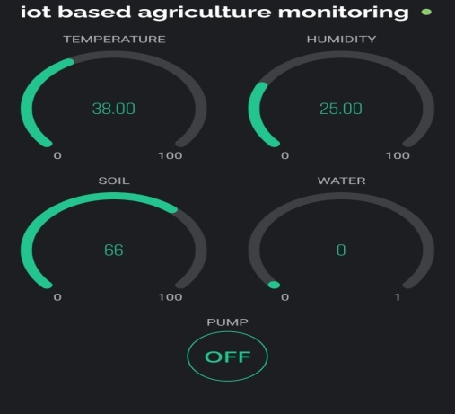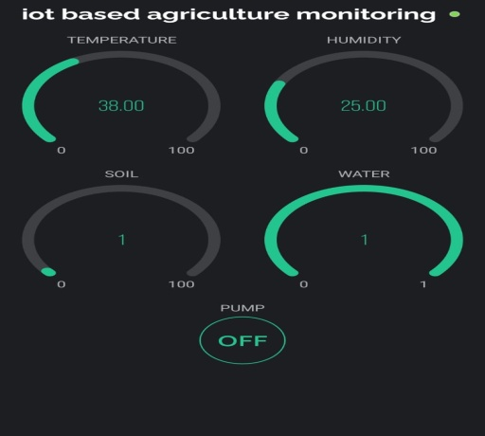

Fig 9: Using Blynk App

**V.CONCLUSION**

The joining of environmentally friendly power into cloud and IoT-based shrewd horticulture addresses a significant development in cultivating rehearses. The blend of soil sensors, water level observing, battery-powered batteries, signal cautions, LCD shows, power bank modules, and distributed computing makes an all encompassing framework that enables ranchers with continuous information, accuracy control, and natural maintainability. This presentation makes way for a top to bottom investigation of every part, its job in the savvy horticulture environment, and the groundbreaking effect of outfitting sustainable power for the fate of cultivating.

**VI.REFERENCES**

[1]"Renewable Energy Systems: A Smart Energy Systems Approach to the Choice and Modeling of 100% Renewable Solutions" by Henrik Lund (2014)

[2]"Internet of Things (IoT) Technologies for Agriculture: Current Status and Future Challenges" by Muhammad Ibrahim et al. (2019)

[3]V.Jyothi, Dr. V. Subramanyam ―An Enhanced technique to improve the Network Lifetime of Cognitive Sensor Network’s, International Journal of Wireless Personal Communications.1275-12763, May-2021DOIhttps://doi.org/10.1007/s11277-021-08575-0 [SCI].

[4] Saraswati, B. Alekya himabindu, Dr. M. V. Subramanyam “Multiple Sensor Data Fusion Based Top-Down Embedded System for Automatic Plant Pot Watering” Journal of Algebraic Statistics Volume 13, No. 1, 2022, p. 884 – 891.

[5] Dr. V. Subramanyam et al ‘Multiple Sensor Data Fusion Based Top-Down Embedded System for Automatic Plant Pot Watering Journal of Algebraic Statistics, e-ISSN: 1309-3452, Marmara University Istanbul University, Istanbul, Vol. 13, No. 1, PP: 884 – 891, 2022, No.3.

[6] “V. Jyothi, Dr. V. Subramanyam “Design and Implementation of Solar Energy Monitoring System Using Lora for Solar Power Plants’, International Journal on Advanced Science & Technology, Vol. 29, No. 03, (2020), Pp. 12757 – 12763, Aug-2020”.

[7] “K. Mallikarjuna, Dr. Satya Prasad, Dr.M.V. Subramanyam,” Sparse Representation Based Image Compression Using Diacranterian Transform”, International Journal of Applied Engineering Research, Vol.10, Pp.13, Pp.33424-33429,2015. (Scopus Indexed)”.

[8] “M. Y. Veeresh, A. M. Prasad, and U. Chaithanya, “A Strategy of High Voltage Gain Switched – Capacitor DC-DC Converter with Reduced Component Rating and Count Fed DC Drive system 1,” vol. 2, no. 9, pp. 1835–1843, 2013”.

[9]M.Y.Veeresh,V.N.B.Reddy,and R. Kiranmayi, “Range Estimation of BatteryElectricVehicle by Mathematical Modelling of Battery’s Depth-of-Discharge,” no. 6, pp. 3987–3992, 2019, doi: 10.35940/ijeat.F8800.088619.

[10] “Dr**.K.Rajasekhara Reddy** "Control of Single Stage Grid Tied Photovoltaic Inverter Using Incremental Conductance Method " in International Journal of Power Electronics and Drives (IJPEDS) (ISSN: 2088-8694, PP- 1702-1708, Volume-9, and Isuue-4, December 2018, DOI: 0.11591/ijpeds.v9n4)”SCOPUS Indexed**.**

[11**]“Dr. K.Rajasekhara Reddy** “Improved Robust Controller Design for Stabilization of Grid-Tied Photovoltaic System " in Journal of Scientific and Industrial Research (JSIR) (ISSN: 0975-1084 (online), 0022-4456 (Print), PP- 431-436, Volume-78, July 2019)” SCIE Indexed.

[12]V. Ramanjaneyulu "DTMF Based Irrigation Water Pump Control System" in International Journal of Research Available at https://edupediapublications.org/journals p-ISSN: 2348-6848 e-ISSN: 2348-795X Volume 05 Issue 12 April 2018.

Internet of Things in agriculture: A survey”.

[13] “Smart Farming Revolution: Farmer’s Perception and Adoption of Smart IoT Technologies for Crop Health Monitoring and Yield Prediction in Jizan, Saudi Arabia”.

[14]"High level energy utilization framework for brilliant ranch in light of responsive energy usage innovations".

[15]"IoT-empowered cloud-based added substance fabricating stage to help quick item advancement".