**Enhancing Medical Image Fusion with Deep Learning-Based Texture-Aware Feature Mapping**

N.Vishnu Varadhan Reddy1, D.Balaji2, B.Phani Chandra3, P.Ramthertham Reddy4

Student1, 2, 3, 4, Santhiram Engineering College, Nandyal, Andhra Pradesh.

**Abstract**

Medical image analysis is essential to healthcare because it helps radiologists and doctors make accurate diagnoses by providing them with specific insights from various imaging modalities. However, due to the complex nature of medical data, it is sometimes necessary to integrate data from multiple modalities in order to provide a comprehensive understanding of the ROI. In order to support clinical diagnosis, this work attempts to merge pathology data from two distinct multimodal pictures of the same region of interest. To direct the fusing of data from input picture matrices, robust fusion weights are generated in the form of individually weighted matrices. Key information is extracted using the quick gray-level co-occurrence matrix-mean approach. characteristics of texture required for the fusion process. The quality of the fusion is assessed by a comprehensive validation process that employs standard criteria and objective analysis. The efficacy and superiority of the suggested strategy will be evaluated by contrasting it with current fusion techniques. **INDEX TERMS** Feature map, GLCM, medical image fusion, texture map, deep learning.

**1. INTRODUCTION**

Multimodal medical image fusion, being an auxiliary approach, assists doctors to diagnose smoothly by leveraging information enhancement from multiple imaging modalities. The objective of image fusion is to integrate details from different parent images of the ROI to derive a comprehensive image that provides composite visual details from the multimodal images [1], [2]. When compared with the parent images, the visual information contained in the fused image is found to be much more detailed. It has the capacity to enhance the amount of visual information which will reduce the redundancy of information present in two or more images. Image fusion is predominantly employed in medical image diagnosis, remote sensing, agriculture, surveillance, and navigation.

**2. LITERATURE SURVEY**

Unlike typical SIFT, which recovers important points based on local extreme in scale-space, DSIFT works by intensively sampling key points across an image at specified intervals. Histograms of gradient orientations calculated inside local image patches surrounding each key point are then used to describe these key points. This description remains constant in terms of scale, rotation, and illumination and viewpoint shifts, but not entirely.

One existing method in medical image analysis is Super-Resolution (SR) fusion. Super-resolution techniques are commonly used to enhance the spatial resolution of medical images, thereby improving visualization and aiding in diagnosis. SR fusion methods typically involve combining information from multiple low-resolution images of the same scene or region to generate a single high-resolution image.

VGG 19 based fusion is an advanced method of image processing that uses deep learning techniques to improve the informational richness and quality of fused images.

Through this feature extraction process, VGG 19 provides a rich and discriminative representation of the input images, facilitating effective integration and fusion.

**3. PROPOSED METHODOLOGY**

In the DL-based fusion networks, the features are extracted by the convolution layers and fused using specific fusion criteria, as shown in Fig. 1. Then, the reconstruction module delivers the fused image from the fused features. In this paper, we proposed a Texture aware Deep Feature map-based linear weighted Image Fusion model (TDFIF). The model tends to work in two primed phases, namely the training phase and the fusion phase. The medical imaging modalities as potential inputs are primarily fed into the proposed network followed by the training procedure being done on it. In the fusion phase, a single pair of MRI and CT images is given as input to the trained model to get the fused output.

**3.1. FEATURE EXTRACTION MODULE**

In this module, there are two convolution layers; the first convolution layer has a kernel of size 3 × 3 with one input as well as 64 output channels, whereas the second layer consists of a kernel of size 3 × 3 with both the input as well as output channels having frequency 64. Moreover, the padding and stride are fixed as unity to make sure that the

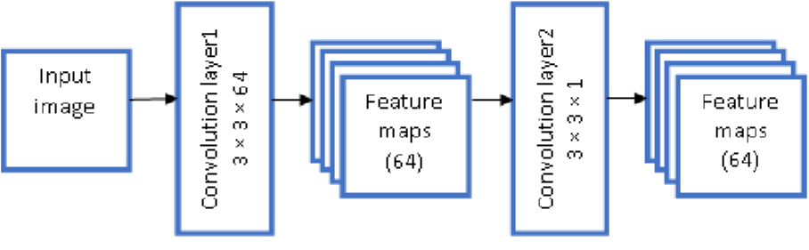

**Fig 1 .** Block diagram of a feature extraction module.

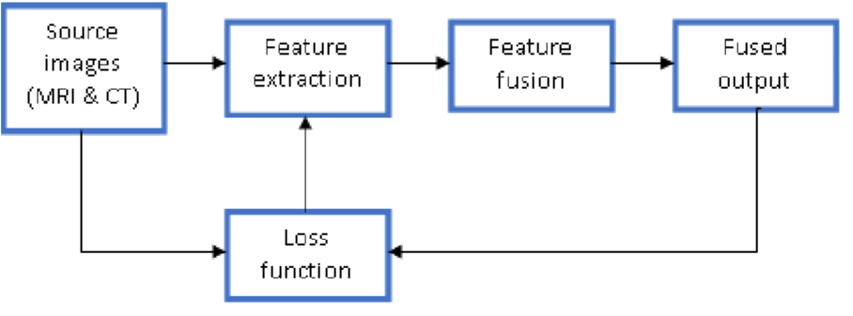

**Fig 2.** Block diagram of a training phase.

**3.2. FEATURE FUSION MODULE**

After feature extraction from the individual modalities, the obtained respective feature maps are summed up independently to produce two summed-up maps. The feature map sum is then divided by the number of feature maps to get a feature map average Favg. Here, Fsum is the feature map sum, Fi is ith feature map. The normalization of grey levels is done to adjust the numeric in the feature map sum to a common scale, without distorting differences in the range of values and hence, we attain the average of all the feature maps as depicted

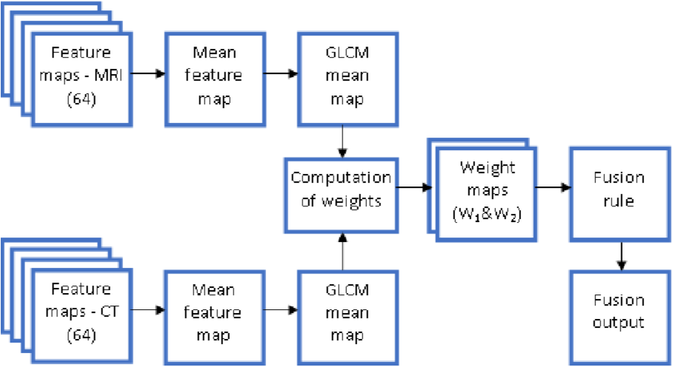

**Fig 3.** Block diagram of feature fusion module.

**4. RESULTS AND ANALYSIS**

The performance of the proposed method is validated by the set of images and analyzed with other fusion methods. Dense shift invariant transform (DSIFT), sparse representation (SR) fusion, ZLMIF, image fusion framework based on CNN (IFCNN) FunFuseAn, and VGG19 [7] are the methods used for comparison. The first experiment among the three experiments is about analyzing the fusion metrics for the four image pairs in the dataset.

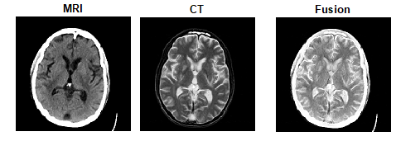

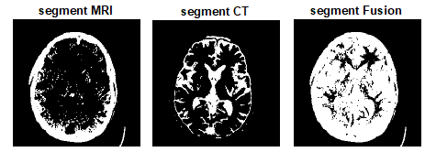

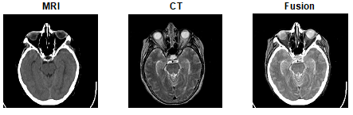

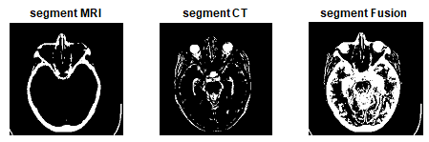

**Fig 4**: Images MRI and CT and fused Image

**5. SOFTWARE DESCRIPTION**

When designing a new system, careful consideration must be given to both hardware and software specifications. The hardware components are chosen based on various factors including CPU processing speed, memory access speed, peripheral channel speed, seek time, and communication speed. These factors determine the efficiency and performance of the system. Additionally, the software configuration plays a crucial role in implementing the proposed system. A thorough requirement analysis is conducted to determine the specific hardware and software configurations necessary for the successful deployment of the system.

1. **Conclusion**

In conclusion, medical image analysis plays a crucial role in facilitating accurate diagnosis and treatment decisions by clinicians and radiologists. With the availability of complementary details from multiple imaging modalities within the same region of interest (ROI), there is a growing need to integrate these modalities for enhanced clinical insights. The main objective of this paper is to achieve a comprehensive fusion of multimodal images, presenting a unified view of the ROI. This is accomplished by generating robust fusion weights in the form of individually weighted matrices, guiding the fusion process to ensure optimal outcomes. These findings underscore the importance of integrating multiple imaging modalities for enhanced clinical diagnosis and highlight the potential of advanced fusion techniques in improving medical image analysis practices.

**References:**

1. R. Vijayarajan and S. Muttan, ‘‘Discrete wavelet transform based principal component averaging fusion for medical images,’’ *AEU-Int. J. Electron. Commun.*, vol. 69, no. 6, pp. 896–902, Jun. 2015.
2. R. Vijayarajan and S. Muttan, ‘‘Adaptive principal component analysis fusion schemes for multifocus and different optic condition images,’’

*Int. J. Image Data Fusion*, vol. 7, no. 2, pp. 189–201, 2016, doi: [10.1080/19479832.2016.1149113.](http://dx.doi.org/10.1080/19479832.2016.1149113)

1. R. Vijayarajan and S. Muttan, ‘‘Iterative block level principal component averaging medical image fusion,’’ *Optik*, vol. 125, no. 17, pp. 4751–4757 , Sep. 2014, doi: [10.1016/j.ijleo.2014.04.068.](http://dx.doi.org/10.1016/j.ijleo.2014.04.068)
2. Y. Zhang, Y. Liu, P. Sun, H. Yan, X. Zhao, and L. Zhang, ‘‘IFCNN: A general image fusion framework based on convolutional neural network,’’ *Inf. Fusion*, vol. 54, pp. 99–118, Feb. 2020.
3. Y. Huang, W. Li, and J. Du, ‘‘Anatomical-functional image fusion based on deep convolution neural networks in local Laplacian pyramid domain,’’ *Int. J. Imag. Syst. Technol.*, vol. 31, no. 3, pp. 1246–1264, Sep. 2021.
4. Z. Omar and T. Stathaki, ‘‘GLCM-based metric for image fusion assessment,’’ in *Proc. 15th Int. Conf. Inf. Fusion*, Jul. 2012, pp. 376–381.

F. Lahoud and S. Susstrunk, ‘‘Zero-learning fast medical image fusion,’’ in *Proc. 22th Int. Conf. Inf. Fusion (FUSION)*, Jul. 2019, pp. 1 – 8.

1. B. Zhang, C. Jiang, Y. Hu, and Z. Chen, ‘‘Medical image fusion based a densely connected convolutional networks,’’ in *Proc. IEEE 5 th Adv. Inf. Technol., Electron. Autom. Control Conf. (IAEAC)*, Mar. 2021 , pp. 2164–2170, doi: [10.1109/IAEAC50856.2021.9390712.](http://dx.doi.org/10.1109/IAEAC50856.2021.9390712)
2. N. Amini and A. Mostaar, ‘‘Deep learning approach for fusion of magnetic resonance imaging-positron emission tomography image based on extract image features using pretrained network (VGG19),’’ *J. Med. Signals Sens.*, vol. 12, pp. 25–31, Jan. 2021.
3. B. Ma, Y. Zhu, X. Yin, X. Ban, H. Huang, and M. Mukeshimana,

‘‘SESF-Fuse: An unsupervised deep model for multi-focus image fusion,’’ *Neural Comput. Appl.*, vol. 33, no. 11, pp. 5793–5804, Sep. 2020.

1. A. Ali Kiaei, H. Khotanlou, M. Abbasi, P. Kiaei, and Y. Bhrouzi, ‘‘An objective evaluation metric for image fusion based on Del operator,’’ 2019, *arXiv:1905.07709*.
2. G. Qu, D. Zhang, and P. Yan, ‘‘Information measure for performance of image fusion,’’ *Electron. Lett.*, vol. 38, no. 7, pp. 313–315, 2002.
3. M. B. A. Haghighat, A. Aghagolzadeh, and H. Seyedarabi, ‘‘A nonreference image fusion metric based on mutual information of image features,’’ *Comput. Electr. Eng.*, vol. 37, no. 5, pp. 744–756, Sep. 2011.
4. C. B. Gao, J. L. Zhou, J. R. Hu, and F. N. Lang, ‘‘Edge detection of colour image based on quaternion fractional differential,’’ *IET Image Process.*, vol. 5, no. 3, pp. 261–272, Apr. 2011.