Enzymatic and biological activity analysis of endophytic fungi isolated from Piper nigrum
Chithra Sivanandan
Mahatma Gandhi University, Kottayam, Kerala, India

Abstract
Piper nigrum is well known for its metabolite richness and medicinal property. So the endophytic fungi associated with the plant can also be expected to have promising bioactive metabolites. In this part of the study, endophytic fungi isolated from P. nigrum were screened for the antimicrobial properties against Staphylococcus aureus, Bacillus subtilis and Vibrio cholerae. For this, the culture extracts were prepared made from the fungal isolates Colletotrichum sp., Diaporthe sp., Phomopsis sp., Mycosphaerella sp., Fusarium sp., Pleosporales sp. and Pseudocercospora sp. The isolates Fusarium sp. and Phomopsis sp. were found to have highest activity against the pathogens screened. However, 80% of isolates were found to be positive for the production of asparaginase. 40% were positive for amylase and protease and 20% showed cellulase and laccase production.
Keywords: Endophytic fungi, Piper nigrum, pathogens, antimicrobial activity
INTRODUCTION
Bioactive natural products produced by endophytic fungi can have tremendous applications. Endophytic fungi isolated from medicinal plants have been recognized as beneficial source of bioactive metabolites (Wen et al., 2022). Recent investigations have proved endophytic microorganisms as potential sources for human beneficial compounds including antibiotics, anti malaria and anti carcinogens (Strobel, 2003). Hence endophytic fungi from medicinal plants have been widely studied for novel secondary metabolites. The emerging information from endophytic studies indicate the chemical nature of bioactive compounds as alkaloids, steroids, terpenoids, isocoumarins, quinones, flavonoids, phenylpropanoids, peptides, phenolics, and aliphatics (Hashem et al., 2023).
Endophytic fungi have the ability to produce valuable enzymes also. Enzymes derived from fungi are used in food, beverages, confectionaries, textiles and leather industries to simplify the processing of raw materials. They are often more stable than enzymes derived from other sources (Toppo et al., 2024). Enzymes such as cellulase, lipase and chitinase are common enzymes produced by endophytic Beauveria, Lecanicillium, Metarhizium and Trichoderma, isolated from various plant species (Bhadra et al., 2023). Asparaginase and tyrosinase are two valuable enzymes with increasing demand due to their wide use in medicine (Juluri et al., 2023). Other major hydrolytic enzymes like amylase, cellulase and laccase of endophytic origin also have various industrial applications(Hawar et al., 2022).
The endophytes from medicinal plants have become an important topic for metabolite discovery (Gouda et al., 2016). Black pepper (Piper nigrum), which belongs to the family Piperaceae is known to have traditional use for the treatment of malaria, gastro intestinal disorders, epilepsy and asthma (Takooree et al, 2019). So endophytic fungi present in this plant can expect to have remarkable biosynthetic potential. In this part of the study, anti microbial, enzyme activity and plant growth promoting features of endophytic fungi isolated from the Piper nigrum was carried out.
2.0 Materials and Methods
2.1 Fungi selected for the study
Among 18 endophytic fungal isolates, seven isolates like Colletotrichum sp.(KC213984), Diaporthe sp. (KC213981), Phomopsis sp. (KC213980), Mycosphaerella sp.(KC213982), Fusarium sp. (KC213986), Pleosporales sp. (KC213985) and Pseudocercospora sp. (KC213983) were selected for the study.
2 . 2 Determination of Enzyme activity
Extra cellular enzyme production property was screened for selected endophytic fungal species from Piper nigrum. The isolates were screened for celluase, laccase, lipase, protease, amylase and asparaginase activity (Hawar et al., 2022).
2.2.1 Amylase
The amylase activity was screened by inoculating the selected isolates on GYP agar medium (1g/L glucose, 0.1g/L yeast extract, 0.5g/L peptone, 16g/L agar, 1000 mL distilled water, pH 6) with 2% soluble starch (Sunitha et al., 2012). After 3-5 days incubation time, the fully formed cultures were flooded with 1% iodine in 2% potassium iodide. Formation of clear halos was considered as positive results.
2.2.2 Cellulase
The cellulase activity was determined by inoculating the isolates on Czapek dox medium (30g/L sucrose, 3 g/L NaNO₃, 1 g/L K₂HPO₄, 0.5 g/L MgSO₄, 0.5 g/L KCl, 0.01 g/L FeSO₄, 16 g/L Agar) amended with 0.5% Na-carboxy methyl cellulose (Mrudala et al., 2011). The plates after incubation were flooded with 0.1% congo red and destained with 1M sodium chloride. Formation of clear zone was considered as positive results.
2.2.3 Laccase
For Laccase activity, the isolates were grown on GYP agar medium (1 g/L glucose, 0.1 g/L yeast extract, 0.5 g/L peptone, 16 g/L agar, pH 6) and 1-naphthol, 0.005% is added along with the media (Jayaram et al., 2023). The oxidation of 1-naphthol by laccase enzyme produced by the isolates was observed.
2.2.4 Lipase
The lipase activity was analyzed by growing the selected isolates on the peptone agar media (10 g/L peptone, 5 g/L NaCl, 0.1 g/L CaCl₂. 7H ₂O, 16 g/L agar, pH 6) as described by Mobarak-Qamsari et al., (2011). To the sterilized peptone agar culture media, previously sterilized Tween 20 was added a final concentration of 1% (v/v). The media was inoculated with the isolates and incubated. The formation of halos around the colony was considered as positive results.
2.2.5 Protease
The proteolytic activity was observed by growing the isolates on GYP agar media (1g glucose, 0.1 g/L yeast extract, 0.5 g/L peptone, 16 g/L agar, pH 6) supplied with 0.4% gelatin. To the sterilized culture media, separately sterilized 8g of gelatin in 100 mL distilled water was added (Sunitha et al., 2013). After incubation, the culture was flooded with saturated aqueous ammonium sulphate. Formation of clear zone around the colony was then observed as indication of hydrolysis of gelatin in media.
2.2.6 Chitinase
For chitinase activity, the endophytic fungi were grown on colloidal chitin agar medium (2g/L colloidal chitin, 16 g/L agar) (Narayana et al., 2009). Formation of clear zone surrounding the colony after incubation was considered positive for chitinase activity.
2.2.7 Asparaginase
For this, the selected endophytic fungal isolates were cultured on PDA for 7 days. The 5 mm disc of mycelium was transferred to Modified Czapex Dox’s (MCD) agar (2.0 g/L glucose, 10.0 g/L L-asparagine, 1.52 g/L KH₂PO₄, 0.52 g/L KCl , 0.52 g/L MgSO₄.7H₂O, 0.001 g/L CuNO₃. 3H₂O, 0.001 g/l ZnSO₄.7H₂O, 0.001 g/L FeSO₄.7H₂O, 16g/L Agar) supplemented with phenol red (0.009% final concentration) indicator (Juluri et al., 2022). Control plates were MCD agar without asparagine. All the plates were incubated at 30°C. Formation of pink zone radius was considered as positive isolates.
2.3 Antibacterial Activity
The crude extracts of endophytic fungi prepared as explained above were tested against Bacillus subtilis, Staphylococcus aureus, and Vibrio cholerae. Anti microbial activity was determined by using well diffusion method. The overnight cultures of test organisms were inoculated in to Muller Hinton Agar (2.00 g/L beef extract , 17.50 g/L acid hydrolysate of casein, 1.50 g/L starch, 12g/L agar) plates using sterile cotton swab. About 6 mm size wells were made and 30µL of crude extract was added into it and kept for incubation at 37°C for 24 h. Same volume of methanol alone was used as control. Anti microbial activity was analyzed based on the zone of inhibition formed (Balouiri et al., 2016).
3.0 RESULTS AND DISCUSSION
In this part of the study, seven endophytic fungi were screened for the presence of extracellular enzymes amylase, cellulase, laccase, chitinase, asparaginase and protease by culturing on specific media (Table 1).
Two endophytic fungal strains (Pleosporales sp. and Mycosphaerella sp.) were identified to have protease activity (Fig. 1). Mucor sp. was previously reported to be the best producer of protease, and with previous reports 82% of endophytic fungi may likely have proteolytic activity. This has application in waste treatment, detergents, cosmetics and leather manufacture, the pharmaceutical and food industries (Orlandelli et al., 2015).
Among the seven endophytic fungi, Phomopsis sp. and Fusarium sp. showed promising amylase activity (Fig. 2) while only Pseudocercospora sp. was found to have cellulase and laccase activity. Amylase is a major enzyme used in starch processing industries for the hydrolysis of polysaccharides into simple sugars (Sunitha et al., 2012). The cellulases produced by many terrestrial fungi are being used in paper industry (Rajput et al., 2016).
Asparaginase is used as a chemotherapeutic agent against acute lymphoblastic leukemia and lympho-sarcoma. The enzyme catalyzes the hydrolysis of L-asparagine into L-aspartic acid and ammonia (Juluri et al., 2022). Here, the enzyme production was observed for five endophytic fungal species like Pseudocercospora sp., Phomopsis sp., Mycosphaerella sp., Fusarium sp. and Pleosporales sp. (Fig. 3).
Fungal enzymes are gaining importance in agriculture, industry and also for medical applications as because of their stability when compared to enzymes plants and animals. Fungal enzymes are used in manufacturing of food, beverages, confectioneries and textile. Hence screening of endophytic fungi for enzymes, antibiotics, anti- cancer drugs will have significant application.
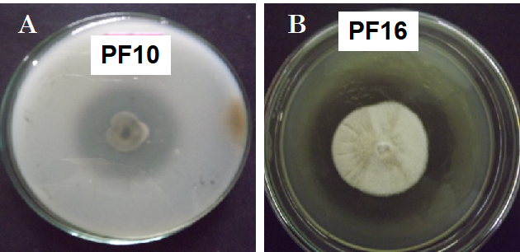

Fig. 1: Protease activity of endophytic fungi isolated from Piper nigrum. A – Mycosphaerella sp. (PF 10); B – Pleosporales sp. (PF 16).

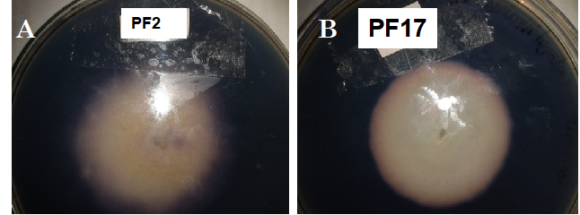
Fig. 2: Amylase activity of endophytic fungi isolated from Piper nigrum. A – Phomopsis sp. (PF 2); B – Fusarium sp. (PF 17).
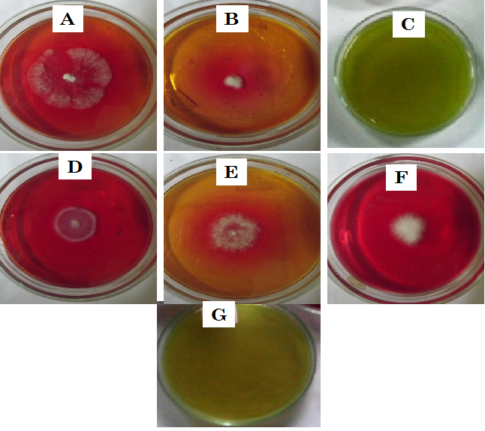
Fig. 3: Endophytic fungal isolates with L-asparaginase production. A - Phomopsis sp. (PF 2) +ve ; B – Pseudocercospora sp.(PF11) +ve; C-Colletotrichum sp. (PF12 no activity); D- Mycosphaerella sp. (PF10) +ve ; E - Pleosporales sp. (PF16) +ve; F-Fusarium sp.(PF17) +ve ; G- Diaporthe sp. (PF7 no activity).

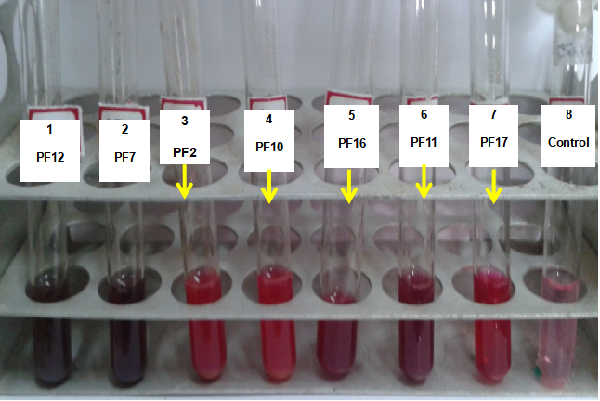
Fig. 4: Qualitative analysis on Asparaginase enzyme production by selected endophytic fungi; dark pink indicates the presence of asparaginase 1- Colletotrichum sp. (PF12 no activity); 2-Diaporthe sp. (PF7 no activity); 3-Phomopsis sp. (PF 2) +ve; 4) Mycosphaerella sp. (PF10) +ve; 5- Pleosporales sp. (PF16) +ve; 6-Pseudocercospora sp. (PF11) +ve ; 7- Fusarium sp. (PF17) +ve; 8- Control

Table 1: Summary of enzyme activity of selected endophytic fungi
Isolates | Enzyme activity screened
Isolates | Amylase | Protease | Laccase | Cellulase | Asparaginase
PF2 (Phomopsis sp.) | ++ | - | - | - | ++
PF10 (Mycosphaerella sp.) | - | ++ | - | - | ++
PF11 (Pseudocercospora sp.) | - | - | + | + | ++
PF12 (Colletotrichum sp.) | - | - | - | - | -
PF7 (Diaporthe sp.) | - | - | - | - | -
PF16 (Pleosporales sp.) |  | ++ | - | - | +
PF17 (Fusarium sp.) | ++ | - | - | - | ++
Enzyme activity of selected endophytic fungi from Piper nigrum. +indicates small activity; ++ indicates good activity; - indicates no activity;

Screening for antibacterial activity of the endophytic isolates was conducted by agar well diffusion method against both gram positive and negative bacteria. The crude extracts of Phomopsis sp., Mycosphaerella sp., Colletotrichum sp., Diaporthe sp., Pseudocercospora sp., Fusarium sp. and Pleosporales sp. showed varying levels of antibacterial activity towards the test organisms like Bacillus subtilis, Staphylococcus aureus, and Vibrio cholerae (Table 2). Most of the fungal extracts were active against Staphylococcus aureus and Bacillus subtilis. However among the isolated strains crude extract of Phomopsis sp. and Fusarium sp. were active against Staphylococcus aureus, Vibrio cholerae and Bacillus subtilis with 30-32 mm of zone of inhibition (Fig. 5). Pleosporales sp., Pseudocercospora sp. and Colletotrichum sp. have highest activity against Bacillus subtilis zone of inhibition about 20-25 mm and Diaporthe have activity against Staphylococcus aureus also. The endophytic Colletotrichum sp. was found to have activity against phytopathogen Rhizoctonia sp.
Jalil et al., (2022) have reported the antimicrobial compounds produced by endophytic fungi are extractable with ethyl acetate. The endophytes such as P. citrinum and N. dimidiatum have been reported tp produce compounds active against the plant pathogenic fungi T. cucumeris and G. zeae (Xia et al., 2022).

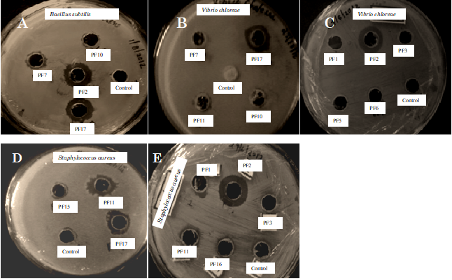
Fig. 5: Antimicrobial activity of endophytic fungi isolated from P. nigrum A) Phomopsis sp. (PF2) and Fusarium sp. (PF17) against Bacillus subtilis B) Fusarium sp. (PF17) against Vibrio cholera C) Phomopsis sp. (PF2) against Vibrio cholera D) Fusarium sp. (PF17) active against Staphylococcus sp. E) Phomopsis sp. (PF2) against Staphylococcus sp.

Table 2: Summary of the antibacterial activity exhibited by endophytic fungal isolates from P. nigrum
Name of organism | Antibacterial activity analysis |  |  | Antifungal activity
Name of organism | Staphylococcus aureus | Vibrio cholerae | Bacillus Subtilis | Rhizoctonia sp.
Phomopsis sp. (PF2) | ++ | ++ | +++ | -
Mycosphaerella sp. (PF10) | - | - | - | -
Pseudocercospora sp. (PF11) | - | - | ++ | -
Fusarium sp. (PF17) | ++ | ++ | + | -
Diaporthe sp. (PF7) | ++ | - | - | -
Colletotrichum sp. (PF12) | - | _ | ++ | +++
Pleosporales sp. (PF16) | + | - | +++ | -
Antimicrobial activity of selected endophytic fungi from Piper nigrum. + indicates > small inhibition; ++ indicates moderate inhibition; +++indicates good inhibition; – indicates no activity.

The crude extract of endophytic fungi was found to have activity against Bacillus subtilis, Staphylococcus aureus and Vibrio cholerae. Among this, highest inhibition was observed to be against Staphylococcus aureus and Bacillus subtilis. Many endophytic fungi have the ability to produce metabolites with antimicrobial activity (Jha et al., 2023). Endophytic fungi from Terminalia brownie showed significant activity against S. aureus, E. faecalis, P. aerouginosa, E.coli and C. albicans (Kouipou et al., 2019). These reports are supportive to the importance of endophytic fungi from medicinal plants as promising source of anti microbial agents. Guimaraes et al., (2008) have reported the endophytic fungi isolated from Viguiera arenaria and Tithonia diversifolia to have activity against S. aureus and E. coli.

4.0 Conclusion
Among 18 endophytic fungi from P. nigrum, Colletotrichum sp. Diaporthe sp. Phomopsis sp. Mycosphaerella sp. Fusarium sp. Pleosporales sp. and Pseudocercospora sp. were selected for further studies. Screening for anti microbial studies revealed Phomopsis sp. and Fusarium sp. to have activity against three bacterial pathogens such as S. aureus, V. cholera and B. subtilis. The endophytic fungi were identified to have the ability to produce enzymes screened. The remarkable production of asparaginase observed in the study is very significant as it is having anticancer effect.
Reference
Balouiri M, Sadiki M, Ibnsouda SK. Methods for in vitro evaluating antimicrobial activity: A review. J Pharm Anal. 2016 , 6(2):71-79. doi: 10.1016/j.jpha.2015.11.005.
Bhadra F, Gupta A, Vasundhara M, Reddy MS. Endophytic fungi: a potential source of industrial enzyme producers. 3 Biotech. 2022, 12(4):86. doi: 10.1007/s13205-022-03145-y.
Gouda S, Das G, Sen SK, Shin HS, Patra JK. Endophytes: A Treasure House of Bioactive Compounds of Medicinal Importance. Front Microbiol. 2016, 7:1538. doi: 10.3389/fmicb.2016.01538. PMID: 27746767; PMCID: PMC5041141.
Guimarães DO, Borges WS, Kawano CY, Ribeiro PH, Goldman GH, Nomizo A, Thiemann OH, Oliva G, Lopes NP, Pupo MT. Biological activities from extracts of endophytic fungi isolated from Viguiera arenaria and Tithonia diversifolia. FEMS Immunol Med Microbiol. 2008, 52(1):134-44. doi: 10.1111/j.1574-695X.2007.00354.
Hashem AH, Attia MS, Kandil EK, Fawzi MM, Abdelrahman AS, Khader MS, Khodaira MA, Emam AE, Goma MA, Abdelaziz AM. Bioactive compounds and biomedical applications of endophytic fungi: a recent review. Microb Cell Fact. 2023, 22(1):107. doi: 10.1186/s12934-023-02118-x.
Hawar SN. Extracellular Enzyme of Endophytic Fungi Isolated from Ziziphus spina Leaves as Medicinal Plant. Int J Biomater. 2022, 2022:2135927. doi: 10.1155/2022/2135927. PMID: 35845475; PMCID: PMC9279100.
Jalil MTM, Zakaria NA, Suhaimi NSM, Ibrahim D. Crude extracts of an endophytic fungus attenuate the growth of pathogenic bacteria in aquaculture. Iran J Microbiol. 2022, 14(3):383-394. doi: 10.18502/ijm.v14i3.9780.
Jayaram S, Biswas S, Philip I, Umesh M, Sarojini S. Differential Laccase Production among Diverse Fungal Endophytes in Aquatic Plants of Hulimavu Lake in Bangalore, India. J Pure Appl Microbiol. 2023, 17(1):298-308. doi: 10.22207/JPAM.17.1.19
Jha P, Kaur T, Chhabra I, Panja A, Paul S, Kumar V, Malik T. Endophytic fungi: hidden treasure chest of antimicrobial metabolites interrelationship of endophytes and metabolites. Front Microbiol. 2023, 14:1227830. doi: 10.3389/fmicb.2023.
Juluri KR, Siu C, Cassaday RD. Asparaginase in the Treatment of Acute Lymphoblastic Leukemia in Adults: Current Evidence and Place in Therapy. Blood Lymphat Cancer. 2022, 12:55-79. doi: 10.2147/BLCTT.S342052.
Kouipou Toghueo RM, Boyom FF. Endophytic Fungi from Terminalia Species: A Comprehensive Review. J Fungi (Basel). 2019, 5(2):43. doi: 10.3390/jof5020043.
Mobarak-Qamsari E, Kasra-Kermanshahi R, Moosavi-Nejad Z. Isolation and identification of a novel, lipase-producing bacterium, Pseudomnas aeruginosa KM110. Iran J Microbiol. 2011 , 3(2):92-8.
Mrudula S, Murugammal R. Production of cellulose by Aspergillus niger under submerged and solid state fermentation using coir waste as a substrate. Braz J Microbiol. 2011 , 42(3):1119-27. doi: 10.1590/S1517-838220110003000033.
Narayana KJ, Vijayalakshmi M. Chitinase Production by Streptomyces sp. ANU 6277. Braz J Microbiol. 2009, 40(4):725-33. doi: 10.1590/S1517-83822009000400002.
Orlandelli RC, de Almeida TT, Alberto RN, Polonio JC, Azevedo JL, Pamphile JA. Antifungal and proteolytic activities of endophytic fungi isolated from Piper hispidum Sw. Braz J Microbiol. 2015, 46(2):359-66. doi: 10.1590/S1517-838246220131042.
Rajput, Kavish & Chanyal, Sheetal & Agrawal, Pavan & Kumar, Pavan. (2016). Optimization of protease production by endophytic fungus Alternaria Alternata isolated from gymnosperm tree- Cupresses Torulosa D. Don. 6. 1034-1054. 10.20959/wjpps20167-7137.
Strobel G, Daisy B. Bioprospecting for microbial endophytes and their natural products. Microbiol Mol Biol Rev. 2003, 67(4):491-502. doi: 10.1128/MMBR.67.4.491-502.2003.
Sunitha VH, Ramesha A, Savitha J, Srinivas C. Amylase production by endophytic fungi Cylindrocephalum sp. isolated from medicinal plant Alpinia calcarata (Haw.) Roscoe. Braz J Microbiol. 2012, 43(3):1213-21. doi: 10.1590/S1517-838220120003000049.
Takooree H, Aumeeruddy MZ, Rengasamy KRR, Venugopala KN, Jeewon R, Zengin G, Mahomoodally MF. A systematic review on black pepper (Piper nigrum L.): from folk uses to pharmacological applications. Crit Rev Food Sci Nutr. 2019, 59.
Toppo P, Jangir P, Mehra N. et al. Bioprospecting of endophytic fungi from medicinal plant Anisomeles indica L. for their diverse role in agricultural and industrial sectors. Sci Rep 2024, 14, 588. https://doi.org/10.1038/s41598-023-51057-5
Wen J, Okyere SK, Wang S, Wang J, Xie L, Ran Y, Hu Y. Endophytic Fungi: An Effective Alternative Source of Plant-Derived Bioactive Compounds for Pharmacological Studies. J Fungi (Basel). 2022, 8(2):205. doi: 10.3390/jof8020205.
Xia Y, Liu J, Chen C, Mo X, Tan Q, He Y, Wang Z, Yin J, Zhou G. The Multifunctions and Future Prospects of Endophytes and Their Metabolites in Plant Disease Management. Microorganisms. 2022, 10(5):1072. doi: 10.3390/microorganisms10051072.

