# MASTER THESIS ON

**COMPARATIVE ANALYSIS OF FINANCIAL STATEMENT OF SAIL AND TATA STEEL**

FOR THE PARTIAL FULFILLMENT OF THE REQUIREMENT FOR THE AWARD OF

MASTER OF BUSINESS ADMINISTRATION

UNDER THE GUIDANCE OF

Prof. (Dr.) JAGRITI GUPTA Professor : SOB

Galgotias University

SUBMITTED BY

MD AQUIB

22GSOB2010178



SCHOOL OF BUSINESS

**ABSTRACT**

Steel Authority of India Limited (SAIL) stands as one of India's premier state-owned steel manufacturers, headquartered in New Delhi and led by Kaustubh Parashar. With an impressive annual turnover of ₹43,337 crore (US$6.8 billion) (FY 2015-16), it ranks among the world's top steel producers. Established on January 24, 1973, SAIL, a public sector undertaking, operates publicly in the market and is predominantly owned by the Government of India. As of October 1, 2016, SAIL boasts a workforce of 85,145 employees. With an annual production of 13.9 million metric tons, SAIL holds the 24th position among the world's steel producers.

On the other hand, TATA STEEL emerges as a global leader in steel production, with annual crude steel deliveries totaling 27.5 million tons (in FY17). It is the second-largest steel company in India by domestic production, boasting an annual capacity of 13 million tons, following SAIL. With manufacturing operations spread across 26 countries, including Australia, China, India, the Netherlands, Singapore, Thailand, and the United Kingdom, Tata Steel employs approximately 80,500 individuals. Its primary manufacturing facility is situated in Jamshedpur, Jharkhand. In 2007, Tata Steel made headlines by acquiring the UK-based steel maker Corus.

**INTRODUCTION**

India ranked as the world’s third-largest steel producer in 2016, driven by the abundant domestic supply of raw materials like iron ore and cost-effective labor, thus significantly contributing to the country’s manufacturing output. The Indian steel industry boasts state-of-the-art steel mills and has consistently pursued modernization and upgrading of older plants, aiming for higher energy efficiency levels. Categorized into major producers, main producers, and secondary producers, the Indian steel industry is a crucial sector. During 2014-2015, India emerged as the third-largest producer of raw steel and the largest producer of sponge iron globally, churning out 91.46 million tons of total finished steel and 9.7 million tons of pig iron, predominantly sourced from iron ore. The Indian Ministry of Steel is tasked with coordinating and planning the growth and development of the iron and steel industry, formulating policies regarding production, pricing, distribution, import, and export of iron and steel, ferro alloys, and refractories, and fostering the development of input industries essential for the steel industry, such as iron ore, manganese ore, chrome ore, and refractories.

**Investments:**

The steel industry and their associated mining sectors have witnessed significant investments. According to data from the Department of Industrial Policy and Promotion (DIPP), the Indian metallurgical industries attracted Foreign Direct Investments (FDI) worth US$ 10.419 billion from April 2000 to September 2017. Key investments in the Indian steel industry include JSW Steel's planned US$ 4.14 billion capital expenditure program to boost steel output capacity from 18 million tons to 23 million tons by 2020. Rashtriya Ispat Nigam Ltd (RINL) signed a Memorandum of Understanding (MOU) with Kudremukh Iron Ore Company Ltd to establish a 1.2 million ton per annum (MTPA) plant project in Vishakhapatnam. Tata Steel is set to increase the capacity of its Kalinga Nagar integrated steel plant from 3 million tons to 8 million tons with an investment of US$ 3.64 billion.

**Market Size:**

In CY 2017, India's crude steel output increased by 5.87 percent year-on-year to reach 101.227 million tons (MT). During April-December 2017, crude steel production grew by 4.6 percent year-on-year to 75.498 MT. Additionally, finished steel exports surged by 102.1 percent to 8.24 MT in 2016-17, while imports declined by 36.6 percent to 7.42 MT. In the same period, finished steel exports rose by 52.9 percent to 7.606 MT, and imports increased by 10.9 percent to 6.096 MT. Total consumption of finished steel grew by 5.2 percent year-on-year to 64.867 MT during April-December 2017.

**Government Initiatives:**

The Indian government's focus on infrastructure development and the resurgence of road projects are boosting demand for steel. Additionally, the anticipated acceleration in the rural economy and infrastructure is expected to drive further demand for steel. The Union Cabinet, Government of India, approved the National Steel Policy (NSP) 2017, aiming to establish a globally competitive steel industry in India. NSP 2017 targets a steel-making capacity of 300 million tons (MT) and a per capita steel consumption of 160 kgs by 2030. Furthermore, initiatives like the 'MSTC Metal Mandi' e-platform under the 'Digital India' initiative, launched jointly by the Metal Scrap Trade Corporation (MSTC) Limited and the Ministry of Steel, facilitate the sale of finished and semi-finished steel products. The Ministry of Steel is also facilitating the establishment of an industry-driven Steel Research and Technology Mission of India (SRTMI) in collaboration with public and private sector steel companies, with an initial corpus of Rs 200 crore (US$ 30 million), to spearhead research and development activities in the iron and steel industry.

**METHODOLOGY**

Exploratory research is employed when addressing a problem that lacks clarity, aiming to prioritize issues, refine operational definitions, and enhance the overall research design. It assists in determining the optimal research design, data collection method, and subject selection. Caution is advised when drawing definitive conclusions from exploratory research due to its foundational nature, as it often reveals that perceived problems may not actually exist.

Exploratory research commonly utilizes the following techniques:

* Secondary research, involving the review of existing literature and data.
* Casually conversing with consumers, employees, management, or competitors to gather insights.
* Employing structured qualitative research approaches such as in-depth interviews, focus groups, projective techniques, case studies, or pilot studies.

**DATA ANALYSIS AND INTERPRETATION**

Forms response chart. Question title: What is your familiarity with financial statements of companies in the steel industry, particularly SAIL and Tata Steel?
. Number of responses: 40 responses.

**Response Distribution**

* **Very Familiar (50%)**: This indicates that half of the respondents are highly familiar with financial statements in the steel industry. They likely possess a deep understanding of financial reports, including those of SAIL and Tata Steel, and are comfortable analyzing and interpreting them confidently.
* **Somewhat Familiar (32.5%)**: Approximately one-third of the respondents have a moderate level of familiarity with financial statements in the steel industry. While not as extensive as those who are "very familiar," they likely have some knowledge and experience in this area and can grasp basic concepts.
* **Not Familiar (17.5%)**: Around 17.5% of the respondents have little to no familiarity with financial statements of steel industry companies, including SAIL and Tata Steel. They may require significant guidance or education to understand these statements effectively.

Forms response chart. Question title: Which financial ratios do you consider most crucial for comparing the financial health of SAIL and Tata Steel?
. Number of responses: 40 responses.

**Response Distribution**

* **Profitability Ratios (52.5%)**: Over half of the respondents consider profitability ratios such as Return on Equity (ROE) and Return on Assets (ROA) to be the most crucial. These ratios measure the companies' ability to generate profits relative to their equity and assets, providing insights into their overall efficiency and profitability.
* **Liquidity Ratios (30%)**: A significant portion of respondents prioritize liquidity ratios like the Current Ratio and Quick Ratio. These ratios assess the companies' ability to meet short-term obligations with their current assets, indicating their liquidity and ability to handle financial emergencies.
* **Solvency Ratios (10%)**: A smaller percentage of respondents focus on solvency ratios such as the Debt-to-Equity Ratio. These ratios evaluate the companies' long-term financial stability by comparing their debt levels to their equity, indicating their ability to meet long-term obligations.
* **Efficiency Ratios (7.5%)**: A minority of respondents emphasize efficiency ratios like the Asset Turnover Ratio. These ratios measure how effectively the companies are utilizing their assets to generate revenue, providing insights into their operational efficiency.

Forms response chart. Question title: What sources or platforms do you primarily use for accessing financial data and reports of companies like SAIL and Tata Steel?
. Number of responses: 39 responses.

**Response Distribution**

* **Company Websites (56.4%)**: The majority of respondents primarily rely on company websites for accessing financial data and reports. These platforms often provide direct access to official financial statements, annual reports, and other relevant information directly from the companies themselves.
* **Financial News Websites (10.3%)**: A smaller percentage of respondents use financial news websites such as Bloomberg or Reuters. These platforms often provide comprehensive coverage of financial markets, including news, analysis, and sometimes access to financial data and reports of specific companies.
* **Financial Databases (17.9%)**: Some respondents use financial databases like Bloomberg Terminal or Capital IQ. These platforms offer extensive databases of financial information and analysis tools for professionals in finance and investment industries.
* **Other (15.4%)**: A portion of respondents indicated using other sources or platforms not specified in the options provided. These sources could include specialized financial research platforms, industry-specific publications, or other proprietary sources.

Forms response chart. Question title: In your opinion, which company between SAIL and Tata Steel has shown better financial performance in the past five years ?
. Number of responses: 40 responses.

**Response Distribution**

* **SAIL (45%)**: A plurality of respondents believe that SAIL has demonstrated superior financial performance over the past five years. Their reasoning could be attributed to factors such as improvements in profitability, growth in revenue, effective cost management, or other positive financial indicators specific to SAIL.
* **Tata Steel (27.5%)**: A significant portion of respondents favor Tata Steel for exhibiting better financial performance during the specified period. Reasons for this opinion might include consistent profitability, strategic acquisitions or expansions, effective management of market challenges, or other favorable financial metrics associated with Tata Steel.
* **Both companies are similar in financial performance (20%)**: Some respondents perceive both SAIL and Tata Steel to have displayed comparable financial performance over the past five years. This viewpoint might stem from similarities in financial metrics, market trends, industry conditions, or overall performance indicators between the two companies.
* **Not Sure (7.5%)**: A small percentage of respondent’s express uncertainty or lack of sufficient information to determine which company has shown better financial performance. This uncertainty could arise from limited access to financial data, complexity in analyzing financial performance, or other factors influencing their decision-making process.

**RESULTS**

**Current Ratio:**

One crucial responsibility of the financial manager is to uphold adequate liquidity. The current ratio serves as a significant measure to assess liquidity and short-term solvency. A ratio of 2:1 is typically regarded as the standard for current ratio.

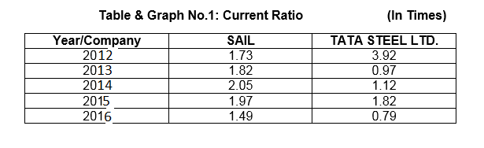

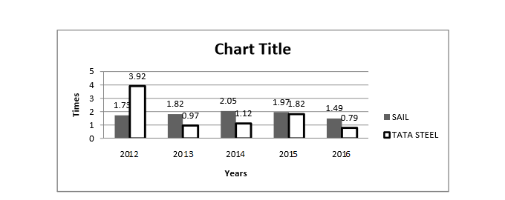

**INTERPRETATION**

Based on the above table and graph, it is evident that in 2012, SAIL had a current ratio of 1.73 times, which increased to 2.05 times by 2014, but decreased to 1.49 times by 2016. In contrast, TATA STEEL LTD. had a current ratio of 3.92 times in 2012, which decreased to 0.79 times by 2016. From this analysis, it can be inferred that SAIL's financial position is superior to that of TATA STEEL LTD.

**Quick Ratio:**

This ratio serves as a more precise assessment of liquidity and solvency compared to others. It specifically considers only liquid assets that can be readily converted into cash, excluding current assets like inventories that are further removed from cash. The quick ratio is calculated by dividing liquid assets by current liabilities, with a ratio of 1:1 generally deemed sufficient.

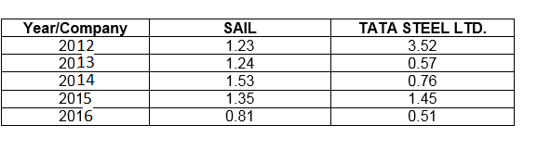

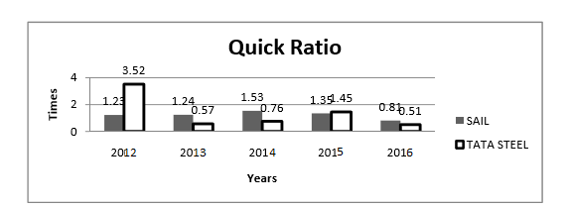

**INTERPRETATION**

From the above table and graph, it's evident that in 2012, SAIL had a quick ratio of 1.23 times, which increased to 1.35 times by 2015 but decreased to 0.81 times by 2016. Notably, this decrease occurred only once during the study period. Conversely, TATA STEEL LTD. had a quick ratio of 3.52 times in 2012, which decreased to 0.51 times by 2016. Based on this analysis, it can be concluded that SAIL's financial position, in terms of the quick ratio, is superior to that of TATA STEEL LTD.

**Inventory Turnover Ratio:**

This ratio reflects the efficiency of stock utilization. A higher ratio is deemed favorable.

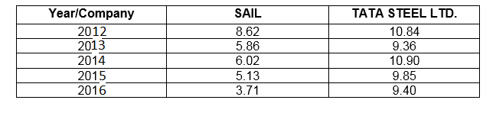

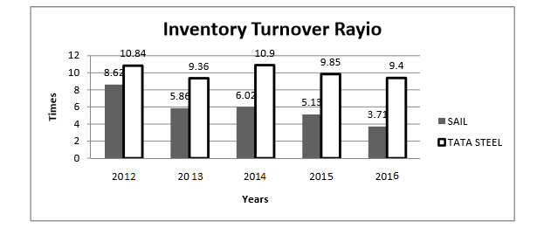

**INTERPRETATION**

This ratio indicates the efficiency of stock utilization, representing how quickly inventory is converted into sales throughout the year. The provided chart and graph illustrate that SAIL's inventory turnover ratio was 8.62 times in 2012 and decreased to 3.71 times in 2016, signifying a notable decline. In contrast, TATA STEEL LTD. had an inventory turnover ratio of 10.84 times in 2012, maintaining a consistent performance with the ratio remaining around 9 times until 2016, where it stood at 9.40 times. In terms of inventory turnover ratio, TATA STEEL LTD.'s financial position surpasses that of SAIL.

**CONCLUSION**

Effective financial management is paramount for the prosperity of any enterprise. Financial performance is a dynamic aspect that evolves rapidly. In today's business landscape, there's a heightened emphasis on financial performance, underscoring its significance. In this analysis, we aimed to compare the financial performance of Steel Authority of India (SAIL) and TATA STEEL LTD.

By scrutinizing their balance sheets and profit and loss statements, we assessed their operational and financial efficiency. Financial performance serves as a critical measure of a company's health, influencing strategic and operational decisions. Continuous efforts towards enhancing financial standing are imperative, leading to improved efficiencies and heightened investor satisfaction.

Both SAIL and TATA STEEL LTD. hold significant positions in India's steel manufacturing sector. However, upon conducting a comparative analysis, we observed that TATA STEEL LTD. outperforms SAIL. This is evident from TATA STEEL LTD.'s higher net profit compared to SAIL and superior inventory management practices.

**ACKNOWLEDGEMENT**

The whole Research report was based “COMPARATIVE ANALYSIS OF FINANCIAL STATEMENT OF SAIL AND TATA STEEL” in the light of course of Finance, results from considerable intellectual and moral support given by our Honorable Mentor, Prof. (Dr.) Jagriti Gupta Professor, School of Business in Galgotias University. She has been our guide from whom We got the inspiration and guidance to learn & Communicate We strongly believe work like this one will surely help us to develop &make us better adapted as well as capable to cope with those issues in today’s world. Moreover, we would like to remember the almighty God for blessing us with.

**REFERENCES**

**Websites**

<https://sail.co.in/background_history>

[http://www.tatasteel.com/background history/investors/financial-performance/financial-results](http://www.tatasteel.com/background%20history/investors/financial-performance/financial-results)

**Books**

Koshy, Keller & Kotler Philip, "Marketing Management", Pearson Publisher, 12th edition, Low Price Edition.

Howkins, Best Ad Coney, "Consumer Behavior", 12th Edition, T.M.H Publisher, Low Price Edition.

Kothari C.R, "Research Methodology", 6th Edition, New Age Publisher.