**A SIMPLIFIED METHOD FOR FRACTAL IMAGE COMPRESSION USING QUAD TREE DECOMPOSITION WITH HUFFMAN CODING**

P.Mohan1, J.Pavan kalyan2, K.Raja Surendra3, M.Bhuvana Chandra4

Student, Santhiram Engineering College, Nandyal, Andhra Pradesh.

**ABSTRACT**

Image compression is a process of reducing the size of a digital image file while preserving its essential visual information, typically by removing redundant or less important data to save storage space or transmission bandwidth. Many approaches in compression have been suggested but they do not satisfy the requirement of less encoding time and high quality reconstructed images. In this paper, Fractal image compression will be used. It uses fractal geometry of the image data stream to achieve lossy compression. Fractal compression of images will be highly effective form of compression. It is based on the parts of an image frequently similar to other parts of the same image. This will result in significant reduction in encoding time and improved quality of reconstructed images. Quad tree decomposition is a type of approach that splits an image into a set of homogenous regions and is the most commonly used partitioning mechanism. Each square image will be partitioned into four equal-sized square blocks, and each block will be examined for homogeneity. Quad tree Decomposition with Huffman Coding Technique will be considered for natural textured images. Huffman Coding, data compression, methodology will be lossless. In this approach, the performance metric of Peak Signal to Noise Ratio (PSNR) will be considered for evaluation.

1. **Introduction**

Compression techniques have become more and more essential in improving the transmission and storage of images. Compression is possible because different regions of an image share similarities and redundancies. Fractal compression of images is a very useful method of compression in these kinds of scenarios. Because of a characteristic called self-similarity, fractals are geometric or rough shapes that may be broken into parts, each of which is a smaller version of the whole. Because fractals are self-similar to one another, they can be separated into parts [4].

**1.1 FRACTAL IMAGE COMPRESSION (FIC)**

Fractal Image Compression (FIC) is an imaging code technology based in the local similarity of image structure. Lossy compression method for digital images. This method is best suited for texture and natural images. Fractal image compression can be obtained by dividing the original grey level image in to un-overlapped blocks. Depending on a threshold value and the well-known techniques of quad tree decomposition

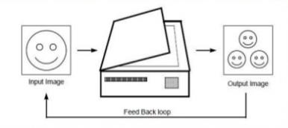

1. **LITERATURE SURVEY**

Uptal Nandi, “Fractal image compression with adaptive quadtree partitioning and non-linear affine map”, 2020, Multimedia tools and applications. A fractal-based method for image compression using nonlinear shrinkage affine maps is proposed, which uses adaptive quadtree partitioning to split images in a response-sensitive manner to improve decoded image quality. This method splits the image to be compressed twice to obtain a set of dimensions and finds the maximum matching nonlinear affine transform space for each dimension. Affine correspondence is not saved in the compressed file. The comparison results show that the proposed technology greatly improves the image quality compared to the existing technology and maintains a high contrast ratio. Both variants are proposed to use lossless coding to increase the contrast of the proposed system without compromising image quality.

Image compression using fractal-based discrete wavelet transform IEEE Transactions on Image Works published a paper titled "Using parallelism techniques" by Umesh B. Kodgule and B A. Sonkamble (2015) describing their research. This article uses Nvidia's GPGPU technology to implement a parallel approach to fractal image compression. It is necessary to follow the above process to learn how to decompose the wavelet transform to reduce the number of block comparisons. Two block distribution and comparison, DWT and comparison block distribution and comparison are being developed for fractal image compression to improve encoder performance.

Rasha Adel Ibrahim et al. They published their findings in 2015. Compression of fractal images was improved by integrating two previously used methods (quantized quad trees and entropy coding) into the process. Initial quantization is used to split the original grayscale image into several blocks and split them again. Entropy coding is used to improve the overall compression quality by increasing compressed data. They evaluated their algorithm in comparison with previous algorithms and found that their compression scheme could reduce encoding time by half. The image quality and compression ratio have also been improved.

Ming-Sheng Wu proposed a new fractal image compression method using techniques such as genetic algorithm (GA) and discrete wavelet transform (DWT). It has been proven through experiments and simulations that the proposed GA technology uses less MSE, including while reducing the PSNR from 0.29 to 0.47 dB. To make the problem worse, the GA method proposed in this study, in addition to having a 100 times faster encoding time than the previous method, also admitted trade-offs in image quality in 2013.

# The Proposed Algorithm

As with the new methodology it is interesting to study interpretations from different perspectives. Several such view of fractal image compression have been considered-

1. Iterated function system(IFS)- Such system are operators in metric spaces and they have fractals subsets as attractors. This motivated Barsely to search for an image compression system that modes image as attractors of IFSs. Jacquin‟s solution of 1989 relies on a crucial modification of IFS‟s, namely that the mappings involved have domains that cover only part of the image. Thus, such IFSs were called local or partitioned.

2. Self vector quantization- The basic fractal encoding is almost the same as a particular type of product code vector quantization (VQ), namely the so-called menremoved shape -gain vector (MRSG-VQ). In that approach an image block is approximated by the sum of a DC component and a scaled copy of an image block taken from the VQ codebook. Fractal encoding differs from MRSG-VQ because the codebook is explicitly available at the decoder but rather given implicitly in a selfreferential manner.

3. Self-quantized wavelet subtrees-It has been noticed that in some cases the fractal encoding is equal to a certain type of wavelet transform coding. The idea is to organize the wavelet coefficient in a tree and to approximate subtrees by scaled copies of other subtrees closer to the wavelet tree.

4. Convolution transform coding- The operation carried out when searching a matching image region for a given one essentially are equivalent to a convolution operation. Only one of the convolution coefficients is selected for the fractal code.

This establishes a close relation to common transformation coding.

**3.1 PROPERTIES OF FRACTAL**

ITERATIONS

Iteration is defined as the process of repeating a method to achieve certain result.

SELF-SIMILARITY

Level of detail remains the same as we zoom in.

CONNECTIVITY

Agents in the system connect to each other to form a pattern.

SELF ORGANISING

System is continually self-organizing through the process of emergence and feedback.

**3.2 PROPOSED TECHNIQUE**

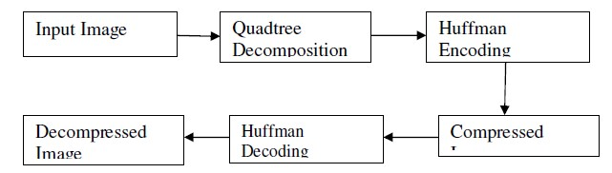

Fig: Proposed Fractal Compression Technique

The algorithm steps are as follows.

The purposed algorithm steps are as follows:

1. Read the input (color /gray) image and set image dimensions.

2. Partition the image using quad-tree decomposition of threshold 0.2, minimum and maximum dimension 2, 64 respectively.

3. Apply modified Huffman encoding to complete image encoding

3.1. By using output data of quadtree, set the boundary elements.

3.2. Specify symbols that data source can produce and find counts of symbols in given data.

3.3. Create the optimal codes for a set of symbols and probabilities and create dictionary.

3.4. Encode the data.

4 .Apply Huffman decoding to reconstruct the image.

5. Calculate Encoding Time, Compression Ratio

**3.3 QUADTREE DECOMPOSITION**

The partitioning scheme used to separate the range blocks is one of the most crucial elements of the fractal compression method[6]. The fidelity and quality of the reconstructed image, the length and the structure of the fractal code, the shape of the transformations used to map domains into ranges and their descriptions in the fractal code, compression ratio, encoding time and all other important characteristics of the compression method are somehow influenced by the choice of the partitioning method. For the issue of fractal image compression, we choose the quad tree partitioning method to partition images because of its regularity, simplicity and efficiency. It consists of a finite set of several nodes which are either empty or consist of a root and at most four non-overlapping quad trees[8]. The quad tree scheme was chosen as it is a typical fractal procedure, suited for square images, and also comparatively easier to code and implement when compared to the other schemes Quad tree partitioning is a unique technique that divides a grey scale level image into a set of homogenous regions. The image is assigned to the tree and some criterion of homogeneity is tested. If the criterion is not met, then it is divided into four sub images. The four sub images have the same size and they are associated with the four child nodes of the root. Next the criterion of each sub image will be tested and the sub image will be divided repeatedly until the criterion condition is met or some minimum.

**3.4 HUFFMAN CODING**

The Huffman encoding algorithm starts by constructing a list of all the alphabet symbols in descending order of their probabilities. It constructs a binary tree with a symbol at every leaf. This is done in steps, where at each step two symbols with the smallest probabilities are selected, added to the top of the partial tree, deleted from the list, and replaced with an auxiliary symbol representing the two original symbols.

1. **Experimental Results:**

In addition to evaluating the algorithm on images, the algorithm was tested by using two similar but slightly different types of satellite images: an urban image with a resolution of 1243 pixels by 988 pixels, and a rural image with a resolution of 1045 pixels by 753 pixels, along with a 512-pixel by 512-pixel Lena image.

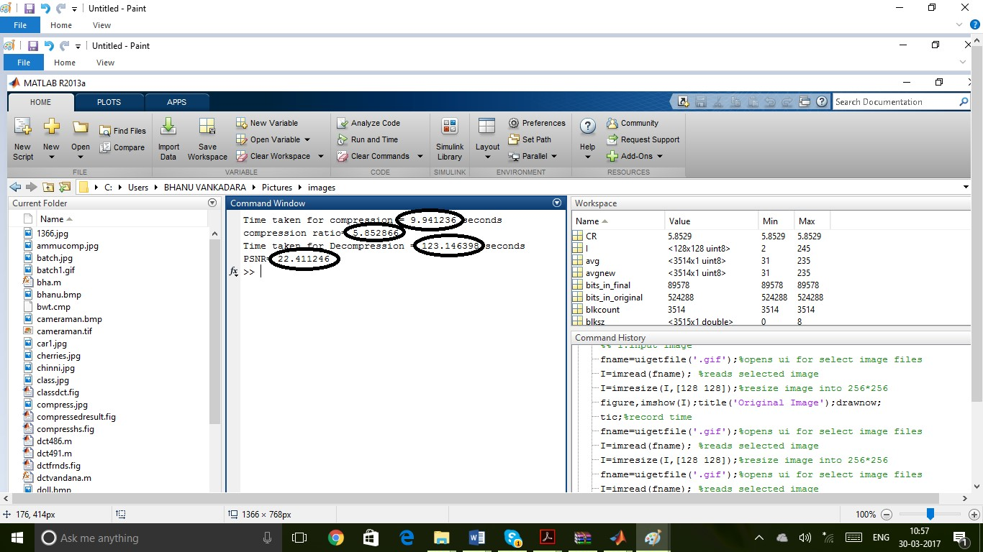

**Fig:** Command Window After Execution

Time taken for compression ratio=9.941226sec

Compression ratio=5.85266

Time taken for decompression=123.146598sec

Psnr=22.4126

|  |  |  |
| --- | --- | --- |
|  |  |  |
| Original image | Quad tree decomposed image | Decompressed image |
| - |  |  |
| Original image | Quad tree decomposed image | Decompressed image |

**Fig:** Comparison of Different Images

Tabular column for Comparison of different images

|  |  |  |  |  |
| --- | --- | --- | --- | --- |
| **Name of image** | **Time for compression ratio(sec)** | **Compression**  **ratio** | **Time for decompression** | **PSNR** |
| Fractal image | 10.8144 | 5.8528 | 122.33 | 22.4112 |
| Lena image | 7.3901 | 9.4566 | 74.6872 | 24.9726 |
| Satellite image | 4.2218 | 8.0076 | 44.6312 | 22.4215 |

1. **CONCLUSION**

Fractal image compression is a compression techniques which exploits similarities in different parts of the image[6]. Fractal is a rough or fragmented geometric shape that can be split into parts, each of which is a reduced-size copy of the whole, a property called self-similarity. The long encoding time in fractal image compression is one of the major difficulties for its application. This paper is based on concept of fractal image compression using quadtree decomposition and modified huffman coding. The quadtree decomposition and modified huffman coding is applied for achieving less encoding time and better PSNR values but it increases compression ratio. Proposed algorithm is tested on various benchmark images.[24] In normal fractal image compression the 2*2 domain blocks were used to code 4*4 range blocks. This generates a lot of 4*4 image block address codes and its transforms codes. The compression ratio is achieved is nearly high.the quality of reconstructed image was found to be high in terms of PSNR.

Further to improve the image quality, to reduce the encoding time and compression ratio some advanced methods can be used. We can also apply other algorithms like neural network, artificial intelligence, fuzzy logic etc to determine self-similarity of images. The threshold value can be calculated automatically by the different threshold methods.

1. **REFERENCES**
2. Rasha Adel Ibrahim et al. " An Enhanced Fractal Image Compression Integrating Quantized Quadtree and Entropy Coding" IEEE 2015
3. R.Praisline Jasmi et al. " Comparison of Image Compression Techniques using Huffman coding, DWT and Fractal Algorithm" IEEE 2015
4. Swalpa Kumar Roy, Samir Kumar Bandyopadhay et al. " Statistical Analysis of Fractal Image Coding and Fixed Size Partitioning Scheme" Global Journal of Computer Science and Technology: F Graphics & Vision, Volume 15, Issue 3, 2015.
5. Umesh B. Kodgule, B A. Sonkamble " Discrete Wavelet Transform based Fractal Image Compression using Parallel Approach" International Journal of Computer Applications, Volume 122 – No.16, July 2015.
6. Khobragade P. B., Thakare S. S." Image Compression Techniques- A Review" International Journal of Computer Science and Information Technologies, Vol. 5, 2014.
7. Preeti Banerjee , Deepak Kumar Xaxa " Designing and Implementation of Efficient DCT Domain Based Fractal Image Compression Technique Using Quadtree Algorithm" International Journal of Engineering Research & Technology, Vol. 3 Issue 4, April – 2014.
8. Ming-Sheng Wu " Genetic algorithm based on discrete wavelet transformation for fractal image compression" Elsevier , 2014
9. Veenadevi.S.V , A.G.Ananth " Fractal Image Compression of Satellite Color Imageries Using Variable Size of Range Block" International Journal of Image Processing, Volume 8, Issue 1, 2014.
10. Shweta Pandey, Megha Seth " Hybrid Fractal Image Compression Using Quadtree Decomposition with Huffman Coding" International Journal of Science and Research, Volume 3 Issue 6, June 2014
11. Sonal Chawla, Meenakshi Beri " Image Compression Techniques: A Review" International Journal of Computer Science and Mobile Computing, Vol.3 Issue.8, August- 2014.
12. Taha mohammed Hasan et al. " An Adaptive Fractal Image Compression" International Journal of Computer Science Issues, Vol. 10, Issue 2, March 2013.

[12] A. K. Sahoo, A. Deshlahra , "Analysis of Image Compression Methods Based On Transform and Fractal Coding", National Inst. of Technology , Rourkela, May-2013.

[13] Dr. K. Kuppusamy, R.Ilackiya " Fractal Image Compression & Algorithmic Techniques " International Journal of Computer & Trends ,Volume3 Issue4 , May 2013

1. Chandan Singh Rawat , Sukadev Meher " A Hybrid Image Compression Scheme using DCT and Fractal Image Compression" The International Arab Journal of Information Technology, Vol. 10, No. 6, November 2013
2. Roshni S. Khedgaonkar, Shailesh D. Kamble " Application of Quadtree Partitioning in Fractal Image Compression using Error Based Approach" IOSR Journal of Engineering, Vol. 2 Issue 1, Jan.2012
3. Veenadevi.S.V et al. "Fractal Image Compression using Quadtree and Huffman coding " Signal & Image Processing : An International Journal ,Vol.3, No.2, April 2012
4. G.M.Padmaja, P.Nirupama " Analysis of Various Image Compression

Techniques" ARPN Journal of Science and Technology, VOL. 2, NO. 4, May 2012

1. Yih-Lon Lin, Wen-Lin Chen " Fast Search Strategies for Fractal Image Compression" journal of Information Science and Engineering, 2012
2. N. A, Koli, M. S. Ali " A Survey on Fractal Image Compression Key Issues " Information Technology Journal 7 ,2008.
3. R.C Gonzalez, R.E Woods, "Digital Image Processing" (Third Edition), Pearson Education,2008.
4. Kuo-Liang Chung, Chung-Hsiang Hsu" Novel prediction- and subblock-based algorithm for fractal image compression" Elsevier, 2005.
5. S. Abdul-Khalik, “Fractal Image Compression Using Shape Structure”, M.Sc. thesis, College of Science, Al-Mustansiriya University, 2005, Iraq
6. M.F. Barnsley "Fractals Everywhere", New York: Acacemic, 1988.
7. J, Rani and Glorindal, G., A Simplified Fractal Texture Analysis Approach using Quadtree Decomposition with Huffman Coding Technique (2021). Middle East Journal of Applied Science & Technology, Vol.4, Iss.3, Pages 01-09, July-September 2021, Available at SSRN: <https://ssrn.com/abstract=3891547>.