**NGO FUNDS TRANSFER SYSTEM USING BLOCKCHAIN**

Swamini Zinje, Shrawani Wadhwane, Prof. Sayali Karmode

UG Students, IT Dept, MGM’s College of Engineering Kamothe, Navi Mumbai, India

Assistant Professor, IT Dept, MGM’s College of Engineering Kamothe, Navi Mumbai, India

[Swaminizinje@gmail.com](mailto:Swaminizinje@gmail.com) , [shrawaniwadhwane@gmail.com](mailto:shrawaniwadhwane@gmail.com) , sayalis.karmode@gmail.com

**Abstract-- non-governmental organizations, or NGOs, are essentially charitable organizations that rely heavily on donations from the general public and NGO members for funding. Being transparent about how donations are handled considerably boosts an organization's credibility and inspires confidence in donors. are employed. Non-governmental organizations (NGOs) get funds from donor organizations to support a range of programs, including economic development, women's empowerment, education promotion, and disaster relief. Because of the misappropriation of funding by certain NGOs, certain donor agencies no longer trust the way NGOs operate. This system is shared by users rather than being owned or managed by a single entity, making it decentralized. As a result, the resources are actually owned by the people, and the entire charity fund system is made more open. Distributed ledgers and blockchain technology have the potential to lower operating costs and move financial institutions toward real-time transactions. Cross-chain is used by the system. Technique for securely sharing data across several Blockchain systems without the need for a middleman. Beneficiaries receive their safe payment transfer to their account only once they file the required forms, appeal for the desired donation, and upload the required paperwork attesting to their accuracy and necessity for the funds for any essential medical care Hospital. The methodology takes into account a worldwide asset positioning structure, secure and actual asset distribution, and full evidence.**

**Keywords:** Ethereum, Distributed ledger, Smart contracts, Solidity, Security, Cryptography

1. **INTRODUCTION**

An NGO is a citizen-based, nonprofit organization that runs without interference from the government and may take part in global social, developmental, or charitable endeavours. An electronic ledger of records shared by all participants is called a block chain. By verifying the people involved, the transaction's time and date, and its contents, this technology addresses the validity of each individual transaction.   
Transaction data is referred to as a "block" when it is organized into a "chain" that links to other blocks of data to build a blockchain. This coordinated strategy helps the systems defines against illegal and unauthorized transactions by making it easy to see any alterations to the chain. The Blockchain is a reliable electronic ledger of economic transactions that may be configured to log almost anything of value, not only money exchanges. The process of transferring money overseas takes three to four days to finish. To complete a transaction, the present banking system necessitates the employment of various third-party verification and transfer services. Between users and the bank system, there is a lack of openness and confidence.   
Blockchain technology is used by the system to solve these issues by enabling speedier payments at less costs than banks. Distributed ledgers and blockchain technology can save operating expenses and get us closer to real-time financial institution transactions. In a multiple Blockchain system, the cross-chain protocol is used to reliably exchange information without the involvement of a third party.

In this context, this project endeavors to conceptualize, design, and implement a state-of-the-art NGO Fund Transfer System that addresses the multifaceted challenges faced by NGOs and donors alike. By harnessing the power of technology, leveraging secure payment gateways, and integrating blockchain principles, this system seeks to revolutionize the way funds are managed, disbursed, and monitored within the NGO sector.

* Decentralized: The decentralized nature of blockchains implies that no one person or group is in charge of the entire organization. Both contributors and beneficiaries can easily and decentralized utilize the website, with each party being able to view all updates made.
* Peer-to-peer network - Blockchain technology facilitates the effective cultivation of cooperation between two groups using a common model without requiring external intervention.
* Permanent: The unchangeable character of a blockchain refers to the fact that any data that has been entered into it cannot be removed. Well, thought out — With blockchains' permanence feature added, it becomes easier to spot any information alteration. Any changes made by donors will be noted on the website.

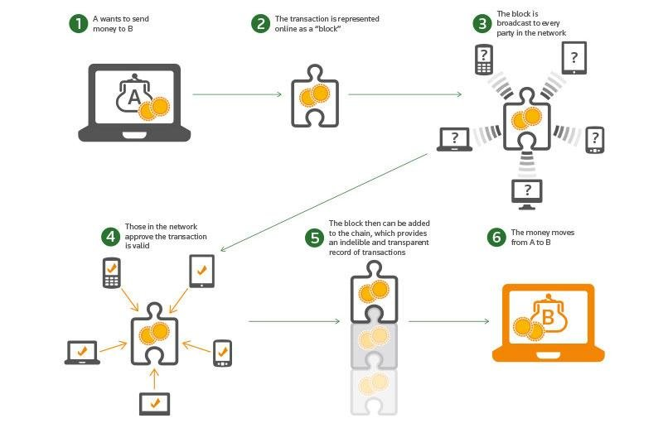

**Fig.1.** Money Transfer in Blockchain System

1. **PROBLEM STATEMENT**

The main challenge facing the top government is low level corruption, which can occasionally be hard to find.   
which denies those in need. It’s an extremely tough task to track. Here, we suggest a clever way to monitor monies given to recipients by the public and state governments as they move through the blockchain process step by step. The XYZ NGO, dedicated to social welfare and development projects, faces challenges in managing funds efficiently and transparently. Currently, the NGO relies on traditional methods for transferring funds to project locations and beneficiaries, which often result in delays, errors, and lack of transparency. To address these issues, the NGO aims to develop a robust funds transfer system that ensures timely disbursement, minimizes administrative overhead, enhances accountability, and provides transparency to donors and stakeholders. Non-Governmental Organizations (NGOs) play a crucial role in addressing social issues, providing aid, and supporting communities. A significant aspect of their operation involves managing funds efficiently and transparently. However, traditional methods of fund transfer often lack transparency, security, and efficiency, leading to potential mismanagement or misuse of funds.

1. **LITERATURE REVIEW**

A new technology called blockchain allows untrusted partners to share data. But it struggles when there are a lot of transactions. Furthermore, there are strong hurdles separating different blockchain systems. In this study, we developed a unique framework called interactive multiple blockchain architecture, which is based on components and allows information to be exchanged across any blockchain system. For inter-blockchain communication, our architecture creates a dynamic multi-chain network. We suggest using the inter-blockchain connection paradigm for message transfer and routing management. Furthermore, in a crossing-chain scenario, our suggested protocols offer transactions with atomicity and consistency. Ultimately, the results of our experiment, which was conducted on a network of private multiple blockchain systems, indicate that the throughput is boosted when numerous chains are running in parallel [1].

Online payments might be transmitted straight between parties without passing thru a banking institution if electronic cash was only available peer-to-peer. Digital signatures help, but if a reliable third party is still needed to stop double-spending, the major advantages are negated. We suggest a fix for the double- difficulty with peer-to-peer networks and spending. By hashing transactions into a continuous chain of hash-based proof-of-work, the network creates a timestamp that cannot be altered without repeating the proof-of-work. In addition to providing evidence of the events that were observed, the longest chain also shows that the greatest amount of CPU power was used to produce it. The nodes that are not collaborating to assault the network will produce the longest chain and overtake the attackers as long as they control the bulk of the CPU power. The network itself needs very little organization. Nodes can leave and rejoin the network at any time, with the longest proof-of-work chain serving as evidence of what transpired while they were away. Messages are distributed based on best effort [2].

The issue of an expanding amount of data stored on the blockchain is made worse by the deployment of blockchain technology outside of finance. Regretfully, in order to verify incoming transactions and obtain a summary of the system's status, new users of the blockchain network must download the entire blockchain. The scalability problems with blockchain applications are attempted to be resolved by strategies such as IOTA, Sewin, and the Lightning Network. Regretfully, rather than addressing the issues that arise from an expanding chain or presenting fresh ideas to completely replace the linear blockchain, they concentrate on tactics to slow down the blockchain's expansion. The method suggested in this paper builds upon Ethereum's idea of maintaining the system's state directly in the current block, but it goes one step further by including the pertinent portion of the current system state into new transactions as well. Other users can now verify incoming transactions without downloading the entire blockchain at first thanks to this.   
By adopting this concept, use cases that call for scalable blockchain technology but don't necessarily need an endless and comprehensive transaction history can be accommodated [3].

Bidirectional communication flow-enabled smart grids should offer more advanced energy trading and consumption monitoring. Nonetheless, there are significant obstacles when it comes to the security and privacy of trading and consumption data. In order to provide transaction security in decentralized smart grid energy trading without depending on reliable third parties, we address this issue in this work. Using multi-signatures, anonymous encrypted chat streams, and blockchain technology, we have developed a proof-of-concept for a decentralized energy trading system that allows peers to safely conduct trade transactions and negotiate energy prices in secret. In order to do security analysis and performance evaluation in the context of the elicited security and privacy criteria, we carried out case studies [4].

We suggest a system that use a trust less decentralized peer-to-peer protocol to enable users to safely send and receive messages as well as subscribe to broadcast messages. To maintain security, users do not need to share any data longer than a short (around 36 character) address, and they are not required to understand the notion of public or private keys in order to utilize the system. Additionally, it is intended to conceal non-content information from anyone not directly involved in the communication, such as the sender and recipient of messages [5].

Hankin, Seidner, and Zietlow (1998) note that non-profit financial management is just as difficult as that of a for-profit organization in the competitive environment we live in today. Managing an organization's financial resources, creating and updating financial policies, accounting, creating budgets and financial reports, making both short- and long-term investments, and controlling and managing risk are all areas of competence that nonprofit managers should possess. According to Bryce (2000), finance is merely an instrument that must be used in order to achieve the strategic goals of the company. The desire for non-profit organizations to be financially accountable has skyrocketed, according to McCarthy (2007). According to McLaughlin (2009), categorizing this industry based on the main economic function that each organization performs is a more useful method to view it from a financial standpoint [6].

1. **PROPOSED SYSTEM**

The banking system transnational data and numerous distributed ledgers are created in Fig. 1, and all transnational data is kept in various data nodes. Every node will store a unique block for every transaction.   
A legitimate block chain is produced by the same block, which has replaced for every node. The system will commit the transaction and retrieve data from every data node, whether it is a transnational query for DDL, DML, or DCL. When data servers are validated, if any block chain is found to be faulty, the system will automatically recover the entire block chain by utilizing the majority of servers. Lastly, we'll deal with run-time server threats, get rid of them, and recover it using our own blockchain.

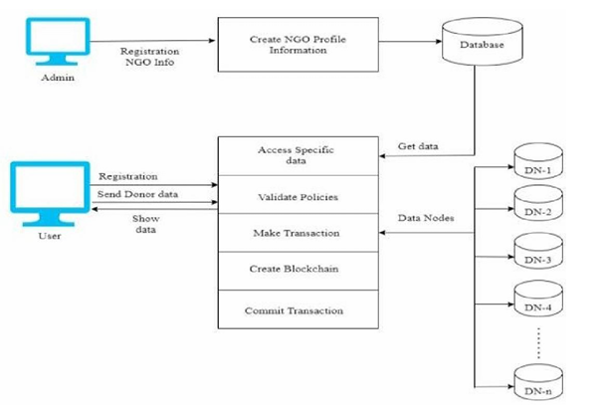

**Fig.2.** System Architecture

1. **METHODOLOGY**

**5.1. Algorithm 1 for Hash Generation:**

Hash Generation input: data d, the Genesis block, the previous hash, Hash H was generated based on the provided data.

Step1: Ente the data as d   
Step2: Utilize SHA 256 from the SHA group.   
Step 3: SHA256(d) = Current Hash   
Step 4: Start Current Hash again.

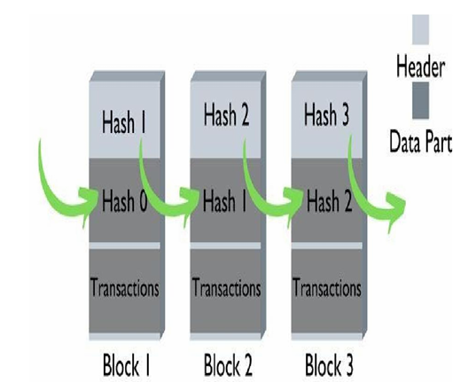

Fig 3: SHA256 Work flow

takes an input of variable length and produces a 256- bit long hash output. SHA-256   
A secure hashing algorithm, often known as SHA-256, is an unkeyed cryptographic hashing function that generates a 256-bit hash output from a variable-length input. SHA-256 is a widely recognized hashing algorithm that was initially employed in blockchains such as Bitcoin, Bitcoin Cash, and Bitcoin SV. A blockchain uses SHA-256 at several points, most notably:   
**Mining:** A block's header, which consists of the transaction data, a nonce, and the hash of the preceding block, is hashed using SHA-256 during the mining process. Miners search for a nonce value that, when paired with the remaining header data, yields a hash output that satisfies a predetermined level of difficulty.

**Block validation:** The integrity of a block's header is checked using SHA-256. Nodes make sure that the header hash is less than the current difficulty target, which is based on the output hash's required number of leading zeros. This guarantees the validity of the block's transactions and the fact that it has been mined lawfully.

**Consensus mechanism:** By changing the value of once in a bitcoin block until they approach the hash below the threshold, miners use SHA256 to determine the hash of new blocks to be formed. Following that, the block can be added to the ledger.   
Block chains: Every block in the ledger has a hash produced by SHA-256 that is derived from the block before it in the chain. Digital **signatures:** To ensure the integrity of a transaction, digital signatures are utilized. First, the sender's private key is encrypted with the data used in the transaction, which is then hashed using SHA-256. Next, in order to confirm the transaction, the miner checks this signature.   
**Avalanche effect:** The output changes significantly when the input changes even slightly. By doing this, it is ensured that it is impossible to determine the hash value from the input values. The hash is more secure as a result.

**5.2Procedure for Peer Verification**

Using the corresponding node ID, the system verifies each and every node connected to the blockchain in this module.   
Algorithm   
Entry: User Transaction Query - CNode[chain] Current Node Chain   
Nodes Chain [Nodeid]'s remaining nodes in the blockchain [Link]   
Return if any of the chains are invalid; if not, carry out the current query.   
**Step 1:** A transaction query (DDL, DML, or DCL) is created by the user.   
**Step 2:** Obtain the current node's (CNode) server blockchain (CChain).   
**Step 3:** For every node in the chain, obtain the blockchain of the node in question (CNode) and contrast it with the other nodes' blockchains (NodesChain). //Proceed to the next node in the chain and mark any node whose blockchain differs from the one that is currently in use as invalid (Flag = 1).   
// Proceed with the query execution (Commit Query) if every node is connected to the same blockchain as the one that is currently in use.   
**Step 4:** Determine how many nodes have a similar blockchain (Count = SimilarNodesBlockchain ()) if Flag == 1 (i.e., at least one node's blockchain is incorrect).   
**Step 5:** Determine which nodes hold the majority of the servers. If this is the case, the current node's blockchain is deemed invalid, then the invalid blockchains must be retrieved.   
**Step 6:** Retrieve the valid blockchain from a particular node in order to recover the current node's blockchain if it is invalid.

**Step 7:** End if. End for End for

1. **RESULT AND DISCUSSION**

**6.1. RESULT**

The implementation of the NGO funds transfer system has yielded significant improvements in efficiency, transparency, and accountability, enhancing the organization's ability to manage funds and support its mission of social welfare and development. Below are the key results of their implications:

1.Efficiency: With an automated funds transfer system in place, the NGO can streamline its financial processes, reducing manual errors and administrative overhead. This efficiency allows for quicker disbursements and better allocation of resources.

2.Transparency: Implementing a transparent tracking mechanism ensures that donors and stakeholders can monitor the flow of funds from donation to utilization. This transparency enhances trust and accountability, fostering stronger relationships with donors and beneficiaries.

3.Time Disbursements; automating fund allocation and disbursement processes, the NGO can ensure timely transfers to project locations and beneficiaries. This timely disbursement is crucial for maintaining project continuity and meeting community needs promptly.

4.Security: incorporating robust security measures safeguards financial transactions and sensitive data, protecting against fraud and unauthorized access. Compliance with industry standards and regulations further enhances the security and integrity of the funds transfer system.

5. Battery Resource Management: By centralizing fund management processes and providing comprehensive reporting and analytics capabilities, the funds transfer system enables the NGO to make informed decisions regarding resource allocation and utilization. This leads to more effective use of funds and greater impact on the communities served by the organization.

6.scalability and flexibility: A scalable system can accommodate the NGO's evolving needs and growing operations, allowing for increased transaction volumes and expanding project portfolios. Flexibility in system architecture and design enables the integration of new features and functionalities to adapt to changing requirements and emerging challenges.

**6.2 DISCUSSION**

An NGO's financial management is comparable to a car's upkeep. The vehicle's functionality deteriorates and it will not run properly if we don't fill it with high-quality fuel and oil and give it regular maintenance. The car will eventually break down and not make it to its destination if it is not taken care of. In actuality, financial management is about adopting proactive measures to maintain an organization's financial stability rather than relying solely on luck. This calls for risk management, strategic management, goal-oriented management, and the management of limited resources (Lewis, 2009). Drawing from the pilot study conducted by a few non-governmental organisations in Karnataka's coastal areas and the existing literature, the suggestions that follow are meant to improve the NGOs' financial sustainability.

a) The NGOs will need to be required to prepare the financial statements and conduct an audit on them.

b) The financial statements' uniformity must be preserved.

c) Annual returns must be filed, exactly as those of for-profit businesses.

d) The public should have access to the financial statements in order to enhance the notion of openness in NGOs' management.

e) To effectively network with other NGOs operating across the nation, NGO networking will need to be strengthened.

1. **CONCLUSION**

In the realm of humanitarian aid and social development, the efficient management of funds is not merely a logistical necessity but a moral imperative. As we draw the curtains on our exploration of the NGO Fund Transfer System, we stand at the precipice of transformative change – a change driven by the unwavering commitment to transparency, accountability, and impact. Throughout this journey, we have witnessed the myriad challenges plaguing traditional methods of fund transfer within the NGO sector. From opacity and inefficiency to high transaction costs and security vulnerabilities, these challenges have often hindered the noble efforts of NGOs and eroded the trust of donors. However, in the face of adversity, we have found opportunity – an opportunity to innovate, to disrupt, and to redefine the status quo. The NGO Fund Transfer System represents more than just a technological solution; it embodies a paradigm shift in the way we approach philanthropy and humanitarian aid. By harnessing cutting-edge technologies, leveraging secure payment gateways, and embracing principles of blockchain, we have forged a pathway towards a more transparent, efficient, and inclusive fund transfer ecosystem. As we reflect on the culmination of our efforts, we are reminded of the profound impact that awaits – impact measured not only in terms of dollars disbursed but in lives transformed, communities uplifted, and futures secured. With every transaction logged, every donation tracked, and every project funded, we inch closer to our shared vision of a world where compassion knows no boundaries and solidarity knows no limits. Yet, our journey does not end here. As we transition from concept to implementation, from vision to reality, we must remain steadfast in our commitment to excellence and continuous improvement. We must listen to the voices of those we seek to serve, adapt to evolving needs, and remain vigilant in our pursuit of integrity and ethics. In the days ahead, let us rise to the challenge with courage and conviction, knowing that the road ahead may be arduous but the destination – a world where hope thrives, and humanity prevails – is more than worth the effort. Together, let us forge ahead, empowered by the belief that through innovation, collaboration, and unwavering resolve, we have the power to transform lives, uplift communities, and create a future of boundless possibility. The journey towards a better tomorrow begins today. Let us seize it with both hands and embark on a voyage of compassion, solidarity, and enduring impact.

1. **FUTURE WORK**

While the development and implementation of the NGO Fund Transfer System mark a significant step forward in enhancing transparency, efficiency, and accountability within the realm of philanthropy, there remain avenues for further innovation and refinement. Future endeavours may focus on the following areas to elevate the system's effectiveness and impact:

1.Enhanced Blockchain Integration: Expanding the utilization of blockchain technology within the fund transfer system can offer additional layers of security, transparency, and immutability. Future iterations may explore advanced smart contract functionalities for automated fund allocation and conditional disbursements, further bolstering trust and accountability.

2 Integration with Impact Measurement Tools: Integrating the fund transfer system with impact measurement tools and frameworks can provide stakeholders with comprehensive insights into the outcomes and effectiveness of funded projects. By capturing and analysing relevant data points, such as project milestones, beneficiaries reached, and socio-economic indicators, the system can facilitate evidence-based decision-making and drive continuous improvement.

3.Expansion of Payment Options: Recognizing the diverse needs and preferences of donors and beneficiaries, future iterations of the system may explore the integration of additional payment options beyond traditional banking channels. This could include support for digital currencies, mobile money solutions, and innovative fintech platforms, ensuring accessibility and inclusivity across various demographics and geographic regions.

4.Scalability and Interoperability: As the reach and impact of NGOs continue to expand globally, ensuring the scalability and interoperability of the fund transfer system becomes paramount. Future efforts may focus on optimizing the system's architecture to accommodate growing transaction volumes and seamlessly integrate with existing financial infrastructure and regulatory frameworks across jurisdictions. Community Engagement and Co-Creation: Embracing a participatory approach to system development and governance can foster greater ownership, collaboration, and trust within the NGO ecosystem. Future initiatives may involve engaging stakeholders, including NGOs, donors, beneficiaries, and technology partners, in co-creating and co-designing features, policies, and standards that align with their needs and values.

5.Continuous Monitoring and Evaluation: Establishing robust mechanisms for continuous monitoring, evaluation, and feedback collection is essential for ensuring the ongoing effectiveness and relevance of the fund transfer system. Future work may involve implementing real-time analytics dashboards, conducting periodic audits, and soliciting feedback from users to identify areas for improvement and optimization.

**REFERENCES**

1. S. Gore, S. Hamsa, S. Roychowdhury, G. Patil, S. Gore and S. Karmode, *"Augmented Intelligence in Machine Learning for Cybersecurity: Enhancing Threat Detection and Human-Machine Collaboration,"* 2023 Second International Conference on Augmented Intelligence and Sustainable Systems (ICAISS), Trichy, India, 2023, pp. 638-644,             doi: 10.1109/ICAISS58487.2023.10250514.
2. Layth Almahadeen, Renzon Daniel Cosme Pecho, Murugananth Gopal Raj, Nichenametla Rajesh, Zainab Mohammed Imneef, Sayali Karmode Yelpale, *“Digital Investigation Forensic Model with P2P Timestamp Blockchain for Monitoring and Analysis”* , Journal of Electrical System, Vol. 1, No 1, (2024): 09-17 ( DOI : <https://doi.org/10.52783/jes.656>)
3. Sayali Karmode, *Security Challenges for IoT Based Applications & Solutions Using Fog Computing: A Survey,* Journal of Journal of Cybersecurity and Information Management, Vol. 3 , No. 1 , (2020) : 21-28 (Doi   :  <https://doi.org/10.54216/JCIM.030103>)
4. M. S. K. Yelpale, “Security and privacy challenges in cloud computing: a review,” *Journal of Cybersecurity and Information Management*, vol. 4, no. 1, pp. 36–45, 2020.  
   View at: [Google Scholar](https://scholar.google.com/scholar_lookup?title=Security%20and%20privacy%20challenges%20in%20cloud%20computing%3A%20a%20review&author=M.%20S.%20K.%20Yelpale&publication_year=2020)
5. Sayali Karmode Yelpale, *“IOT Technology for Pandemic Situation”, NJITM*, vol. 4, no. 2, pp. 25–27, Jan. 2022  https://mbajournals.in/index.php/JoITM/article/view/806
6. Karmode, S. S., & Bhagat, V. B. (2017). *DETECTION AND BLOCKING SOCIAL MEDIA MALICIOUS POSTS. International journal of modern trends in engineering and research*, *4*(5).
7. Kermode, S. S., & Bhagat, V. B. (2016). A Review: Detection and Blocking Social Media Malicious Posts. *Int. J. Mod. Trends Eng. Res*, *3*(11), 130-136.  doi: [10.21884/IJMTER.2016.3133.Q4M8O](https://doi.org/10.21884/IJMTER.2016.3133.Q4M8O) .
8. Prof. Bhushan B. Thakare, Prof. Sayali Karmode Yelpale, “Smart Home with Edge Computing”, International Journal of Interdisciplinary Innovative Research & Development (IJIIRD), Vol 6, 2021

<https://ijiird.com/wp-content/uploads/CSE016-1.pdf>

1. Sayali Karmode, “Blockchain Technology Security Issues and Concerns : A Review”, International Research Journal of Modernization in Engineering Technology and Science, Vol 6, Issue 03, March 2024  DOI : https://www.doi.org/10.56726/IRJMETS50249
2. Pranav Chavan, Harshraj Deshmukh, Aakash Dhotre, Aditya Gharat, Sayali Karmode, “Blockchain Democracy : Evaluating a Secure Voting System”, International Research Journal of Modernization in Engineering Technology and Science, Vol 6, Issue 03, March 2024                            DOI : <https://www.doi.org/10.56726/IRJMETS50478>
3. B. J. Dange, Kaustubh Manikrao Gaikwad, H. E. Khodke, Santosh Gore, S. N. Gunjal, Kalyani Kadam, Sayali Karmode, “Machine Learning for Quantum Computing Bridging the Gap between AI and Quantum Algorithms”, *Int J Intell Syst Appl Eng*, vol. 12, no. 21s, pp. 600–605, Mar. 2024.
4. N Kumar, E Howard, S Karmode, “[Reinforcement Learning for Optimal Treatment Planning in Radiation Therapy](https://scholar.google.com/scholar?oi=bibs&cluster=12796027889473991021&btnI=1&hl=en)”, NATURALISTA CAMPANO, Vol 28, Issue 1, 2024

https://museonaturalistico.it/index.php/journal/article/view/355

1. “Public Fund Care Tracking System based on Blockchain” Auth:Srishti Kumari,Tushar Dixit,Prem Prakash Vaishali Sharma 10.1109/ASIANCON55314.2022.9908651,2022.
2. “Decentralized Fundraising Application Using Blockchain” Auth:Rishi Dange,Aditya Sawant,Aditya Chavan Prerna Bhardwaj,Ashwini Bundele 10.1109/ICBDS53701.2022.9935998,2022.
3. “Aid, Charity and Donation Tracking System Using Blockchain” Auth:Aashutosh Singh,Rohan Rajak,Harsh Mistry Prachi Raut 10.1109/ICOEI48184.2020.9143001,2022.
4. “Smart NGO Tracking System Using Blockchain Technology” Auth:Yashwanth Kumar G N,Supreetha M 10.1109/MysuruCon55714.2022.9972465,2022.
5. Sayali Karmode, *Security Challenges for IoT Based Applications & Solutions Using Fog Computing: A Survey,* Journal of Journal of Cybersecurity and Information Management, Vol. 3 , No. 1 , (2020) : 21-28 (Doi   :  <https://doi.org/10.54216/JCIM.030103>)
6. S. Gore, S. Hamsa, S. Roychowdhury, G. Patil, S. Gore and S. Karmode, *"Augmented Intelligence in Machine Learning for Cybersecurity: Enhancing Threat Detection and Human-Machine Collaboration,"* 2023 Second International Conference on Augmented Intelligence and Sustainable Systems (ICAISS), Trichy, India, 2023, pp. 638-644,             doi: 10.1109/ICAISS58487.2023.10250514.