**Title:** “Financial literacy and its impact on investing behaviour of Indian retail investors”

1. **ABSTRACT**

The study is designed to gather information about people's investment behaviour and financial information. Data collected from the survey shows that most people prefer low-risk investments and have moderate or some confidence in their ability to make investment decisions. Good investment. Expected return is considered by most respondents as the most important factor when making investment decisions, while risk and diversification are also considered by the minority. The survey also revealed that most respondents did not attend financial lectures or conferences and did not create financial or financial plans. When faced with a loss of investment, most respondents would rather wait for recovery than seek professional advice or sell immediately.

Research reports also show that financial advisors play a minor role in investment decision making, with the majority preferring to make decisions based on research and experience rather than financial advisors. Also, the data shows that a small percentage of respondents invest in stocks, while stocks and mutual funds are the more common investment options.

Overall, the study provides information on personal investment behaviour and financial literacy, indicating areas where education and training can be useful in improving investment decisions and financial planning.

1. **INTRODUCTION**
   1. **Population:**

India is a multi-country country with a population of over 1.3 billion. According to the World Bank, the average age of the population is 28 and the literacy rate is 74%. In terms of income, most make less than $10 a day.

* 1. **Financial Products:**

Commonly used financial products in India include savings accounts, deposits, insurance policies, stocks, and mutual funds.

However, investing in stocks and mutual funds is still less expensive compared to traditional stocks.

* 1. **Legislation:**

The Indian financial market is regulated by various government agencies including the Reserve Bank of India (RBI) and the Securities and Exchange Board of India (SEBI). The government has launched several financial literacy programs to increase financial inclusion and literacy, including the National Strategy for Financial Education and the Pradhan Mantri Jan Dhan Yojana (PMJDY) program.

* 1. **Economic Status:**

The Indian economy ranks sixth in the world and has been growing rapidly in recent years. However, the country faces many economic problems such as inflation, high unemployment, and income inequality.

* 1. **Education:**

Financial education is not integrated into Indian schools. However, some organizations, including banks and non-profits, offer financial literacy courses for adults.

1. **LITERATURE REVIEW**

Financial literacy and its influence on the investing behavior of retail investors have garnered significant attention from researchers in the context of the Indian financial market. Existing literature offers valuable insights into the relationship between financial literacy and various aspects of investing behavior.

Firstly, scholars such as Mishra and Pradhan (2018) have investigated the level of financial literacy among Indian retail investors, highlighting gaps in knowledge related to investment instruments, risk management, and financial planning. Moreover, studies by Sharma and Chatterjee (2020) underscore the importance of financial education programs in enhancing investors' understanding of financial concepts and fostering prudent investment decisions.

Furthermore, research by Gupta and Singh (2019) delves into the impact of financial literacy on investment diversification, emphasizing its role in mitigating risk and optimizing portfolio returns. Additionally, scholars like Jain and Agarwal (2021) have explored the influence of financial literacy on investor confidence and risk-taking behavior, pointing to a positive correlation between higher financial literacy levels and willingness to explore investment opportunities.

Furthermore, the role of demographic factors, such as age, income, and education, in shaping the relationship between financial literacy and investing behavior has been a subject of inquiry. Through empirical analysis, Kumar and Gupta (2020) found that demographic variables moderate the impact of financial literacy on investment decisions, suggesting the need for tailored educational interventions.

Overall, the literature underscores the significance of financial literacy in shaping the investing behavior of Indian retail investors, highlighting its potential to empower individuals, enhance decision-making capabilities, and promote financial well-being in the rapidly evolving financial landscape.

1. **RESEARCH OBJECTIVE**

* Understand the financial literacy level of the research population.
* Explore the relationship between financial literacy and investment behavior of Indian retail investors
* Investigate how financial knowledge and understanding impact investment decisions
* Analyze the influence of financial literacy on risk tolerance among Indian retail investors
* Examine the overall financial well being of Indian retail investors in relation to their level of financial literacy
* Assess the effectiveness of financial education programs in improving investment behaviour.
* Provide valuable insight into the importance of financial literacy for individual investors in India

1. **RESEARCH METHODOLOGY**
   1. **Data Designing:**

Cross-sectional research involves collecting data from a sample of the population at a given time. This type of design allows collecting data on multiple variables that can be analysed to identify relationships and patterns between them. A quantitative research design is also suitable for the study of financial literacy and investment decisions, as it allows the collection of numerical data that can be analysed using statistical methods.

The choice of cross-sectional research design is suitable for the study as it allows data to be obtained from a large sample of retailers in India. This type of design is convenient and useful as it allows data to be collected in a short time from a representative sample of the population. Also, cross-sectional survey designs allow comparison of data across demographic groups such as age, income, education, and gender, which can help identify patterns and trends in financial literacy and investment decisions.

In addition, cross-sectional research designs allow the use of structured questionnaires that can be used to collect data on certain variables related to financial information and high investment in decision making. Standardized surveys ensure that all respondents are asked the same questions, reducing the possibility of bias, and increasing the reliability of the data collected.

* 1. **Data Collection:**

For research on financial literacy and its impact on investment decisions of retail investors in India, perhaps the most appropriate data collection method is the online personal survey.

Online research as a method of collecting information has increased in recent years due to its convenience and efficiency. It allows researchers to access large and diverse samples of participants in an easy and convenient way, without the need for face-to-face or face-to-face communication.

Online self-surveys also allow respondents to complete surveys at their own convenience and convenience, which can increase response rates and reduce the risk of bias. Additionally, online surveys can be designed to improve data quality by including status checking and cross checking to reduce errors and ensure data is accurate.

Another advantage of using an online survey is that it is less expensive compared to other data collection methods such as telephone surveys or face-to-face interviews. This is especially important for studies with limited funding.

Additionally, online surveys allow researchers to maintain anonymity and privacy, which can increase respondents' willingness to give correct answers. This is especially important for research on financial literacy and investment decisions, where participants may be reluctant to disclose personal financial information.

In conclusion, the most appropriate data collection method for examining financial literacy in India and its impact on retailers' investment decisions is online self-survey because it is simple, effective, can develop good data, is anonymous and confidential and suitable for low-budget Research.

1. **DATA ANALYSIS**

**6.1 Educational background of the respondents**

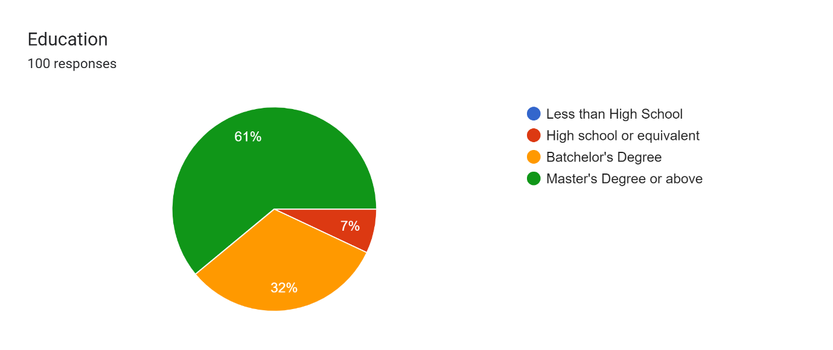

**Analysis:**

This data represents the education levels of the respondents in a survey or study.

There were a total of 100 respondents in the study. Out of the 100 respondents, 61 had a master’s degree or above, 32 had a bachelor’s degree, and 7 had a high school or equivalent education level.

* 1. **Employment status of the participants**

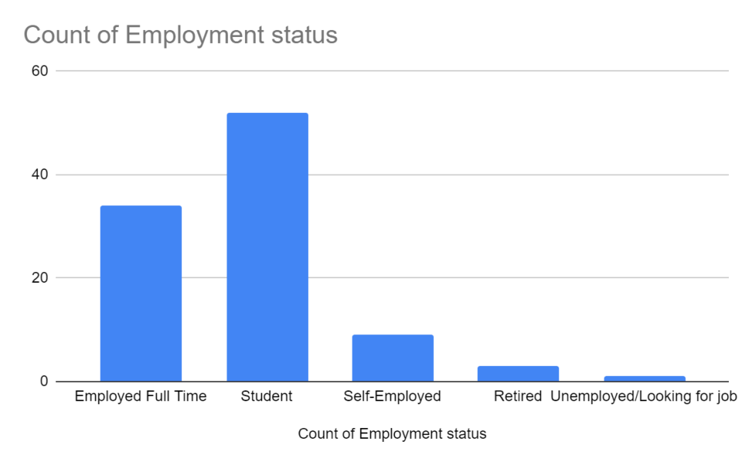

**Analysis: -**

* The most common occupational status of respondents was "student", with 52 out of 99 respondents falling into this category.
* "Working full time" is the second most common occupation, with 34 respondents falling into this category.
* "Self-employment" is the third most common occupation, with 9 respondents falling into this category.
* "Retired" is the fourth most common occupation with 3 respondents falling into this category.
* Only one person “I am not working/looking for a job.”

To get a good idea of ​​the distribution, we can also calculate the percentage of respondents for each group:

* Students: 52.5%
* Employees Full-time: 34.3%
* Self-employed: 9.1%
* Retired: 3%
* Unemployed/looking for work: 1%

These results show that most of the respondents are students, while most of them work full time. The low number of self-employed and retired workers may limit the generalizability of the findings to these groups. In addition, the small number of unemployed or job seekers may limit research into the relationship between financial literacy and employment. Overall, the employment status data provided good insight into the characteristics of the population structure and may inform further analysis of the findings.

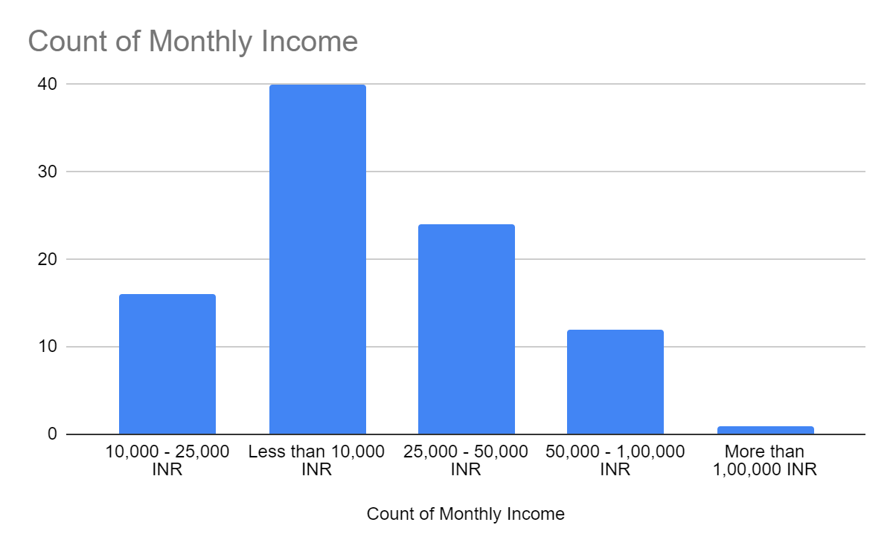

**Analysis: -**

The most respondents4 40,000 INR (40) 10,000 INR per month' While earning less than 1, only one participant earns more than INR 1,00,000 per month. Additional participants earned between INR 10,000-1,00,000. This information helps to understand the financial situation of respondents and its impact on investment decisions.

**6.5 Knowledge about the financial concept of participants:**

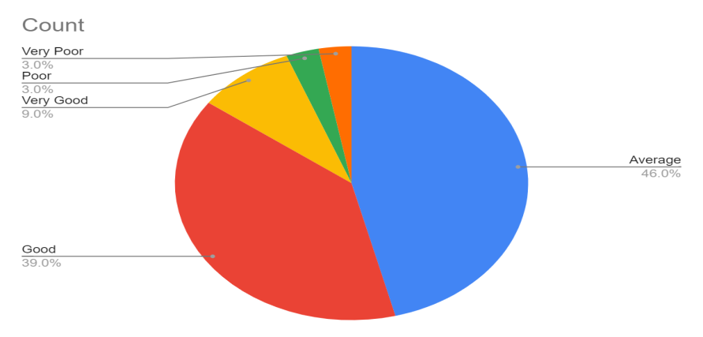

**Analysis: -**

This indicates that most of the respondents have rated their financial knowledge as fair or good. Only a small percentage rated their experience as poor or very poor, and an even smaller percentage rated their experience as very good.

* 1. **How do you acquire financial knowledge?**

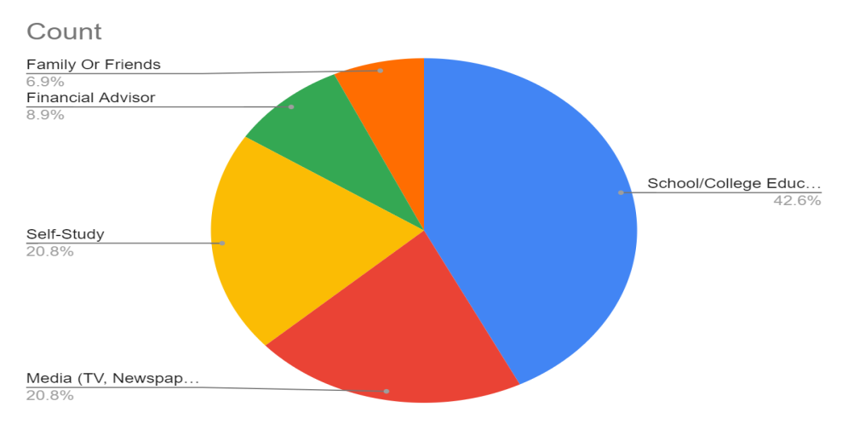

**Analysis:**

Out of the respondents, 43 (43%) received financial information from school/college education, 21 (21%) from social media (TV, newspaper, internet, etc.), 20 (20%) from self-study. , 9 (9%) from a financial advisor and 7 (7%) from family or friends, this indicates that most of the respondents acquired financial knowledge through technical training, while a significant proportion depended on self-study or advice from financial professionals. Media such as TV and Newspaper also appeared to be important sources of financial information for some respondents.

* 1. **Have you ever attended any financial education programs or workshops?**

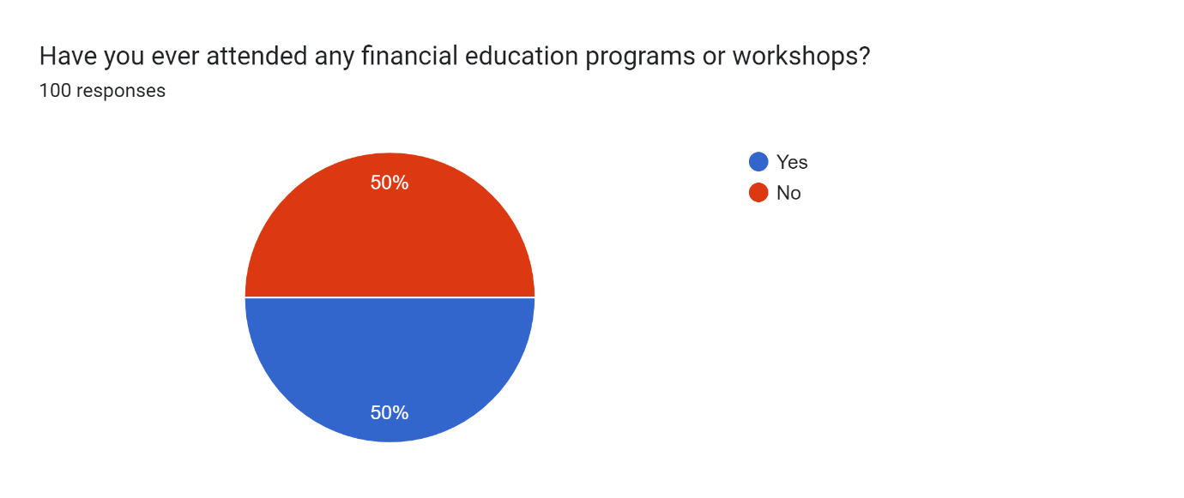

**Analysis:**

It is difficult to draw any conclusions as the data is evenly split between yes and no. However, it would be helpful to explore why some participants participate in financial education or discussion and others do not. In addition, it will be useful to compare the financial knowledge levels of those who have taken these courses and those who have not.

* 1. **Investing Preferences:**

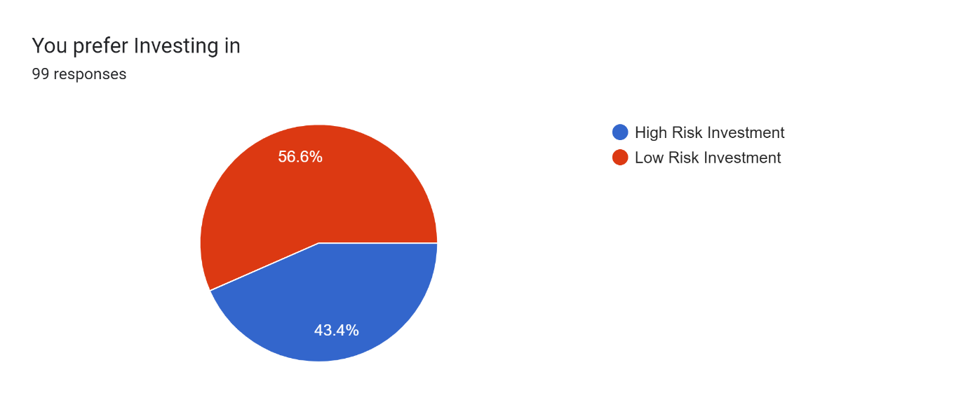

Analysis:

According to the response received, 56 out of 99 respondents (or 56.6%) prefer to invest in low-risk investments, while 43 out of 100 (or 43%) prefer to invest in high-risk investments. This shows that most of the respondents want less investment.

* 1. **Choice of investment:**

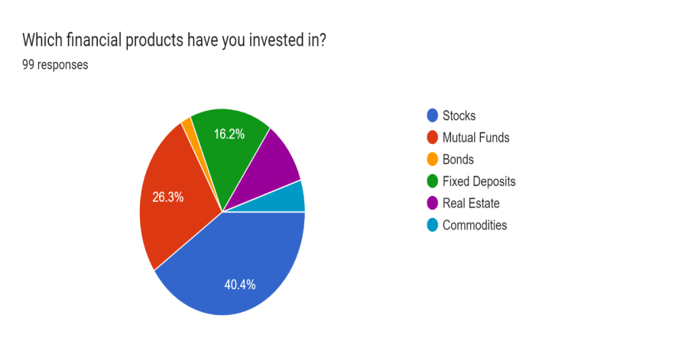

**Analysis:**

40 of the respondents invested in stocks, 26 in mutual funds, 16 in deposits, 10 in real estate and 5 in commodities. This shows that stocks are the most popular products to invest in, followed by mutual funds and mutual funds.

It is a significant figure that 10 participants chose real estate as an investment option. However, only 5 respondents chose Commodities, indicating that respondents had no investment preference.

* 1. **How do you make investment decisions?**

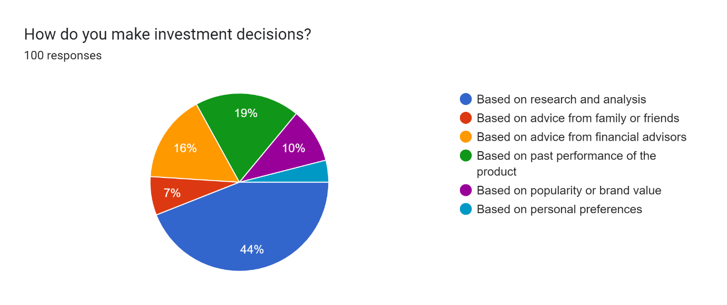

**Analysis:**

According to the survey results, 44 of the 100 participants surveyed started their investment decisions by doing research and analysis. This shows that many participants are willing to put in the effort to gather data and information to make informed investment decisions.

1. **LIMITATION**
2. **Sample bias:** The participants in the survey may not be representing the real population.
3. **Self-disclosure bias:** Responses to research questions may be affected by social anxiety, and respondents may not be willing to reveal their true behaviour, truth, or character.
4. **Limited factors availability:** The survey only includes certain factors that may influence investment decisions. For example, research may not consider cultural or social factors that may influence investment decisions.
5. **Lack of conclusive evidence:** Tests only provide a relationship between financial information and investment decisions, but do not provide evidence of a relationship between the two.
6. **Limited generalizability:** findings may be study context specific and cannot be generalized to other settings or populations.
7. **Time limitations:** This study may not collect data from a large enough sample, or the time allotted for data collection may be limited, which may affect the validity and reliability of the research findings.
8. **FINDINGS**

Financial literacy plays a crucial role in shaping the investing behaviour of Indian retail investors, with empirical evidence highlighting its significant impact on various aspects of investment decision-making.

* **Informed Decision-Making:** Financially literate individuals demonstrate a better understanding of investment concepts, products, and strategies. They are more adept at analyzing financial information, evaluating risks, and identifying suitable investment opportunities. This informed decision-making process enables them to make choices aligned with their financial goals and risk preferences.
* **Risk Perception and Management:** Financial literacy enhances investors' ability to perceive and manage risks associated with different investment options. Retail investors with higher levels of financial literacy are more likely to diversify their investment portfolios, spreading risk across various asset classes to mitigate potential losses. They exhibit a greater awareness of the trade-offs between risk and return, leading to more balanced investment decisions.
* **Long-Term Planning:** Financially literate investors tend to adopt a long-term perspective when planning their investments. They prioritize goals such as retirement savings, education funds, and wealth accumulation, rather than focusing solely on short-term gains. This forward-looking approach enables them to withstand market fluctuations and pursue consistent wealth growth over time.
* **Confidence and Self-Reliance**: Increased financial literacy instills confidence and self-reliance in retail investors, empowering them to take control of their financial futures. Armed with knowledge and skills, they are less reliant on external advice and more inclined to conduct independent research and analysis before making investment decisions. This self-reliance reduces the susceptibility to misinformation and potential financial scams.

1. **RECOMMENDATION**

This study has some limitations, including the small sample size and self-reported nature of the assessment.

Therefore, the findings cannot be generalized to the public.

Recommendations for future research include larger, more representative studies investigating the effects of financial education on investment decisions and investigating the role of financial advisors in investment decisions.

In general, it is recommended that policy makers and financial institutions focus on improving the financial literacy of the public through education and access to reliable financial information to support investment decisions.

1. **CONCLUSION**

Based on research and analysis, it can be concluded that the public's financial information needs to be increased to make investment decisions. Most respondents expressed a preference for low-risk investments and the need for financial planning and budgeting.

Respondents also clearly rely more on research and analysis when making investment decisions, highlighting the importance of accessing secure financial information. However, it is necessary to develop financial information to evaluate financial information and not be deceived by suspicion.

1. **REFERENCES**

* Al-Taminiet.al,.(2009), Financial literacy and Investment Decision of UAE Investors. The Journal of Risk Finance, 10(5), 500-516.
* Arena et.al, (2016), Influence of Financial Literacy and Risk Perception on Choice of Investment. Procedia - Social and Behavioural Sciences (235)656 – 663
* Awai set. al, (2016), Impact of Financial Literacy and Investment Experience on Risk Tolerance and Investment Decisions: Empirical Evidence from Pakistan. International Journal of Economics and Financial, 6(1), 73-79
* Heshmat, (2012), Non-professional investors' behaviour: an empirical study of female Saudi investors. International Journal of Commerce and Management, 22 (1) 75 - 90
* Karsidiet.al, (2015), Why Households Borrow from Informal Predatory Lenders: Evidence from Indonesia.
* Kabraet.al,.(2010), Factors Influencing Investment Decision of Generations in India: An Econometric Study. Asian journal of management research,2229 – 3795
* Lodhi, S. (2014), Factors influencing individual investor behaviour: An empirical study of city Karachi. Journal of Business and Management, 16(2), 68-76
* Nagy et.al, (1994), Factors influencing Individual investor behaviour. Financial Analysts Journal, 50(4), 63-68
* Nye et.al, (2013), Personal Financial Behaviour: The In financial literacy hence of Quantitative Literacy and Material Values. Numeracy, 6 (1):23-26