**Intelligent Fault Detection With Ardiuno UNO : Safeguarding Electrical Systems From Overload Theifting And Earth Faults**

**Monica.S*1, Pravenkumar.R*2, Surya.S*3,** **Meenakshi Krishnaveni. A*4.**

*1,2,3 UG Student, Department of Electrical and Electronics Engineering, Sri Venkateswaraa College of Technology, Sriperumbudur, Kancheepuram, Tamil Nadu, India.

*4 Associate Professor, Department of Electrical and Electronics Engineering, Sri Venkateswaraa College of Technology, Sriperumbudur, Kancheepuram, Tamil Nadu, India.

_________________________________________________________________________________________________________________________________

# ABSTRACT:

# This abstract outlines a pioneering electrical system leveraging an Arduino Uno as the core controller to identify overload theft and earth faults. Equipped with current and voltage sensors, alongside an ESP8266 module for mode selection, the system ensures comprehensive fault detection. Upon detecting an overload theft the Arduino triggers a relay to deactivate AC bulbs and sends an alert via a GSM module. Similarly, in the event of an earth fault, appropriate measures are taken while notifying the user promptly. Featuring an LCD screen for status updates, the system prioritizes safety, real-time alerts, and user accessibility. Its versatility extends to residential, industrial, and commercial settings, guaranteeing electrical safety, equipment preservation, and efficient energy management. Through these functionalities, the system promises to enhance safety protocols, streamline fault management, and optimize electrical operations across various domains.

# Index Terms: Arduino-based system, Fault detection, Relay action, Real-time alerts, Energy management.

# ______________________________________________________________________________________

# INTRODUCTION:

The implementation of a robust electrical fault detection system is crucial for ensuring safety and efficiency in various settings. At the core of this pioneering system lies the Arduino Uno, functioning as the central controller for detecting both overload theft and earth faults within electrical systems. By leveraging sophisticated sensors and modules, this system demonstrates a proactive approach to fault management, aiming to prevent potential hazards and optimize operational performance.

Through the integration of a current sensor and an ESP8266 IoT module, the Arduino Uno enables continuous monitoring of electrical current and dynamic mode selection for detecting either overload or earth faults. This intelligent setup ensures adaptability to diverse scenarios, allowing for swift detection and response to potential faults. The system's proactive measures become apparent when it detects an overload situation, where it promptly deactivates connected AC bulbs through a relay system to mitigate further risks. Simultaneously, a GSM module sends real-time alerts to registered mobile numbers, providing immediate notification of the fault occurrence ltage sensor to identify earth faults, another critical aspect of electrical safety management. Upon detecting voltage on the earth, indicative of a fault, the Arduino Uno initiates necessary actions such as turning off AC bulbs and sending alert messages via GSM. This comprehensive approach to fault detection and management underscores the system's commitment to ensuring safety and efficient operation. Additionally, the inclusion of an LCD screen provides users with valuable real-time information on the system's status, detected fault types, and alerts sent, enhancing accessibility and facilitating informed decision-making.

# LITERATURE SURVEY:

**Yiwei Zhang, Dezhi Xu, Weilin Yang, Kaitao Bi, Wenxu Yan [ ],[January, 2019]** Fault Tolerant Control for Load Frequency Control System via a Fault Observer. This paper introduces a control system to ensure the stability and reliability of a multi-area power grid even when sensors fail. The system uses a fault observer to estimate sensor failures in different areas and then employs a distributed sliding mode control scheme based on these estimates. This ensures that the frequency of each part of the power grid stays within acceptable limits. Simulation experiments were conducted on a three-area power grid with various sensor faults, demonstrating the effectiveness and desired performance of this fault-tolerant control scheme. **Zijian Wu, Qing-Shan Jia, Xiaohong Guan [1] ,[February 2019]** explain Optimal Control of Multiroom HVAC System: An Event-Based Approach . In this work, we tackle this problem with key contributions. Firstly, we frame the multiroom HVAC control problem as event-based optimization, focusing on decisions during specific events, reducing complexity. Secondly, we develop an approximate method for local-event-based policies, simplifying calculations. Finally, we validate our approach with numerical examples, demonstrating near-optimal solutions for small-scale cases and outperforming other methods in larger setups.

**Erwin Burkhard, Lothar Ficker, Frank Jenau [1], [May, 2020 ]** The “Short-term Compensation Change” to Detect Earth Faults in Compensated Networks. The network does not have the necessary switched off due to low voltage during fault occurrence. Therefore supply reliability is increased and that detect the earth fault. The issue is the stationary earth fault required to be exist approximately 30 sec.

**Qi Zheng; Zhao Xinyi; Bilal Matloob [2],[January, 2019]** This Fault In Distribution Network Based On The Variance Of Three-phase Asymmetrical Current Fault Component. When single-phase earth fault occurs in the distribution network, the three-phase fault path current is different from the non-fault path current that can be used for line selection. The variance of the fundamental wave amplitude of the three-phase difference result is calculated, so that the fault characteristics of the faulted path are significantly different from the healthy path. The fault location is detected by comparing the results of different lines.

# METHODOLOGY:

The methodology for the proposed overload theft, fault detection and safety system involves the deployment of current and voltage sensors within the electrical system to monitor the flow of electrical current and detect the presence of voltage on the earth. These sensors continuously collect data, which is processed by an Arduino Uno microcontroller. Through analysis of this data, the system identifies overload theft and earth faults. In the event of an overload theft, the system activates a relay to disconnect AC lamps, while for an earth fault, appropriate safety measures are initiated. Furthermore, upon detecting a fault, the system triggers a GSM module to send real-time alert messages to a registered mobile number, ensuring prompt notification of the user. Incorporates IoT technology for notifications by integrating it into the electrical board webpage and provides users with convenient access to crucial information. This methodology enables continuous monitoring of the electrical system, enhancing safety by facilitating immediate action and alerting users to any detected faults in real-time.

# BLOCK DIAGRAM:

This is the block diagram of our system. This system consists two parts of portions.

1. Overload Detection Module
2. Earth Fault Detection Module
3. Alert Module

**ARDUINO UNO**

**POWER SUPPLY**

**VOLTAGE SENSOR**

**LCD DISPLAY**

**CURRENT SENSOR**

**FOUR CHANNELRELAY**

**LAMP (2)**

**GSM**

**IOT**

**GPS**

**1. OVERLOAD DETECTION MODULE**

The Overload Detection Module is a crucial component of the system, utilizing a current sensor to monitor electrical current continuously. This data is processed by an Arduino Uno acting as the central controller, along with an ESP8266 module enabling user selection of overload detection mode. In case of an overload, detected by the system, the Arduino deactivates two AC bulbs through a relay to maintain safety. Additionally, it triggers a GSM module to send an alert message to a registered mobile number, notifying users of the overload occurrence. GPS functionality is also integrated for locating the system's position.

**2. EARTH FAULT DETECTION MODULE**

The Earth Fault Detection Module is essential for ensuring electrical system safety, utilizing a voltage sensor to detect voltage presence on the earth, indicating an earth fault. Upon detection, the Arduino Uno triggers a relay to disconnect power to AC bulbs, enhancing safety. The ESP8266 module enables mode selection for earth fault detection, while a GSM module sends alert messages to registered mobile numbers, promptly notifying users of the fault. This module enhances safety across residential, industrial, and commercial environments, safeguarding against potential hazards posed by earth faults.

**3. ALERT MODULE**

The Alert Module in the system sends SMS alerts via GSM upon detecting overload or earth faults and features an LCD display for visual status updates. GPS enables location tracking, and IoT provides real-time system information on the electrical board webpage. This integration ensures comprehensive monitoring and swift response to electrical faults.

# RESULTS:

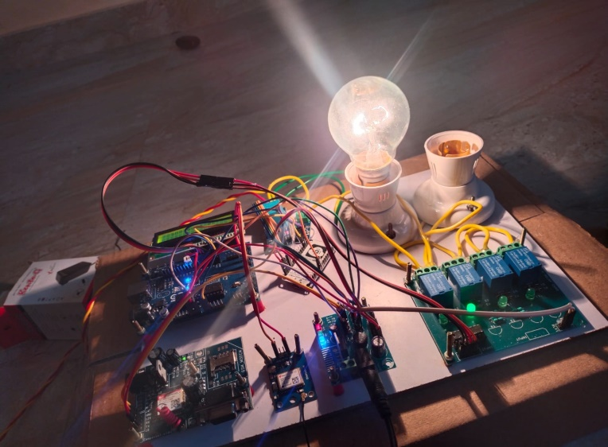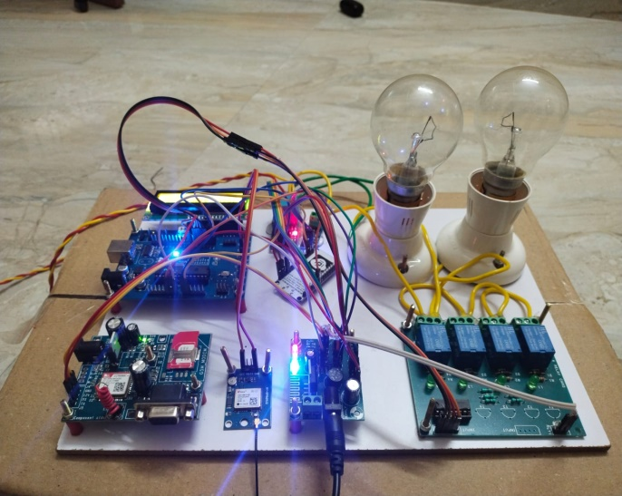

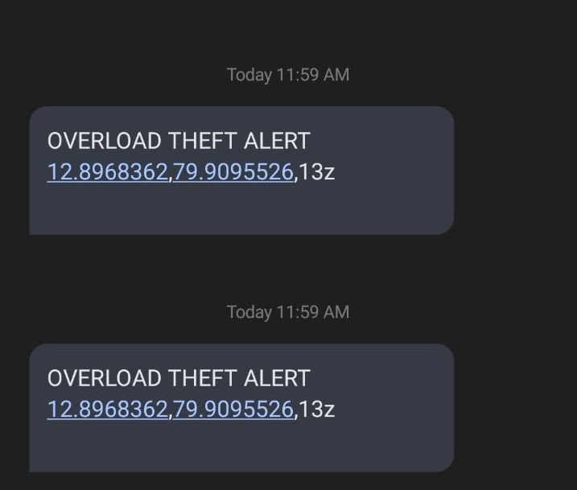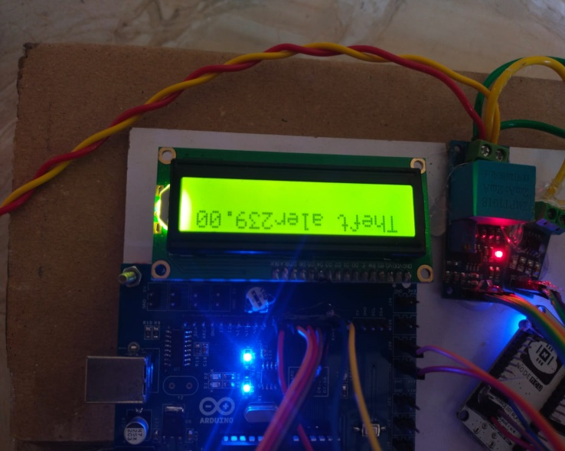

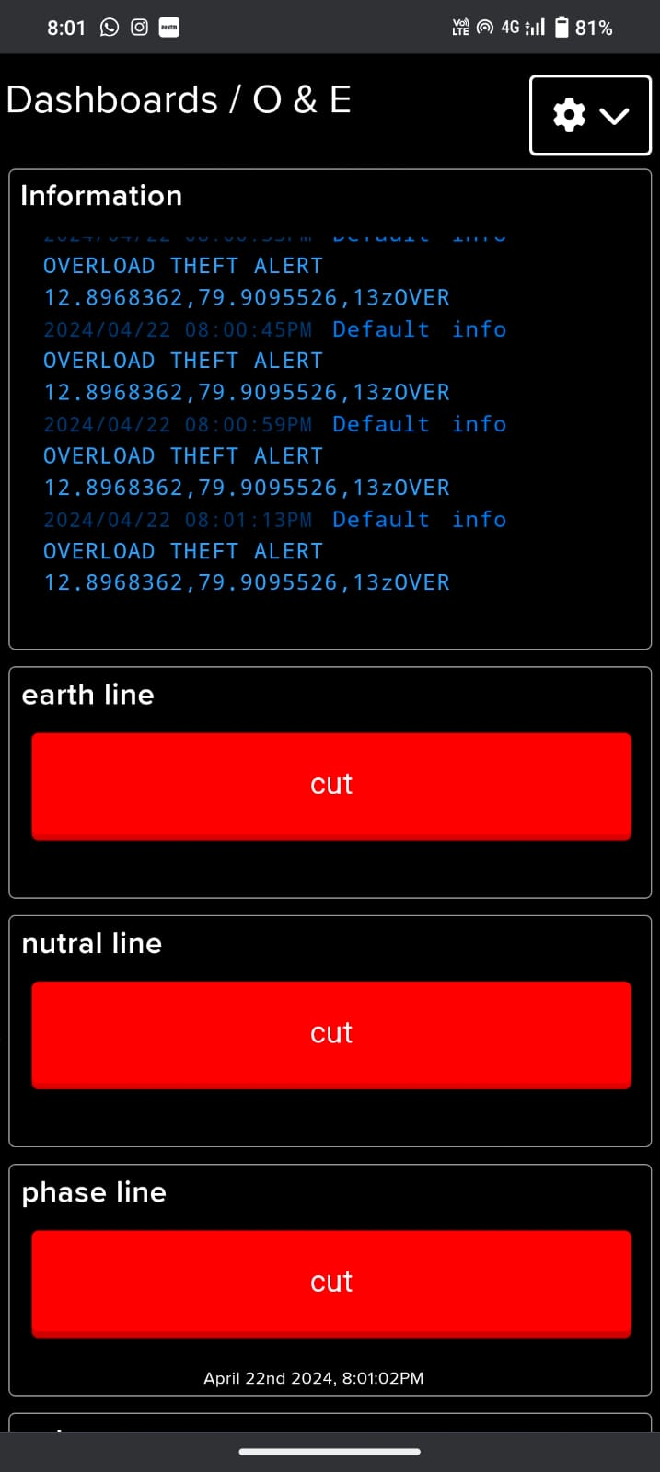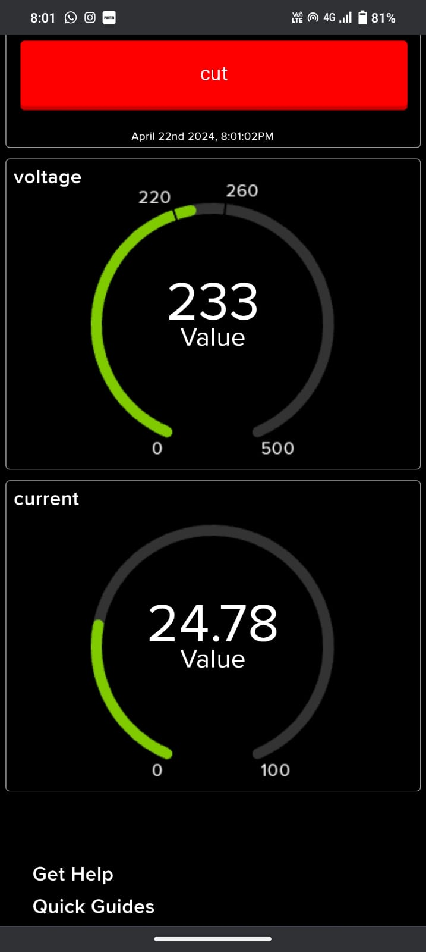

**CONCLUSION:**

In conclusion, the project's innovative approach integrates the Arduino Uno, current and voltage sensors, and the ESP8266 module to create a robust system for detecting overload and earth faults in electrical setups. With real-time fault detection and mitigation, along with features like GSM modules for alerts and an LCD screen for visual feedback, the system enhances electrical safety and user-friendliness. Additionally, by incorporating IoT capabilities to display information on a webpage, and potentially tracking location via GPS, it further improves accessibility and monitoring. With ongoing improvements, this system has the potential to revolutionize fault detection and prevention, contributing to the reliability and sustainability of electrical infrastructure across various environments.

# FUTURE SCOPE:

# A promising future enhancement for this system could involve the implementation of machine learning algorithms for predictive maintenance. By continuously collecting data on electrical system behavior, including current and voltage patterns, the system can establish baseline parameters and usage patterns. Machine learning models can then analyze this data to predict potential overload or earth fault occurrences before they happen. This proactive approach would not only prevent electrical faults but also optimize energy usage, reducing downtime and maintenance costs. Furthermore, incorporating remote monitoring and control through an internet-connected interface could provide users with real-time insights and the ability to remotely manage electrical systems, enhancing overall safety, efficiency, and convenience, especially in complex industrial or commercial environments where quick responses to faults are crucial.

# REFERENCE:

[1] I. U. Khalil et al., “Comparative analysis of photovoltaic faults and performance evaluation of its detection techniques,” IEEE Access, vol. 8, pp. 26676–26700, 2020.

[2] M. K. Alam, F. Khan, J. Johnson, and J. Flicker, “A comprehensive review of catastrophic faults in PV arrays: Types, detection, and mitigation techniques,” IEEE J. Photovolt., vol. 5, no. 3, pp. 982–997, May 2015.

[3] M. Köntges et al., Review of Failures of Photovoltaic Modules. Paris, France:International Energy Agency, 2014.

[4] A. F. Murtaza, M. Bilal, R. Ahmad, and H. A. Sher, “A circuit analysis- based fault finding algorithm for photovoltaic array under L-L/L-G faults,” IEEE J. Emerg. Sel. Topics Power Electron., vol. 8, no. 3, pp. 3067–3076, Sep. 2020.

[5] R. Hariharan, M. Chakkarapani, G. Saravana Ilango, and C. Nagamani, “A method to detect photovoltaic array faults and partial shading in PV systems,” IEEE J. Photovolt., vol. 6, no. 5, pp. 1278–1285, Sep. 2016.

[6] S. Roy, M. K. Alam, F. Khan, J. Johnson, and J. Flicker, “An irradiance- independent, robust ground-fault detection scheme for PV arrays based on spread spectrum time-domain reflectometry (SSTDR),” IEEE Trans. Power Electron., vol. 33, no. 8, pp. 7046–7057, Aug. 2018.

[7] M. K. Alam, F. Khan, J. Johnson, and J. Flicker, “PV ground-fault detection using spread spectrum time domain reflectometry (SSTDR),” in Proc. IEEE Energy Convers. Congr. Expo., 2013, pp. 1015–102.

[8] T. Pei, L. Li, J. Zhang, and X. Hao, “Module block fault locating strategy for large-scale photovoltaic arrays,” Energy Convers. Manag., vol. 214, 2020, Art. no. 112898.

[9] Y. Hu et al., “Online two-section PV array fault diagnosis with optimized voltage sensor locations,” IEEE Trans. Ind. Electron., vol. 62, no. 11, pp. 7237–7246, Nov. 2015.

[10] P. Jain et al., “A digital twin approach for fault diagnosis in distributed photovoltaic systems,” IEEE Trans. Power Electron., vol. 35, no. 1, pp. 940–956, Jan. 2020.