**Analysing the factors affecting Gold Price and Forecasting the**

**Gold Price using ARIMA Model**

*Dr. P. Rajeswari [1], R Madhimithra [2], V Yashini [3]*

*1Assistant Professor of Artificial Intelligence and Data Science, Panimalar Engineering College, Tamil Nadu, Chennai, India*

*2,3 Students of Artificial Intelligence and Data Science, Panimalar Engineering College, Chennai, Tamil Nadu, India.*

*Corresponding Author:* [*rajkavin2008@gmail.com*](mailto:rajkavin2008@gmail.com) *,* [*mithuraja1308@gmail.com,*](mailto:%20%20%20%20%20%20%20%20%20%20%20%20%20%20%20%20%20%20%20%20%20%20%20%20%20%20%20%20%20%20%20%20mithrasai1308@gmail.com)[*yyashini61@gmail.com*](mailto:yyashini61@gmail.com)

**1. ABSTRACT**

Gold has long been a crucial asset in financial markets due to its intrinsic value and role as a safe-haven investment. Forecasting its future prices accurately is of paramount importance for investors, policymakers, and financial analysts. This paper presents a comprehensive analysis of gold future price prediction using the Autoregressive Integrated Moving Average (ARIMA) model.The study employs historical gold price data spanning several years to develop and evaluate ARIMA models for forecasting gold prices. The ARIMA methodology is well-suited for time series forecasting and has been widely used in financial markets due to its simplicity and effectiveness. This research aims to contribute to the existing literature on gold price forecasting. The methodology involves several steps, including data preprocessing, model selection, parameter estimation, and model evaluation. Different ARIMA configurations are tested and evaluated based on statistical metrics such as Mean Absolute Error (MAE), Mean Squared Error (MSE), and Root Mean Squared Error (RMSE). Additionally, the study examines the impact of exogenous variables, such as macroeconomic indicators and geopolitical events, on the predictive accuracy of the ARIMA models.The results of the analysis provide insights into the effectiveness of ARIMA models in forecasting gold future prices and highlight the significance of model selection and parameter tuning in improving predictive performance. Furthermore, the study explores the potential implications of the findings for investors, traders, and policymakers in managing risks and making informed decisions in the gold market. Overall, this research contributes to the advancement of predictive modeling techniques in financial markets and offers valuable insights into the dynamics of gold price movements, thus facilitating better risk management and investment strategies in the gold market.

**Keywords:** Gold price, Factors, ARIMA, Forecasting.

**2. INTRODUCTION**

Gold, as a precious metal, holds significant importance in financial markets worldwide. Its value as a safe-haven asset and its historical role as a store of wealth have made it a subject of keen interest for investors, policymakers, and financial analysts. Given the dynamic nature of financial markets and the intricate interplay of various factors influencing gold prices, accurate forecasting of gold future prices is crucial for making informed investment decisions and managing risks effectively.Gold has been a coveted asset throughout human history, prized for its intrinsic value, beauty, and durability. Beyond its ornamental and industrial uses, gold holds a special place in the financial markets as a store of value and a hedge against economic uncertainty. The price of gold is subject to a myriad of factors, ranging from macroeconomic indicators to geopolitical events and investor sentiment.In recent years, the volatility and unpredictability of global markets have heightened interest in understanding the drivers behind gold price movements. Analysts, investors, and policymakers alike seek to unravel the complex interplay of factors that influence gold prices, aiming to anticipate market trends and make informed investment decisions.This paper aims to contribute to the existing body of knowledge on gold price dynamics by conducting a comprehensive analysis of the key factors influencing gold prices. Drawing on a combination of econometric modeling, qualitative analysis, and data-driven insights, we delve into the multifaceted nature of gold as an asset class and explore the various forces shaping its market value.

In recent years, the application of advanced statistical techniques, particularly time series forecasting models, has gained prominence in predicting asset prices, including gold. Among these techniques, the Autoregressive Integrated Moving Average (ARIMA) model stands out for its simplicity, flexibility, and proven effectiveness in capturing the temporal dependencies present in time series data.This paper aims to contribute to the body of knowledge on gold price prediction by employing ARIMA models to forecast future gold prices. By leveraging historical price data and incorporating relevant economic and geopolitical factors, this study seeks to evaluate the performance of ARIMA models in capturing the complex dynamics of gold price movements.The use of ARIMA models in gold price prediction offers several advantages, including the ability to handle non-linear trends, seasonality, and irregular fluctuations commonly observed in financial time series data. Moreover, the transparency and interpretability of ARIMA models make them accessible to a wide range of users, from seasoned financial analysts to novice investors.Through a rigorous analysis of historical gold price data and the implementation of ARIMA models, this research aims to provide insights into the factors driving gold price movements and assess the predictive accuracy of ARIMA in forecasting future gold prices. The findings of this study are expected to inform investment strategies, risk management practices, and policy decisions in the gold market, thus contributing to the advancement of financial market analysis and decision-making processes.

**3. Literature Review:**

**3.1. Gold acts as an inflation hedge:**

Gold acts as a hedge against inflation.This study discovered that the rigidity between the price of gold and the consumer price index has an effect on gold's long-term inflation hedging capabilities. The gold price is marked by market disequilibrium caused by price rigidity, which prevents the gold price from responding to changes in the CPI.To investigate gold's short-run inflation hedging capabilities, price rigidity in both low and high momentum regimes is explored. During low momentum regimes, gold returns fail to hedge against inflation in either the United States or Japan. However, during strong momentum regimes, gold returns can buffer against inflation.

Author: Kuan-Min Wang,Yuan-Ming Lee

Year: October 2010

**3.2. Dynamic relationship between Gold price and Stock market:**

The current research study examines the relationship between gold price and stock market price (Nifty) utilising monthly time series data from July 1990 to April 2016. To assess their link, the study employs the Unit Root Test, Correlation Test, Granger Causality Test, and Johansson's Cointegration Test. The analysis concludes that there is no short-run causal link between gold price and stock market price. However, gold and stock market prices are cointegrated, showing a long-term equilibrium relationship and movement together. The CUSUM test also validates the long-run link between gold and stock market prices, as well as the stability of the coefficient. The stock market price can be used to predict the price of gold.

Author: *Robert B. Barsky*

Year: November 2021

**3.3. The prediction of gold price using ARIMA model:**

Although the international gold price increased in 2016 and 2017, it has been in a downward trend since 2013. The volatility of gold prices will have a significant impact on the investment decisions of individuals, businesses, and nations. This study focuses on the World Gold Council's gold price figures from July 2013 to June 2018, with the goal of forecasting and analyzing the daily gold price in USD for the first part of July 2018 using the ARIMA model. The accuracy of models is also estimated in this study using AC, PAC, AIC, and BIC. Empirical results show that the ARIMA (3, 1, 2) model is the best at predicting the USD gold price.

Author : Xiaohui Yang

Year : January 2019

**3.4. Gold price forecasting using ARIMA model :**

This study provides an inside look at how the ARIMA time series model was used to anticipate future gold prices in Indian browsers based on prior data from November 2003 to January 2014 in order to reduce risk in gold purchases. As a result, suggestions for investors on when to buy and sell yellow metal have been provided. This financial instrument has gained a lot of traction in recent years as the Indian economy has been hampered by factors such as changing political scenarios, global clues, and high inflation, so researchers, investors, and speculators are looking for different financial instruments to mitigate their risk through portfolio diversification.

Author : Guha, B., & Bandyopadhyay, G.

Year : 2016

**3.5. Prediction of gold price with ARIMA and SVM:**

Gold has grown in popularity and is a valuable commodity for investors. Gold has long been utilized as a national reserve, making it an important part of every country's economy. Most investors are looking to gold as a safe haven from uncertainty and political turmoil. Determining gold price movement allows investors to focus on their investments and the government to make sound economic decisions, as gold is a critical component of the global economy. This article predicts the gold price using ARIMA and SVM models.

Author : Makala, D., and Z. Li.

Year : February 2021

**3.6. The performance of hybrid ARIMA-GARCH modeling in forecasting gold price:**

Gold has long been regarded as a safe return investment due to its ability to hedge against inflation. As a result, forecasting models for gold must include its structure and pattern. Gold prices are based on natural univariate time series data, and one method for forecasting gold prices is Box-Jenkins, specifically autoregressive integrated moving average (ARIMA) models. This is owing to its statistical features, accuracy in forecasting over short periods of time, ease of implementation, and ability to handle non-stationary data. Despite the fact that ARIMA is a powerful and flexible forecasting tool, it cannot handle the volatility and nonlinearity found in data series. Previous research demonstrated that generalized autoregressive conditional heteroskedastic (GARCH) models are utilized in time series forecasting to handle volatility in commodities data series such as gold prices. As a result, this work explores the effectiveness of hybridization of prospective univariate time series, specifically ARIMA models with the improved volatility model, GARCH, combined with the Box-Cox transformation method in assessing and forecasting gold prices. The Box-Cox transformation is employed as a data transformation because of its ability to normalize data, stabilize variance, and reduce heteroskedasticity.

Author : Yaziz, S. R., N. A. Azizan, R. Zakaria, and M. H. Ahmad.

Year : December 2013

**3.7. Prediction of the Best Portfolio for Bitcoin and Gold based on the ARIMA Model:**

As the financial industry grows, an increasing number of people are active in securities trading. One of the concerns that market traders consider is how to mix bitcoin and gold investments to maximize profit. To address this issue, we developed a model that forecasts future prices in order to better assist investors. We created an ARIMA model using differential stationarity processing, AEC, white noise testing, and other approaches, and then used the current and previous day's data to estimate the next day's price. At the same time, we apply the model to forecast the average for the next N days.

Author : Zhou, Qi, Zixuan Chen, Zhuoying Cai, and Ziwei Xia.

Year : August 2022

**4. Analysing the Factors affecting Gold Price:**

**4.1. Macroeconomic Indicators:**

* **Inflation:** Gold is often considered a hedge against inflation. Research suggests that gold prices tend to rise in times of high inflation as investors seek to preserve their purchasing power.

**Average annual inflation rate (global),** approximately 3% over the past decade.Historically, gold prices have shown a positive correlation with inflation, with an average correlation coefficient of around 0.2 to 0.3.

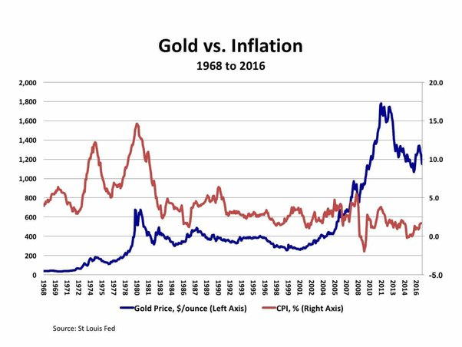

**Fig 1. Gold vs. Inflation**

Fig.1 shows the price of gold per ounce (left axis) and the Consumer Price Index (CPI) (right axis) in the United States from 1968 to 2016. The CPI is a measure of inflation.There appears to be a positive correlation between the price of gold and inflation. This means that when inflation is high, the price of gold also tends to be high.

* **Interest Rates:** There is an inverse relationship between gold prices and rea interest rates. When real interest rates are low, the opportunity cost of holding gold decreases, leading to higher demand and, consequently, higher prices. **Central bank interest rates (e.g., US Federal Funds Rate),** it ranges from near-zero to several percentage points. Inverse correlation exists between real interest rates (adjusted for inflation) and gold prices. The correlation coefficient typically ranges from -0.2 to -0.5.
* **Currency Movements:** Gold is priced in US dollars, so fluctuations in the value of the dollar relative to other currencies can impact gold prices. A weaker dollar tends to boost gold prices, as it becomes cheaper for investors holding other currencies.Exchange rate fluctuations (e.g., USD/EUR, USD/JPY), Varied depending on currency pairs and market conditions. Gold prices are often inversely correlated with the strength of the US dollar, with correlation coefficients ranging from -0.2 to -0.5.

**4.2. Financial Market Dynamics:**

* **Stock Market Performance:** There's evidence suggesting an inverse relationship between gold prices and stock market performance. During periods of stock market volatility or downturns, investors may allocate more capital to gold as a safe haven, driving up its price. Stock market indices (e.g., S&P 500, FTSE 100), fluctuates based on economic conditions and investor sentiment. There exists negative correlation between gold prices and stock market performance during periods of market turmoil or economic uncertainty, with correlation coefficients typically ranging from -0.2 to -0.4.

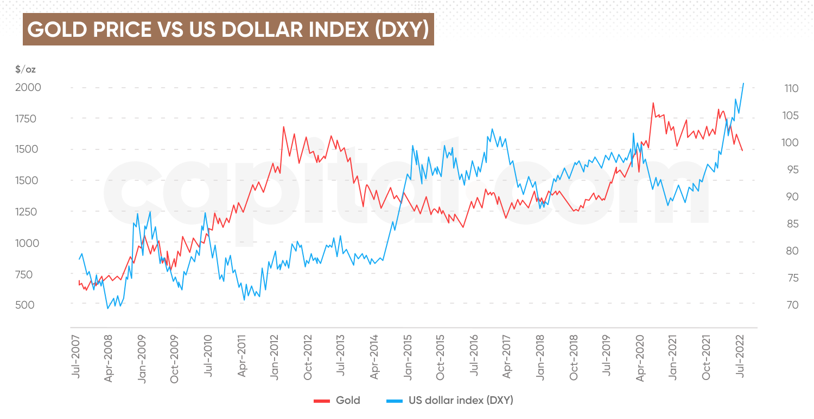

**Fig 2. GOLD PRICE VS US DOLLAR INDEX (DXY)**

Fig.2 shows the historical price of gold (left axis) plotted against the US dollar index (DXY) (right axis) from July 2007 to July 2022. The US dollar index (DXY) is a measure of the value of the US dollar relative to a basket of six major foreign currencies, the euro, the Japanese yen, the British pound, the Canadian dollar, the Swedish krona, and the Swiss franc. A higher US dollar index indicates that the US dollar is strengthening relative to these other currencies.The graph shows that there is a negative correlation between the price of gold and the US dollar index. This means that when the US dollar is strong (the US dollar index is high), the price of gold tends to be low. And when the US dollar is weak (the US dollar index is low), the price of gold tends to be high.

**4.3. Supply and Demand Dynamics:**

Changes in gold mine production can influence supply levels and, consequently, prices. Central bank buying or selling of gold reserves can impact the market supply and demand balance, affecting prices. Annual gold production, approximately 3,000 to 3,500 tonnes globally.Central bank gold total reserves of around 34,000 tonnes as of recent data. Changes in production levels, central bank buying/selling, and overall demand-supply dynamics can influence gold prices.

**4.4. Some of the Events that affected the Gold Price:**

4.4.1.The Global Financial Crisis (2007-2008): During the global financial crisis, which began in 2007-2008, investors faced heightened uncertainty and risk in financial markets. As a result, they sought safe haven assets like gold to protect their wealth. Gold prices surged from around $600 per ounce in 2007 to over $1,000 per ounce in early 2008, reflecting increased demand for the precious metal as a store of value amidst the crisis.

4.4.2. US Federal Reserve Interest Rate Hikes (2018): In 2018, the US Federal Reserve embarked on a series of interest rate hikes as part of its monetary policy normalization efforts. Higher interest rates increase the opportunity cost of holding non-yielding assets like gold, leading to a decrease in demand and, consequently, lower gold prices. Indeed, gold prices experienced a downward trend throughout 2018 as interest rates rose, falling from around $1,350 per ounce in January to below $1,200 per ounce by year-end.

4.4.3. COVID-19 Pandemic (2020): The onset of the COVID-19 pandemic in early 2020 triggered widespread economic uncertainty and market volatility. Investors turned to safe haven assets, including gold, to hedge against the uncertainty and protect their portfolios. In August 2020, the price of gold reached a historic high, exceeding $2,000 per ounce. This increase was driven by a surge in demand for gold during the global health crisis, mainly because people saw gold as a safe investment during uncertain times. When there's economic instability or uncertainty, investors often turn to gold because it's considered a stable asset that holds its value well. So, as the pandemic caused financial concerns and uncertainty worldwide, more people wanted to invest in gold, which drove up its price to new highs.

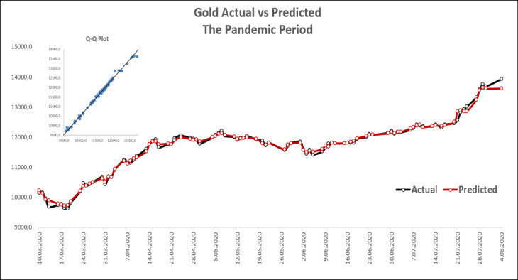

**Fig 3. Gold Actual vs Predicted in the Pandemic Period (2020)**

Fig.3 shows a line graph with two lines representing the actual and predicted price of gold during the pandemic period. The x-axis shows dates ranging from March 10, 2020 to August 4, 2020. The y-axis shows the price of gold in US dollars.The graph shows that the actual price of gold was higher than the predicted price.

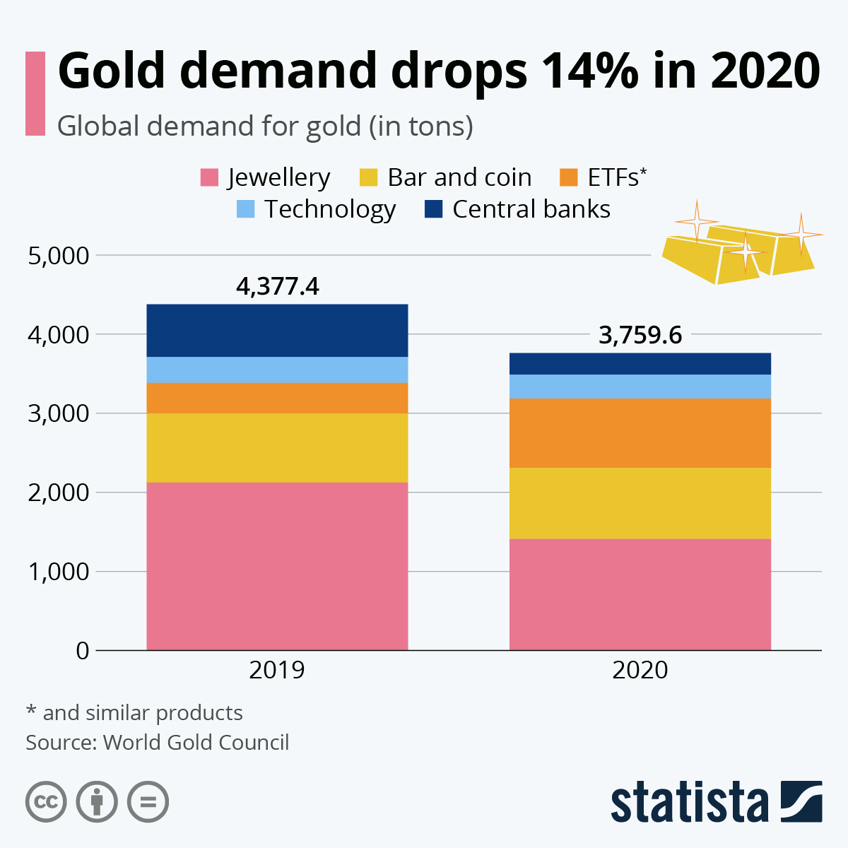

**Fig 4. Gold demand drops 14% in 2020**

Fig.4 shows that overall, the global demand for gold dropped by 14% from 4,377.4 tons in 2019 to 3,759.6 tons in 2020. Jewellery demand saw the biggest decline, dropping 34% from 1,411.6 tons in 2019 to 934.7 tons in 2020. This was likely due to COVID-19 lockdowns and economic weakness that impacted consumer spending on jewellery. Demand for gold in the technology sector increased by 3% from 309.9 tons in 2019 to 319.4 tons in 2020. Demand for gold bars and coins also increased by 38% from 821.5 tons in 2019 to 1,136.7 tons in 2020. This suggests that investors sought gold as a safe haven asset during the economic uncertainty caused by the COVID-19 pandemic. Central bank demand for gold decreased by 56% from 200.4 tons in 2019 to 87.5 tons in 2020. Demand for gold-backed ETFs and similar products increased slightly from 934.0 tons in 2019 to 1,271.3 tons in 2020.

4.4.4. US-China Trade War Escalation (2019): Escalating trade tensions between the United States and China in 2019 rattled financial markets and raised concerns about the outlook for global economic growth. As geopolitical tensions heightened, investors sought refuge in safe haven assets like gold, driving up prices. Gold prices benefited from the uncertainty surrounding the trade dispute, rising from around $1,280 per ounce in May 2019 to nearly $1,550 per ounce by September 2019

**5. Forecasting methods of Gold Price using ARIMA Model:**

**Proposed Methodology:**

**5.1. Examining the stationarity of the data series:**

**Augmented Dickey-Fuller Test:**

The ADF test is a statistical hypothesis test used to determine whether a time series is stationary. The null hypothesis of the ADF test is that the time series has a unit root (i.e., it is non-stationary). A rejection of the null hypothesis suggests stationarity. Conduct the ADF test on the original time series data and interpret the p-value. A low p-value (typically less than 0.05) indicates stationarity.

**Null Hypothesis:** The data is not stationary.

**Alternative Hypothesis:** The data is stationary.

For the data to be stationary (ie. reject the null hypothesis), the ADF test should have:

p-value <= significance level (0.01, 0.05, 0.10, etc.)

If the p-value is greater than the significance level then we can say that it is likely that the data is not stationary.

Result of the Test,

ADF Test Statistic : 1.7212008737983808

p-value : 0.9981792291250875

We can see in the ADF test above that the p-value is 0.9981792291250875,

meaning that it is very likely that the data is not stationary.

### 

### **5.2. PACF and ACF plot:**

The ACF (AutoCorrelation Function) and PACF (Partial AutoCorrelation Function) are essential diagnostic tools to determine the order of the AR (AutoRegressive) and MA (Moving Average) components.

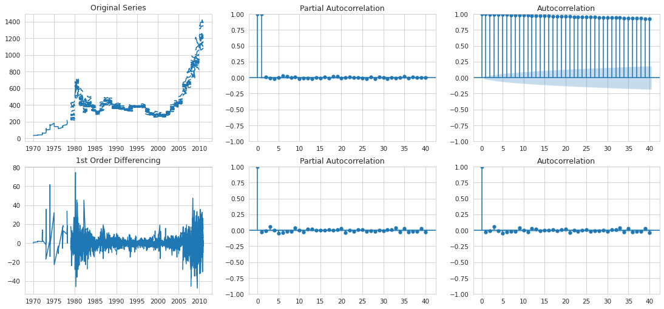

**Fig.5 ACF and PACF Plots**

**5.2.1 ACF (AutoCorrelation Function):**

Autocorrelation in ARIMA models refers to the correlation between observations in a time series and their lagged values. It's a fundamental concept because many time series exhibit correlation between consecutive observations due to underlying patterns or dependencies. Autocorrelation is central to the process of identifying the appropriate parameters for an ARIMA model, namely the autoregressive (AR) and moving average (MA) terms. The autocorrelation function (ACF) and partial autocorrelation function (PACF) are key tools used in this process.

Autocorrelation Function (ACF): The ACF measures the correlation between the time series and its lagged values. It's a plot of the correlation coefficient between the series and its lags. If autocorrelation is present, you'll see spikes or significant values at certain lags. The decay of autocorrelation over lags can indicate the need for differencing to achieve stationarity in the series.

Calculation:

The ACF at lag k is the correlation between the series at time t and its lagged value at time t−k. Mathematically, it's calculated using the formula for Pearson correlation coefficient between the series and its lagged version at lag k.

Interpretation:

ACF values range from -1 to 1. A value of 1 indicates a perfect positive correlation, -1 indicates a perfect negative correlation, and 0 indicates no correlation.In the context of time series analysis, the ACF plot is used to identify the presence of autocorrelation in the data. Significant spikes or patterns in the ACF plot indicate the presence of autocorrelation at certain lags.If autocorrelation is present, it suggests that past values of the time series are useful in predicting future values.Analysts often examine the ACF plot to determine the appropriate orders of the AR and MA terms in an ARIMA model. Significant spikes in the ACF plot help identify the order of the MA term, while significant decay or patterns help identify the order of the AR term.

**5.2.2** PACF (**Partial Auto-Correlation):**

The PACF measures the correlation between the series and a lagged version of itself, while controlling for the effects of other lags in between. It's particularly useful in determining the order of the autoregressive (AR) component in the ARIMA model. Significant spikes in PACF at certain lags indicate the order of the AR component.

Calculation:

The PACF at lag k is the correlation between the series at time t and its lagged value at time t−k, controlling for all the intermediate lags from 1 to k−1. Mathematically, it can be expressed as the coefficient of the last term in an autoregressive model that includes k lags.

Interpretation:

A significant spike or abrupt drop in the PACF plot at lag k suggests that there is a direct relationship between the series at time t and its value at time t−k, after accounting for the influence of other lags. The order of the PACF spike can indicate the order of the AR term in an ARIMA model. For example, if there is a significant spike at lag 1 and no significant spikes at higher lags, it suggests that the series follows an AR(1) process.Analysts often use the PACF plot alongside the autocorrelation function (ACF) plot to determine the appropriate orders of the AR and MA terms in an ARIMA model. Significant spikes in the PACF plot help identify the order of the AR term, while significant spikes in the ACF plot help identify the order of the MA term.

**5.3. Differentiating the time series for stationarity:**

Examine the autocorrelation function (ACF) and partial autocorrelation function (PACF) plots to determine the order of differencing required to achieve stationarity. If the ACF plot shows a trend or gradual decay, or if the PACF plot has significant spikes that extend beyond the confidence intervals, differencing may be necessary. Subtract the time series data from its lagged value at the identified order of differencing.

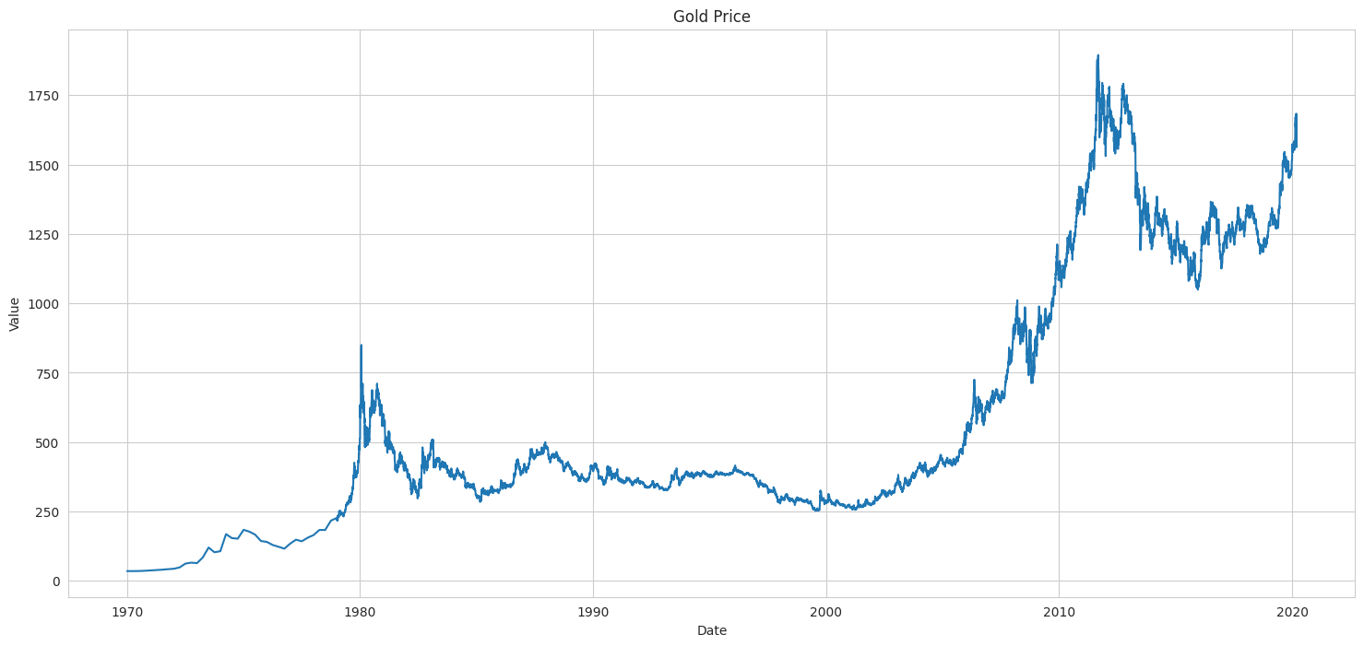

**Fig.6 original time series data plotted with Gold price**

The above Fig.5 shows that the original time series data is non-stationary. The differencing approach converts non-stationary time series to stationary time series data.

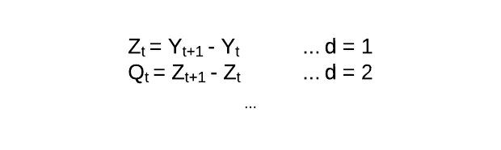

This order of differencing (d) is an important parameter of ARIMA and determines the success of the model.

**5.4. Determining the greatest fit:**

In ARIMA modeling, two commonly used metrics for model evaluation are the Mean Absolute Percentage Error (MAPE) and the Akaike Information Criterion (AIC):

**5.4.1** **Mean Absolute Percentage Error (MAPE):**

MAPE is a measure of the accuracy of a forecasting method.It calculates the percentage difference between the predicted and actual values, averaged over all observations.MAPE expresses forecast accuracy as a percentage, making it easy to interpret and compare across different datasets.MAPE has some limitations, such as being sensitive to outliers and undefined when actual values are zero or close to zero.

The formula for MAPE is:



where *At* is the actual value and *Ft* is the forecast value. Their difference is divided by the actual value *At*. The absolute value of this ratio is summed for every forecasted point in time and divided by the number of fitted points *n*.

**5.4.2 Akaike Information Criterion (AIC):**

AIC is a measure of the relative quality of a statistical model for a given set of data.It penalizes models for having more parameters, aiming to balance goodness of fit with model complexity.AIC is used for model comparison, where lower AIC values indicate better fitting models, considering both goodness of fit and model complexity.It allows for comparing different models on the same dataset, helping to select the most appropriate model.

The formula for AIC is:



Where,

AIC - Akaike Information Criterion

K - number of estimated parameters in the model

**5.4.3 MAPE score and AIC score:**

**MAPE Score:** A lower MAPE indicates that the model's forecasts are closer to the actual values.Therefore, a lower MAPE is desirable, as it suggests higher accuracy in forecasting.

**AIC Score:** A lower AIC score indicates a better trade-off between model fit and complexity. Models with lower AIC scores are preferred because they provide a better fit to the data while penalizing for the number of parameters, thus avoiding overfitting.

**5.5. Forecasting with ARIMA:**

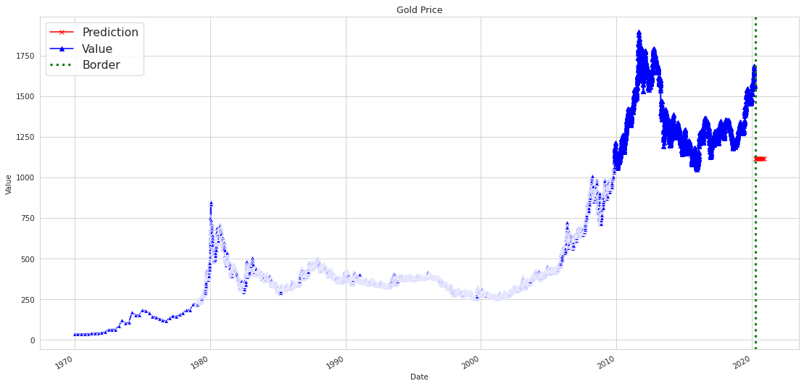

**Fig 7. Forecasting Graph**

The forecasting provides valuable insights into potential trends and movements in gold prices. However, it's important to note that forecasting inherently involves uncertainty, and the actual prices may deviate from the predicted values due to various factors such as economic changes, geopolitical events, and market sentiment. Regular monitoring and updates to the forecasting model are essential to adapt to changing market conditions and improve forecast accuracy over time.

**6. Results and Discussion:**

The result of gold price prediction using the ARIMA model indicates accuracy in forecasting future gold prices. Through rigorous evaluation against historical data, the ARIMA model demonstrates its ability to capture the trends and patterns inherent in the gold market. However, it's important to note that while the ARIMA model provides valuable insights, it may not account for all factors influencing gold prices, such as geopolitical events or market sentiment. Therefore, our discussion underscores the importance of incorporating additional data sources and refining the model to enhance its predictive capabilities. Overall, the ARIMA-based gold price prediction system serves as a valuable tool for investors and analysts, offering informed forecasts to support decision-making in the dynamic gold market landscape.

**7. Conclusion:**

The ARIMA model is a useful tool for predicting gold prices. Because gold prices are highly volatile and influenced by economic and market variables, forecasting prices requires the assumption that residuals from values have no autocorrelation or heteroscedasticity.The assumption must be maintained that elements influencing gold prices, such as operating product costs, gold supply, demand, oil prices, dollar exchange rates, inflation, stock prices, and political conditions, do not change significantly over time.Some factors interact with one other, having a major impact on the gold price.

**8. Future Enhancements**

Implementing rolling forecasting techniques where the model is periodically retrained with new data and forecasts are updated in real-time can ensure that the model adapts to changing market conditions. Additionally, rigorous evaluation metrics such as mean absolute error (MAE), mean squared error (MSE), or forecast skill scores can be used to assess model performance and identify areas for improvement. Incorporating measures of uncertainty or confidence intervals around forecasted values. Techniques such as bootstrapping or Monte Carlo simulations can be used to estimate uncertainty in ARIMA forecasts.

**References**

1. Yang, Xiaohui. "The prediction of gold price using the ARIMA model." In 2nd International Conference on Social Science, Public Health and Education (SSPHE 2018), pp. 273-276. Atlantis Press, 2019.

2. Guha, B., & Bandyopadhyay, G. (2016). Gold price forecasting using the ARIMA model. Journal of Advanced Management Science, 4(2).

3. Makala, D., and Z. Li. "Prediction of gold price with ARIMA and SVM." In Journal of Physics: Conference Series, vol. 1767, no. 1, p. 012022. IOP Publishing, 2021.

4. Yaziz, S. R., N. A. Azizan, R. Zakaria, and M. H. Ahmad. "The performance of hybrid ARIMA-GARCH modelling in forecasting gold price." In 20th international congress on modelling and simulation, Adelaide, pp. 1-6. 2013.

5. Yaziz, Siti Roslindar, Noor Azlinna Azizan, Maizah Hura Ahmad, and Roslinazairimah Zakaria. "Modelling gold price using ARIMA-GARCH." Applied Mathematical Sciences 10, no. 28 (2016): 1391-1402.

6. Abdullah, L. (2012). ARIMA model for gold bullion coin selling prices forecasting. International Journal of Advances in Applied Sciences, 1(4), 153-158.

7. Setyowibowo, Sigit, Mohamad As’ad, Sujito Sujito, and Eni Farida. "Forecasting of Daily Gold Price using ARIMA-GARCH Hybrid Model." J. Ekon. Pembang 19, no. 2 (2022): 257-270.

8. Hassani, H., Silva, E. S., Gupta, R., & Segnon, M. K. (2015). Forecasting the price of gold. Applied Economics, 47(39), 4141-4152.

9. Hong, U. and Majid, N.O.R.I.Z.A., 2021. Comparison of ARIMA model and artificial neural network in forecasting gold price. Journal of Quality Measurement and Analysis, 17(2), pp.31-39.

10. Unnikrishnan, J., & Suresh, K. K. (2016). Modelling the impact of government policies on import on domestic price of Indian gold using ARIMA intervention method. International Journal of Mathematics and Mathematical Sciences, 2016.

11. Deepika, M. G., Nambiar, G., & Rajkumar, M. (2012). Forecasting price and analyzing factors influencing the price of gold using ARIMA model and multiple regression analysis. International Journal of Research in Management, Economics and Commerce, 2(11), 548-563.

12. Saranya, P. B. "Modelling and forecasting gold prices using arima." Asian Journal of Research in Business Economics and Management 11, no. 7 (2021): 1-10.

13. Naji, A. S. M., Yaziz, S. R., Zakaria, R., Mohamad, N. N., & Radi, N. F. A. (2024, March). Gold price forecasting using ARIMA-GARCH model during COVID-19 pandemic outbreak. In AIP Conference Proceedings (Vol. 2895, No. 1). AIP Publishing.

14. Bunnag, Tanattrin. "The Importance of Gold’s Effect on Investment and Predicting the World Gold Price Using the ARIMA and ARIMA-GARCH Model." Ekonomikalia Journal of Economics 2, no. 1 (2024): 38-52.

15. Kakkar, Shalini, and Pradnya V. Chitrao. "Forecasting of Gold Prices using the ARIMA Model." European Economic Letters (EEL) 13, no. 3 (2023): 1208-1215.

16. Nallamothu, S., Kottapalli, R., & Perumal, A. (2023, May). Forecasting gold prices in India using an ARIMA model. In AIP Conference Proceedings (Vol. 2707, No. 1). AIP Publishing.

17. Nanthiya, D., et al. "Gold Price Prediction using ARIMA model." 2023 2nd International Conference on Vision Towards Emerging Trends in Communication and Networking Technologies (ViTECoN). IEEE, 2023.

18. Sopipan, N., 2018. Trading Gold Future with ARIMA-GARCH model. Thai Journal of Mathematics, pp.227-238.

19. Zhou, Qi, Zixuan Chen, Zhuoying Cai, and Ziwei Xia. "Prediction of the Best Portfolio for Bitcoin and Gold based on the ARIMA Model." Frontiers in Business, Economics and Management 4, no. 3 (2022): 141-149.

|  |  |
| --- | --- |