**To enhance the productivity and Speed of Construction using application of Automation (Robotics) in Construction Industry**

**Sagar Khandagale *1 V.D. Pore*2, Maruti Bhosale*3**

1 P.G. Student, Department of Civil Engineering, Dattakala Group Of Institutions Faculty Of Engineering, Bhigwan, Maharashtra, India

2 Assistant Professor, Department of Civil Engineering, Dattakala Group Of Institutions Faculty Of Engineering, Bhigwan, Maharashtra, India.

3 Lecturer, Department of Civil Engineering, Fabtech Technical Campus college of Engineering & Research, Polytechnic ,Sangola, Maharashtra,India.

**ABSTRACT**

Building has progressed from the use of crude tools to equipment, with an increasing trend toward automation. Construction efficiency, precision, and safety can all benefit from process automation and robotics. Structured prefabrication for building, on the other hand, is becoming more popular around the world as a way to boost productivity and reduce the environmental effect of traditional construction methods. As a result of the integration and application of automation and prefabrication technologies, the construction sector may experience new advances. This study examines the use of automated technologies in structural prefabrication and construction, covering current advancements, problems, and future prospects. Design, construction management, robotic production, self-driving transportation, and automatic structural assembly are the five processes intended to follow the construction sequence. The paper concludes that widespread use of automation technology is preferable to structural prefabrication for construction, and that the design for robotic construction introduced through connection innovations may be beneficial as a means of avoiding complex operations and thus improving robotic assembly processes' efficiency.

Thus, in the construction industry there are many machines which can be used to so as to reduce the human effort, the overall labour cost and increase the productivity of the work. In India where there is a scope of infrastructural development use of automation in construction should be increased.

***Keywords: Automation, construction industry, Infrastructure projects, Building project.***

**INTRODUCTION**

**1.1 General Introduction**

The Robot Industries Association (RIA) has defined an industrial robot as "a reprogrammable multi-functional manipulator designed to move material, parts, tools or specialized devices.

A robot equipped with sensory devices that detect the presence of an obstacle or a human worker within its work space, could automatically shut itself down in order to prevent any harm to itself and/or the human worker.

**Where can cobots are deployed?**

The advantage of [Cobot](https://en.wikipedia.org/wiki/Cobot) is that it is small, lightweight and easy to assemble. The Cobot can carry out its tasks in places where there is little space and is easy to move.

For example, you could mount this collaborative robot on a moving workbench and let it do its work somewhere else on a regular basis, but a robot can also stay in one place for a longer period of time.

**What are the COBOT?**

Traditional industrial robots are built and programmed to do a single task at a distance from workers on the manufacturing or assembly floor. Common types include articulated arms, wheeled mobile robots, and gantry/rectilinear models, and they are often used to process large batches of single items: welding, drilling, spray application (paint, adhesive), transporting items across an area, loading and unloading heavy items. They are large, heavy, fast, and very strong, all of which make them hazardous to humans and require them to be surrounded by fencing or other barriers. Because they operate independently of the people around them, traditional industrial robots work in parallel, not in collaboration.

Collaboration is defined less by the task performed than by the features of the robot that make it safe and helpful for working side by side with humans. Machine and person can work on the same task, assembly, object, or activity at the same time in the same physical area, such as a work cell, station, or work bench.

Rather than removing human workers from jobs entirely, cobots usually integrate into the portions of a process that are repetitive or dull enough to risk errors or injury. Their small size and dexterous movement mean they make great assistants for tasks with small parts or intricate placement – the types of jobs humans do at workbenches and on the manufacturing floor. Examples include:

* Pick and place
* Machine tending
* Packaging and palletizing
* Process tasks, when equipped with end effector tools (e.g. gluing, drilling, welding)
* Finishing (sand, polish, deburr, trim)
* Quality inspection, when equipped with a vision camera
* Assembly
* Dispensing (e.g. adhesive, lubricant, sealant)
* Painting, coating, dipping

The scope of construction automation is extensive, spanning all stages of the construction life cycle, from original planning and design to facility construction, operation and maintenance, and final disassembly and recycling of buildings and engineering structures. Recent advancements in the domains of computer science and robotics have aided in the creation of new construction technologies. Japan, a world leader in robotics and automation, has produced a slew of innovative technologies and tools that have aided the construction sector in reducing human labour, lowering construction costs, and shortening project timelines while increasing productivity.

Construction work is sometimes carried out in hazardous conditions, necessitating the use of robotics to optimize equipment functioning and increase worker safety and quality. Because of the automated construction process, there is no downtime throughout the year. More and 2/5 more machines and equipment should be used in the building sector for rapid construction with reduced danger and good quality. The use of machines, robots, and other automated devices at appropriate locations reduces human effort and risk. Because India possesses the world's second-largest manpower, automation is not a replacement for human labour, but rather a necessary supplement to meet the demands of megaprojects and fast-track building. Because unskilled labours do not do good quality work in comparison to automation, human power is being replaced by emerging technologies of automation in India today. When compared to unskilled people, automation boosts construction project productivity, reduces the duration and tedious work, improves construction safety, and improves the quality of work. The main research activities in the construction sector are grouped into two large areas based on applications: civil infrastructure and housing building. Road, tunnel, and bridge construction, as well as earthwork, are examples of typical civil infrastructure robot applications. Building skeleton erection and assembly, concrete compaction, interior finishing, and other applications fall under the category of house construction.

**Areas of automation in Construction**

* Roads & Runways construction
* Structures
* Buildings construction
* Ports
* Tunnels
* Factories and industries

Technology has played a critical part in this progress. Because of this, the trend continues today the automobile market's fierce competitiveness, with highly linked production lines with specialized equipment robots.

The scope for automation and robotics technologies implementation in construction can be fairly broad, encompassing all stages of the construction life-cycle, from initial design to on-site construction, building maintenance or control after completion, and eventual dismantling or demolition of the building. This would include the use of automation and robotics technologies in all stages of construction, from the automation of the design process via Computer Aided Design, the production of cost estimates, construction schedules, and project management via costing and planning software, to actual ingenious machines that use intelligent control during on-site operations. The degree to which automation and robotics systems are used in construction differs dramatically from one project to the next.

**On-site construction work with automation and robotics**

Any building's construction process contains several stages, ranging from earthworks to structure construction (concreting, frame assembly, walling, etc.) to finishing works. Traditionally, the construction technologies used in these stages have been recognized to be labour intensive and carried out in a variety of hazardous settings. Furthermore, in the construction business, issues such as labour supply volatility and rising labour prices are appearing. By implementing specialized automation at construction sites, it is possible to reduce labour force dependency and boost productivity. As a result, various researchers have been working hard to find appropriate ways to integrate automation and robotics into building sites.

Automation and robotics technologies are being used in the construction process on-site.

In construction job execution, automation and robots provide a number of advantages that could aid in the adoption of these systems. Among the most significant benefits are:

* Less reliance on direct labour – fewer problems related to quality and repetitiveness of work performed, as well as costs, may be reduced by reducing labour, whereas the automated system requires fewer operators;
* Increased productivity – productivity is improved by disengaging the operation from the limitations of the human factor; iii. increased occupational safety – automated systems may carry out a variety of tasks;
* Quality increase – operations with automated and robotized systems are typically carried out with less variability than human workers; v. greater control over the productive process – problems can be detected more easily because each stage of the process is controlled to verify the correct outcome.

Today, a new branch of construction technology - space construction - is experiencing significant expansion. There are various well-defined schemes in this area of construction work that are equally applicable to hazardous construction activities in civilian applications. It is also feasible to examine them for use in certain building applications by selecting the appropriate materials while taking into account the desired level of safety, cost, and procurement options. The notion of In-Situ Resource Utilization (ISRU), for example, might be used to both civilian and military robotics. Consider the scenario of lunar concrete in order to visualize an ISRU notion.

1. **METHODOLOGY**

**1]** In the dissertation following methodology has been decided to measure and manage the By operating advance technology (Application Of COBOT) at construction project reduce delay in transporting of material and increase efficiency of work that ultimately reflect of time and cost in construction Sector.From literature found that because of frequent change of project managers, Appointment of staffs in the site who are not experienced and also Non sequential progress of works and that Work was not followed as per procedure instead it was followed as per availability of resources caused delays in construction project on pandemic situation. Unavailability of adequately trained health workers and lack of experience in managing an unprecedented emergency; the pandemic and the confinement measures created a psychosocial burden for the population and, especially, the wellbeing of the health workforce.

The construction industry is the vehicle through which physical development is achieved, and this is truly the locomotive of the national economy. The more resources, engineering know-how, labor, materials, equipment, capital, and market exchange provided from within the national economy, the higher the extent of self- reliance. The increasing complexity of infrastructure projects and the environment, within which they are constructed, place greater demands on construction managers to deliver projects on time, within the planned budget and with high quality.

Therefore, improving construction efficiency by means of cost-effectiveness and timeliness would certainly contribute to cost savings for the country as a whole. Efforts directed to cost and time effectiveness were associated with managing time and cost.

It also aims to identify the main factors that lead to project delays and to suggest recommendations on how to overcome or mitigate effects of the problem. Data is gathered from responses from questionnaire survey and interviews with those involved in automation construction project.

The surveys and research findings indicate that delay incidents & Accidents occur mainly during the construction phase of a project and one or more parties usually contribute to delay. This paper highlights the importance of having more experienced and capable construction managers as well as skilled labourers to enable the industry to develop at a faster rate either nationally or internationally.

A questionnaire and personal interviews have formed the basis of this research. Factor analysis and regression modelling were used to examine the significance of the delay factors. From the factor analysis, most critical factors of construction delay were identified.

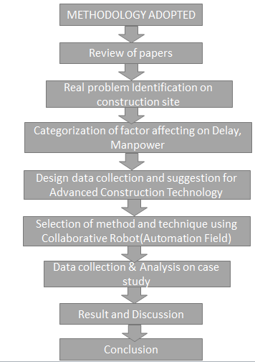

**Figure1.1: Flow of Methodology**

**2] Software**

* + Arduino
  + Auto-cad
  + Pad to Pad
  + Proteus

**3] Hardware**: -

* + ATmega328P
  + Moor Driver(L293D)
  + Buzzer
  + Dc Motor
  + Power Supply
  + Temperature Sensor
  + Ultrasonic Sensor
  + Touch Sensor

**BUZZER**

An Active Buzzer Alarm Module for Arduino is an audio signalling device, which may be mechanical, electromechanical, or piezoelectric. Just like what you are viewing now, it is 3.3V-5V DC Electronic Part Active Buzzer Module. Using top quality material, it is durable in use.

An active buzzer rings out as long as it is electrified. Compared with a passive buzzer, it is a bit expensive but easier to control. Typical uses of buzzers include alarm devices, timers, and confirmation of user input such as a mouse click or keystroke.

**Specifications of Active Buzzer Module: -**

1. Product Name: 3.3 to 5V Active Buzzer Alarm Module Sensor

2. Transistor drive module uses 8550

3. with fixed bolt hole- easy installation- 2.6mm aperture.

4. Operating voltage 3.3V-5V

5. PCB Dimensions: 34.28 mm (L) * 13.29 mm (W) * 11.5 mm (H)

**Features: -**

Passive buzzer features are: -

1. Passive internal shocks without source- so if you cannot make it with a DC signal tweet. Must be a square wave 2K ~ 5K to drive it

2. Sound frequency control- you can make a “more than a meter hair Seola” effect.

3. In some special cases- you can reuse a control and LED mouth.

**Active buzzer features are: -**

1. An active buzzer with a concussion internal source- so long as it will be called an energized

2. Program easy to control- SCM can let a high-low sound- while passive buzzer did not.

**Module interface specification (3-wire): -**

+ External 3.3V-5V voltage (can be directly connected with the 5v and 3.3v MCU MCU)

– External GND out external microcontroller IO port.

**4] DATA COLLECTION**

Cobot in constructions, or collaborative robots, are the more approachable and accessible successors of classic industrial robots. They're smaller, less expensive, and easier to programme for non-experts thanks to intuitive software. Built-in safety features extend the types of activities they can do and enable them to operate with humans on complex procedures. They can even be reprogrammed to swap functions within the same facility, making them versatile and cost-effective. Its past time for manufacturers who believed robotic automation was out of reach to reconsider.



**Human interaction between co-bots**

* The Robot Industries Association (RIA) has defined an industrial robot as "a reprogrammable multi-functional manipulator designed to move material, parts, tools or specialized devices.
* A more general definition of a robot is: a general-purpose, reprogrammable machine capable of processing certain human characteristics such as judgment, reasoning, learning, and vision.
* An intelligent robot is one that responds to changes to its environment through sensors connected to its controller. And one of the most important considerations in using a robot in a workplace is human safety.
* A robot equipped with sensory devices that detect the presence of an obstacle or a human worker within its work space, could automatically shut it down in order to prevent any harm to itself and/or the human worker.

**5] DATA ANALYSIS**

**SPSS Software**

The questionnaire design practice advanced on a communicating basis. It was categorized into profile of the respondent and various factors affecting construction cost and time required completing particular work with automation.

Questions in the respondent profile were created to collect information such as job position, experience of the work, locations of the current and/or previous works and contact information. It was studied; these questions in the survey were of great important to the research by analyzing personal qualification concerns from a variety of different profiles from different regions

The set of questions was prepared and targeting the factors/sources affecting cost saved on Automation Industry. The responses were to be based on the understanding, knowledge and experience of the respondents and related to particular project.

This simple and straight method was selected to establish a means of developing a list of factors affecting cost. A Five-point scale of 1 to 5 was considered for evaluating the impact of each factor. Questions are attached in annexure page. These numerical impact values are assigned to the respondents’ rating:

1: Strongly agree

2: Agree

3: Neutral

4. Disagree

5. Strongly Disagree

1. **MODELING AND ANALYSIS**

Analysis of the questionnaires survey was done using IBM SPSS Software. SPSS Statistics is a software package used for statistical analysis. The software name originally stood for Statistical Package for the Social Sciences (SPSS), reflecting the original market. It is a Windows based program that can be used to perform data entry and analysis and to create tables and graphs. It is capable of handling large amounts of data and can perform all of the analyses covered in the text and much more. It is a widely used program for statistical analysis in social science. It is also used by market researchers, health researchers, survey companies, government, education researchers, marketing organizations, data miners, and others. All the responses obtained from the questionnaires are entered in to the software. First, the variables or the questions are entered in the data view, then, the responses are entered into the software from the various data entered into the software, frequency can be found which is used to determine the importance factor.

**SPSS data View:**

The Questionary Survey responses were reported in excel file. After opening data, SPSS displays them in a spread sheet-like fashion as shown in below figure. The excel file was export in data View and check the values and other information in spread sheet.

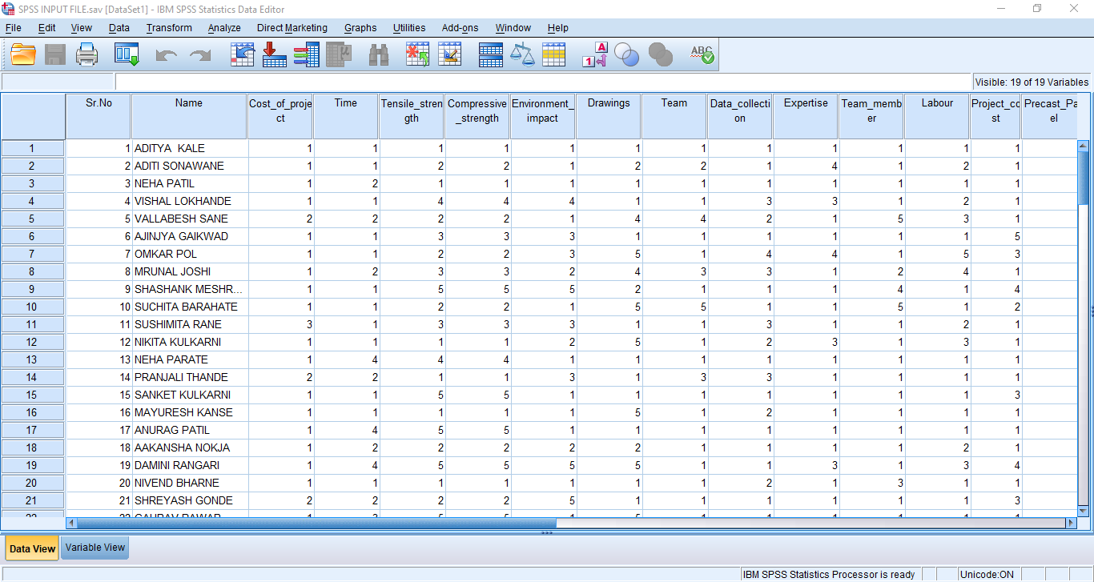

**Figure 2.1: SPSS Data view**

**SPSS Variable View:**

An SPSS data file always has a second sheet called variable view. It shows the metadata associated with the data. Metadata is information about the meaning of variables and data values. In Variable View, different columns are displayed. Each line corresponds to a variable

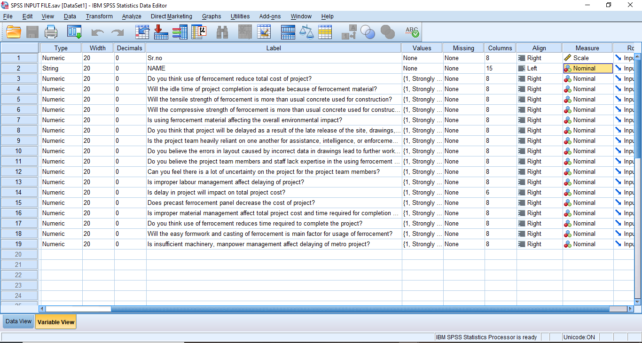

**Figure 2.2 : SPSS Variable View**

A variable is simply a quantity of something, which varies and can be measured, such as height, weight, number of children, educational level, gender and so forth. Name of the variable it is your own choice, but make it understandable and do not use numbers or symbols as the first letter since SPSS will not accept it. Moreover, you cannot use spaces in the name. The name of variable was used such as EMI, Construction material etc. The variable view spread sheet is shown in the below figure.

**SPSS Data analysis:**

SPSS can open all sorts of data and display them -and their metadata- in two sheets in its Data Editor window. In our data contain a variable holding respondents’ on related question, we can compute the frequency by navigating to Descriptive Statistics as shown in below figure. For better understanding and detailed study pie charts and Bar chart option is also selected.

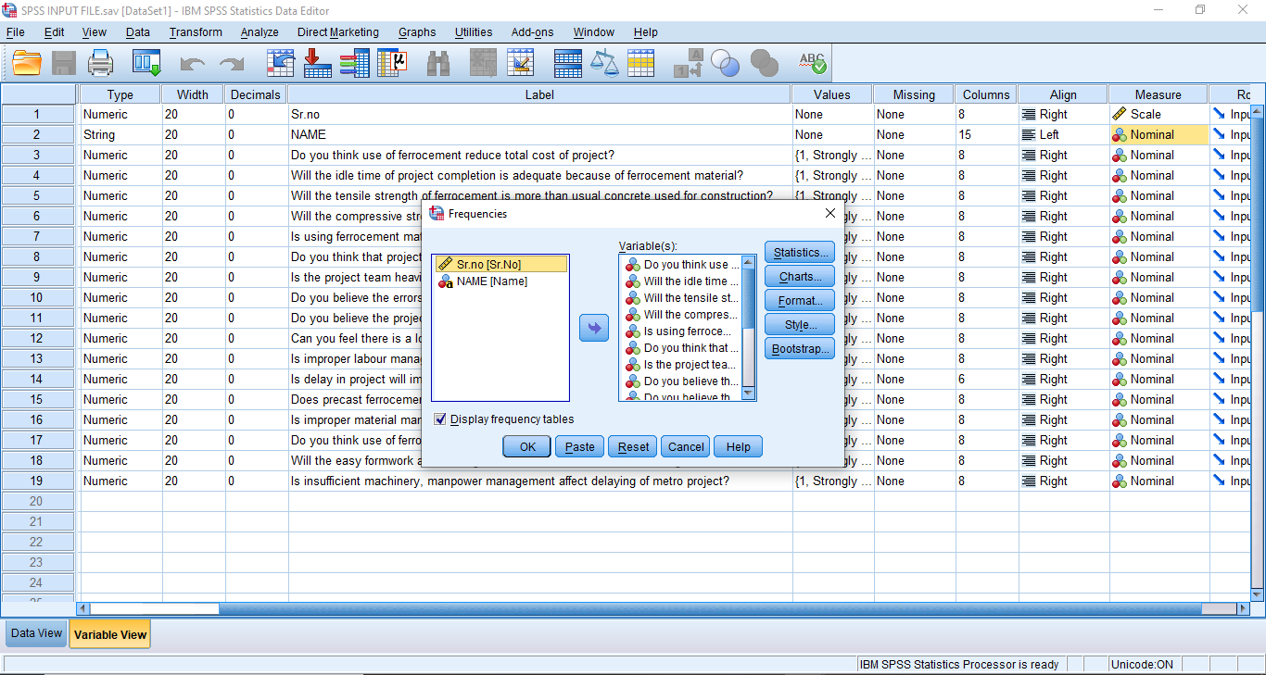

**Figure 2.3: SPSS data analysis**

**SPSS Output Window:**

After clicking Ok, a new window opens up, SPSS output viewer window. It holds a nice table with all statistics on all variables we chose. The screenshot below shows what it looks like. As we see, the Output Viewer window has a different layout and structure than the Data Editor window we saw earlier. Creating output in SPSS does not change our data in any way; unlike Excel, SPSS uses different windows for data and research outcomes based on those data.

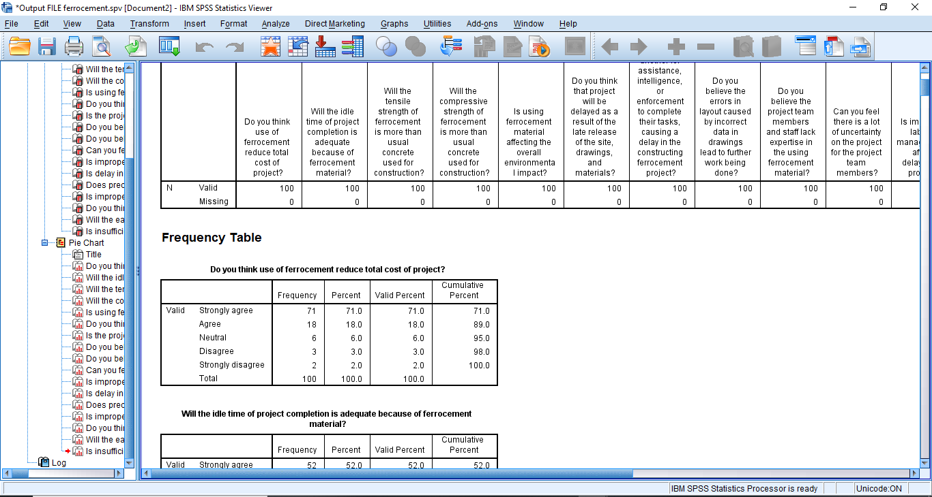

**Figure 2.4: Output File**

**Frequency Table**

With India in mind, it introduces the idea of building. However, companies implementing construction tools and strategies from a corporate point of view are unlikely to maintain their use or achieve maximum advantages from the implementation of construction because their operation is not accompanied by sufficient strategic planning.

**RII Method**

The sample for this study is relatively small. As a result, the analysis had combined all groups of respondents (clients, consultants, contractors and regulatory boards) in order to obtain significant results. Data was analyzed by calculating frequencies and Relative Importance Index (RII). In this project, Relative Importance Index technique approach is used for data analysis. This technique is used to determine the relative importance of the various factors affecting the waste generation working on construction sites. The data analysis was carried out using SPSS software. SPSS was used to generate the frequency (fi) of the response category index for the cause and effect factors. The relative importance index (RII) for each factor was calculated using the frequency data for each response categories generated from SPSS.

Assessment of questionnaire was carried out using three point likert scale from 1 to 5 representing can be not at all, no, most of the times, yes respectively. Data analysis was done calculating Relative Important Index (RII) by following formula. Ranking of the various factors according to their significance, and calculating their Relative Importance Index (RII)

1. **RESULTS AND DISCUSSION**

* Time-intensive steps waiting for material to come up to temperature, time for parts to queue, etc especially if an operator could be working on something else during this time
* Tasks that require multiple operators’ Routine quality problems like a frequent need to scrap or rework, or areas of inconsistent quality between operators
* Points of wasted labor or labor that is better spent on “human-only” tasks installing delicate electrical wires or soldering tiny components
* Consistent bottlenecks and backups in production
* Work that utilizes heavy tools or parts - especially since these often cause workers to slow down as the shift progresses
* Rule-based operations (e.g. sorting, simple if-then logic)
* Tasks that don’t rely on human senses to complete (e.g. process that can only begin once paint/adhesive is dry to the touch)
* Jobs or locations in your facility with a record of accidents or near misses
* Jobs employees complain about, dislike, or find challenging
* Areas with exposure to gases, dust, or byproducts of the manufacturing process
* Activities with repetitive motion and ergonomic problems, especially over time and repeated exposure
* Tasks requiring prolonged, intense focus or constantly shifting attention.

1. **CONCLUSION**

1] The major goal of this study is to discover how automation is now used in construction and on-site construction labour. And the most significant impediments to the use of automation technologies in the building industry.

2] Factors relating to the barriers are discovered through literature reviews and case studies.

After that, questionnaires are created for survey work, and the data is evaluated using the frequency analysis approach.

3] The high cost, size of the firm, and technology that is difficult to maintain and update are top rated barriers in the deployment of automation in construction, according to the Frequency analysis technique. Barriers such as workers' lack of technological understanding and technology that is difficult to use are among the lowest scored in the survey.

4] The cost of automation technology (buy cost, maintenance cost, and upgrade costs), the size of the firm, project magnitude, and staff limit were all found to have a strong link with the amount of site automation.

5] From this study, it can be concluded that barriers will be reduced by developing technologies that are easier to use and understand, as well as training programmers for workers and employees, which are rated highest in the survey, and making technology more affordable to maintain and update, which is rated lowest in the survey.

6] The use of automation technology in construction had a significant impact on project performance, with a stronger impact on enhanced job quality, time savings, improved working conditions, increased safety, and increased productivity.

7] Because of the high complexity, nature of the development process, and technological advancements in development, a long-term plan is required to provide access to cutting-edge development methodologies. In this adjustment technique, modelers, specialists, and every other member of the development process must be coordinated. Automation will be improved in both the short and long term, and will be tailored to the specific application.

8] The necessity for current infrastructure project and development enterprises to boost productivity, worker safety, and job quality is one of the advantages of implementing automation technologies. Small and medium-sized businesses require automation advancements in a variety of areas.

**ACKNOWLEDGEMENTS**

A Research Paper cannot be completed without the help of many people who contribute directly or indirectly through there constructive criticism in the evolution and preparation of this work. It would not be fair on my part, if I don’t say a word of thanks to all those whose sincere advice made this period a real educative, enlightening, pleasurable and memorable one.

I would like to express my deepest appreciation to my **Guide**, **Prof. Pore V.D. & Mr. Bhosale M.S.** for his gracious efforts and keen pursuits, which has remained as a valuable asset for the successful instrument of my seminar/project report. His dynamism and diligent enthusiasm has been highly instrumental in keeping my spirit high. His flawless and forthright suggestions blended with an innate intelligent application have crowned my task a success. I am fortunate to have an opportunity to work under him.

**REFERENCES**

1. Application of Automation and Robotics Technology in High-Rise Building Construction: An Overview 35th International Symposium on Automation and Robotics in Construction (ISARC 2018)
2. A proposed “model for adoption” of high technology products (robots) for Indian construction industry S. Jain and Dr. M. Phadtare National Institute of Construction Management and Research, Balewadi, Pune, India
3. Cao, D., Li, H., Wang, G., & Huang, T. (2017). Identifying and contextualizing the motivations for BIM implementation in construction projects: An empirical study in China. International journal of project management, 35(4), 658-669.
4. Bogue R. What are the prospects for robots in the construction industry? Ind Robot 2018; 45:1–6.
5. Kaneko K, Kaminaga H, Sakaguchi T, et al. Humanoid robot HRP-5P: an electrically actuated humanoid robot with high-power and wide-range joints. IEEE Robot Autom Lett 2019; 4:1431–8
6. Ma G, Wang L, Ju Y. State-of-the-art of 3D printing technology of cementitious material: an emerging technique for construction. Sci China Technol SC 2018; 61:475–95
7. Satasivam S, Bai Y. Mechanical performance of modular FRP-steel composite beams for building construction. Mater Struct 2016; 49:4113–29.
8. Eversmann P, Gramazio F, Kohler M. Robotic prefabrication of timber structures: towards automated large-scale spatial assembly. Construction Robotics 2017; 1:49–60
9. Hunt CJ, Wisnom MR, Woods BK. Design, manufacturing, and testing of an automated winding machine for WrapToR composite truss structures. In: 18th European Conference on Composite Materials, Athens, Greece, 2018; 1–8.
10. Peshkin, M. A., Colgate, J. E., Wannasuphoprasit, W., Moore, C. A., Gillespie, B. and Akella, P., Cobot Architecture, IEEE Trans. Robot. Automat., vol. 17, pp. 377– 390, Aug. 2018 (13) http://lims.mech.northwestern.edu/projects/utla/
11. Wannasuphoprasit, W., Akella, P., Peshkin, M.A., Colgate, J.E. “Cobots: a novel material handling technology,” ASME Vol. 98-WA/MH-2, 2019
12. Moore, Carl A. “Design, Construction, and Control of a 3-Revolute Arm Cobot,” Ph.D. dissertation, Dept. Mech. Eng., Northwest Univ., IL, 20119
13. Schloerb, David W. A Quantitative Measure of Telepresence. Presence: Tele-operators and Virtual Environments. Vol. 4, no. 1, pp. 64-80. Winter 1995.
14. Rosenberg, Louis B. Virtual Fixtures: Perceptual Tools for Telerobotic Manipulation. IEEE Conference Proceedings, 1993, pp. 76-82.
15. Colgate, J. E. and Brown, J. M., 1994, “Factors Affecting the Z-Width of a Haptic Display,” Proc. IEEE International Conf. On Robotics and Automation, pp. 3205- 3210.
16. Colgate, J. E. and Schenkel, G. C., 1997. “Passivity of a Class of Sampled-Data Systems: Application to Haptic Interface,” Journal of Robotic Systems, 14(1), pp. 37-47.
17. Faulring, E. L., Colgate, J. E. and Peshkin, M. A. A High Performance 6-DOF Haptic Cobot. Proc. IEEE ICRA, pp. 1980-1985, 2004.
18. Heckendorn, F. and Kress, R., “Outline for Large-Scale System Operations and D&D Report,” U.S. Dept. of Energy, WSRC-TR-2000-00364.