Research Paper

SOCIAL MEDIA INFLUENCERS ON CONSUMER BEHAVIOUR

Vikram Kumar
Galgotias University
Prof. Dr. Subrato Ganguly

ABSTRACT
The think about the complex intuitive that exist between social media influencers and shopper behavior in the present day advanced world, highlighting the imperative part that influencers play in impacting client inclinations, buying choices, and sees of brands. The inquire about looks at how influencers influence buyer conduct utilizing a mixed-methods approach that incorporates studies, interviews, and quantitative examination of social media engagement measurements. It emphasizes relatability, believe, and realness as significant components in building connections between influencers and their adherents. The victory characteristics of influencer showcasing campaigns, moral issues counting straightforwardness and genuineness, the maintainability of influencer showcasing in the confront of changing social media patterns, and the plausibility of influencer weakness are a few of the major subjects that were inspected. This think about includes to the body of information as of now in presence, which makes a difference marketers, businesses, and governments explore the ever-changing world of advanced showcasing in the twenty-first century.

Keywords: Influencer weakness, Advanced showcasing, Social media engagement measurements, Influencer promoting campaigns, Buyer behavior, Social media influencers

INTRODUCTION

The rise of social media influencers has a huge affect on how buyers carry on in the cutting edge computerized world. Since of the broad notoriety of locales like Instagram, YouTube, and Facebook, influencers play a pivotal part in deciding the tastes, suppositions, and suppositions of shoppers with respect to brands. The promoting scene has changed as a result of their capacity to construct honest to goodness associations with groups of onlookers, develop believe, and lock in with devotees. In arrange to completely get it the complex impact that social media influencers have on customer conduct, this ponder investigates the energetic relationship between influencers and online conduct. This ponder points to clarify the complexities of influencer-consumer connections by completely analyzing believe flow, realness, relatability, and moral contemplations. The consider employments a mixed-methods approach to examine the long-term supportability and victory viewpoints of influencer showcasing endeavors. It incorporates overviews, interviews, and quantitative investigation of social media engagement markers. In the conclusion, this examination propels our information of how influencers influence customer conduct and offers smart direction to marketers, companies, and lawmakers exploring the energetic field of computerized promoting.

In the field of computerized communication, the rise of social media influencers has been a progressive improvement. Much appreciated to the availability and reach of a few social media stages, individuals from a assortment of foundations have gotten to be conspicuous characters able of affecting well known culture and shopper conduct. Social media democratizes impact by empowering anyone with an web association to conceivably pick up a taking after and create their claim brand character, in differentiate to conventional media where impact was regularly concentrated in the hands of a little number of people.

In expansion to reflecting bigger societal shifts towards computerized utilization, the rise of social media influencers too highlights the developing noteworthiness of online communities in impacting shopper designs and conduct. Influencers will likely proceed to play a major part in affecting customer choices and open talk as social media stages spread and alter. But as the influencer advertise creates, issues like protecting realness, dealing with moral problems, and managing with divulgence and straightforwardness troubles still matter. In common, the development of social media influencers highlights the long-lasting impacts of computerized communication on modern society by flagging a principal alter in how individuals connected with and devour content.

Influencer promoting can productively reach and lock in target gatherings of people in a veritable and significant way, it has ended up a vital portion of current promoting methodology. In differentiate to routine publicizing strategies that habitually depend on troublesome techniques, influencer promoting capitalizes on the specialist and influence of individuals who have built committed social media followings. These influencers—which run in measure from micro-influencers with littler but exceptionally locked in groups of onlookers to macro-influencers with millions of followers—have the uncommon capacity to relate to clients actually, which builds validity and believe in their recommendations.

Additionally, influencer showcasing gives companies get to to statistic bunches and strength markets that might be difficult to reach through routine promoting strategies. Influencers that serve specific communities, pastimes, or ways of life can offer assistance marketers way better target their informing so that it talks to their target clients in a more important and honest to goodness way. By empowering genuine associations and discussions among shoppers inside their particular communities, this focused on approach not as it were makes strides the chances of coming to buyers who are really interested in the brand or item, but it too increments the by and large viability of promoting campaigns. Influencer showcasing has in this manner ended up a valuable apparatus for companies looking to effectively associated with clients whereas exploring the challenging world of advanced marketing.

OBJECTIVE OF THE STUDY
The objective of a study on the social media influencers on consumer behavior would likely be to investigate and understand the impact that influencers have on the choices and actions of consumers in various contexts. This could involve examining the effectiveness of influencer marketing campaigns, analyzing the factors that contribute to influencer credibility and persuasiveness, and exploring how different types of influencers (Ex;- macro, micro, nano) influence different demographics of consumers.

Furthermore, the research might aim to uncover the mechanisms through which influencers shape consumer behavior, such as through social proof, authority, likability, or similarity. Understanding these mechanisms could provide insights into how marketers can leverage influencer partnerships to effectively reach and engage their target audience.

Additionally, the objective could involve assessing the potential risks and challenges associated with influencer marketing, such as issues related to transparency, authenticity, and credibility. By examining both the positive and negative aspects of influencer influence, the research could contribute to the development of best practices and guidelines for marketers seeking to harness the power of social media influencers in their promotional efforts.

The research objectives are as follows:
To explore the potential features of social media influencers and their practices.
To understand the mechanism by which influencers change customer loyalty.
To analyze the relationship between customer loyalty and consumer behavior.
To examine the role of demographic factors in influencer marketing.
The research will delve into the various aspects of influencer marketing, such as building trust and authenticity, enhancing brand awareness, leveraging social proof and FOMO, targeted marketing, and user-generated content. By studying these factors, the research aims to provide insights into how influencers shape purchasing decisions, brand perceptions, and overall consumer attitudes.
The study will also explore the psychological factors that contribute to the effectiveness of influencer marketing, such as the development of para-social relationships, perceived similarity, and psychological closeness. These factors contribute to the influence consumer behavior.

RESEARCH METHODOLOGY

The research methodology for a study on the impact of social media influencers on consumer behavior involves a mixed-methods approach combining quantitative and qualitative research methods.
Quantitative research methods can include surveys to gather data on how social media influencers influence consumer behavior, focusing on aspects like trust, authenticity, and purchasing decisions. Statistical analysis of survey data can help identify trends and patterns in consumer behavior influenced by social media influencers.
Qualitative research methods, such as in-depth interviews or focus groups with influencers and their followers, can provide deeper insights into the mechanisms through which influencers affect consumer behavior. These methods can explore topics like the authenticity of influencer content, the trustworthiness of influencers, and the psychological factors influencing consumer decisions.
Additionally, a meta-analysis of existing literature can be conducted to synthesize empirical findings on the characteristics of social media influencers and their impact on customer engagement and purchase intention. This meta-analysis can help identify common themes and relationships across different studies, providing a comprehensive overview of the research landscape on social media influencers and consumer behavior.
By combining quantitative surveys, qualitative interviews, and a meta-analysis of existing literature, the research methodology aims to provide a holistic understanding of how social media influencers influence consumer behavior, shedding light on the mechanisms and factors driving this phenomenon.

METHODS OF COLLECTING DATA

Surveys and Questionnaires: Researchers often employ surveys and questionnaires to gather quantitative data from consumers about their attitudes, perceptions, and behaviors related to social media influencers. These tools can be distributed online or in-person to capture a broad range of responses.
Interviews: In-depth interviews provide researchers with qualitative insights into the thoughts, feelings, and motivations of consumers regarding social media influencers. These interviews can be conducted one-on-one or in focus groups to explore different perspectives and experiences.
Observational Research: Researchers may employ observational techniques to directly observe consumer behavior on social media platforms. This could involve tracking interactions with influencer content, such as likes, comments, and shares, to understand engagement levels and trends.
Content Analysis: Content analysis involves systematically analyzing the content of social media posts by influencers and their impact on consumer behavior. Researchers may use tools like sentiment analysis to evaluate the tone and sentiment of comments and reactions to influencer content.
Data Mining and Web Scraping: Data mining techniques can be used to extract and analyze large datasets from social media platforms to identify patterns and trends related to consumer behavior and influencer marketing. Web scraping tools can automate the collection of data from social media platforms for analysis.
Experimental Research: Experimental methods allow researchers to manipulate variables related to influencer marketing and observe their effects on consumer behavior. This could involve conducting controlled experiments or A/B testing to measure the impact of different influencer strategies on consumer attitudes and purchase intentions.
Ethnographic Research: Ethnographic approaches involve immersing researchers in the social media environment to understand consumer behavior in context. This may include participant observation of online communities and interactions with influencers to gain a deeper understanding of their influence on consumer behavior.

DATA ANALYSIS & INTERPRETATION

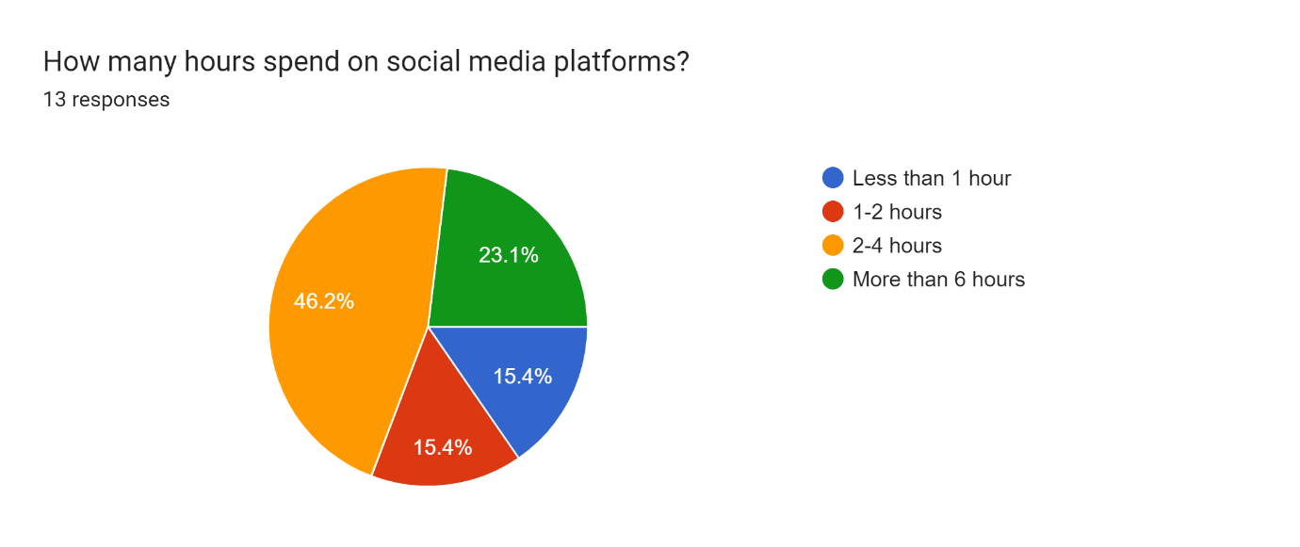

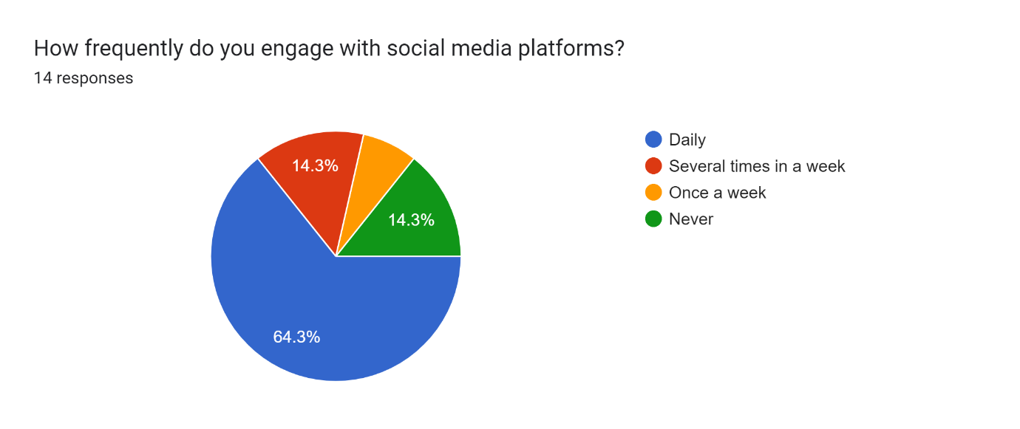

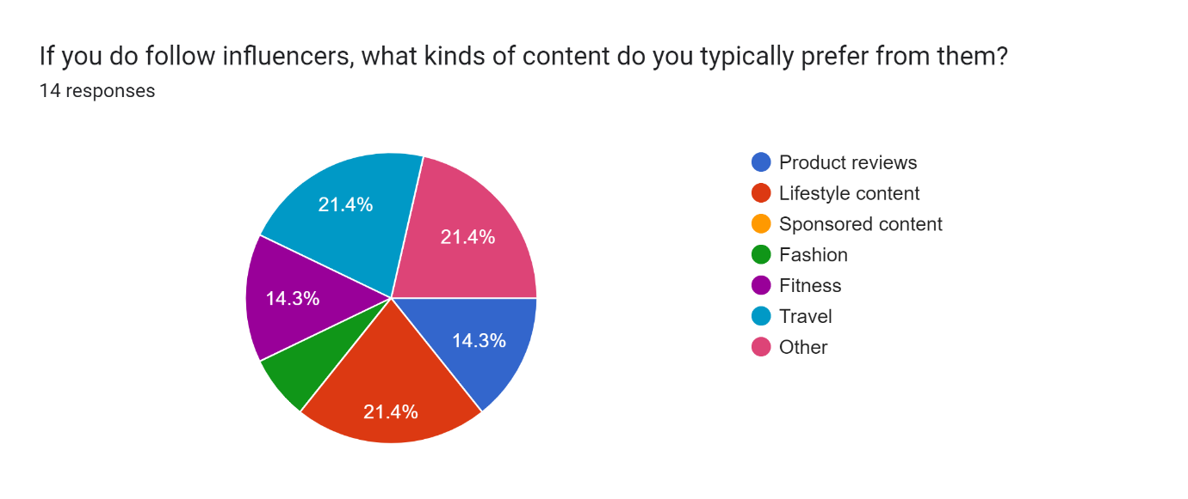

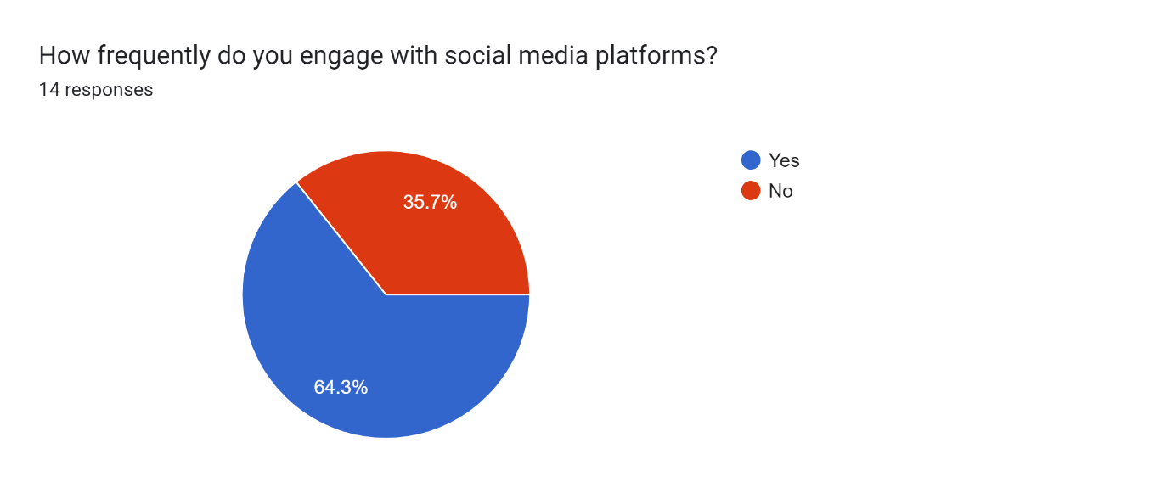

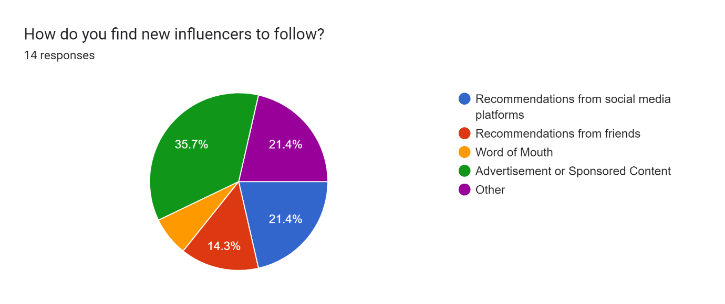

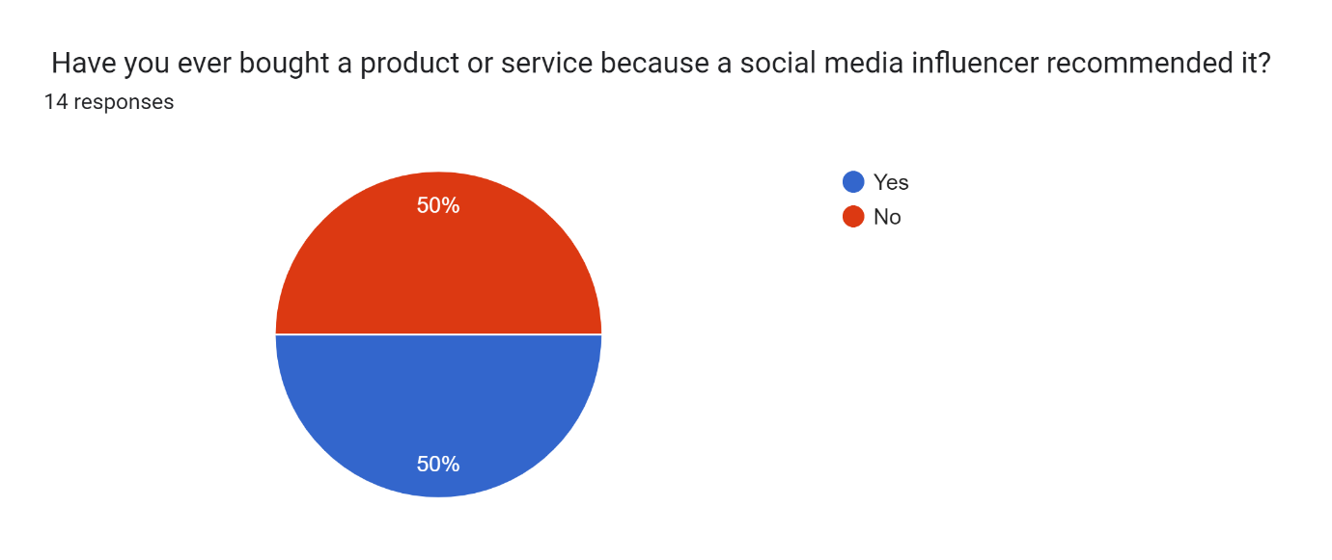

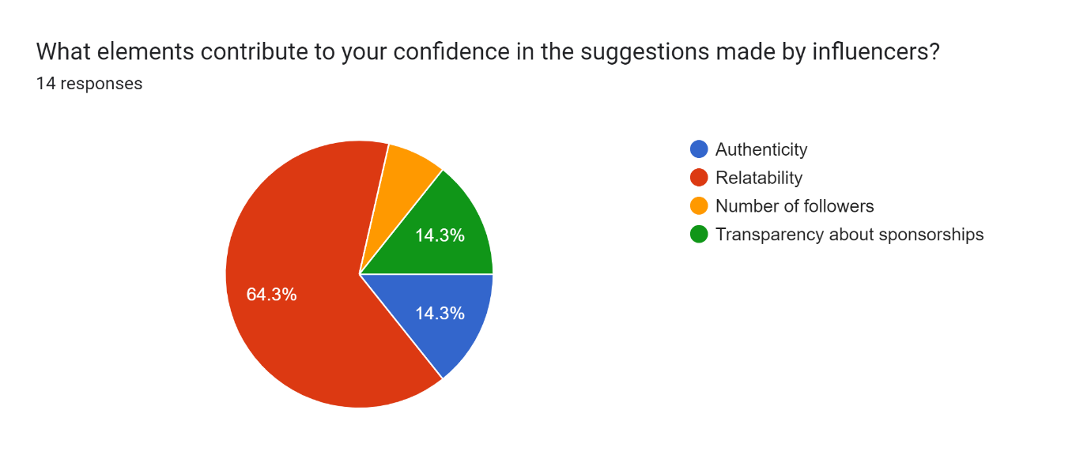

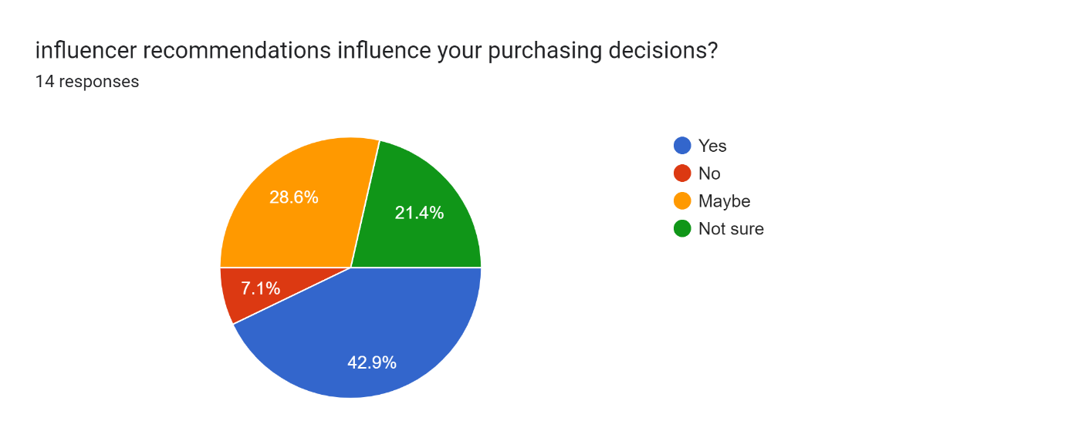

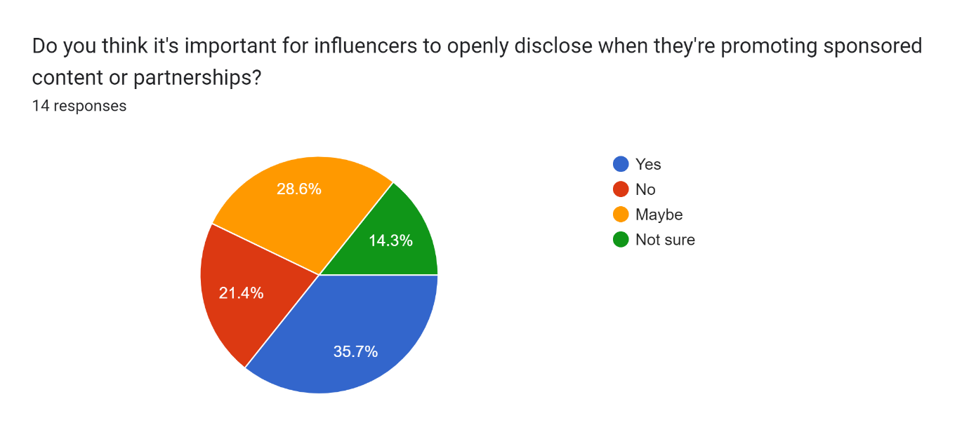

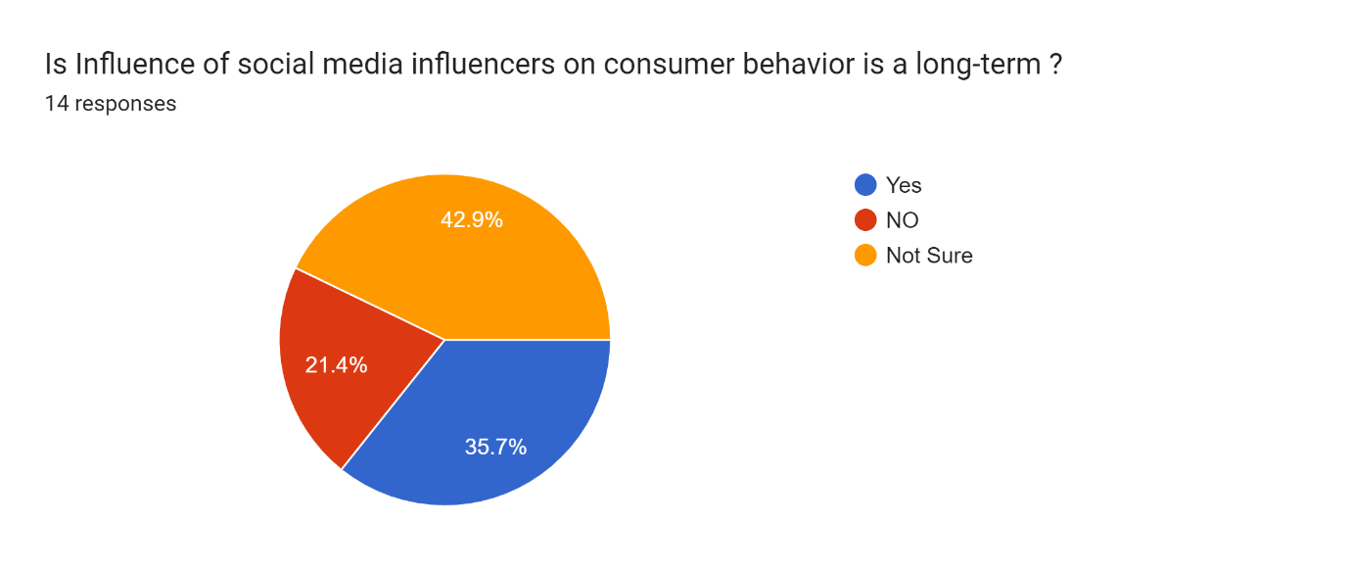

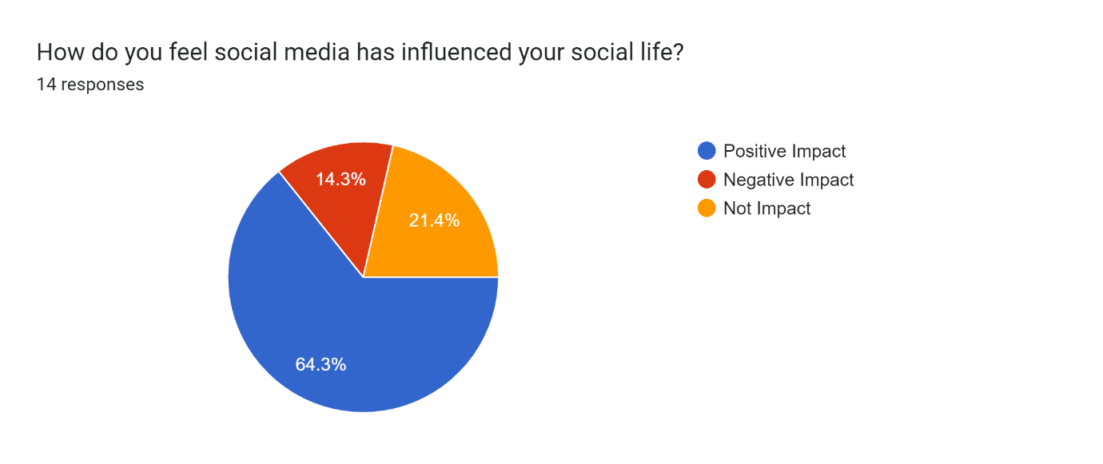

LIMITATION

Generalizability: One of the primary limitations is the challenge of generalizing findings to broader populations. Studies often focus on specific demographics or social media platforms, making it difficult to extrapolate results to different contexts or populations.
Sample Bias: Research may suffer from sample bias, as participants who voluntarily engage in surveys or studies about social media influencers may have different attitudes and behaviors compared to the general population. This bias can impact the validity and reliability of the findings.
Self-Reported Data: Much of the data collected in research on social media influencers relies on self-reported measures, such as surveys and interviews. However, self-reporting can be subject to biases, including social desirability bias and recall bias, which may affect the accuracy of the data.
Causality vs. Correlation: Establishing causality between social media influencer content and consumer behavior can be challenging. While studies may identify correlations between influencer activities and consumer actions, determining causality requires rigorous experimental designs that are often difficult to implement in real-world settings.
Ethical Considerations: Research involving social media influencers raises ethical considerations related to privacy, informed consent, and the manipulation of consumer behavior. Ensuring ethical practices in data collection and analysis is essential but can present logistical challenges.
Rapidly Evolving Landscape: The landscape of social media and influencer marketing is constantly evolving, with new platforms, trends, and regulations emerging regularly. This rapid evolution presents challenges for researchers in keeping their studies current and relevant over time.
Measurement Challenges: Measuring the impact of social media influencers on consumer behavior can be complex, as it involves quantifying intangible factors such as brand perception, trust, and purchase intent. Developing valid and reliable measures for these constructs is a persistent challenge in research.

CONCLUSION

social media influencers' impact on consumer behavior highlights the significant role these individuals play in shaping purchasing decisions and brand preferences. Through various channels such as Instagram, YouTube, and TikTok, influencers have established themselves as trusted sources of information and recommendations for their followers. Their ability to create authentic and relatable content has led to a strong influence on consumer perceptions and behaviors.
Moreover, the findings suggest that the relationship between influencers and consumers is evolving, with both parties becoming more discerning and savvy. Consumers are increasingly aware of sponsored content and the potential biases that influencers may have, leading to a more critical evaluation of their recommendations. At the same time, influencers are adapting their strategies to maintain trust and credibility among their audience, emphasizing transparency and authenticity in their partnerships with brands.
Looking ahead, the influence of social media influencers on consumer behavior is likely to continue as a long-term trend, albeit with potential shifts in the dynamics and strategies involved. As social media platforms evolve and new trends emerge, researchers and marketers will need to stay abreast of these developments to understand and harness the full potential of influencer marketing in shaping consumer preferences and driving purchasing decisions.
The comes about highlight the esteem of influencer promoting as a powerful apparatus that makes a difference companies lock in with their target statistic, set up brand notoriety, and cultivate client dependability. Brands may viably open up their promoting messages and reach a more extensive gathering of people with more noteworthy affect by utilizing influencers' believe and authenticity.
Furthermore, the think about highlights how imperative it is for companies to carefully select influencers who share their values and interface with their target gathering of people. Influencer associations require a tall degree of realness and believe since shoppers are getting to be more segregating and value-driven in their purchases.
According to the report, influencer showcasing is likely to stay a critical calculate in forming client behavior in the advanced time. For businesses to appropriately use the control of influencers, their promoting procedures must adjust to the advancing social media scene and moving client tastes. Through the comprehension and utilization of social media influencers.

RECOMMENDATION

Historical Evolution: Begin by tracing the historical evolution of influencer marketing, examining how it has evolved from traditional celebrity endorsements to the rise of social media influencers. Discuss key milestones and shifts in consumer behavior influenced by this evolution.

Types of Influencers: Investigate different types of social media influencers, such as macro-influencers, micro-influencers, and nano-influencers. Explore how each type engages with their audience and impacts consumer behavior differently.

Impact on Purchase Decisions: Analyze the influence of social media influencers on consumer purchase decisions. Explore factors such as credibility, trustworthiness, and relatability that contribute to the effectiveness of influencer marketing campaigns.

Psychological Mechanisms: Delve into the psychological mechanisms underlying the influence of social media influencers on consumer behavior. Explore concepts such as social proof, cognitive biases, and the parasocial relationship between influencers and their followers.

Effectiveness of Campaigns: Evaluate the effectiveness of influencer marketing campaigns in driving consumer engagement, brand awareness, and sales. Examine case studies and empirical research to assess the ROI of influencer marketing initiatives.
Ethical Considerations: Discuss ethical considerations surrounding influencer marketing, such as transparency, authenticity, and disclosure of sponsored content. Explore how regulatory frameworks and industry guidelines influence the ethical practices of influencers and brands.

REFERENCES:

Chan, D. F. ( 2022). A Study of Social Media Influencers and Impact on Consumer Buying Behaviour in the United Kingdom. International Journal of Business & Management Studies, 79-134.
Młodkowska, B. (2019). Influencers on Instagram and YouTube and Their Impact on Consumer Behaviour. Journal of Marketing and Consumer Behaviour in Emerging Markets, 4-13.
Piotr Kwiatek, R. B. (2021). THE IMPACT OF CREDIBILITY OF INFLUENCERS RECOMMENDATIONS ON SOCIAL MEDIA ON CONSUMERSBEHAVIOR TOWARDS BRANDS. Informatologia , 181-196.
Rebeka-Anna Pop, Z. S.-C.-A. (2021). The impact of social media influencers on travel decisions: the role of trust in consumer decision. Current Issues in Tourism, 1-21.
Žaneta Kavaliauskienė, H. M. (2019). IMPACT OF INFLUENCERS ON A CONSUMER DECISION TO PURCHASE . PROFESSIONAL STUDIES: Theory and Practice , 40-47.
“The history of social media”, [Online] Available:
http://historycooperative.org/the-history-of-social-media/

