**AN IMPROVED HYBRID FILTER FOR POWER QUALITY IMPROVEMENT FOR NON-LINEAR LOAD APPLICATIONS**

**K.BABY KUMARI, E.VISWA TEJ, K.VENKATA RAO, K.SEERSHIKA**

**ABSTRACT:**

In order to solve power system distortions and instability, the project integrates technology from Thyristor-Controlled Reactors (TCR) and Shunt Hybrid Power Filters (SHPF). Our goal is to improve overall quality by balancing reliable power supply and disturbance filtering. Our objective is to develop a flexible reactive power control and noise filtering system that can be used in a variety of industrial and commercial contexts and is verified by simulations and tests.

**INTRODUCTION:**

In order to improve power quality, this study presents a combined approach that makes use of the technologies of Thyristor-Controlled Reactor (TCR) and Shunt Hybrid Power Filter (SHPF). Our goal is to increase dependability and efficiency by merging these. For harmonic and reactive power adjustment, the system combines a fifth-harmonic-tuned LC passive filter with a small-rating active power filter (APF). For TCR, proportional-integral control is used, and for SHPF, nonlinear control. The SHPF-TCR compensator is appropriate for a range of loads and power systems due to its effective reduction of distortions and reactive power compensation, as demonstrated by simulation and experimental findings.

**Power electronics devices:**

* Diode
* Silicon-controlled rectifier
* Insulated-gate bipolar transistor
* Bipolar junction transistor
* Thyristor Gate turn-off thyristor
* Triac
* Power MOSFET

**INTRODUCTION TO SIMULINK:**

A program for modeling, simulating, and analyzing dynamical systems is called Simulink. It works with discrete, hybrid, and continuous time domains for both linear and nonlinear systems. Through the use of a graphical interface, models are constructed as block diagrams that make it simple to explore the nuances of the model and create it hierarchically. A variety of integration techniques may be used to carry out simulation, including real-time result display. You can change the parameters at any time to enable interactive exploration. It is possible to export simulation results to MATLAB for additional analysis and visualization. Because of its versatility, Simulink may be used to model a wide range of dynamic systems, including mechanical, thermodynamic, and electrical circuits.

**BASIC STRUCTURE AND OPERATION:**

The n-channel IGBT is akin to a DMOS with a P-layer at the bottom for the collector, boosting current density and cutting forward voltage drop. It acts like a BJT, with a wide base and small current gain. Negative collector voltage blocks current, while positive maintains forward blocking until breakdown. Positive gate voltage forms an n-channel, allowing electron flow and hole injection for emitter-collector current. Rising current density saturates base current, leading to collector current saturation. NPT IGBTs use a thicker drift region to prevent punch through, slashing on-state voltage drop.

**The power conversion systems can be classified according to the type of the input and output power**

* AC to DC (rectifier)
* DC to AC (inverter)
* DC to DC (DC-to-DC converter)
* AC to AC (AC-to-AC converter)

**THYRISTOR-CONTROLLED REACTOR:**

One essential part of power systems for controlling reactive power is a Thyristor Controlled Reactor (TCR). It is made up of a reactor and thyristor switches that allow reactive power to be dynamically controlled by varying the firing angles of the thyristors. This control system quickly modifies the TCR's effective reactance, enabling it to either absorb or provide reactive power as required. TCRs may swiftly fine-tune their reactive power output, enhancing voltage stability and overall system dependability, by modifying conduction time. TCRs are essential in contemporary power grids because of their advantages, which include quick reaction times, great efficiency, small size, and enhanced system stability. Their dynamic control guarantees seamless electrical network functioning and maximizes power system performance.

**INTRODUCTION TO SIMULINK:**

A flexible program for modeling, simulating, and analyzing dynamical systems is called Simulink. It can handle hybrid, sampled, or continuous time linear and nonlinear systems. Block diagrams with hierarchical modeling utilizing top-down or bottom-up techniques may be created with its graphical interface. Simulation provides real-time results and parameter modifications for exploration and may be started via menus or the MATLAB command window. It is possible to export results to MATLAB for additional analysis. utilizing a two-step method that involves model development and simulation utilizing input information, Simulink models a variety of systems, including electrical circuits, shock absorbers, and brake systems.

**BLOCK DIAGRAM:**

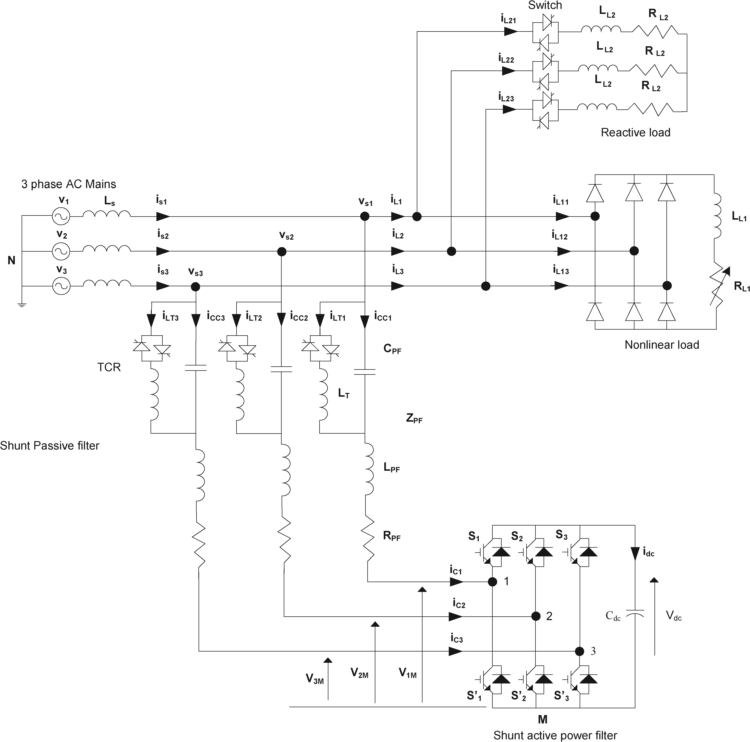

**Basic Circuit diagram of The Proposed SHPF-TCR Compensator**

A Simulink block diagram, which is made up of linked blocks that depict simple dynamic systems, is a visual representation of a dynamic system. Blocks can provide outputs constantly or at predetermined intervals, and they can be discrete or continuous. The relationships between block inputs and outputs are shown as lines. The relationship between outputs and inputs, states, and time is determined by each type of block.

**Blocks are grouped by behavior in Simulink's block libraries:**

1. Signals are produced by sources.
2. Block output is seen or written by sinks.
3. Discrete refers to components of discrete time.
4. Linear functions are described by continuous.
5. General mathematical functions are covered by math.
6. Table lookup and generic functions are handled by Functions & Tables.
7. Nonlinear functions are described by nonlinear.
8. Data passing, demultiplexing, and multiplexing are all possible using Signal & Systems.
9. Multiple subsystems are created by subsystems.
10. Specialized blocks in the Extras library are included in Block sets and Toolboxes.

**DETERMINING BLOCK UPDATE ORDER:**

A crucial order is necessary for reliable findings since Simulink updates block states and outputs once every time step during simulation. To guarantee the authenticity of the output, blocks must be updated after blocks driving their inputs. Blocks are categorized by Simulink according to output-input interactions into categories called direct feed through and non-direct feed through. Gain, Product, and Sum blocks are examples of direct feed through blocks; Integrator, Constant, and Memory blocks are examples of non-direct feed through blocks. Blocks can be given priorities for update sequencing, where blocks with higher priorities are updated before those with lower priorities. Simulink, however, only adopts these priorities inasmuch as they are consistent with its block sorting guidelines.

**COMPONENTS USED IN SIMULATION:**

* Abs
* Clock
* Constant
* Demux
* Derivative
* Discrete Transfer Function
* Discrete Zero-Pole
* Fcn
* From Workspace
* Gain
* In port
* Integrator
* Look-Up Table
* Mux
* Out port
* Product
* Relay
* Scope
* Step Fcn
* Subsystem

**SIMULATION RESULTS:**

MATLAB 2009a is used to simulate the whole circuit setup, and the Power Graphical User Interface (GUI) is used for analysis. In POWERGUI, the Fast Fourier Transformation is used to determine Total Harmonic Distortion (THD). For reactive and harmonic power correction, the system comprises of a combined Shunt Hybrid Power Filter (SHPF) and Thyristor-Controlled Reactor (TCR). A fifth-harmonic-tuned LC passive filter and a small-rating Active Power Filter (APF) are combined to form SHPF. For reactive power compensation, the tuned passive filter and TCR combine to create a shunt passive filter, or SPF. A lookup table is utilized to extract a triggering alpha, which is then used to regulate the TCR using a proportional-integral controller. APF's nonlinear control is designed to track current and regulate voltage.

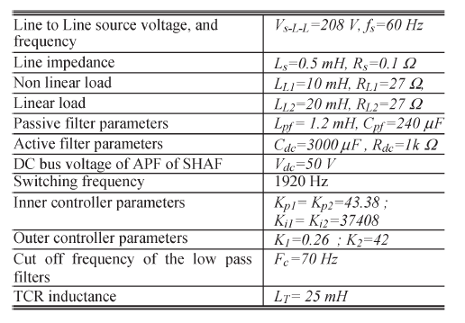

Under steady-state circumstances, the first circuit illustrates the overall circuit design without the Thyristor-Controlled Reactor and Shunt Hybrid Power Filter. Comprehensive MATLAB-based findings within the POWERGUI environment are displayed in the second figure.

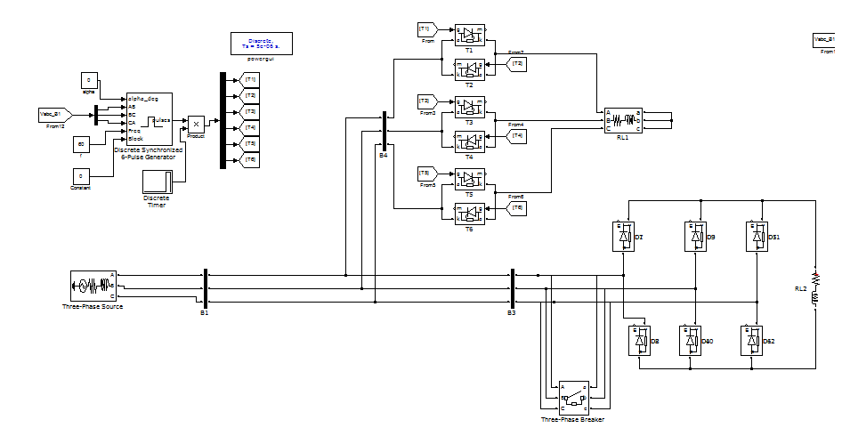

**CONVENTIONAL CIRCUIT CONFIGURATION**

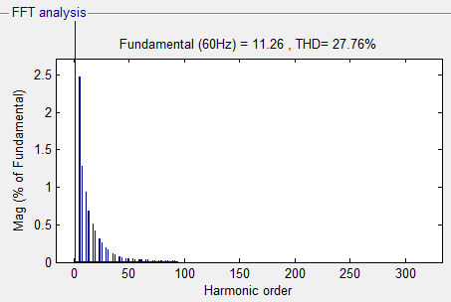

**Harmonic order for the conventional circuit configuration**

The setup of the Thyristor-Controlled Reactor and Shunt Hybrid Power Filter under steady-state circumstances is shown in the circuit below. The complete MATLAB-based findings in the POWERGUI environment are shown in the following picture.

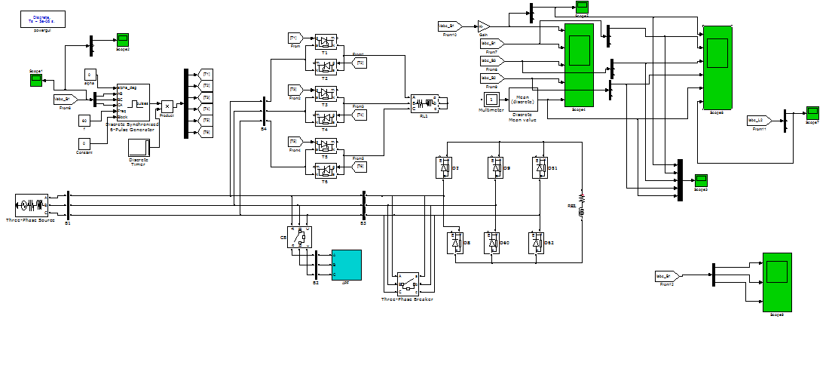

**A Combination of Shunt Hybrid Power Filter and Thyristor-Controlled Reactor in steady state condition**

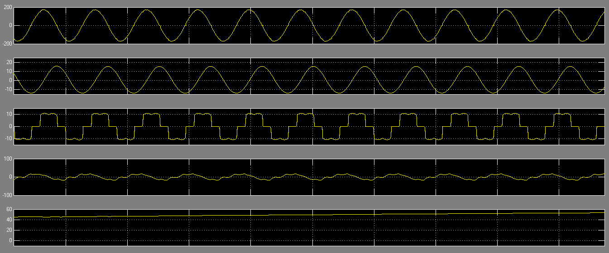

**Wave form representation of A Combination of Shunt Hybrid Power Filter and Thyristor-Controlled Reactor in steady state condition**

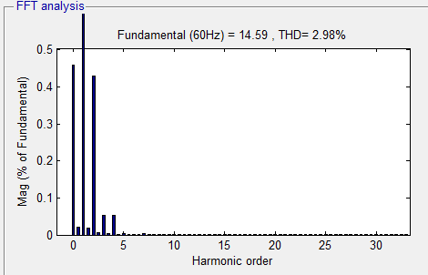

**Harmonic order A Combination of Shunt Hybrid Power Filter and Thyristor-Controlled Reactor in steady state condition**

The Shunt Hybrid Power Filter and Thyristor-Controlled Reactor's dynamic state setup is shown in the circuit below. The following graphic shows detailed MATLAB findings in the POWERGUI environment.

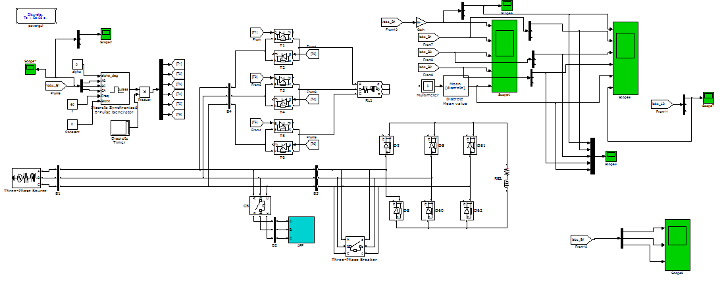

**circuit configuration of A Combination of Shunt Hybrid Power Filter and Thyristor-Controlled Reactor in dynamic state condition**

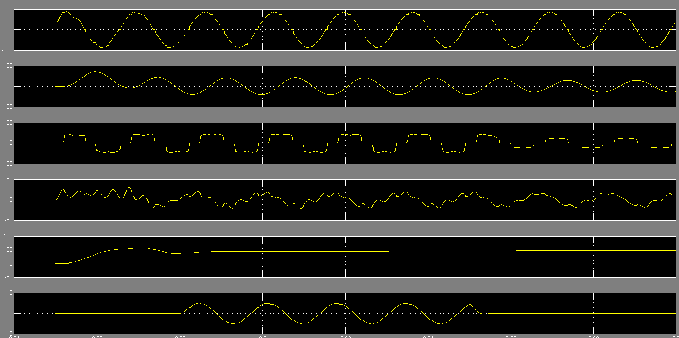

**MATLAB based waveforms of A Combination of Shunt Hybrid Power Filter and Thyristor-Controlled Reactor in dynamic state condition**

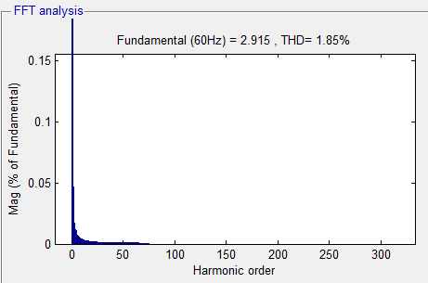

**Harmonic order A Combination of Shunt Hybrid Power Filter and Thyristor-Controlled Reactor in dynamic state condition**

**CONCLUSION:**

By reducing harmonic distortions and controlling reactive power fluctuations, the combination of a thyristor-controlled reactor (TCR) with a shunt hybrid power filter (SHPF) is a viable solution for power quality problems. This all-inclusive method lowers operating costs and improves energy efficiency, which makes it perfect for a variety of power distribution applications. The performance of the SHPF-TCR compensator is improved by a suggested nonlinear control strategy that makes use of pulse width modulation. This method successfully removes current harmonics and compensates reactive power under a range of operating circumstances. The system performs well in both steady-state and transient operations, responds quickly to changes in conditions, and lowers Total Harmonic Distortion (THD) in supply currents than the IEEE-519 standard limit of 5%.

**REFERENCE:**

[1] A. Hamadi, S. Rahmani, and K. Al-Haddad, “A hybrid passive filter configuration for VAR control and harmonic compensation,” IEEE Trans. Ind. Electron., vol. 57, no. 7, pp. 2419–2434, Jul. 2010.

[2] P. Flores, J. Dixon, M. Ortuzar, R. Carmi, P. Barriuso, and L. Moran, “Static Var compensator and active power filter with power injection capability, using 27-level inverters and photovoltaic cells,” IEEE Trans. Ind. Electron., vol. 56, no. 1, pp. 130–138, Jan. 2009. [3] H. Hu, W. Shi, Y. Lu, and Y. Xing, “Design considerations for DSPcontrolled 400 Hz shunt active power filter in an aircraft power system,” IEEE Trans. Ind. Electron., vol. 59, no. 9, pp. 3624–3634, Sep. 2012.

[4] X. Du, L. Zhou, H. Lu, and H.-M. Tai, “DC link active power filter for three-phase diode rectifier,” IEEE Trans. Ind. Electron., vol. 59, no. 3, pp. 1430–1442, Mar. 2012.

[5] M. Angulo, D. A. Ruiz-Caballero, J. Lago, M. L. Heldwein, and S. A. Mussa, “Active power filter control strategy with implicit closedloop current control and resonant controller,” IEEE Trans. Ind. Electron., vol. 60, no. 7, pp. 2721–2730, Jul. 2013.

[6] X. Wang, F. Zhuo, J. Li, L. Wang, and S. Ni, “Modeling and control of dual-stage high-power multifunctional PV system in d-q-0 coordinate,” IEEE Trans. Ind. Electron., vol. 60, no. 4, pp. 1556–1570, Apr. 2013

[7] J. A. Munoz, J. R. Espinoza, C. R. Baier, L. A. Moran, E. E. Espinosa, P. E. Melin, and D. G. Sbarbaro, “Design of a discrete-time linear control strategy for a multicell UPQC,” IEEE Trans. Ind. Electron., vol. 59, no. 10, pp. 3797–3807, Oct. 2012