**SOLAR BASED WIRELESS ELECTRICAL VEHICLE CHARGING SYSTEM**

**U. M. SANDEEP KUMAR1, S. N. NETHAJI2, B. PURUSHOTHAM NAIDU3,**

**B. CHANDRA MOULI4, M. YASWANTH 5, S. IRFAN6**

1Assistant Professor, Department of EEE, Santhiram Engineering College, Nandyal, A.P,

2,3,4,5,6UG Student Scholar, Department of EEE, Santhiram Engineering College, Nandyal, A.P

[sandeep.eee@srecnandyal.edu.in](mailto:sandeep.eee@srecnandyal.edu.in), [21x55a0230@srecnandyal.edu.in](mailto:21x55a0230@srecnandyal.edu.in)

**ABSTRACT**

The use of solar power as a sustainable energy source is growing. Solar heating, solar power, solar thermal electricity, solar architecture, saltwater power plants, artificial photosynthesis, and other constantly developing technologies capture the sun's radiant light and heat converts them into electrical energy. Solar panel or module trackers guide them to face the sun. In order to get the most of the sun's rays, these gadgets pivot throughout the day. This study shows that the use of solar energy in transportation. This revolutionize the way of transportation and decreases being dependent of petroleum products and other non-renewable resources. We are going to install a solar panel on the top the car. As the sun-lights falls upon solar panel the light energy is converted into the electrical energy. The converted energy is transferred to the rechargeable batteries using a battery management system this energy transfer is over seen by a Power Bank Charging Module to prevent excessive transfer of power that can destroy the components. In this way, An Electrical vehicle (EV) can charge using solar energy without stopping at any charging stations. Hence saving time, cost of transport and energy, protecting the environment.

**1.INTRODUCTION**

In the field of transportation, electric vehicles (EVs) speak to a novel concept. Electric vehicles (EVs) are anticipated to take over the vehicle advertise in the close future. The charging method for electric vehicles (EVs) must be controlled in this setting in arrange to protect the quality of the control systems. In show disdain toward of this, with the development of electric vehicles (EVs), there will be a noteworthy amount of vitality put away in the batteries, which will permit for the inverse impact. EV interactivity will be vital innovation in future savvy lattices, contributing to the independence of the control lattice. Due to diminishing carbon dioxide outflows and rising fossil fills, the electric vehicle has ended up more competitive than the customary inside combustion motor vehicle. In show disdain toward of these disadvantages, the EV was not for the most part received in the advertise since of its tall vehicle fetched. There is a shortage of fast-charging stations and a lack of all-electric vehicles. There are two sorts of electric vehicles: those that are fueled completely by electric control and those that are somewhat fuelled by electric control. In expansion to their moo working costs and small effect on the environment, electric vehicles utilize small or no fossil fills at all. Electric vehicles will be the essential implies of transportation in the future to upgrade charging station productivity. When it comes to securing an electric vehicle, the nonattendance of charging framework is the most common contention given for not doing so. The versatile EV charger was tried by bringing down charging time with renewable vitality. A half breed control framework is utilized in this thing about to give an interesting benefit to long-distance EV drivers. Our project system uses solar panel, rechargeable batteries, dc motors, charging Board Micro USB with Current Protection, ultrasonic sensor, buzzer, Esp32 module and LCD screen to display the percentage battery. There is no need to stop for recharging with this system because electric vehicles may be charged while travelling. As a charge controller connects battery to the solar panel, the batteries are charged on the go and saves the time of waiting while charging the vehicle using charger-based EV stations.

**2. LITERATURE SURVEY**

Bugatha Ram Vara Prasad et al. (2021) proposed a sun powered charging station for electric vehicles that utilizes a sun-based board cluster and a control conditioning unit to change over the sun powered vitality into electrical vitality. The framework incorporates a vitality administration framework that directs the charging prepare and optimizes the utilize of renewable vitality sources. T.D. Nguyen et al. (2020) conducted a achievability ponder on bipolar cushions for remote control chargers. The think about assessed the execution and productivity of bipolar cushions for remote charging, highlighting the potential benefits of this innovation in diminishing the dependence on physical associations. Bugatha Ram Vara Prasad and K. Aswini (2021) planned a bidirectional battery charger for electric vehicles that empowers proficient charging and releasing of the vehicle's battery. The framework incorporates a battery administration framework that controls the charging handle and guarantees ideal execution. a real-time coordination framework for electric vehicles to back the network at the dispersion substation level. The framework utilizes a communication organize and cleverly calculations to oversee the charging and releasing of the vehicles, optimizing the utilize of renewable vitality sources and lessening the dependence on the control lattice.

The writing audit highlights the significance of renewable vitality sources and remote charging advances in advancing maintainable and proficient charging arrangements for electric vehicles. This considers emphasize the require for progressed vitality administration frameworks and brilliantly calculations to direct the charging handle and optimize the utilize of renewable vitality sources.

Bugatha Slam Vara Prasad and K. Aswini (2021) outlined a bidirectional battery charger for EVs that permits for more productive battery charging and release. An coordinates battery administration framework controls charging and ensures crest execution. the grid's conveyance substations with an electric car coordination framework that works in real-time. The framework upgrades the usage of sources of clean vitality and diminishes reliance on the control network by overseeing both the charging and releasing of electric cars utilizing a communication organize and intelligent calculations. Renewable vitality sources and versatile charging innovations are emphasized in the writing audit as pivotal to the advancement of successful and naturally inviting electric car charging alternatives. Inquire about appears that savvy calculations and modern vitality administration frameworks are fundamental to control charging and get the most out of renewable control.

A Comprehensive survey on electric vehicles charging frameworks and their impacts on power-quality of the utility framework Electric vehicle (EV) charging stations are getting to be more common in the current utility lattice, which is causing a number of power-quality issues that are having a noteworthy effect on the stack exhibitions seen by both enormous and little customers. This drift is getting to be more recognizable as more and more individuals are selecting for electric cars over those fueled by inside combustion motors (IC engines) since of their numerous points of interest. Electric vehicle (EV) chargers change over AC control into DC power so that EV batteries may be charged. The power-quality of the grid's line current is corrupted since sounds are presented into the framework amid this control change handle by control gadgets that utilize high-frequency exchanging converters. Dispersion transformers are over-burden electrically and thermally due to the presentation of sounds, which diminishes their life expectancy. Other issues incorporate voltage variety, utility framework request and supply awkward nature, pulling as well much power from the network, and so on. In this manner, when charging an electric vehicle, the control quality must follow to the. An audit of electric vehicle fast charging stations, their impacts on the existing control network, and potential arrangements to these issues are all included in this consider.

**Existing Method**

The existing system of electric vehicles charging is using the charging stations located at designated locations. This idea is a replacement to the petrol bunks instead of petrol the electrical energy is powered into the vehicles. The power which is charged to the vehicles is supplied from the grid and some stations uses the solar plants to generate the power using solar panels.

There is another system which is still under developing phase as it uses the magnetic coil under the road. This works with the principle of magnetic induction. This principle is created by the “Faraday” and called as “Faraday's First Law of Electromagnetic Induction” as it states that whenever a conductor is placed in a varying magnetic field, an electromotive force is induced. If the conductor circuit is closed, a current is induced, which is called induced current. Using the above principle the coils are played below the road and the coils are located under the electrical vehicles also when the vehicles move above the coils under the road the current passes into the vehicles by using Electromagnetic Induction.

**Proposed Method**

The proposed system leverages the solar energy generated from the solar panel which is placed on the top of the electric vehicle. In order to make your EV green-energy approved, you'll need to charge it using a renewable energy source. Solar panels are one way to accomplish that.

There is various form of energy which we are using in form of thermal, chemical, mechanical, electrical and etc. The most popular form of energy is Electrical Energy as it is easy to transfer with maximum efficiency. The demand of Electrical Energy is increasing day by day. We are mostly generating it through conventional sources like fossil fuels, nuclear fuels etc. But the conventional sources are limited and creates pollution and exhaust one day. So, we are shifting to non-conventional sources like wind, solar, tidal, geothermal etc. The Solar Energy is the biggest form of energy, all the other form of energy depends on it only like wind is due to air currents which is due to expansion of air by solar energy only, fossil fuels due to life cycle which also depend on Solar Energy. So instead of taking it indirectly we can directly convert into electrical energy by using photovoltaic cell, or Solar cell. But we are not able to harness that much amount of energy. Solar energy can be converted to electrical energy through solar panels. They give maximum output when rays incident on 90 degrees. But in current scenario we are using fixed solar panel so it is not able to give maximum output hence the efficiency decreases.

The power collected from the panel is sent to the the battery by using the TP4056 1A Li-Ion Battery Charging Board Micro USB with Current Protection. Then the power in transferred to the two dc motors situated at the bottom of the vehicle. This dc motors are paired with wheels and moves when the signal is sent from the mobile which is connected with Bluetooth with the help of ESP32 micro controller. In this way the vehicle moves with use of any external power supply and completely free, Eco-friendly.

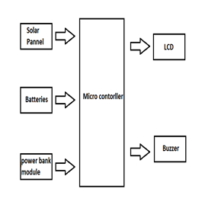

**Figure 1: Block Diagram**

**Lithium Battery Management System (BMS):** As the solar energy is generating when the sunlight is available and the generation takes place non-stop as long as sunlight is available, due to this phenomenon the generated power will be transferred non-stop without any precautions whether the batteries are charging or not and they continue to send the supply even after the batteries are charged at its full capacity. This process can damage the micro-controller and other electronic components in our project. So, in order to avoid this damage, we are going to use a battery management system. This Battery Management system provides as a constant flow of power from solar panels to the rechargeable batteries. In our project we are going to use a “TP4056 1A Li-Ion Battery Charging Board Micro USB with Current Protection”.

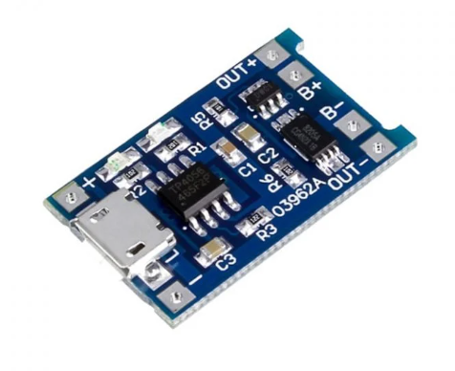

**Figure 2: Lithium Battery Management System**

**Solar Panel:**Solar PV modules work on the principle of photovoltaic effect, which is the process of converting sunlight into electricity. When sunlight hits the photovoltaic cells, it releases electrons, which flow through the circuit and generate a current. This current is then used to power electrical devices and charge batteries.

The photovoltaic cells in solar PV modules are made of silicon, which is a material that is highly efficient at converting sunlight into electricity. The cells are connected in series and parallel to increase the voltage and current, respectively. The resulting electrical output is then used to power electrical devices and charge batteries. When light reaches the p-n junction, the light photons can easily enter in the junction, through very thin p-type layer. The light energy, in the form of photons, supplies sufficient energy to the junction to create a number of electron-hole pairs. The incident light breaks the thermal equilibrium condition of the junction. The free electrons in the depletion region can quickly come to the n-type side of the junction. Similarly, the holes in the depletion can quickly come to the p-type side of the junction. Once, the newly created free electrons come to the n-type side, cannot cross because of barrier potential of the junction

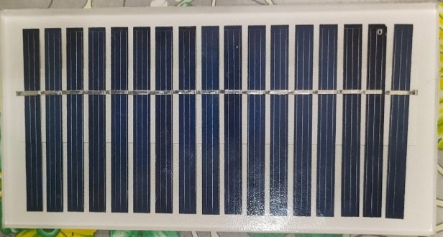

**Figure 3: Solar Panel**

**Power bank charging module with digital display:** In this project, we are going to use a power bank charging module with digital display so that we can see the percentage of power available in the batteries. Th module which we are going to use is This is the Dual USB 5V 1A 2.1A Digital LCD 18650 Lithium Battery Charging Module Accessories, 18650 Circuit board shell. This is a circuit board is designed make a power bank. Designed to meet the individual needs of DIY power bank. Motherboard comes with protection function: Charging overcharge protection Over-discharge protection Overcurrent protection Intelligent output device after charging full Automatically stop charging, to prevent mobile phones overcharge Output voltage and current stable, will not harm user devices.

The circuit board is connected to the battery negative B-, B + is the positive Do not connect reverse, connecting reversed will burn the board Note: There should be proper insulation between the battery and the circuit board No battery lead should touch the circuit board, so as not to cause a short circuit.

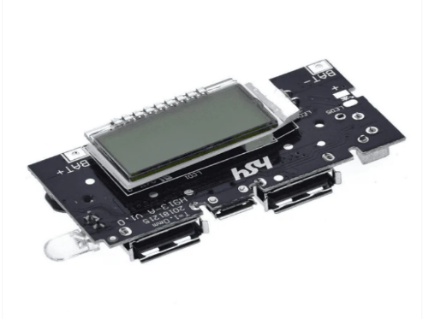

**Figure 4: Power bank charging module with digital display**

**ESP 32:**The Arduino Nano ESP32 is the first ever Arduino board based on a ESP32 microcontroller from Espressif, the NORA-W106 module from u-blox®. USB-C® connector, 16 MB (128 Mbit) of Flash, support for MicroPython & Arduino Cloud enabled, it is a very versatile development board. ESP32 comes with an on-chip 32-bit microcontroller with integrated Wi-Fi + Bluetooth + BLE features that targets a wide range of applications. It is a series of low-power and low-cost developed by Espressif Systems.

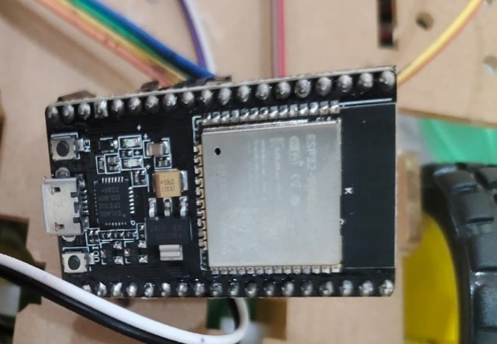

**Figure 5: ESP 32Micro controller**

**Buzzer:**A buzzer or beeper is a sound signalling gadget, which may be mechanical, electromechanical, or piezoelectric (piezo for brief). Normal employments of buzzers and beepers include alarm gadgets, clocks, prepare and affirmation of client input such as a mouse trap or keystroke.What is a Buzzer? A sound signalling gadget like a beeper or buzzer may

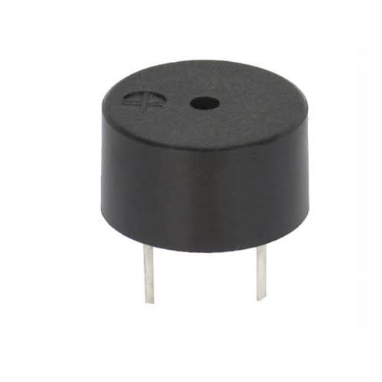be electromechanical or piezoelectric or mechanical sort. The fundamental work of this is to change over the flag from sound to sound. By and large, it is fuelled through DC voltage and utilized in clocks, alert gadgets, printers, alerts, computers, etc.

**Figure 6: Buzzer**

**L293D Driver IC:**The L293D is a well-known 16-pin coordinates circuit (IC) that acts as a double H-bridge driver, particularly planned to control two DC motors.The centre usefulness lies in its two coordinates H-bridges. An H-bridge is an electronic circuit that permits you to control the course of current stream through a DC motor. By giving particular computerized signals to the input and empower pins, you can control the heading and actuation of each engine associated to the L293D's yields. The IC basically acts as an interpreter between the computerized control signals from your microcontroller and the control required to drive the DC engines.

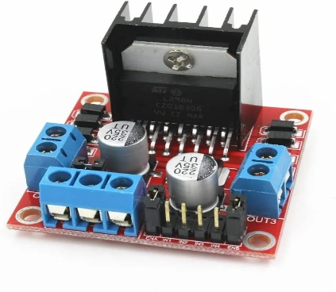

**Figure 7: L293D Driver IC**

**Rechargeable Battery:**A rechargeable battery, moreover known as an auxiliary cell or capacity battery, is an electrochemical gadget that you can more than once charge and release. Not at all like expendable batteries, which are tossed absent after utilize, rechargeable batteries offer a more feasible and cost-effective arrangement for fueling electronic gadgets.

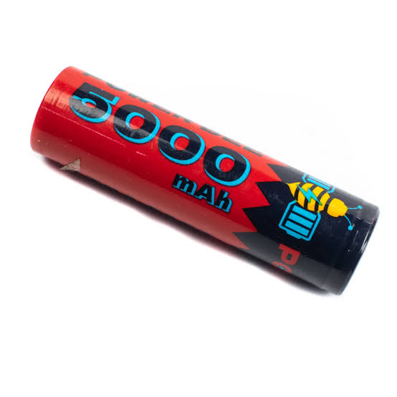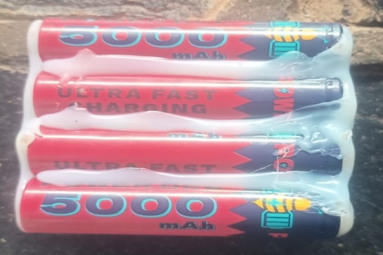

**Figure 8: Rechargeable Battery**

**Dual Shaft Dc Geared Motor (100 RPM):**In this project we are going to use a Dual Shaft DC Geared Motor with 100 rotations per minute (RPM). This motor has a low power requirement and compared to other motors available in the market this motor works perfectly without any errors. As the name suggests this motor as a Dual Shaft which can be powered by Dc supply. This motor has many applications. In this project we have used four Dc Shaft DC geared motors with 100 rpm. Only two motors as connected to the power supply and where as other two are just installed to the prototype for movement functions. Dual shaft geared motors are useful in robotics applications. Shaft on both sides allows the user to use a Wheel and an Encoder simultaneously. Not only this, the user gets enough headroom for the orientation of the motor and can be used in any orientation as per the application is required. It is a plastic based geared Dual shaft DC motor operating between a voltage range of 3V to 9V and has a torque of 0.8 Kg/cm with an RPM of 100 which is pretty decent for most of the applications. It is recommended to use this motor with more than 5V to have optimum torque in working condition.



**Figure 9: Dual Shaft DC Motor**

**Ultrasonic sensor:** An ultrasonic sensor is a gadget that employments sound waves to identify the nearness, remove, or vicinity of objects. It works by emanating high-frequency sound waves that are over the capable of being heard extend for people. These sound waves travel through the discuss and bounce off any objects in their way. The sensor at that point recognizes the reflected sound waves and measures the time it took for them to return. By knowing the speed of sound, the sensor can at that point calculate the remove to the protest.

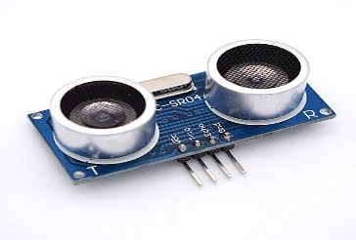

**Figure 10: Ultrasonic Sensor**

**3.FUNCTIONAL BLOCKS OF PROPOSED SYSTEM**

The ESP32 supports three types of I/O modes with each GPIO Pin: Digital, Analog and Internal Sensors.

**Analog:** Used to send/receive analog data using the following functions:

# examples based on Arduino IDE

analogRead();

analogWrite();

Digital: Used to send/receive digital data using the following functions:

# examples based on Arduino IDE

digitalRead();

digitalWrite();

The ESP32 Dev Kit C is a popular development board for the ESP32 microcontroller. Here's a breakdown of its key pin functionalities:

**Power:** Micro-USB: Provides power and programming interface through USB connection.

**5V & 3.3V:** These pins allow external power supply. The onboard regulator converts 5V to 3.3V if needed.

Important Note: The ESP32 chip operates at 3.3V. Never apply voltages exceeding 3.3V to any pin, as it can damage the chip.

**General Purpose Input/Output (GPIO) Pins:**39 digital pins: Out of these, 34 can be used as GPIOs for various functionalities like digital input, output, PWM (Pulse Width Modulation), SPI (Serial Peripheral Interface), I2C (Inter-Integrated Circuit), and ADC (Analog-to-Digital Converter).

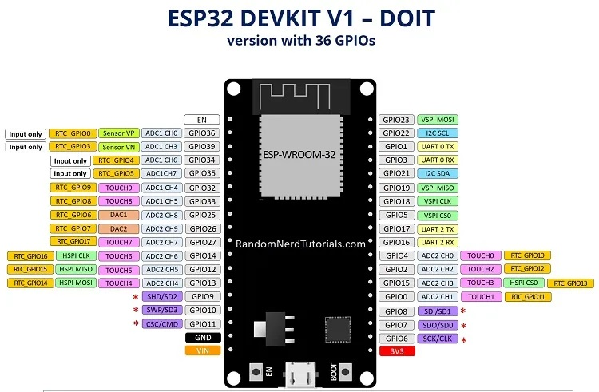

**Figure 11: Esp32 Board Guide**

**D0 - D3, CMD, CLK:** These pins are reserved for internal communication between the ESP32 and SPI flash memory. Avoid using them for external connections.

**GPIO16 & GPIO17:** Availability depends on the specific ESP32 module on the board. They might be reserved for internal use on ESP32-WROVER modules but are usable for general purposes on ESP32-WROOM and ESP32-SOLO-1 modules.

**Other Notable Pins:** Strapping pins (GPIO 0, 2, 4, 5, 12, 15) These pins are used to put the ESP32 into different modes like boot or flashing mode. The Dev Kit C usually sets these pins automatically during operation.

**4.HARDWARE EXPERIMENTAL RESULT**

ESP 32 micro controller is the brain of the robot, responsible for processing sensor data, controlling motors, and making decisions based on the program. Motor Driver Module An interface between the Arduino and the motors. It amplifies the control signals from the Arduino to drive the robot's movement.A sturdy frame is built to hold all the components and provide structural support for the EV Vehicle. The material selection (metal, wood) depends on the Vehicle weight and desired sturdiness.

**4.1 Working Conditions**

The below fig 14 shows all the assembled components in our projects. All the connections are to be made as per the block diagram and connect with the right pins. Power On the prototype by using the click switch located at the side of Battery Charging Module. The LED screen shows the available percentage of battery power from the rechargeable battery pack as shown in fig 15. The ESP32 micro-controller turns on and starts searching for the user mobile network as in as WI-FI module embedded within it. When the micro-controller founds the user mobile network it gets connected and an indicator will glow as shown in fig 16. Now, the user has to open the Blink application which is downloaded from the playstore. This application is used to control the prototype vehicle as we already customised the controls sensitivity and layout as shown in fig 18. When the prototype is placed in the sunlight the solar panels start converting the solar energy into the electric energy and passes it to the battery management system (BMS). Later this energy is passed to the rechargeable battery pack to store the electric energy and also to the Battery charging system as well to run the prototype without any power halts. In this way this prototype shows that the use of solar panels in Electric vehicles in order to overcome the hours of waiting in the charging stations.

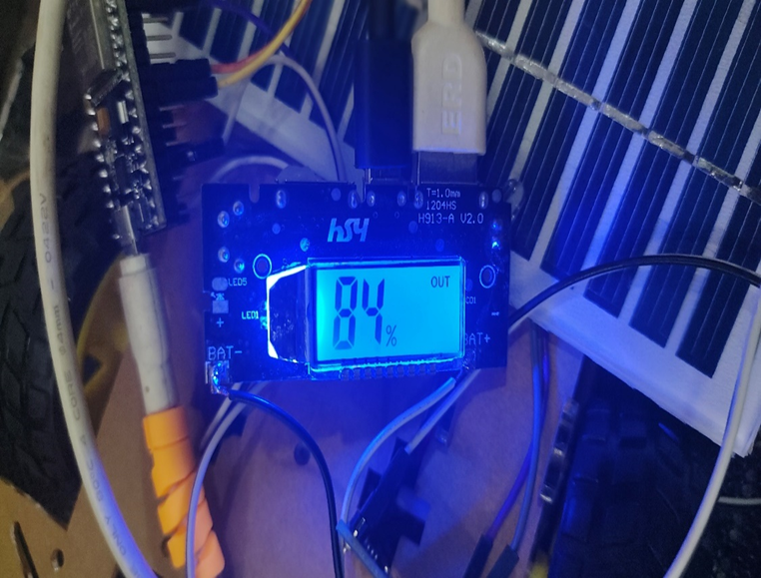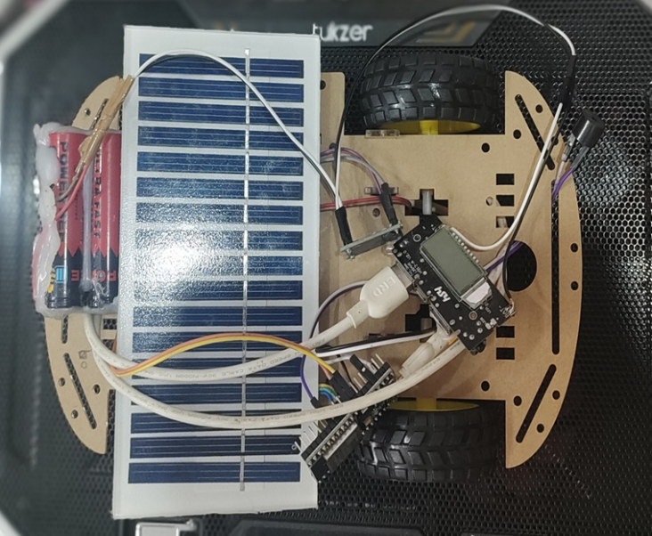

**Figure 14: assembly of all components Figure 15: Battery Charging Module Power ON**

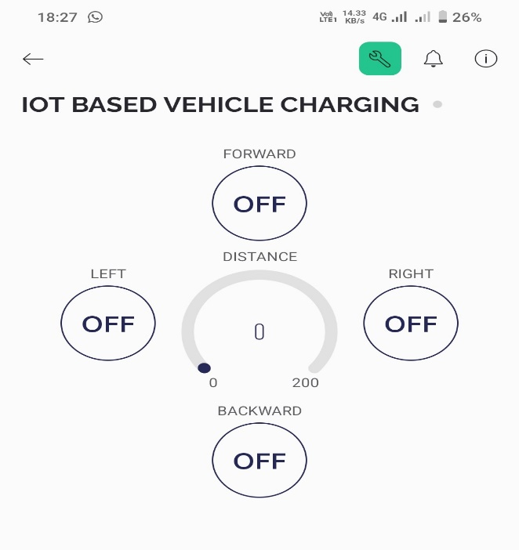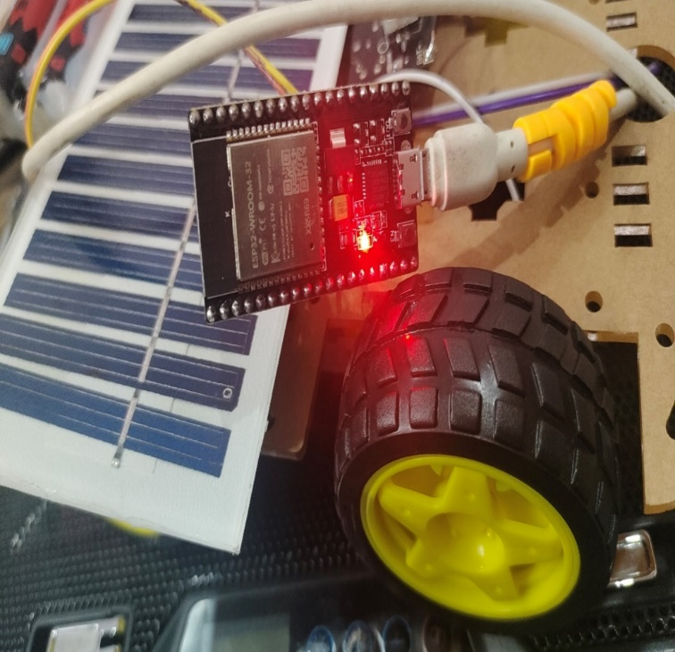

**Figure 16: ESP32 Power ON Figure 17: Blink Application**

**5.CONCLUSION:**

This study presents a revolutionary way in the history of modern transportation. This method saves the time of recharging the batteries when using a charger-based EV charging method. This method helps the people to use the time to travel and reach the designated location faster. In this method there is no need of stopping the vehicle as the charging of batteries takes place on the move. The solar power transfer takes place using the charge controller unit which help to maintain the right transfer frequency to recharge the battery without damaging the components. The process is safe and can be done in any harsh weather conditions especially in rain. As the price of petroleum products increases, this method provides a relief to the electric vehicle users has the solar energy is completely free and easy to transfer and stored. Solar-powered electric car charging represents a key solution in the transition to a sustainable transportation system. With advancements in solar technologies and energy storage solutions, the potential to provide renewable energy for electric vehicles is within reach. Solar-powered charging offers numerous benefits, including reduced emissions, cost savings, and energy independence. However, challenges such as limited sunlight and infrastructure requirements need to be addressed. As we move forward, continued innovation and investment in solar-powered charging technologies will shape the future of electric vehicle mobility.

**REFERENCES**

[1] J.Sofiapriyadarshani &,Dr.M.V.Subramanyam ‘Emperor Penguin optimized User Association Scheme for Mmwave Wireless Communication’ Wireless Personal Communications. An International Journal,Issn 0929-6212 Doi 10.1007/S11277-020-07269-3.

[2] Mallikarjuna Rao Y, Dr.M.V Subramanyam, Dr.K.Staya Prasad,” A Multi-Layer Routing Protocol for Mobility Management in Wireless Mesh Networks”, Proceedia Computer Science, Vol. 89,Pp. 51-56, 8/1/2016. (Scopus Indexed).

[3] S.Lprathapa Reddy, M.V.Surbramanyam, K.Sathya Prasad,” Power Control in Mac Protocol For Wireless Networks Using Hybrid Optimization Techniques”, Indian Jounal Of Science And Technology, Vol. 9 (44),Pp. 1-8, 2016. (Scopus Indexed).

[4] Mallikarjuna Rao Y, Dr.M.V Subramanyam, Dr.K.Satya Prasad, “An Efficient Resource Mangement Algorithm for Mobility Management In Wireless Mesh Networks”, International Conference On Energy, Communication, Data Analytics And Soft Computing (Icecds) , Skr Engineering College, Chennai,1-2 August,Pp.406-412,2017. (Scopus Indexed).

[5] V.Jyothi, Dr.M. V. Subramanyam “Design and Implementation of Solar Energy Monitoring System Using Lora

For Solar Power Plants’, International Journal on Advanced Science & Technology, Vol. 29, No. 03, (2020), Pp.12757 – 12763, Aug-2020. [ Http://Sersc.Org/Journals/Index.Php/Ijast/Article/View/30414/16821].

[6] M. Y. Veeresh, V. N. B. Reddy, and R. Kiranmayi, “Range Estimation of Battery Electric Vehicle by Mathematical Modelling of Battery’ s Depth-of-Discharge,” no. 6, pp. 3987–3992, 2019, doi: 10.35940/ijeat.F8800.088619

[7] M. Y. Veeresh, V. N. B. Reddy, and R. Kiranmayi, “Performance Of PMSM-Based Battery Electric Vehicle Using P.I., P.I.D., And F.L. Controllers,” J. Appl. Sci. Eng., vol. 27, no. 7, pp. 2847–2855, 2024, doi: 10.6180/jase.202407_27(7).0015.

[8] Dr.K.Rajasekhar Reddy "Simulation of a Matrix Converter Fed Induction Motor" in international journal of Research science and Management (IJRSM) ( ISSN: 2349-5197, PP- 51-59,Volume-2, Isuue-9, August 2015).

[9] Bugatha Ram Vara prasad T.deepthi n.satyavathi v.satish varma r.hema kumar, “Solar charging station for electricvehicles,” Int. J. Adv. Res. Sci. Commun. Technol., vol. 7, no. 2, pp. 316–325, 2021, doi: 10.48175/IJARSCT-1752.

[10] T. D. Nguyen, S. Li, W.Li, and C.Mi, “feasibility study on bipolar pads for efficient wireless power chargers,”in Proc. APEC Expo., Fort Worth, TX, USA 2020.

[11] Bugatha Ram Vara prasad and K. Aswini, “Design of Bidirectional Battery Charger for Electric Vehicle,” Int. J. Eng. Res. Technol., vol. 10, no. 7, pp. 410–415, 2021, doi: 10.1088/1757-899x/1055/1/012141.

[12] M. Singh, K. Thirugnanam, P. Kumar, I. Kar Real-time coordination of electric vehicles to support the grid at the distribution substation level IEEE Syst J, 9 (2019), pp. 1000- 1010, 10.1109/JSYST.2013.2280821.

[13] R. Das, K. Thirugnanam, P. Kumar, R. Lavudiya, M. Singh Mathematical modeling for economic evaluation of electric vehicle to smart grid interaction IEEE Trans Smart Grid, 5 (2020), pp. 712-721, 10.1109/TSG.2013.2275979

[14] Bugatha Ram Vara Prasad, T. Deepthi, N. Satyavathi, V. Satish Varma, R. Hema Kumar, A Comprehensive Review on Photovoltaic Charging Station for Electric Vehicles, World Academics Journal of Engineering Sciences, Vol.8, Issue.2, pp.45-49, 2021.

[15] Bugatha Ram Vara Prasad, C. Prasanthi, G. Jyothikasanthoshini, K. J. S. V. Kranti Kumar, And K. Yernaidu, “Smart Electrical Vehicle,” I manager’s J. Digit. Signal Process., vol. 8, no. 1, p. 7, 2020, doi:10.26634/jdp.8.1.17347.

[16] X. Zhou, S. Lukic, S. Bhattacharya, and A. Huang, “Design and control of grid-connected converter in bi-directional battery charger for plug-in hybrid electric vehicle application,” in Proc. IEEE Vehicle Power and Propulsion Conference (VPPC), 2019, pp. 1716–1721