

**Research Report:**

“COMPARATIVE STUDY OF MARKETINGSTRATEGY OF TOYOTA AND FORD”

RAJAT SHUKLA

21GSOB1060039

**BBA(MAM) (09)**

**Professor**- Dr ANSHU GOEL

**(School of Business)**

**ABSTRACT-**

This research compares the marketing approaches of two well-known automakers, Ford and Toyota. Within the automobile business, two different methods for marketing have been represented by multinational corporations: Ford Motor Company, an American company, and Toyota Motor Corporation, a Japanese company. The study examines a number of marketing strategy elements, such as target market, advertising channels, product positioning, and brand image. To give a thorough picture, statistical data on brand perception, innovation, market share, sales performance, financial measures, and environmental effects are integrated. Toyota targets a wide range of consumers with an emphasis on digital media involvement while emphasizing innovation, dependability, and environmental sustainability. Ford, on the other hand, markets itself as a brand that embodies sturdiness, strength, and American tradition. It does this by using emotional appeals and narratives to target market niches. Comparative analysis provides light on

**INTRODUCTION**

**Toyota**

Toyota is a global producer of automobiles, with its headquarters located in Toyota City, Aichi, Japan. Kiichiro Toyoda started it in 1937. With an annual production of almost 10 million cars, it is among the largest automakers in the world. Toyota is highly known for both its creative mass-production techniques and its commitment to extensive research and development. The business gained international recognition for manufacturing durable, high-quality cars that came in a wide price range, from little cars to luxury and sports cars. Toyota is a pioneer in the realm of electric car technology, most recognized for having made the Prius model widely available. The Prius model went on to become the top-selling hybrid worldwide.

**Ford**

Henry Ford established the American multinational automaker Ford Motor Company in 1903; it is based in Dearborn, Michigan. Ford established methods for managing industrial labor on a large scale and manufacturing automobiles on a large scale. The assembly line approach was one of these methods, and it revolutionized the automotive industry. The majority of people can now afford vehicles, thanks to this innovation. Early Ford vehicles—the Model T in particular—became symbols of American industry and inventiveness. Ford continues to be one of the leading automakers in the world, renowned for its trucks, SUVs, and passenger cars. It also makes large expenditures on electric car technology and smart transportation solutions.

**OBJECTIVES**

The primary objective of this research is to compare the marketing strategies of Ford and Toyota, with an aim to understand:

1. How do Toyota and Ford develop their marketing strategies?
2. What are the key components of their marketing strategies?
3. How are their marketing techniques influenced by technical, cultural, and economic factors?
4. What lessons can be learned from the similarities and differences in their strategies?

**RESEARCH METHODOLOGIES**

**Secondary Data Analysis:**

Reviewing existing literature, industry reports, market analyses, and company documents to gather background information and insights relevant to Toyota and Ford's marketing strategies. This secondary data analysis complements primary research efforts and provides a broader perspective on the subject.

Internet

**Surveys**:

Conducting surveys among consumers to gather data on brand perception, preferences, purchase behaviour, and satisfaction levels related to Toyota and Ford vehicles. This quantitative approach allows for statistical analysis and comparison of responses.

**Data Analysis:**

Utilizing existing quantitative data, such as sales figures, market share data, and consumer demographics, to identify trends and patterns in the automotive market and the performance of Toyota and Ford's marketing strategies.

**SUMMARIZE AND GRAPH**

**Do you think after-sales care and customer satisfaction are important?**

Dealers for Toyota and Ford both place a high value on customer satisfaction and after-sale support because they feel that if a consumer is happy with their experience, they will stick with them for future purchases; if not, they will look to other automakers. Additionally, providing superior sales support will improve consumers' perceptions.

**Take out the following marketing research tasks**:

In response, a few dealers stated that they carry out research to determine which marketing tactic has drawn in the most clients, so they may attempt to advertise more using that tactic. If not, they don't carry out any studies. Typically, it is done at the corporate level rather than the dealer level.

**Car Users:-**

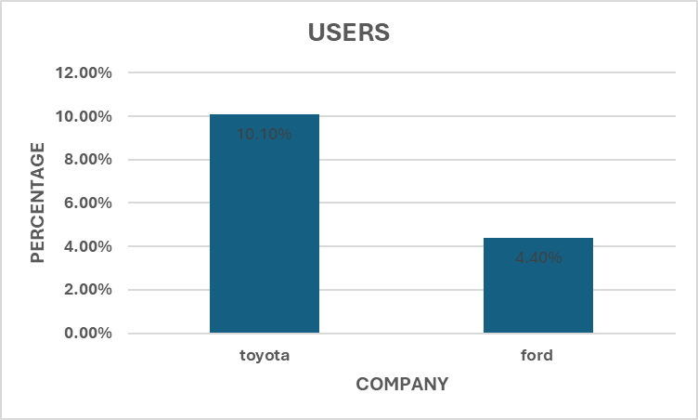

Below graph show that 10.10% are Toyota user’s and 4.40% are ford users.

**Most preferred cars­: -**

After the survey it was found that corolla from Toyota and endeavour from ford from the various range available are the most preferred cars amongst the customers.

Forms response chart. Question title: 
Among the options provided below, which car would you prefer to use: 
. Number of responses: 19 responses.In the chart of Toyota corolla cars.is no. 1 car in the year of 2023

**Reasons for Using Toyota and Ford Car:-**

Forms response chart. Question title: What factors influence your decision to choose between Ford and Toyota for an EMI purchase? 
. Number of responses: 14 responses.

**What criteria do buyers considered when purchasing a car;-**

Forms response chart. Question title: What criteria do buyers consider when purchasing a car? 
. Number of responses: 19 responses.

It was found that while purchasing the car customer’s look for the complete car of their choice which gives them good performance, Looks, mileage and also it should be reasonable in price.

**CUSTOMER RATING TO CAR PERFORMANCE**

Forms response chart. Question title: "What is your primary reason for choosing between Ford and Toyota cars?
. Number of responses: 15 responses.

**Pricing: -**

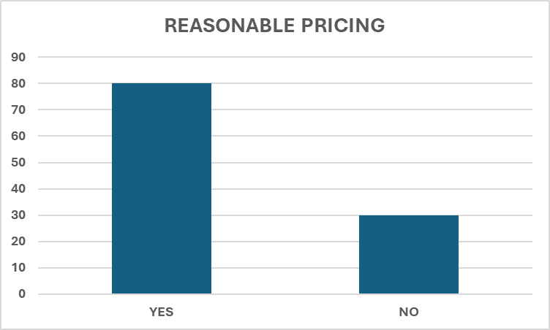

Most customers found that prices of these cars are affordable for their Pockets while few customers found that price is little higher.

**What percentage of car buyers opt for installment-based payment plans,**

**CONCLUSION**

In conclusion, both Ford and Toyota stand as formidable forces within the automotive industry, each showcasing unique strengths and addressing distinct challenges. Ford's iconic brand heritage, coupled with its dominant position in the North American market and emphasis on innovation, positions it as a key player in the industry. However, Ford faces hurdles such as overdependence on its domestic market and the imperative to adapt swiftly to evolving consumer preferences towards sustainability and electric vehicles.

On the other hand, Toyota's global presence, renowned brand reputation, and relentless pursuit of innovation place it at the forefront of the automotive landscape. Toyota's diversified product portfolio, including a strong focus on hybrid and electric vehicles, positions it well for the future. Nevertheless, Toyota grapples with challenges like market dependence and occasional setbacks due to product recalls.

Moving forward, both companies must navigate a rapidly changing landscape characterized by technological disruptions, shifting consumer preferences, and stringent regulatory requirements. Embracing sustainability, investing in research and development, and fostering strategic collaborations will be imperative for sustaining competitive advantage. Furthermore, agility and adaptability will be critical in responding effectively to emerging trends and challenges.

Ultimately, Ford and Toyota's commitment to innovation, coupled with their ability to leverage their respective strengths and address weaknesses, will determine their success in an increasingly dynamic and competitive automotive industry. By staying attuned to market dynamics, consumer demands, and technological advancements, both companies can continue to thrive and shape the future of mobility.

**REFERENCES**

**SEARCH ENGINE-**

[**https://www.google.co.in/**](https://www.google.co.in/)

[**https://in.search.yahoo.com/?fr2=inr**](https://in.search.yahoo.com/?fr2=inr)

**Websites: -**

https://www.toyota.com/

www.toyota.com

www.Ford.com

www.google.com

www.globalautomobile.com

www.overdrive.com