 |  |  | INTERNATIONAL JOURNAL OF PROGRESSIVE |  |  |  |  |  |  |  |  |  | e- |  |  |  | ISSN :
 |  |  |  |  |  |  |  |  |  |  |  |  | 2583-
 |  | RESEARCH |  |  | IN ENGINEERING |  |  |  |  |  | MANAGEMENT AND
 |  |  |  |  |  |  |  |  |  |  |  |  | 1062
 |  |  |  |  |  | SCIENCE |  |  |  | (IJPREMS)
 |  |  |  |  |  |  |  |  |  |  |  |  |  |  | Impact
 | www.ijprems.co
 | www.ijprems.co |  | Vol. 04, Issue 01, January 2024, pp : xx-xx
 | m |  |  |  |  |  |  |  |  |  |  |  | Factor :


Empowering Aspiring Developers: A Comprehensive Study on Building a Learn Coding Website with MERN Stack

Suchitra Devi A¹, Raman Dubey², Sanskar Kulkarni³ ,Udit Sharma⁴,Suraj Acharya⁵

- Asst Professor, Dept. Of Cse, Sambhram Institute Of Technology, Bengaluru-560091, Karnataka, India ^{2,3,4,5} Eight Semester,Dept Of Cse,Sambhram Institute Of Technology, Bengaluru -560091, Karnataka, India

ABSTRACT

The abstract of the LearnCoding ed-tech platform project outlines the development of a comprehensive online learning platform using the MERN stack (MongoDB, Express.js, ReactJS, Node.js). The platform aims to offer an engaging and interactive learning experience for students while providing a space for instructors to share their expertise globally. The project encompasses a detailed system architecture, front-end and back-end design, API implementation following REST principles, deployment strategies, testing procedures, and potential future enhancements to enhance user engagement and satisfaction. Challenges such as integrating various technologies and debugging errors are expected during the development process.

Keywords:Education,Learning.

1. INTRODUCTION

The introduction of the LearnCoding ed-tech platform project sets the stage for the development of an innovative online learning platform. LearnCoding is designed to revolutionize the way students engage with educational content and how instructors showcase their expertise to a global audience. By leveraging the power of the MERN stack - MongoDB, Express.js, ReactJS, and Node.js - the platform aims to provide a seamless and interactive learning experience for users. The introduction highlights the key objectives of LearnCoding, including creating a user-friendly interface, offering a diverse range of courses, and fostering a collaborative learning environment. Additionally, the introduction emphasizes the importance of continuous improvement and future enhancements to meet the evolving needs of students, instructors, and administrators.

2. LITERATURE SURVEY

A literature survey for the LearnCoding ed-tech platform project would involve researching existing studies and resources on online learning platforms, MERN stack technologies, RESTful API design, user engagement in e-learning, and future trends in educational technology. This survey aims to gather insights on the design, development, and effectiveness of online learning platforms, the utilization of MongoDB, Express.js, ReactJS, and Node.js in web applications, best practices for RESTful API implementation, strategies to enhance user engagement in e-learning environments, and emerging technologies like machine learning recommendations and virtual reality/augmented reality integration. By exploring relevant literature in these areas, the LearnCoding project team can leverage existing knowledge and industry trends to inform the platform's development and potential enhancements.
 |  |  | INTERNATIONAL JOURNAL OF PROGRESSIVE |  |  |  |  |  |  |  |  |  | e- |  |  |  | ISSN :
 |  |  |  |  |  |  |  |  |  |  |  |  | 2583-
 |  | RESEARCH |  |  | IN ENGINEERING |  |  |  |  |  | MANAGEMENT AND
 |  |  |  |  |  |  |  |  |  |  |  |  | 1062
 |  |  |  |  |  | SCIENCE |  |  |  | (IJPREMS)
 |  |  |  |  |  |  |  |  |  |  |  |  |  |  | Impact
 | www.ijprems.co
 | www.ijprems.co |  | Vol. 04, Issue 01, January 2024, pp : xx-xx
 | m |  |  |  |  |  |  |  |  |  |  |  | Factor :

3. PROBLEM STATEMENT

In the rapidly evolving landscape of online education, there exists a growing demand for a comprehensive and interactive ed-tech platform that seamlessly integrates quality educational content, personalized learning paths, and robust instructor management tools. Current online learning platforms often lack the flexibility to cater to individual learning styles, the engagement features to enhance user motivation, and the efficient tools for instructors to showcase their expertise and connect with a global audience. This gap in the market highlights the need for the development of LearnCoding, a cutting-edge platform leveraging the MERN stack technologies, to revolutionize the online learning experience. LearnCoding aims to bridge these gaps by offering personalized learning paths tailored to each student's interests and learning preferences, implementing gamification features to boost user engagement, and providing a user-friendly interface for instructors to create, manage, and deliver courses effectively. By addressing these challenges, LearnCoding seeks to redefine the standards of online education and provide a dynamic and immersive learning environment for students, instructors, and administrators alike..

4. SYSTEM ARCHITECTURE
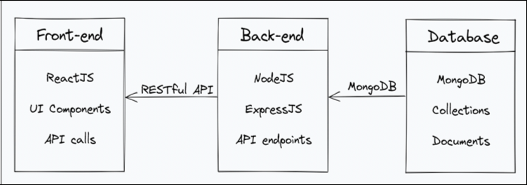

Figure. 1: SYSTEM ARCHITECTURE

The LearnCoding ed-tech platform is architectured around a client-server model, with three core components: the front end, back end, and database. The front end is developed using ReactJS, facilitating the creation of dynamic and responsive user interfaces that interact with the back end through RESTful API calls. Frameworks like CSS, Tailwind, and Redux are employed for styling, state management, and enhanced functionality, while development is carried out in the VSCode environment. On the back end, Node.js and Express.js form the foundation, with MongoDB serving as the primary database for flexible and scalable data storage. Key functionalities include user authentication, course management, and payment integration. MongoDB's NoSQL structure allows for efficient storage of course content, user data, and platform-related information, ensuring a seamless and engaging
 |  |  | INTERNATIONAL JOURNAL OF PROGRESSIVE |  |  |  |  |  |  |  |  |  | e- |  |  |  | ISSN :
 |  |  |  |  |  |  |  |  |  |  |  |  | 2583-
 |  | RESEARCH |  |  | IN ENGINEERING |  |  |  |  |  | MANAGEMENT AND
 |  |  |  |  |  |  |  |  |  |  |  |  | 1062
 |  |  |  |  |  | SCIENCE |  |  |  | (IJPREMS)
 |  |  |  |  |  |  |  |  |  |  |  |  |  |  | Impact
 | www.ijprems.co
 | www.ijprems.co |  | Vol. 04, Issue 01, January 2024, pp : xx-xx
 | m |  |  |  |  |  |  |  |  |  |  |  | Factor :
learning experience for students, instructors, and administrators

5. DATA MODELS AND DATABASE SCHEMA
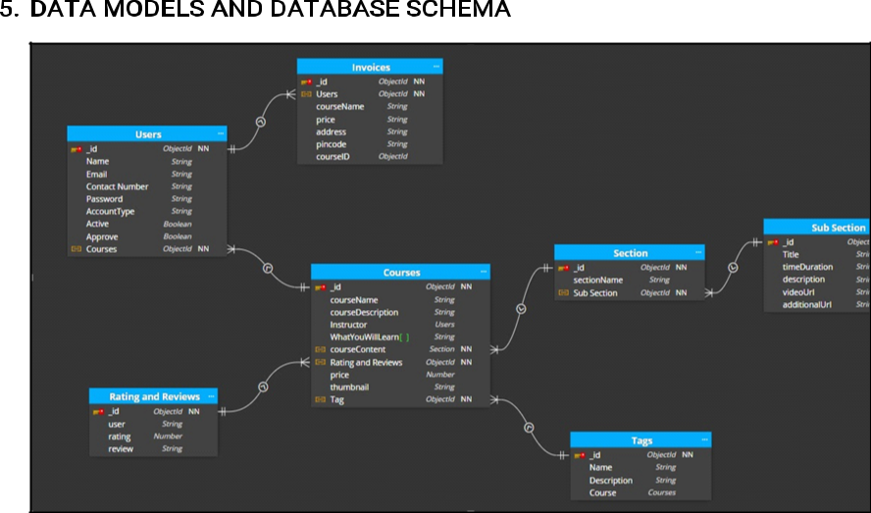

Figure. 2:Data Models and Database Schema:

The data models and database schema of the LearnCoding ed-tech platform play a crucial role in managing and organizing the platform's data effectively. Here is an overview based on the provided information:

Data Models:

Student Schema: Includes fields such as name, email, password, and course details for each student. This schema likely stores information related to student profiles, authentication credentials, and enrolled courses. Instructor Schema: Contains fields like name, email, password, and course details for each instructor. This schema is likely responsible for storing instructor profiles, authentication details, and courses taught by each instructor.
Course Schema: Includes fields such as course name, description, instructor details, and media content. This schema likely stores information about the courses available on the platform, including course details, associated instructors, and multimedia content like videos, images, and documents.
Database Schema:

MongoDB Implementation: MongoDB is utilized as the primary database for the platform, offering a flexible and scalable data storage solution.
Structured Data Storage: The database schema likely reflects the data models mentioned above, organizing data into collections that correspond to students, instructors, and courses.
 |  |  | INTERNATIONAL JOURNAL OF PROGRESSIVE |  |  |  |  |  |  |  |  |  | e- |  |  |  | ISSN :
 |  |  |  |  |  |  |  |  |  |  |  |  | 2583-
 |  | RESEARCH |  |  | IN ENGINEERING |  |  |  |  |  | MANAGEMENT AND
 |  |  |  |  |  |  |  |  |  |  |  |  | 1062
 |  |  |  |  |  | SCIENCE |  |  |  | (IJPREMS)
 |  |  |  |  |  |  |  |  |  |  |  |  |  |  | Impact
 | www.ijprems.co
 | www.ijprems.co |  | Vol. 04, Issue 01, January 2024, pp : xx-xx
 | m |  |  |  |  |  |  |  |  |  |  |  | Factor :
Relationships and Indexing: The schema may include relationships between entities (e.g., students enrolled in courses, instructors teaching courses) and indexes for efficient data retrieval and querying.
Cloud-Based Media Management: Cloudinary, a cloud-based media management service, is used to store and manage all media content, including images, videos, and documents. This integration enhances the platform's multimedia capabilities and ensures seamless access to course materials.
Overall, the data models and database schema of LearnCoding are designed to efficiently store and manage student, instructor, course, and multimedia content, enabling seamless interactions and content delivery within the platform. By leveraging MongoDB and cloud-based media management services, LearnCoding ensures a robust and scalable database architecture to support its educational offerings and user interactions effectively.

6. IMPLEMENTATION

The implementation of the LearnCoding ed-tech platform involves the development and integration of various components, technologies, and functionalities to create a seamless and interactive learning experience for users. Here is an overview of the implementation based on the provided information:

Front-end Implementation:

Utilization of ReactJS: The front end is built using ReactJS, a popular JavaScript library for building user interfaces. ReactJS enables the creation of dynamic and responsive UI components.
Styling Frameworks: CSS and Tailwind are used for styling the front end, ensuring a visually appealing and responsive design.
State Management: Redux is employed for managing the state of the application, facilitating efficient data flow and interaction within the front end.
Additional Functionality: npm packages are utilized to add extra functionality to the front end, enhancing user experience and feature capabilities.
Development Environment: Visual Studio Code (VSCode) serves as the primary code editor for developing the front-end components and functionalities.
Back-end Implementation:

Monolithic Architecture: The back end is built using Node.js and Express.js within a monolithic architecture, consolidating all application modules into a single large program for better control, security, and performance. Database Integration: MongoDB is used as the primary database for storing and retrieving data, providing a flexible and scalable solution for managing user information, course details, and platform content.
Features and Functionalities: The back end offers functionalities such as user authentication and authorization, course management (creation, update, deletion), and payment integration through Razorpay for seamless checkout and enrollment processes.
Data Models and Database Schema Implementation:

Student, Instructor, and Course Schemas: Data models are implemented to define the structure and attributes of student, instructor, and course entities within the database.
MongoDB Integration: The data models are mapped to MongoDB collections, ensuring efficient storage and retrieval of data in alignment with the defined schema.
Cloud-Based Media Management: Cloudinary is integrated for storing and managing media content, enhancing
 |  |  | INTERNATIONAL JOURNAL OF PROGRESSIVE |  |  |  |  |  |  |  |  |  | e- |  |  |  | ISSN :
 |  |  |  |  |  |  |  |  |  |  |  |  | 2583-
 |  | RESEARCH |  |  | IN ENGINEERING |  |  |  |  |  | MANAGEMENT AND
 |  |  |  |  |  |  |  |  |  |  |  |  | 1062
 |  |  |  |  |  | SCIENCE |  |  |  | (IJPREMS)
 |  |  |  |  |  |  |  |  |  |  |  |  |  |  | Impact
 | www.ijprems.co
 | www.ijprems.co |  | Vol. 04, Issue 01, January 2024, pp : xx-xx
 | m |  |  |  |  |  |  |  |  |  |  |  | Factor :
the platform's multimedia capabilities and content delivery.

By effectively implementing the front-end components, back-end functionalities, and database schema as per the outlined architecture and requirements, the LearnCoding platform aims to deliver a comprehensive and engaging educational experience for students and instructors. The integration of technologies like ReactJS, Node.js, Express.js, and MongoDB ensures a robust and scalable infrastructure to support the platform's features and user interactions seamlessly

7. Interface

.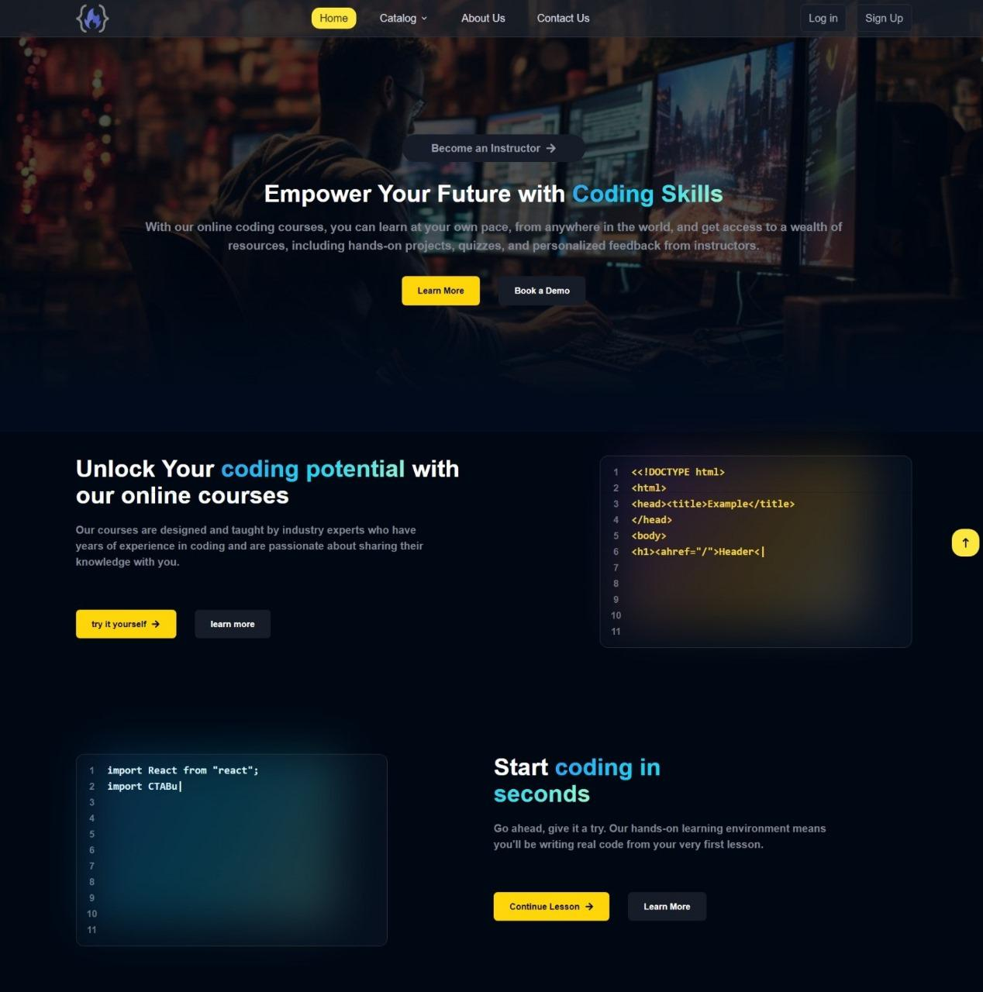

 |  |  | INTERNATIONAL JOURNAL OF PROGRESSIVE |  |  |  |  |  |  |  |  |  | e- |  |  |  | ISSN :
 |  |  |  |  |  |  |  |  |  |  |  |  | 2583-
 |  | RESEARCH |  |  | IN ENGINEERING |  |  |  |  |  | MANAGEMENT AND
 |  |  |  |  |  |  |  |  |  |  |  |  | 1062
 |  |  |  |  |  | SCIENCE |  |  |  | (IJPREMS)
 |  |  |  |  |  |  |  |  |  |  |  |  |  |  | Impact
 | www.ijprems.co
 | www.ijprems.co |  | Vol. 04, Issue 01, January 2024, pp : xx-xx
 | m |  |  |  |  |  |  |  |  |  |  |  | Factor :

8. CONCLUSION AND FUTURE SCOPE

In conclusion, this document outlines the architecture, features, and functionalities of the LearnCoding ed-tech platform. It highlights the use of MERN stack technologies and REST API design and outlines the deployment process using free hosting services, Vercel for the front-end, Render.com or Railway.app for the backend, and MongoDB Atlas for the database. Additionally, it lists potential future enhancements that could be implemented to improve the platform, along with their estimated timelines and priorities.

Throughout the development of the project, various achievements will be made in terms of implementing the desired functionalities and creating a user-friendly interface. However, there will be challenges to be faced during the development process, such as integrating different technologies and debugging

9. REFERENCE

- A. D. Dumford and A. L. Miller, “Online learning in higher education: exploring advantages and disadvantages for engagement,” Journal of Computing in Higher Education, vol. 30, no. 3, pp. 452–465, Dec 2018. [Online]. Available: https://doi.org/10.1007/s12528-018-9179-z

- F. Ferri, P. Grifoni, and T. Guzzo, “Online learning and emergency remote teaching: Opportunities and challenges in emergency situations,” Societies, vol. 10, no. 4, p. 86, Nov 2020. [Online]. Available: http://dx.doi.org/10.3390/soc10040086

  - M. Riedel, G. Eisenkolb, N. Amann, A. Karge, B. Meyer, M. Tensil, F. Recker, A. M. Dobberkau, F. Riedel, B. Kuschel, and E. Klein, “Experiences with alternative online lectures in medical education in obstetrics and gynecology during the covid-19 pandemic—possible efficient and student-orientated models for the future?” Archives of Gynecology and Obstetrics, vol. 305, no. 4, pp. 1041–1053, Apr 2022. [Online]. Available: https://doi.org/10.1007/s00404-021-06356-5

- J. Chen, “Adoption of m-learning apps: A sequential mediation analysis and the moderating role of personal innovativeness in information technology,” Computers in Human Behavior Reports, vol. 8, no. 1, p. 100237, Dec 2022

