**Optimizing the KYC Verification System Using Ethereum Blockchain**

# Ms. Syed Nazia Banu1, S.M.Shabana2, B.Usha3, V.Vennela devi4, C.Pujitha5

# T.Nikhila6

1 Assistant Professor in Department of Computer Science and Engineering, Santhiram Engineering College, Nandyal, Kurnool, Andhra Pradesh, India.

2,3,4,5,6 Student, Department of Computer Science and Engineering, Santhiram Engineering College, Nandyal, Kurnool, Andhra Pradesh, India.

E-mail: [nazia.cse@srecnandyal.edu.in](mailto:nazia.cse@srecnandyal.edu.in)

**ABSTRACT**

With today's advances in digitalization, people use their personal identity documents on a daily basis, which are shared with third parties without their prior authorization and maintained in a number of random places. Government organizations, banks, credit agencies, and other financial institutions keep such identity information in their own databases. The presence of such sensitive information in several places raises the likelihood of vulnerabilities. For a long time, the financial industry has been looking for answers to such difficulties, and one feasible alternative is blockchain. By keeping a single safe database on blockchain, the Know Your Customer (KYC) verification procedure reduces the repetitive KYC checks that banks presently do. Because blockchain is immutable and unalterable by definition, illegal modifications to data are instantly invalidated. Blockchain’s decentralized design will enable the collection of data from different authoritative service providers into a single immutable, safe, and verified database. The Blockchain KYC system uses a secure, public digital ledger to provide rapid and fully secure identity verification.

**Keywords:** Know Your Customer, Blockchain, Ethereum, Tokenization, Smart contract, decentralization, Immutable ledger.

# I.INTRODUCTION

The Know Your Customer (KYC) process is a crucial component of the financial sector, ensuring compliance with regulations and safeguarding against financial crimes such as money laundering and terrorist financing. However, traditional KYC procedures are often cumbersome, time-consuming, and prone to vulnerabilities due to scattered data storage across multiple databases [1]. These challenges have led to the exploration of innovative solutions, with blockchain technology emerging as a promising avenue for optimizing the KYC verification process.

Blockchain technology, particularly Ethereum's blockchain, offers a decentralized framework for developing applications, including smart contracts, which can revolutionize KYC procedures [2]. By leveraging Ethereum's blockchain, the project aims to address the inefficiencies and vulnerabilities inherent in traditional KYC systems, offering a secure, transparent, and streamlined approach to identity verification in the financial sector.

# EXISTING SYSTEM

A blockchain-based KYC confirmation system that would create a block for each bank was presented in writing. The client should enter the KYC data after each bank's block has been created. This data is then kept in the blockchain network by opening a blockchain account through the client account. They can then demand that the bank open a record for their sake, and the information will be put away on the blockchain. Just the shopper can alter or change the data contained in a blockchain, and just with their assent. Just the mentioning bank might get to the client KYC desk work by presenting a view solicitation to the client profile. The customer can decide to acknowledge or dismiss the solicitation when it is shipped off their profile.

# Disadvantages of the existing system:

* + - 1. Despite the fact that blockchain is utilized in the ongoing work for KYC check, our answer might offer a more significant level of information security and changelessness than the current work.
      2. Clients should over and over give KYC data to each bank under the ongoing framework, which brings about dreary information section. Clients might view this as baffling and tedious.
      3. In the existing system, the customer's access control options are restricted to "allow" or "deny." This could be restrictive, especially in cases where more nuanced access control is needed.

# PROPOSED SYSTEM

We want to foster a framework that use the capacities of the Ethereum blockchain to safely store and recover client or client information, as well as to plan natural UIs that monetary foundations and clients can use to send and get information. Using blockchain innovation, the Know Your Client (KYC) confirmation process limits the quantity of monotonous KYC makes sure that banks presently perform. Unlawful information refreshes are quickly negated on the grounds that blockchain is by definition permanent and unalterable. The decentralized engineering of blockchain innovation will work with the solidification of information from a few trustworthy specialist co-ops into a bound together, secure, and approved data set. The Blockchain KYC arrangement offers fast and totally secure character confirmation using a public, secure computerized record.

# WORKING PRINCIPLE

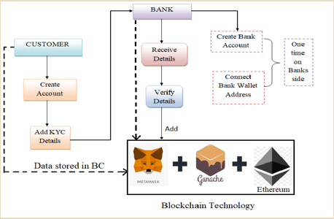

**Fig 1: Project flow**

# Advantages of the Proposed System:

* + - 1. The Ethereum blockchain, eminent for its solid security highlights, is used in our work. In contrast with the ongoing framework, this gives a more elevated level of information security, bringing down the chance of information breaks and unlawful access.
      2. We influence the decentralized quality of blockchain innovation to assemble data from different respectable specialist co-ops. It turns into a solitary, brought together, and confirmed data set therefore, expanding its viability and constancy.
      3. Our work is expected to be faster and more powerful in handling KYC demands, diminishing hang tight times for clients and monetary establishments. This is made conceivable by Ethereum's blockchain, which empowers speedy and totally secure personality check.
      4. The blockchain of Ethereum is extremely impervious to undesirable information adjustments since it is permanent by plan. This ensures the precision and consistency of KYC information.

# RESULTS

 

Fig 2 Home page Fig 3 open an account page

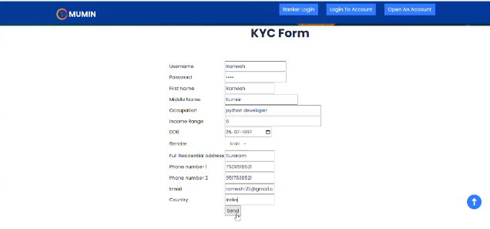 

Fig 4 kyc form page Fig 5 request sent to the banker 

Fig 6 banker login Fig 7 banker login page

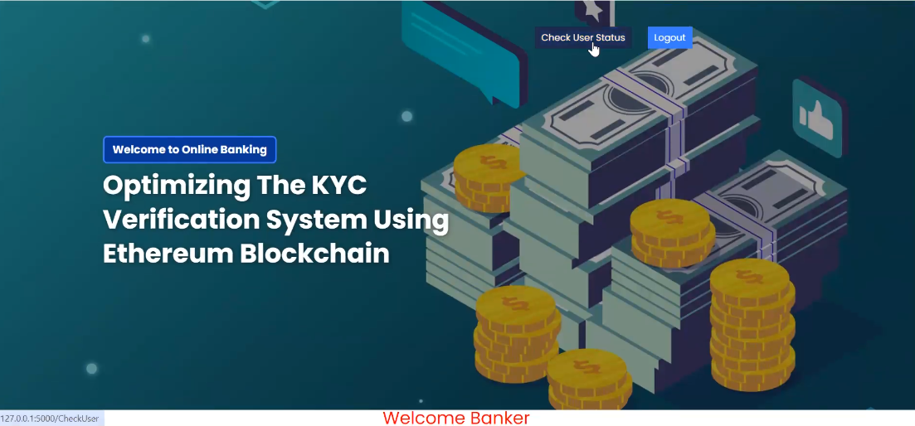

Fig 8 main page Fig 9 check user status page

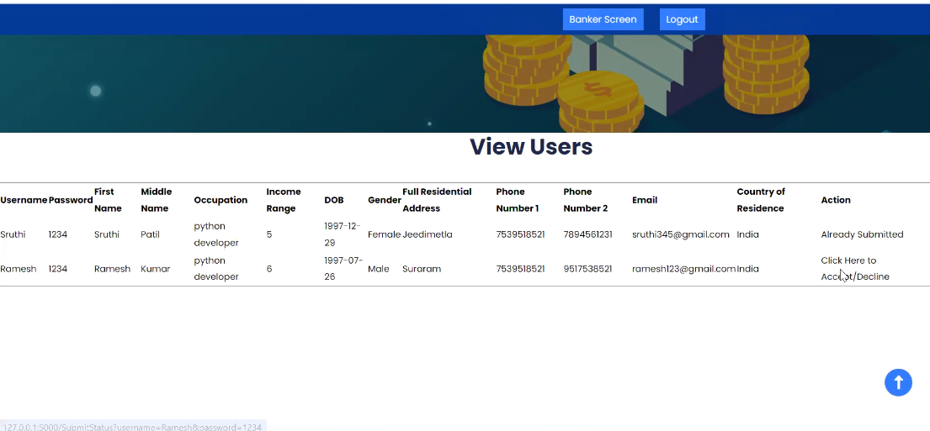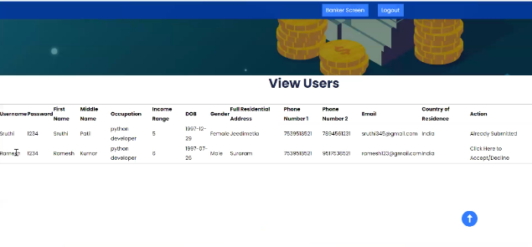

Fig 10 view users page Fig 11 details page

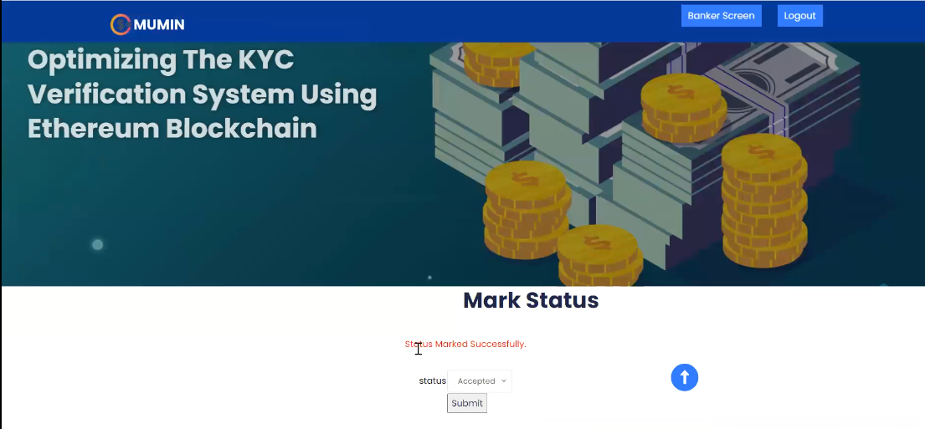

Fig 12 mark status Fig 13 status marked successfully page

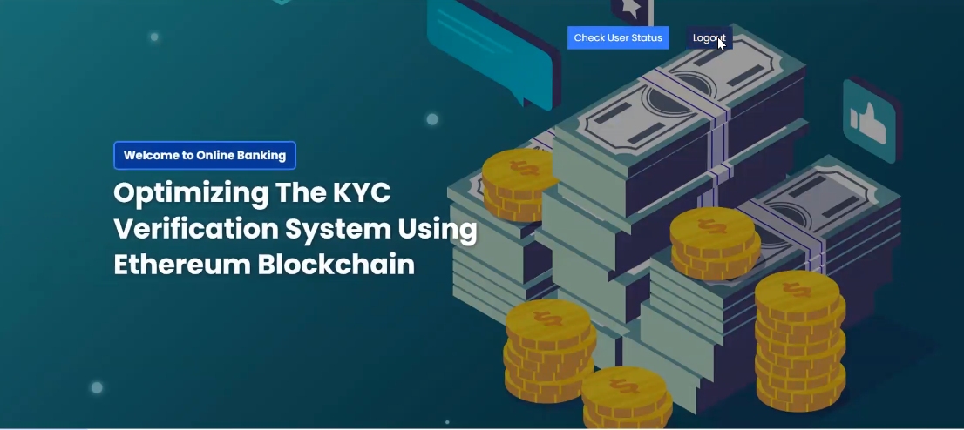 

Fig 14 logout Fig 15 login to account

 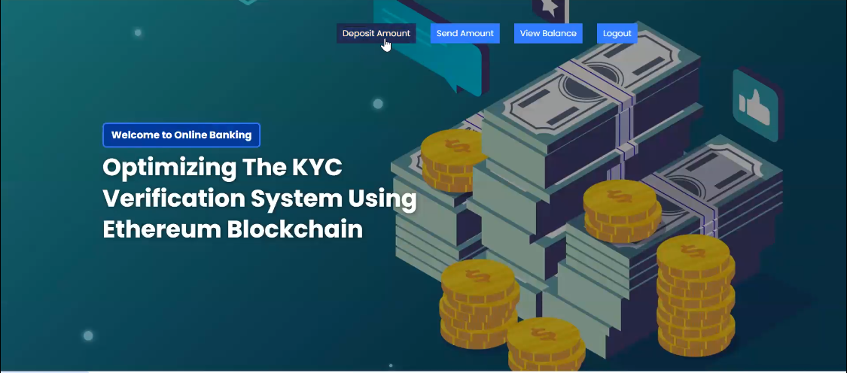

Fig 16 user login page Fig 17 main page

 

Fig 18 deposite amount Fig 19 amount deposite page

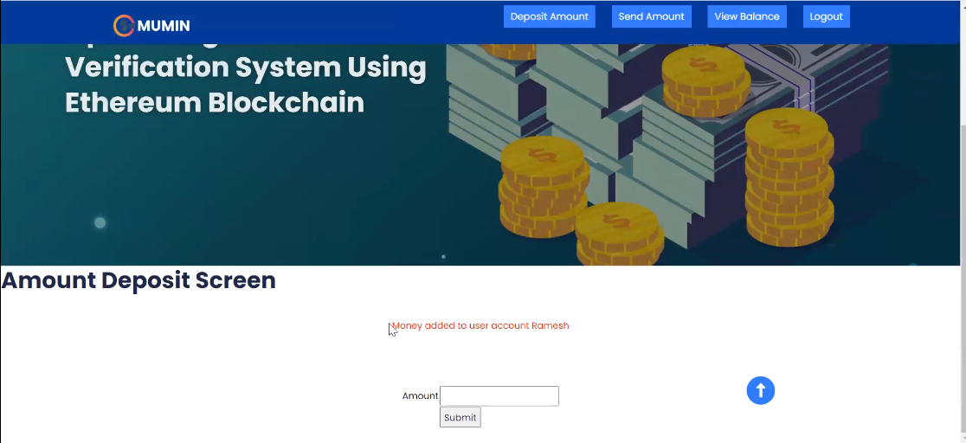 

Fig 20 money added to user account page Fig 21 send amont page

 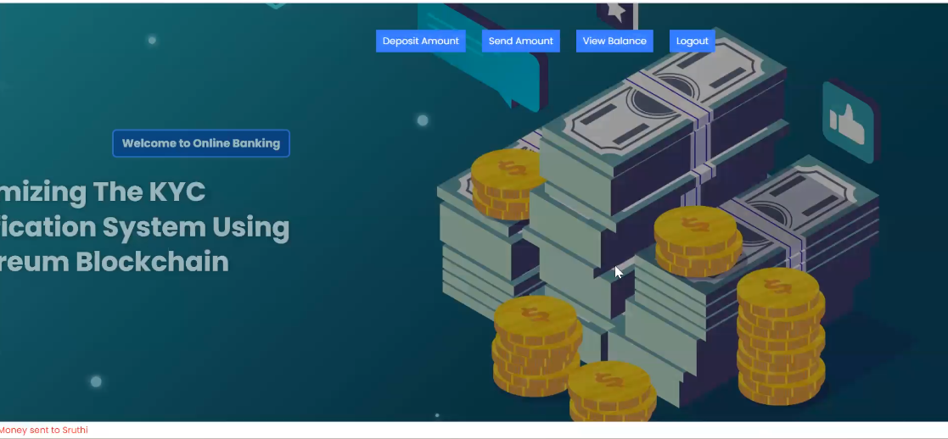

Fig 22 transfer amount page Fig 23 online banking page

 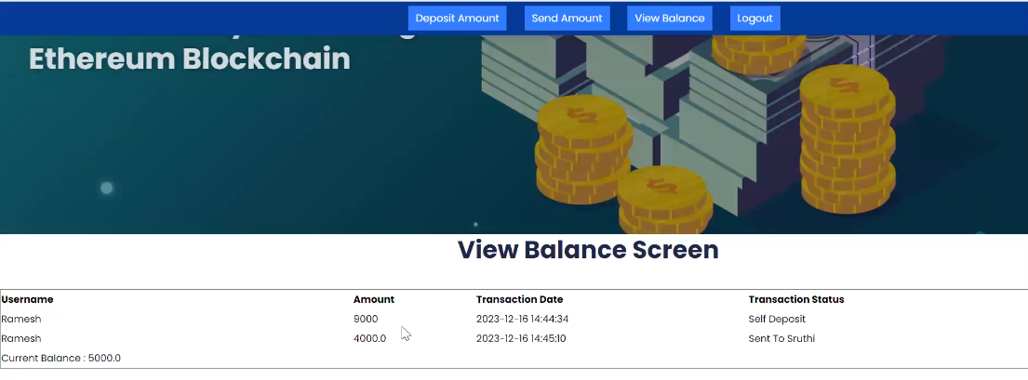

Fig 24 view balance page Fig 25 view balance page

 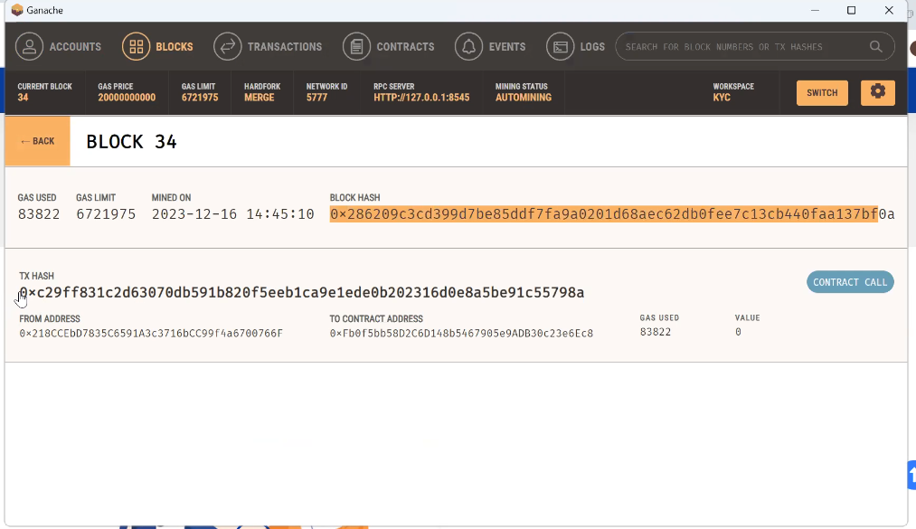

Fig 26 logout page Fig 27 Ganache



Fig 28 Metamask

# VI .CONCLUSION

In this project, We have analyzed the merits and the drawbacks of the previously implemented systems and its benefits. The results of our review showed the shortcomings of the traditional KYC system and the demand for a better architecture that is secure and safe from the current redundancies. We have found the implementation of blockchain technology for such a system to be appropriate and feasible. The nature of blockchain is immutable and decentralized which is exactly the requirement for the desired system. The majority of the review studies show that blockchain is the necessary technology to improve the finance sector not only limited to the KYC process. The issues in the current KYC process is greatly apparent when compared to the similar systems that use blockchain. Overall blockchain is one of the most promising technologies for KYC process and required to create the system that eliminates the inconsistencies of the current system.

**REFERENCES:**

1. Mahammad, F. S., & Viswanatham, V. M. (2020). Performance analysis of data compression algorithms for heterogeneous architecture through parallel approach. The Journal of Supercomputing, 76(4), 2275-2288.
2. Karukula, N. R., & Farooq, S. M. (2013). A route map for detecting Sybil attacks in urban vehicular networks. Journal of Information, Knowledge, and Research in Computer Engineering, 2(2), 540-544.
3. Farook, S. M., & NageswaraReddy, K. (2015). Implementation of Intrusion Detection Systems for High Performance Computing Environment Applications. Inter national journal of Scientific Engineering and Technology Research, 4(0), 41.
4. Sunar, M. F., & Viswanatham, V. M. (2018). A fast approach to encrypt and decrypt of video streams for secure channel transmission. *World Review of Science, Technology and Sustainable Development*, *14*(1), 11-28.
5. Mahammad, F. S., & Viswanatham, V. M. (2017). A study on h. 26x family of video streaming compression techniques. *International Journal of Pure and Applied Mathematics*, *117*(10), 63-66.
6. Devi,S M. S., Mahammad, F. S., Bhavana, D., Sukanya, D., Thanusha, T. S., Chandrakala, M., & Swathi, P. V. (2022).” Machine Learning Based Classification and Clustering Analysis of Efficiency of Exercise Against Covid-19 Infection.” Journal of Algebraic Statistics, 13(3), 112-117.
7. Devi, M. M. S., & Gangadhar, M. Y. (2012).” A comparative Study of Classification Algorithm for Printed Telugu Character Recognition.” *International Journal of Electronics Communication and Computer Engineering*, *3*(3), 633-641.
8. Devi, M. S., Meghana, A. I., Susmitha, M., Mounika, G., Vineela, G., & Padmavathi, M. MISSING CHILD IDENTIFICATION SYSTEM USING DEEP LEARNING.
9. V. Lakshmi chaitanya. "Machine Learning Based Predictive Model for Data Fusion Based Intruder Alert System." journal of algebraic statistics 13, no. 2 (2022): 2477-2483.
10. Chaitanya, V. L., & Bhaskar, G. V. (2014). Apriori vs Genetic algorithms for Identifying Frequent Item Sets. International journal of Innovative Research &Development, 3(6), 249-254.
11. Chaitanya, V. L., Sutraye, N., Praveeena, A. S., Niharika, U. N., Ulfath, P., & Rani, D. P. (2023). Experimental Investigation of Machine Learning Techniques for Predicting Software Quality.
12. Lakshmi, B. S., Pranavi, S., Jayalakshmi, C., Gayatri, K., Sireesha, M., & Akhila, A. Detecting Android Malware with an Enhanced Genetic Algorithm for Feature Selection and Machine Learning.
13. Lakshmi, B. S., & Kumar, A. S. (2018). Identity-Based Proxy-Oriented Data Uploading and Remote Data Integrity checking in Public Cloud. International Journal of Research, 5(22), 744-757.
14. Lakshmi, B. S. (2021). Fire detection using Image processing. Asian Journal of Computer Science and Technology, 10(2), 14-19.
15. Devi, M. S., Poojitha, M., Sucharitha, R., Keerthi, K., Manideepika, P., & Vasudha, C. Extracting and Analyzing Features in Natural Language Processing for Deep Learning with English Language.
16. Kumar JDS, Subramanyam MV, Kumar APS. Hybrid Chameleon Search and Remora Optimization Algorithm-based Dynamic Heterogeneous load balancing clustering protocol for extending the lifetime of wireless sensor networks. Int J Commun Syst. 2023; 36(17):e5609. doi:[10.1002/dac.5609](https://doi.org/10.1002/dac.5609)
17. David Sukeerthi Kumar, J., Subramanyam, M.V., Siva Kumar, A.P. (2023). A Hybrid Spotted Hyena and Whale Optimization Algorithm-Based Load-Balanced Clustering Technique in WSNs. In: Mahapatra, R.P., Peddoju, S.K., Roy, S., Parwekar, P. (eds) Proceedings of International Conference on Recent Trends in Computing. Lecture Notes in Networks and Systems, vol 600. Springer, Singapore. <https://doi.org/10.1007/978-981-19-8825-7_68>
18. Murali Kanthi, J. David Sukeerthi Kumar, K. Venkateshwara Rao, Mohmad Ahmed Ali, Sudha Pavani K, Nuthanakanti Bhaskar, T. Hitendra Sarma, “A FUSED 3D-2D CONVOLUTION NEURAL NETWORK FOR SPATIAL-SPECTRAL FEATURE LEARNING AND HYPERSPECTRAL IMAGE CLASSIFICATION,” J Theor Appl Inf Technol, vol. 15, no. 5, 2024, Accessed: Apr. 03, 2024. [Online]. Available: [www.jatit.org](http://www.jatit.org)
19. Prediction Of Covid-19 Infection Based on Lifestyle Habits Employing Random Forest Algorithm FS Mahammad, P Bhaskar, A Prudvi, NY Reddy, PJ Reddy journal of algebraic statistics 13 (3), 40-45
20. Machine Learning Based Predictive Model for Closed Loop Air Filtering System P Bhaskar, FS Mahammad, AH Kumar, DR Kumar, SMA Khadar, ...Journal of Algebraic Statistics 13 (3), 609-616
21. Kumar, M. A., Mahammad, F. S., Dhanush, M. N., Rahul, D. P., Sreedhara, K. L., Rabi, B. A., & Reddy, A. K. (2022). Traffic Length Data Based Signal Timing Calculation for Road Traffic Signals Employing Proportionality Machine Learning. Journal of Algebraic Statistics, 13(3), 25-32.
22. Kumar, M. A., Pullama, K. B., & Reddy, B. S. V. M. (2013). Energy Efficient Routing In Wireless Sensor Networks. International Journal of Emerging Technology and Advanced Engineering, 9(9), 172-176.
23. Kumar, M. M. A., Sivaraman, G., Charan Sai, P., Dinesh, T., Vivekananda, S. S., Rakesh, G., & Peer, S. D. BUILDING SEARCH ENGINE USING MACHINE LEARNING TECHNIQUES.
24. “ Providing Security in IOT using Watermarking and Partial Encryption. ISSN No:

2250-1797 Issue 1, Volume 2 (December 2011)

1. The Dissemination Architecture of Streaming Media Information on Integrated CDN and P2P, ISSN 2249-6149 Issue 2, Vol.2 ( March-2012)
2. Provably Secure and Blind sort of Biometric Authentication Protocol using Kerberos, ISSN: 2249-9954, Issue 2, Vol 2 (APRIL 2012)
3. D.LAKSHMAIAH, DR.M.SUBRAMANYAM, DR.K.SATYA PRASAD,” DESIGN OF LOW POWER 4- BIT CMOS BRAUN MULTIPLIER BASED ON THRESHOLD VOLTAGE TECHNIQUES”, GLOBAL JOURNAL OF RESEARCH IN ENGINEERING, VOL.14(9),PP.1125-1131,2014.
4. R SUMALATHA, DR.M.SUBRAMANYAM, “IMAGE DENOISING USING SPATIAL ADAPTIVE MASK FILTER”, IEEE INTERNATIONAL CONFERENCE ON ELECTRICAL, ELECTRONICS, SIGNALS, COMMUNICATION &AMP; OPTIMIZATION (EESCO-2015), ORGANIZED BYVIGNANS INSTITUTE OF INFORMATION TECHNOLOGY, VISHAKAPATNAM, 24 TH TO 26TH JANUARY 2015. (SCOPUS INDEXED)
5. P.BALAMURALI KRISHNA, DR.M.V.SUBRAMANYAM, DR.K.SATYA PRASAD, “HYBRID GENETIC OPTIMIZATION TO MITIGATE STARVATION IN WIRELESS MESH NETWORKS”, INDIAN JOURNAL OF SCIENCE AND TECHNOLOGY,VOL.8,NO.23,2015. (SCOPUS INDEXED)
6. Y.MURALI MOHAN BABU, DR.M.V.SUBRAMANYAM,M.N. GIRI PRASAD,” FUSION AND TEXURE BASED CLASSIFICATION OF INDIAN MICROWAVE DATA – A COMPARATIVE STUDY”, INTERNATIONAL JOURNAL OF APPLIED ENGINEERING RESEARCH, VOL.10 NO.1, PP. 1003-1009, 2015. (SCOPUS INDEXED)