Secure Review: Private and Anonymous Feedback Platform

Bhavya Sri Guduri *Information Technology (JNTUK) Shri Vishnu Engineering College for*

*Women, Bhimavaram (JNTUK)*

Bhimavaram, India [bhavyasriguduri@gmail.com](mailto:bhavyasriguduri@gmail.com)

Bhargavi Chanapathi *Information Technology (JNTUK) Shri Vishnu Engineering College for*

*Women, Bhimavaram (JNTUK)*

Bhimavaram, India [bhargavichanapathi23@gmail.com](mailto:bhargavichanapathi23@gmail.com)

Veneela Sai Siva Priya Earlapati

*Information Technology (JNTUK) Shri Vishnu Engineering College for Women, Bhimavaram (JNTUK)*

Bhimavaram, India

[veneelaearlapati555@gmail.com](mailto:veneelaearlapati555@gmail.com)

Anusha Gude *Information Technology (JNTUK) Shri Vishnu Engineering College for*

*Women, Bhimavaram (JNTUK)*

Bhimavaram, India [gudeanusha81@gmail.com](mailto:gudeanusha81@gmail.com)

G.A.K.S. Rajeev Kumar Assistant Professor

*Information Technology (JNTUK) Shri Vishnu Engineering College for Women, Bhimavaram (JNTUK)*

Bhimavaram, India

[gaksit@svecw.edu.in](mailto:gaksit@svecw.edu.in)

***Abstract***— ***The goal of Secure Review is to offer an all- inclusive and intuitive web platform that facilitates easy user registration and location-based experience sharing. One of its main features is an advanced grading and evaluation system designed specifically for content provided by verifiers. Users can feel secure knowing that their shared information is confidential and intact because the system uses strong encryption techniques like Triple DES and AES to give the highest level of security for user data.***

**Keywords**— ***all-inclusive, intuitive web, confidential, location- based , encryption***

# Introduction

It is becoming more and more clear that a safe and user- friendly platform is required for sharing location-based experiences in this age of digital connection and connectivity. In order to meet this need, this project will provide a strong web platform that will guarantee the safe sharing of location-specific content while also facilitating easy user registration. By utilizing cutting-edge encryption methods and an extensive review system, the site provides users with a reliable space to interact, discover, and exchange their wide range of experiences.

In the digital age, the proliferation of location-based services has led to an increasing demand for secure and private mechanisms for generating and verifying location proofs. Existing solutions often rely on centralized authorities or entities, introducing vulnerabilities such as single points of failure, data breaches, and privacy concerns. Our goal is to create a decentralized system that's privacy- aware, minimizing the risks of centralized control and collusion attacks while ensuring the reliability and confidentiality of location proofs. We're building a Secure

Review platform to let users securely generate and rate posts posted by verifier , addressing these challenges head-on.

# Related Work

The security and privacy requirements for LBS in mobile and vehicular networks are analyzed in this paper. This study specifically discusses cryptographic techniques and privacy-enhancing technologies that offer location privacy in mobile and vehicle networks. Open study areas are identified and a comparison of the various methodologies suggested in the literature is made.

For private location-based queries, a hybrid technique is put out by. Both the LBS database and the user are safeguarded by this method. By applying a PIR protocol to the requests from the cloaked region and generalizing the user location to coarse-grained cloaked regions, they offer significant privacy protection.

# Literature Review

1. *A survey of fingerprint-based outdoor localization*

This survey's primary contribution is to categorize the current state of fingerprint-based localization techniques, which match and sense various environmental cues to determine an object's location. We first explain the operation of each fingerprinting technique and then go over the benefits and drawbacks of the systems that are constructed using these techniques. We end by pointing out a number of enhancements and areas of use for localization based on fingerprinting.

1. *An exploration to location–based service and its privacy preserving techniques*

In order to protect user location privacy, a number of researchers have proposed a variety of strategies based on

distributed and centralized methods. In this study, we conduct an exploratory assessment of these strategies. A significant percentage of these methods compromise on privacy, effectiveness, usability, and service quality. The numerous methods now in use for protecting the participating user's location privacy in LBS are described in depth and analyzed in this study.

# Research Design & Methodology

To guarantee the platform's successful development, the Secure Review project's research and design methodology entails a number of crucial elements. In order to comprehend current technologies and solutions linked to safe location proof generation and verification, a thorough literature analysis is conducted first. Requirement analysis is then carried out to specify project objectives and get feedback from stakeholders. The architecture, database structure, user interface, and security measures are described in the system design that follows. Through early feedback and design concept validation through prototyping, iterative refinement can be achieved. After that, compatibility and scalability are ensured by employing suitable technologies like Java and MySQL for development. Reliability, security, and performance are guaranteed by extensive testing and evaluation, with incremental enhancements made in response to test and user input. The ultimate goal of this methodical approach is to provide a reliable, safe, and easy- to-use platform for the creation and verification of secure location proof.

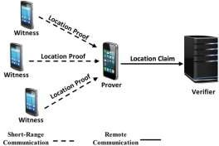

# Conclusion

The project introduces a robust framework for secure and private location proof generation and verification. Through the implementation of decentralized architecture and innovative protocols like P-TREAD, it effectively mitigates fraudulent activities, ensuring the integrity of location proofs. The system's emphasis on user privacy, reliability against collusion attacks, and efficient LP generation process positions it as a promising solution for ad hoc mobile applications.

By successfully integrating these components, Secure Review offers a comprehensive platform that addresses the key challenges in location-based authentication.

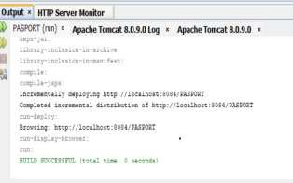

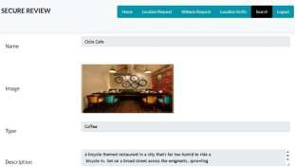

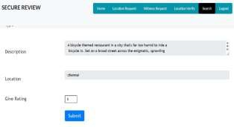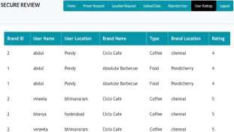

# Acknowledgment

We would like to express our sincere gratitude to Mr.

G.A.K.S Rajeev Kumar Sir, Assistant Professor at the Department of Information Technology, Shri Vishni Engineering College for Women, Bhimavaram, Andhra Pradesh, for invaluable guidance and support throughout this

research project. His expertise, encouragement, and constructive feedback have been instrumental in shaping the direction of this work. We are deeply grateful for mentorship and dedication to our academic and professional development

# References

1. P. Asuquo *et al.*, “Security and privacy in location-based services for vehicular and mobile communications: An overview, challenges, and countermeasures,” *IEEE Internet Things J.*, vol. 5, no. 6, pp. 4778- 4802, Dec. 2018.
2. Q. D. Vo and P. De, “A survey of fingerprint-based outdoor localization,” *IEEE Commun. Surveys Tuts.*, vol. 18, no. 1, pp. 491– 506, 1st Quart., 2016.
3. R. Gupta and U. PRao, “An exploration to location–based service and its privacy preserving techniques: A survey,” *Wireless Pers. Commun.*,vol. 96, no. 2, pp. 1973–2007, 2017K. Elissa, “Title of paper if known,” unpublished.
4. *Global Location–Based Services Market (2018–2023)*. Accessed: Jul. 20, 2019. [Online]. Available: <https://www.businesswire.com/news/> home/20180927005490/en/Global–Location-based-Services-Market 2018-2023-Projected-Grow.
5. Y. Li, L. Zhou, H. Zhu, and L. Sun, “Privacy–preserving location proof-for securing large–scale database–driven cognitive radio

networks,” *IEEE Internet Things J.*, vol. 3, no. 4, pp. 563–571, Aug. 2016.

1. A. Pham, K. Huguenin, I. Bilogrevic, I. Dacosta, and J. P. Hubaux, “SecureRun: Cheat–proof and private summaries for location–based activities,” *IEEE Trans. Mobile Comput.*, vol. 15, no. 8, pp. 2109– 2123, Aug. 2016.
2. I. Boureanu, A. Mitrokotsa, and S. Vaudenay, “Practical and prov ably secure distance–bounding,” J. Comput. Secur., vol. 23, no. 2, pp. 229–257, 2015.
3. M. R. Nosouhi, S. Yu, M. Grobler, Y. Xiang, and Z. Zhu, “SPARSE: Privacy-aware and collusion resistant location proof generation and verification,” in Proc. IEEE GLOBECOM, Dec. 2018, pp. 1–6
4. M. Grissa, A. A. Yavuz, and B. Hamdaoui, “Location privacy preserva tion in database–driven wireless cognitive networks through encrypted probabilistic data structures,” IEEE Trans. Cogn. Commun. Netw., vol. 3, no. 2, pp. 255–266, Jun. 2017.
5. G. Avoine et al., “Security of distance–bounding: A survey,” ACM Comput. Surv., vol. 51, no. 5, pp. 1–33, Jan. 2019.
6. C. Javali, G. Revadigar, K. B. Rasmussen, W. Hu, and S. Jha, “I am alice, i was in wonderland: Secure location proof generation and verification protocol,” in Proc. IEEE 41st Conf. Local Comput. Netw. (LCN), Nov. 2016, pp. 477–485.
7. S. Brands and D. Chaum, “Distance–bounding protocols,” in Proc. EUROCRYPT, 1993, pp. 344–359.