**Revolution Construction of house: “Dwell Well**

**System Based on Anomaly Detection”**

**1Utkarsh Deshmane,2 Prathamesh Parmar,3Darshan Borse,** **4Saurabh Sanmane,** **5Prof. Trupti Farande**

1Student, AI &DS, SRCOE, Pune, Maharashtra, India

2Student, AI &DS, SRCOE, Pune, Maharashtra, India

3Student, AI &DS, SRCOE, Pune, Maharashtra, India

4Student, AI &DS, SRCOE, Pune, Maharashtra, India

5 Professor, AI &DS, SRCOE, Pune, Maharashtra, India

**ABSTRACT**

**The construction of houses under the Pradhan Mantri Awaas Yojana Gramin (Dwell Well Systems) in India is a crucial initiative aimed at providing affordable housing to the rural population. However, ensuring the structural integrity of these houses is of utmost importance to ensure the safety and wellbeing of the occupants. This report presents a comprehensive approach to detecting anomalies in Dwell Well Systems housing construction, utilizing artificial intelligence and machine learning techniques.**

**The objective of this report is to develop an anomaly detection approach that can effectively identify any structural anomalies or defects in Dwell Well Systems housing construction. By leveraging predictive analysis models and image accuracy assessment, the proposed system aims to provide a reliable and efficient solution for ensuring the structural integrity of these houses.**

**Providing a solid foundation for understanding anomaly detection approach, this report begins with an introduction**  **that outlines the background and motivation behind the research. The background section provides an overview of the Dwell Well Systems scheme and highlights the importance of ensuring the structural integrity of the constructed houses. It also discusses the challenges and limitations faced in the current construction practices.**

**The motivation behind this research stems from the need to address the potential risks associated with structural anomalies in Dwell Well Systems housing construction. These anomalies can lead to severe consequences, including safety hazards and financial losses.**

1. **INTRODUCTION**

The "DwellWell" Application is an innovative web portal that Traditionally home inspections were time-consuming, manual processes**,** manual processes way house inspections are conducted. This report provides a comprehensive overview of the application, its features, and the impact it has on the house inspection industry.

The report begins with an introduction to the background and motivation behind the development of the DwellWell Application. It explores the challenges faced by Managers, inspectors, and clients in the traditional house inspection process and highlights **You** need **better** **and** more accurate **solutions**

The objective of the report is to provide a detailed understanding of the DwellWell Application, its scope, and the algorithms and mathematical models that drive its machine learning capabilities. It delves into the various modules and functionalities of the application, showcasing its applications in real-world scenarios.

The report also discusses the UML diagrams and goals of the application, along with the testing strategies employed, including unit testing and integration testing. Overall, this report serves as a comprehensive guide to the DwellWell Application, offering insights into its implementation, results, and future scope. It concludes with a reflection on the potential impact of the application on the house inspection industry and the benefits it brings to Managers, inspectors, and clients alike.

1. **METHODOLOGY**

The DwellWell Application is an innovative web portal that harnesses the power of machine learning to revolutionize the way house inspections are conducted. This application serves as a centralized platform for homeowners, inspectors, and clients to streamline the process of identifying anomalies within houses, notifying relevant parties, and facilitating efficient resolutions.

Traditionally, house inspections have been a time- consuming and manual process. Inspectors would physically visit properties, meticulously examine various aspects of the house, and document their findings. This process often involved extensive paperwork, which could be prone to errors and delays. Additionally, anomalies or issues discovered during inspections were often communicated through phone calls or emails, leading to potential miscommunication and inefficiencies.

The Dwell Well Application aims to address these challenges by leveraging machine learning algorithms and providing a user-friendly interface for all stakeholders involved in the house inspection process. By automating certain aspects of the inspection process and facilitating seamless communication, the application aims to enhance the overall efficiency and accuracy of house inspections.

1. **MODELING AND ANALYSIS**

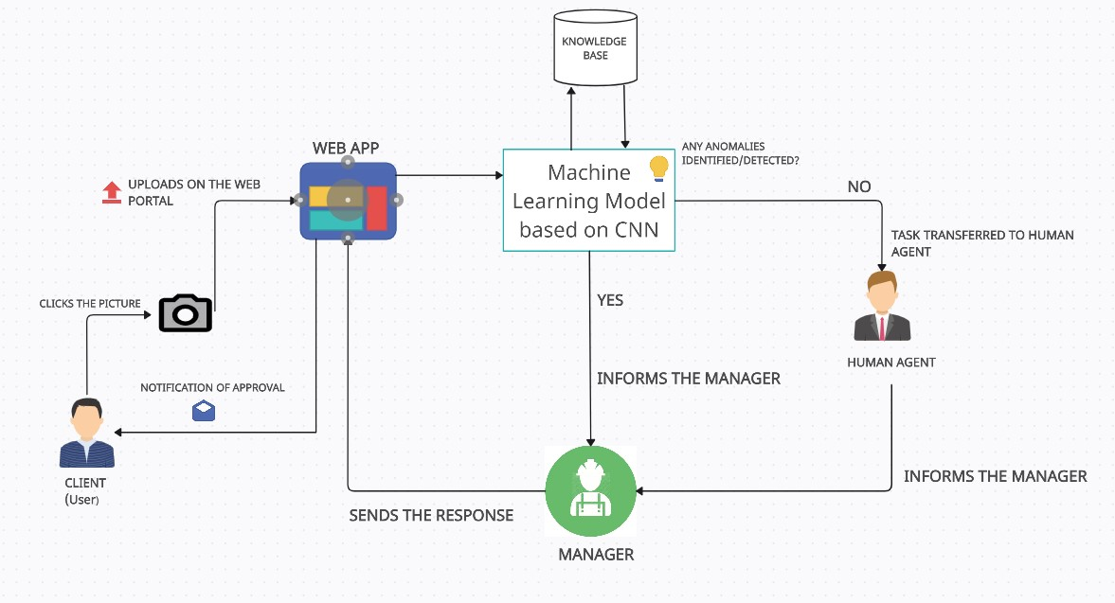

The DwellWell Application consists of three main modules: the Manager Module, the Inspector Module, and the Client Module.

**Manager Module:**

* Property Management: Managers can add and manage properties, keeping track of details like address and size.
* Inspection Scheduling: Managers can schedule inspections and plan accordingly.
* Anomaly Notifications: Managers receive real-time notifications about anomalies detected during inspections.
* Resolution Facilitation: Managers can communicate with relevant parties to resolve issues efficiently.
* Data Visualization: Visual representations help Managers analyze inspection data effectively.

**Benefits for Managers:**

1. Convenience: Centralized platform for management and scheduling.
2. Timely Notifications: Real-time alerts about anomalies.
3. Efficient Resolutions: Streamlined communication for quick issue resolution.
4. Data-driven Decision Making: Visual data representation aids in decision-making.
5. Peace of Mind: Confidence in thorough property assessment and issue resolution.

**Inspector Module:**

* User-friendly interface: Clean and intuitive for easy navigation.
* Inspection Management: Inspectors can create, schedule, and document inspections.
* Anomaly Identification and Reporting: Utilizes machine learning to detect anomalies and generate detailed reports.
* Communication and Collaboration: Facilitates communication with Managers and clients, scheduling follow-ups, and sending notifications.
* Integration with Other Modules: Seamlessly integrates with Manager and Client Modules for data flow.

**Client Module:**

* User Interface: Visually appealing and responsive for easy access.
* Property Management: Clients can manage properties, schedule inspections, and track progress.
* Inspection Reports and Findings: Access detailed reports with descriptions, images, and interactive features.
* Communication and Collaboration: Allows clients to communicate with inspectors, leave comments, and receive updates.
* Notifications and Reminders: Keeps clients informed about inspection status and anomaly updates.

These modules work together to streamline the inspection process, enhance communication, and ensure efficient resolution of issues detected during inspections.

1. **RESULTS**
2. **Module Functionality and Performance:**
   * Overview of how each module performed in terms of functionality and user experience.
   * Feedback from users (Managers, Inspectors, and Clients) on the usability and effectiveness of the modules.

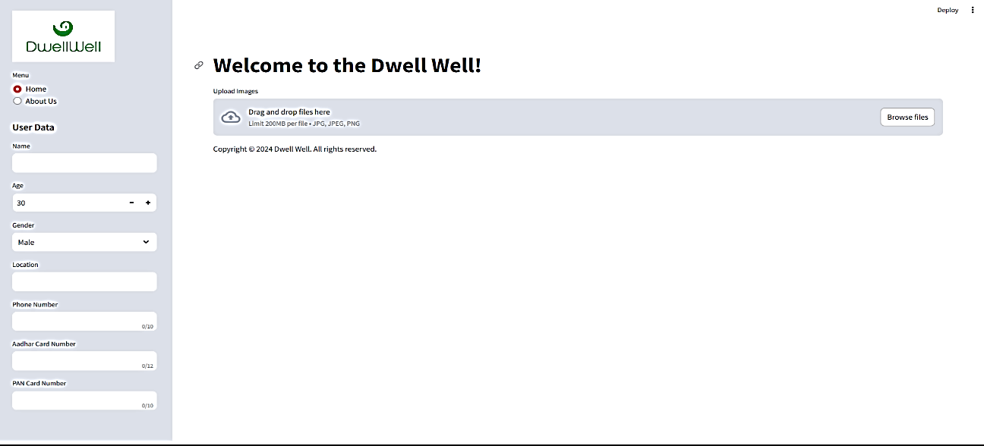

**2.User Satisfaction:**

* + Surveys or interviews with users to gauge satisfaction with the application.
  + Ratings and feedback provided by users regarding the overall experience.

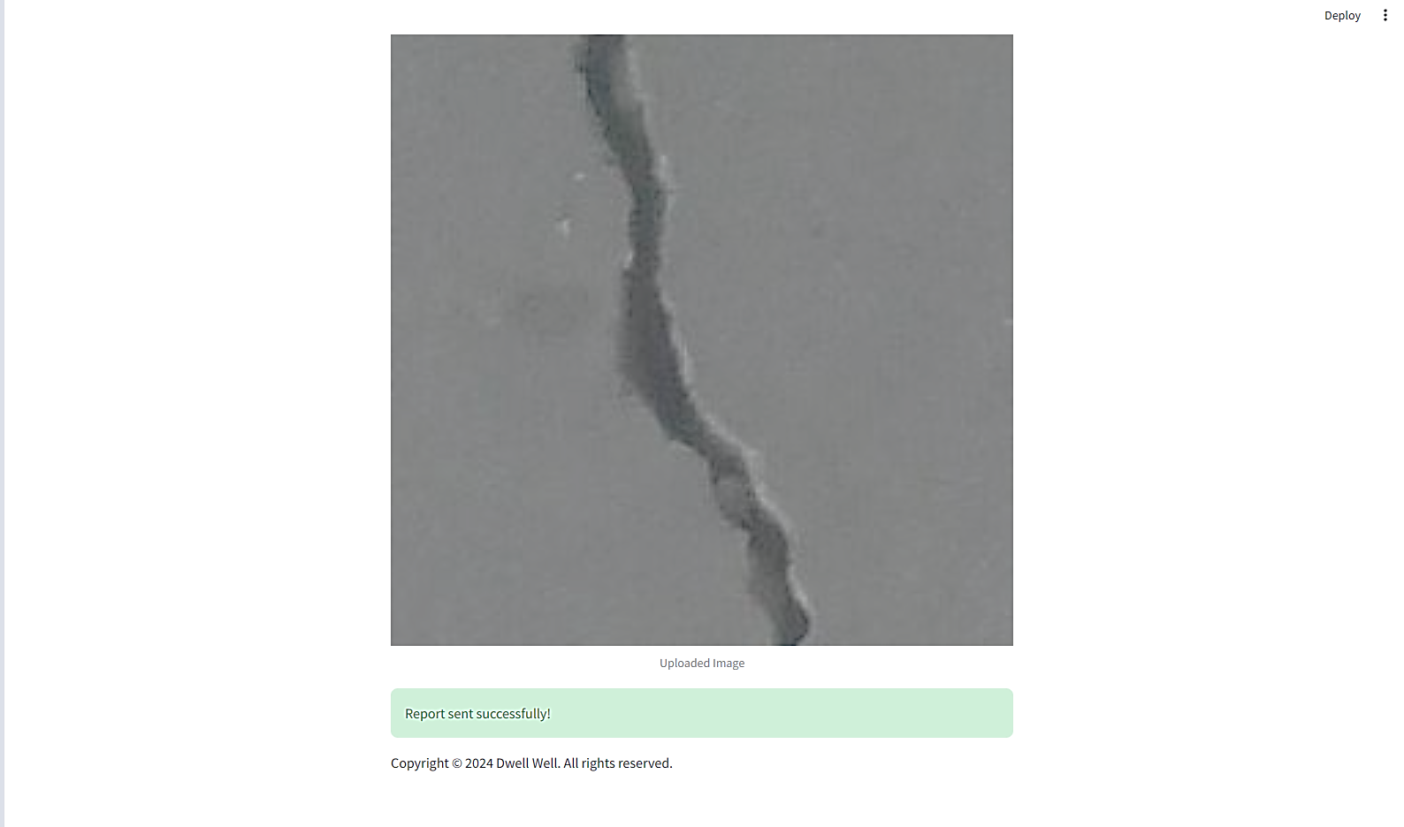

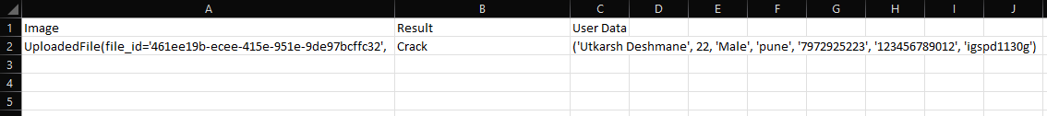

1. **CONCLUSION**

The "DwellWell" application represents a significant advancement in the field of house inspections by leveraging machine learning techniques. Through the development and implementation of this web portal, the process of conducting house inspections has been revolutionized. By harnessing the power of machine learning, "DwellWell" offers several notable advantages over traditional inspection methods. The application automates and streamlines various aspects of the inspection process, leading to increased efficiency and accuracy. Through the utilization of machine learning algorithms, "DwellWell" is able to analyze and interpret vast amounts of data related to house inspections. This allows for the identification of potential issues or areas in need of attention, providing valuable insights to inspectors and Managers. Furthermore, "DwellWell" enables predictive capabilities by leveraging historical data and patterns. Machine learning algorithms can analyze past inspection reports and housing data to make predictions about future maintenance needs or areas of concern. This proactive approach can help Managers and inspectors take appropriate actions in a timely manner, potentially mitigating risks and reducing costs.

1. **REFERENCES**
2. V. Chandola, A. Banerjee, and V. Kumar, “Anomaly Detection :A Survey,” ACM Comput. Surv., vol. 41, no. 3, pp. 71–97, 2009,doi: 10.1145/1541880.1541882.
3. M. Injadat, F. Salo, A. B. Nassif, A. Essex, and A. Shami,“Bayesian Optimization with Machine Learning Algorithms Towards Anomaly Detection,” in 2018 IEEE Global Communications Conference (GLOBECOM), 2018, pp. 1–6, doi:10.1109/GLOCOM.2018.8647714
4. T. Schlegl, P. Seeb¨ock, S. M. Waldstein, U. Schmidt-Erfurth,and G. Langs, Unsupervised Anomaly Detection with Generative Adversarial Networks to Guide Marker Discovery, vol. 10265, no. 2. Cham: Springer International Publishing, 2017.
5. F. Salo, M. Injadat, A. B. Nassif, A. Shami, and A. Essex, “Data mining techniques in intrusion detection systems: A systematic literature review,” IEEE Access. 2018, doi:10.1109/ACCESS.2018.2872784.
6. S. Agrawal and J. Agrawal, “Survey on anomaly detection usingdata mining techniques,” Procedia Comput. Sci., vol. 60, no. 1,pp. 708–713, 2015, doi: 10.1016/j.procs.2015.08.220.
7. R. A. Ariyaluran Habeeb, F. Nasaruddin, A. Gani, I. A. TargioHashem, E. Ahmed, and M. Imran, “Real-time big dataprocessing for anomaly detection: A Survey,” Int. J. Inf.Manage., vol. 45, no. February, pp. 289–307, 2019, doi:10.1016/j.ijinfomgt.2018.08.006.