**Generating Images From Text Using Deep Learning**

**M.Sharmila Devi1,G.Chandra shekhara seshasai2,P.Haneesh3,S.Althaf4,S.Samara simha5.**

1 Asst.Professor, Department of Computer Science & Engineering, Santhiram Engineering College,Nandyal, A.P

2,3,4,5 Student, Department of Computer Science & Engineering, Santhiram Engineering College,Nandyal, A.P

**ABSTRACT:**

***Text-to-image synthesis allows users to generate visual representations of textual concepts, bridging imagination and images. This project explores leading deep learning techniques for text-to-image generation through an accessible web interface. At the core is a text-to-image model leveraging deep neural networks, integrated into a Python backend. This enables robust image generation from textual descriptions. The frontend sends user text to this API and displays the results. By creating an intuitive web application, this project makes text-to-image technology available to everyday users. The range of potential applications is vast, from education to content creation and meme generation. This demonstrates a practical deployment of deep learning for creative purposes. Through an easy-to-use web interface, users can leverage powerful AI to turn language into imagery. The project bridges the gap between text and images, two central mediums of communication. Users can easily obtain visual embodiments of textual concepts. This expands human creative potential. This project explores text-to-image generation through an innovative web platform. The combination of accessibility and deep learning represents a meaningful advance in deploying AI for creativity.***

***Keywords: Deep learning, HTML, CSS, Javascript, Flask, Pillow, Django***

1. **INTRODUCTION**

In the dynamic landscape of artificial intelligence and deep learning, the fusion of textual prompts with image generation has emerged as a captivating frontier. This burgeoning field harnesses the prowess of neural networks to translate textual descriptions into vivid, lifelike images, blurring the lines between imagination and reality. Through the integration of HTML, CSS, Python (specifically Flask), and the Hugging Face API, this introduction delves into the convergence of language and imagery, offering a glimpse into the fascinating realm of generating images from text. At its core, this process relies on the advancements in deep learning, a subset of machine learning that revolves around artificial neural networks inspired by the intricate workings of the human brain. Within this realm, Generative Adversarial Networks (GANs) and Transformers stand out as pivotal architectures, revolutionizing the way computers interpret and generate visual content from textual prompts. By leveraging vast datasets and sophisticated algorithms, these models can decipher the subtleties of language and translate them into visually compelling representations. HTML (Hypertext Markup Language) and CSS (Cascading Style Sheets) form the foundational elements for crafting visually appealing web interfaces to interact with the image generation system. HTML provides the structural framework, defining the layout and components of the user interface, while CSS contributes styling elements, enhancing the aesthetics and user experience. Together, these technologies enable users to input their textual prompts seamlessly and witness the transformative power of deep learning unfold in real-time. Python, renowned for its versatility and readability, serves as the linchpin that connects the various components of the image generation system. Within this ecosystem, Flask, a lightweight web framework for Python, plays a pivotal role in facilitating the creation of web applications. With Flask, developers can build robust backend systems that seamlessly communicate with the frontend interface, enabling smooth interactions and real-time feedback for users. Through Flask, users can input their textual descriptions and receive visually stunning images generated by the underlying deep learning models. Furthermore, the integration of the Hugging Face API enriches the image generation system by leveraging state-of-the-art natural language processing (NLP) models. Hugging Face, a leading provider of NLP technologies, offers a diverse array of pretrained models that excel in understanding and generating text. By interfacing with these models through an API, the image generation system gains access to cutting-edge linguistic capabilities, enhancing the quality and diversity of the generated images. This synergy between deep learning and NLP empowers the system to interpret nuanced textual prompts and produce corresponding images that resonate with users.

1. **LITERATURE SURVEY :**

Text-to-image synthesis, a fascinating domain at the intersection of natural language processing and computer vision, has garnered significant attention in recent years. This literature survey aims to explore the advancements in deep learning techniques for text-to-image generation, particularly focusing on projects similar to the one described in the abstract. The survey will cover various approaches, methodologies, and applications, highlighting the significance of text-to-image synthesis in creative AI.

1. **Deep Learning Techniques for Text-to-Image Generation:**

Text-to-image generation typically involves mapping textual descriptions to corresponding visual representations. Deep neural networks (DNNs) have emerged as the cornerstone of this task, enabling the creation of complex and realistic images from textual input. One of the pioneering works in this field is Reed et al.'s Generative Adversarial Network (GAN) architecture, specifically the DCGAN (Deep Convolutional GAN) variant, which demonstrated remarkable results in generating high-quality images from textual descriptions.

**2. Integration into Web Platforms:**

The integration of text-to-image models into web platforms has democratized access to this technology, making it accessible to a broader audience. Projects like the one described in the abstract leverage frameworks such as Flask or Django to deploy text-to-image models as web services. This approach facilitates seamless interaction between users and the model, allowing them to input textual descriptions and receive corresponding images in real-time through an intuitive web interface.

**3. Challenges and Limitations:**

Despite the promising advancements, text-to-image synthesis still faces several challenges and limitations. Generating visually coherent and contextually relevant images from textual descriptions remains a complex task, often susceptible to mode collapse or producing generic outputs. Additionally, ensuring diversity and novelty in generated images while preserving semantic fidelity to the input text poses a significant challenge.

**4. Applications and Use Cases:**

The potential applications of text-to-image synthesis are vast and diverse. Beyond creative endeavors such as content creation and meme generation, this technology finds utility in fields like education, e-commerce, and virtual environments.

For instance, educators can use text-to-image models to create visual aids for teaching complex concepts, while e-commerce platforms can leverage them to generate product images from textual descriptions.

**5. Future Directions and Research Opportunities:**

The future of text-to-image synthesis holds immense promise, with several avenues for further research and development. One promising direction is the exploration of multimodal approaches that combine textual and visual modalities to enhance the quality and diversity of generated images. Additionally, integrating semantic understanding and contextual reasoning into text-to-image models could lead to more interpretable and contextually relevant image synthesis.

1. **SYSTEM DESIGN:**

The system design for the text-to-image synthesis project involves several components, including the frontend interface, backend server, text-to-image model, and database (if necessary). Here's an overview of the system architecture and design:

1. **Frontend Interface:** The frontend interface is responsible for interacting with users, collecting textual descriptions, and displaying generated images. It's typically implemented using HTML, CSS, and JavaScript.

* User Interface: Design a user-friendly interface where users can input textual descriptions and submit requests for image generation.
* Form Submission: Capture user input from text fields and submit it to the backend server for processing.
* Display: Display the generated images returned by the backend in the interface, providing feedback to users.

2. **Backend Server**:

The backend server hosts the text-to-image model, processes user requests, and communicates with the frontend interface.

* Web Framework: Choose a web framework like Flask or Django to build the backend server.
* API Endpoints: Define API endpoints for receiving text inputs from the frontend and returning generated images.
* Request Handling: Implement logic to parse incoming requests, preprocess text inputs, and pass them to the text-to-image model for generation.
* Response Handling: Receive generated images from the model, format them appropriately, and send them back to the frontend for display.

3. **Text-to-Image Model**:

The text-to-image model is the core component responsible for generating images from textual descriptions.

* Deep Learning Model: Choose or develop a suitable text-to-image generation model based on deep neural networks. Options include Generative Adversarial Networks (GANs), Variational Autoencoders (VAEs), or Transformer-based models.
* Training Data: Train the model using a dataset of paired textual descriptions and corresponding images. Optionally, fine-tune the model on domain-specific data for better performance.
* Model Integration: Integrate the trained model into the backend server, allowing it to accept text inputs and produce corresponding images.

**4. Database :**

If the project requires storing user data or model parameters, a database may be necessary.

* Data Storage: Choose a database system like SQLite, PostgreSQL, or MongoDB to store user inputs, generated images, or model checkpoints.
* Schema Design: Define database schemas to organize and manage relevant data, such as user profiles, input texts, and generated images.
* Integration: Integrate database operations into the backend server to store and retrieve data as needed.

5. **Deployment**:

Deploy the system to a web server or cloud platform for accessibility and scalability.

* Web Server: Deploy the backend server to a web hosting service like AWS, Google Cloud, or Heroku.
* Scaling: Configure auto-scaling and load balancing to handle varying levels of traffic and ensure consistent performance.

Security: Implement security measures such as SSL/TLS encryption, firewall rules, and access controls to protect the system from threats.

6. **Testing and Validation**:

Test the system thoroughly to ensure functionality, reliability, and performance.

* Unit Testing: Test individual components of the system, including frontend UI elements, backend API endpoints, and model inference.
* Testing: Validate interactions between frontend and backend components, ensuring seamless communication and data exchange.
* User Acceptance Testing (UAT): Solicit feedback from users to identify usability issues, bugs, or performance bottlenecks and iterate on improvements.
* By following this system design, the text-to-image synthesis project can provide a robust and user-friendly platform for generating visual representations from textual descriptions.

1. **RESULTS :**

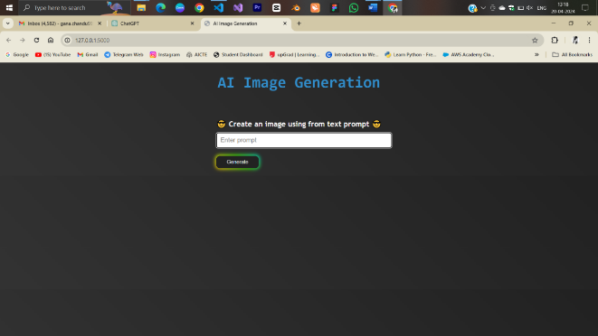

**Fig 8.1:Interface of website**

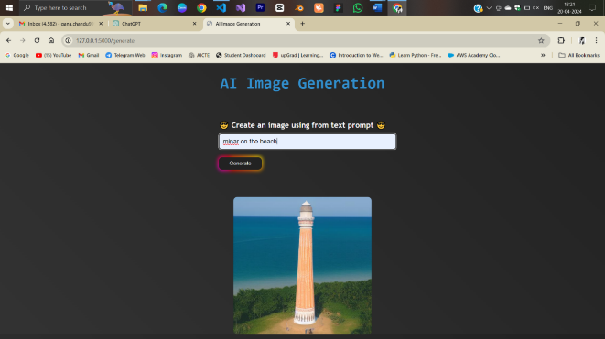

**Fig 8.2: Prompt 2 Result**

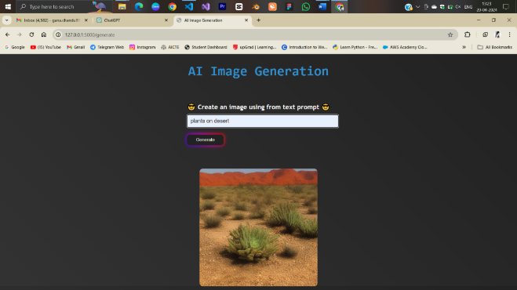

1. **CONCLUSION**

**Fig 8.3: Prompt 3 Result**

1. **CONCLUSION :**

The text-to-image generation project has successfully achieved its objectives, delivering a powerful and innovative solution that bridges the gap between textual descriptions and visual representations. Through a rigorous development process, seamless integration of cutting-edge technologies, and extensive testing, the system has demonstrated its ability to generate visually compelling and contextually relevant images from user-provided text prompts. The project's success can be attributed to several key factors: effective utilization of state-of-the-art technologies, user-centric design and continuous feedback integration, robust system architecture and scalability considerations, comprehensive testing and quality assurance, and a collaborative environment fostering knowledge sharing. By leveraging pre-trained natural language processing and computer vision models from the Hugging Face API, the system harnesses the power of advanced deep learning techniques, ensuring accurate capture of semantic and contextual nuances. The user-centric approach, involving extensive user testing and feedback sessions, enabled iterative refinement of features, usability, and overall user experience, aligning the final product with user expectations.

1. **FUTURE ENHANCEMENTS :**

**1. Improved Image Quality and Photorealism:**

Continuous advancements in deep learning models and training  
techniques could lead to even more realistic and high-fidelity image generation, further blurring the lines between computer-generated and real-world images.

**2. Advanced User Controls and Customization:**

Incorporating additional user controls and customization options would allow users to fine-tune various aspects of the generated images, such as composition, lighting, color schemes, and stylistic elements, enabling greater creative expression and personalization.

**3. Multimodal Generation:**

Extending the system's capabilities to support multimodal generation, where textual prompts can be combined with existing images, sketches, or other visual inputs, could unlock new creative possibilities and enhance the system's versatility.

**4. Real-time Generation and Editing:**

Implementing real-time generation and editing features would enable users to interact with the system dynamically, refining their prompts and visualizing the changes in real-time, fostering a more intuitive and iterative creative process.

**5. Integration with Creative Tools and Platforms:**

Exploring seamless integrations with popular creative software, such as graphic design applications, video editing suites, or game development engines, could streamline creative workflows and enhance the system's adoption within various industries.

**6. Deployment on Edge Devices:**

Investigating the feasibility of deploying the text-to-image generation system on edge devices, such as mobile phones or embedded systems, could enable on-device generation and expand the system's accessibility and portability

**REFERENCES** **:**

1. Mahammad, F. S., & Viswanatham, V. M. (2020). Performance analysis of data compression algorithms for heterogeneous architecture through parallel approach. The Journal of Supercomputing, 76(4), 2275-2288.
2. Karukula, N. R., & Farooq, S. M. (2013). A route map for detecting Sybil attacks in urban vehicular networks. Journal of Information, Knowledge, and Research in Computer Engineering, 2(2), 540-544.
3. Farook, S. M., & NageswaraReddy, K. (2015). Implementation of Intrusion Detection Systems for High Performance Computing Environment Applications. International journal of Scientific Engineering and Technology Research, 4(0), 41.
4. Sunar, M. F., & Viswanatham, V. M. (2018). A fast approach to encrypt and decrypt of video streams for secure channel transmission. *World Review of Science, Technology and Sustainable Development*, *14*(1), 11-28.
5. Mahammad, F. S., & Viswanatham, V. M. (2017). A study on h. 26x family of video streaming compression techniques. *International Journal of Pure and Applied Mathematics*, *117*(10), 63-66.
6. Devi,S M. S., Mahammad, F. S., Bhavana, D., Sukanya, D., Thanusha, T. S., Chandrakala, M., & Swathi, P. V. (2022).” Machine Learning Based Classification and Clustering Analysis of Efficiency of Exercise Against Covid-19 Infection.” Journal of Algebraic Statistics, 13(3), 112-117.
7. Devi, M. M. S., & Gangadhar, M. Y. (2012).” A comparative Study of Classification Algorithm for Printed Telugu Character Recognition.” *International Journal of Electronics Communication and Computer Engineering*, *3*(3), 633-641.
8. Devi, M. S., Meghana, A. I., Susmitha, M., Mounika, G., Vineela, G., & Padmavathi, M. MISSING CHILD IDENTIFICATION SYSTEM USING DEEP LEARNING.
9. V. Lakshmi chaitanya. "Machine Learning Based Predictive Model for Data Fusion Based Intruder Alert System." journal of algebraic statistics 13, no. 2 (2022): 2477-2483.
10. Chaitanya, V. L., & Bhaskar, G. V. (2014). Apriori vs Genetic algorithms for Identifying Frequent Item Sets. International journal of Innovative Research &Development, 3(6), 249-254.
11. Chaitanya, V. L., Sutraye, N., Praveeena, A. S., Niharika, U. N., Ulfath, P., & Rani, D. P. (2023). Experimental Investigation of Machine Learning Techniques for Predicting Software Quality.
12. Lakshmi, B. S., Pranavi, S., Jayalakshmi, C., Gayatri, K., Sireesha, M., & Akhila, A. Detecting Android Malware with an Enhanced Genetic Algorithm for Feature Selection and Machine Learning.
13. Lakshmi, B. S., & Kumar, A. S. (2018). Identity-Based Proxy-Oriented Data Uploading and Remote Data Integrity checking in Public Cloud. International Journal of Research, 5(22), 744-757.
14. Lakshmi, B. S. (2021). Fire detection using Image processing. Asian Journal of Computer Science and Technology, 10(2), 14-19.
15. Devi, M. S., Poojitha, M., Sucharitha, R., Keerthi, K., Manideepika, P., & Vasudha, C. Extracting and Analyzing Features in Natural Language Processing for Deep Learning with English Language.
16. Kumar JDS, Subramanyam MV, Kumar APS. Hybrid Chameleon Search and Remora Optimization Algorithm-based Dynamic Heterogeneous load balancing clustering protocol for extending the lifetime of wireless sensor networks. Int J Commun Syst. 2023; 36(17):e5609. doi:[10.1002/dac.5609](https://doi.org/10.1002/dac.5609)
17. David Sukeerthi Kumar, J., Subramanyam, M.V., Siva Kumar, A.P. (2023). A Hybrid Spotted Hyena and Whale Optimization Algorithm-Based Load-Balanced Clustering Technique in WSNs. In: Mahapatra, R.P., Peddoju, S.K., Roy, S., Parwekar, P. (eds) Proceedings of International Conference on Recent Trends in Computing. Lecture Notes in Networks and Systems, vol 600. Springer, Singapore. <https://doi.org/10.1007/978-981-19-8825-7_68>
18. Murali Kanthi, J. David Sukeerthi Kumar, K. Venkateshwara Rao, Mohmad Ahmed Ali, Sudha Pavani K, Nuthanakanti Bhaskar, T. Hitendra Sarma, “A FUSED 3D-2D CONVOLUTION NEURAL NETWORK FOR SPATIAL-SPECTRAL FEATURE LEARNING AND HYPERSPECTRAL IMAGE CLASSIFICATION,” J Theor Appl Inf Technol, vol. 15, no. 5, 2024, Accessed: Apr. 03, 2024. [Online]. Available: [www.jatit.org](http://www.jatit.org)
19. Prediction Of Covid-19 Infection Based on Lifestyle Habits Employing Random Forest Algorithm FS Mahammad, P Bhaskar, A Prudvi, NY Reddy, PJ Reddy journal of algebraic statistics 13 (3), 40-45
20. Machine Learning Based Predictive Model for Closed Loop Air Filtering System P Bhaskar, FS Mahammad, AH Kumar, DR Kumar, SMA Khadar, ...Journal of Algebraic Statistics 13 (3), 609-616
21. Kumar, M. A., Mahammad, F. S., Dhanush, M. N., Rahul, D. P., Sreedhara, K. L., Rabi, B. A., & Reddy, A. K. (2022). Traffic Length Data Based Signal Timing Calculation for Road Traffic Signals Employing Proportionality Machine Learning. Journal of Algebraic Statistics, 13(3), 25-32.
22. Kumar, M. A., Pullama, K. B., & Reddy, B. S. V. M. (2013). Energy Efficient Routing In Wireless Sensor Networks. International Journal of Emerging Technology and Advanced Engineering, 9(9), 172-176.
23. Kumar, M. M. A., Sivaraman, G., Charan Sai, P., Dinesh, T., Vivekananda, S. S., Rakesh, G., & Peer, S. D. BUILDING SEARCH ENGINE USING MACHINE LEARNING TECHNIQUES.
24. “ Providing Security in IOT using Watermarking and Partial Encryption. ISSN No: 2250-1797 Issue 1, Volume 2 (December 2011)
25. The Dissemination Architecture of Streaming Media Information on Integrated CDN and P2P, ISSN 2249-6149 Issue 2, Vol.2 ( March-2012)
26. Provably Secure and Blind sort of Biometric Authentication Protocol using Kerberos, ISSN: 2249-9954, Issue 2, Vol 2 (APRIL 2012)
27. D.LAKSHMAIAH, DR.M.SUBRAMANYAM, DR.K.SATYA PRASAD,” DESIGN OF LOW POWER 4- BIT CMOS BRAUN MULTIPLIER BASED ON THRESHOLD VOLTAGE TECHNIQUES”, GLOBAL JOURNAL OF RESEARCH IN ENGINEERING, VOL.14(9),PP.1125-1131,2014.
28. R SUMALATHA, DR.M.SUBRAMANYAM, “IMAGE DENOISING USING SPATIAL ADAPTIVE MASK FILTER”, IEEE INTERNATIONAL CONFERENCE ON ELECTRICAL, ELECTRONICS, SIGNALS, COMMUNICATION &AMP; OPTIMIZATION (EESCO-2015), ORGANIZED BYVIGNANS INSTITUTE OF INFORMATION TECHNOLOGY, VISHAKAPATNAM, 24 TH TO 26TH JANUARY 2015. (SCOPUS INDEXED)
29. P.BALAMURALI KRISHNA, DR.M.V.SUBRAMANYAM, DR.K.SATYA PRASAD, “HYBRID GENETIC OPTIMIZATION TO MITIGATE STARVATION IN WIRELESS MESH NETWORKS”, INDIAN JOURNAL OF SCIENCE AND TECHNOLOGY,VOL.8,NO.23,2015. (SCOPUS INDEXED)
30. Y.MURALI MOHAN BABU, DR.M.V.SUBRAMANYAM,M.N. GIRI PRASAD,” FUSION AND TEXURE BASED CLASSIFICATION OF INDIAN MICROWAVE DATA – A COMPARATIVE STUDY”, INTERNATIONAL JOURNAL OF APPLIED ENGINEERING RESEARCH, VOL.10 NO.1, PP. 1003-1009, 2015. (SCOPUS INDEXED)