VEHICAL FUTURE PRICE PREDECTION USING MACHINE LEARNING
1 Prof. Anand Gyanbote , 2 Iqbal Inamdar , 3 Vikas Singh
Brahmdevdada Mane Institute of Technology,Belati, Solapur.
1 anandgyanbote@gmail.com, 2 iqbalinamdar957@gmail.com, 3 vikassingh@gmail.com

ABSTRACT:

The price of a new car in the industry is fixed by the manufacturer with some additional costs incurred by the new
Government in the form of taxes. So, customers buying a new car can be assured of the money they invest to be worthy. But, due to the increased prices of new cars and the financiain capability of the customers to buy them, Used Car sales are on a global increase. Therefore, there is an urgent need for a
Used Car Price Prediction system which effectively determines the worthiness of the car using a variety of features. Existing System includes a process where a seller decides a price
randomly and buyer has no idea about the car and it’s value in the present day scenario. In fact, seller also has no idea about the car’s existing value or the price he should be selling the car at. To overcome this problem we have developed a model which will be highly effective. Regression Algorithms are used because they provide us with continuous value as an output and not a categorized value. Because of which it will be possible to predict the actual price a car rather than the price range of a car. User Interface has also been developed which acquires input from any user and displays the Price of a car
according to user’s inputs.

Keywords
GPS - Global Positioning System
GSM - Global System for Mobile

- INTRODUCTION
In this project we are careating web application using python flask in machine learning and linear regression algorihm and random forest algorithm for accurate prididtion for the vhicle price ML algorithms fabricate a model in light of test information, known as preparing information, to make forecasts without being expressly modified to do as such. AI
contingent upon the idea of the sign or input accessible to the learning framework. Administered learning, solo
learning, and Reinforcement learning are the three classifications of machine learning. ML is a part of artificial
intelligence (AI) and software engineering which centers around the utilization of information and Algorithm to mimic
the way that human learn, bit by bit working on its precision. ML algorithms fabricate a model in light of test
information, known as preparing information,
calculations are utilized in a wide assortment of utilizations, like medication, discourse acknowledgment and PC vision. ML algorithms are customarily isolated into three general classifications, contingent upon the idea in this project we are creating aaplication which predict the price 78% accuracy based on given input like vhicle name, purches year, kilo meter driven, company, model, and is predict the accurate price.
Regression, Ridge Regression, Lasso Regression, and Random Forest Regression ML algorithms in predicting the price of used cars. An important qualification of a price prediction tool is that depreciation can be represented to better utilize past data for current price prediction. The study has been conducted with a large public dataset of used cars. The results show that Random Forest Regression demonstrates the highest price prediction performance across all metrics used. It was also able to represent average depreciation much more closely than the other algorithms, at 13.7% predicted annual geometric depreciation for the dataset independent of vehicle age.

2. LITERRATURE REVIEW

2.1) Design and Implementation of vhicle price prediction
This work will use a quantitative method to achieve the scientific goals.
The evaluation of models will be done by collecting and comparing various performance metrics for each of the machine learning algorithms to be tested in the work To ensure the highest possible accuracy for the various models, a resultdriven iterative process including data cleaning, model training, and model testing will be used to refine the models.
This work will be evaluated by how well the results derived from the method description are able to produce satisfactory answers to the research questions. The method should be able to produce conclusive answers to the first two research questions. It will be possible to train and test the Machine Learning models chosen, so long as they are viable for regression analysis. Through the creation of dummy variables, the categorical features in the dataset can be converted to continuous
variables to be used as inputs in the regression models. This can however
lead to a loss of information and reduced performance of the various ML
models to different degrees .
2.2) Prediction The Price using linear regression algorithm and random forest algorithm.
The data, after being cleaned and normalized, is split into training and
test data using a randomized 80-20 split. This is to ensure that the data used for testing does not contain any of the data used for training. Thus 20% of the data is reserved for testing purposes (see 4.4 Inference). The training dataset was used to train the four price prediction MLmodelschosen:Multiple
LinearRegression, Lasso Regression, Ridge Regression, and Random Forest Regression. All machine learning algorithms used in this report were imported from the sklearn library. Some models were provided input parameters to implement. The motivations for the choice of input parameters are explained in this section for the models that require them.
Random Forest was implemented with default parameters and random_state=0. The random state is necessary because it is a stochastic process that takes a seed value to begin. When testing different values, there was no noticeable performance increase. The random_state
throughout training was therefore set consistently to 0, minimizing stochastic behavior resulting from varying the random_state.

2.3) Data Cleaning and Normalization.
A limitation on any ML algorithm’s performance is the dataset. If the
dataset does not include features that are strongly correlated to the price,
the ML algorithm might not have access to enough information to accurately infer the price. Some strongly correlated features can be rendered redundant if another feature is included in the dataset and is strongly correlated to the redundant feature.It can only be opened when an authorized user is present, since there are no keys or combinations to be copied or stolen, or locks that can be picked. The fingerprint based lock therefore provides a wonderful solution to conventionally encountered inconveniences. This report focuses on the use of fingerprints
These were chosen somewhat arbitrarily but with the purpose of removing an somewhat arbitrarily but with the purpose of removing an appropriate percentage of uncommonly occurring extreme values in the dataset. This increases the performance of the models

2.4)Machine Learning Dataset Limitations.
A limitation on any ML algorithm’s performance is the dataset. If the dataset does not include features that are strongly correlated to the price, the ML algorithm might not have access to enough information to accurately infer the price. Some strongly correlated features can be rendered redundant if another feature is included in the dataset and is strongly correlated to the redundant feature.and mobile say 10 meters.

3. WORK CARRIED OUT
Main purpose of this project to help dealers To save the time and mony of people whose know about the how dealership handle and buy and purches the vhicle its also help to sellers also how don’t now about real price of ours vhicle its predict the price given user input like company, model, year of purches, kilometre driven, and give the accurate output.
4. APPLICATION DEVELOPMENT
The implementation aims to user easily use the our web application and its friendly to use its very simple ask for input and give the out put basis of input and in this we python flask which is python framework which proived real time
Ui friendly application and user easye to use and solve their problem user also give new vihicle price price pridtction also and its really works.
predict price of used car and hence
appropriate algorithms must be used to do the two different tasks. Before the algorithms are selected for further use,
different algorithms were compared for its accuracy. The well-suited one for the task was chosen.

4.1) Training and Testing Accuracy Comparison
The three performance metrics that were taken for machine learning algorithm are R-squared, RMSE, and MAPE. These measurements were taken for both the training and testing inferences and averaged across all five iterations of inferences taken to produce a table of metrics.Therefore, the dataset was split into four price categories and MAPE measurements taken for the inferences each algorithm. The four price categories were each approximately 25% of the dataset each, with the first one being the lowest priced cars and the last
being the highest priced cars. In other words, the MAPE was taken for cars belonging to the 0th-25th price percentile, 25th-50th price percentile,
50th-75th price percentile, and 75th-100th price percentile. This serves to
demonstrate the performance of each algorithm across different price categories of cars.

4.2) IMPLEMENTATION DETAILS
1. Data Sets.
Kaggle Dataset: The dataset was sourced from Kaggle and includes 122,144 car listings from the years 2018, 2019, and 2020 from all areas in the United States. It is available publicly. It includes all types of road-going consumer and also used , we also collect data from car dekho.com and local dealers list also
- Dataset features:
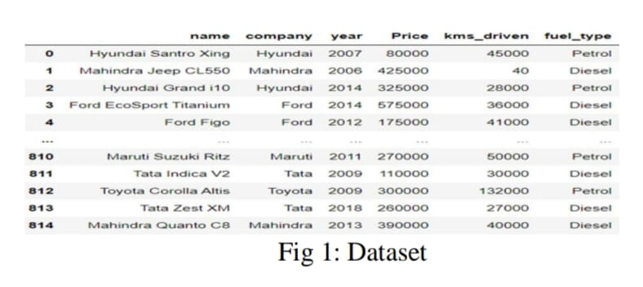

- Linear Regression
Linear Regression is a technique to estimate the linear relationship between each of a number of independent variables and a dependent variable. LineaRegression fits a linear model with coefficients w = (w1, …, wp) to minimize the residual sum of squares between the
observed targets in the dataset,and the targets predicted by the linear
approximation. [5]
- Random Forest Algorithm
Random Forest is an ensemble learning technique for classification and regression tasks. The algorithm makes use of Decision Trees. They
consist of a set of independent binary trees, each stochastically trained on random subsets of data. Although these trees individually may be over trained, the randomness in the process of training results in the trees producing independent estimates, which are then combined to produce a result

5. Results

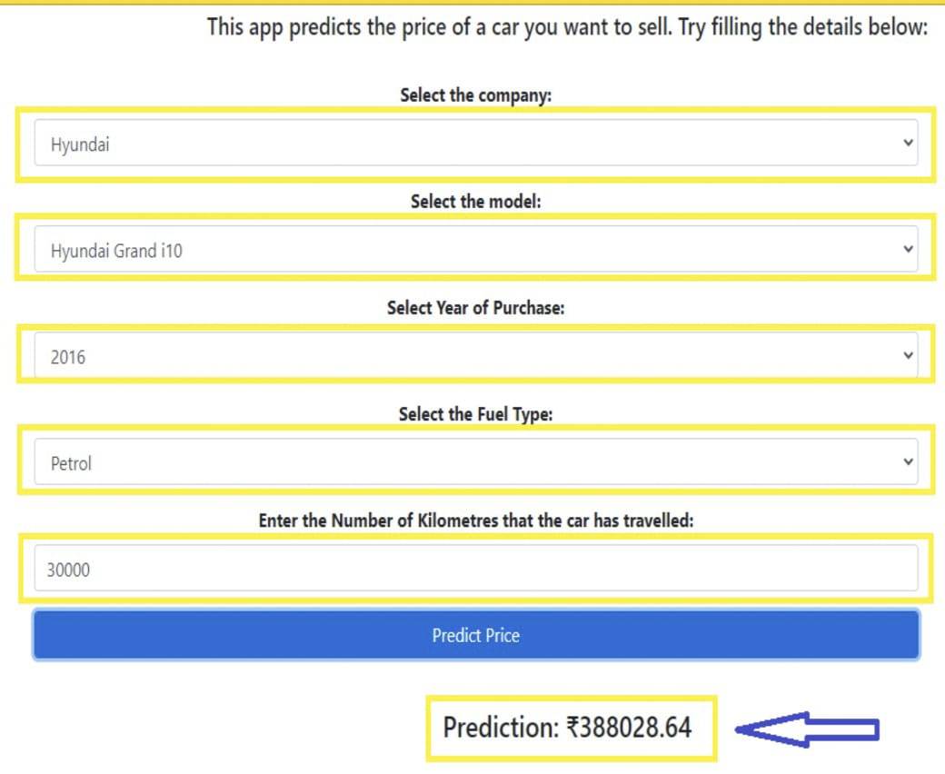

6. Conclusions
In this paper we discuss the challenges faced by both buyrs and sellers to address this issue we are creating this web application, to solve this problem its application aimed to demonstrate skills machine learning and web development this approach involves problem solving of and predict the price of vehicle and they get better results .
7. References
[1] Karl Storchmann, “On the depreciation of automobiles: An international comparison”. Department of Economics, Yale University, 2004. pp. 372-373.
[2] Sri Totakura, Harika Kosuru, ”Comparison of Supervised Learning Models for predicting prices of Used Cars”. C.S. Bachelors Thesis, Blekinge Institute of Technology, Karlskrona, 2021.
[3] Enis Gegic, Becir Isakovic, Dino Keco, Zerina Masetic,Jasmin Kevric, ”Car Price Prediction Using Machine Learning”; (TEM Journal 2019).
[4] Jaideep A Muley, “Prediction of Used Cars’ Prices by Using SAS EM”, Oklahoma State University

[5] Enis gegic, Becir Isakovic, Dino Keco, Zerina Masetic, Jasmin Kevric, ”Car Price Prediction Using Machine Learning”; (TEM Journal 2019)

