**SMART CITY SOLUTIONS : IOT-BASED TRASH BIN LEVEL MONITORING FOR EFFICIENT WASTE MANAGEMENT**

**Harini B *1, Hariharan J *2, Purushothaman S *3, Balamurugan S M *4**

*1,2,3 UG Student, Department of Electrical and Electronics Engineering, Sri Venkateswaraa College of Technology, Sriperumbudur, Kancheepuram, Tamil Nadu, India.

*4 Associate Professor, Department of Electrical and Electronics Engineering, Sri Venkateswaraa College of Technology, Sriperumbudur, Kancheepuram, Tamil Nadu, India.

**ABSTRACT :**

Improper disposal of solid waste poses significant health risks and environmental pollution. Various types of schemes are implemented for the advancement of waste management, but still people lack serious awareness about waste management. To address this issue, a real-time remote monitoring system is proposed, which includes a special feature, providing a monetary incentive for people who dispose of their trash properly into bins. This process is achieved by using a load cell setup and validation of self powered and easily deployable internet of things are used.

**______________________________________________________________________________**

**INTRODUCTION :**

As urban populations continue to grow, the efficient management of waste has become a critical challenge for municipalities worldwide. In response, smart city solutions are increasingly leveraging innovative technologies to tackle this issue. One such solution gaining traction is IoT-based trash bin level monitoring. By incorporating sensors into waste bins, the municipal authorities can collect real-time data on fill levels**.** This explores the transformative potential of IoT technology in waste management, highlighting its ability to optimize collection routes, reduce operational costs, and minimize environmental impact. With IoT-enabled monitoring, municipalities can move away from static collection schedules towards dynamic, demand-driven approaches, ensuring timely and efficient waste removal. Moreover, by analyzing data trends, municipalities can identify opportunities for waste reduction and recycling initiatives, fostering sustainability and circular economy principles. This sets the stage for a deeper exploration of how IoT-based trash bin monitoring is reshaping waste management paradigms in smart cities, driving towards cleaner, more resilient urban environments for future generations.

**LITERATURE SURVEY :**

**Parkash[1][February 2016]**In the proposed system, numerous dustbins are strategically positioned throughout the city or campus. Each dustbin is equipped with a low-cost embedded device designed to monitor the garbage level. Additionally, each dustbin is assigned a unique identifier to facilitate easy identification of full bins. Once the garbage level surpasses a predetermined threshold, the device transmits this information along with the respective unique ID. Authorized personnel can access these details remotely via the internet, enabling prompt action to clean the dustbins as needed.

**J.anand[1][March 2022]** Explains that the proposed system is fully based on Arduino Uno, a load sensor and a wifi-module. When the user disposes of garbage into the dustbin, it undergoes initial crushing within the shredder, followed by the gathering of shredded debris onto the dustbin's load-detecting plate. The weight of the deposited trash is subsequently measured by a sensor. Upon reaching the predefined weight threshold, the router's password is displayed on the LCD panel, even if the router remains powered off.

**N. Rajavizhi [1][February 2023]** A proposed system that includes a water sensor. This sensor detects rainwater and automatically closes the bin to mitigate human health and environmental risks. The ultrasonic sensor positioned within the dustbin will ascertain the depth of the waste, with the collected data stored in the microcontroller and subsequently showcased on a webpage. Additionally, a water sensor situated atop the bin will detect rainfall, prompting automatic closure of the bin to segregate dry and wet waste. This versatile system can be deployed effortlessly in various locations, offering reliable operation, swift implementation, and extensive coverage over long distances.

**S.Vishnu[1][July 2021]** This study explains, In the deployment of PBLMUs, a LoRaWAN networking architecture is utilized, whereas for HBLMUs associated with homes, a Wi-Fi-based communication system is employed. PBLMUs transmit unfilled level and geo-location data from trash bins to the LoRaWAN gateway using a frequency of 915 MHz. The LoRaWAN gateway collects the data from PBLMUs and uploads it to the server for storage and visualization. Additionally, HBLMUs are equipped with Wi-Fi modules, allowing them to connect with home routers and upload data to the central monitoring system.

**Aniqua Banu[1][December 2020]** Tells that the proposed system operates on edge-nodes, with each trash bin serving as an intelligent node within the waste management process. The proposed Solid Waste Management (SBM) system consists of three primary components: trash bins (TB), a trash collecting vehicle (TCV), and a central database (CDB).

**METHODOLOGY :**

In the proposed method, an Arduino Uno microcontroller is used as an interface between the sensors , communication devices and trash bin system. a load cell setup is employed to determine whether the trash bin is filled or not. additionally a metal detector is used to identify any unwanted or any prohibited item present in the trash bin. Further more the system incorporates GPS functionality to send the specific location of the filled trash bin to the iot web page. A LCD display is included in the system for the purpose of presenting the systems current status and information to the user. led lights are utilised to visually indicate the fill level of trash bin .so there is no chance for the overflow of trash bins.

**BLOCK DIAGRAM :**

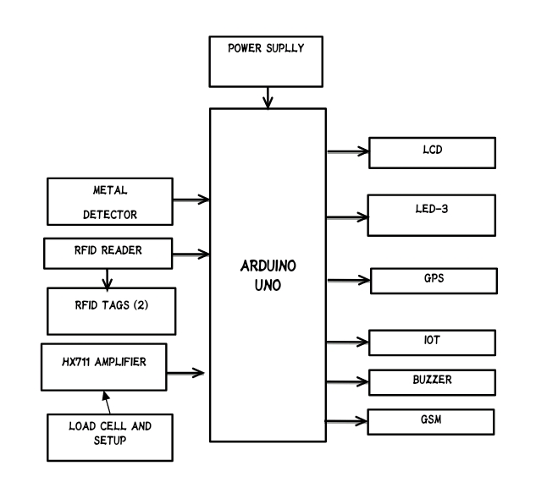

**WORKING :**

The Arduino uno serves as the central processing unit for this innovative project.its primary function is to manage and coordinate the various components involved in the waste management system. RFID tags plays a crucial role in user identification,granting access to the dustbin.a key component, the load cell, measures the weight of the disposed waste,influencing the amount of credit assigned to the user. In addition to the visual cues, a buzzer provides an audible alert to the user,ensuring they are aware of their actions.simultaneously, an SMS alert is sent,coveying the updated information,including the location of the dustbin. This enhances user awareness and ensures a seamless waste disposal process. Moreover, the project is equipped with Iot capabilities,allowing automatic alerts to be transmitted to the corporations designated webpage when metal items are detected. This real-time communication facilitates prompt action and efficient management.

**RESULT :**

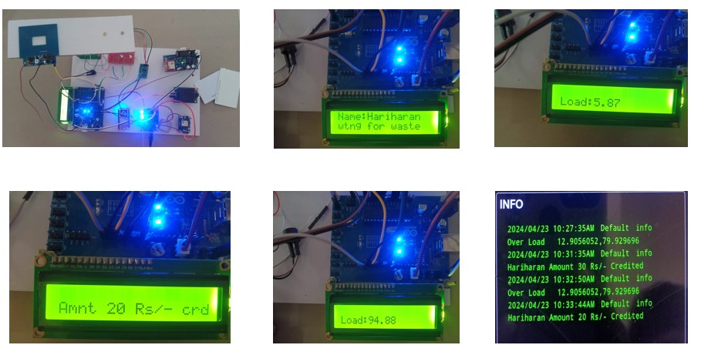

**CONCLUSION :**

Implementing IoT-based trash bin level monitoring is a crucial step towards achieving efficient waste management in smart cities. By leveraging technology to monitor and manage waste levels in real-time, cities can optimize waste collection routes, reduce operational costs, and minimize environmental impact. However, the future scope extends beyond mere monitoring, with opportunities to integrate advanced analytics, citizen engagement platforms, smart grid integration, sensor fusion, and circular economy initiatives. Through continuous innovation and collaboration, smart cities can build sustainable waste management systems that benefit both the environment and the community.

**FUTURE SCOPE :**

**Advanced Analytics:** Enhance the system with advanced analytics capabilities to predict waste generation patterns, optimize collection schedules, and identify areas for waste reduction initiatives.

**Integration with Smart Grids:** Integrate trash bin monitoring data with smart grids to optimize energy consumption during waste collection and processing, reducing overall environmental impact.

**Sensor Fusion:** Combine data from various sensors, such as air quality and temperature sensors, to provide a more comprehensive understanding of environmental conditions and their impact on waste management.

**Citizen Engagement:** Develop interactive mobile apps or platforms that allow citizens to report waste-related issues, provide feedback on collection services, and participate in community recycling programs.

**Circular Economy Initiatives**: Explore opportunities to incorporate circular economy principles by promoting resource recovery, reuse, and recycling, thereby minimizing waste generation and maximizing resource efficiency within the city ecosystem.

**REFERENCES :**

1. Monika K A, Rao N, Prapulla S B and Shobha G 2016 Smart Dustbin-An Efficient Garbage Monitoring System International Journal of Engineering Science And Computing 67113-16.
2. Vasagade, T.S.; Tamboli, S.S.; Shinde, A.D. Dynamic solid waste collection and management system based on sensors, elevator and GSM. In Proceedings of the 2017 International Conference on Inventive Communication and Computational Technologies (ICICCT), Coimbatore, India, 10–11 March 2017.
3. P. Devi, W. S. Ravindra, and S. K. L. V. S. Prakash, ‘‘An IoT enabled smart waste management system in concern with Indian smart cities,’’ in Proc. 2nd Int. Conf. Trends Electron. In format. (ICOEI), May 2018, pp. 64–69 doi: 10.1109/ICOEI.2018.8553764.
4. C. Balakrishna, “Enabling Technologies for Smart City Services and Applications”, IEEE 6th International Conference on Next Generation Mobile Applications, Services and Technologies (NGMAST), 2012, pp. 223-227.
5. Murugaanandam, S., Ganapathy, V & Balaji, R. (2018, April). Efficient IOT based smart bin for clean environment. In 2018 International Conference on Communication and Signal Processing (ICCSP) (pp. 0715-0720). IEEE.
6. Prakash, Prabu V “ IOT Based waste management for smart city “ International journal of innovative research in computer and communication engineering, Vol 4, issue 2, DOI : 10.15680/IJIRCCE.2016. 0402029 February 2016.