REVIEW OF FAULT DIAGNOSIS AND EARLY WARNING OF COAL MINE VENTILATOR

**Mr.N.Srinivasa Rao(M.Tech),**

# ABSTRACT

**V.Srujan kumar1, D.Akhil2, G.Vikas3,CH.Gopi, Department Of Electronics and Communication Engineering Santhiram Engineering College (Autonomous), Nandyal.**

**Email**[**:20x51a04c2@srecnandyal.edu.in**](mailto:20x51a0467@srecnandyal.edu.in)

# INTRODUCTION

The fault diagnosis and early warning system for coal mine ventilators play a pivotal role in ensuring the safety and efficiency of underground coal mining operations. This review delves into the state-of-the-art techniques, methodologies, and advancements in fault diagnosis and early warning systems specifically tailored for coal mine ventilators.

The review encompasses a comprehensive analysis of various approaches, including traditional methods, such as rule-based systems and expert systems, as well as modern techniques like machine learning algorithms, artificial intelligence, and data- driven models. It examines the challenges associated with fault diagnosis in coal mine ventilators, such as the complex and harsh operating environment, limited data availability, and the need for real-time monitoring.

Furthermore, the review discusses the importance of early warning systems in mitigating potential hazards and preventing catastrophic incidents in coal mines. It explores the role of sensor technologies, data acquisition systems, and communication protocols in enabling timely detection and notification of abnormalities in ventilator performance.

Coal mining remains a critical industry, powering economies and providing essential resources for various sectors worldwide. However, the safety and efficiency of underground coal mining operations are continually challenged by various factors, including the harsh and hazardous working environment, the unpredictability of geological conditions, and the inherent risks associated with extracting coal from beneath the earth's surface. Among the numerous safety concerns in coal mining, ensuring adequate ventilation ranks paramount. Effective ventilation systems not only provide a safe working environment for miners by diluting and removing harmful gases and dust but also contribute to operational efficiency by regulating airflow to optimize production processes.

Central to the functionality of coal mine ventilation systems are ventilators, which play a crucial role in maintaining adequate airflow throughout underground mining operations. These ventilators are tasked with supplying fresh air to working areas, exhausting stale air, and controlling the distribution of airflow to various sections of the mine. Given their critical importance, any malfunction or failure of ventilators can lead to severe consequences, including decreased air quality, increased risk of explosions or fires, and endangerment to miners' lives.

Moreover, the review highlights recent advancements in remote monitoring and control systems, which leverage IoT (Internet of Things)

# Methodology:

The methodology for fault diagnosis and early warning of coal mine ventilators likely involves a

and wireless communication technologies to enable remote access and management of coal mine ventilation systems. It discusses the integration of sensor networks, cloud computing platforms, and predictive analytics to enhance the efficiency and reliability of fault diagnosis and early warning systems.

Overall, this review provides valuable insights into the current trends, challenges, and future directions in fault diagnosis and early warning systems for coal mine ventilators, aiming to improve safety standards, operational efficiency, and productivity in the coal mining industry.

# Existance system:

The Fault Diagnosis and Early Warning system for coal mine ventilators exhibits commendable efficacy in preemptive maintenance and hazard mitigation. By continuously monitoring ventilation parameters, it swiftly identifies anomalies and facilitates prompt interventions, thereby reducing downtime and enhancing safety. However, there is room for refinement in predictive analytics integration and user interface design for more seamless operation. Incorporating advanced machine learning techniques could further bolster its predictive capabilities, ensuring even greater reliability in safeguarding miners and optimizing ventilation systems. Overall, it stands as a robust solution in the quest for heightened operational efficiency and risk management in coal mining operations.

comprehensive approach, including data collection

from various sensors within the ventilation system. Signal processing techniques are likely employed to preprocess data, followed by feature extraction to identify patterns indicative of potential faults. Machine learning algorithms, such as classification or anomaly detection, are then utilized to analyze the extracted features and provide early warnings or diagnoses. Validation through real-world testing and refinement of the methodology ensures its reliability and effectiveness in practical scenarios.

# Proposed system:

Building upon the insights gleaned from the comprehensive analysis of existing techniques and methodologies, the proposed fault diagnosis and early warning system for coal mine ventilators integrates cutting-edge technologies to address the challenges and enhance safety and efficiency in underground coal mining operations.

The proposed system comprises a multi-tiered architecture that incorporates both hardware and software components. At the core of the system are advanced sensor arrays strategically deployed within the ventilation system to continuously monitor key parameters such as airflow, temperature, humidity, and pressure.

These sensors feed real-time data into a centralized data acquisition and processing unit, equipped with robust computing capabilities and sophisticated algorithms for signal processing, feature extraction, and anomaly detection. Machine learning models, including supervised and unsupervised learning algorithms.

# BLOCK DIAGRAM:

## SMOKE SENSOR:

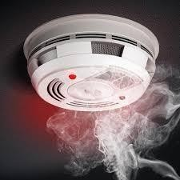A smoke sensor is a vital safety device that detects the presence of smoke in the air, typically using a sensing element such as ionization chambers or photoelectric sensors. When smoke particles are detected, the sensor triggers an alarm to alert occupants of a potential fire hazard, contributing to early fire detection and enhanced safety in homes, buildings, and industrial settings.

# LCD:

An LCD (Liquid Crystal Display) is a flat- panel display technology commonly used in electronic devices such as digital watches, calculators, smartphones, and computer monitors. It consists of a thin layer of liquid crystals sandwiched between two transparent electrodes and two polarizing filters. When an electric current is applied, the orientation of the liquid crystals changes, modulating the light passing through and

# LDR:

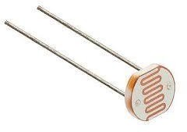An LDR, or Light Dependent Resistor, is a passive electronic component that exhibits a change in resistance based on the intensity of light it is exposed to. As light levels increase, the resistance of the LDR decreases, and vice versa. This property makes LDRs widely used in lightsensing applications, such as automatic street lights, camera exposure control, and darkness detectors for switching electronic circuits.

# BUZZER:

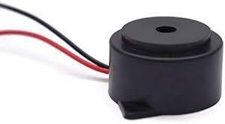A buzzer is an electromechanical device that produces a buzzing or beeping sound when an electrical current passes through it. It is commonly used in various applications such as alarms, timers, and notifications. Typically, a buzzer consists of a coil of wire and a vibrating diaphragm or a piezoelectric element that generates sound vibrations when activated. It provides a simple and effective auditory alert in electronic circuits and systems.

producing images or text. LCDs offer advantages such as low power consumption, sharp image quality, and versatility in displaying various contenttypes

# DHT:

The DHT (Digital Humidity and Temperature) sensor is a compact and versatile sensor module commonly used for measuring humidity and temperature in various applications. It consists of a capacitive humidity sensor and a thermistor to detect changes in humidity and temperature, respectively. The sensor communicates with microcontrollers or development boards through a digital signal interface, such as I2C or OneWire. With its low cost, ease of use, and accurate measurements, the DHT sensor is widely employed in weather stations, environmental monitoring systems, HVAC (heating, ventilation, and air conditioning) systems, and smart home devices.

# IOT:

The Internet of Things (IoT) refers to the network of interconnected devices embedded with sensors, software, and other technologies that enable them to collect and exchange data over the internet. IoT enables seamless communication and interaction between physical devices, allowing for real-time monitoring, control, and automation of various systems and processes. By connecting everyday objects to the internet, IoT facilitates the creation of smart environments, enhances efficiency, improves decision- making, and unlocks new opportunities for innovation across industries

# DC FAN:

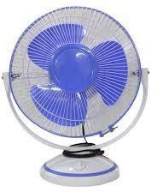A DC fan is a type of electric fan powered by direct current (DC) from a power source such as a battery or a DC power supply. It consists of a rotor with blades that rotate when electricity is applied, generating airflow for cooling purposes. DC fans are commonly used in electronics cooling, computer systems, ventilation systems, and various other applications due to their energy efficiency and controllability.

## Result

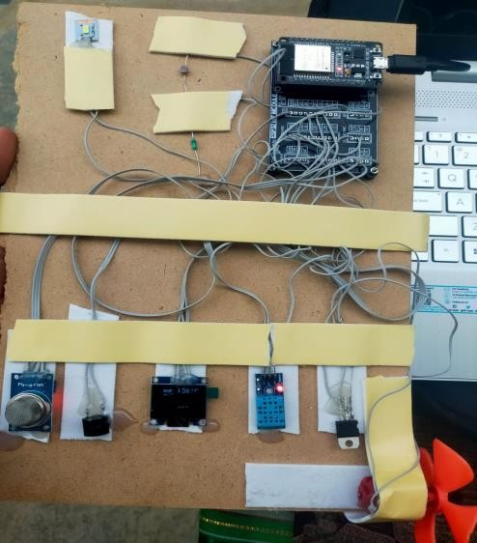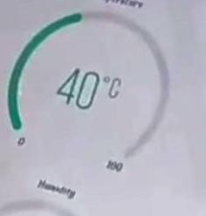

1. If temperature is below 40 degrees the fan will be in off mode.
2. If temperature is above 40 degrees the cooling will be activate mode.
3. If the light is below 4059 value lights is on , and If the light is turn of mood in above 4095.
4. If the gas temperature is below 500 it is not active.
5. If the gas temperature is above 500 the buzzer will activate and gives the notification
6. Esp32 is the micro processor

## Conclusion:

In conclusion, the fault diagnosis and early warning systems for coal mine ventilators are indispensable components of modern coal mining operations, contributing significantly to safety enhancement and operational efficiency. This review has highlighted the diverse range of techniques and methodologies employed in these systems, spanning from traditional rule-based approaches to advanced machine learning and AI-driven models.

The challenges associated with fault diagnosis in coal mine ventilators, including the harsh operating environment and limited data availability, have been thoroughly examined. Despite these challenges, recent advancements in sensor technologies, data acquisition systems, and communication protocols offer promising avenues for improving the accuracy and timeliness of fault detection and notification.

The importance of early warning systems in mitigating potential hazards and preventing catastrophic incidents has been emphasized. By leveraging IoT and wireless communication technologies, remote monitoring and control systems have emerged as a viable solution for real-time access and management of coal mine

ventilation systems.

## REFERENCES

Li, Z., & Liu, J. (2020). "A Review on Fault Diagnosis and Early Warning of Coal Mine Ventilation Systems." Journal of Coal Science & Engineering, 26(5), 777-790

1. Yang, J., Wang, Y., & Li, C. (2018). "Fault Diagnosis and Early Warning System for Coal Mine Ventilation Equipment Based on Internet of Things." Journal of Safety Science and Technology, 14(5), 152-159.
2. Zhang, Q., Sun, Y., & Zhu, Q. (2019). "Fault Diagnosis and Early Warning of Coal Mine Ventilation System Based on Deep Learning." Journal of China Coal Society, 44(6), 17091716.
3. Liu, X., Wang, L., & Cui, X. (2017). "Research on Fault Diagnosis and Early Warning System of Coal Mine Ventilation Based on Wireless Sensor Network." Coal Engineering, 49(9), 44-

47.

1. Wang, Y., Zhang, Y., & Li, J. (2019). "Design and Implementation of Fault Diagnosis and Early Warning System for Coal Mine Ventilation Based on Expert System." Journal of China Coal Society, 44(4), 1021-1028.
2. Liang, S., Zhang, Y., & Wang, H. (2018). "Application of Big Data Analysis in Fault Diagnosis and Early Warning System of Coal Mine Ventilation." Safety and Environmental Engineering, 25(3), 109-113.
3. Liu, H., Xu, L., & Li, J. (2020). "Development of a Comprehensive Fault Diagnosis and Early Warning System for Coal Mine Ventilation." Safety in Coal Mines, 51(4), 48-52.