**PRIVACY-PRESERVING ON-SCREEN ACTIVITY TRACKING AND CLASSIFICATION IN E-LEARNING USING FEDERATED LEARNING**

Mrs. M.Anusha,1a),M.Bhavana1b),N. Pranathi 1c) ,T.Likhitha1d), T.Vigna Sree

*Department of Computer Science & Engineering, Santhiram Engineering College, Nandyal-518501, Andhra Pradesh, India*

*a)Corresponding Author:* [*anusha.cse@srecnandyal.edu.in*](mailto:anusha.cse@srecnandyal.edu.in)

**Abstract:** In the evolving landscape of remote and online learning, the ability to monitor and assess students' productivity has become increasingly. This project is used for "Privacy-Preserving On-Screen Activity Tracking and Classification in E-Learning Using Federated Learning." It aims whether students are utilizing their time for knowledge development or wasting it. E-learning platforms have gained popularity, especially in remote education. However, students are actively focused during online sessions. Our approach uses Federated Learning, to user privacy while accurately classifying onscreen activities. By this technique, we address the challenge of preserving user privacy and providing valuable insights into the efficiency of online learning. Federated Learning uses to our system to train machine learning models across multiple user devices, eliminating the need to centralize sensitive data on a single server. keywords using CNN, decision tree, and linear discriminant analysis.

# I.INTRODUCTION

In privacy-preserving on-screen activity tracking and classification in e-learning, the goal is to monitor and analyze the activities of learning during online courses while maintaining their privacy. Machine learning algorithms are used to automatically track and classify the on-screen activities such as mouse movements and keyboard inputs, without compromising the learner’s personal information. It develops on-screen activity tracking and classification mechanisms into e-learning platforms while prioritizing user privacy through the implementation of federated learning. Federated learning also known as collaborative learning is a decentralized approach to training machine learning models.The proposed system leverages advanced machine learning algorithms to analyze on-screen activities, including mouse movements, keyboard inputs, and other relevant metrics, to understand user engagement and learning patterns. Through federated learning, these algorithms are trained collectively without exposing individual data points, preserving the privacy of each learner. This innovative approach not only enhances the adaptability of e-learning content but also addresses the critical concerns surrounding data privacy in educational technology. The project aims to contribute to the broader discourse on the responsible integration of technology in education by providing a privacy-centric solution for on-screen activity tracking.

# EXISTING SYSTEM

The existing method for on-screen activity classification relies on Stochastic Gradient Descent (SGD), a widely used optimization algorithm in machine learning.However, while SGD has been effective in various applications, it presents several limitations when applied to the task of on-screen activity classification in e-learning environments.

# Disadvantages of the existing system:

* Privacy Concerns: SGD requires centralized data, posing a significant privacy risk as user data is stored and processed on a central server.
* Scalability Issues: It may not scale well for large-scale e-learning platforms with numerous users and diverse activities.
* Data Imbalance: SGD may struggle to handle imbalanced datasets, affecting the accuracy of classification.accuracy.

# PROPOSED SYSTEM

Our proposed system harnesses the power of three advanced machine learning techniques: Convolutional Neural Networks (CNN), Decision Trees, and Linear Discriminant Analysis (LDA) for the purpose of on-screen activity classification. This ensemble of methods brings a multi-faceted approach to the task, ensuring accurate and comprehensive

# WORKING PRINCIPLE

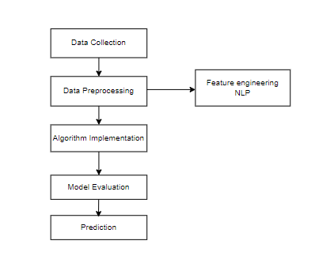

**Fig 1: Work Flow**

# Advantages of the Proposed System:

* Privacy-Preserving: Federated Learning ensures that user data remains on local devices, preserving individual privacy.
* Accuracy: CNN excels at feature extraction from on-screen activities, while Decision Trees and Linear Discriminant Analysis enhance classification
* Scalability: The combination of these algorithms allows the system to scale effectively, accommodating a large number of users and diverse learning activities.

# RESULTS

Data need to be pre-processed according to the models it helps to increase the accuracy of the model and better information about the data.



**Fig 2: Home Page**



**Fig 3: Registration Page**



**Fig 4: Login Page**

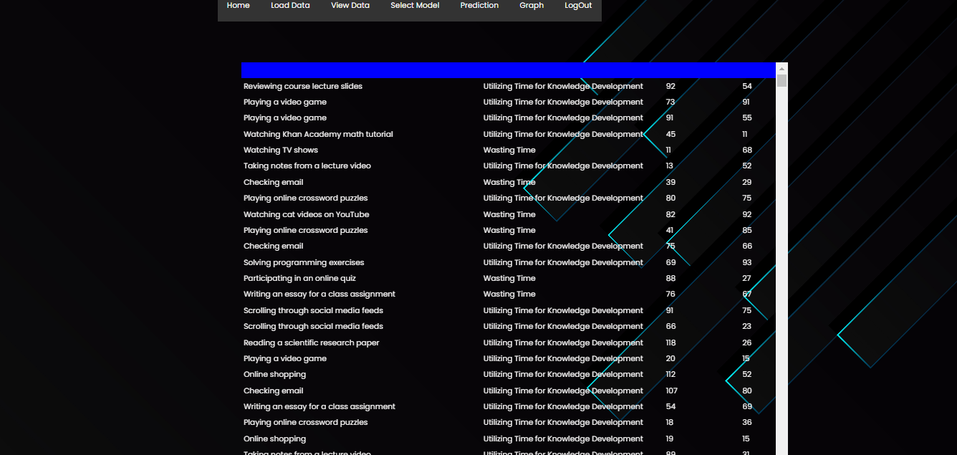

**Fig 5: View Data**

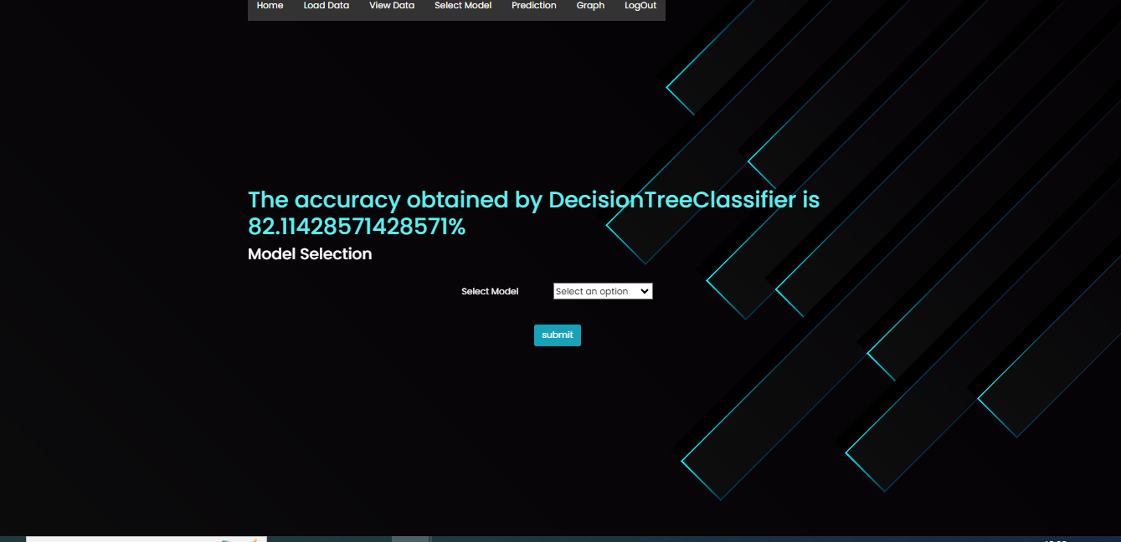

**Fig 6: Model Selection**

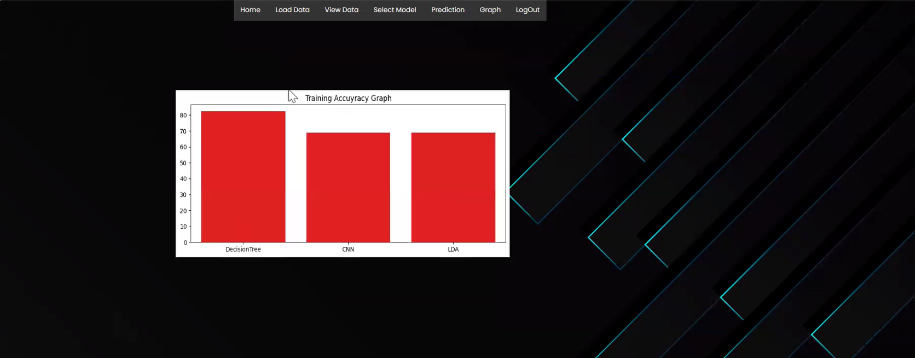

**Fig 7: Graph Page**

# VI . CONCLUSION

The implementation of privacy-preserving on-screen activity tracking and classification in e-learning through federated learning represents a significant stride toward addressing the delicate balance between data analytics and user privacy. This innovative approach not only ensures the confidentiality of users' sensitive information but also fosters a secure and trustworthy e-learning environment. By leveraging federated learning, the model learns and improves without compromising the individual user's data, thereby mitigating privacy concerns that often accompany traditional centralized tracking systems. The adoption of this methodology contributes to the advancement of personalized learning experiences while upholding the principles of user privacy, paving the way for a more ethical and sustainable integration of technology in education. As technology continues to play a pivotal role in shaping the future of e-learning, this privacy-preserving framework offers a promising foundation for responsible and effective educational analytics.

**REFERENCES**

1. Mahammad, F. S., & Viswanatham, V. M. (2020). Performance analysis of data compression algorithms for heterogeneous architecture through parallel approach. The Journal of Supercomputing, 76(4), 2275-2288.
2. Karukula, N. R., & Farooq, S. M. (2013). A route map for detecting Sybil attacks in urban vehicular networks. Journal of Information, Knowledge, and Research in Computer Engineering, 2(2), 540-544.
3. Farook, S. M., & NageswaraReddy, K. (2015). Implementation of Intrusion Detection Systems for High Performance Computing Environment Applications. Inter national journal of Scientific Engineering and Technology Research, 4(0), 41.
4. Sunar, M. F., & Viswanatham, V. M. (2018). A fast approach to encrypt and decrypt of video streams for secure channel transmission. World Review of Science, Technology and Sustainable Development, 14(1), 11-28.
5. Mahammad, F. S., & Viswanatham, V. M. (2017). A study on h. 26x family of video streaming compression techniques. International Journal of Pure and Applied Mathematics, 117(10), 63-66.
6. Devi,S M. S., Mahammad, F. S., Bhavana, D., Sukanya, D., Thanusha, T. S., Chandrakala, M., & Swathi, P. V. (2022).” Machine Learning Based Classification and Clustering Analysis of Efficiency of Exercise Against Covid-19 Infection.” Journal of Algebraic Statistics, 13(3), 112-117.
7. Devi, M. M. S., & Gangadhar, M. Y. (2012).” A comparative Study of Classification Algorithm for Printed Telugu Character Recognition.” International Journal of Electronics Communication and Computer Engineering, 3(3), 633-641.
8. Devi, M. S., Meghana, A. I., Susmitha, M., Mounika, G., Vineela, G., & Padmavathi, M. MISSING CHILD IDENTIFICATION SYSTEM USING DEEP LEARNING.
9. V. Lakshmi chaitanya. "Machine Learning Based Predictive Model for Data Fusion Based Intruder Alert System." journal of algebraic statistics 13, no. 2 (2022): 2477-2483.
10. Chaitanya, V. L., & Bhaskar, G. V. (2014). Apriori vs Genetic algorithms for Identifying Frequent Item Sets. International journal of Innovative Research &Development, 3(6), 249-254.
11. Chaitanya, V. L., Sutraye, N., Praveeena, A. S., Niharika, U. N., Ulfath, P., & Rani, D. P. (2023). Experimental Investigation of Machine Learning Techniques for Predicting Software Quality.
12. Lakshmi, B. S., Pranavi, S., Jayalakshmi, C., Gayatri, K., Sireesha, M., & Akhila, A. Detecting Android Malware with an Enhanced Genetic Algorithm for Feature Selection and Machine Learning.
13. Lakshmi, B. S., & Kumar, A. S. (2018). Identity-Based Proxy-Oriented Data Uploading and Remote Data Integrity checking in Public Cloud. International Journal of Research, 5(22), 744-757.
14. Lakshmi, B. S. (2021). Fire detection using Image processing. Asian Journal of Computer Science and Technology, 10(2), 14-19.
15. Devi, M. S., Poojitha, M., Sucharitha, R., Keerthi, K., Manideepika, P., & Vasudha, C. Extracting and Analyzing Features in Natural Language Processing for Deep Learning with English Language.
16. Kumar JDS, Subramanyam MV, Kumar APS. Hybrid Chameleon Search and Remora Optimization Algorithm-based Dynamic Heterogeneous load balancing clustering protocol for extending the lifetime of wireless sensor networks. Int J Commun Syst. 2023; 36(17):e5609. doi:10.1002/dac.5609
17. David Sukeerthi Kumar, J., Subramanyam, M.V., Siva Kumar, A.P. (2023). A Hybrid Spotted Hyena and Whale Optimization Algorithm-Based Load-Balanced Clustering Technique in WSNs. In: Mahapatra, R.P., Peddoju, S.K., Roy, S., Parwekar, P. (eds) Proceedings of International Conference on Recent Trends in Computing. Lecture Notes in Networks and Systems, vol 600. Springer, Singapore. https://doi.org/10.1007/978-981-19-8825-7_68
18. Murali Kanthi, J. David Sukeerthi Kumar, K. Venkateshwara Rao, Mohmad Ahmed Ali, Sudha Pavani K, Nuthanakanti Bhaskar, T. Hitendra Sarma, “A FUSED 3D-2D CONVOLUTION NEURAL NETWORK FOR SPATIAL-SPECTRAL FEATURE LEARNING AND HYPERSPECTRAL IMAGE CLASSIFICATION,” J Theor Appl Inf Technol, vol. 15, no. 5, 2024, Accessed: Apr. 03, 2024. [Online]. Available: www.jatit.org
19. Prediction Of Covid-19 Infection Based on Lifestyle Habits Employing Random Forest Algorithm FS Mahammad, P Bhaskar, A Prudvi, NY Reddy, PJ Reddy journal of algebraic statistics 13 (3), 40-45
20. Machine Learning Based Predictive Model for Closed Loop Air Filtering System P Bhaskar, FS Mahammad, AH Kumar, DR Kumar, SMA Khadar, ...Journal of Algebraic Statistics 13 (3), 609-616
21. Kumar, M. A., Mahammad, F. S., Dhanush, M. N., Rahul, D. P., Sreedhara, K. L., Rabi, B. A., & Reddy, A. K. (2022). Traffic Length Data Based Signal Timing Calculation for Road Traffic Signals Employing Proportionality Machine Learning. Journal of Algebraic Statistics, 13(3), 25-32.
22. Kumar, M. A., Pullama, K. B., & Reddy, B. S. V. M. (2013). Energy Efficient Routing In Wireless Sensor Networks. International Journal of Emerging Technology and Advanced Engineering, 9(9), 172-176.
23. Kumar, M. M. A., Sivaraman, G., Charan Sai, P., Dinesh, T., Vivekananda, S. S., Rakesh, G., & Peer, S. D. BUILDING SEARCH ENGINE USING MACHINE LEARNING TECHNIQUES.
24. “ Providing Security in IOT using Watermarking and Partial Encryption. ISSN No: 2250-6149 Issue 1, Volume 2 (December 2011)
25. The Dissemination Architecture of Streaming Media Information on Integrated CDN and P2P, ISSN 2249-6149 Issue 2, Vol.2 ( March-2012)
26. Provably Secure and Blind sort of Biometric Authentication Protocol using Kerberos, ISSN: 2249-9954, Issue 2, Vol 2 (APRIL 2012)
27. D.LAKSHMAIAH, DR.M.SUBRAMANYAM, DR.K.SATYA PRASAD,” DESIGN OF LOW POWER 4- BIT CMOS BRAUN MULTIPLIER BASED ON THRESHOLD VOLTAGE TECHNIQUES”, GLOBAL JOURNAL OF RESEARCH IN ENGINEERING, VOL.14(9),PP.1125-1131,2014.
28. R SUMALATHA, DR.M.SUBRAMANYAM, “IMAGE DENOISING USING SPATIAL ADAPTIVE MASK FILTER”, IEEE INTERNATIONAL CONFERENCE ON ELECTRICAL, ELECTRONICS, SIGNALS, COMMUNICATION &AMP; OPTIMIZATION (EESCO-2015), ORGANIZED BYVIGNANS INSTITUTE OF INFORMATION TECHNOLOGY, VISHAKAPATNAM, 24 TH TO 26TH JANUARY 2015. (SCOPUS INDEXED)
29. P.BALAMURALI KRISHNA, DR.M.V.SUBRAMANYAM, DR.K.SATYA PRASAD, “HYBRID GENETIC OPTIMIZATION TO MITIGATE STARVATION IN WIRELESS MESH NETWORKS”, INDIAN JOURNAL OF SCIENCE AND TECHNOLOGY,VOL.8,NO.23,2015. (SCOPUS INDEXED)
30. Y.MURALI MOHAN BABU, DR.M.V.SUBRAMANYAM,M.N. GIRI PRASAD,” FUSION AND TEXURE BASED CLASSIFICATION OF INDIAN MICROWAVE DATA – A COMPARATIVE STUDY”, INTERNATIONAL JOURNAL OF APPLIED ENGINEERING RESEARCH, VOL.10 NO.1, PP. 1003-1009, 2015. (SCOPUS INDEXED)