# Iris Recognition Modern Voting System Based on

# Deep Learning

**Mr. J. David Sukeerthi Kumar1, A. Syam Sundar Reddy2, S. Inthiyas3, U. Sridhar4, K. Kanna Mahesh5, A. Venkata Bhaskar Reddy6.**

1 Asst.Professor, Department of Computer Science & Engineering, Santhiram Engineering College,Nandyal, A.P

1 HOD of Computer Science & Engineering-Design, Santhiram Engineering College,Nandyal, A.P

2,3,4,5,6 Student, Department of Computer Science & Engineering, Santhiram Engineering College,Nandyal, A.P

E-mail: david.cse@srecnandyal.edu.in

**ABSTRACT:**

***A Project ballot or an Electronic Voting Machine (EVM) based on Direct Response Electronic (DRE) or Identical Ballot Boxes have traditionally been used for voting. This study recommends a digital voting system based on Deep Learning algorithm that uses Iris recognition to address the flaws in the current voting process in order to fix the traditional voting system's flaws. A program called the Iris recognition-based Voting System identifies people based on the iris pattern of their eyes. Iris recognition is an automated biometric identification technology that analyses video evidence of one or both of an individual's iris to identify complex patterns that are distinct, stable, and visible from a distance. A voter may only cast one ballot, where the proposed technology prohibits multiple votes from the same person because it can spot duplicate entries. Additionally, this technique does away with the need for the user to carry a voter ID that has the relevant information since the Aadhar is incorporated with the voter ID thus enhancing the digitalization by means of digital verification of biometric and iris pattern available in Aadhar card of every user. At the voting venue, a simple iris scan will allow the voter's iris to be collected and used as identification. The iris recognition process consists of the following four steps: image acquisition, iris segmentation, feature extraction, and pattern matching. Iris recognition is one of the most trustworthy biometric modalities due to its high identification rate. Thereby this system eliminates the major drawbacks of traditional voting systems and enhances the digital voting by incorporating the modern transformation.***

***Key words: Deep Learning, Iris recognition, Image Segmentation, Databases, Deep Learning algorithms.***

1. **INTRODUCTION**

The biometric process has been mainly used to recognize individual types of physical aspects and features. For this purpose, a tremendous amount of acknowledgement technologies have been generally provided with the actual fingerprint, iris procedures and voice acknowledgement. The biometric mainly deals with the proper technical and technological fields for the body controls and body dimensions. The authentication system is based on the appropriate biometric security system that has increased the actual importance within all countries. The used system has been shown the proper valid and best impressive performance based on all these procedures and aspects. For this purpose, the fingerprint is the only procedure for providing the proper security techniques to provide the true uniqueness and the strong privacy properties of the entire system. The exceptional fingerprint assurance or the proper kind of imprint approval has been mainly insinuating the automated methods and procedures to ensure similarity between the two people fingerprints. The entire chapter has been generally provided with the actual purpose of the fundamental research that is overall dependent on the research objectives and respective research questions. In this chapter, the research framework of the entire study has also been provided. The fundamental research has described all the factors that are responsible for this recognition process. There are various types of problems and significant issues that have been mainly faced by the biometric security system. The central and foremost issue is the biometric authentication process, and technologies have been mainly raised in the various types of privacy concerns and security concerns (Hamd & Ahmed, 2018). During the processing time of the biometric data, there is no other option to undo or retrieve the respective information from the damage. For the case of the compromised passwords, anyone can modify it with fingerprint, iris scanner and the ear image effects. So for all these aspects, the simple working performance of the biometrics remains within the security risks and privacy risks. There are various types of problems that have been shown in the different slides of the iris recognition system, such as the sensor module, preprocessor module and feature extraction process. All these security and privacy issues can be adequately solved by the appropriate types of technologies and modern and advanced techniques. The security process should also be secured with the help of a strong password and robust system process. For this purpose, several types of publications have been mainly documented with respect to the high accuracy states and the excellent reliability of the neural networks like the multilayer perceptions (MLP). This is mainly provided between the present times patterned recognition and accurate classifier applications. This research study there mainly used the particular machine learning technique "convolution neural network (CNN)" for improving the privacy security process within the validation system. The input image is mainly needed for reducing the size of the processed data and to achieve satisfactory working performance (Herbadji et al. 2020). The respective working performance has been done within several image processing states like image enlargement, image partitioning and factor extraction.

1. **LITERATURE REVIEW**

The literature review chapter has been mainly provided with a detailed description of the various problems and different types of recognition aspects that has been mainly associated with the entire area of the research study. The fundamental research has been conducted with the help of the different types of research notes of different authors and researchers. The entire process is also evaluated by the brief description of the research from the different online articles, journals and various websites. The fundamental research has been conducted with respect to the in-depth analysis process of the entire validation based recognition system. Including all of these, this particular chapter has also demonstrated the particular models and theories of the proposed topic for evaluating the entire description process. In this part, there are also described the literature gaps that are generally missing in the existing research notes of various authors.

According to the author Alrahawe (2018), a biometric system is one of the safest ways to work with the digital world. Since biometrics such as fingerprints, face, and iris recognition are different for different persons, these are safer compared to any other processes to secure confidential data (Alrahawe, 2018). However, in the olden days, there was a lack of technology for which there was less security provided for any confidential information. With the advancement in technology in recent times, biometric security has been an integral part of any system. Moreover, the author states that these kinds of processes for security in digitalization have become error-free, for which this system is getting implemented in the latest systems (Singh & Kant, 2021). Due to minor errors in the system, this is pretty reliable for security purposes. The biometric system has used various types of recognition processes, among which it also uses the finger-knuckle recognition system.

According to the author Elhoseny (2018), there was a unimodal system for identification and verification processes. However, through the unimodal system, the accuracy was not fully maintained since it failed to meet the proper decision-making criteria. It was found that there was a significant amount of reduction in accuracy while using the unimodal system for verification (Elhoseny, 2018). Thus the multimodal system was introduced. As the multimodal system uses fusion technology, the overall accuracy from the verification was achieved. While comparing the different sorts of modalities, fingerprint and iris always have the highest distinctiveness and permanence. Moreover, they are cost-efficient too, and the speed is relatively higher when compared to any other modalities. While the unimodal system was not totally involved in the decision making concept, the multimodal system covers four different tasks such as acquisition, extracting the feature from the modalities, matching with the actual one and then providing the decisions (La, 2021). The unimodal systems are also used in many cases where less security can be helpful. But for high-security purposes and the sectors that deal with massive amounts of confidential data require multimodal systems.

According to the author Adamu (2019), the biometric system has been dealt with the particular types of the technical and technological field and department for controlling the entire body dimensioning process. The process has also been stated to have different types of metrics that are directly related to the proper characteristics of the human being (Adamu, 2019). Biometric verification has mainly proposed various types of processors as the accurate method for accessing the complete human body control and human process control. The system has generally dealt with the proper identification and measurement of the individual's process for correctly clustering the various techniques under proper investigation (Regouid *et al.*, 2019). The biometric process is the most unique and contains valuable features and factors to describe all the entities. This particular technology is an excellent addition to the best innovation, and it is very much helpful and necessary for the higher quality business cases that are mainly faced by different types of massive data violation processes. Biometric recognition is a valid and reliable method to verify the real personality of the living person that is totally dependent on physiological qualities and social qualities (Naika, 2018). All these kinds of assumptions are basically constant and irreversible processes without noticeable stress (academia.edu, 2019).

According to the author Garg & Gupta (2017), iris recognition has been mainly considered as the popular types of biometric methods for the purpose of the human identification procedures and verification stages. This particular method is mainly used for the purpose of the unique characteristics and unique features and aspects that have been mainly used to show the dissimilarity between all persons with respect to the security purpose. The entire study has proposed the multi algorithmic characteristics for the proper types of extraction techniques in the case of the personal iris recognition process. The ultimate localization and the segmentation technologies are used with respect to the circular transformation process (Garg & Gupta, 2017). The process can be used for isolating the iris from the entire human body for detecting the particular noise. With the various types of factors, the investigation process should be quickly done with respect to the specific angles, ergonomic aspects and features, and various types of mental viewpoints of the customer. The entire has been enhanced for the case of the best impression of the particular impression of the client based on the proper convenience stages of the specific biometrics. These specific factors have been compromised with the proper adequacy level and the best effectiveness on the concentration process (Nelufule & de Kock, 2020). The ergonomic features have been mainly considered various types of physical attributes and psychological attributes of the clients, such as availability, affordability (academia.edu, 2017).

With respect to the research note of the author Gogate & Azad (2021), the biometric oriented individual identification process has been mainly observed like the practical and particular necessary techniques. All the techniques are mainly used for the automatic working process and working performance with the high quality of the confidence levels for proper identification of the person (Gogate & Azad, 2021). The multimodal oriented biometric system has been mainly consolidated with proper access with respect to the respective biometric modality sources by the actual evidence. This particular system has used different types of technologies for properly overcoming the various types of issues and challenges based on the combination of the various types of informative data under the same identity process (Oyeniran & Oyeniyi, 2019). In this case, all the ethical issues have been mainly done with respect to the proper acceptance of the fingerprint method for validation of the system to enhance the complete security and privacy based networking system to increase the validity rates. The facial acknowledgement process and administration oriented various types of issues can be easily solved by the uniqueness of the entire process and specific characteristics of the fingerprint-based iris recognition process. The entire type of recognition system can be done quickly with the help of the "convolution neural networks (CNN)" (Wang *et al.* 2018).

1. **SYSTEM ANALYSIS AND DESIGN**

**EXISTING SYSTEM**

The process of encoding and processing an individual's irises requires a large number of new calculations. When it comes to built frameworks and calculations, almost always only superior is guaranteed. However, neither of the computations has been subjected to extensive testing due to the lack of publicly available large-scale and even medium-size databases. The largest collection of infrared frontal iris images is now available online. Two notable solutions to the calculation testing problem in the lack of data.

* **Disadvantages:**

Errors are probable due to hazy iris images and the fact that segmentation and noise detection are handled in separate processes.

**PROPOSED SYSTEM**

For this project, we are using the CASIA IRIS dataset, which contains photos of 108 people, to train a CNN model that may be used to predict or detect people based on their IRIS. To train a CNN model, we are using the IRIS features extracted from eye pictures by the HoughnCircles technique.

**Advantages:**

The algorithm has good clustering, as shown by theoretical analysis and comprehensive experimental findings.

1. **SYSTEM ARCHITECTURE**

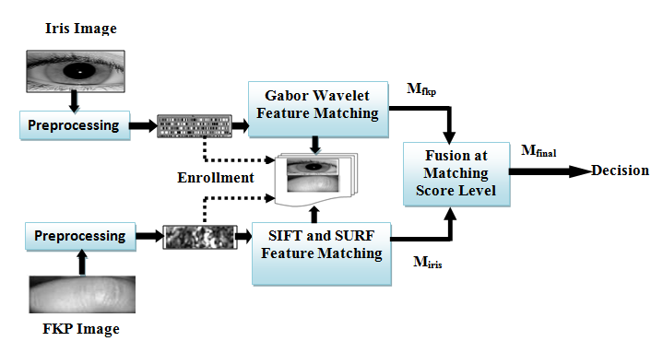

##### Figure 4: Architecture for fingerprint recognition method

1. **MODULES**

**Upload Iris dataset**

This section is for integrating the Iris dataset into the program.

**Preparing the Data**

When a dataset is preprocessed with this module, it is ready for further analysis.

**Purpose:** Feature Extraction

In this step, information is divided into two categories: training data and test data. Data, for instance, might be split into a "training" set and a "test" set with a 70%:30% split.

**Synthesis of Models**

As for the language used to actualize the strategy, it would be Python. Theano and tensorflow, two Python packages, are very potent for any given deep learning model. Indirectly constructing a model from these libraries, however, is challenging. That's why we utilize Keras and tensorflow as our backend library to make the model as precise as possible. Keras's sequential model includes components referred to as CNN layers. To improve the model's accuracy, these layers perform in-depth processing of the data by analyzing various patterns that emerge in the dataset. In the next step, the data are fed into the selected model to be trained.

**Construction of a Convolutional Neural Network Model**

Using this component, a CNN Model can be constructed for testing and training purposes.

**Graph of Accuracy and Error**

By doing so, we may compare the efficiency of different deep learning methods with that of feature extraction algorithms in a graphical format.

**Iris Recognition Test Image Upload**

With this feature, users can put an image through its paces by uploading it for testing and subsequent recognition by the software.

1. **RESULT AND DISCUSSION**

Iris Recognition using Machine Learning Technique

In this project to recognize person from IRIS we are using CASIA IRIS dataset which contains images from 108 peoples and by using this dataset we are training CNN model and then we can use this CNN model to predict/recognize persons. To train CNN model we are extracting IRIS features by using HoughCircles algorithm which extract IRIS circle from eye images. Below screen shots showing dataset with person id and this dataset saved inside ‘CASIA1’ folder



In above screen we have IRIS images from 108 peoples and just go inside any folder to get that person IRIS images like below screen

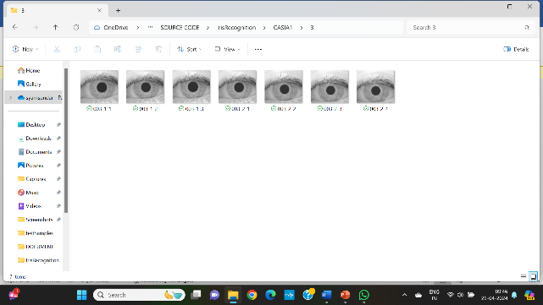

SCREEN SHOTS

To run project double click on ‘run.bat’ file to get below screen

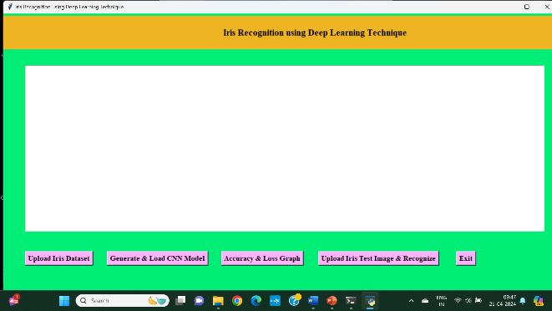

In above screen click on ‘Upload Iris Dataset’ button and upload dataset folder



In above screen selecting and uploading ‘CASIA1’ folder and then click on ‘Select Folder’ button to load dataset and to get below screen

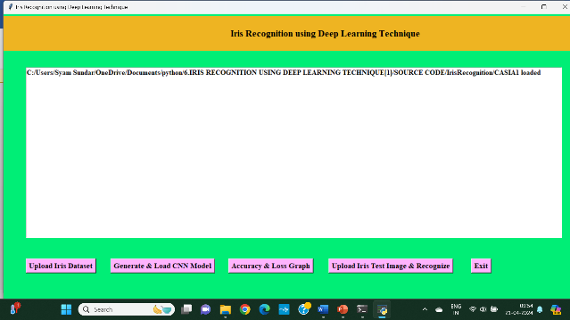

In above screen dataset loaded and now click on ‘Generate & Load CNN Model’ button to generateCNN model from loaded dataset

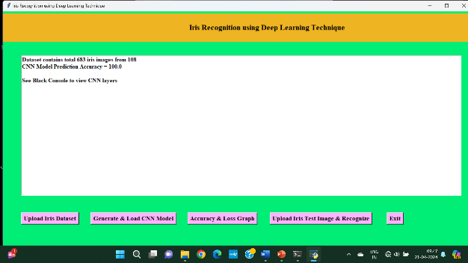

In above screen 683 images loaded from different 108 peoples and we got it prediction accuracy as 100%. Now model is ready and now click on ‘Accuracy & Loss Graph’ button to get below graph

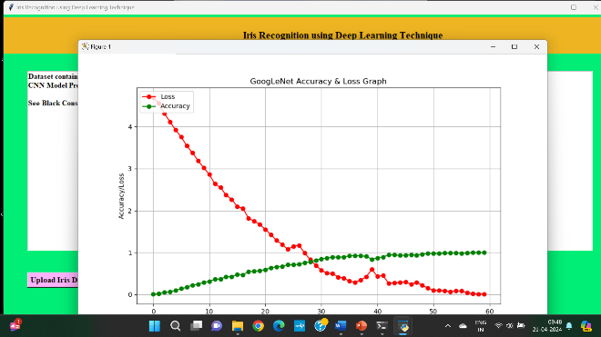

In above graph red line represents CNN model loss value and we can see at first iteration loss was more than 4% and when epoch increases then LOSS value reduce to 0 and green line represents accuracy and at first iteration accuracy was 0% and when epoch/iterations of model increases then accuracy reached to 100% and in above graph x-axis represents EPOCH and y-axis represents accuracy and loss values. Now click on ‘Upload Iris Test Image & Recognize’ button and upload any test image and then CNN will recognize person ID from that IRIS image. If you want you can upload test image from CASIA folder also and you will see prediction will be 100% correct

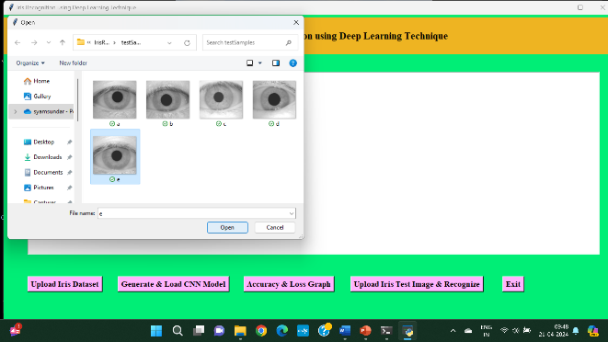

In above screen selecting and uploading ‘b.jpg’ file and then click on ‘Open’ button to get below screen

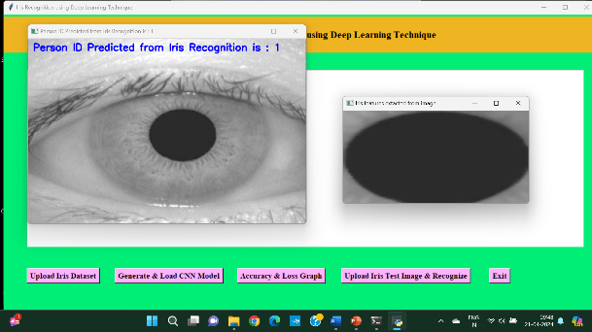

In above screen from uploaded image we extract IRIS features which is displaying in first image and then this image feeds to CNN and then CNN predicted that IRIS belong to person ID 15. Now I will upload one image from CASIA folder and then test whether CNN will predict correctly or not

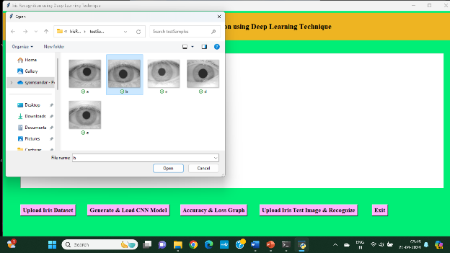

In above screen from CASIA folder I am uploading IRIS of person ID 38 and then click ‘Open’ button to get below result

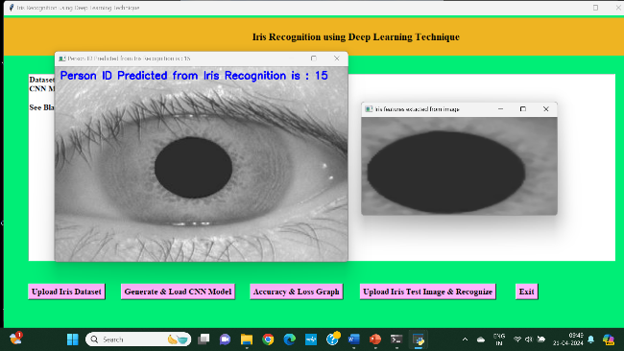

In above screen CNN predicted ID is 38 which is 100% correct.

1. **CONCLUSION**

The entire research note properly discusses the iris recognition system for the proper validation process. In the entire system, the biometric system is the main science for the best measurement of the various physical characteristics and the automatic characteristics. Between all these characteristics, there are the best effective measurements that have been mainly done on the face recognition method, fingerprint-based recognition method. In this case, the machine learning technology and the artificial intelligence system is very much effective and smarter for properly creating the actual revolution in the proper field of technology. The entire research has mainly focused on the development of the iris recognition system by the "convolution neural networking (CNN)" technique for the best security purpose. For this purpose, the overall technology should be more advanced for capturing all the requirements. The proper design process and the implementation of the multimodal biometric process are very much challenging, and the process has influenced the entire working performance. With respect to the literature review, the discussed models and theories are able to properly and briefly describe all the necessities and importance of the entire system. The proper involvement of the various kinds of technologies can be done with respect to the accurate software that will be very much effective for all the audience. This entire research has been mainly provided with the proper software works for a better understanding of all the audience.

1. **REFERENCES**

[1] Mahammad, F. S., & Viswanatham, V. M. (2020). Performance analysis of data compression algorithms for heterogeneous architecture through parallel approach. The Journal of Supercomputing, 76(4), 2275-2288.

[2] Karukula, N. R., & Farooq, S. M. (2013). A route map for detecting Sybil attacks in urban vehicular networks. Journal of Information, Knowledge, and Research in Computer Engineering, 2(2), 540-544.

[3] Farook, S. M., & NageswaraReddy, K. (2015). Implementation of Intrusion Detection Systems for High Performance Computing Environment Applications. Inter national journal of Scientific Engineering and Technology Research, 4(0), 41.

[4] Sunar, M. F., & Viswanatham, V. M. (2018). A fast approach to encrypt and decrypt of video streams for secure channel transmission. *World Review of Science, Technology and Sustainable Development*, *14*(1), 11-28.

[5] Mahammad, F. S., & Viswanatham, V. M. (2017). A study on h. 26x family of video streaming compression techniques. *International Journal of Pure and Applied Mathematics*, *117*(10), 63-66.

[6] Devi,S M. S., Mahammad, F. S., Bhavana, D., Sukanya, D., Thanusha, T. S., Chandrakala, M., & Swathi, P. V. (2022).” Machine Learning Based Classification and Clustering Analysis of Efficiency of Exercise Against Covid-19 Infection.” Journal of Algebraic Statistics, 13(3), 112-117.

[7] Devi, M. M. S., & Gangadhar, M. Y. (2012).” A comparative Study of Classification Algorithm for Printed Telugu Character Recognition.” *International Journal of Electronics Communication and Computer Engineering*, *3*(3), 633-641.

[8] Devi, M. S., Meghana, A. I., Susmitha, M., Mounika, G., Vineela, G., & Padmavathi, M. MISSING CHILD IDENTIFICATION SYSTEM USING DEEP LEARNING.

[9] V. Lakshmi chaitanya. "Machine Learning Based Predictive Model for Data Fusion Based Intruder Alert System." journal of algebraic statistics 13, no. 2 (2022): 2477-2483.

[10] Chaitanya, V. L., & Bhaskar, G. V. (2014). Apriori vs Genetic algorithms for Identifying Frequent Item Sets. International journal of Innovative Research &Development, 3(6), 249-254.

[11] Chaitanya, V. L., Sutraye, N., Praveeena, A. S., Niharika, U. N., Ulfath, P., & Rani, D. P. (2023). Experimental Investigation of Machine Learning Techniques for Predicting Software Quality.

[12] Lakshmi, B. S., Pranavi, S., Jayalakshmi, C., Gayatri, K., Sireesha, M., & Akhila, A. Detecting Android Malware with an Enhanced Genetic Algorithm for Feature Selection and Machine Learning.

[13] Lakshmi, B. S., & Kumar, A. S. (2018). Identity-Based Proxy-Oriented Data Uploading and Remote Data Integrity checking in Public Cloud. International Journal of Research, 5(22), 744-757.

[14] Lakshmi, B. S. (2021). Fire detection using Image processing. Asian Journal of Computer Science and Technology, 10(2), 14-19.

[15] Devi, M. S., Poojitha, M., Sucharitha, R., Keerthi, K., Manideepika, P., & Vasudha, C. Extracting and Analyzing Features in Natural Language Processing for Deep Learning with English Language.

[16] Kumar JDS, Subramanyam MV, Kumar APS. Hybrid Chameleon Search and Remora Optimization Algorithm-based Dynamic Heterogeneous load balancing clustering protocol for extending the lifetime of wireless sensor networks. Int J Commun Syst. 2023; 36(17):e5609. doi:[10.1002/dac.5609](https://doi.org/10.1002/dac.5609)

[17] David Sukeerthi Kumar, J., Subramanyam, M.V., Siva Kumar, A.P. (2023). A Hybrid Spotted Hyena and Whale Optimization Algorithm-Based Load-Balanced Clustering Technique in WSNs. In: Mahapatra, R.P., Peddoju, S.K., Roy, S., Parwekar, P. (eds) Proceedings of International Conference on Recent Trends in Computing. Lecture Notes in Networks and Systems, vol 600. Springer, Singapore. <https://doi.org/10.1007/978-981-19-8825-7_68>

[18] Murali Kanthi, J. David Sukeerthi Kumar, K. Venkateshwara Rao, Mohmad Ahmed Ali, Sudha Pavani K, Nuthanakanti Bhaskar, T. Hitendra Sarma, “A FUSED 3D-2D CONVOLUTION NEURAL NETWORK FOR SPATIAL-SPECTRAL FEATURE LEARNING AND HYPERSPECTRAL IMAGE CLASSIFICATION,” J Theor Appl Inf Technol, vol. 15, no. 5, 2024, Accessed: Apr. 03, 2024. [Online]. Available: [www.jatit.org](http://www.jatit.org)

[19] Prediction Of Covid-19 Infection Based on Lifestyle Habits Employing Random Forest Algorithm FS Mahammad, P Bhaskar, A Prudvi, NY Reddy, PJ Reddy journal of algebraic statistics 13 (3), 40-45

[20] Machine Learning Based Predictive Model for Closed Loop Air Filtering System P Bhaskar, FS Mahammad, AH Kumar, DR Kumar, SMA Khadar, ...Journal of Algebraic Statistics 13 (3), 609-616

[21] Kumar, M. A., Mahammad, F. S., Dhanush, M. N., Rahul, D. P., Sreedhara, K. L., Rabi, B. A., & Reddy, A. K. (2022). Traffic Length Data Based Signal Timing Calculation for Road Traffic Signals Employing Proportionality Machine Learning. Journal of Algebraic Statistics, 13(3), 25-32.

[22] Kumar, M. A., Pullama, K. B., & Reddy, B. S. V. M. (2013). Energy Efficient Routing In Wireless Sensor Networks. International Journal of Emerging Technology and Advanced Engineering, 9(9), 172-176.

[23] Kumar, M. M. A., Sivaraman, G., Charan Sai, P., Dinesh, T., Vivekananda, S. S., Rakesh, G., & Peer, S. D. BUILDING SEARCH ENGINE USING MACHINE LEARNING TECHNIQUES.

[24] “ Providing Security in IOT using Watermarking and Partial Encryption. ISSN No:

2250-1797 Issue 1, Volume 2 (December 2011)

[25] The Dissemination Architecture of Streaming Media Information on Integrated CDN and P2P, ISSN 2249-6149 Issue 2, Vol.2 ( March-2012)

[26] Provably Secure and Blind sort of Biometric Authentication Protocol using Kerberos, ISSN: 2249-9954, Issue 2, Vol 2 (APRIL 2012)

[27] D.LAKSHMAIAH, DR.M.SUBRAMANYAM, DR.K.SATYA PRASAD,” DESIGN OF LOW POWER 4- BIT CMOS BRAUN MULTIPLIER BASED ON THRESHOLD VOLTAGE TECHNIQUES”, GLOBAL JOURNAL OF RESEARCH IN ENGINEERING, VOL.14(9),PP.1125-1131,2014.

[28] R SUMALATHA, DR.M.SUBRAMANYAM, “IMAGE DENOISING USING SPATIAL ADAPTIVE MASK FILTER”, IEEE INTERNATIONAL CONFERENCE ON ELECTRICAL, ELECTRONICS, SIGNALS, COMMUNICATION &AMP; OPTIMIZATION (EESCO-2015), ORGANIZED BYVIGNANS INSTITUTE OF INFORMATION TECHNOLOGY, VISHAKAPATNAM, 24 TH TO 26TH JANUARY 2015. (SCOPUS INDEXED)

[29] P.BALAMURALI KRISHNA, DR.M.V.SUBRAMANYAM, DR.K.SATYA PRASAD, “HYBRID GENETIC OPTIMIZATION TO MITIGATE STARVATION IN WIRELESS MESH NETWORKS”, INDIAN JOURNAL OF SCIENCE AND TECHNOLOGY,VOL.8,NO.23,2015. (SCOPUS INDEXED)

[30] Y.MURALI MOHAN BABU, DR.M.V.SUBRAMANYAM,M.N. GIRI PRASAD,” FUSION AND TEXURE BASED CLASSIFICATION OF INDIAN MICROWAVE DATA – A COMPARATIVE STUDY”, INTERNATIONAL JOURNAL OF APPLIED ENGINEERING RESEARCH, VOL.10 NO.1, PP. 1003-1009, 2015. (SCOPUS INDEXED)

[31] Kumar, J. David Sukeerthi. "Investigation on secondary memory management in wireless sensor network." International Journal of Computer Engineering In Research Trends 2.6 (2015): 387-391.