**STATE GOVERNMENT FUND ALLOCATION & TRACKING SYSTEM OVER BLOCKCHAIN**

# S.MD.Riyaz Naik1, S.Sumiya Banu2, N.Leela Manasa3, G.Hema Sudha4, H.Sadaf Sultana 5

# 

1 Assistant Professor in Department of Computer Science and Engineering, Santhiram Engineering College, Nandyal, Kurnool, Andhra Pradesh, India.

2,3,4,5 Student, Department of Computer Science and Engineering, Santhiram Engineering College, Nandyal, Kurnool, Andhra Pradesh, India.

E-mail: [riyaz.cse@srecnandyal.edu.in](mailto:riyaz.cse@srecnandyal.edu.in).

**Abstract:**

There are several departments within the state government,each of which manages a variety programs for citizens eho qualify based on the criteria established by the government for each scheme. This mandates a centralized system capable of keeping track of the various applications, document approval status,sanctioned amounts, and all government schemes.This system, however, must be highly secure and ensure that only authorized users have access to it, these issues can be resolved by utilizing Blockchain technology.This properties of Blockchain such as immutability, consensus mechanisms and crytographic encryption ensure security and prevent unauthorized users from being able to access or edit data on the blockchain. The Transaction in this system will be placed within a transaction pool before a new block is mined which means several transaction can be verified and recorded together to reduce the costs invovled in blockchain transactions. Improvement in overall efficiency and quality of user experience for government can lead to tracking of other administrative problems using emerging technologies like Blockchain. In literature they use blockchain which enables cryptography and transation security at every stage while maintaining transparency so that every transaction is backed up eith proof of its authenticity. Hence, they present a framework that uses blockchain innovation and a full-proof fund transfer system. Blockchain contains growing list of records called blocks.

KEYWORDS: Fund allocation, Smart Contracts, Fraud Prevention.

**1. INTRODUCTION**

In modern governance, the trust of citizens in government schemes and policies is paramount for their successful implementation and impact. The effectiveness of these programs hinges not only on their design and execution but also on the transparency and efficiency with which citizens can access and benefit from them. Blockchain technology, with its unique attributes such as immutability, cryptographic encryption, and consensus mechanisms, presents a promising solution to streamline the process of applying for government grants under various schemes. By leveraging blockchain, governments can enhance security, transparency, and accountability in the administration of public funds [1].

Governments worldwide administer a plethora of schemes aimed at providing financial assistance and support to citizens across various sectors, including healthcare, education, agriculture, and social welfare. However, the traditional processes involved in applying for and disbursing these grants are often plagued by inefficiencies, bureaucratic red tape, and concerns regarding data security. As a result, eligible citizens may face delays or barriers in accessing the benefits they are entitled to, while the administration grapples with challenges related to fraud, corruption, and data mismanagement [2].

The advent of blockchain technology offers a transformative opportunity to address these challenges and revolutionize the way governments interact with citizens in the realm of grant allocation. Blockchain, originally conceptualized as the underlying technology behind cryptocurrencies like Bitcoin, has evolved into a robust framework for secure, decentralized data management and transaction processing. At its core, blockchain is a distributed ledger system where data is stored across a network of interconnected nodes, with each transaction cryptographically linked to the preceding one, ensuring transparency and tamper-resistance [3].

One of the key advantages of blockchain technology in the context of government schemes is its ability to enhance data security and integrity. The immutability of blockchain ensures that once data is recorded on the ledger, it cannot be altered or deleted retroactively without the consensus of the network participants. This feature not only mitigates the risk of data tampering and fraud but also instills trust among citizens by providing a verifiable record of transactions and approvals [4].

Moreover, the cryptographic encryption mechanisms employed in blockchain systems offer robust protection against unauthorized access and data breaches. By encrypting sensitive information at both the transactional and network levels, blockchain platforms safeguard citizen data from malicious actors and unauthorized tampering, thereby bolstering privacy and confidentiality [5].

Another salient feature of blockchain technology is its consensus mechanisms, which enable decentralized decision-making and validation of transactions within the network. Through consensus algorithms such as Proof of Work (PoW) or Proof of Stake (PoS), blockchain networks ensure that all transactions are verified and confirmed by a majority of participants, thereby establishing trust and consensus without the need for centralized intermediaries [6].

The proposed system outlined in this article seeks to leverage the capabilities of blockchain technology to simplify and expedite the process of applying for government grants under various schemes. In this system, department heads have access to a centralized blockchain platform where they can define and manage different schemes offered by the government. Citizens, in turn, can access this platform to understand the eligibility criteria and requirements for each scheme, submit their applications, and upload the necessary documents securely [7].

Once a citizen submits an application, government officers responsible for verifying the documents can access the blockchain platform to review and validate the submitted information. Upon successful verification, the relevant documents are securely stored on the blockchain, ensuring their integrity and accessibility for future reference. Subsequently, the approved grant amount is disbursed to the respective citizen applicant, with the entire transaction history recorded transparently on the blockchain ledger [8].

Overall, the integration of blockchain technology in government grant allocation systems holds immense potential to enhance transparency, efficiency, and trust in the administration of public funds. By leveraging the inherent security and decentralization of blockchain, governments can mitigate risks associated with data manipulation, streamline bureaucratic processes, and empower citizens with greater accessibility and accountability in accessing government schemes [9].

**2. LITERATURE SURVEY**

Blockchain technology has garnered significant attention in recent years for its potential to revolutionize various sectors, including government fund allocation and tracking systems. Several scholarly works have explored the application of blockchain in enhancing transparency, security, and efficiency in government schemes and policies. This literature survey aims to provide an overview of existing research in this domain, drawing insights from a range of academic publications.

Gawade et al. [1] introduced a Government Fund Allocation and Tracking System using Blockchain, highlighting the importance of leveraging blockchain technology to streamline the process of fund allocation and monitoring. The study emphasizes the role of blockchain in ensuring data security, transparency, and accountability in government transactions. Similarly, Vadher et al. [2] proposed a State government fund allocation and transaction system using blockchain technology, focusing on the benefits of decentralization and cryptographic encryption in enhancing the integrity of government funds.

Katore and Choubey [3] presented a study on Government Scheme and Funds Tracker using Blockchain, emphasizing the role of blockchain in providing a tamper-proof and transparent record of government schemes and fund utilization. The authors highlighted the potential of blockchain to mitigate fraud and corruption in government fund management, thereby increasing public trust and confidence in the administration.

Ansari et al. [4] contributed to the literature with their work on Government Fund’s Allocation and Tracking System Using Blockchain Technology, wherein they discussed the implementation of blockchain-based solutions to track and monitor government fund allocation. The study underscored the importance of immutability and consensus mechanisms in ensuring the integrity and transparency of government transactions.

In a similar vein, Jambulkar and Ratnaparkhi [5] explored the use of blockchain technology in Government Fund Distribution and Tracking System, highlighting its potential to streamline the distribution process and eliminate intermediaries. The authors discussed the benefits of decentralization and data immutability in enhancing the efficiency and trustworthiness of government fund management.

Mohite and Acharya [6] proposed a blockchain-based solution for government fund tracking using Hyperledger, a popular blockchain platform. The study focused on the technical aspects of implementing blockchain in government systems, highlighting the scalability and security features of Hyperledger for large-scale applications.

Collectively, these studies underscore the growing interest in leveraging blockchain technology to address challenges in government fund allocation and tracking. By providing a transparent, immutable, and decentralized ledger of transactions, blockchain offers a promising solution to enhance accountability, reduce fraud, and improve the efficiency of government schemes and policies. However, further research is needed to explore the practical implementation and scalability of blockchain solutions in real-world government settings, taking into account factors such as interoperability, regulatory frameworks, and user adoption [7].

Overall, the literature surveyed demonstrates the potential of blockchain technology to transform government fund management, paving the way for more transparent, accountable, and efficient governance systems. By leveraging the inherent features of blockchain, governments can foster greater trust and confidence among citizens while enhancing the effectiveness of public policies and programs [8].

**3. METHODOLOGY**

**a) Proposed Work:**

Privacy of applicant’s data, transparency in the system, and security of the data stored are the biggest problems that exist in the current systems.

The proposed system is based on the technology of blockchain which lends transparency and authentication mechanisms to this system due to its consensus mechanisms and its cryptographic

encryption gives the data an additional layer of security.

The system secures data using hashes to keep a block of transactions in a chain. It enables a complete proof, secure, and authentic financial distribution and tracking mechanism, which contributes to the formation of an incorruptible government.

The system will ensure that the documents uploaded by the applicants are only viewed by the authorized government officers. This system also ensures that no single user has access to edit or change all types of data within the system.

Automation through smart contracts accelerates the approval process, leading to faster disbursal of funds to eligible citizens.

Blockchain facilitates interoperability, allowing for seamless integration between different government departments and systems.

**b) System Architecture:**

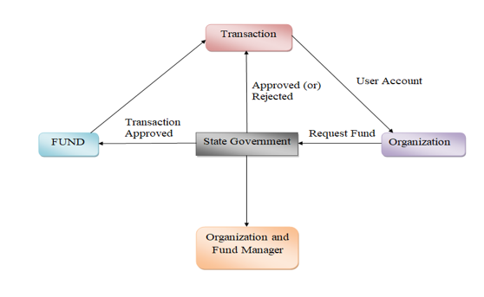

Fig1 Proposed Architecture

The state government funds transaction organization and funds manager organization's system architecture leverages blockchain technology for secure and transparent fund management. At the core of the architecture is a decentralized blockchain network, ensuring immutability, cryptographic encryption, and consensus mechanisms. The system comprises three main layers: the data layer, the logic layer, and the presentation layer.

In the data layer, blockchain stores all transactional data securely, ensuring tamper-proof records of fund transactions. The logic layer encompasses smart contracts governing fund allocation, verification, and disbursement processes. Smart contracts automate decision-making and ensure compliance with predefined rules and criteria.

The presentation layer provides user interfaces for stakeholders, including citizens, government officials, and auditors, facilitating seamless interaction with the system. Through intuitive interfaces, users can submit applications, track fund transactions, and access transparent reports on fund utilization. Overall, the system architecture ensures trust, efficiency, and accountability in state government fund management.

**c) Modules**

To implement this project we used the following modues are organization,transaction,state government,funds.

These modules description given below:

**New Organization Signup** In this module, new organizations can register to participate in the system by providing essential details such as name, contact information, and credentials. Upon registration, the organization is added to the system and granted access to their account for subsequent interactions and transactions.

**Organization Login** Registered organizations can log in using their credentials, gaining access to their accounts within the system. Upon logging in, organizations can engage in a range of functions, including viewing transaction history and initiating actions such as adding or requesting funds as per their requirements and permissions.

**View Transaction** This module enables organizations to access and review transaction records associated with their account. They can examine comprehensive details of past transactions, encompassing fund allocation and expenditure. Through this feature, organizations can maintain transparency and track the flow of funds within the system effectively.

**State Government Login** State government officials and administrators access the system using their unique credentials, granting them access to an array of functions. These include adding funds, allocating funds to projects, viewing transaction records, and managing organizations. This login provides officials with comprehensive oversight and control over fund management activities within the system.

**Add Amount** State government users, upon login, can add funds to the system by specifying the amount, funding source, and pertinent details. These added funds contribute to the total available for allocation to diverse projects, enhancing the financial resources accessible for government initiatives and programs.

**Allocate Fund** State government administrators utilize this module to allocate funds to designated projects or initiatives, specifying the project, allocated amount, and relevant details. This systematic allocation process ensures that funds are distributed in alignment with government priorities and policies, facilitating efficient resource utilization and program implementation

**View Transaction** State government officials have access to a comprehensive transaction records module, akin to organizations, enabling them to monitor fund flow, project allocations, and expenditures at a broader scale. This feature empowers officials with insights into the utilization of funds within the government allocation system, facilitating effective oversight and management.

**View Organization** State government users have access to a module to view details of registered organizations participating in the fund allocation system. They can review each organization's information, status, and activities, gaining insights into their participation and contributions. This feature enhances transparency and facilitates informed decision-making in fund allocation processes.

**d) BLOCK CHAIN INTEGRATION**

The project leverages blockchain technology to create a platform for tracking government fund allocation, ensuring transparency and accountability in financial transactions. This integration of blockchain enhances the security and immutability of transaction records, thereby fostering trust in the fund allocation process.

Blockchain technology is utilized to establish a government fund allocation procedure that is resistant to corruption and fraud, providing transparency and security at each stage of the allocation process. This ensures that funds are distributed fairly and without tampering, bolstering public confidence in the system.

Cryptographically hashed data is incorporated into the blockchain system to strengthen the security and integrity of transaction information, making it resistant to unauthorized access and data tampering, thereby ensuring the utmost level of data security and reliability in the project.

**GANACHE**

Ganache is a local Ethereum blockchain emulator used for the development and testing of Ethereum smart contracts, allowing developers to simulate an Ethereum network on their local machines. in Ganache server, developers can:Create Ethereum accounts with private keys for testing.Simulate transactions and interactions with smart contracts.Monitor transaction details, gas usage, and execution logs.

Ganache emulates an Ethereum blockchain, consisting of a series of blocks. Each block contains recorded transactions and has a unique block number. These blocks serve to validate and record transactions and interactions in the simulated Ethereum network.

Ganache is utilized in this project to retrieve information stored on the local Ethereumblockchain, including data related to government funds allocation, project details, fund recipients,and various transactions or interactions within the state government's blockchain-based allocation and tracking system.

**EXPERIMENTAL RESULTS**

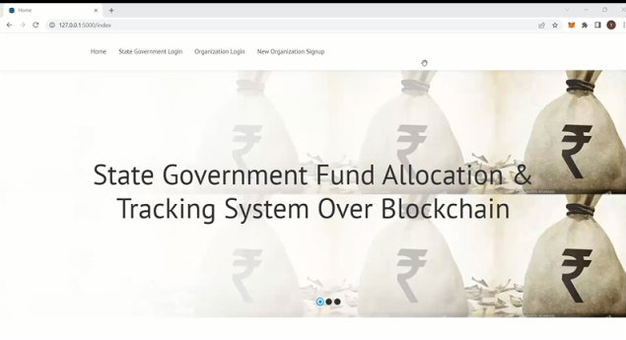

Fig 2 home page

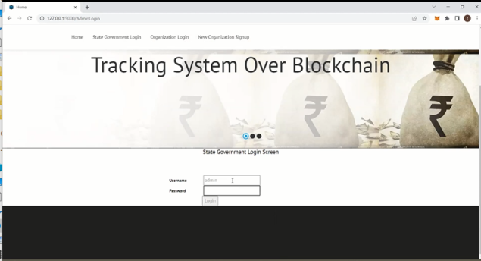

Fig 3 login screen page

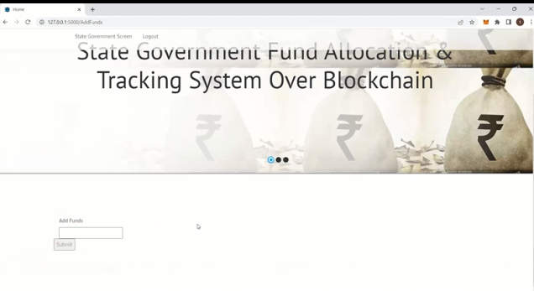

Fig 4 funds donating page

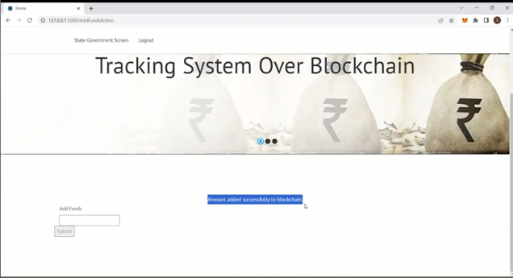

.

Fig 5 amount adding to block chain page

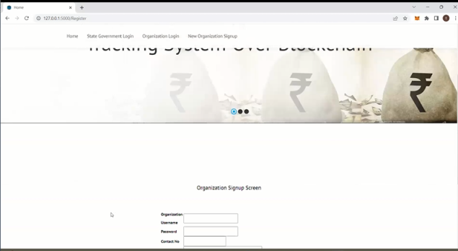

Fig 6 organization sign up screen

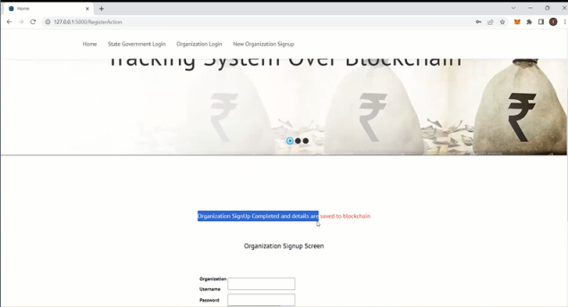

Fig 7 details page

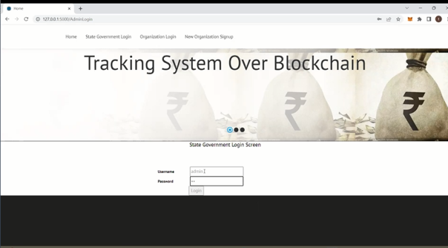

Fig 8 log in screen page

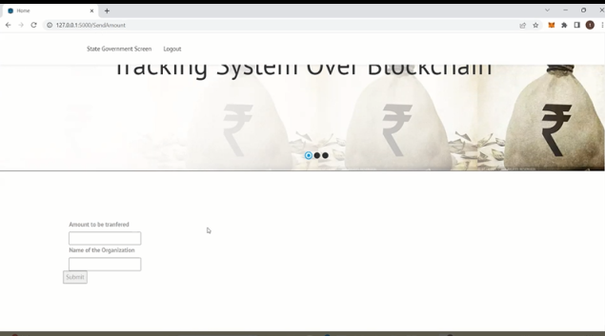

Fig 9 details page

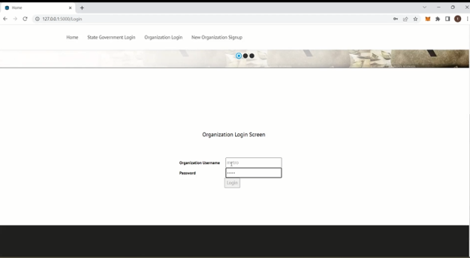

Fig 10 organization login screen page

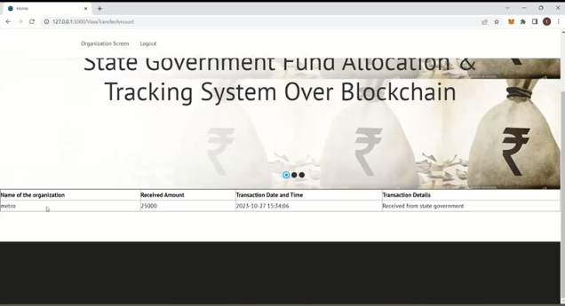

Fig 11 details page

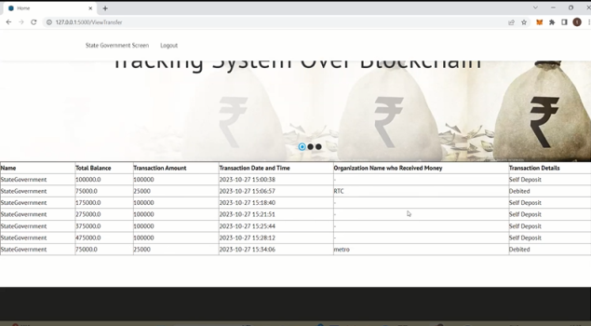

Fig 12 out put page

**CONCLUSION**

In conclusion, the integration of blockchain technology into government fund allocation and tracking systems yields multifaceted benefits that profoundly impact transparency, accountability, security, and data integrity. By leveraging blockchain, the project establishes a framework that elevates transparency and accountability, providing stakeholders with a clear view of fund utilization and allocation processes. Additionally, charitable foundations benefit from centralized donation data and automated report generation, facilitating efficient management of philanthropic activities.

Moreover, blockchain fortifies the security and integrity of the system, mitigating the risks of corruption and unauthorized access. The adoption of cryptographically hashed data ensures the immutability and trustworthiness of transaction records, bolstering public confidence in the reliability of financial information.

Overall, the incorporation of blockchain technology represents a pivotal step towards enhancing governance practices and fostering trust between governments, organizations, and citizens. By embracing innovation and prioritizing transparency, the project sets a precedent for effective and accountable management of public funds in the digital age.

**FUTURE SCOPE**

Incorporating the Byzantine consensus mechanism can significantly enhance the scalability and robustness of the proposed project by enabling efficient consensus among network participants, even in the presence of malicious actors. This ensures that the system remains resilient andcapable of accommodating a growing volume of transactions without compromising security or performance. Additionally, augmenting data encryption further strengthens the system's security posture, safeguarding sensitive information from potential threats or breaches.

Moreover, bundling multiple documents using a unique identifier holds promise for streamlining tracking processes, simplifying record-keeping, and enhancing overall efficiency. Introducing sub-contractors into the system can expedite fund disbursement processes by facilitating direct transactions between government entities and subcontractors, thereby minimizing administrative overhead and improving resource allocation.

These proposed enhancements not only address existing challenges but also pave the way for future innovations in government fund allocation and tracking systems. By embracing scalability, security, and efficiency improvements, the project can evolve into a more resilient and adaptable platform capable of meeting the dynamic needs of stakeholders and supporting sustainable governance practices.

**REFERENCES**

* Mahammad, F. S., & Viswanatham, V. M. (2020). Performance analysis of data compression algorithms for heterogeneous architecture through parallel approach. The Journal of Supercomputing, 76(4), 2275-2288.
* Karukula, N. R., & Farooq, S. M. (2013). A route map for detecting Sybil attacks in urban vehicular networks. Journal of Information, Knowledge, and Research in Computer Engineering, 2(2), 540-544.
* Farook, S. M., & NageswaraReddy, K. (2015). Implementation of Intrusion Detection Systems for High Performance Computing Environment Applications. Inter national journal of Scientific Engineering and Technology Research, 4(0), 41.
* Sunar, M. F., & Viswanatham, V. M. (2018). A fast approach to encrypt and decrypt of video streams for secure channel transmission. *World Review of Science, Technology and Sustainable Development*, *14*(1), 11-28.
* Mahammad, F. S., & Viswanatham, V. M. (2017). A study on h. 26x family of video streaming compression techniques. *International Journal of Pure and Applied Mathematics*, *117*(10), 63-66.
* Devi,S M. S., Mahammad, F. S., Bhavana, D., Sukanya, D., Thanusha, T. S., Chandrakala, M., & Swathi, P. V. (2022).” Machine Learning Based Classification and Clustering Analysis of Efficiency of Exercise Against Covid-19 Infection.” Journal of Algebraic Statistics, 13(3), 112-117.
* Devi, M. M. S., & Gangadhar, M. Y. (2012).” A comparative Study of Classification Algorithm for Printed Telugu Character Recognition.” *International Journal of Electronics Communication and Computer Engineering*, *3*(3), 633-641.
* Devi, M. S., Meghana, A. I., Susmitha, M., Mounika, G., Vineela, G., & Padmavathi, M. MISSING CHILD IDENTIFICATION SYSTEM USING DEEP LEARNING.
* V. Lakshmi chaitanya. "Machine Learning Based Predictive Model for Data Fusion Based Intruder Alert System." journal of algebraic statistics 13, no. 2 (2022): 2477-2483.
* Chaitanya, V. L., & Bhaskar, G. V. (2014). Apriori vs Genetic algorithms for Identifying Frequent Item Sets. International journal of Innovative Research &Development, 3(6), 249-254.
* Chaitanya, V. L., Sutraye, N., Praveeena, A. S., Niharika, U. N., Ulfath, P., & Rani, D. P. (2023). Experimental Investigation of Machine Learning Techniques for Predicting Software Quality.
* Lakshmi, B. S., Pranavi, S., Jayalakshmi, C., Gayatri, K., Sireesha, M., & Akhila, A. Detecting Android Malware with an Enhanced Genetic Algorithm for Feature Selection and Machine Learning.
* Lakshmi, B. S., & Kumar, A. S. (2018). Identity-Based Proxy-Oriented Data Uploading and Remote Data Integrity checking in Public Cloud. International Journal of Research, 5(22), 744-757.
* Lakshmi, B. S. (2021). Fire detection using Image processing. Asian Journal of Computer Science and Technology, 10(2), 14-19.
* Devi, M. S., Poojitha, M., Sucharitha, R., Keerthi, K., Manideepika, P., & Vasudha, C. Extracting and Analyzing Features in Natural Language Processing for Deep Learning with English Language.
* Kumar JDS, Subramanyam MV, Kumar APS. Hybrid Chameleon Search and Remora Optimization Algorithm-based Dynamic Heterogeneous load balancing clustering protocol for extending the lifetime of wireless sensor networks. Int J Commun Syst. 2023; 36(17):e5609. doi:[10.1002/dac.5609](https://doi.org/10.1002/dac.5609)
* David Sukeerthi Kumar, J., Subramanyam, M.V., Siva Kumar, A.P. (2023). A Hybrid Spotted Hyena and Whale Optimization Algorithm-Based Load-Balanced Clustering Technique in WSNs. In: Mahapatra, R.P., Peddoju, S.K., Roy, S., Parwekar, P. (eds) Proceedings of International Conference on Recent Trends in Computing. Lecture Notes in Networks and Systems, vol 600. Springer, Singapore. <https://doi.org/10.1007/978-981-19-8825-7_68>
* Murali Kanthi, J. David Sukeerthi Kumar, K. Venkateshwara Rao, Mohmad Ahmed Ali, Sudha Pavani K, Nuthanakanti Bhaskar, T. Hitendra Sarma, “A FUSED 3D-2D CONVOLUTION NEURAL NETWORK FOR SPATIAL-SPECTRAL FEATURE LEARNING AND HYPERSPECTRAL IMAGE CLASSIFICATION,” J Theor Appl Inf Technol, vol. 15, no. 5, 2024, Accessed: Apr. 03, 2024. [Online]. Available: [www.jatit.org](http://www.jatit.org)
* Prediction Of Covid-19 Infection Based on Lifestyle Habits Employing Random Forest Algorithm FS Mahammad, P Bhaskar, A Prudvi, NY Reddy, PJ Reddy journal of algebraic statistics 13 (3), 40-45
* Machine Learning Based Predictive Model for Closed Loop Air Filtering System P Bhaskar, FS Mahammad, AH Kumar, DR Kumar, SMA Khadar, ...Journal of Algebraic Statistics 13 (3), 609-616
* Kumar, M. A., Mahammad, F. S., Dhanush, M. N., Rahul, D. P., Sreedhara, K. L., Rabi, B. A., & Reddy, A. K. (2022). Traffic Length Data Based Signal Timing Calculation for Road Traffic Signals Employing Proportionality Machine Learning. Journal of Algebraic Statistics, 13(3), 25-32.
* Kumar, M. A., Pullama, K. B., & Reddy, B. S. V. M. (2013). Energy Efficient Routing In Wireless Sensor Networks. International Journal of Emerging Technology and Advanced Engineering, 9(9), 172-176.
* Kumar, M. M. A., Sivaraman, G., Charan Sai, P., Dinesh, T., Vivekananda, S. S., Rakesh, G., & Peer, S. D. BUILDING SEARCH ENGINE USING MACHINE LEARNING TECHNIQUES.
* “ Providing Security in IOT using Watermarking and Partial Encryption. ISSN No:
  + 2250-1797 Issue 1, Volume 2 (December 2011)
* The Dissemination Architecture of Streaming Media Information on Integrated CDN and P2P, ISSN 2249-6149 Issue 2, Vol.2 ( March-2012)
* Provably Secure and Blind sort of Biometric Authentication Protocol using Kerberos, ISSN: 2249-9954, Issue 2, Vol 2 (APRIL 2012)
* D.LAKSHMAIAH, DR.M.SUBRAMANYAM, DR.K.SATYA PRASAD,” DESIGN OF LOW POWER 4- BIT CMOS BRAUN MULTIPLIER BASED ON THRESHOLD VOLTAGE TECHNIQUES”, GLOBAL JOURNAL OF RESEARCH IN ENGINEERING, VOL.14(9),PP.1125-1131,2014.
* R SUMALATHA, DR.M.SUBRAMANYAM, “IMAGE DENOISING USING SPATIAL ADAPTIVE MASK FILTER”, IEEE INTERNATIONAL CONFERENCE ON ELECTRICAL, ELECTRONICS, SIGNALS, COMMUNICATION &AMP; OPTIMIZATION (EESCO-2015), ORGANIZED BYVIGNANS INSTITUTE OF INFORMATION TECHNOLOGY, VISHAKAPATNAM, 24 TH TO 26TH JANUARY 2015. (SCOPUS INDEXED)
* P.BALAMURALI KRISHNA, DR.M.V.SUBRAMANYAM, DR.K.SATYA PRASAD, “HYBRID GENETIC OPTIMIZATION TO MITIGATE STARVATION IN WIRELESS MESH NETWORKS”, INDIAN JOURNAL OF SCIENCE AND TECHNOLOGY,VOL.8,NO.23,2015. (SCOPUS INDEXED)
* Y.MURALI MOHAN BABU, DR.M.V.SUBRAMANYAM,M.N. GIRI PRASAD,” FUSION AND TEXURE BASED CLASSIFICATION OF INDIAN MICROWAVE DATA – A COMPARATIVE STUDY”, INTERNATIONAL JOURNAL OF APPLIED ENGINEERING RESEARCH, VOL.10 NO.1, PP. 1003-1009, 2015. (SCOPUS INDEXED)