

**“DIGITAL MARKETING TREND IN INDIA“**

*PROJECT REPORT SUBMITTED IN PARTIAL FULFILLMENT FOR THE AWARD OF THE DEGREE OF:*

Master of Business Administration

*By: Ankur Sharma (22GSOB2010109)*

*IN BRANCH OF STUDY:* SCHOOL OF BUSINESS

*UNDER THE SUPERVISION OF:*

*Mr.Vivek Verma*

*Title of the research paper:* **More Then DIGITAL MARKETING TREND IN INDIA**

**Abstract:**

This project says about Digital Marketing in Indian scenario. The main purpose of this project is to aware the people of the modern concept of digital marketing which is cost effective and time saving concept.

Under this project I have described the concept of marketing, digital marketing and digital advertising. I have described about the marketing mix, 7P’s of digital marketing, types of digital advertising. I have given the example of dell and I pod Touch Company about how they used the digital advertising to bring the awareness of the product.

The USP of this project is the case study about the companies namely; DELL and I POD TOUCH, extended marketing mix, merits of digital marketing.

Under this project I have tried to study about the digital marketing in India and its effect, the importance of digital marketing in the growing world or advanced world. Anybody reading this project will surely get an insight of digital marketing concept and its growing importance.

**Keywords:-** Digital Marketing, Video Marketing, Social Media, Influencer Marketing, Content Marketing, Chatbots, AI, E-commerce, Voice Search Optimization, Data Privacy, Personalization, Augmented Reality, Virtual Reality, India.

# Introduction:

MARKETING

Marketing Spelled Pronunciation marketing which means:

1. The act of buying or selling in a market.

2. The total of activities involved in the transfer of goods from the producer or seller to the consumer or buyer, including advertising, shipping, storing, and selling. At the beginning of the century, social life was mostly local. It was followed by a period in which commodities were produced on a mass scale. Consumer Marketing operated on mass marketing principles and business primarily concerned itself with how to build the best sales force. At the end of the century, there is an emerging global culture. The major driver of these changes is technology. Technological change has moved steadily back focusing on the individual. These changes shape the possibility and conduct of business. Marketing is especially tied to communication and transportation revolution. As the tools and reach of marketing increase, the job and responsibilities of marketers have evolved with them.



PHILIP KOTLER

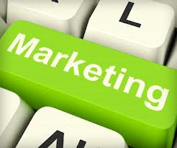

Philip Kotler formalized this evolution with his book "Marketing Management". His key stages are production, sales and brand management. Each of these is strongly motivated by technological opportunities, which permit new methods and new opportunities. A fourth stage, a focus on the individual customer, is also important. As the new technology of the Internet develops, it reinforces the new marketing emphasis - which in many ways is a return to business at the turn of the century.

In today’s technology driven world, a new fast paced digital economy is emerging. Tomorrow there will be companies that will exist only inside computer networks. Most business transactions will be made electronically, directly from the producer to the consumer, bypassing the supply chain. In the digital marketing environment, the consumer becomes an integral player in the development of the product. In fact, a consumer might build the product himself from a wide array of parts provided by the Company. It is e-commerce that is changing the way products and services are conceived, manufactured, promoted, priced, distributed and sold. The reason being that it is much cheaper; it allows vast coverage and helps in serving the customer better.

**Findings:**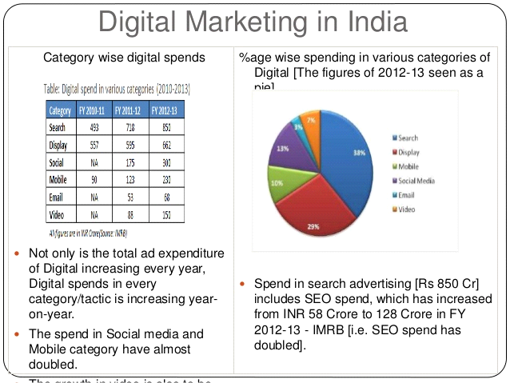

# Literature Review:

The purpose of doing research in the area of digital marketing is because it seem huge, intimidating and foreign. Businesses are looking for clearer picture to start but do not know where and how to start doing digital marketing. In today’s time, social media channels such as Face book, Twitter, Google and other social media firms have successfully transformed the attitudes and perceptions of consumers and in the end helped revolutionized many businesses. This was done through measurable vast network of customers with trustworthy data with real-time feedback of customer experiences. It is much more convenient for businesses to conduct surveys online with a purpose to get relevant information from targeted groups and analyzing the results based on their responses. Potential customers can look for reviews and recommendations to make informed decisions about buying a product or using the service. On the other hand, businesses can use the exercise to take action on relevant feedback from customers in meeting their needs more accurately. Digital marketing is the use of technologies to help marketing activities in order to improve customer knowledge by matching their needs (Chaffey, 2013). Marketing has been around for a long time. Business owners felt the need to spread the word about their products or services through newspapers and word of mouth. Digital marketing on the other end is becoming popular because it utilizes mass media devices like television, radio and the Internet. The most common digital marketing tool used today is Search Engine Optimization (SEO). Its role is to maximize the way search engines like Google find your website. Digital marketing concept originated from the Internet and search engines ranking of websites. The first search engine was started in 1991 with a network protocol called Gopher for query and search. After the launch of Yahoo in 1994 companies started to maximize their ranking on the website (Smyth 2007). When the Internet bubble burst in 2001, market was dominated by Google and Yahoo for search optimization. Internet search traffic grew in 2006; the rise of search engine optimization grew for major companies like Google (Smyth 2007). In 2007, the usage of mobile devices increased the Internet usage on the move drastically and people all over the world started connecting with each other more conveniently through social media.

# Research Objectives:

* To compare the trust level of traditional advertising and digital advertising (consumers point of view)
* To find the effectiveness of digital advertising (reach and creation of awareness)
* To find the reliability of digital advertising (recall and remembrance)

# Research Design and Methodology

# Research Design:

**Research design**

This is a descriptive research as it will clarify the doubts about online advertising.

It would give us a clear picture on the effectiveness and reliability of online advertising compared to the traditional form of advertising.

**Data collection**

Secondary data: Online reports related to advertising

Primary data: Questionnaire, Personal Interview, Interview with Marketing Professional

**Sample universe**

Basis of sampling:

* Sample should be a user of internet or should have knowledge about internet
* 50 numbers in all

**Sampling Technique**:

Judgmental Non Probability sampling can be used to select the individual units for better productivity of the questionnaire. A well educated person may be able to reason out the questions in the better way.

**Research Design and Methodology**

Research design

This is a descriptive research as it will clarify the doubts about online advertising.

It would give us a clear picture on the effectiveness and reliability of online advertising compared to the traditional form of advertising.

Data collection

Secondary data: Online reports related to advertising

Primary data: Questionnaire, Personal Interview, Interview with Marketing Professional

Sample universe

Basis of sampling:-

* Sample should be a user of internet or should have knowledge about internet
* 50 numbers in all

Sampling Technique:-

Judgmental Non Probability sampling can be used to select the individual units for better productivity of the questionnaire. A well educated person may be able to reason out the questions in the better way.

**Limitations:**

Limited Scope: The project focuses primarily on digital marketing trends in India, which may not encompass all aspects of digital marketing globally.

Time Constraints: The project may not cover the most recent trends in digital marketing due to the time frame of the study ending in January 2024, potentially missing out on emerging trends.

Sample Size:The sample size for primary data collection is relatively small (50 respondents), which may not represent the diverse perspectives and experiences of all digital marketing professionals in India.

Sampling Bias The use of judgmental non-probability sampling technique could introduce bias, as it relies on the researcher's judgment rather than random selection, potentially skewing the results.

Dependency on Secondary Data: Reliance on secondary data sources for literature review might limit the depth of analysis and overlook recent developments not covered in existing literature.

Generalization: Findings and conclusions drawn from case studies of specific companies like Dell and iPod Touch may not be universally applicable to all businesses operating in the digital marketing domain.

Subjectivity in Interpretation: Interpretation of data collected through questionnaires and interviews may be subjective, influenced by the researcher's perspective, potentially affecting the validity of the findings.

Data Collection Methods: The project primarily relies on questionnaires, personal interviews, and interviews with marketing professionals for data collection, potentially overlooking other valuable sources of information such as focus groups or observational studies.

Resource Constraints:Limited resources, both financial and human, may have restricted the depth of analysis and the extent of data collection, impacting the comprehensiveness of the study.

Dynamic Nature of Digital Marketing: Digital marketing trends evolve rapidly, and the project's findings may become outdated shortly after completion, necessitating continuous updates and revisions to remain relevant.

# CONCLUSION:

Practically it has been proved through the research that online advertising is neither effective nor reliable as compared to the traditional medium which is Television commercials and print media i.e. newspapers and magazines. Also, consumers trust the traditional medium more than that of online and there is a vast difference in their trust levels. Of course, it could be because of the Indian culture which is different from the western countries that are more into e-commerce and prefer to buy things online and they trust the internet more as compared to the other forms. Therefore, Internet advertising is more successful in those countries. All in vain in India, as we prefer to tangibles the things that we buy. Being collective we go shopping along with family friends and relatives.