# IOT BASED SMART BLIND STICK

Prof. Pallavi Mukesh Rokade

Email: pallavi.ece@tgpcet.com

Chetan Vishveshwar Shiwarkar

Email: shiwarkarchetan@gmail.com

Jayesh Ravichandra Burbure

Email: jayeshsince2000@gmail.com

Alisha Vinod Sakhare

Email: alishasakhare@gmail.com

Pratyush Prakash Shende

Email: pratyushshende6@gmail.com

Department of Electronics and Communication Eng.

Tulsiramji Gaikwad Patil College of

Engineering and Technology Nagpur India

1. ABSTRACT.

In this research paper, we place emphasis on the blind individuals within our society. The construction of our paper involves the prototyping of features and real-life applications. Our primary focus is on IoT in our research, utilizing a myriad of sensors to enrich our study further.Our project is adorned with GSM, the heart of IoT. It can detect the location of the blind individual and generate necessary messages based on different sensor readings, transmitting this information to the user's relatives. Through the use of multiple sensors, our stick is capable of issuing commands that can be likened to the eyes of a blind individual. We also employ an indicator to confirm that the user is blind. Our stick has the capability to identify any obstacles in the vicinity of the blind person, including those on the left, right, up, and down. The control system is significantly straightforward, enabling any blind person to operate it with ease.

1. PROBLEM STATEMENT

Blind individuals navigate through various challenges in their everyday lives. The task of navigating unfamiliar environments is challenging for them, mainly due to their reliance on auditory cues and tactile feedback. Alternative formats or assistive technologies must be employed by them to access printed information, which presents another hurdle. Non-verbal cues in social interactions often go missed, making effective communication difficult. Limited employment opportunities often come as a result of inaccessible work environments and technologies.

However, it is inspirational to see many of these individuals overcoming their obstacles using adaptive strategies, societal support, and advancements in technology. This showcases their resilience and resourcefulness. Despite hardships, blind people lead normal lives, albeit in their own unique styles of doing things.

Their challenges, largely due to inaccessible infrastructure and societal issues, are significant. It warrants an empathetic understanding of their daily struggles, problems, and challenges. Visual impairments restrict the ways they can interact with others, access information, and gain personal knowledge and experiences. This calls for an aid to help them cope with different scenarios.

Most aids and assistive technologies available in the market today pose a financial challenge for the majority of users who fall in the normal and low-income brackets. This situation necessitates the creation of new, cost-effective devices that can perform similar tasks to their expensive counterparts. With this in mind, we are embarking on a mission to develop an affordable, highly-functional spectacle that will serve as a useful and cost-efficient tool for visually-impaired individuals.

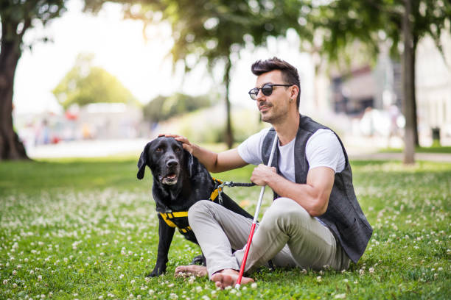

1. INTRODUCTION

Blind people encounter numerous challenges daily, one of the key ones being navigating the streets. The twofold problem of abundant vehicles and an array of obstacles potentially blocking their path necessitated a solution. Hence, we designed a smart blind stick, utilizing the Internet of Things (IOT). This stick employs an ultrasonic sensor to scan in front for obstacles, and it's connected to a GPS to aid others in locating the blind person.

In unfortunate instances of accidents involving a blind person, our device can send an SOS message via the GPS module, alerting nearby individuals to the situation. We believe that society needs to provide care and attention to blind people, enabling them to lead confident and independent lives.

The safety of blind individuals during their walks remains a significant concern. Most opt for a blind cane, the simple structure and singular function of which allows them to find their way by tapping on the ground or circumnavigating obstacles. Despite the ease of use, these canes have evident limitations. Users often encounter issues such as poor road conditions and unforeseen obstacles, to which ordinary canes cannot provide accurate responses. This greatly impacts the safety of blind pedestrians.

Our smart ultrasonic stick for blind people resolves this problem. It consists of a wearable stick equipped with ultrasonic sensors for detecting obstacles. A buzzical

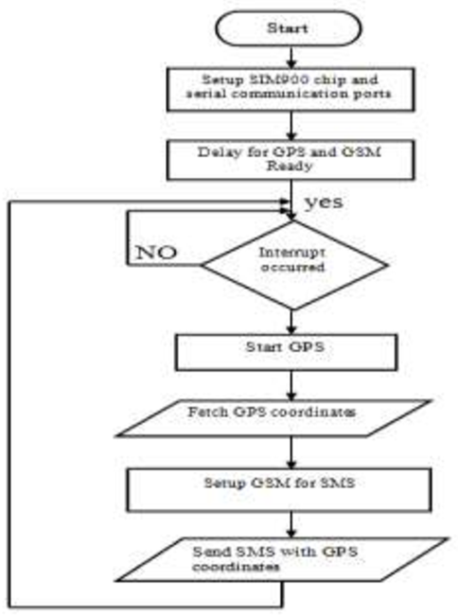

Fig 1. System flow on the smart blind stick

gives alerts according to the direction of an obstacle from the user. An Arduino NANO central processing unit (CPU) processes information from the sensor about obstacle distance, according to the specific coding we use, and transmits the output through the buzzer.

The stick operates through a central power supply that distributes power to the different components. The sensor, placed between the top bar and the bridge in the smart stick, connects to the central unit using single-strand copper wires. We opted for ultrasonic sensors due to their low energy consumption over long propagation distances. This makes them ideal for measuring long lengths. Furthermore, the sensors adapt well to various harsh conditions such as darkness, dust, smoke, electromagnetic interference, and toxicity, proving their wide range of applications.

1. METHODOLOGY

* Ultrasonic sensor to detect more obstacles.
* UsingArduino Nano.
* GSM module to send the massage.
* GPS module- caretakers track the blind persons location.
* Water level sensor to spot the water holes.
* Buzzer to alert the blind person.

1. BLOCK DIAGRAM

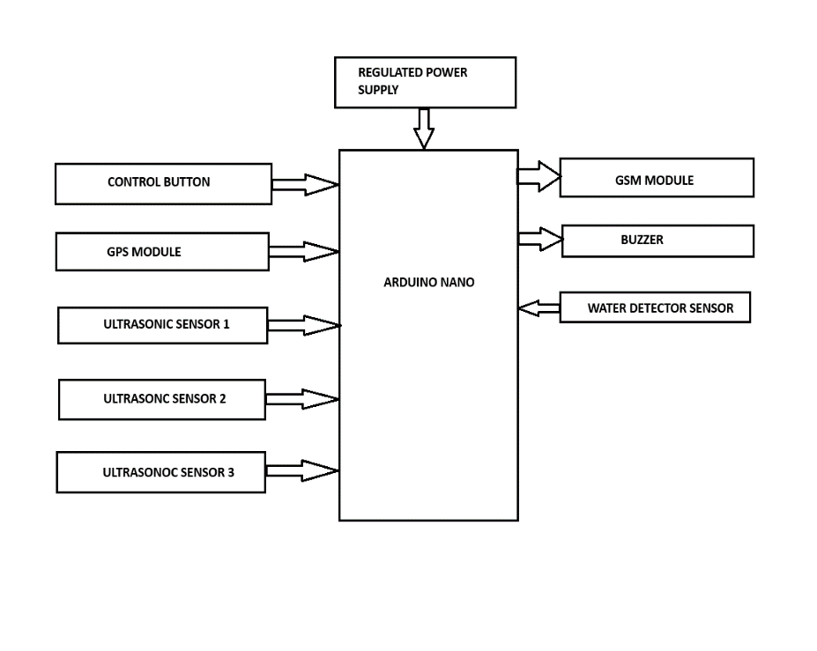

Fig 2. Block diagram of smart blind stick

* ARDUINO NANO

The Arduino Nano Every, an evolution of the classic Arduino Nano, shares the exact same pinout. However, it features the ATMega4809, a processor that is more powerful, 48KB of CPU Flash memory and it boasts a higher clock speed of 20 MHz. I am going to show you how to send data from the Nano Every board to another board using I2C.

* GPS

The Global Positioning System (GPS) is a space-based radio navigation system that provides reliable positioning,

Navigation, and timing services to users on a continuous worldwide basisfreely available to all. The GPS is made up of

three parts. Satellites which are orbiting the earth, control and monitoring stations on the earth, the GPS receivers owned by

the users.

* ULTRASONIC SENSOR

Ultrasonic sensor is very famous sensor to detect the obstacle. The sender which is attached to the sensor emits the

ultrasonic wave which come back after collide by the obstacle and received by the receiver attached to the ultrasonic sensor.

Ultrasonic sensor calculate the distance of the object by calculating the time between the emission and receiving of ultrasonic

waves by sender and receiver.

* BUZZER

A buzzer is an electroacoustic device that produces sound when an electric current passes through it. It typically consists of a coil of wire, a diaphragm, and a magnet. When the current flows through the coil, it creates a magnetic field that interacts with the magnet, causing the diaphragm to vibrate. These vibrations generate sound waves, producing the audible buzzing or beeping sound.

* GSM

A GSM module operates by establishing a connection to the GSM network using a SIM card. This SIM card endows the module with a unique identification number that plays a crucial role in identifying the device on the network. Following this, the GSM module engages in communication with the network by utilizing a specific set of protocols. This in turn, enables it to both dispatch and retrieve data.

* WATER DETECTOR SENSOR

The sensor incorporates a built-in red indicator LED. This LED illuminates whenever water is detected, providing a clear visual signal. Additionally, the detection signal outputs a high signal when it identifies the presence of water. This enhances the accuracy and efficiency of the detection process. If you need to change the polarity of the detection signal, simply ground the black wire. This action will convert the detection signal type to an active low signal, allowing for greater flexibility in how the sensor operates.

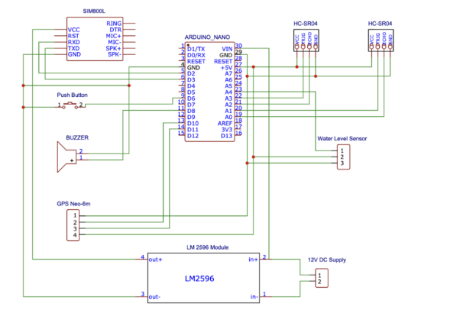

Fig 3. Circuit diagram of smart blind stick

1. LITERATURE REVIEW.

Paper [1] Title: Smart Stick for the Blind a complete solution to reach the destination. This system uses IR sensor, Ultrasound

sensor and water sensor to detect the obstacle. However, this system just gives an alert if any one of the sensor is triggered, it

uses a buzzer to alert the blind person. This system does not use any location identifier or location indicator.

Paper [2] Title: Pothole detection for visually impaired which uses a camera that captures image 15 frame per second and

based on the concept of image processing the pothole is detected. Problem with this system is use of camera makes it

expensive, and also a lot of images captured per second increases overhead and storage requirement.

Paper [3] Title: Smart Walking Stick for Blind describes about a Stick which use Raspberry Pi [10] and an ultrasonic sensor

to detect objects and intruder, the system also has a camera embedded with it, and based on the images captured the objects

are detected. The objects are analyze based on the set of image datasets that are already stored. This system however,

becomes costly due to the use of high-end camera and also because of storage constraints as large volume of datasets are

needed to be stored.

This system, sometimes might also be inaccurate because the obstacles are detected based on dataset (large set of images) as

different objects vary in their shape and size.

Paper [4]Title: Smart Belt for Blind uses a belt embedded with ultrasound sensor which detects the obstacle. The belt also has

a buzzer which vibrates when obstacle is detected. The entire system is developed in such a way that the distance calculated

is sent as an audio message for the blind person, where in which he hears the distance calculated using a speaker.

Paper [5] Title: A wearable ultrasonic obstacle sensor for visually impaired. This system uses a couple of ultrasound sensor

on either side over the strap of the goggles. This project can detect the intruder in front of the blind person who is wearing the

goggles. This system is not robust as the sensor embedded with the goggles makes it heavier and also it cannot detect

complex objects such as water, vehicle etc.

1. CONCLUSION

Blind people often find it difficult to move or live in their surrounding without assistance. Therefore, they typically use a white cane to guide them during their movements. Although this tool can be helpful, it does not offer a complete guarantee for their safety from potential risks. The traditional methods like this can only detect low-level obstacles.

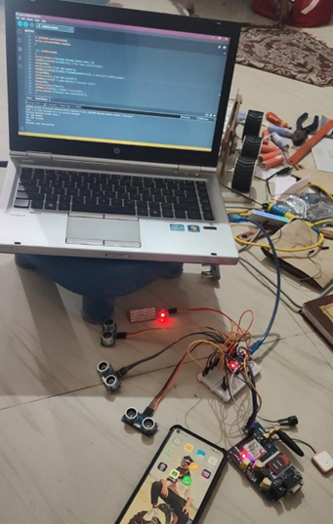

Fig 4. Internal circuit of smart blind stick

The smart stick comes into the picture as a foundational platform for the upcoming generation of more supportive devices. Its primary function is to ensure safe navigation for the visually impaired both indoors and outdoors. This tool, being both effective and affordable, has shown promising results in detecting obstacles on the user's path. The system, apart from being low-cost and reliable, offers a robust solution for navigation. It is portable, consumes less power, and most importantly, it is capable of delivering short response times.



Fig 5. System flow on the smart blind stick

1. REFFERENCES

[1] Ankit Agarwal, Deepak Kumar, Abhishek Bhardwaj- International Journal of Engineering and Computer Science ISSN:2319- 7242Volume 4 Issue 4(April 2015)

[2] Assistive Infrared Sensor Based Smart Stick for Blind People, Ayat A. Nada| Science and Information Conference 2015 July 28-30, 2015 London, UK

[3] Sung Jae Kang, Young Ho, Kim, In Hyuk Moon, “Development of An Intelligent Guide-Stick for The Blind”, IEEE International Conference on Robotics &Automation Seoul, Korea, May 21-26, 2001.

[4] Alessio Carullo and Marco Parvis, “An Ultrasonic Sensor for Distance Measurement in Automotive Applications”, IEEE Sensors Journal, Vol.1, No.2, August 2001.

[5] Md. S. Arefi and T. Mollick (2013). Design of an Ultrasonic Distance Meter, International journal of scientific and engineering research, 4(3), Available at: https://www.ijser.org/paper/Design-of-anUltrasonic-Distance-Meter.html.

[6] A. Agarwal, D. Kumar and A. Bhardwaj (2015). Ultrasonic Stick for Blind, International journal of engineering and computer science, 4(4), 11375-11378, Available at;] The Amazon way on IoT by John Ross man, volume 2, 20th July,2016

[7] Designing the Internet of Thingsby Adrian McEwen, Wiley Publication, Edition 1 2013.

[8] The Amazon way on IoT by John Ross man, volume 2, 20th July,2016

[9] Designing the Internet of Thing’s by Adrian McEwen, Wiley Publication, Edition 1 2013