**ANALYSING THE CUSTOMERS PERCEPTION OF PRICING IN E-COMMERCE PLATFORMS FOR APPAREL PRODUCTS: A STUDY WITH REFERENCE TO URBAN CONSUMERS**

**1Shivjanav.G, 2Dr. Syed Shahid Raza**

1Student, Dept of Business Analytics, CMS B-School, Jain (Deemed-to-be-University).

2Assistant Professor, Dept of Business Analytics, CMS B-School, Jain (Deemed-to-be-University)

**ABSTRACT**

In the context of India's growing e-commerce sector, this study investigates urban consumers' perceptions of pricing strategies for apparel products. Drawing upon insights from recent research, the study explores the evolving consumer behaviour influenced by factors such as convenience, flash sales, and festive shopping trends. It addresses concerns related to counterfeit products and fraudulent practices, emphasizing the importance of regulatory measures in maintaining consumer trust and market integrity. Furthermore, the study examines strategic initiatives undertaken by e-commerce platforms to enhance customer engagement and build brand loyalty through supply chain optimization, technological integration, and cross-border expansion. Leveraging innovative pricing models and advanced technologies like Convolutional Neural Networks (CNN), the study offers actionable insights for optimizing pricing strategies and gaining a competitive edge in India's dynamic e-commerce landscape.

**Keywords:** e-commerce, pricing perception, urban consumers, apparel products, consumer behaviour, regulatory measures, brand loyalty.

1. **INTRODUCTION**

The rationale for conducting this study on analysing customer perceptions of pricing in e-commerce platforms for apparel products stems from the increasing prominence of online shopping, particularly in urban areas. With the proliferation of e-commerce platforms offering apparel products, understanding how customers perceive pricing in this context is crucial for both businesses and consumers. Apparel is a significant segment of the e-commerce market, and pricing strategies employed by these platforms can significantly impact consumer behaviour and purchasing decisions.

Moreover, understanding urban consumers' perceptions of pricing in e-commerce platforms for apparel products can shed light on various factors influencing their purchasing behaviour, such as perceived value, price fairness, and willingness to pay. By exploring these dimensions, businesses can tailor their pricing strategies to align with consumer preferences, thereby optimizing revenue generation and market positioning. In the context of e-commerce platforms selling apparel products, there exists a lack of comprehensive understanding regarding how pricing strategies influence the perceptions and purchasing behaviours of urban consumers. Despite the growing popularity of online shopping for apparel, little research has been conducted to specifically investigate the impact of pricing strategies on consumer attitudes and behaviours within this domain. Therefore, the research problem at hand is to explore and analyse the relationship between pricing strategies implemented by e-commerce platforms and the perceptions and behaviours of urban consumers when purchasing apparel products online.

1. **METHODOLOGY**

**2.1 Research Objectives**

* To explore urban consumers' attitudes towards pricing strategies employed by e-commerce platforms for apparel products.
* To identify the key determinants influencing urban consumers' perceptions of pricing in e-commerce platforms for apparel product.

**2.2 Research Design**

Quantitative research methods to gain comprehensive insights into consumer perceptions of pricing in e-commerce platforms for apparel products.

**2.3 Methods for Data Collection**

A structured questionnaire was developed to collect quantitative data from a sample of urban consumers who have engaged in online apparel shopping. The survey has included questions related to pricing perceptions, perceived value, price fairness, willingness to pay, promotional influences, trust in pricing information, shopping behaviour, and demographic variables. The survey was circulated through online platforms and social media channels in the form of Google forms to reach a diverse sample of respondents.

1. **MODELING AND ANALYSIS**
2. **Descriptive Statistics:**

This image contains six histograms showing the distribution of different variables related to pricing and customer perception. The variables include fair pricing, listed price, affordability, cost effectiveness, premium price, and assortments. These histograms provide insights into the distribution of customer perceptions related to various pricing and product aspects, which can be useful for understanding market dynamics and making informed business decisions.

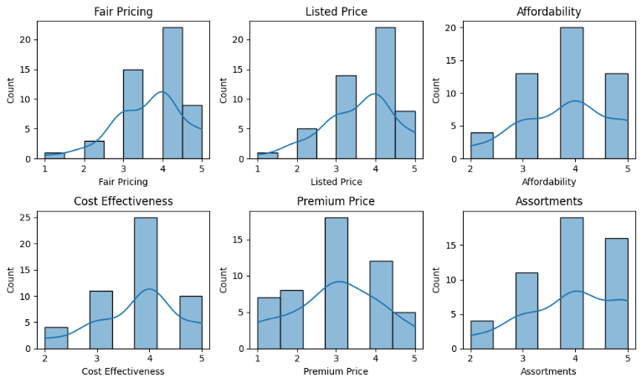

*Figure 1 Descriptive Statistics*

1. **Correlation Analysis:**

The diagonal elements (coloured in dark red) represent a perfect correlation of 1.0, as each variable is perfectly correlated with itself. There are strong positive correlations (darker shades of red) between certain pairs of variables, most other variable pairs have relatively weak correlations (lighter shades of blue or red), indicating low levels of association.

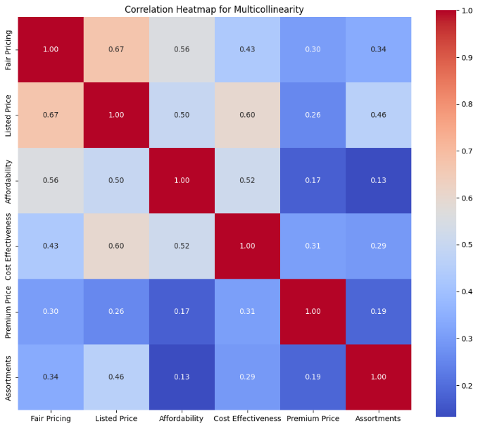

Figure 2 Correlation Heatmap for Multicollinearity

**H01:** **There is no significant relationship between urban consumers' perceptions of fair pricing and their purchase frequency of apparel products on e-commerce platforms.**

Correlation coefficient the value of -0.3111, the p-value of 0.02785 based on the results, there is a moderate negative correlation between 'Purchase Frequency' and 'Fair Pricing', which is statistically significant at the 0.05 level. This suggests that as consumers make more frequent purchases, their perception of fair pricing tends to decrease, or conversely, as their perception of fair pricing increases, their purchase frequency tends to decrease.

**H02:** **There is no significant relationship between urban consumers' perceptions of pricing and their likelihood to recommend the e-commerce platform for apparel products.**

Correlation coefficientthe value of 0.35032, the p-value of 0.0126 based on the results, there is a moderate positive correlation between 'Fair Pricing' and 'Recommendation', which is statistically significant at the 0.05 level. This suggests that as consumers perceive pricing to be fairer, they are more likely to recommend the e-commerce platform or product to others.

1. **Regression Analysis:**

**H03:** **Urban consumers' perceptions of pricing in e-commerce platforms for apparel products are not significantly influenced by factors such as brand, quality, variety, discounts, and reviews.**

**Coefficients:** Brand= 0.044 units, Quality= 0.088 units, Variety= 0.296 units, Discounts= 0.166 units, Reviews =0.052 units.

**Intercept:** The intercept value is 3.321.

**H04:** **Urban consumers' perceptions of pricing have no significant impact on their loyalty towards e-commerce platforms for apparel products.**

**Coefficient:** A one-unit increase in Fair Pricing is associated with an increase in Loyalty by 0.180 units.

**Intercept:** Fair Pricing is unlikely to be zero in this context, so the intercept may not have a meaningful interpretation.

1. **Hypothesis Testing:**

**T- statistics:**

t-statistic=-0.37, p-value= 0.71.

The t-test results suggest that there is no significant difference in Fair Pricing between male and female respondents. This conclusion is based on the obtained t-statistic and the associated p-value, which is greater than the conventional significance level (e.g., 0.05). Therefore, we fail to reject the null hypothesis of no difference in Fair Pricing between genders.

**ANOVA (Analysis of Variance)**

**H05:** **There is no significant difference in urban consumers' attitudes towards the listed price of apparel products on e-commerce platforms based on their monthly income.**

The F-statistic is 0.308. The p-value is 0.819.

Since the p-value (0.819) is greater than the typical significance level of 0.05, we fail to reject the null hypothesis. Therefore, there is no statistically significant difference in the listed price of apparel products across different monthly income groups.

**H06: There is no significant difference in urban consumers' perceptions of pricing based on their age and gender.**

Mean Squared Error (MSE)= 0.676, R-squared= 0.110, suggesting that the model explains around 11% of the variance in the 'Fair Pricing' variable.

The linear regression model has been trained using the dummy variables for age and gender to predict fair pricing. The coefficients of the regression model can be examined to understand the effect of different age and gender groups on fair pricing. These metrics are used to assess the performance of the linear regression model in predicting 'Fair Pricing' based on the features derived from 'Age' and 'Gender'.

1. **Machine Learning Algorithms:**

**K-Means Clustering:**

The clusters array contains the cluster labels assigned to each data point. Each element in the array represents the cluster assignment for the corresponding data point in 'X'. In this case, the array shows the cluster labels for each data point after clustering. These cluster labels can be further analysed to understand the grouping of data points based on their pricing perceptions. Clustering helps in identifying similar patterns or groups within the data, which can be useful for segmentation or understanding customer preferences.

**Random Forest Classifier:**

A higher accuracy value indicates better performance, with 1.0 being perfect accuracy. However, the interpretation of accuracy depends on the specific context and requirements of the problem at hand.

1. **Factor Analysis:**

The output prints the explained variance ratio for each principal component. Each value represents the percentage of total variance explained by the corresponding principal component. The output indicates that the first principal component explains approximately 40.36% of the total variance, the second component explains approximately 21.60%, and so on. These values help understand how much information each principal component retains from the original data. Typically, you aim for a high cumulative explained variance ratio, indicating that the selected principal components capture most of the variability in the data.

1. **RESULTS AND DISCUSSIONS**

Urban consumers generally show neutral to positive perceptions of pricing strategies, with moderately positive mean values and low variability. Insights reveal demographic trends in pricing perceptions and significant relationships between fair pricing, listed price, and product attributes. Key predictors include brand reputation, product quality, variety, discounts, and reviews. Significant correlations exist between fair pricing, purchase frequency, and loyalty, demonstrating the influence of demographic factors on consumer behaviour. Random forest classifiers and k-means clustering highlight the predictive power of pricing perceptions and segmentation among urban consumers.

# **REFERENCES**

Chandio, J., Talpur, M. S., Ahad, A., Khokhar, H., Shah, A., Abbasi, N., & Saima, M. (n.d.). Study Of Customers Perception About Shopping Trend Involving E-Commerce: A Comparative Study. *Turkish Online Journal of Qualitative Inquiry*.

Duan, Y., Liu, T., & Mao, Z. (n.d.). How online reviews and coupons affect sales and pricing: An empirical study based on e-commerce platform. *Journal of Retailing and Consumer Services* .

Guo, L. (n.d.). Cross-border e-commerce platform for commodity automatic pricing model based on deep learning. *Electronic Commerce Research*.

Hufnagel, G., Schwaiger, M., & Weritz, L. (n.d.). Seeking the perfect price: Consumer responses to personalized price discrimination in e-commerce. *Journal of Business Research*.

Li, C., Chu, M., Zhou, C., & Zhao, L. (n.d.). Two-period discount pricing strategies for an e-commerce platform with strategic consumers. *Computers & Industrial Engineering*.

Nasabi, A. N., & H, S. (n.d.). Consumer Buying Behaviour Trends of E-Commerce in India- A Case Study. *International Journal of Management, Technology and Social Sciences (IJMTS)*.

Natarajan, T., Balasubramanian, S. A., & Kasilingam, D. L. (n.d.). Understanding the intention to use mobile shopping applications and its influence on price sensitivity. *Journal of Retailing and Consumer Services*.

Octaviani, O. C., Rizan, M., & P, A. K. (n.d.). The Effect of E-Service Quality and Perceived Price Fairness on Customer Loyalty Which Customer Satisfaction as Intervening Study on Online Shopping Site in Indonesia. *JURNAL DINAMIKA MANAJEMEN DAN BISNIS*.

Singh, M. (n.d.). A Study on the Impact of online Flash sales on Indian Consumers.

Wu, C.-H., Yan, Z., Tsai, S.-B., Wang, W., Cao, B., & Li, X. (n.d.). An Empirical Study on Sales Performance Effect and Pricing Strategy for E-Commerce: From the Perspective of Mobile Information.