ANALYZING THE CUSTOMER RETENTION STRATEGIES OF SUBSCRIBERS OF "OVER-THE-TOP" (OTT) MEDIA STREAMING SERVICES: CAPTURING THE INSIGHTS OF URBAN CONSUMERS USING DATA ANALYTICS
¹Aishwarya Galdinus, ²Dr. Syed Shahid Raza
¹Student, Dept of Business Analytics, CMS B-School, Jain (Deemed-to-be-University).
²Assistant Professor, Dept of Business Analytics, CMS B-School, Jain (Deemed-to-be-University)

ABSTRACT
The over-the-top (OTT) media streaming services is an ever-evolving industry continually witnessing growth, particularly in the urban market. As a result, understanding and enhancing customer retention strategies has become paramount for service providers. This study delves into the effectiveness of customer retention strategies employed by OTT services, specifically focusing on urban consumers. Leveraging comprehensive data analytics tools, this study investigates the patterns, preferences and behaviours of urban consumers within the OTT platforms. The aim is to dissect the key drivers of urban audience retention, scrutinizing the impact of diverse tactics like content personalization, strategic pricing, exclusive offerings, loyalty programs, and community engagement. This analysis will lead to the development of data-driven segmentation models, empowering OTT service providers to craft targeted retention campaigns and loyalty programs in order to maximise customer lifetime value and thrive in the competitive urban market.

Keywords : Content Personalization, Customer Retention, Data-driven models, OTT services, Subscriber Strategies, Urban Consumers.

- INTRODUCTION
Customer retention is paramount for OTT platforms to sustain growth and profitability. By analysing how emerging technologies like AI-driven personalization influence customer retention rates, this study aims to provide insights into effective strategies for retaining subscribers. Understanding the factors that contribute to higher retention rates can inform decision-making processes and drive initiatives aimed at reducing churn. The rapid growth of the OTT market has intensified competition among streaming platforms. Traditional metrics like viewing time are no longer sufficient to gauge user engagement accurately. This study aims to explore deeper insights into user behaviour beyond surface-level metrics.
Enhancing the customer experience is paramount for OTT platforms. By leveraging advanced technologies like AI-driven personalization, platforms can offer tailored experiences to users. This study seeks to understand how these technologies influence customer retention rates, optimize content curation, and meet evolving consumer expectations. Ultimately, it aims to provide insights that empower OTT service providers to thrive in a dynamic and competitive landscape.
The central issue pertains to understanding the effectiveness of current customer retention strategies employed by OTT service providers and exploring the impact of sustainability initiatives on customer loyalty. Additionally, there is a need to identify key factors influencing customer churn and loyalty within the OTT industry and derive actionable insights to assist service providers in navigating this competitive digital entertainment landscape effectively. This study aims to address these challenges by investigating customer retention strategies, evaluating the role of sustainability initiatives, and providing practical recommendations for enhancing customer retention in the OTT industry.
Existing research has provided insights into factors influencing customer retention in OTT streaming, such as pricing, content differentiation, and user experience. However, a research gap persists in comprehensively exploring customer engagement metrics, particularly in qualitative aspects. This gap underscores the need for a deeper understanding of user engagement dynamics within the OTT landscape. Moreover, while some studies address emerging technologies like VR and AR, there is limited research on their future implications for OTT platforms, including interactive content and AI-driven personalization. Bridging this gap would provide valuable insights into evolving customer retention strategies in the OTT industry.

- METHODOLOGY
  - Research Objectives
- To explore user engagement beyond traditional metrics like viewing time or frequency.
- To analyse how emerging technologies, such as AI-driven personalization influence customer retention rates.
  - Research Design
A quantitative approach is employed to analyse large datasets obtained from OTT service providers, encompassing user engagement metrics, demographic information, and usage patterns. Statistical techniques such as ANOVA, chi-square tests, and predictive modelling are utilized to explore relationships between variables and predict customer retention rates.
  - Methods for Data Collection
Quantitative data was collected through online surveys distributed via Google Forms. The survey questionnaire included demographic information such as age, gender, and usage patterns, as well as questions related to user engagement metrics, preferences, and perceptions regarding OTT streaming platforms. Additionally, variables related to emerging technologies, such as AI-driven personalization and immersive experiences, were included to assess their impact on customer retention rates.

- MODELING AND ANALYSIS
- Multicollinearity Assessment using VIF

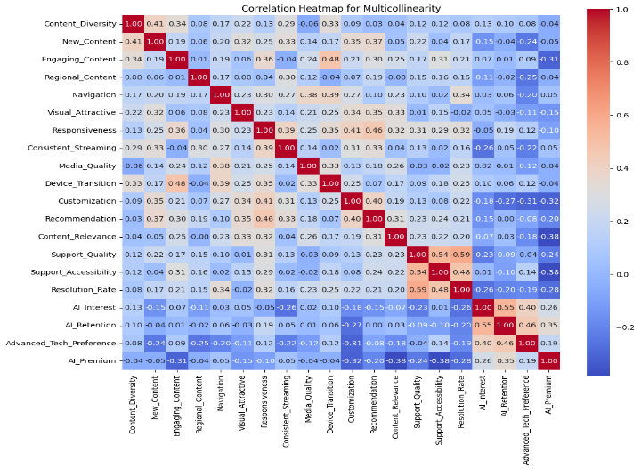
Figure 1 Correlation Heatmap of Variables
- Content Quality variables such as Content Diversity, New Content, and Engaging Content have VIF values ranging from approximately 15 to 22, suggesting strong correlations among these variables.
- User Interface variables, including Navigation, Visually Attractive, and Responsiveness, have VIF values ranging from approximately 16 to 20, indicating potential multicollinearity.
- Streaming Experience variable Media Quality has a particularly high VIF value of approximately 32, indicating a strong correlation with other variables in the model.

The high VIF values observed across multiple variables within each latent variable group indicate that the variables within each latent variable are measuring similar underlying dimensions, and there may be redundancy in the information they provide.
- Dimension Reduction using Principal Component Analysis

The output of PCA, a single principal component, represents a new latent. This new variable incorporates the most critical information from the original set, addressing multicollinearity and providing a more concise measure of perceived content quality. This newly created variable is added back to the original dataset. This allows us to utilize it in subsequent analyses alongside other variables to explore their combined influence on customer retention.
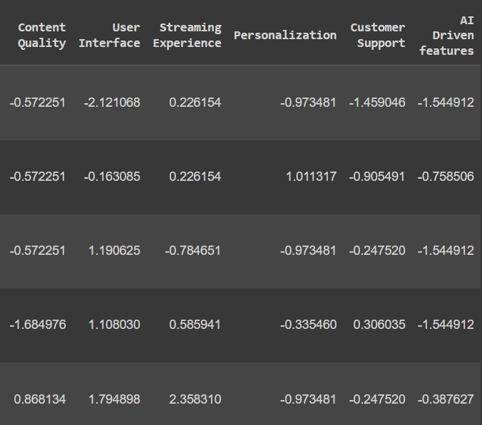
Figure 2 PCA values for Latent Variables

- Factor Analysis

In this case, the scree plot suggests retaining three factors, as they are above the "elbow" point where the eigenvalues start to level off.
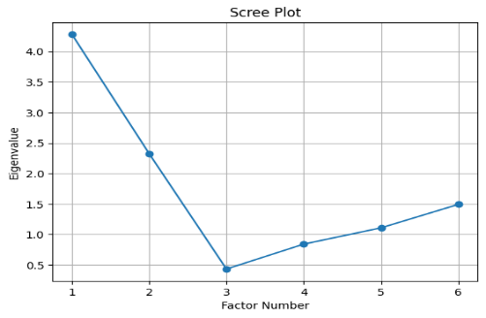
Figure 3 Scree plot for Factor Number

Factor 1:
- This factor has high loadings on User Interface (0.98871836) and Streaming Experience (0.5601952), indicating that these two latent variables are strongly correlated and likely capture a common underlying dimension.
- Content Quality (0.27213295) and Personalization (0.5529297) also have moderate loadings on this factor, suggesting they are related to the same underlying dimension.
- This factor seems to capture the overall streaming experience, including the user interface, streaming quality, and personalization. This suggests that these factors are closely related and should be considered together when developing customer retention strategies.

Factor 2:
- This factor has a very high loading on Content Quality (0.95516515), suggesting that this latent variable is the primary driver of this factor.
- User Interface (0.14053631) and Streaming Experience (0.256099) have lower loadings on this factor, indicating a weaker relationship.
- The second factor is largely driven by content quality, indicating that this is a critical factor for customer retention and should be a primary focus for OTT service providers.
Factor 3:
- This factor has a high loading on AI Driven features (0.71723223), indicating that this latent variable is the primary contributor to this factor.
- Customer Support (0.35002663) has a moderate loading on this factor, suggesting a relationship between AI-driven features and customer support.
- The third factor is dominated by AI-driven features, which appear to be closely linked to customer support. This highlights the importance of incorporating AI-powered solutions to enhance the customer experience and provide effective support.

- Multiple Linear Regression
Hypothesis 1 - There is a difference in customer retention rate among subscribers of different age. The results of this regression analysis shows that :

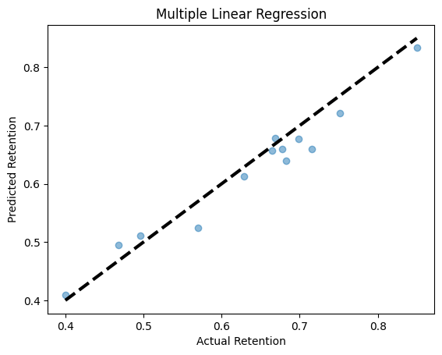
Figure 4 Multiple Linear Regression

- Intercept: The intercept value of 0.621represents the predicted user engagement score when all the independent variables (Content Quality, User Interface, Streaming Experience, Personalization, Customer Support, and AI Driven features) are equal to 0.
- Coefficients: Content Quality = -0.029, User Interface= -0.026, Streaming Experience= -0.0263, Personalization= -0.0203, Customer Support= -0.0121, AI Driven features= 0.0301.
- Accuracy: The model achieves an accuracy of 0.9434 on the test set.

- Chi – square Test
Hypothesis 2 - There is a difference in customer retention rates among subscribers of different genders. The results of chi square test for hypothesis 2 show that: The chi-square statistic is 59.9988. The p-value is 0.4393.
Since the p-value (0.4393) is greater than the significance level (0.05), we fail to reject the null hypothesis. The statistical analysis does not provide sufficient evidence to conclude that there is a difference in user engagement rates among subscribers of different genders. In other words, the results suggest that the user engagement rates are not significantly different across different genders.

- Analysis of Variance (ANOVA)
Hypothesis 3 - The number of devices used for streaming and perceived affordability have an impact on customer retention rates. Based on the ANOVA results, it cannot be concluded that the number of devices used for streaming and perceived affordability have a significant impact on customer retention rates. The main effects of Devices and Affordability, as well as their interaction effect, are not statistically significant. This means that the data does not provide enough evidence to support the hypothesis that the number of devices used for streaming and perceived affordability are important factors in determining customer retention rates.
Hypothesis 4 - User Interface and Streaming Experience have a positive effect on customer retention rates. These results underscore the importance of focusing on user experience design and optimizing these key features to enhance customer retention. Specifically, ensuring a visually appealing interface, responsive user interactions, consistent streaming experience, and seamless device transitions should be prioritized in the development and improvement of the platform. While Navigation and Media Quality did not show statistically significant effects, their p-values suggest that they may still have some influence on customer retention, and their importance should not be entirely dismissed. Further investigations or sensitivity analyses may be warranted to better understand their potential impact.
Hypothesis 5 - Personalization, Recommendation Satisfaction, and Content Relevance have a positive impact on customer retention rates. The analysis suggests that the recommendation feature has a statistically significant effect on customer retention, indicating that providing personalized and relevant recommendations to users is a crucial factor in maintaining high retention rates. On the other hand, the level of customization offered to users and the relevance of the content do not appear to have a statistically significant impact on customer retention rates, at least based on the current data and analysis.
Hypothesis 6 - Quality of assistance, Support Accessibility, and Resolution Satisfaction contribute to higher customer retention rates. The ANOVA results indicate that the quality of customer support, the accessibility of support, and the resolution rate of customer issues do not have a statistically significant impact on customer retention rates. This finding suggests that these support-related features may not be the primary drivers of customer retention for the platform.

- Logistic Regression
Hypothesis 7 - Content Quality, Engaging Content, and Content Diversity positively influence customer retention rates. The results of this logistic regression analysis shows that :
- The intercept value is 2.756, coefficient for Content Quality is -1.3971, accuracy is 0.8462 on the test set.
- The results from the logistic regression analysis do not support the hypothesis that Content Quality positively influences customer retention rates. Instead, the analysis suggests that an increase in Content Quality is associated with a decrease in the log-odds of high customer retention rates.
Hypothesis 8 - AI driven features are associated with higher customer retention rates. The results from the logistic regression analysis show that :
- The intercept value is 1.884, coefficients for the AI-driven feature variables are: AI Interest: -0.082, AI Retention: 1.12, Advanced Tech Preference: 0.128, AI Premium: -0.46, accuracy is 0.7692 on the test set.
- The analysis provides partial support for the hypothesis, indicating that certain AI-driven features, such as AI Retention and Advanced Tech Preference, may positively influence customer retention, while others, like AI Interest and AI Premium, may have a negative association.

- RESULTS AND DISCUSSION
The study delved into various aspects of user engagement beyond traditional metrics, such as viewing time or frequency, by analysing factors like content quality, user interface, streaming experience, personalization, customer support, and AI-driven features. Findings revealed that while certain factors like recommendation satisfaction and streaming experience significantly impact user engagement, others like customization and support quality showed less influence. The results from the analysis underscore the importance of focusing on user experience design and optimizing these key features to enhance customer retention. Specifically, ensuring a visually appealing interface, responsive user interactions, consistent streaming experience, and seamless device transitions should be prioritized in the development and improvement of the platform. The insights from this ANOVA analysis can guide the development of targeted strategies and interventions to improve customer retention rates. By addressing the identified significant factors, the platform can work towards enhancing the user experience and ultimately retaining a greater number of engaged customers.
These findings can inform the prioritization of user experience improvements and the allocation of development resources. The platform should focus on enhancing the recommendation system to provide more personalized and relevant recommendations to users, as this is likely to have a direct and significant impact on customer retention. While Customization and Content Relevance did not show statistically significant effects, their p-values suggest that they may still have some influence on customer retention. The analysis also points to other user experience factors, such as the recommendation system, visual attractiveness, responsiveness, and consistent streaming, as more influential in determining customer retention rates.
The research demonstrated the significant impact of emerging technologies, particularly AI-driven personalization, on customer retention rates in OTT streaming platforms. Results of logistic regression analyses highlighted the role of AI-driven features, such as AI Retention and Advanced Tech Preference, in positively influencing customer retention, emphasizing the importance of integrating innovative technologies to enhance user experience and retention. However, certain AI features, such as AI interest and AI premium, exhibited a negative association with customer retention, suggesting the need for careful implementation and customization of AI-driven solutions.

REFERENCES
Acharya, S., & Goritiyal, D. C. (2022). User Subscription Fatigue Encouraging Innovation Among OTT Platforms. Aweshkar.
Chakkambath, D. R., M.V., M. A., & Cherian, M. J. (2023). Understanding Intention to Continue OTT Platforms. International Research Journal for Education and Technology.
Chawla, U., Shaw, J., & Choudhary, S. (2022). Streaming Apps - A Study on Consumer Satisfaction Toward the Usage of These Platforms During COVID-19 in Kolkata, West Bengal. Indian Journal of Marketing.
Choudhary, S., Dixit, D. R., & Govil, N. (2023). Analysing Consumer Preferences and Pattern for Ott Platforms: A Study. SSRN.
Eriksson, Bokström, V., & Elin. (2023). Customer Retention in OTT Subscription services. 103.
Friederich, F., Palau-Saumell, R., Matute, J., & Meyer, J.-H. (2023). Digital natives and streaming TV platforms: an integrated perspective to explain continuance usage of over-the-top services. Emerald.
Gupta, G., & Singharia, K. (2021). Consumption of OTT Media Streaming in COVID-19 Lockdown: Insights from PLS Analysis. Sage Journals.
Kour, G., & Chhabria, B. (2022). Understanding platform strategies for consumer stickiness on OTT platforms. Emarald Insight.
Kumar, S., & Meena, R. (2023). The Rise of OTT Platform: Changing Consumer Preferences. INTERNATIONAL JOURNAL OF MANAGEMENT.
Lee, C. C., Lee, L. W., & Lim, H. S. (2019). Factors Affecting Over-the-Top Services: An Expanded Technology Acceptance Model.
Menon, D. (2022). Purchase and continuation intentions of over -the -top (OTT) video streaming platform subscriptions: a uses and gratification theory perspective. Elsevier.
Palomba, A. (2021). Building OTT brand loyalty and brand equity: Impact of original series on OTT services. Elsevier.
Polisetty, A., Sowmya, G., & Pahari, S. (2023). Streaming towards innovation: Understanding consumer adoption of OTT services through IRT and TAM.
Sadana, M., & Sharma, D. (2021). How over-the-top (OTT) platforms engage young consumers over traditional pay television service? An analysis of changing consumer preferences and gamification. Emerald Insight.
Shah, S., & Mehta, N. (2022). Over-the-Top (OTT) Streaming Services: Studying Users’ Behaviour Through the UTAUT Model. Sage.
Tsai, L. L. (2023). A deeper understanding of switching intention and the perceptions of non-subscribers. Emerald.

