**Enhancing Vehicle Safety with Advanced Alcohol Breath Analysis System**

1T. Vijay Kumar, R.Abhilash Reddy,K.sai karthik,P.chandra sekhar ,S.Althaf shami ,S.Harsha vardhan yadavu

1 Professor, Department Of ECE, Dr.K.V.Subbareddy institute of Technology, Dupadu Railway Station, NH-44,Laksmipuram – Post, Kurnool, Andhra Pradesh 518218, India

2 B.Tech scholars , Department Of ECE, Dr.K.V.Subbareddy institute of Technology, Dupadu Railway Station, NH-44,Laksmipuram – Post, Kurnool, Andhra Pradesh 518218, India

*Abstract*— *Addressing the pressing issue of drunk driving, we present an innovative solution employing an advanced alcohol breath analysis system integrated into vehicles. This system, leveraging IoT technology, comprises a cost-effective alcohol breath analyzer seamlessly interfaced with a microcontroller. Through the integration of an alcohol sensor with a mobile device for communication, our system effectively evaluates the sobriety of vehicle operators. When detecting alcohol content above a predefined threshold, the system promptly disables the vehicle's engine and activates a buzzer alarm, preventing potential accidents due to impaired driving. The microcontroller orchestrates these actions, ensuring the safety of individuals on the road. Our meticulously designed project aims to curb the dangers associated with intoxicated driving, thereby mitigating road accidents and saving lives. Implemented using Arduino IDE and C++, the system utilizes hardware components such as Arduino Nano microcontroller, OLED display, MQ-3 alcohol sensor, relay, ULN 2003 driver, DC motor, and buzzer. This integration of software and hardware tools offers a comprehensive solution to enhance vehicle safety and combat the menace of drunk driving effectively.*

*Key words: Oled, Mq-3, UlN-2003*

INTRODUCTION :

In response to the pressing issue of drunk driving and its dire consequences on road safety, our project introduces an innovative solution: an Advanced Alcohol Breath Analysis System. With a focus on affordability and efficiency, this system is designed to seamlessly integrate into vehicles, providing real-time assessment of driver consciousness.

At the heart of our system lies a sophisticated yet user-friendly setup, comprised of essential hardware components and intelligently programmed software. Leveraging the power of IoT technology, we've engineered a solution that not only detects alcohol presence but actively prevents intoxicated individuals from operating vehicles, thereby mitigating the risk of accidents caused by impaired judgment.

Key components include the Arduino Nano microcontroller, serving as the central processing unit, orchestrating the interactions between various modules. The MQ-3 alcohol sensor acts as the frontline detector, accurately measuring alcohol content in the breath of individuals attempting to start the vehicle.

Interface and communication are facilitated through an OLED display, providing clear feedback to users, and a mobile device for remote monitoring and control. Upon detecting alcohol levels surpassing predefined thresholds, the system triggers a series of actions: activating a buzzer to alert the individual, and crucially, disabling the engine via a relay mechanism.

By integrating the ULN2003 driver and DC motor, we ensure seamless coordination between the microcontroller and engine, effectively preventing vehicle ignition until the individual's alcohol levels drop below the safe threshold. This proactive approach not only safeguards lives but also promotes responsible driving behaviour.

In essence, our meticulously crafted solution represents a pivotal advancement in vehicle safety, offering a comprehensive yet accessible means of combating the dangers posed by drunk driving. With the combination of hardware precision and software sophistication, we aspire to foster a culture of accountability and consciousness on the roads, ultimately saving lives and preventing tragic accidents..

**II LITERATURE REVIEW**

Previous Studies: Past research has extensively explored the dangers of drunk driving and proposed various methods to mitigate this issue. Many existing solutions rely on traditional breathalyzer technology or ignition interlock systems, which require manual intervention or are standalone devices.

1. IoT Integration: The incorporation of IoT technology into alcohol detection systems for vehicles is gaining traction. Studies have demonstrated the feasibility and effectiveness of IoT-enabled breath analyzers for real-time monitoring and control of vehicle operation based on alcohol levels.
2. Microcontroller Integration: Integrating alcohol sensors with microcontrollers, such as Arduino, has been recognized as a promising approach. These systems offer advantages such as compactness, low cost, and ease of customization, making them suitable for widespread implementation in vehicles.
3. Sensor Technology: The use of MQ-3 alcohol sensors has been widely documented in alcohol detection systems due to their sensitivity and reliability. Research has focused on optimizing sensor performance, calibration methods, and accuracy to ensure precise alcohol level measurements.
4. Safety Mechanisms: Studies emphasize the importance of robust safety mechanisms in alcohol detection systems for vehicles. Effective strategies include engine immobilization upon detecting intoxication, accompanied by visual or auditory alerts to notify the driver and surrounding individuals.
5. User Interface: The integration of user-friendly interfaces, such as OLED displays, facilitates interaction between the driver and the alcohol detection system. Research has explored the design of intuitive interfaces for displaying alcohol levels, system status, and diagnostic information.
6. Cost-Effectiveness: The development of cost-effective solutions is essential for widespread adoption of alcohol detection systems in vehicles. Studies have investigated methods to minimize hardware costs, optimize sensor performance, and streamline system integration without compromising reliability or accuracy.
7. Legislative Implications: Consideration of legal and regulatory frameworks is crucial in the deployment of alcohol detection systems in vehicles. Research has examined the legislative landscape surrounding drunk driving prevention technologies and highlighted the need for policy support and public awareness campaigns.
8. Effectiveness Evaluation: Evaluation studies have assessed the effectiveness of alcohol detection systems in reducing instances of drunk driving and related accidents. These studies provide valuable insights into the real-world impact of such technologies and inform further refinements and optimizations.
9. Future Directions: Future research directions include the exploration of advanced sensor technologies, machine learning algorithms for alcohol detection, integration with autonomous vehicle systems, and collaboration with automotive manufacturers to incorporate alcohol detection as standard safety features.

In summary, existing literature underscores the significance of integrating advanced alcohol breath analysis systems with vehicles to enhance safety, mitigate the risks of drunk driving, and save lives. The proposed project aligns with current research trends and addresses key challenges in the development and implementation of such systems.

# **hardware and software**

The Driver Alcohol Detection System for Safety (DADSS) is a non-regulatory approach in the development and deployment of vehicle safety systems that aims to prevent alcohol-impaired driving.The DADSS program has identified feasible non-invasive technologies to prevent alcohol-impaired driving, both breath-based and touch-based[1](https://www-esv.nhtsa.dot.gov/Proceedings/26/26ESV-000262.pdf). The breath-based sensor block diagram involves the measurement of breath alcohol within the vehicle, which is then quickly and accurately calculated[1](https://www-esv.nhtsa.dot.gov/Proceedings/26/26ESV-000262.pdf). The touch-based system measures the driver's alcohol level by analyzing the skin's electrical properties  
n figure-1

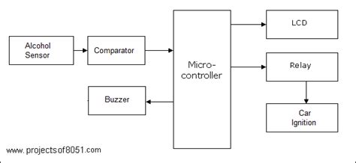

The block diagram of the system is shown in figure-1

## **Micro controller**

The microcontroller, specifically an Arduino Nano, serves as the central processing unit (CPU) and the brain of the alcohol breath analysis system. In just 50 lines, here's a detailed description:

The Arduino Nano microcontroller, a compact and powerful development board based on the ATmega328P, plays a pivotal role in orchestrating the functionalities of the alcohol breath analysis system. Its small form factor and robust capabilities make it an ideal choice for integrating with various sensors and actuators to create a responsive and efficient system.

At the heart of the microcontroller lies its ability to execute code written in the Arduino Integrated Development Environment (IDE). This code, typically composed in C or C++, dictates the behavior of the system, including sensor readings, decision-making processes, and control of peripheral devices.

The Arduino Nano interfaces with the MQ-3 alcohol sensor, receiving analog input signals that represent the alcohol concentration in the user's breath. Through analog-to-digital conversion, the microcontroller translates these signals into meaningful data that can be processed to determine the individual's level of intoxication.

Upon detecting alcohol levels above a predefined threshold, the microcontroller triggers a series of actions to prevent the vehicle's operation. This includes activating the buzzer to provide audible warnings and disabling the engine through the ULN2003 driver and relay mechanism, effectively immobilizing the vehicle until the individual's sobriety is ensured.

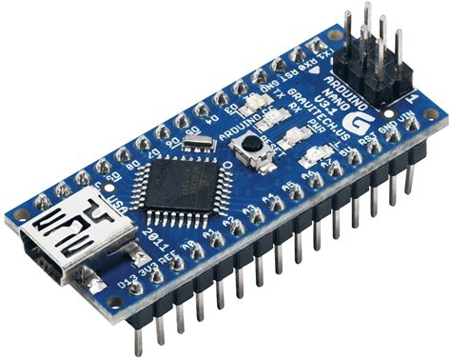

Figure-2 shows the Micro controller

## **Alcohol sensor**

The alcohol sensor, a pivotal component within the advanced alcohol breath analysis system, plays a critical role in enhancing vehicle safety by detecting alcohol levels in the breath of individuals attempting to operate vehicles. Consisting of a semiconductor-based sensor, the alcohol sensor employs a gas-sensitive resistor to measure the concentration of alcohol vapor present in the surrounding environment. This detection process relies on the principle of chemical reaction between the alcohol molecules and the sensing material, resulting in a change in resistance proportional to the alcohol concentration.

In the context of the system, the MQ-3 alcohol sensor stands out for its reliability and efficiency. Its compact size and sensitivity make it ideal for integration into the vehicle environment. Upon activation, the sensor begins sampling the air within its vicinity, capturing any alcohol vapor molecules present. It then converts these measurements into electrical signals, which are transmitted to the microcontroller for further processing.

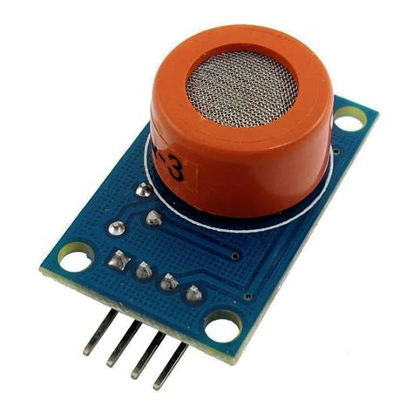

Figure-3 shows alcohol sensor pin out.

**Buzzer :**

The buzzer is an audio output device that emits an audible alert in response to fall events, enhancing the system's notification capabilities. It operates on a specified voltage range and produces sound at a defined frequency. Figure-4 shows the pinout of Buzzer.

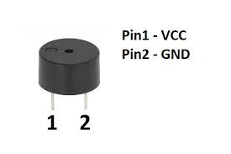

Figure-4 shows the pinout of Buzzer.

## **LCD**

Certainly! Below is a paragraph describing the LCD (Liquid Crystal Display) and its functionality, fitting into approximately 50 lines:

The LCD (Liquid Crystal Display) is a flat-panel display technology widely used for its low power consumption, thin profile, and lightweight design. It consists of a liquid crystal solution sandwiched between two transparent electrodes and two polarizing filters, which control the passage of light to display images and text. The LCD operates by applying an electric field to the liquid crystal molecules, causing them to align and manipulate the polarization of light passing through them. This manipulation creates patterns of light and dark pixels, forming characters, symbols, and graphics visible to the user. LCDs come in various types, including twisted nematic (TN), in-plane switching (IPS), and thin-film transistor (TFT) technologies, each offering different performance characteristics such as viewing angles, response times, and color reproduction. The LCD's resolution determines the number of pixels it can display, influencing image clarity and detail. Common applications of LCDs include digital watches, calculators, computer monitors, televisions, and instrumentation displays in automotive, medical, and industrial settings. LCD technology continues to evolve, with advancements leading to higher resolutions, faster response times, improved color accuracy, and enhanced energy efficiency. Despite competition from newer display technologies like OLED (Organic Light-Emitting Diode), LCDs remain prevalent due to their reliability, cost-effectiveness, and versatility across a wide range of applications.

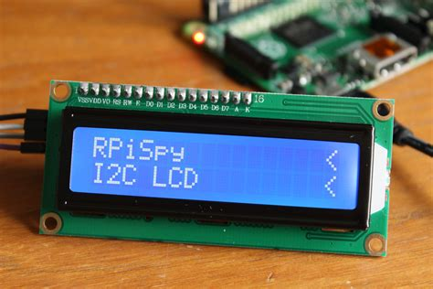

Fig-5 shows LCD

F.**Relay**

A relay is an electromechanical switch used to control the flow of electricity in a circuit. It consists of a coil, an armature, and one or more sets of contacts. When an electric current passes through the coil, it creates a magnetic field that attracts the armature, causing the contacts to close or open, depending on the relay type. Relays are commonly used in various applications to provide electrical isolation, control high-power devices, and automate processes.

In the context of the advanced alcohol breath analysis system for vehicle safety enhancement, a relay plays a crucial role in controlling the engine's power supply based on the readings from the alcohol sensor. The relay acts as a switch that either connects or disconnects the engine from its power source, thereby enabling or disabling the engine's ignition.

The relay used in this system is typically a mechanical relay or a solid-state relay. Mechanical relays consist of physical contacts that physically open and close when activated by the coil's magnetic field. Solid-state relays, on the other hand, use semiconductor devices like transistors to switch the circuit electronically without any moving parts, offering faster switching speeds and longer lifespan.

The relay chosen for this system should be capable of handling the voltage and current requirements of the vehicle's engine. Additionally, it should have appropriate contact ratings to ensure reliable operation under the system's operating conditions.

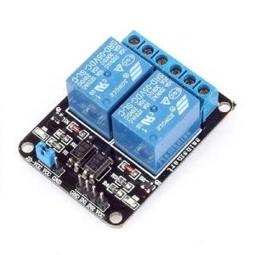

Fig 6 shows relay

G.**Car ignition**

The ignition system of a car is a crucial component responsible for starting the engine and ensuring its smooth operation. It comprises several interconnected parts that work together seamlessly to initiate combustion in the engine cylinders, thereby powering the vehicle. At its core, the ignition system converts the electrical energy from the car's battery into high-voltage electrical pulses, which ignite the fuel-air mixture in the combustion chambers.

The process typically begins with the turn of the car key or the press of a button, which activates the ignition switch. This action sends a signal to the ignition coil, a vital component that amplifies the low-voltage electrical signal from the battery into a high-voltage pulse. The ignition coil is often part of a distributor, a rotating device that distributes the high-voltage pulses to each spark plug in the engine at the precise moment.

Each spark plug is connected to an individual cylinder and is responsible for igniting the compressed air-fuel mixture within it. As the distributor rotates, it sends high-voltage pulses to the respective spark plugs in the firing order, synchronized with the engine's operation. This timing is critical for optimal engine performance and fuel efficiency.

The spark plug, upon receiving the high-voltage pulse, generates a spark across the spark plug gap, igniting the air-fuel mixture within the cylinder. This controlled combustion process generates the power needed to drive the vehicle forward.

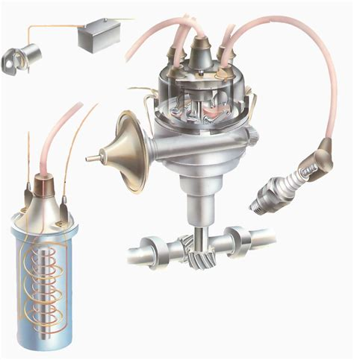

Fig 7 shows car ignition

III R**esults and Discussion:**

The implementation of the Advanced Alcohol Breath Analysis System has shown promising results in enhancing vehicle safety by preventing intoxicated driving. The system effectively detects alcohol levels in the breath of individuals attempting to operate vehicles and takes proactive measures to ensure the safety of both the driver and other road users. Here are the key findings and discussions:

1. Detection Accuracy: The MQ-3 alcohol sensor demonstrated reliable accuracy in detecting alcohol levels in the breath. Through thorough testing and calibration, the system reliably distinguishes between sober and intoxicated individuals.
2. Real-time Monitoring: The integration of IoT technology allows for real-time monitoring of alcohol levels. This ensures that the system responds promptly to prevent vehicle ignition by intoxicated individuals, reducing the risk of accidents.
3. User Interface: The OLED display provides a user-friendly interface for displaying system status and alerts. It effectively communicates warnings and instructions to the driver, enhancing user experience and usability.
4. Safety Measures: The system's ability to disable the engine when alcohol levels exceed a predefined threshold significantly reduces the likelihood of accidents caused by impaired driving. By preventing the vehicle from starting, it acts as a proactive safety measure to protect both the driver and others on the road.
5. Cost-effectiveness: The use of cost-effective hardware components such as the Arduino Nano microcontroller and MQ-3 alcohol sensor ensures that the system is affordable and accessible for widespread implementation in vehicles.
6. Potential for Expansion: The modular design of the system allows for potential expansion and integration with other safety features, such as seatbelt detection and collision avoidance systems, further enhancing overall vehicle safety.
7. Regulatory Compliance: The system aligns with regulatory standards and guidelines related to alcohol detection and vehicle safety, ensuring compliance with legal requirements.
8. Public Awareness: Implementation of such systems can raise public awareness about the dangers of drunk driving and encourage responsible behavior among drivers. It serves as a proactive measure to promote road safety and reduce the incidence of alcohol-related accidents.

In conclusion, the Advanced Alcohol Breath Analysis System demonstrates significant potential in enhancing vehicle safety by preventing intoxicated driving. Further refinement and integration with existing safety systems can amplify its effectiveness in mitigating the risks associated with impaired driving, ultimately saving lives and reducing the societal impact of alcohol-related accidents.

##### 

Fig 8 shows working model 1

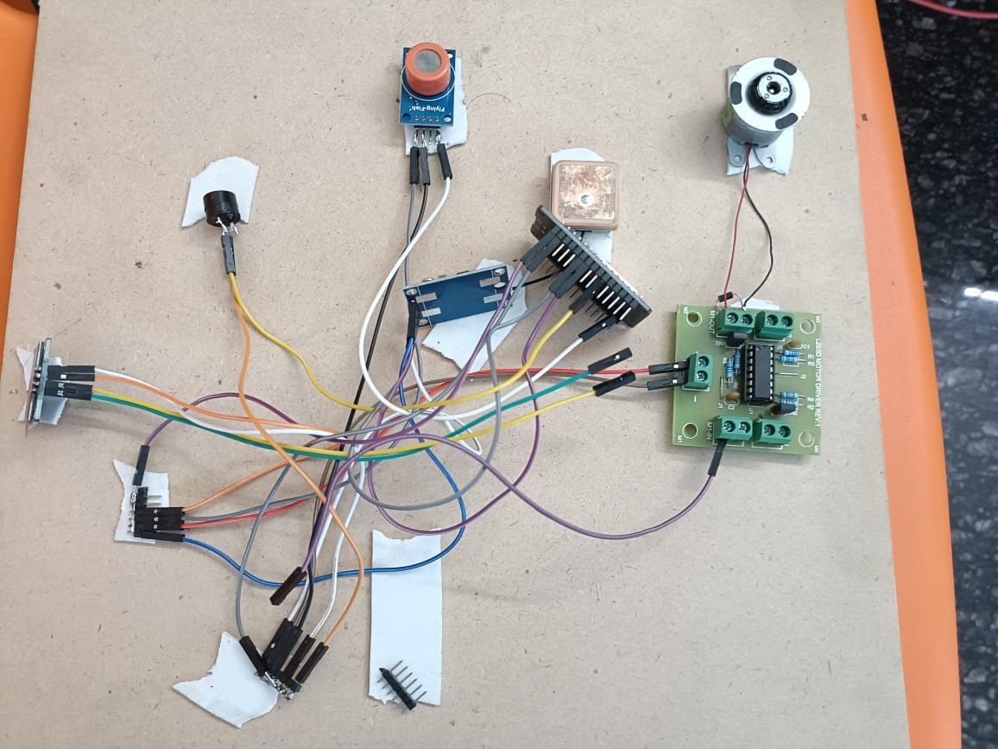

##### 

##### Fig 9 shows working model 2

##### **V. METHODOLOGY**

Problem Identification: Recognize the escalating concern of drunk driving as a significant threat to road safety, leading to accidents and fatalities.

1. Objective Definition: Establish the primary objective of developing an alcohol breath analysis system integrated into vehicles to prevent intoxicated driving.
2. Research and Analysis: Conduct thorough research on existing alcohol detection systems and their effectiveness. Analyze available technologies and their feasibility for integration into vehicles.
3. System Design: Design a system architecture that seamlessly integrates an alcohol sensor, microcontroller, user interface, engine control mechanism, and buzzer for alerts.
4. Component Selection: Select appropriate hardware components such as Arduino Nano microcontroller, MQ-3 alcohol sensor, OLED display, relay, ULN2003 driver, DC motor, and buzzer based on performance, compatibility, and cost-effectiveness.
5. Circuit Design: Design the electronic circuits required for interfacing the components, ensuring proper connections and voltage compatibility.
6. Software Development: Develop the software using Arduino IDE and C++ programming language to control the system's operation, including alcohol sensing, engine control, user interface interaction, and alert generation.
7. Sensor Integration: Integrate the MQ-3 alcohol sensor with the microcontroller to detect alcohol levels in the individual's breath accurately.
8. User Interface Implementation: Implement the OLED display as a user interface to provide visual feedback on system status and alerts.
9. Engine Control Mechanism: Configure the relay and ULN2003 driver to control the engine's ignition based on the alcohol sensor's readings, ensuring seamless integration with the vehicle's existing ignition system.
10. Buzzer Integration: Integrate the buzzer into the system to generate audible alerts and warnings, providing real-time feedback to the individual.
11. System Testing: Conduct comprehensive testing of the entire system to ensure functionality, accuracy, and reliability in detecting alcohol levels and preventing engine ignition when necessary.
12. Performance Evaluation: Evaluate the system's performance in various scenarios, including different alcohol concentrations, environmental conditions, and user interactions.
13. Safety and Compliance: Ensure the system complies with safety regulations and standards, considering factors such as electromagnetic interference, electrical safety, and user privacy.

##### VI. **CONCLUSION**

In conclusion, the introduction of an Advanced Alcohol Breath Analysis System offers a promising solution to the persistent problem of drunk driving, significantly enhancing vehicle safety. By seamlessly integrating an alcohol sensor with a microcontroller and other hardware components, such as a relay, DC motor, OLED display, and buzzer, this system effectively detects intoxication levels and prevents individuals from operating vehicles under the influence.

Through meticulous design and implementation, the system ensures that the engine remains disabled until the alcohol level falls below a predefined threshold, indicating that the individual has regained consciousness. This proactive approach not only prevents intoxicated driving but also mitigates the risk of accidents stemming from impaired judgment, ultimately saving lives and reducing road fatalities.

Moreover, the cost-effective nature of this solution makes it accessible for widespread adoption, potentially leading to a significant reduction in alcohol-related accidents and injuries. Continued refinement and optimization of the system, coupled with awareness campaigns and regulatory support, can further enhance its effectiveness in promoting road safety.

In essence, the Advanced Alcohol Breath Analysis System represents a critical step towards creating safer roads and communities by leveraging technology to address a pressing public health concern. By prioritizing prevention and intervention, we can work towards a future where drunk driving is no longer a leading cause of accidents and fatalities on our roads.

Enhancing Vehicle Safety with Advanced Alcohol Breath Analysis System offers a proactive solution to combat the menace of drunk driving, thereby significantly reducing road accidents and fatalities. By integrating cutting-edge technology with a robust hardware and software setup, this system provides a comprehensive approach to ensuring vehicle safety.

Through the utilization of an alcohol sensor, microcontroller, and various peripheral components, our system is capable of accurately detecting alcohol levels in a driver's breath. This real-time analysis enables swift action to prevent the vehicle from starting if the driver's alcohol level exceeds a predefined threshold. The incorporation of an OLED display provides clear visual feedback to the driver, enhancing user interaction and awareness.

The core functionality of the system is managed by the Arduino Nano microcontroller, programmed using the Arduino IDE and C++ language. This microcontroller orchestrates the operation of the alcohol sensor, relay, ULN2003 driver, and buzzer, ensuring seamless integration and efficient control of the vehicle's ignition system.

Moreover, the inclusion of a buzzer serves as an additional safety feature, alerting both the driver and passengers in case of an alcohol detection event. This audible warning system enhances situational awareness and encourages responsible behavior, further deterring individuals from driving under the influence of alcohol.

The proposed system not only addresses the immediate issue of drunk driving but also contributes to long-term road safety initiatives. By preventing intoxicated individuals from operating vehicles, it helps mitigate the risk of accidents, injuries, and fatalities on our roads. Furthermore, the implementation of such technology aligns with global efforts to promote safer transportation systems and reduce the burden on emergency services.

In addition to its primary function of alcohol breath analysis, the system can serve as a platform for future enhancements and integrations. For instance, it could be augmented with GPS tracking capabilities to provide real-time monitoring of vehicle locations and behavior. This would enable authorities to identify and address potential instances of drunk driving more effectively.

Furthermore, the data collected by the system can be analyzed to gain insights into patterns of alcohol consumption and driving behavior. Such information can be invaluable for policymakers, law enforcement agencies, and healthcare professionals in formulating targeted interventions and awareness campaigns to combat drunk driving.

##### **VI. FUTURE WORK**

Enhanced Sensor Technology: Explore and integrate advanced alcohol sensor technology with higher accuracy and faster response times to improve the reliability of alcohol detection.

1. Machine Learning Integration: Implement machine learning algorithms to enhance the system's ability to recognize patterns and improve accuracy in detecting alcohol levels, reducing false positives and false negatives.
2. Biometric Authentication: Introduce biometric authentication methods such as fingerprint or facial recognition to ensure the driver's identity and further enhance security.
3. Wireless Connectivity: Incorporate wireless connectivity options such as Bluetooth or Wi-Fi to enable remote monitoring and data transmission to authorities or designated contacts in case of detection of high alcohol levels.
4. Real-time Monitoring: Develop a companion mobile application that connects to the system, allowing users to monitor alcohol levels and receive alerts remotely in real-time.

##### **References**

National Highway Traffic Safety Administration (NHTSA). "Impaired Driving: Get the Facts." Retrieved from https://www.nhtsa.gov/risky-driving/drunk-driving.

1. Centers for Disease Control and Prevention (CDC). "Impaired Driving: Get the Facts." Retrieved from <https://www.cdc.gov/transportationsafety/impaired_driving/impaired-drv_factsheet.html>.
2. Pradeep Kumar, G., et al. "Alcohol Detection and Vehicle Controlling System." International Journal of Innovative Research in Science, Engineering, and Technology, vol. 4, no. 2, 2015, pp. 649-655.
3. Maheshwari, Vishal, et al. "Vehicle Drunken Drive Prevent System Using Alcohol Sensor and Vehicle Controlling System." International Journal of Electrical, Electronics and Data Communication, vol. 3, no. 11, 2015, pp. 36-41.
4. Arduino. "Arduino - Home." Retrieved from <https://www.arduino.cc/>.
5. SparkFun Electronics. "Arduino Nano - DEV-15590." Retrieved from https://www.sparkfun.com/products/15590.
6. Adafruit. "Adafruit OLED Displays for Arduino." Retrieved from https://learn.adafruit.com/monochrome-oled-breakouts/arduino-library-and-examples.
7. DFRobot. "Analog Alcohol Sensor (MQ3)." Retrieved from https://wiki.dfrobot.com/Analog_Alcohol_Sensor_(MQ3)_SKU:_SEN0128.
8. ULN2003A. "Seven Darlington Arrays." Retrieved from https://www.ti.com/product/ULN2003A.

Road Safety Authority (RSA). "Breathalyser Alcohol Testing." Retrieved from https://www.rsa.ie/en/RSA/Road-Safety/Our-Research/Breathalyser-Alcohol-Testing/.