**“The Bullwhip Effect in Supply Chain Information Dynamics in brake pad company”**

**Dr. G. BALAMURUGAN1**, Assistant professor, Department of management studies, University college of engineering (BIT campus), Anna University, Tiruchirappalli.

**R. SAKTHIVEL2**, Post Graduate Student, Department of Management Studies, University college of engineering (BIT campus), Anna University, Tiruchirappalli.

**Abstract:**

The bullwhip effect represents a phenomenon observed in supply chains where small fluctuations in consumer demand lead to amplified variations in upstream inventory levels and orders. This paper examines the manifestation of the bullwhip effect specifically in the context of information flow within supply chains. By analyzing the dynamics of information transmission, processing, and decision-making among supply chain partners, we identify key factors contributing to the bullwhip effect. Incomplete or inaccurate information sharing between supply chain partners can distort demand signals, leading to inefficiencies such as overproduction, stockouts, and increased transportation costs. Furthermore, we explore the implications of the bullwhip effect on inventory management, operational efficiency, and overall supply chain performance. This paper investigates the bullwhip effect in the supply chain of a brake pad company. We explore how information sharing practices and forecasting methods can contribute to or mitigate the bullwhip effect. The paper concludes by suggesting recommendations for improved information sharing and forecasting techniques to reduce the bullwhip effect and create a more efficient and responsive supply chain for the brake pad company.

**Keywords:**

The bullwhip effect, dynamics of information, inventory management, operational efficiency, overall supply chain performance.

1. **Introduction:**

The bullwhip effect stands as a critical challenge in supply chain management, pervasive across numerous companies. Its indefinable nature stems from a multitude of underlying causes that are often challenging to pinpoint. Essentially, the bullwhip effect denotes a phenomenon wherein order variability escalates within a supply chain. The bullwhip effect describes how order variability increases as we move up the supply chain. As we progress higher in the chain, order variance increases, resulting in inefficiencies across the entire supply network. Brake pads are a critical component of a vehicle's braking system, and ensuring their timely availability is crucial for both the company and its customers. We investigate how information sharing practices and forecasting methods can influence the bullwhip effect within the brake pad supply chain. This article will examine how the bullwhip effect disrupts supply chains and explore how changes in corporate culture can be used to mitigate it. This reveals in lower service levels, including delayed deliveries, order discrepancies, surplus inventory, uneven strain on production capabilities, and ineffective transportation. These factors collectively undermine the economic performance of organizations involved in the supply chain, reduce their competitiveness and market visibility over time. To reduce the bullwhip effect's influence, companies must improve the flow of information throughout the supply chain. This can be achieved by fostering greater cooperation between all partners involved.

1. **REVIEW OF LITERATURE:**

Hau L. Lee, et al have been investigated that paper suggests that the transmission of information through "orders" often becomes distorted, potentially leading upstream members astray in their inventory and production planning. Specifically, it notes that the variability in orders may exceed that of actual sales, with the distortion worsening as one moves further upstream—a phenomenon dubbed the "bullwhip effect." This study examines four contributors to this effect: the processing of demand signals, the dynamics of rationing, the practice of order batching, and fluctuations in prices. Additionally, the paper explores strategies to alleviate the negative consequences of this distortion. they concluded that distortions in demand may arise due to optimization behaviours among participants in the supply chain. To manifest this, a combination of strategies including leveraging sell-through data, sharing inventory status information, coordinating orders, and adopting simplified pricing schemes can help reduce the bullwhip effect. Traditionally, sales and inventory data have been regarded as proprietary to retailers, with no obligation to share it. However, to effectively combat the bullwhip effect, this paper suggests a shift in mindset where manufacturers gain access to such data. While this benefits the manufacturer, the paper does not delve into why retailers should provide this data. The redistribution of benefits from efficient supply chain management among members warrants attention, highlighting the need to explore how gains and costs can be equitably shared.

Keah Choon Tan have explored that a frame work of supply chain. This study examines the evolution of supply chain management from two distinct trajectories that eventually converged into the contemporary era characterized by a comprehensive and strategic approach to operations, materials, and logistics management. Furthermore, it aims to provide a clear understanding of supply chain management, considering the abundance of buzzwords in the literature that often refer to specific aspects or phases of this modern management philosophy. Additionally, the article explores different strategies of supply chain management and the circumstances that foster its effective implementation. Prior literature commonly presents three primary descriptions of supply chain management. First, it is often employed as a convenient describing the purchasing and supply operations of manufacturers. Second, it may depict the transportation and logistics functions of merchants and retailers. Lastly, it can encompass all value-added activities spanning from raw material extraction to end-user delivery, incorporating recycling processes as well.

Buchmeister B et at This authors conducted experiments using two scenarios: one involving stable demand with a single 5% change and another involving fluctuating demand with periodic 10% increases followed by decreases. They analyzed two stock-keeping policies across all stages of the supply chain: maintaining stock levels equivalent to one or two periods' demand. The findings, presented in tables and charts, reveal an increase in the variability of production orders and stocks throughout the supply chain. This variability suggests a lack of synchronization among supply chain members due to distorted key information about actual demand. The paper concludes by discussing various actions aimed at coordinating the operational activities within the supply chain, informed by an understanding of its dynamics.

An-Yuan Chang et al This study aims to investigate the bullwhip effect within the retail industry's supply chain. It measures the significance of key factors influencing this phenomenon, as well as the causal connections between these factors. Employing a questionnaire survey using the fuzzy Delphi method, experts' insights on the pivotal factors contributing to the bullwhip effect were gathered and subjected to quantitative analysis and screening procedures. Interpretive structural modelling and decision-making trial and evaluation laboratory techniques were utilized to analyse the impacts of these factors and their hierarchical causal relationships. This approach offers supply chain managers a more effective means of identifying the underlying causes of the bullwhip effect. they concluded as For the retail industry, this implies that supply chain managers must prioritize monitoring the emergence of comparable alternatives in the market. These new alternatives typically possess ample marketing resources and tend to attract consumers more effectively than older ones. This factor can effectively transmit its influence through other factors, potentially triggering the bullwhip effect within the supply chain. Additionally, managers should emphasize fostering flexible contract systems with suppliers to accommodate order cancellations or modifications. Moreover, decision-makers must focus on enhancing forecasting accuracy and minimizing uncertainty in order placement cycles.

Jennifer K. Ryan et al they quantifies the bullwhip effect in basic, two-stage supply chains, involving one retailer and one manufacturer. Our model incorporates two factors often attributed to causing this effect: demand prediction and order lead times. We expand these findings to encompass multi-stage supply chains, examining scenarios both with and without centralized customer demand data. Our analysis shows that while centralizing demand information can mitigate the bullwhip effect, complete elimination is not achievable.

**3.RESEARCH**

3.1 BULLWHIP EFFECT IN BUSINESS PRACTICES:

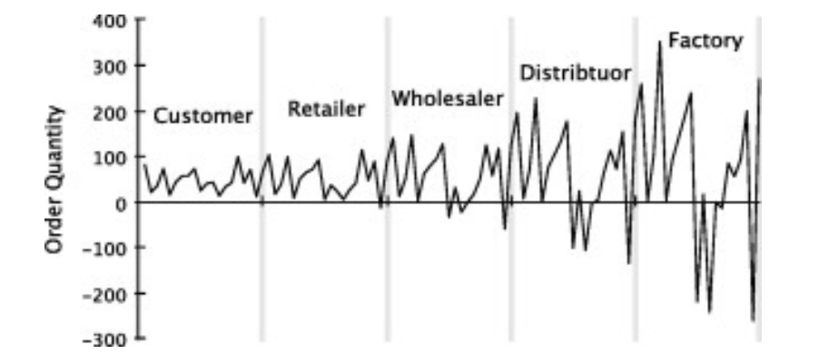The bullwhip effect refers to a phenomenon in which demand variability increases as one moves up the supply chain. This happens because sales fluctuations prompt exaggerated demand changes further along the chain, resulting in amplified variations in supplier plans.

Fig3.1: A simple example of the Bullwhip effect

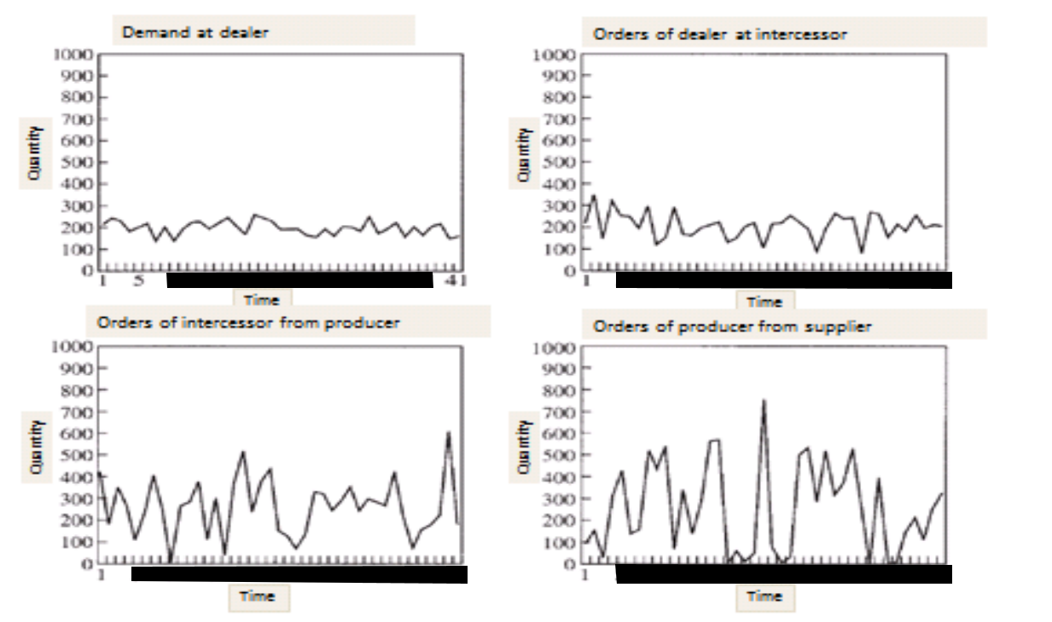In reality, incomplete information exchange among supply chain partners primarily causes this effect. The challenge in mitigating the bullwhip effect lies in its multifaceted and often hidden causes. The assumption underlying this issue is that the company faces fluctuating demands for its products or services. A significant factor contributing to increased order variability is the lack of accurate information on final demand at higher supply chain levels. Instead, these levels rely on order information from lower chains, which can lead to overreactions to demand changes.

Fig3.2: Increase in the variability of orders with comparison to actual demand on upstream supply chain

For instance, a salesperson may anticipate a demand increase and place a larger order as a precaution against potential stock depletion. Subsequently, each successive link in the chain may further inflate their orders based on their own assumptions, impairing the bullwhip effect. One common contributor to this effect is the use of demand forecasting methods, where short-term demand changes are extrapolated into longer-term trends. This can lead to excessive reactions to demand shifts, further magnifying order variability. As we move up the supply chain, the variability of orders surpasses that of actual demand, culminating in the bullwhip effect. Periodic stock management systems exacerbate this issue by setting order quantities based on future demand expectations. Since future demand behavior is uncertain, these systems often lead to overestimation of demand trends and increased order variability. This is particularly pronounced when delivery times are lengthy, as it amplifies changes in target stock levels and subsequently, order quantities. The decision on stock management systems becomes crucial, especially in the face of highly variable demand. Opting for a system with a smaller bullwhip effect may incur higher initial costs but could ultimately reduce overall supply chain costs. Balancing the trade-off between bullwhip effect reduction and stock management costs is essential in making informed decisions regarding supply chain efficiency.

3.2 FINDINGS

1. Demand Variability: Analysis revealed significant variability in demand for brake pads, with demand fluctuations increasing as one moves upstream in the supply chain. Retailers experienced relatively stable demand, while distributors and manufacturers faced increasingly volatile order patterns.

2. Order Batching: The tendency of distributors and retailers to batch orders, either due to order consolidation or inventory management practices, contributed to the amplification of demand variability. Large, infrequent orders placed by downstream partners resulted in distorted demand signals and inventory imbalances.

3. Information Delays: Delays in information transmission along the supply chain exacerbated the bullwhip effect. Poor visibility into real-time demand and inventory levels hindered the ability of manufacturers and suppliers to respond promptly to changes in demand, leading to inefficient production scheduling and excess inventory.

4. Forecasting Challenges: Forecasting accuracy was hampered by the bullwhip effect, as historical sales data failed to capture the magnitude of demand variability. Traditional forecasting methods proved inadequate in predicting sudden spikes or dips in demand, resulting in suboptimal inventory management decisions.

3.3 Impact of bullwhip effect:

3.3.1 Inventory Management:

The bullwhip effect can significantly impact inventory management practices within a brake pad company:

* Excess Inventory: Fluctuations in demand, amplified by the bullwhip effect, can lead to overestimation of required inventory levels. As a result, manufacturers and distributors may maintain excess inventory as a buffer against perceived demand variability, tying up working capital and increasing holding costs.
* Stockouts: Conversely, sudden spikes in demand, exaggerated by the bullwhip effect, can catch suppliers off guard, leading to stockouts and lost sales opportunities. Inadequate inventory levels due to inaccurate demand forecasts can result in delayed order fulfillment and dissatisfied customers.

3.3.2 Operational Efficiency:

The bullwhip effect can disrupt production schedules and capacity utilization, impacting operational efficiency:

* Production Variability: Manufacturers may experience erratic production schedules as a result of fluctuating demand signals propagated upstream. Underutilized capacity during periods of low demand and production bottlenecks during periods of high demand can lead to inefficiencies and increased manufacturing costs.
* Supply Chain Coordination: Poor coordination among supply chain partners, exacerbated by the bullwhip effect, can result in inefficiencies such as double ordering, expedited shipments, and excess handling costs.

3.3.3 Customer Service:

The bullwhip effect can adversely affect customer service levels within a brake pad company:

* Lead Time Variability: Variations in lead times caused by demand variability can impact delivery reliability and customer satisfaction. Inconsistent lead times resulting from the bullwhip effect may lead to missed delivery deadlines and customer dissatisfaction.
* Product Availability: Stockouts and inventory imbalances resulting from inaccurate demand forecasts can compromise product availability, leading to lost sales and erosion of customer loyalty.

3.3.4 Costs and Profitability:

The bullwhip effect can have financial implications for a brake pad company:

* Inventory Holding Costs: Maintaining excess inventory to buffer against demand variability incurs additional holding costs, including storage, obsolescence, and carrying costs.
* Ordering and Transportation Costs: Erratic demand patterns resulting from the bullwhip effect may necessitate frequent ordering and expedited transportation, leading to increased procurement and logistics costs.
* Lost Sales and Market Share: Stockouts and delivery delays resulting from the bullwhip effect can lead to lost sales opportunities and potential erosion of market share, impacting long-term profitability.

3.3.5 Supply Chain Resilience:

* Vulnerability to Disruptions: Fluctuations in demand, amplified by the bullwhip effect, can increase the vulnerability of the supply chain to disruptions such as supply shortages, production delays, and transportation bottlenecks.
* Risk Mitigation: Proactive risk management strategies, including demand sensing techniques, supply chain visibility, and collaboration with key stakeholders, are essential for mitigating the impact of the bullwhip effect and enhancing supply chain resilience.

**4. SUGGESTIONS:**

4.1 RECOMMENDATIONS TO IMPLIMENTATION:

1. Demand Sensing: Invest in demand sensing technologies that leverage advanced analytics and machine learning algorithms to detect demand signals and patterns in real-time. By continuously monitoring consumer behavior and market dynamics, demand sensing can improve the accuracy of demand forecasts and reduce the bullwhip effect.
2. Vendor-Managed Inventory (VMI): Implement VMI programs with key suppliers to allow them to manage inventory levels based on actual consumption data from the brake pad company. VMI enables suppliers to replenish inventory proactively, reducing lead times and minimizing the risk of stockouts or excess inventory buildup.
3. Reduced Order Batching: Minimize order batching by adopting a leaner approach to inventory management. Encourage smaller, more frequent orders to align production and replenishment with actual demand, thereby reducing the amplification of demand variability and mitigating the bullwhip effect.
4. Demand-Driven Supply Chain: Transition towards a demand-driven supply chain model that prioritizes responsiveness and flexibility. By aligning production and inventory levels with actual customer demand, the brake pad company can reduce the need for speculative ordering and minimize the bullwhip effect.
5. Supplier Collaboration and Visibility: Strengthen relationships with key suppliers and enhance visibility into their operations and inventory levels. Collaborate closely with suppliers to synchronize production schedules, streamline order fulfillment processes, and reduce lead times throughout the supply chain.
6. Continuous Improvement: Continuously monitor and evaluate supply chain performance metrics to identify areas for improvement. Implement a culture of continuous improvement, where feedback loops and data-driven insights drive ongoing refinements to forecasting techniques, inventory management practices, and supply chain processes.

4.2 Demand sensing techniques:

By adopting Demand Sensing techniques, the brake pad company can better anticipate short-term demand fluctuations, reduce uncertainty, and improve supply chain responsiveness, ultimately minimizing the bullwhip effect and enhancing overall efficiency.

1. Real-Time Data Analytics: Invest in advanced data analytics technologies that can process and analyze real-time sales data, inventory levels, and customer demand patterns. By leveraging predictive analytics and machine learning algorithms, the company can accurately forecast demand, identify trends, and anticipate fluctuations in demand more effectively.
2. Collaboration and Information Sharing: Foster closer collaboration and information sharing among supply chain partners, including suppliers, distributors, and retailers. Implement collaborative planning, forecasting, and replenishment (CPFR) initiatives to exchange real-time data and insights. This collaboration helps to align production and inventory levels with actual demand, reducing the distortion of information as it travels upstream.
3. Reduce Lead Time Variability: Work closely with suppliers to reduce lead time variability. This may involve negotiating shorter lead times, improving communication channels, and implementing vendor-managed inventory (VMI) programs. By reducing lead time variability, the company can better match supply with demand and minimize the amplification of demand fluctuations.
4. Implement Just-in-Time (JIT) Inventory: Adopt a just-in-time inventory management approach to minimize excess inventory and reduce the risk of overordering. JIT principles focus on producing and delivering goods only when needed, thereby reducing the need for large buffer stocks and mitigating the bullwhip effect.
5. Machine Learning Algorithms: Implement machine learning algorithms to analyze historical sales data and identify patterns and correlations that can improve demand forecasting accuracy. These algorithms can automatically adjust forecasts based on changing market conditions, seasonal variations, and other factors affecting demand for brake pads.
6. Point-of-Sale (POS) Data Integration: Integrate POS data from retailers and distributors into the company's demand forecasting system. POS data provides valuable insights into consumer purchasing behavior and allows the company to adjust production and inventory levels based on actual sales data rather than relying solely on historical trends.

**5.Conclusion:**

In conclusion, our investigation into the bullwhip effect within the supply chain of a brake pad company underscores the critical role of information dynamics in shaping supply chain performance. Our findings reveal that incomplete or inaccurate information sharing practices among supply chain partners can exacerbate the bullwhip effect, leading to inefficiencies such as overproduction, stockouts, and increased transportation costs.

Through our analysis, we have identified several key factors contributing to the manifestation of the bullwhip effect, including information delays, forecast inaccuracies, and order batching practices.

These factors highlight the importance of improving information transmission, processing, and decision-making processes within the supply chain to mitigate the bullwhip effect.

Moreover, our study highlights the implications of the bullwhip effect on inventory management, operational efficiency, and overall supply chain performance in the context of a brake pad company. We have demonstrated how the bullwhip effect can lead to suboptimal inventory levels, production inefficiencies, and challenges in meeting customer demand. To address these challenges, we recommend implementing improved information sharing practices and forecasting techniques. By enhancing supply chain visibility, collaboration, and the accuracy of demand forecasts, brake pad companies can reduce the bullwhip effect and create a more efficient and responsive supply chain. Overall, our study contributes to the understanding of the bullwhip effect and provides actionable recommendations for brake pad companies to mitigate its impact and improve supply chain performance. By addressing information dynamics within the supply chain, brake pad companies can enhance their competitiveness, customer satisfaction, and overall profitability in an increasingly complex and dynamic market environment.

**REFERENCE:**

1. H. Lee, V. Padmanabhan, and S. Whang, “Information Distortion in a Supply Chain: The Bullwhip Effect,” Management Science, vol. 43, no. 4, pp. 546–558, 1997.
2. F. Chen (et al.), “Quantifying the Bullwhip Effect in a Simple Supply Chain: The Impact of Forecasting, Lead Times and Information,” Management Science, vol. 46, no. 3, pp. 436–443, 2000.
3. C. Tan, “A framework of supply chain management literature,” European Journal of Purchasing & Supply Management, vol. 7, no. 1, pp. 39–48, 2001.
4. J. Dejonckheere (et al.), “Transfer function analysis of forecasting induced bullwhip in supply chains,” International Journal of Production Economics, vol. 78, no. 2, pp. 133–144, 2002.
5. V. Giard, and M. Sali, “The bullwhip effect in supply chains: A study of contingent and incomplete literaturę,” International Journal of Production Research, vol. 51, no. 13, pp. 3880-3893, 2005.
6. D. Simchi-Levi, P. Kaminsky, and E. Simchi-Levi, Designing and Managing the Supply Chain. New York: McGraw-Hill/Irwin, 2007.
7. B. Buchmeister, J. Pavlinjek, I. Palcic, and A. Polajnar, “Bullwhip effect problem in supply chains,” Advances in Production Engineering & Management, 3 (1), 44–55, 2008.
8. A. Y. Chang, H. F. Yu, and T. H. Yang, “A study of the key factors contributing to the bullwhip effect in the supply chain of the retail industry,” Journal of Industrial and Production Engineering, vol. 30, no. 7, pp. 433-442, 2013.
9. G. Zotteri, “An empirical investigation on causes and effects of the Bullwhip-effect: Evidence from the personal care sector,” International Journal of Production Economics, vol. 143, no. 2, pp. 489–498, 2013.
10. D. Chatfield, “Underestimating the bullwhip effect: a simulation study of the decomposability assumption,” International Journal of Production Research, vol. 51, no. 1, pp. 230-244, 2013.