"DESIGN AND ANALYSIS OF BRAKE DISC PLATE WITH TWO DIFFERENT MATERIALS USING FINITE ELEMENT ANALYSIS (FEA) "

Rishabh Kumar Bhatt1, Akhilesh Pati Tiwari2

1MTech. Scholar Mechanical Eng. Dept. FCEM, Faridabad, India.

2Asst. Prof. Mechanical Eng. Dept. FCEM, Faridabad, India.

**ABSTRACT**

Brake is a device by means of which frictional resistance is applied to rotating disc, in order to slowdown or to stop the motion of vehicle. During the braking phase, the frictional heat generated at the interface of the disc and pads can lead to high temperatures. The frictional heat generated on the rotor surface can influence excessive temperature rise which, in turn, leads to undesirable effects such as thermal elastic instability (TEI), premature wear and thermally excited vibrations (TEV). In this project we analyse the thermal and static structural behaviour of the brake disc rotor with Titanium alloy (Ti 550) and conventional Stainless-Steel material in finite element software ANSYS R 19.2 Modelling of the disc brake rotor is done using CREO PARAMETRIC 5.0. Finally, a comparison is made between conventional stainless steel and Ti 550 materials and the analysis is done based on the magnitude of Von misses’ stresses, temperature distribution and deformation from the coupled thermal analysis.

**Keywords:** FEA, Ansys, Stress, Efficient Brake, Titanium alloy, Creo Parametric

# INTRODUCTION

Brake systems have been widely used in automobiles, motorcycles, rail trains, and aircrafts. In brake systems, friction is both a principal performance factor and a potential cause of undesirable noise and vibration. The structures and principles of the brake systems of different kinds of vehicles are analogous and similar. Friction dynamics has been one of the most challenging problems in the brake industry.

Friction dynamics related issues affect the reliability and quality of brake systems in many ways. For instance, [brake squeal](https://www.sciencedirect.com/topics/engineering/brake-squeal), an acoustic phenomenon caused by dynamic instability that occurs at one or more of the natural frequencies of the brake system, has been the most challenging issue in automotive brake systems, as it has been perceived to be equal to the quality of products by customers. In aircraft braking systems, friction-induced torque oscillations can lead to excessively high loads in the landing gear and brake structure, which results in passenger discomfort, component failure, or both, and thereby leading to warranty claims.

# Disc Brake

# A disc brake is a type of [brake](https://en.wikipedia.org/wiki/Brake) that uses the [calipers](https://en.wikipedia.org/wiki/Disc_brake" \l "Calipers) to squeeze pairs of [pads](https://en.wikipedia.org/wiki/Disc_brake#Brake_pads) against a disc or a rotorto create [friction](https://en.wikipedia.org/wiki/Friction). There are two basic types of brake pad friction mechanisms: abrasive friction and adherent friction. This action slows the rotation of a shaft, such as a [vehicle](https://en.wikipedia.org/wiki/Vehicle) [axle](https://en.wikipedia.org/wiki/Axle), either to reduce its rotational speed or to hold it stationary. The energy of motion is converted into [heat](https://en.wikipedia.org/wiki/Heat), which must be dispersed.

[Hydraulically](https://en.wikipedia.org/wiki/Hydraulic_brakes) [actuated](https://en.wikipedia.org/wiki/Actuator) disc brakes are the most commonly used mechanical device for slowing motor vehicles. The principles of a disc brake apply to almost any rotating shaft. The components include the disc, [master cylinder](https://en.wikipedia.org/wiki/Master_cylinder), and caliper, which contain at least one cylinder and two [brake pads](https://en.wikipedia.org/wiki/Brake_pad) on both sides of the rotating disc.

# LITERATURE REVIEW

**Chebrolu Bhanuprakash et. al. (2023) -** Brake failure is a major safety concern in vehicles, particularly in two-wheelers, and can lead to accidents. To improve the safety of two-wheelers, this study proposes a new design for brake disc rotors with slots that can withstand the stresses and heat generated during the braking process. The performance of the rotor was analyzed using ANSYS 16 software through a combination of static structural analysis and transient thermal analysis. Static structural analysis was conducted by applying a braking force to a specific area while keeping the brake mount points fixed, and transient thermal analysis evaluated the effects of temperature changes on the brake system over time. The study considered various materials, including Grey cast iron, Ti6Al4V, and AISI 6150. Based on the analysis of von-mises stresses, shear stresses, strains, deformations, and total heat flux, AISI 6150 was identified as the best material for the brake disc rotors, as it can increase the performance of disc rotors and potentially reduce accidents. The findings of this study have practical implications for the design and manufacture of safer and more efficient brake systems in vehicles. [1]

**Sumit Kalipada Sau et. al. (2022)** - The objective of this study is to compare the different thermal characteristics of a material, and how they vary when used in an automobile’s disc brake. It is vital that a brake rotor is able to efficiently dissipate heat for its proper functioning. Overheating can lead to warping of the rotor and even stress cracks in some situations. Furthermore, ineffective dissipation of heat can also lead to brake fading which has been the root cause of accidents time and time again. Being a wear and tear product, they are meant to be periodically replaced. But, optimising the design keeping heat dissipation in mind will prolong the intervals between replacement, and prevent premature failure. By simulating the functioning of the brakes under different conditions, the maximum withstand temperature, pressure and heat can be find out before distorting. Using this information, the material is selected that can endure the specific level of heat and friction while maintaining efficiency over time. Doing this will help reduce the dependence on driving characteristics to get the most out of your brake rotors. Upon studying the simulation results of the disc brakes made of the three selected materials - Stainless steel 420, Grey Cast Iron and [Aluminium](https://www.sciencedirect.com/topics/materials-science/aluminum) 7068, Stainless steel 420 showed the best heat dissipation rate and [mechanical strength](https://www.sciencedirect.com/topics/materials-science/mechanical-strength) under the selected test conditions. [2]

**Ali Belhocine and Oday Ibrahim Abdullah et. al. (2021) -** The study used numerical simulations to analyse the behaviour of three brake disc materials. It included 3D thermal analysis to understand heat distribution and a comparative analysis to identify the best material for optimal vehicle braking. Results were visualized using a thermomechanical model to draw conclusions. [3]

**Srushti Newase, Pradnya Kosbe et. al. (2021)-** This research aims to analyze the thermal properties of vented disc brake rotors for Mahindra Bolero. The goal is to find materials for the brake rotors and pads that can effectively dissipate heat generated during braking, while ensuring structural safety.[4]

**Adarsh Bhat et. al. (2021)-** This project analyses the advantages of disc brakes over drum brakes in terms of stopping distance, heat dissipation, and more. While drum brakes have cost benefits, research aims to improve disc brake designs and materials to reduce deformation and improve thermal characteristics.[5]

**Aakash Jawla, Rahul Anand, Shobhit Agarwal et. al. (2020)**- This study uses thermal analysis to investigate the performance of stainless-steel materials in disc brake design, focusing on heat generation during braking and resulting thermal stress. SolidWorks and ANSYS Workbench are used for analysis. The findings will contribute to understanding disc brake thermal behaviour and material selection for improved performance.[6]

**Sanket Darekar, Ajinkya Dhage et. al. (2020)**- The project designs the disc brake of Bajaj Pulsar 220F with 3D models in CATIA software, and analyses the temperature distribution during braking using ANSYS Workbench. The study compares various disc brake models to select an optimized design based on analysis results.[7]

**Bikesh Suwala, Sanjeev Maharjan et.al. (2020)**- The study analyses the importance of disc brake systems in ensuring vehicle safety and designs four-disc rotor models to improve the weight, mechanical, and thermal performance of the original disc brake of Yamaha Fz-25. The analysis suggests that disc rotor model 4 is the best design with improved performance and reduced production cost.[8]

**S.A.M Da Silva, DVV Kallon et. al. (2019)-** This research aims to compare the performance of a grooved-disc brake and a drilled and grooved disc brake rotor under different applied linear loads. The study will analyze parameters like stress concentrations, load, and displacement to identify critical zones on each rotor using Brembo brake rotor design for a Renault vehicle and software analysis.[9]

**Anurag Parag Borse et. al. (2019)-** The abstract discusses the importance of brakes in vehicles and focuses on the analysis of the disc or rotor of a disc brake, which is a commonly used form of brake for motor vehicles. The study analyses the thermo-mechanical behaviour of the brake disc during the braking phase using ANSYS software.[10]

**Joyson Sam Devapaul P, Paul Gnanam J et. al. (2018)**- The project aims to analyse the thermal and structural behaviour of a two-wheeler brake disc using Solid works and Ansys software. The study investigates the effects of different materials on stress, deformation, and temperature distribution in the disc. [11]

**B.Subbarayudu, Ginjala Kishore et. al. (2018)-** The objective of this study is to analyse a ventilated disc brake by creating Finite Element models using SolidWorks and ANSYS. The study aims to determine the optimal design of the brake disc rotor by evaluating its strength under varying heat flow rates and materials with different cross-sectional variations.[12]

**Deekshith Ch et. al. (2017)-** The work is about analysing the thermal and structural behaviour of a disc brake rotor of a vehicle. Two different materials and thicknesses are considered for the analysis using CATIA and ANSYS software. The objective is to compare the temperature distribution and heat flux of the two materials to optimize the rotor's manufacturing using CNC machine.[13]

**Alampally Sainath1, Prathamesh Mahesh Dehadray et. al. (2015)-** This study aims to use ANSYS to analyze how motorcycle disc brakes affect their surface through thermal stress and deformation. The goal is to prevent damage caused by heat generation and identify the best material for improved performance in terms of temperature, stress, and deformation.[14]

**Ali Belhocine, et. al. (2014)-** The study examines the effect of heat and mechanical stress on brake discs using ANSYS11 software. Through modeling, it identifies an ideal geometric design for ventilation in vehicles. The analysis also measures deformation, stress, and pressure distribution. The study's results are consistent with existing literature.[15]

# METHODOLOG

**Fig 1**: Methodology

**Design of Existing Rotor Disc1 and New Rotor Disc2**

Existing model of disc rotor and new rotor is designed using Creo parametric 5.0 based and analysed using Ansys R 19.2. Following Table No.1 shows the dimensions of brake rotor Disc1 and Disc 2

**Table No.1:** Dimension of Disc1 and Disc2

|  |  |  |
| --- | --- | --- |
| **Parameters** | **Values Disc1** | **Values Disc2** |
| Rotor outer diameter | 240 mm | 170 mm |
| Rotor inner diameter | 110 mm | 60 mm |
| Rotor thickness | 4 mm | 5.5 mm |
| Rotor disc material | SS 410 | Ti 550 (Ti-6Al-4V) |
| Coefficient of friction (Dry) | 0.3-0.5 | 0.4 |
| Maximum pressure applied | 1 MPa | 1 MPa |

* **Properties of TITANIUM 550 (Ti-6Al-4V) and SS 410**

The following Table No.2 shows the mechanical properties of the Titanium 550 (Ti-6Al-4V) material and Stainless Steel (SS 410)

**Table No.2:** Mechanical properties of the Ti 550 (Ti-6Al-4V) and SS 410

|  |  |  |
| --- | --- | --- |
| **Properties** | **Values Ti 550 (Ti-6Al-4V)** | **Values SS 410** |
| Density (g/cm3) | 4.43 | 7.7 |
| Friction coefficient | 0.3 | 0.4 |
| Elastic modulus (MPa) (Tension) | 1030 | 210 |
| Poisson’s ratio | 0.34 | 0.3 |
| Thermal conductivity (W/m ◦C) | 7.5 | 42.0-62.0 |
| Specific heat J/(kg K) | 586 (20–570 ◦C) | 460 (20–570 ◦C) |

**Input parameters for calculation**

|  |  |
| --- | --- |
| **Parameters** | **Values** |
| Mass of vehicle (m) | 210 kg |
| Initial velocity(u) | 25 m/s |
| Final velocity(v) | 0 m/s |
| Brake rotor dia. (OD) | 240 mm |
| Coefficient of friction (µ) | 0.4 |
| Acceleration due to gravity(g) | 9.81 m/s2 |
| Assuming weight distribution on front wheel while braking (Γ) | 0.65 |

**Table No.3:** Input Parameter for Heat Flux Calculation

Rotor disc heat flux is calculated assuming, the bike moving with a velocity 27.78 m/s (100kmph) and the following Table No.3 shows the input parameter for heat flux calculat

**Theoretical calculation**

* **Deceleration (a)**

For safe braking purpose, taking deceleration (a)= 18 ft/s2 =(ft/s2)/3.281

**a= 4.57 m/s2**

* **Time (t)**

Time taken to bring the bike at rest= u/a = 25/4.57

**t= 5.47 sec**

* **Average braking power on the front wheel (qa)**

Braking power qo is given by = (u*a*w)/2*g = (25* 4.75 *210*9.81)/2*9.8

**(qo) = 11996.25 W**

* **Average braking power(qa)**= 11996.25*.65*0.5

**(qa)= 3898.78 W**

* **Swept area (A)**

Swept area of rotor = {π*(0.242-0.182)}/4 = **A=0.0198 m2**

* **Heat Flux (Φ)**

Heat flux is given as = qa /(A*t) = 3898.78/ (0.0198*5.47)

**Φ = 35997.82 W/m2**

# MODELLING AND ANALYSIS

**Modelling in Creo Parametric 5.0**

# Disc structure significantly defines the air flow characteristics, Existing disc with drilled holes shown in Fig.1 and new disc rotor shown in Fig.2 with different shape and grooves is modelled in Creo 5.0 software.

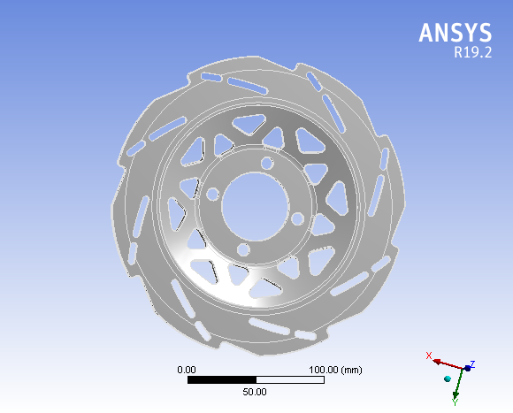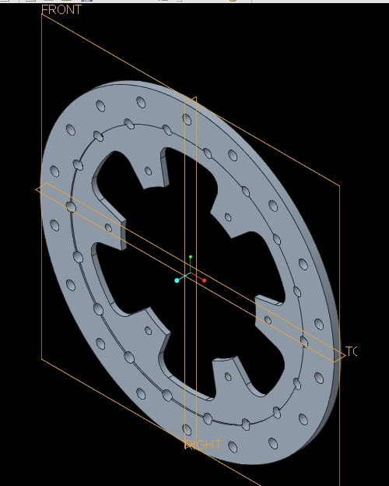

**Fig.2:**  Existing Disc with holes **Fig.3:**  New Disc with grooves

**Analysis**

**Meshing of the disc**

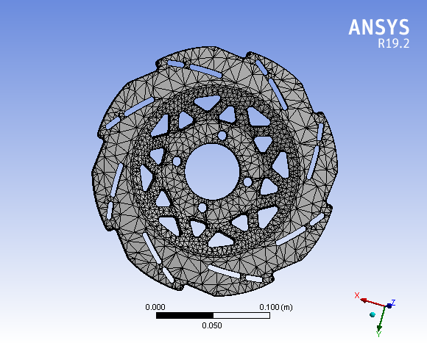Meshing is important to simulate the boundary technique of problem. Mesh quality has great influence on the results. Mesh size decides the numerical convergence of solution. If the mesh size is poor then it will not give proper results. Fine mesh gives numerical convergence with accurate results.

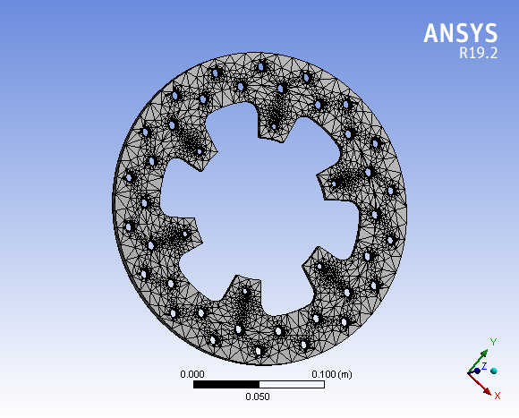

**Fig.4:**  Mesh of Existing Disc **Fig.5:**  Meshing of New Disc

**Table No**. 4: Nodes and Elements

|  |  |  |
| --- | --- | --- |
| **Parameter** | **Disc 1** | **Disc 2** |
| Nodes | 38161 | 67223 |
| Elements | 199556 | 36043 |

**Steady state thermal analysis**

After formulation of the heat flux thermal boundary conditions are applied on the FE model to obtain an estimate of the temperature and heat flux distribution in the disc rotor. The thermal

boundary conditions on the rotor are shown in the following Table No.4

**Table No.5:** Thermal Boundary condition values

|  |  |
| --- | --- |
| **Parameters** | **Values** |
| Heat flux (W/m2) | 35998 (W/m2) |
| Convective heat transfer coefficient (W/m2) | 100 (W/m2) |
| Ambient temperature (oC) | 22 (oC) |

**Static structural analysis**

Static analysis determines stress, strain, deformation in structure or component caused by loads that do not induce inertia and damping effects. This project deals with the study of stress, deformation on different brake disc models under static condition. Pressure is applied on the swept area of brake disc and the bolt holes are fixed. Static structure analysis is performed with combined thermal loads on the rotor. The following Table No.5 shows the boundary conditions parameters for static structural analysis.

**Table No.6:** Static Structural Boundary condition values

|  |  |
| --- | --- |
| **Parameters** | **Values** |
| Support | Fixed |
| Angular Velocity (rad/s) | 208.62 rad/s |
| Pressure on Disc (MPa) | 1 MPa |

# RESULTS

**Thermal Analysis results**

* **Maximum values of temperature in Disc1 and Disc2**

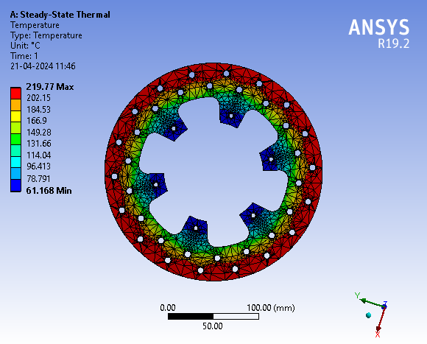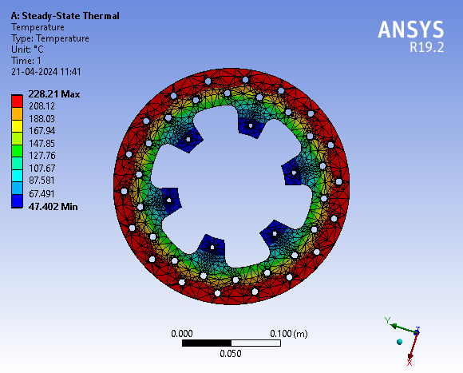

**Fig.6:** Max temp in SS410 Disc 1 is 228.21oC **Fig.7**: Max temp in Ti 550 Disc 1 is 219.77oC

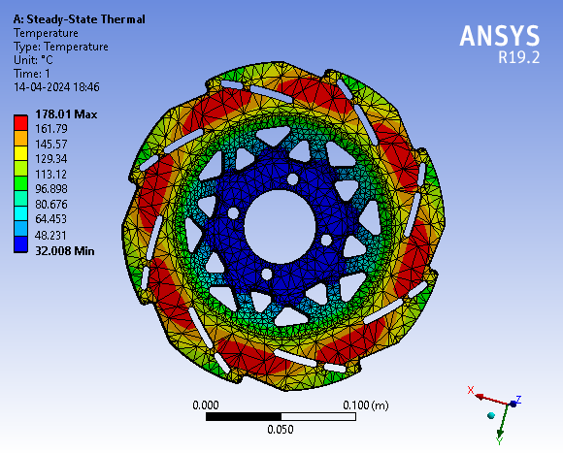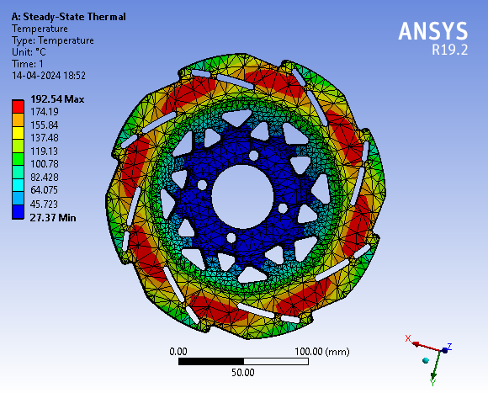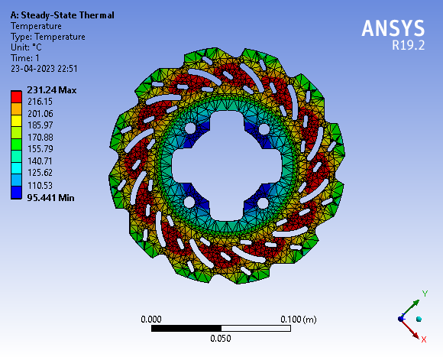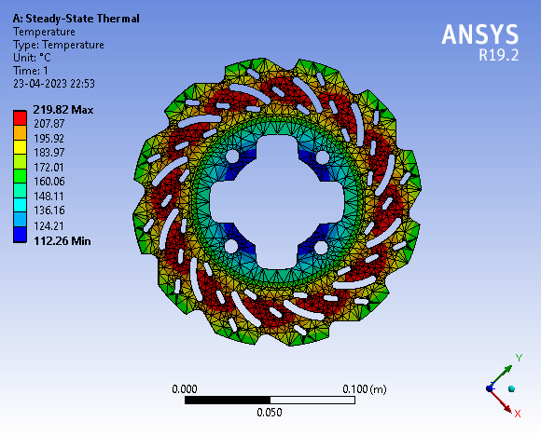

**Fig.8**: Max temp in SS410 Disc 2 is 192.54oC **Fig.9**: Max temp in Ti 550 Disc 2 is 178.01oC

**Static structural analysis results with combined thermal loads**

* 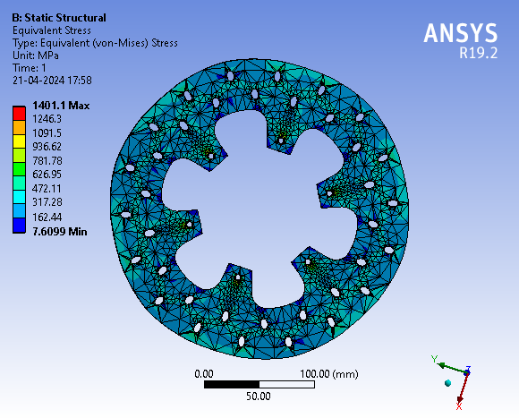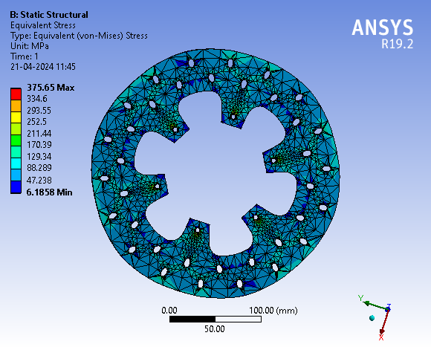**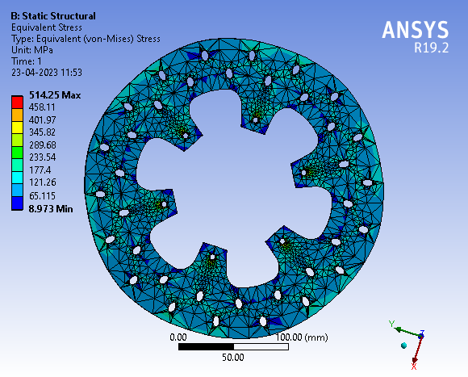Maximum values of Von Mises stress in Disc 1 and Disc 2** 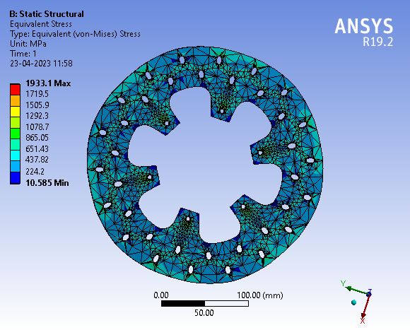

**Fig.10**: Max Stress in SS410 Disc 1 is 1401.1 MPa **Fig.11**: Max Stress in Ti550 Disc 1 is 375.65 MPa

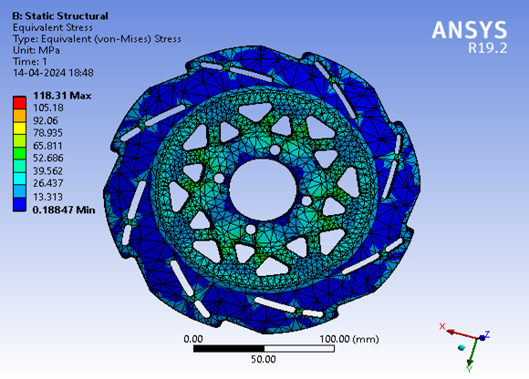 **Fig.12**: Max Stress in SS410 Disc 2 is 563.84 M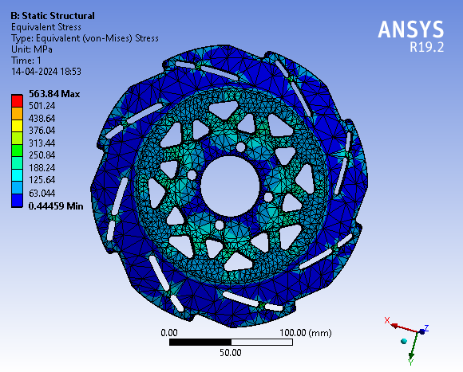 **Fig.13**: Max Stress in Ti550 Disc2 is 118.31 MPa

* **Maximum values of Total Deformation in Disc 1 and Disc 2**

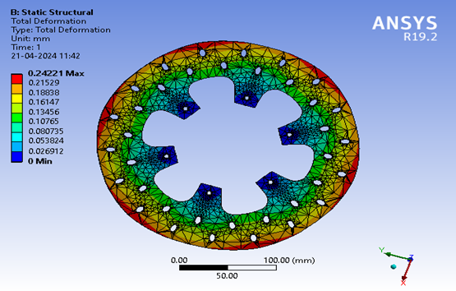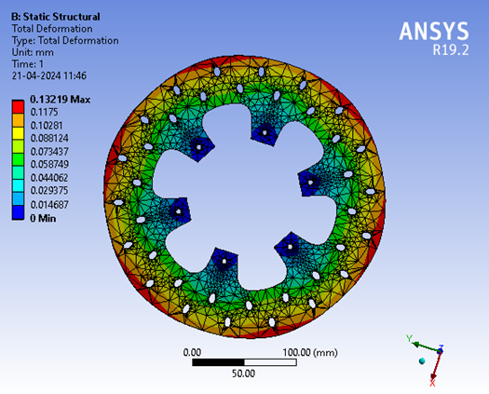

**Fig.14**: Total deformation in SS410 Disc1 is 0.242mm **Fig.15**: Total deformation in Ti550 Disc 1 is 0.132mm

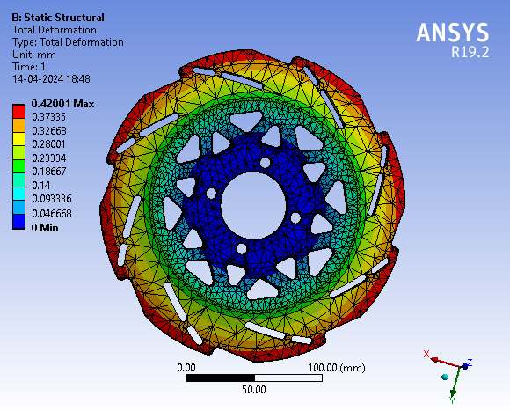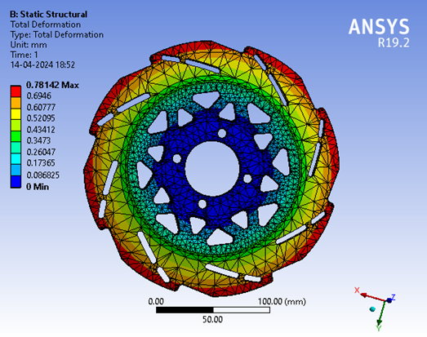

**Fig.16**: Total deformation in SS410 Disc 2 is 0.781mm **Fig.17**: Total deformation in Ti550 Disc 2 is 0.420mm

**Result Comparison**

The steady state thermal and coupled static structural analysis gives the values of Temperature, Stress and Deformation in Disc 1 and Disc 2. The comparison is done in the following tables to understand thermal and structural load variation due to change in design and material.

**Table No.7:** Max Temp. values in Disc 1 & Disc 2

|  |  |  |
| --- | --- | --- |
| **Material** | **Max Temperature (oC) in Disc1** | **Max Temperature (oC) in Disc2** |
| SS 410 | 228.21oC | 192.54 oC |
| Ti 550 | 219.77 oC | 178.01 oC |

**Fig.18**: Max Temp. Comparison Chart. **Fig.19**: Max Stress Comparison Chart.

**Table No.8:** Max Stress values in Disc 1 & Disc 2

|  |  |  |
| --- | --- | --- |
| **Material** | **Max Von Mises Stress (MPa) in Disc1** | **Max Von Mises Stress (MPa) in Disc2** |
| SS 410 | 1401.10 MPa | 563.84 MPa |
| Ti 550 | 375.65 MPa | 118.31 MPa |

**Table No.9:** Max Deformation values in Disc 1 & Disc 2

|  |  |  |
| --- | --- | --- |
| **Material** | **Total Deformation (mm) in Disc1** | **Total Deformation (mm) in Disc2** |
| SS 410 | 0.242 mm | 0.781 mm |
| Ti 550 | 0.132 mm | 0.420 mm |

# CONCLUSION

**From the above comparison, the following points can be concluded**

* Material SS 410 exhibits higher maximum temperatures in both Disc1 and Disc2 compared to Ti 550, indicating that it may experience higher thermal loads during braking.
* Material SS 410 also shows higher maximum Von Mises stress values in both Disc1 and Disc2, suggesting that it may experience higher mechanical loads during braking.
* Material SS 410 has higher total deformations in both Disc1 and Disc2 compared to Ti 550, indicating that it may undergo more deformation or wear during braking.
* Material Ti 550 exhibits lower values for maximum temperature, maximum Von Mises stress, and total deformation in both Disc1 and Disc2, suggesting that it may have better thermal and mechanical performance compared to SS 410.

Based on the given data, Ti 550 may be a more suitable material for brake disc rotors as it shows lower values for temperature, stress, and deformation, which could potentially lead to better performance and longer durability under braking conditions.

# REFERENCES

[1] Chebrolu Bhanuprakash, S. Venkata Sai sudheer , Bandaru Bangarraju, Ch. Naveen kumar, Mangam Venu “A numerical investigation of disc brake by providing slots on rotor disc” Material Processing Today [Volume 81, Part 5](https://www.sciencedirect.com/journal/materials-today-proceedings/vol/65/part/P8), 2023.

[2]Sumit KalipadaSau, Kuruvilla GeorgePulinat, Pratik NoelMoss, Pranav Ranjeet, S. Senthur Prabu “A comparative study on the thermal and dynamic analysis of a disc brake using Ansys” [International Conference on Materials and Sustainable Manufacturing Technology](https://www.sciencedirect.com/science/journal/22147853/65/part/P8) [Volume 65, Part 8](https://www.sciencedirect.com/journal/materials-today-proceedings/vol/65/part/P8), 2022, Pages 3714-3723

[3] Ali Belhocine and Oday Ibraheem Abdullah, A thermomechanical model for the analysis of disc brake using the finite element method in frictional contact, Journal of Engg. Research Vol.10 No. (4B) pp. 128-141 DOI: 10.36909/jer.8617

[4] Srushti Newase, Pradnya Kosbe, Thermal Analysis of Disc Brake System, ISSN: 2321-9653; IC Value: 45.98; SJ Impact Factor: 7.429 Volume 9 Issue VIII Aug 2021-

[5] Adarsh Bhat, Structural Analysis of A Two-Wheeler Disc Brake, Iop Conf. Series: Materials Science And Engineering 1013 (2021)

[6] Aakash Jawla, Rahul Anand, Design and Thermal Analysis of Brake Disc for Optimum Performance, ISSN: 2321-9653; IC Value: 45.98; SJ Impact Factor: 7.429 Volume 8 Issue IV Apr 2020

[7] Sanket Darekar, Ajinkya Dhage, Design and Analysis of Automotive Disc Brake using FEM, International Research Journal of Engineering and Technology (IRJET) e-ISSN: 2395-0056 Volume: 07 Issue: 01 | Jan 2020

[8] Bikesh Suwala, Sanjeev Maharjan, Design of Rotor Disc Brake using Structural & Thermal Analysis, ISSN: 2350-8914 (Online), 2350-8906 (Print) Year: 2020

[9] S.A.M Da Silva, DVV Kallon FEA On Different Disc Brake Rotors, 2351-9789 © 2019 The Authors. Published By Elsevier B.V. Peer-Review Under Responsibility Of The Organizing Committee Of SMPM 2019.

[10] Anurag Parag Borse, Design and Analysis of Brake Rotor (DISC), International Research Journal of Engineering and Technology (IRJET) e-ISSN: 2395-0056 Volume: 06 Issue: 08 | Aug 2019

[11] Joyson Sam Devapaul P1, Paul Gnanam J, Thermal and Structural Analysis of Two-Wheeler Disc Brake Using Softwares, www.ijirset.com Vol. 7, Issue 11, November 2018

[112] B.Subbarayudu, Ginjala Kishore, Design And Analysis Of Ventilated Disc Brake, IOSR Journal Of Mechanical And Civil Engineering (IOSR-JMCE) E-ISSN: 2278-1684,P-ISSN: 2320-334X, Volume 15, Issue 5 Ver. I (Sep. - Oct. 2018), PP 46-59 Www.Iosrjournals. Org

[13] Deekshith Ch, Design, Analysis and Manufacturing of Disc Brake Rotor, International Journal of Engineering Research and Development, Volume 13, Issue 11 (November 2017)

[14] Alampally Sainath, Prathamesh Mahesh Dehadray The Thermal And Stress Analysis Of Disc Brake, IOP Conf. Series: Materials Science And Engineering 1128 (2021) 012015 IOP Publishing Doi:10.1088/1757-899X/1128/1/01201

[15] Ali Belhocine, Mostefa Bouchetara, Structural and Thermal Analysis Of Automotive Disc Brake Rotor, Vol. Lxi 2014 Number 1 10.2478/Meceng-2014-0005