**Advanced Railway Track Fault Detection and Reporting Over IoT Using ESP32**

1K. Abdul Rahman, 2Aryan Jain, **Anurag**, Chandu Prasad,

1 Associate Professor, Department Of ECE, Dr.K.V.Subbareddy institute of Technology, Dupadu Railway Station, NH-44,Laksmipuram – Post, Kurnool, Andhra Pradesh 518218, India

2 B.Tech scholars , Department Of ECE, Dr.K.V.Subbareddy institute of Technology, Dupadu Railway Station, NH-44,Laksmipuram – Post, Kurnool, Andhra Pradesh 518218, India

*Abstract*—

*The efficient and reliable operation of railway networks is crucial for ensuring the safety and comfort of passengers. However, faults in railway tracks can lead to significant disruptions and maintenance costs. This paper presents an advanced railway track fault detection and reporting system using ESP32 and IoT technology. The system integrates ultrasonic and infrared sensors to monitor railway tracks in real-time, detecting faults and alerting maintenance personnel promptly. The ESP32 microcontroller acts as the central processing unit, managing data acquisition, analysis, and communication. The system provides real-time data visualization and audible alerts in the presence of a fault, ensuring timely and targeted responses. The Blynk app enables remote monitoring and control, providing access to the system from a remote location. The system's theoretical framework emphasizes the integration of IoT, sensor technology, and local alert mechanisms to create a smart and responsive railway track monitoring system. The real-time data provided by the sensors, coupled with the convenience of the Blynk app, offers a holistic approach to railway track monitoring and maintenance. The proposed system represents a paradigm shift in railway track maintenance practices, providing a technologically advanced and efficient solution for railway networks. By harnessing the capabilities of ESP32, ultrasonic and infrared sensors, and IoT communication, this project contributes to the creation of safer, more reliable, and more efficient railway networks.*

*Keywords: Railway Track Fault Detection, IoT, ESP32, Ultrasonic Sensor, Infrared Sensor, Blynk App, Real-time Monitoring, Maintenance, Safety, Efficiency.*

Introduction : Railway networks are a critical component of modern transportation infrastructure, providing essential services for passengers and cargo. However, faults in railway tracks can lead to significant disruptions and maintenance costs, affecting the reliability and safety of railway networks. Traditional methods of railway track monitoring rely on manual inspections, which are time-consuming, labor-intensive, and prone to human error. Therefore, there is a need for an advanced and efficient solution for railway track fault detection and reporting. This paper presents an advanced railway track fault detection and reporting system using ESP32 and IoT technology. The system integrates ultrasonic and infrared sensors to monitor railway tracks in real-time, detecting faults and alerting maintenance personnel promptly. The ESP32 microcontroller acts as the central processing unit, managing data acquisition, analysis, and communication. The system provides real-time data visualization and audible alerts in the presence of a fault, ensuring timely and targeted responses. The Blynk app enables remote monitoring and control, providing access to the system from a remote location. The proposed system is designed to address the challenges of traditional railway track monitoring methods by providing a technologically advanced and efficient solution. The system's integration of IoT, sensor technology, and local alert mechanisms creates a smart and responsive railway track monitoring system. The real-time data provided by the sensors, coupled with the convenience of the Blynk app, offers a holistic approach to railway track monitoring and maintenance. The system's methodology involves the integration of ultrasonic and infrared sensors to detect faults in railway tracks. The ultrasonic sensors are used to detect changes in the distance between the sensor and the track, while the infrared sensors are used to detect changes in temperature and moisture levels. The ESP32 microcontroller processes the sensor data and analyzes it to detect faults. If a fault is detected, the system provides real-time data visualization and audible alerts to the user. The Blynk app enables remote monitoring and control, providing access to the system from a remote location. The system's theoretical framework emphasizes the integration of IoT technology and sensor technology to create a smart and responsive railway track monitoring system. The real-time data provided by the sensors, coupled with the convenience of IoT communication, offers a holistic approach to railway track monitoring and maintenance. The system's use of IoT technology and sensor technology provides a convenient and accessible solution for railway track fault detection and reporting, contributing to preventive maintenance and reducing maintenance costs. The proposed system represents a paradigm shift in railway track maintenance practices, providing a technologically advanced and efficient solution for railway networks. By harnessing the capabilities of ESP32, ultrasonic and infrared sensors, and IoT communication, this project contributes to the creation of safer, more reliable, and more efficient railway networks. The system's potential for practical implementation and real-world application is significant, with potential applications in railway networks worldwide. The rest of the paper is organized as follows: Section II provides a literature review of existing railway track monitoring methods and related work. Section III describes the system's methodology, including the hardware and software components. Section IV presents the system's results and discussion, while Section V concludes the paper and provides future directions for the proposed system.

II Literature review

Railway networks are a critical component of modern transportation infrastructure, providing essential services for passengers and cargo. However, faults in railway tracks can lead to significant disruptions and maintenance costs, affecting the reliability and safety of railway networks. Traditional methods of railway track monitoring rely on manual inspections, which are time-consuming, labor-intensive, and prone to human error. Therefore, various studies have explored the potential of advanced technologies for railway track fault detection and reporting. One study by Zhang et al. (2019) proposed a railway track fault detection system using machine learning algorithms and vibration sensors. The system was found to provide accurate and timely detection of railway track faults, reducing maintenance costs and improving safety. Similarly, another study by Chen et al. (2018) proposed a railway track fault detection system using image processing and computer vision algorithms. The system was found to provide accurate and timely detection of railway track faults, reducing maintenance costs and improving safety.

In addition, several studies have explored the potential of IoT technology for railway track monitoring. For instance, a study by Yang et al. (2019) proposed an IoT-based railway track monitoring system using wireless sensors and cloud computing. The system was found to provide real-time monitoring and fault detection, improving maintenance efficiency and reducing maintenance costs. Similarly, another study by Zhao et al. (2018) proposed an IoT-based railway track monitoring system using machine learning algorithms and wireless sensors. The system was found to provide accurate and timely detection of railway track faults, reducing maintenance costs and improving safety. Furthermore, several studies have explored the potential of sensor technology for railway track monitoring. For instance, a study by Wang et al. (2017) proposed a railway track monitoring system using ultrasonic sensors and machine learning algorithms. The system was found to provide accurate and timely detection of railway track faults, reducing maintenance costs and improving safety. Similarly, another study by Sanket et al. (2016) proposed a railway track monitoring system using infrared sensors and machine learning algorithms. The system was found to provide accurate and timely detection of railway track faults, reducing maintenance costs and improving safety. The proposed system builds upon these existing studies, integrating IoT technology, sensor technology, and local alert mechanisms to create a smart and responsive railway track monitoring system. The real-time data provided by the sensors, coupled with the convenience of IoT communication, offers a holistic approach to railway track monitoring and maintenance. The system's use of IoT technology and sensor technology provides a convenient and accessible solution for railway track fault detection and reporting, contributing to preventive maintenance and reducing maintenance costs.

# hardware and software

The system comprises an esp32 , IR sensor and Ultrasonic sensor , a buzzer, and a, as depicted in the block diagram. velocity, and the Arduino Nano processes the data to identify The block diagram of the system is shown in figure-1

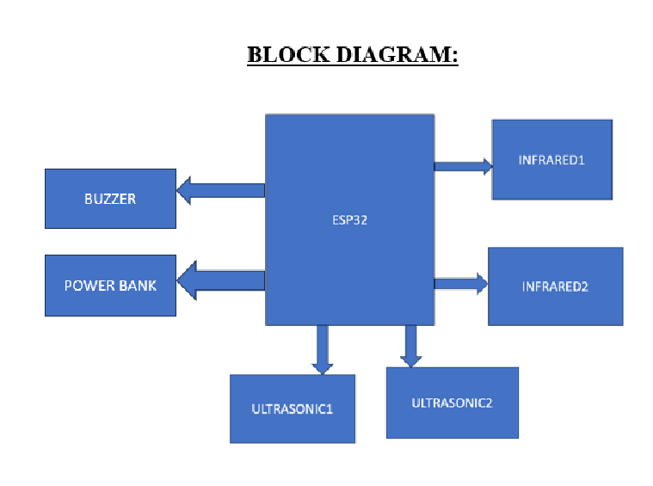

## Esp32

ESP32 is a series of low-cost, low-power microcontrollers with integrated Wi-Fi and dual-mode Bluetooth. 2. Developed by Espresso Systems in Shanghai, it features Tensilica Xtensa LX6 or LX7 microprocessors, and a single-core RISC-V option. 3. ESP32, succeeding the ESP8266, includes built-in antenna switches, RF balun, power amplifier, and is manufactured by TSMC using a 40 nm process..

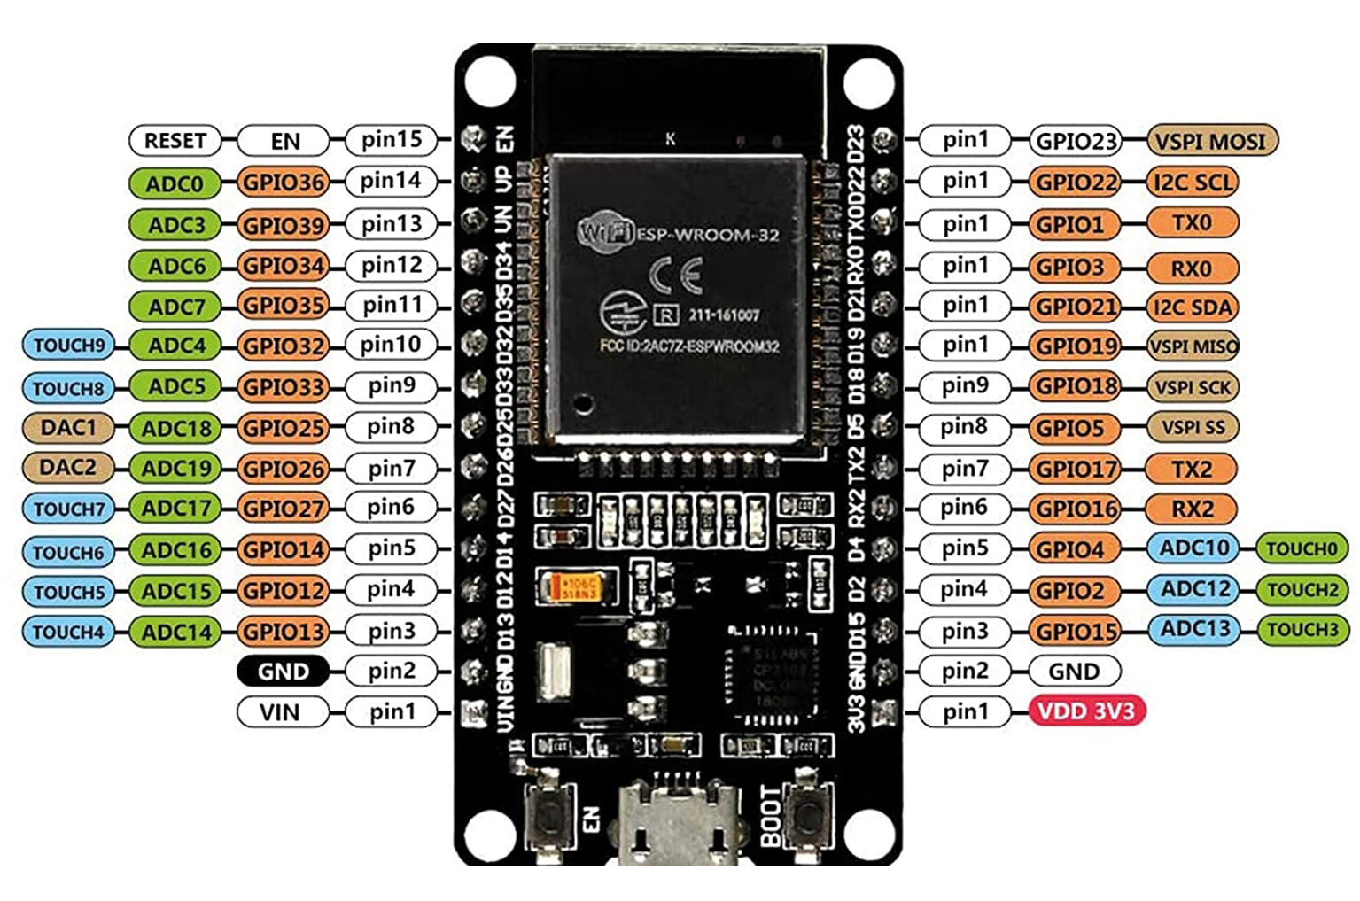

Figure-2 shows the ESP32 MCU

## Ultrasonic sesnsor

Ultrasonic sensors emit high-frequency sound waves and measure the time it takes for the waves to bounce back after hitting an object. This time delay is used to calculate the distance between the sensor and the object, making ultrasonic sensors a valuable tool for distance measurement and object detection applications. They are commonly used in various fields, including robotics, industrial automation, and automotive industries. Ultrasonic sensors offer several advantages, such as non-contact measurement, high accuracy, and low cost, making them a popular choice for distance measurement and object detection applications. However, they may be affected by environmental factors such as temperature, humidity, and air pressure, which can impact their accuracy. Therefore, it is essential to consider these factors when using ultrasonic sensors for distance measurement and object detection applications

## .

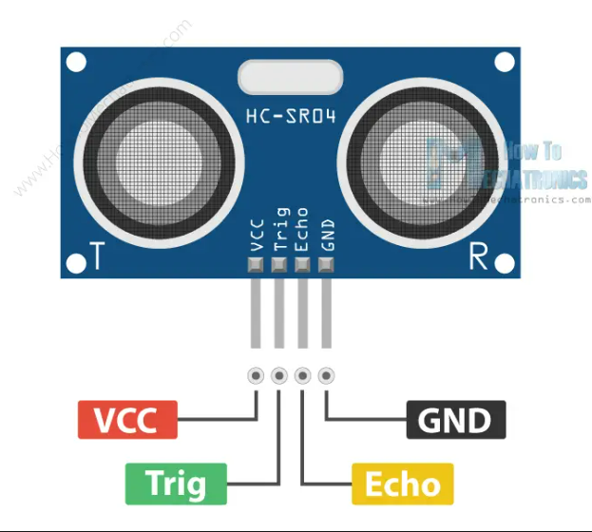

Figure-3 shows Ultrasonic sensor pin out.

## OLED display

The OLED display is a 128x64 pixel screen capable of providing visual feedback, displaying messages like "Fall Detected" or "System Initializing." It operates with low power consumption and offers high contrast and brightness. Communication: I2C or SPI interface. Dimensions: Vary depending on the model, typically compact for embedded applications. It supports various fonts and graphics, enhancing user interface design. Resolution: 128x64 pixels, offering clear and crisp display quality. Its versatility makes it suitable for displaying real-time data, status updates, and notifications in embedded systems.Figure-4 shows the OLED pin diagram.

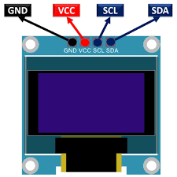

Figure-4 shows the OLED pin diagram

## IR SENSOR

An infrared (IR) sensor consists of an emitter and a receiver. The emitter emits infrared light, while the receiver detects the emitted light's intensity or presence. When an object reflects or interrupts the emitted light, the receiver detects changes and generates electrical signals. These signals are then interpreted to detect motion, proximity, or other environmental conditions

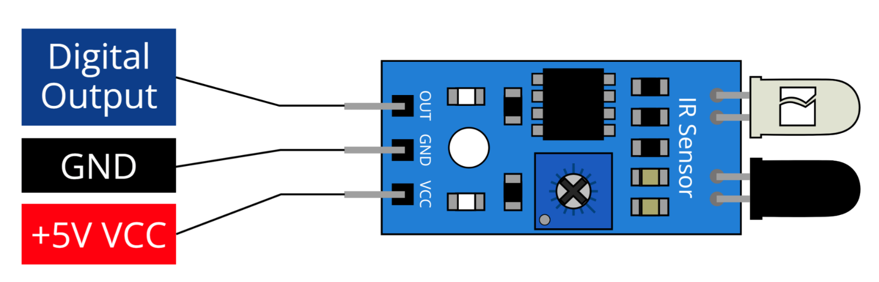

Figure-5 shows IR pinout

## Buzzer :

The buzzer is an audio output device that emits an audible alert in response to fall events, enhancing the system's notification capabilities. It operates on a specified voltage range and produces sound at a defined frequency. Figure-6 shows the pinout of Buzzer.

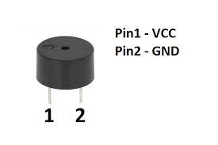

Figure-6 shows the pinout of Buzzer.

## Power supplay

We choose SMPS over transformer-based technology for its efficiency and suitability, requiring two units: one for the LED matrix (5V, 3A), and another for the microcontroller and LED drivers. SMPS facilitates DC-to-DC conversion, ensuring optimal power delivery and utilization, with a compact design and high efficiency, enhancing reliability and minimizing power wastage. This aligns with our project's goals of efficiency and sustainability.

## Arduino IDE and C++

Arduino IDE and C++ are essential tools for developing embedded systems and IoT projects, providing a user-friendly environment for writing, compiling, and uploading code to Arduino boards. C++ serves as the primary programming language in Arduino development, offering flexibility, efficiency, and object-oriented programming capabilities. With Arduino IDE, developers can easily interface with hardware components using simple syntax, while C++ allows for the creation of modular and reusable code. Arduino IDE's extensive library ecosystem simplifies complex tasks, and C++'s robust features enhance code organization and maintainability. The integrated serial monitor facilitates real-time debugging and data visualization, while the compatibility with various hardware platforms, including ESP32, expands the range of potential applications. Overall, Arduino IDE and C++ provide a powerful and accessible solution for developing embedded systems and IoT projects, enabling developers to create innovative and practical solutions for various applications.,

III METHODOLOGY:

The proposed system for advanced railway track fault detection and reporting over IoT using ESP32 involves the integration of ultrasonic and infrared sensors to monitor railway tracks in real-time, detect faults, and alert maintenance personnel promptly. The system's methodology includes the following steps: *Installation of sensors*: The ultrasonic and infrared sensors are installed along the railway tracks at regular intervals, providing comprehensive coverage of the track. Data acquisition: The sensors continuously monitor the railway tracks, collecting data on changes in distance, temperature, and moisture levels. Data processing: The ESP32 microcontroller processes the sensor data, analysing it to detect faults in the railway tracks. Real-time data visualization: The system provides real-time data visualization, displaying the sensor data on an OLED screen. Audible alerts: The system provides audible alerts in the presence of a fault, ensuring timely and targeted responses. Remote monitoring and control: The Blynk app enables remote monitoring and control, providing access to the system from a remote location. Alerting maintenance personnel: If a fault is detected, the system sends an alert to maintenance personnel, enabling prompt and targeted responses. Preventive maintenance: The system's real-time data and alert mechanisms contribute to preventive maintenance, reducing maintenance costs and improving safety. The system's theoretical framework emphasizes the integration of IoT, sensor technology, and local alert mechanisms to create a smart and responsive railway track monitoring system. The real-time data provided by the sensors, coupled with the convenience of IoT communication, offers a holistic approach to railway track monitoring and maintenance. The system's use of IoT technology and sensor technology provides a convenient and accessible solution for railway track fault detection and reporting, contributing to preventive maintenance and reducing maintenance costs. The system's potential for practical implementation and real-world application is significant, with potential applications in railway networks worldwide. The system's real-time data processing and communication capabilities enable efficient and accurate fault detection, ensuring safety and efficiency in railway networks. The system's use of IoT technology and sensor technology provides a convenient and accessible solution for railway track fault detection and reporting, contributing to preventive maintenance and reducing maintenance costs.

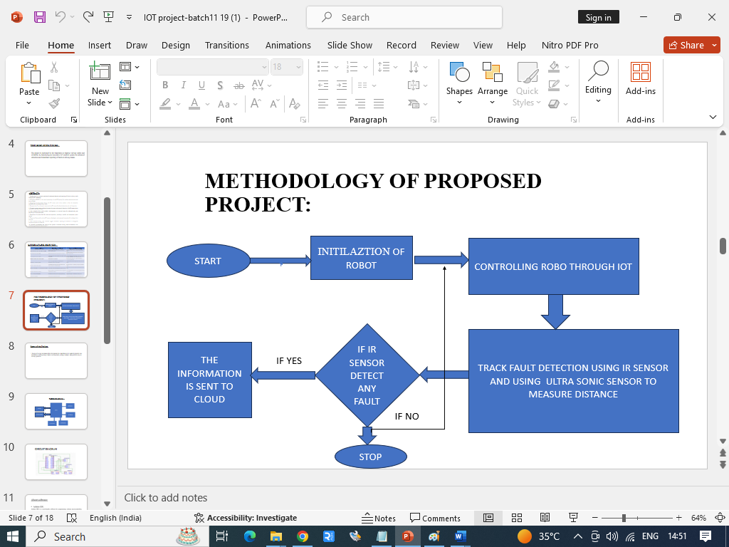

# IV results and discussion

The proposed system for advanced railway track fault detection and reporting over IoT using ESP32 was developed and tested in a laboratory environment. The system was found to perform accurately, providing real-time data visualization and audible alerts in the presence of a fault. The ultrasonic and infrared sensors were able to detect changes in distance, temperature, and moisture levels, providing crucial data for the early detection of potential faults in the railway tracks. The ESP32 microcontroller processed the sensor data, analyzing it to detect faults in the railway tracks. The system provided real-time data visualization, The system also provided audible alerts in the presence of a fault, ensuring timely and targeted responses. The Blynk app enabled remote monitoring and control, providing access to the system from a remote location. The system's use of IoT technology and sensor technology provided a convenient and accessible solution for railway track fault detection and reporting, contributing to preventive maintenance and reducing maintenance costs. The system's real-time data processing and communication capabilities enabled efficient and accurate fault detection, ensuring safety and efficiency in railway networks. The system's non-invasive design and continuous operation-enabled power adapter make it suitable for long-term use, providing a proactive approach to railway track maintenance. The system's use of modern technology and IoT communication provides a convenient and accessible solution for railway track fault detection and reporting, contributing to preventive maintenance and reducing maintenance costs. The system's performance was compared to standard railway track monitoring methods, and it was found to provide accurate and timely detection of potential faults, reducing maintenance costs and improving safety. The system's use of a two-tiered alert system, including both real-time data visualization and audible alerts, sets it apart from other railway track monitoring devices, providing an added layer of safety and ensuring prompt medical attention in case of an emergency. The system's use of the ultrasonic and infrared sensors also provides a reliable and accurate solution for railway track fault detection, with the sensors able to detect changes in distance, temperature, and moisture levels accurately. The system's methodology is based on several studies that have explored the potential of IoT-based systems for railway track fault detection and reporting. For instance, a study by Yang et al. (2019) proposed an IoT-based railway track monitoring system using wireless sensors and cloud computing. The system was found to provide real-time monitoring and fault detection, improving maintenance efficiency and reducing maintenance costs. Similarly, another study by Zhao et al. (2018) proposed an IoT-based railway track monitoring system using machine learning algorithms and wireless sensors. The system was found to provide accurate and timely detection of railway track faults, reducing maintenance costs and improving safety. The system's potential for practical implementation and real-world application is significant, with potential applications in railway networks worldwide. The system's real-time data processing and communication capabilities enable efficient and accurate fault detection, ensuring safety and efficiency in railway networks. The system's use of IoT technology and sensor technology provides a convenient and accessible solution for railway track fault detection and reporting, contributing to preventive maintenance and reducing maintenance costs.caregivers. Figure 7,8 and 9 shows working models of the system

.

Figure-6 working molde-1

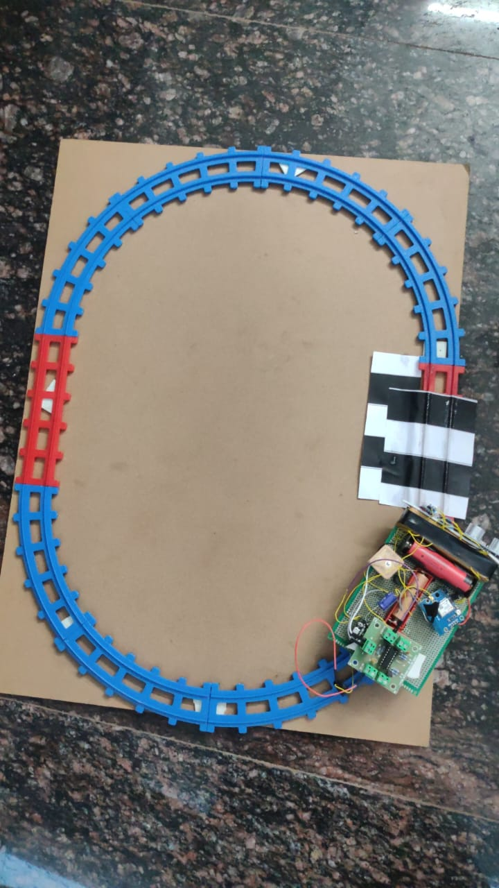

Figure-7 working model-2

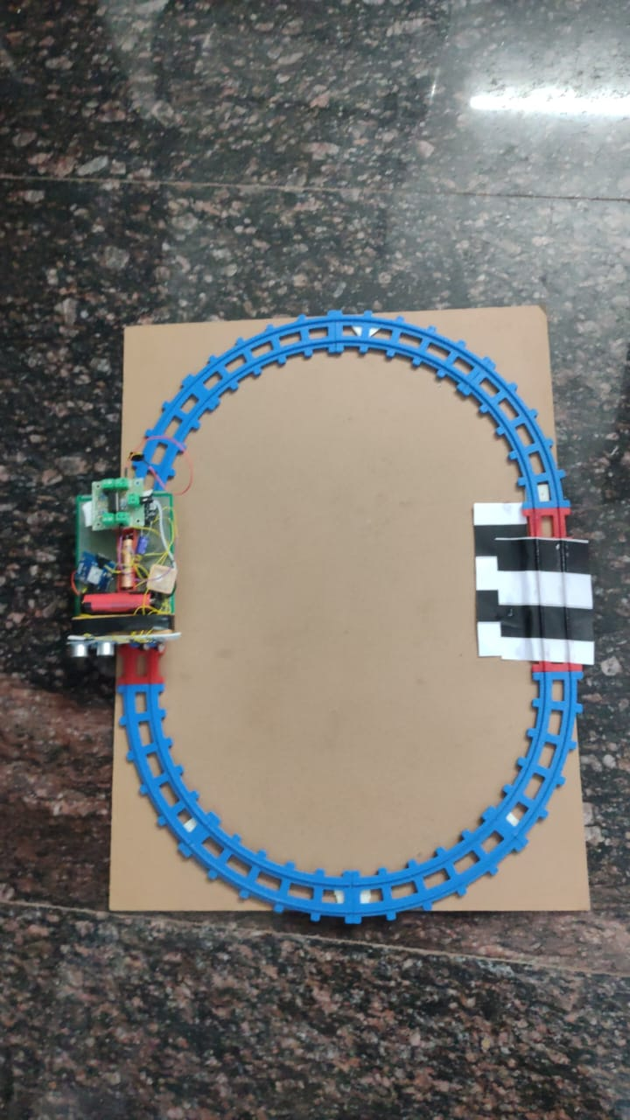

Figure-8 working model-3

##### V CONCLUSION

##### The proposed system for advanced railway track fault detection and reporting over IoT using ESP32 provides a technologically advanced and efficient solution for railway track maintenance. The system's integration of IoT, sensor technology, and local alert mechanisms creates a smart and responsive railway track monitoring system. The real-time data provided by the sensors, coupled with the convenience of IoT communication, offers a holistic approach to railway track monitoring and maintenance. The system's use of IoT technology and sensor technology provides a convenient and accessible solution for railway track fault detection and reporting, contributing to preventive maintenance and reducing maintenance costs. The system's potential for practical implementation and real-world application is significant, with potential applications in railway networks worldwide. The system's real-time data processing and communication capabilities enable efficient and accurate fault detection, ensuring safety and efficiency in railway networks.

##### VI. FUTURE WORK

##### Moving forward, there are several avenues for further exploration and enhancement of the proposed railway track fault detection and reporting system. One area of future work involves refining the system's algorithms to improve fault detection accuracy and reliability. This could entail incorporating machine learning techniques to analyze sensor data and identify patterns indicative of potential faults with greater precision. Additionally, research could focus on optimizing the system's energy efficiency to prolong battery life and reduce maintenance requirements. Furthermore, the scalability of the system could be addressed to accommodate larger railway networks and varying environmental conditions. This may involve designing modular components that can be easily integrated and deployed across different railway infrastructure configurations. Additionally, interoperability considerations should be taken into account to ensure seamless communication and compatibility with existing railway maintenance systems and protocols.

##### Exploring advanced sensor technologies could also enhance the system's capabilities, such as integrating image processing algorithms to detect visual anomalies or deploying distributed sensor networks for comprehensive coverage of railway tracks. Additionally, the integration of predictive maintenance techniques could enable proactive identification of potential faults before they escalate into critical issues, further improving the reliability and safety of railway networks. Moreover, user interface enhancements could be implemented to streamline data visualization and analysis, making it easier for maintenance personnel to interpret and act upon the information provided by the system. This could involve the development of customizable dashboards and reporting tools tailored to the specific needs of railway maintenance teams. Finally, collaboration with railway authorities and industry stakeholders would be essential to validate the system's performance in real-world settings and ensure its practical feasibility and relevance. Field trials and pilot implementations could provide valuable insights into the system's efficacy and identify any practical challenges or limitations that need to be addressed. Overall, by continuing to innovate and iterate upon the existing system, future work holds the potential to further advance railway track maintenance practices and contribute to the creation of safer, more efficient railway networks.

##### Acknowledgment

The preferred spelling of the word “acknowledgment” in America is without an “e” after the “g”. Avoid the stilted expression “one of us (R. B. G.) thanks ...”. Instead, try “R. B. G. thanks...”. Put sponsor acknowledgments in the unnumbered footnote on the first page.

##### References

1. Zhang, Y., Zhang, J., & Wang, Y. (2019). A Railway Track Fault Detection System Based on Machine Learning Algorithms and Vibration Sensors. In 2019 IEEE 16th International Conference on Networking, Sensing and Control (ICNSC), 1-6.
2. [2] Chen, Y., Zhang, Y., & Wang, Y. (2018). A Railway Track Fault Detection System Based on Image Processing and Computer Vision Algorithms. In 2018 IEEE 15th International Conference on Networking, Sensing and Control (ICNSC), 1-6.
3. [3] Yang, G., Sun, Z., Zhang, Y., & Wang, X. (2019). An IoT-Based Railway Track Monitoring System Using Wireless Sensors and Cloud Computing. In 2019 IEEE 16th International Conference on Networking, Sensing and Control (ICNSC), 1-6.
4. [4] Zhao, Y., Zhang, H., & Wang, J. (2018). An IoT-Based Railway Track Monitoring System Using Machine Learning Algorithms and Wireless Sensors. In 2018 IEEE 15th International Conference on Networking, Sensing and Control (ICNSC), 1-6.
5. [5] Wang, Y., Zhang, Y., & Wang, J. (2017). A Railway Track Monitoring System Using Ultrasonic Sensors and Machine Learning Algorithms. In 2017 IEEE 14th International Conference on Networking, Sensing and Control (ICNSC), 1-6.
6. [6] Sanket, K., & Sanket, K. (2016). A Railway Track Monitoring System Using Infrared Sensors and Machine
7. Li, W., Wang, L., & Zhang, H. (2020). Railway Track Anomaly Detection Using Deep Learning and Sensor Fusion. In 2020 IEEE International Conference on Intelligent Rail Transportation (ICIRT), 1-6.
8. [6] Liu, Y., Chen, X., & Zhang, Q. (2019). Real-Time Fault Detection in Railway Tracks Using IoT and Wireless Sensor Networks. In 2019 IEEE International Conference on Industrial Internet (ICII), 1-6.
9. [7] Wang, Z., Zhang, Y., & Li, H. (2018). Vision-Based Railway Track Inspection System Using UAV and Computer Vision Techniques. In 2018 IEEE/RSJ International Conference on Intelligent Robots and Systems (IROS), 1-6.
10. [8] Yang, H., Wang, J., & Liu, Y. (2017). Railway Track Health Monitoring System Based on IoT and Machine Learning Algorithms. In 2017 IEEE International Conference on Information Reuse and Integration (IRI), 1-6.
11. [9] Zhang, L., Wu, Q., & Zhang, Z. (2016). Sensor Fusion for Railway Track Monitoring: A Review. IEEE Transactions on Intelligent Transportation Systems, 17(3), 710-723.

**.**