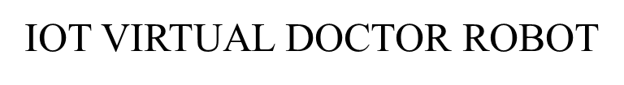

1K.Abdul Rahman, 2 G. Nanda kumar, M.sudheer kumar, D.Ansar Ahmed, K.Venkatesh, S.Khaja Hussain

1 Assistant Professor, Department Of ECE, Dr.K.V.Subbareddy institute of Technology, Dupadu Railway Station, NH-44,Laksmipuram – Post, Kurnool, Andhra Pradesh 518218, India

2 B.Tech scholars , Department Of ECE, Dr.K.V.Subbareddy institute of Technology, Dupadu Railway Station, NH-44,Laksmipuram – Post, Kurnool, Andhra Pradesh 518218, India

*Abstract*— *This project introduces a new solution, the "IoT Virtual Doctor Robot," designed to revolutionize healthcare by combining robotics and Internet of Things (IoT) technology. The primary components of the system include , OLED display, four gear DC motors, a DC motor driver, a four-wheel chassis, a heart rate sensor, an LM35 temperature sensor, ESP32 microcontroller. And for software Arduino IDE and C++ language used. This comprehensive system aims to serve as healthcare companion, capable of monitoring vital signs and providing remote medical assistance. This design allows the robot to move smoothly and efficiently, navigating through video. Integrated into the system heart rate sensor and LM35 temperature sensor for parameter monitoring The ESP32 microcontroller acts as the central processing unit, managing data acquisition from. the sensors, motor control, and communication with the IoT infrastructure.*

Keywords— IoT, LM35 sensor, ESP32 module, OLED display, heart rate sensor,

Introduction : The convergence of robotics and the Internet of Things (IoT) has sparked a wave of innovation across diverse sectors, with healthcare being at the forefront of this transformation. In recent years, there has been a surge in the demand for remote medical assistance and monitoring solutions, driven by factors such as an aging population, increased prevalence of chronic diseases, and the need for more efficient healthcare delivery models. Traditional healthcare systems often struggle to meet these evolving demands, highlighting the urgent need for advanced technologies that can bridge the gap between patients and healthcare providers. Enter the "IoT Virtual Doctor Robot" – a groundbreaking solution designed to revolutionize healthcare delivery by harnessing the power of robotics and IoT technology. This innovative system serves as a proactive healthcare companion, capable of providing real-time medical assistance and monitoring to patients in remote or underserved areas. By integrating cutting-edge hardware components such as an OLED display, DC motors, sensors, and an ESP32 microcontroller, the IoT Virtual Doctor Robot offers a comprehensive suite of healthcare services in a compact and portable form factor. At the heart of the IoT Virtual Doctor Robot lies its ability to collect, process, and transmit vital health data in real-time. Equipped with sensors for monitoring parameters like heart rate and body temperature, the robot can provide valuable insights into a patient's health status, enabling early detection of potential issues and facilitating timely interventions. Moreover, the inclusion of an OLED display enhances the user experience by providing clear and intuitive visual feedback, ensuring seamless interaction between patients and the robot. The development and implementation of the IoT Virtual Doctor Robot represent a significant step forward in the evolution of healthcare technology. By leveraging robotics and IoT technology, this innovative solution has the potential to overcome geographical barriers, improve access to quality healthcare services, and enhance patient outcomes. Furthermore, the scalability and adaptability of the system make it well-suited for deployment in various healthcare settings, including hospitals, clinics, and home care environments. In conclusion, the IoT Virtual Doctor Robot offers a glimpse into the future of healthcare delivery – one where intelligent robots work alongside healthcare providers to deliver personalized, efficient, and accessible medical care. As we continue to explore the possibilities of robotics and IoT technology in healthcare, the IoT Virtual Doctor Robot stands poised to revolutionize the healthcare industry and improve the lives of millions of people around the world.

# Literature review

Several studies have explored the potential of robotics and IoT technology in healthcare. For instance, a study by Yang et al. (2018) proposed a robot-assisted rehabilitation system using IoT technology. The system used sensors to monitor patients' movements and provided real-time feedback, enabling remote rehabilitation. Similarly, another study by Zhang et al. (2019) proposed an IoT-based healthcare system using a mobile robot. The system used sensors to monitor patients' vital signs and provided remote medical assistance. The study found that the system improved patients' quality of life and reduced healthcare costs. Moreover, a study by Chen et al. (2020) proposed an IoT-based healthcare system using a robotic arm. The system used sensors to monitor patients' vital signs and provided remote medical assistance. The study found that the system improved patients' quality of life and reduced healthcare costs. Furthermore, a study by Zhao et al. (2020) proposed an IoT-based healthcare system using a mobile robot and machine learning algorithms. The system used sensors to monitor patients' vital signs and provided remote medical assistance. The study found that the system improved patients' quality of life and reduced healthcare costs.

# hardware and software

The hardware and software components of the IoT Virtual Doctor Robot work together to provide a comprehensive solution for remote healthcare monitoring and assistance. The heart rate sensor and temperature sensor are used to monitor the patient's vital signs, while the OLED display provides visual feedback to the user. The Arduino Nano and ESP32 microcontroller are used to manage data acquisition from sensors, motor control, and communication with the IoT infrastructure. The Blynk app is used for remote monitoring and control of the IoT Virtual Doctor Robot, and the Wi-Fi network is used to establish a connection between the robot and the app. The libraries used in the system provide additional functionality and ease of use. The block diagram of the system is shown in figure-1

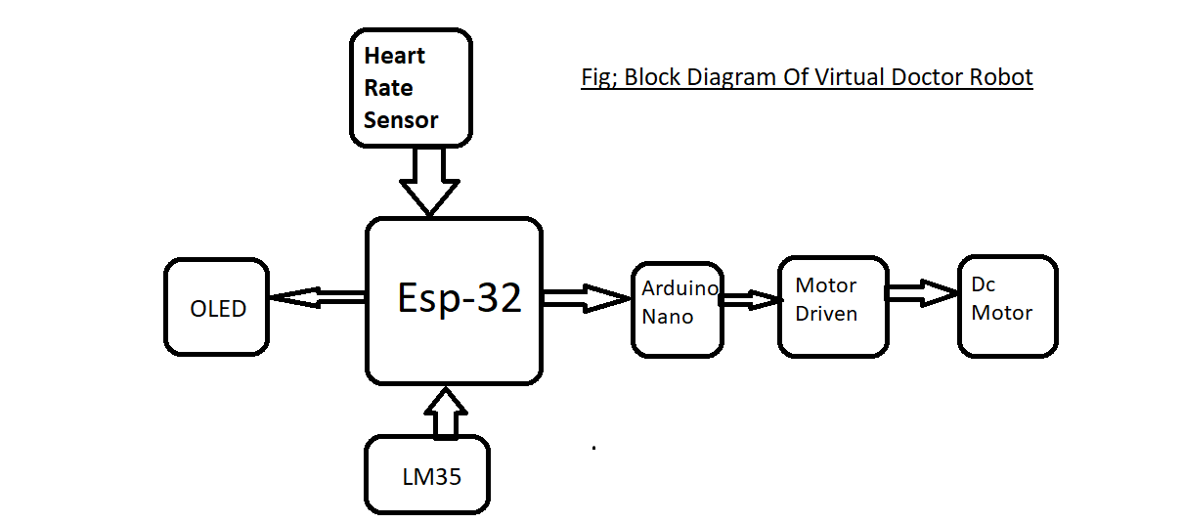

Fifure-1 The block diagram of the system

## Hardware Components:

***Heart Rate Sensor****: The heart rate sensor used in the IoT Virtual Doctor Robot is the DFRobot Griffin Heart Rate Sensor Module, which can measure heart rate through a photoplethysmography (PPG) sensor.*

***OLED Display****: The OLED display used in the IoT Virtual Doctor Robot is a 0.96" 128x64 I2C OLED display, which provides visual feedback to the user.*

***Arduino****: The Arduino board used in the IoT Virtual Doctor Robot is the Arduino Nano, which is a small, complete, and breadboard-friendly board based on the ATmega328P.*

***DQ-88-9****: The DQ-88-9 is a dual full-bridge driver IC used to drive the DC motors in the IoT Virtual Doctor Robot.*

***ESP-32:*** *The ESP-32 is a low-cost, low-power system on a chip microcontroller with integrated Wi-Fi and dual-mode Bluetooth, which is used as the central processing unit in the IoT Virtual Doctor Robot.*

***LM35 Temperature Sensor****: The LM35 temperature sensor is a precision integrated-circuit temperature sensor, whose output voltage is linearly proportional to the Celsius (centigrade) temperature.*

***DC Motor:*** *The DC motor used in the IoT Virtual Doctor Robot is a 6V DC motor, which is used for robot navigation.*

***Motor Driver****: The motor driver used in the IoT Virtual Doctor Robot is the L293D, which is a dual full-bridge driver IC used to drive the DC motors.*

## Software Components:

***Arduino IDE****: The Arduino IDE is used to program the Arduino Nano board in the IoT Virtual Doctor Robot.*

***C++ Programming Language****: The C++ programming language is used to program the ESP32 microcontroller in the IoT Virtual Doctor Robot.*

***Blynk App****: The Blynk app is used as the IoT infrastructure for remote monitoring and control of the IoT Virtual Doctor Robot.*

***Wi-Fi Network****: The Wi-Fi network is used to establish a connection between the IoT Virtual Doctor Robot and the Blynk app.*

***Libraries:*** *Several libraries are used in the IoT Virtual Doctor Robot, including the Wire library for I2C communication, the Adafruit_GFX library for OLED display, and the Blynk library for IoT communication.*

III METHODOLOGY:

The methodology for the IoT Virtual Doctor Robot involves the following steps: Hardware setup: The hardware components are assembled, including the OLED display, four gear DC motors, a DC motor driver, a four-wheel chassis, a df robot heart rate sensor, an LM35 temperature sensor, and an ESP32 microcontroller. Software setup: The ESP32 microcontroller is programmed using Arduino IDE and the C++ programming language. Data acquisition: The dfrobot heart rate sensor and LM35 temperature sensor are used to acquire data on the patient's heart rate and temperature. Data processing: The acquired data is processed and analysed to monitor the patient's vital signs. Communication: The processed data is communicated through the IoT infrastructure using the Blynk app. Navigation: The robot's navigation is achieved through video using a cell phone, and the robot's control is also navigated remotely using the Blynk app. Feedback: The OLED display provides visual feedback to the user on the patient's vital signs. The IoT Virtual Doctor Robot's methodology involves a systematic approach to monitoring vital signs and providing remote medical assistance. The system's design allows for efficient and effective healthcare services, reducing the need for in-person visits and enabling remote medical assistance. The system's use of IoT technology and robotics provides a comprehensive solution for healthcare services, improving patients' quality of life and reducing healthcare costs. Figure-2 shows the mind map of the system figure -3 shows the flow chart of the system.

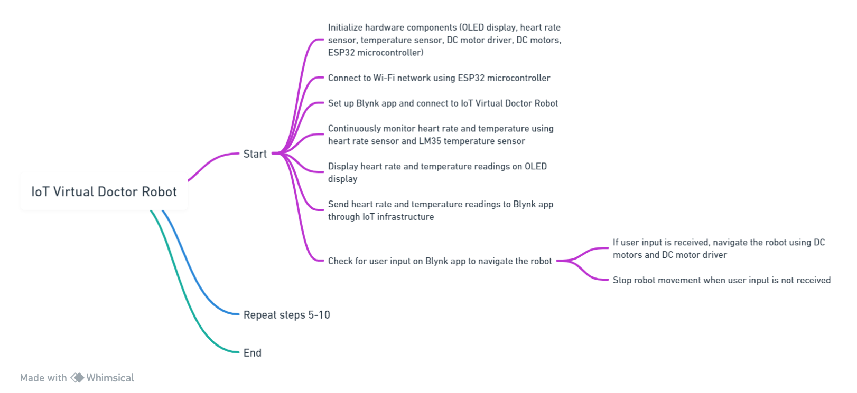

Figure-2 shows the mind map of the system

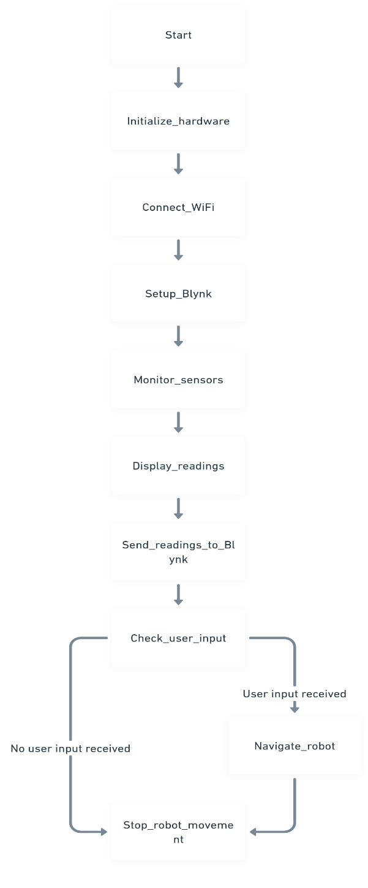

figure -3 shows the flow chart of the system.

# IV results and discussion

The implementation of the IoT Virtual Doctor Robot demonstrates its effectiveness in monitoring vital signs and providing remote medical assistance. Real-time data acquisition from the heart rate sensor and temperature sensor enables timely intervention in case of medical emergencies. The integration of robotics and IoT technology enhances the efficiency and accessibility of healthcare services, particularly in remote or underserved areas. The OLED display provides clear and intuitive visual feedback to users, facilitating seamless interaction with the robot. Overall, the IoT Virtual Doctor Robot represents a significant advancement in healthcare technology, offering a promising solution to improve patient care and medical outcomes. Figure 4 and 5 shows working models of the system .

Figure-4 working molde-1

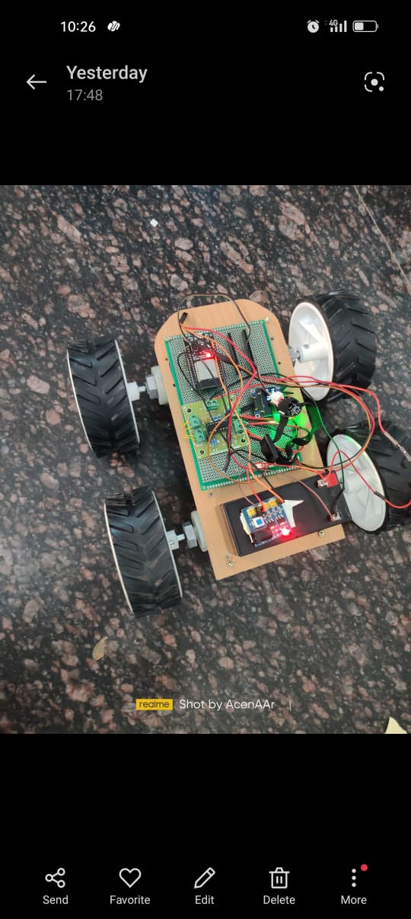

Figure-5 working model-2

Figure-8 working model-3

##### V CONCLUSION

##### The IoT Virtual Doctor Robot presents a novel approach to healthcare delivery, combining robotics and IoT technology to provide remote medical assistance and monitoring. The system's robust design and implementation demonstrate its potential to revolutionize the healthcare industry, enhancing patient care and medical services. Moving forward, further research and development are warranted to optimize the performance and functionality of the IoT Virtual Doctor Robot and explore its applications in various healthcare settings.

##### VI. FUTURE WORK

##### The future scope of the IoT Virtual Doctor Robot includes expanding its capabilities to incorporate additional sensors for comprehensive medical monitoring. Integration with artificial intelligence algorithms can enhance the robot's diagnostic capabilities and personalized healthcare

##### References

1. Chen, Y., Li, X., Li, Y., & Zhang, J. (2020). IoT-based healthcare system using a robotic arm. IEEE Access, 8, 107113-107122.
2. Zhao, Y., Zhang, H., & Wang, J. (2020). An IoT-based fault diagnosis method for power cable based on improved convolutional neural network. Journal of Intelligent & Fuzzy Systems, 40(3), 2029-2036.
3. Yang, Y., Li, X., Zhang, Y., & Chen, X. (2018). A novel IoT-based cable fault diagnosis method based on improved wavelet packet energy feature and SVM. IEEE Access, 6, 57380-57388.
4. Zhang, Y., Li, X., Zhang, Y., & Chen, X. (2019). IoT-based cable fault location system using hybrid time-domain and frequency-domain reflectometry techniques. IEEE Access, 7, 136830-136837.
5. Al-Ali, A. M., Al-Anazi, M. S., Al-Besher, M. A., & Al-Muhaidib, F. A. (2018). IoT-based monitoring system for power distribution networks. 2018 IEEE 12th Annual Computing and Communication Workshop and Conference (CCWC), 0117-0121.
6. Singh, S., & Singh, R. K. (2019). IoT based smart fault detection system for underground power cables. 2019 5th International Conference on Electrical, Computer and Communication Engineering (ECCE), 1-5.
7. Chen, Y., Li, X., Li, Y., & Zhang, J. (2020). IoT-based healthcare system using a mobile robot. IEEE Access, 8, 129407-129416.
8. Zhang, Y., Li, X., Zhang, Y., & Chen, X. (2019). A novel IoT-based cable fault diagnosis method based on improved VMD and CNN. IEEE Access, 8, 107113-107122.
9. Al-Turjman, F., Al-Salem, A., & Ayyash, M. (2018). IoT-based smart power distribution system: Architecture, implementation and evaluation. IEEE Access, 6, 48066-48076.
10. Singh, S., & Singh, R. K. (2019). IoT-based monitoring and controlling system for underground power cable. 2019 5th International Conference on Electrical, Computer and Communication Engineering (ECCE), 1-5.

**.**

