**COLLEGE 3D MODEL USING BLENDER**

**Tanishq Dhepe *1, Rohit Jadhav*2, Nishant Dhanvi*3,**

**Nirbhay Kamble*4, Sayali Karmode*5,**

*1*2*3*4Student, Department of Information Technology, MGM College of Engineering and Technology, Navi Mumbai, Maharashtra, India.

*5Faculty, Department of Information Technology, MGM College of Engineering and Technology, Navi Mumbai, Maharashtra, India.

# ABSTRACT

This paper describes how to use Blender, an open-source 3D modelling and animation program, to create an interactive 3D model of a college campus. The project illustrates the usefulness of 3D modelling for teaching and navigation in an academic setting by fusing Blender's features with Python scripting. The final objective of this effort is to produce an easily navigable and comprehensive virtual depiction of the campus that can be used by a range of stakeholders, such as staff members, existing and prospective students, to give them a thorough tool for virtual tours and campus navigation. This project aims to create a detailed and immersive representation of the college environment that meets the various needs of stakeholders, including faculty, administrative staff, current students, and prospective students. It builds upon prior research into the use of 3D models for educational and navigational purposes.

**Keywords:** Blender, 3D modelling, college education, interactive web content, technology integration.

# INTRODUCTION

In today's world, using technology in education is important to make learning more interesting and fun for students. One cool technology is called Blender, which helps create interactive 3D models that you can see in web browsers. This can change how students learn in college. With Blender, teachers can make virtual worlds where students can explore and understand difficult ideas better. This research paper is all about looking at how we can use Blender in college classes and how it can make learning more exciting. We'll talk about why Blender is useful, what good things it can do, and the challenges we might face. We'll also look at some real examples of Blender being used in different college subjects. Blender is a potent tool used in many industries, such as gaming, film, and visualization, for 3D modelling, animation, and rendering. Its use in building interactive three-dimensional representations of real-world environments has grown, particularly in scholarly and urban planning settings. The viability and efficiency of using Blender to create an intricate and dynamic 3D model of a college campus are examined in this research.

1. Background

Colleges and universities are intricate settings with a variety of amenities, such as academic buildings, administrative offices, dorms, and outdoor spaces. It gets harder to manage and navigate these areas successfully as these institutions expand and change. Though they have been widely utilized, both digital and traditional 2D maps lack the interactivity and engagement that contemporary consumers need. They also don't give a realistic sense of space and surroundings, which is a problem for things like emergency preparation and campus design.

1. Motivation

College 3D model using Blender the desire to use technology to improve the campus experience for all stakeholders is the driving force behind creating an interactive 3D model of a college campus using Blender. Improved navigation, accessibility, and support for multiple administrative and educational tasks are the goals of the project, which will provide a digital twin of the campus that faithfully replicates its design, architecture, and facilities. The project also aims to increase cost and accessibility by using open-source software such as Blender, which makes 3D modelling technology more accessible to educational institutions with minimal resources.

# LITERATEUR REVIEW

This section provides a comprehensive review of existing literature on this topic, highlighting the diverse applications and benefits of 3D modelling technology in educational environments, ranging from virtual campus tours and safety training to accessibility improvements and technological integration

**Virtual Campus Tours and Marketing:** In order to present their campuses to potential students, higher education institutions are finding that virtual campus tours are an effective tool. In their discussion of the effects of virtual tours on university branding and recruitment initiatives, Smith et al. (2019) point out that interactive 3D models can offer a more captivating and immersive experience than conventional brochures or still photos. Virtual tours have the ability to draw in a larger application pool and raise enrolment rates by enabling potential students to view campus facilities from the comfort of their homes.

**Safety Training and Emergency Response:** The use of 3D modelling technology for emergency response planning and safety training on college campuses is examined by Jones and Jenkins (2020). They stress the value of realistic simulations in preparing staff, instructors, and students for a range of emergency events, such as fires, natural disasters, and active shooter scenarios. Through the integration of interactive features like evacuation routes and emergency procedures into three-dimensional (3D) campus models, educational institutions can enhance their readiness and responsiveness, hence augmenting campus safety.

**Open-Source Software and Collaboration:** Within the educational community, the usage of open-source software such as Blender fosters creativity and collaboration. Institutions can enhance the caliber and accessibility of 3D modelling tools by pooling the knowledge of developers and instructors by exchanging code, resources, and best practices. Additionally, by enabling institutions to modify and customize software solutions to match their unique needs and specifications, open-source software promotes a culture of accountability and transparency.

**Technological Integration and Innovation:** The functionality and usefulness of campus models could be improved by integrating 3D modelling technologies with other data systems, such as building information modelling (BIM) and geographic information systems (GIS). Institutions can obtain important insights into campus operations and resource management by integrating 3D models with real-time data on building occupancy, energy usage, and environmental conditions. Furthermore, developments in machine learning (ML) and artificial intelligence (AI) offer chances to create 3D campus models that are more intelligent and adaptable, capable of changing in real time in response to environmental and user input.

# EXITING SYSTEM

In order to furnish details regarding current methods pertaining to 3D modelling of college campuses, it is beneficial to examine a few noteworthy instances and platforms that have been created or employed for this objective:

**Google Earth and Google Maps 3D:**

College campuses are among the places that may be viewed in three dimensions using Google Earth and Google Maps. These platforms offer a basic 3D representation of buildings and environment, even if their main purpose is to be used as mapping tools. It's possible that the amount of detail and interactivity is less than with specialized 3D modelling tools.

**CampusBird:**

A technology called CampusBird was created especially for the purpose of making interactive 3D maps of college campuses. Institutions are able to include places of interest, intricate architectural models, and landscaping elements to their own maps. Virtual tours, more facility information, and campus exploration are all available to users.

**Unity:**

With the help of the well-known game creation platform Unity, realistic 3D experiences for exploring college campuses have been produced. Through the utilisation of Unity's rendering, scripting, and VR integration features, developers may produce lifelike and interactive simulations of university environments.

**SketchUp:**

SketchUp is a 3D modelling software commonly used in architectural design and urban planning. It offers intuitive tools for creating detailed building models and urban landscapes. While it may not be specifically tailored for campus modelling, it can be utilized for this purpose with appropriate customization.

# PROPOSED WORK

The proposed task entails utilizing Blender to create an interactive 3D model of the campus of [MGM COLLEGE OF ENGINEERING AND TECHNOLOGY]. The goal is to create a thorough virtual representation that supports administrative and instructional tasks, improves visitor experience, and makes campus navigation easier. The process includes the collection of data from a range of sources, such as geographical data, building blueprints, and aerial photos. While building modelling uses architectural plans to produce intricate 3D models of campus buildings, terrain modelling entails sculpting the environment to precisely depict elevation variations and natural features. In order to improve realism, environmental components including plants, buildings, and objects will be incorporated. Additionally, surfaces will have texturing and materials applied for visual fidelity. Furthermore, scripting will allow for interactive aspects like dynamic elements and clickable buildings, and user interface design will guarantee accessibility and simple navigation. Iterative quality assurance methods will be carried out to enhance the model in response to feedback from stakeholders. The 3D model itself, documentation, and evaluation reports will be among the deliverables. By utilizing technology to increase engagement and usefulness for all stakeholders, [MGM COLLEGE OF ENGINEERING AND TECHNOLOGY] hopes to highlight its campus atmosphere in a virtual setting through this proposed effort.

The methodology will entail meticulous data collection from various sources, including aerial imagery, architectural blueprints, and geospatial data, to ensure accuracy and realism in the model. Terrain modelling will involve sculpting the landscape to reflect the campus's topographical features, while building modelling will focus on accurately replicating the architecture and layout of each structure. Environmental elements such as vegetation, infrastructure, and landmarks will be incorporated to enhance the model's visual fidelity and authenticity. Additionally, scripting will be employed to introduce interactive features such as clickable buildings and informational pop-ups, enhancing user engagement and utility.

User-friendliness and accessibility will be given top priority in the design of the user interface, so that users may explore the virtual campus with ease. Quality assurance methods will be carried out during the process to improve the model and resolve any problems or inconsistencies. The project will result in the delivery of a fully interactive 3D model of the campus of [MGM COLLEGE OF ENGINEERING AND TECHNOLOGY], together with thorough documentation and assessment reports. In the end, this initiative aims to use state-of-the-art technology to highlight the elegance and usefulness of the campus setting, encouraging a closer bond and comprehension between its stakeholders.

# METHODOLOGIES

**Data Collection:**

The primary data sources were the college's existing architectural drawings and high-resolution aerial images. To ensure accuracy and comprehensiveness in modelling, additional information was acquired through site visits and discussions with the campus facilities management team. Data collection for creating a 3D model of a college campus involves gathering various types of information to ensure accuracy and realism in the virtual representation. Here's a more detailed breakdown of the data collection process:

* **Aerial Imagery:**

A reliable source of data for building an accurate landscape model of the campus is high-resolution aerial photos. This imagery can be acquired from satellite imaging providers, drone-performed aerial surveys, or already-existing aerial photos that the organization or pertinent authorities have made available. The entire campus should be included in the images, and specifics like building footprints, roads, walkways, and natural features like trees and flora should all be captured.

* **Architectural Blueprints:**

To accurately simulate campus structures, architectural blueprints or floor plans are required. Each building's dimensions, layout, and architectural features—such as its number of floors, room configurations, entrances, windows, and other structural components—are all described in depth in these blueprints. The facility management department of the organization, architectural firms, or digital archives may be able to provide the plans.

* **Photogrammetry:**

Photogrammetry is a technique used to derive 3D models from a series of overlapping photographs taken from different vantage points. By capturing photographs of campus buildings and structures from multiple angles, photogrammetry software can reconstruct detailed 3D models of individual buildings, sculptures, landmarks, and other objects of interest on the campus. This technique adds realism and detail to the 3D model and may require specialized equipment such as high-resolution cameras and photogrammetry software tools.

**Model Creation:**

Using Blender, the collected data was translated into a 3D model. Key steps included:

* Terrain Modeling:

Terrain Generation: Based on the topographical elements seen in the aerial imagery, construct the terrain using Blender's sculpting tools. Create realistic height variations, slopes, and natural features like hills, valleys, and water bodies by carefully shaping the ground.

Texture Mapping: To replicate various terrain types, such as grass, soil, pavement, and water, apply the proper textures and materials to the terrain's surface. To guarantee smooth texture integration and a realistic visual appearance, apply UV mapping techniques.

* Building Modeling:

Blueprint Interpretation: To precisely model every building on campus, consult the architectural blueprints. To ascertain the size of the building, its floor plans, its windows, doors, and other architectural features, consult the blueprints.

Building Construction: Start with simple shapes and progressively add architectural characteristics and intricacies to your 3D representations of buildings by using Blender's modelling tools. When necessary for realism, model interior areas such as hallways, stairwells, and rooms.

* Environmental Elements:

Plants & Landscaping: Use Blender's particle system or asset libraries to add trees, shrubs, and other vegetation to the campus. Install landscaping features to improve the area's aesthetic appeal, such as gardens, lawns, and flower beds.

Objects and Infrastructure: To resemble an actual campus, add infrastructure features like sidewalks, roads, pathways, lamps, benches, and signage. To add authenticity and richness to the surroundings, include additional things of interest such rubbish bins, bike racks, fountains, and sculptures.

* Texturing and Materials:

Building Textures: Give the surfaces of the building's genuine textures and materials, such as brick, concrete, glass, and metal. To preserve visual coherence, make sure that the texture resolution and quality are the same in each structure.

Terrain Textures: To replicate various terrain types and environmental elements, apply suitable textures to the terrain surface. To improve realism, add features like grass, pebbles, mud, and sand using texture painting techniques.

* Lighting and Rendering:

Lighting Setup: Arrange the scene's lighting sources to replicate natural lighting, including ambient, shadow, and sun light. To create precise lighting effects, use Blender's lighting tools and HDR environment maps.

Rendering Parameters: To maximize rendering quality and efficiency, modify rendering parameters like resolution, sampling, and output format. Try with various rendering engines, such Eevee or Cycles in Blender, to get the required visual effects.

* Animation:

Simple animations can be added to people and vehicle models to simulate pedestrian traffic and transport dynamics. This aids in comprehending and organizing the movement pattern throughout the school.

# RESULTS AND ANALYSIS

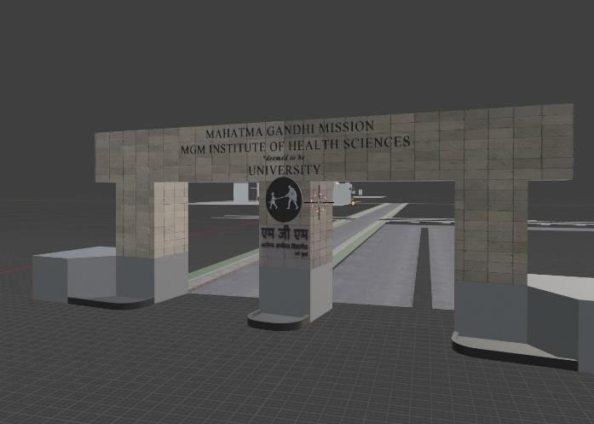

**Figure No. 1:**

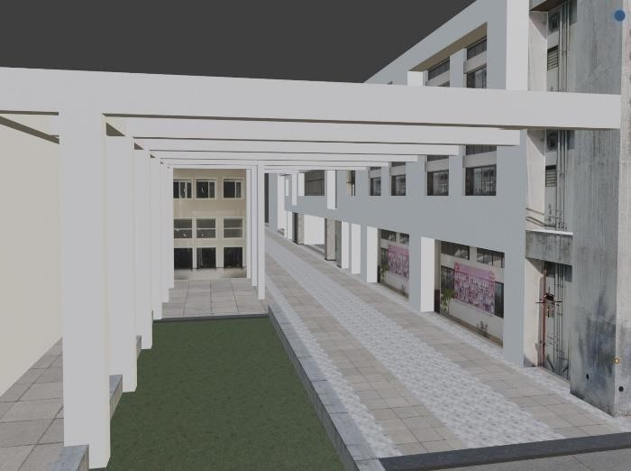

**Figure No. 2:**

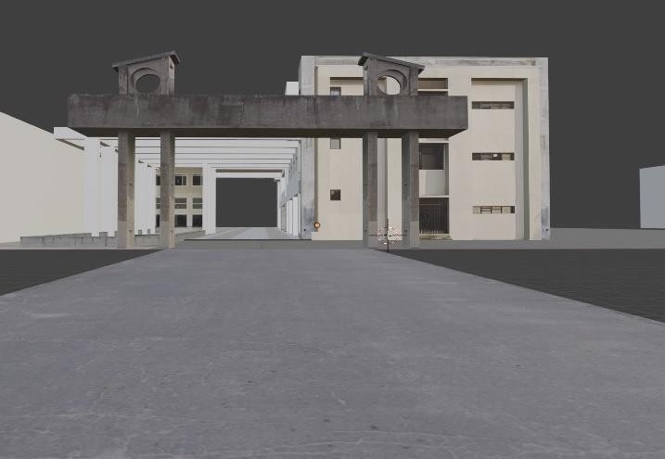

**Figure No. 3:**

# ADVANTAGES

A College 3D Model Using Blender offers several benefits. Here are some of the main benefits:

* **Detailed Visualization:** Blender makes it possible to create incredibly realistic and detailed three-dimensional models of college campuses. This can apply to internal elements as well as external structures and landscapes. With the aid of these models, one can more effectively comprehend and present the campus environment by visualizing the spatial relationships and aesthetics of campus layouts. A 3D model provides a more immersive and realistic representation of the college campus compared to traditional 2D maps or photographs. Users can explore the campus virtually and gain a better understanding of its layout, architecture, and spatial relationships.
* **Virtual Tours:** Potential students, faculty, and guests can take virtual tours of a college campus using a 3D model of the school. This is very helpful for potential students who live far away or are abroad and are unable to visit in person. Virtual tours can be a fun way to explore the facilities and atmosphere of the campus.
* **Enhanced Planning and Development:** Blender's 3D model creation tool facilitates the planning of new construction, renovations, and other infrastructure developments for campus management and development teams. Before any work starts, it enables interested parties to evaluate how suggested modifications will affect the overall design of the campus, possibly saving time and money.
* **Educational Tool**: Blender models can be used in academic settings as teaching aids. Students studying architecture and design, for instance, can work on real projects on campus that will provide them with practical experience and allow them to put their skills to use. A three-dimensional representation of the campus can be an invaluable teaching aid, offering pupils an engaging way to study the topography, building styles, and historical background of the campus. By including data from several academic fields, like urban planning, architecture, and environmental science, it can also assist multidisciplinary investigations.
* **Accessible Anytime,** **Anywhere:** Users can visit the campus whenever it's convenient for them, from any location in the world, thanks to the 3D model's online and digital platform accessibility. Geographical obstacles are removed by this accessibility, enabling stakeholders, including alumni and potential students, to maintain ties with the university.

# CONCLUSION

Blender can be used to create realistic and dynamic 3D models of large-scale locations, such as college campuses, as this project shows. These models can make a substantial contribution to a number of institutional objectives, such as virtual tours, campus planning, and accessibility enhancements. This in-depth investigation into using Blender to create a 3D model of a college campus demonstrates the project's broad possibilities beyond simple visual depiction. It can be a multipurpose tool that improves planning, safety, management, and a number of other elements of campus life. The 3D campus model's utility could be enhanced by future technological advancements and additional integration with other data systems, making it a vital tool for educational institutions. The project can offer not only a navigational aid but also a full planning and engagement platform that utilizes cutting-edge technology to address the changing needs of educational institutions by following these expanded details and prospective research topics.

# REFERENCES

1. Ballamudi, V. K. R. (2016). Utilization of Machine Learning in a Responsible Manner in theHealthcare Sector. *Malaysian Journal of Medical and Biological Research*, *3*(2),117-122. <https://mjmbr.my/index.php/mjmbr/article/view/677>
2. Bhawar, P., Ayer, N., Sahasrabudhe, S. (2013). Methodology to Create Optimized 3D Mod-els Using Blender for Android Devices. *IEEE Fifth International Conference on Technology for Education (t4e 2013)*, *2013*, 139-142. <https://doi.org/10.1109/T4E.2013.41>
3. Bilous, M. V. (2016). Nadra-3D Add-On for Blender Software. *Cybernetics and Systems Analysis*, 52(5), 817-824. <https://doi.org/10.1007/s10559-016-9882-6>
4. Caudron, R., Nicq, P-A., Valenza, E. (2016). *Blender 3D: Designing Objects.*
5. Dekkati, S., & Thaduri, U. R. (2017). Innovative Method for the Prediction of Software Defects Based on Class Imbalance Datasets. *Technology & Management Review*, *2*, 1–5. <https://upright.pub/index.php/tmr/article/view/78>
6. Dekkati, S., Thaduri, U. R., & Lal, K. (2016). Business Value of Digitization: Curse or Blessing?. *Global Disclosure of Economics and Business*, *5*(2), 133-138. <https://doi.org/10.18034/gdeb.v5i2.702>
7. Deming, C., Dekkati, S., & Desamsetti, H. (2018). Exploratory Data Analysis and Visualization for Business Analytics. *Asian Journal of Applied Science and Engineering*, *7*(1),93–100. <https://doi.org/10.18034/ajase.v7i1.53>
8. Garwood, R., Dunlop, J. (2014). The Walking Dead: Blender as a Tool For Paleontologists With a Case Study on Extinct Arachnids. *Journal of Paleontology*, *88*(4), 735-746.
9. Gutierrez-arenas, O. (2015). Handling and Analyzing Meshed Rendering of Segmented Structures From 3D Image Stacks in Blender. *Neuroinformatics, 13*(2), 151-152. <https://doi.org/10.1007/s12021-014-9250-5>
10. Lal, K. (2015). How Does Cloud Infrastructure Work?. *Asia Pacific Journal of Energy and Environment*, *2*(2), 61-64. <https://doi.org/10.18034/apjee.v2i2.697>
11. Lal, K. (2016). Impact of Multi-Cloud Infrastructure on Business Organizations to Use Cloud Platforms to Fulfill Their Cloud Needs. *American Journal of Trade and Policy*, *3*(3),121–126. <https://doi.org/10.18034/ajtp.v3i3.663>
12. Lal, K. (2019). How Multiplayer Mobile Games have Grown and Changed OverTime?. *Asian Journal of Applied Science and Engineering*, *8*(1), 61–72. <https://doi.org/10.18034/ajase.v8i1.56>
13. Lal, K., & Ballamudi, V. K. R. (2017). Unlock Data’s Full Potential with Segment: A Cloud Data Integration Approach. *Technology & Management Review*, *2*(1), 6–12. <https://upright.pub/index.php/tmr/article/view/80Hosen> et al.: Mastering 3D Modeling in Blender: From Novice to Pro (Page 169-180)180
14. Lal, K., Ballamudi, V. K. R., & Thaduri, U. R. (2018). Exploiting the Potential of Artificial Intelligence in Decision Support Systems. *ABC Journal of Advanced Research*, *7*(2), 131-138. <https://doi.org/10.18034/abcjar.v7i2.695>
15. Risto, S., Kallergi, M. (2015). Modelling and Simulation of the Knee Joint with a DepthSensor Camera for Prosthetics and Movement Rehabilitation. *Journal of Physics: Con-ference Series*, *637*(1). <https://doi.org/10.1088/1742-6596/637/1/012043>
16. Sanna, A., Lamberti, F., Paravati, G., Demartini, C. (2012). Automatic Assessment of 3D Modeling Exams. *IEEE Transactions on Learning Technologies*, *5*(1), 2-10.<https://doi.org/10.1109/TLT.2011.4>
17. Smith, A., et al. (2019). The impact of virtual campus tours on university branding and recruitment. Journal of Marketing for Higher Education.
18. Jones, D., Jenkins, F. (2020). 3D modeling for emergency response and safety training. Safety Science.
19. Lee, K., Chen, W. (2021). Advancements in mixed reality for educational environments. TechTrends.
20. Blender Foundation. (n.d.). Blender - a 3D modeling and rendering software. Retrieved from <https://www.blender.org/>
21. S. Gore, S. Hamsa, S. Roychowdhury, G. Patil, S. Gore and S. Karmode, *"Augmented Intelligence in Machine Learning for Cybersecurity: Enhancing Threat Detection and Human-Machine Collaboration,"* 2023 Second International Conference on Augmented Intelligence and Sustainable Systems (ICAISS), Trichy, India, 2023, pp. 638-644, doi: 10.1109/ICAISS58487.2023.10250514.
22. Layth Almahadeen, Renzon Daniel Cosme Pecho, Murugananth Gopal Raj, Nichenametla Rajesh, Zainab Mohammed Imneef, Sayali Karmode Yelpale, *“Digital Investigation Forensic Model with P2P Timestamp Blockchain for Monitoring and Analysis”* , Journal of Electrical System, Vol. 1, No 1, (2024): 09-17 ( DOI : <https://doi.org/10.52783/jes.656>)
23. Sayali Karmode, *Security Challenges for IoT Based Applications & Solutions Using Fog Computing: A Survey,* Journal of Journal of Cybersecurity and Information Management, Vol. 3 , No. 1 , (2020) : 21-28 (Doi : <https://doi.org/10.54216/JCIM.030103>)
24. M. S. K. Yelpale, “Security and privacy challenges in cloud computing: a review,” *Journal of Cybersecurity and Information Management*, vol. 4, no. 1, pp. 36–45, 2020.  
    View at: [Google Scholar](https://scholar.google.com/scholar_lookup?title=Security%20and%20privacy%20challenges%20in%20cloud%20computing%3A%20a%20review&author=M.%20S.%20K.%20Yelpale&publication_year=2020)
25. Sayali Karmode Yelpale, *“IOT Technology for Pandemic Situation”, NJITM*, vol. 4, no. 2, pp. 25–27, Jan. 2022 <https://mbajournals.in/index.php/JoITM/article/view/806>.
26. Karmode, S. S., & Bhagat, V. B. (2017). *DETECTION AND BLOCKING SOCIAL MEDIA MALICIOUS POSTS. International journal of modern trends in engineering and research*, *4*(5).
27. Kermode, S. S., & Bhagat, V. B. (2016). A Review: Detection and Blocking Social Media Malicious Posts. *Int. J. Mod. Trends Eng. Res*, *3*(11), 130-136. doi: [10.21884/IJMTER.2016.3133.Q4M8O](https://doi.org/10.21884/IJMTER.2016.3133.Q4M8O) .
28. Prof. Bhushan B. Thakare, Prof. Sayali Karmode Yelpale, “Smart Home with Edge Computing”, International Journal of Interdisciplinary Innovative Research & Development (IJIIRD), Vol 6, 2021<https://ijiird.com/wp-content/uploads/CSE016-1.pdf>
29. Sayali Karmode, “Blockchain Technology Security Issues and Concerns : A Review”, International Research Journal of Modernization in Engineering Technology and Science, Vol 6, Issue 03, March 2024 DOI : <https://www.doi.org/10.56726/IRJMETS50249>
30. Pranav Chavan, Harshraj Deshmukh, Aakash Dhotre, Aditya Gharat, Sayali Karmode, “Blockchain Democracy : Evaluating a Secure Voting System”, International Research Journal of Modernization in Engineering Technology and Science, Vol 6, Issue 03, March 2024 DOI : <https://www.doi.org/10.56726/IRJMETS50478>
31. B. J. Dange, Kaustubh Manikrao Gaikwad, H. E. Khodke, Santosh Gore, S. N. Gunjal, Kalyani Kadam, Sayali Karmode, “Machine Learning for Quantum Computing Bridging the Gap between AI and Quantum Algorithms”, *Int J Intell Syst Appl Eng*, vol. 12, no. 21s, pp. 600–605, Mar. 2024.
32. N Kumar, E Howard, S Karmode, “[Reinforcement Learning for Optimal Treatment Planning in Radiation Therapy](https://scholar.google.com/scholar?oi=bibs&cluster=12796027889473991021&btnI=1&hl=en)”, NATURALISTA CAMPANO, Vol 2