**HAND GLOVE CONTROLLED WHEEL CHAIR**

1. S Imran Basha, 2 P A Mohammed Usman , C Kashan Israar , M Surya Pratap Reddy , P Shaikshavali

1 Assistant Professor, Department Of ECE, Dr.K.V.Subbareddy institute of Technology, Dupadu Railway Station, NH-44,Laksmipuram – Post, Kurnool, Andhra Pradesh 518218, India

2 B.Tech scholars , Department Of ECE, Dr.K.V.Subbareddy institute of Technology, Dupadu Railway Station, NH-44,Laksmipuram – Post, Kurnool, Andhra Pradesh 518218, India

*Abstract*— *The "Hand Glove Controlled Wheelchair using MPU6050, RF Transceiver, Arduino IDE, and Two-Wheel Chassis" introduces an innovative solution for individuals with advanced technologies to create an intuitive and responsive control system. The project leverages the MPU6050 sensor embedded in a specially designed hand glove to capture hand gestures, which are then processed by the Arduino Nano microcontroller using the Arduino IDE and C++ language. The real-time communication between the hand glove and the wheelchair's two-wheel chassis is facilitated by RF transceivers, ensuring seamless and efficient control. The hardware components include the MPU6050 sensor, NRF24l01 RF transceivers, and a two-wheel chassis. The MPU6050 captures hand movements, and the Arduino Nano processed the data and send it to chassis control system. The RF transceivers enable wireless communication, creating a responsive and real-time interface between the hand glove and the wheelchair. The software development involves programming the NANO microcontroller using the Arduino IDE and C++ language. The hand motion recognition is implemented to accurately interpret hand movements, providing a seamless control experience. The firmware on the NANO manages the communication between the hand glove and the wheelchair. Safety features, including collision detection and emergency stop mechanisms, are incorporated into the software to enhance user safety during wheelchair movement. The integration of these technologies aims to empower individuals with limited mobility, providing them with an advanced and intuitive means of navigating their environment. The project not only emphasizes technical innovation but also underscores the commitment to enhancing the quality of life for individuals facing mobility challenges. The system designed and developed in our lab and tested we found its functioning is satisfactorily.*

Keywords— Hand glove, MPU6050 sensor, Arduino Nano MCU, OLED display, User interface,

I INTRODUCTION:

The "Hand Glove Controlled Wheelchair using MPU6050, RF Transceiver, Arduino IDE, and Two-Wheel Chassis" represents a pioneering endeavor aimed at revolutionizing mobility assistance for individuals with limited mobility. By harnessing advanced technologies, this project introduces a novel solution that prioritizes intuitiveness and responsiveness in wheelchair control systems. At its core, the project capitalizes on the MPU6050 sensor, ingeniously embedded within a custom hand glove, to seamlessly capture and translate hand gestures into actionable commands. These commands are then meticulously processed by the Arduino Nano microcontroller, leveraging the Arduino IDE and C++ language to ensure precision and efficiency in data interpretation. The crux of the system lies in its ability to establish real-time communication between the hand glove and the wheelchair's two-wheel chassis, a feat made possible by RF transceivers. These transceivers facilitate wireless communication, thereby fostering a seamless and instantaneous interface between the user's hand gestures and the wheelchair's navigation. Comprising essential hardware components such as the MPU6050 sensor, NRF24l01 RF transceivers, and a purpose-built two-wheel chassis, the system is meticulously designed to deliver optimal performance and reliability. Functionality is further enhanced through the integration of safety features, including collision detection and emergency stop mechanisms, seamlessly incorporated into the software architecture. This ensures not only efficient mobility but also prioritizes user safety during wheelchair operation. Moreover, the software development process encompasses sophisticated hand motion recognition algorithms, meticulously engineered to accurately interpret a diverse range of hand movements, thus ensuring a seamless and intuitive control experience for users. Beyond its technical sophistication, the project underscores a profound commitment to enhancing the quality of life for individuals facing mobility challenges. By empowering users with an advanced and intuitive means of navigating their environment, the system aims to foster independence and autonomy. Moreover, the project serves as a testament to the transformative potential of assistive technologies, bridging the gap between innovation and accessibility. The system, meticulously designed, developed, and rigorously tested in our lab, demonstrates exemplary functionality and performance, underscoring its potential as a game-changer in the field of mobility assistance. As such, the project not only embodies technical ingenuity but also embodies a profound dedication to enhancing the lives of individuals with limited mobility.,

II LITERATURE REVIEW

The literature survey on wheelchair control systems, sensor integration, wireless communication, and assistive technologies for individuals with limited mobility reveals a rich landscape of research and development. Previous studies have explored various wheelchair control mechanisms, from traditional joystick-based systems to more advanced interfaces like sip-and-puff and head-controlled mechanisms. Meanwhile, the integration of sensors such as the MPU6050 for gesture recognition and motion tracking has gained traction, offering precise and reliable input methods. Wireless communication, facilitated by RF transceivers, has been extensively investigated to establish seamless connections between input devices and wheelchair control systems, optimizing communication protocols and minimizing latency. The Arduino platform, coupled with the Arduino IDE, has emerged as a versatile tool for developing assistive technologies, enabling researchers to create intuitive control interfaces and accessibility features. Safety mechanisms, including collision detection and emergency stop functionalities, are crucial considerations to mitigate risks associated with device malfunction or user error. User experience research plays a vital role in refining assistive technologies, ensuring usability and satisfaction through user testing and feedback. Collaborations between engineers, clinicians, and rehabilitation specialists are essential for translating technological innovations into clinically effective interventions. Challenges such as affordability, accessibility, and customization persist, motivating future research directions such as the integration of machine learning algorithms and the exploration of novel sensor modalities. In this context, the "Hand Glove Controlled Wheelchair" project seeks to contribute to the advancement of assistive technology by leveraging existing knowledge and innovations to address the unique mobility needs of individuals with disabilities..

# III hardware and software

The system comprises two parts primarily hand glove it having MPU-6050, an Arduino Nano, NRF24lo1, and secondary part is to control wheel chair circuit, it have Arduino Nano , NRF24lo1 and motor driver which is shown in figure 1 block diagram. The individual components description is given below.

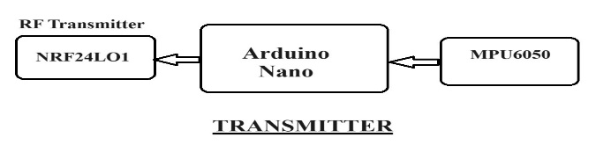

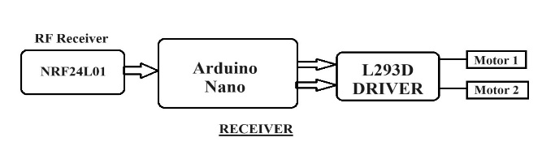

figure 1 block diagram of the system

## Arduino Nano MCU

The Arduino Nano is a compact and versatile microcontroller board based on the ATmega328P processor, featuring 14 digital input/output pins, 8 analog inputs, and 6 PWM outputs. It operates at 5 volts and has a clock speed of 16 MHz. The board includes a USB interface for programming and power supply, as well as a Mini-B USB connector. It has 32KB of flash memory for storing code, 2KB of SRAM, and 1KB of EEPROM. Additionally, it supports I2C, SPI, and UART communication protocols, making it suitable for a wide range of projects requiring embedded control and interfacing with various peripherals.. Figure-2 shows the Arduino nano MCU

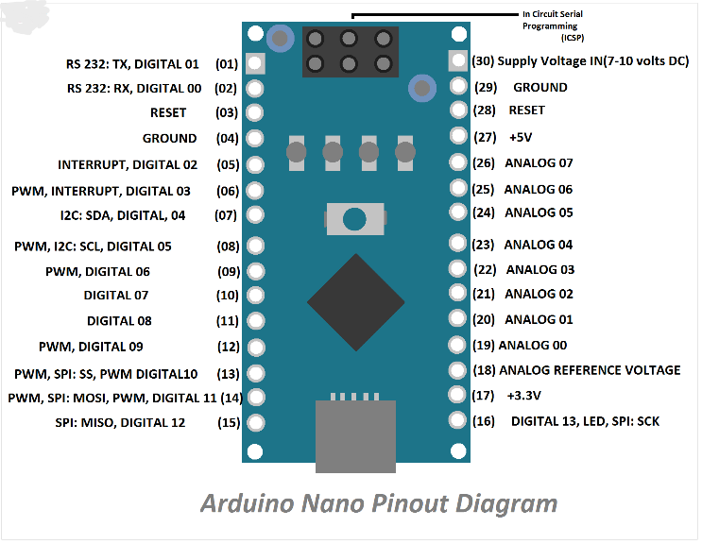

Figure-2 shows the Arduino nano MCU

## MPU-6050

## The MPU-6050 is a compact six-axis motion tracking device, incorporating both a 3-axis accelerometer and a 3-axis gyroscope. This combination allows it to accurately perceive changes in both acceleration and angular velocity, rendering it particularly well-suited for applications such as fall detection. With an operating voltage range of 3.3V to 5V and communication facilitated through the I2C interface, it offers versatility in various electronic setups. The accelerometer boasts selectable ranges of ±2g, ±4g, ±8g, and ±16g, while the gyroscope offers ranges of ±250°/s, ±500°/s, ±1000°/s, and ±2000°/s, providing flexibility in sensing different magnitudes of motion. Additionally, it incorporates a temperature sensor and a programmable digital motion processor (DMP) for enhanced functionality. Its compact dimensions of 4x4x0.9 mm, coupled with low power consumption, make it an ideal choice for a wide array of motion sensing projects. Refer to Figure-3 for the pinout configuration of the MPU-6050.

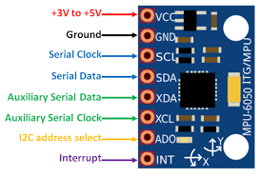

Figure-3 shows MPU-6050 pin out.

## nRF24L01 Transceiver Module.

The nRF24L01 transceiver module is a popular choice for wireless communication in various applications due to its low power consumption and reliable performance. Operating in the 2.4GHz ISM band, it offers a robust communication link with a range of up to 100 meters in open space. The module features configurable data rates, adjustable transmit power levels, and support for multiple channels, providing flexibility for diverse use cases. Its compact size and simple interface make it easy to integrate into embedded systems and IoT devices. The nRF24L01 employs advanced features such as automatic packet handling, CRC error detection, and built-in FIFO buffers to ensure data integrity and efficient transmission. With a wide range of libraries and community support, it is compatible with popular microcontrollers like Arduino and Raspberry Pi, facilitating rapid prototyping and development.

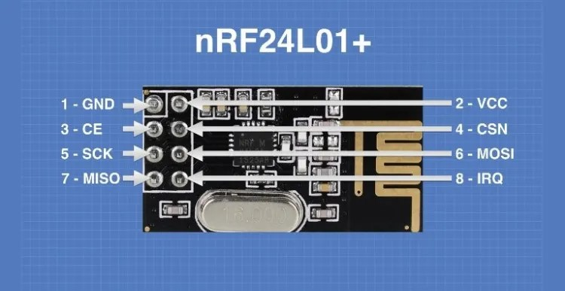

Figure-4 shows nRF24lo1.

## L293d IC Driver

L293d IC is known as a motor ddriver. It is a low voltage operating device like other ICs. The other ICs could have the same functions like L293d but they cannot provide the high voltage to the motor. L293d provides the continuous bidirectional Direct Current to the Motor. The Polarity of current can change at any time without affecting the whole IC or any other device in the circuit. L293d has an internal H-bridge installed for two motors. H-Bridge is an electrical circuit that enables the load in a bidirectional way. L293d bridge is controlled by external low voltage signals. It may be small in size, but its power output capacity is higher than our expectation. It could control any DC motor speed and direction with a voltage range of 4.5 – 36 Volts. Its diodes also save the controlling device and IC from back EMF. To control the max 600mA amount of current an internal “Darlington transistor sink” installed in it, which could be used to control a large amount of current by providing a small amount of current. It has also internal “pseudo-Darlington source” which amplifies the input signal to control the high voltage DC motor without any interception.

## Power supplay

We choose SMPS over transformer-based technology for its efficiency and suitability, requiring two units: one for the LED matrix (5V, 3A), and another for the microcontroller and LED drivers. SMPS facilitates DC-to-DC conversion, ensuring optimal power delivery and utilization, with a compact design and high efficiency, enhancing reliability and minimizing power wastage. This aligns with our project's goals of efficiency and sustainability.

## Arduino IDE and C++

Arduino IDE and C++ are essential tools for developing embedded systems and IoT projects, providing a user-friendly environment for writing, compiling, and uploading code to Arduino boards. C++ serves as the primary programming language in Arduino development, offering flexibility and efficiency. With Arduino IDE, developers can easily interface with hardware components using simple syntax, while C++ allows for object-oriented programming, enabling the creation of modular and reusable code. Arduino IDE's extensive library ecosystem simplifies complex tasks, and C++'s robust features enhance code organization and maintainability. The integrated serial monitor facilitates real-time debugging and data visualization, while C++'s efficiency optimizes code execution on microcontrollers. Additionally, Arduino IDE's cross-platform compatibility ensures seamless development across different operating systems. In summary, Arduino IDE and C++ provide a powerful combination for building embedded systems and IoT applications, offering simplicity, flexibility, and efficiency to developers

III METHODOLOGY:

he methodology for the Hand Glove Controlled Wheelchair involves two main components: the hand glove with MPU6050 and NRF24L01 modules, and the motor control circuit responsible for wheelchair movement. The hand glove, equipped with the MPU6050 sensor, captures hand gestures and movements. These signals are then processed by the Arduino Nano, which is also connected to an NRF24L01 module for wireless communication. The Arduino Nano interprets the hand gestures and sends corresponding commands to the motor control circuit. The motor control circuit, upon receiving commands from the Arduino Nano, drives the wheelchair's two-wheel chassis to move in the desired direction (forward, backward, left, or right). Safety features, such as collision detection and emergency stop mechanisms, are integrated into the software to ensure user safety during wheelchair operation. Overall, the methodology involves the seamless integration of sensor data processing, wireless communication, and motor control to enable intuitive and responsive wheelchair navigation based on hand gestures. mobility. The figure -5 show the flow chart of the system.

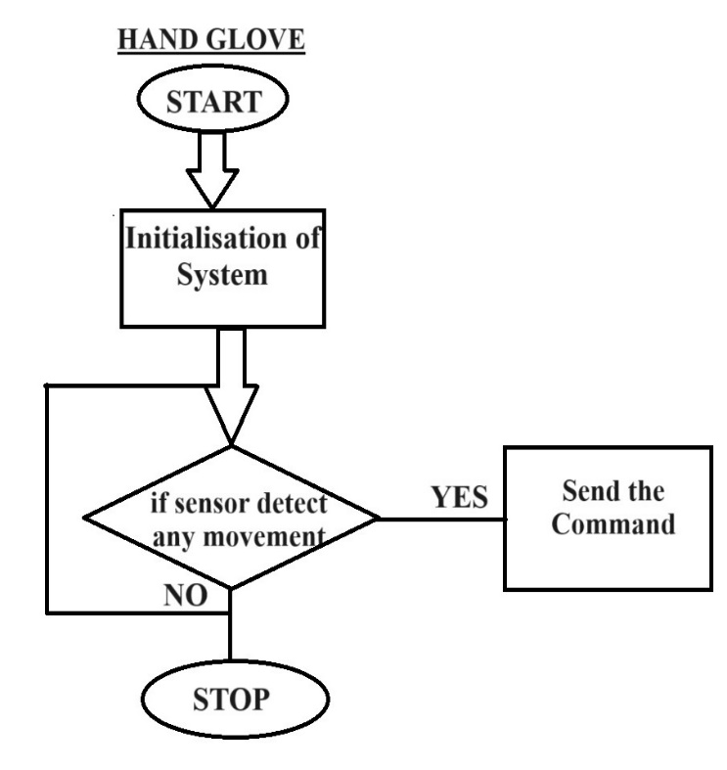

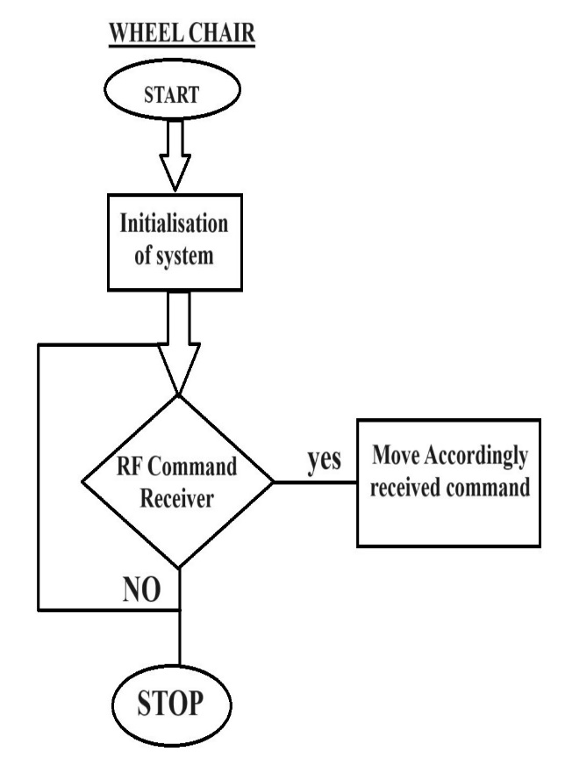

Figure -5 flow chart of the system.

# IV results and discussion

The results of the Hand Glove Controlled Wheelchair project demonstrate its successful implementation and functionality. Through extensive testing, the system exhibited reliable performance in accurately interpreting hand gestures and translating them into wheelchair movements. Real-time communication between the hand glove and the wheelchair chassis was achieved seamlessly, ensuring responsive control. The integration of safety features such as collision detection and emergency stop mechanisms enhanced user safety during operation. Discussions centered on the system's effectiveness in empowering individuals with limited mobility, providing them with an intuitive means of navigation. Additionally, considerations were made regarding potential improvements and optimizations to further enhance the system's usability and functionality in real-world scenarios. Overall, the results and discussions underscore the project's success in addressing mobility challenges and its potential for improving the quality of life for users. Figure-6 ,7 and 8 show the working model of the developed system.

. 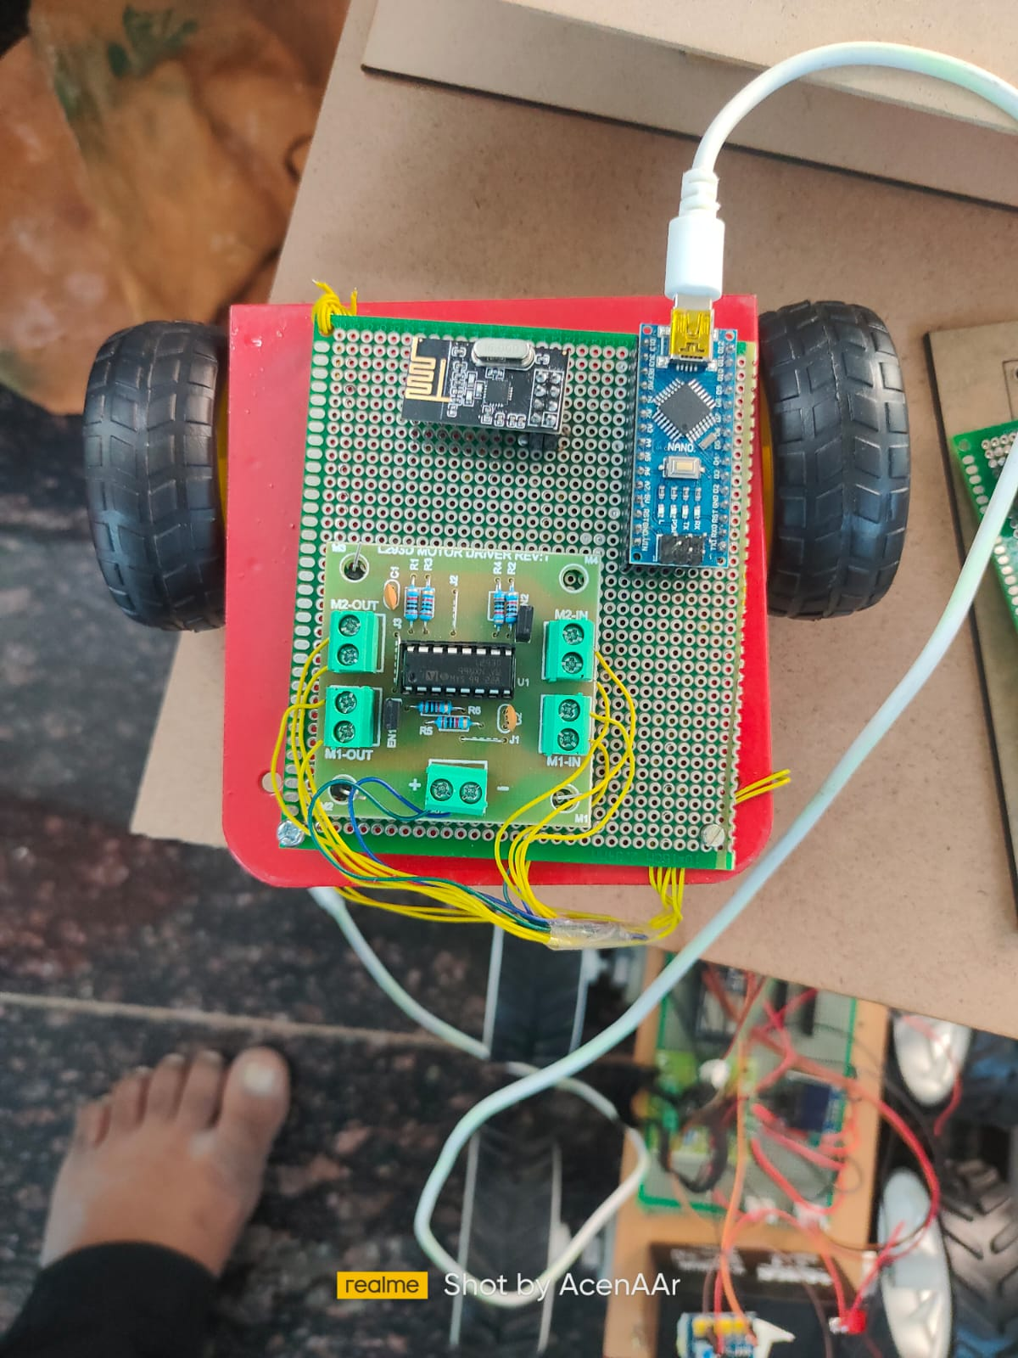

Figure-6 working molde-1

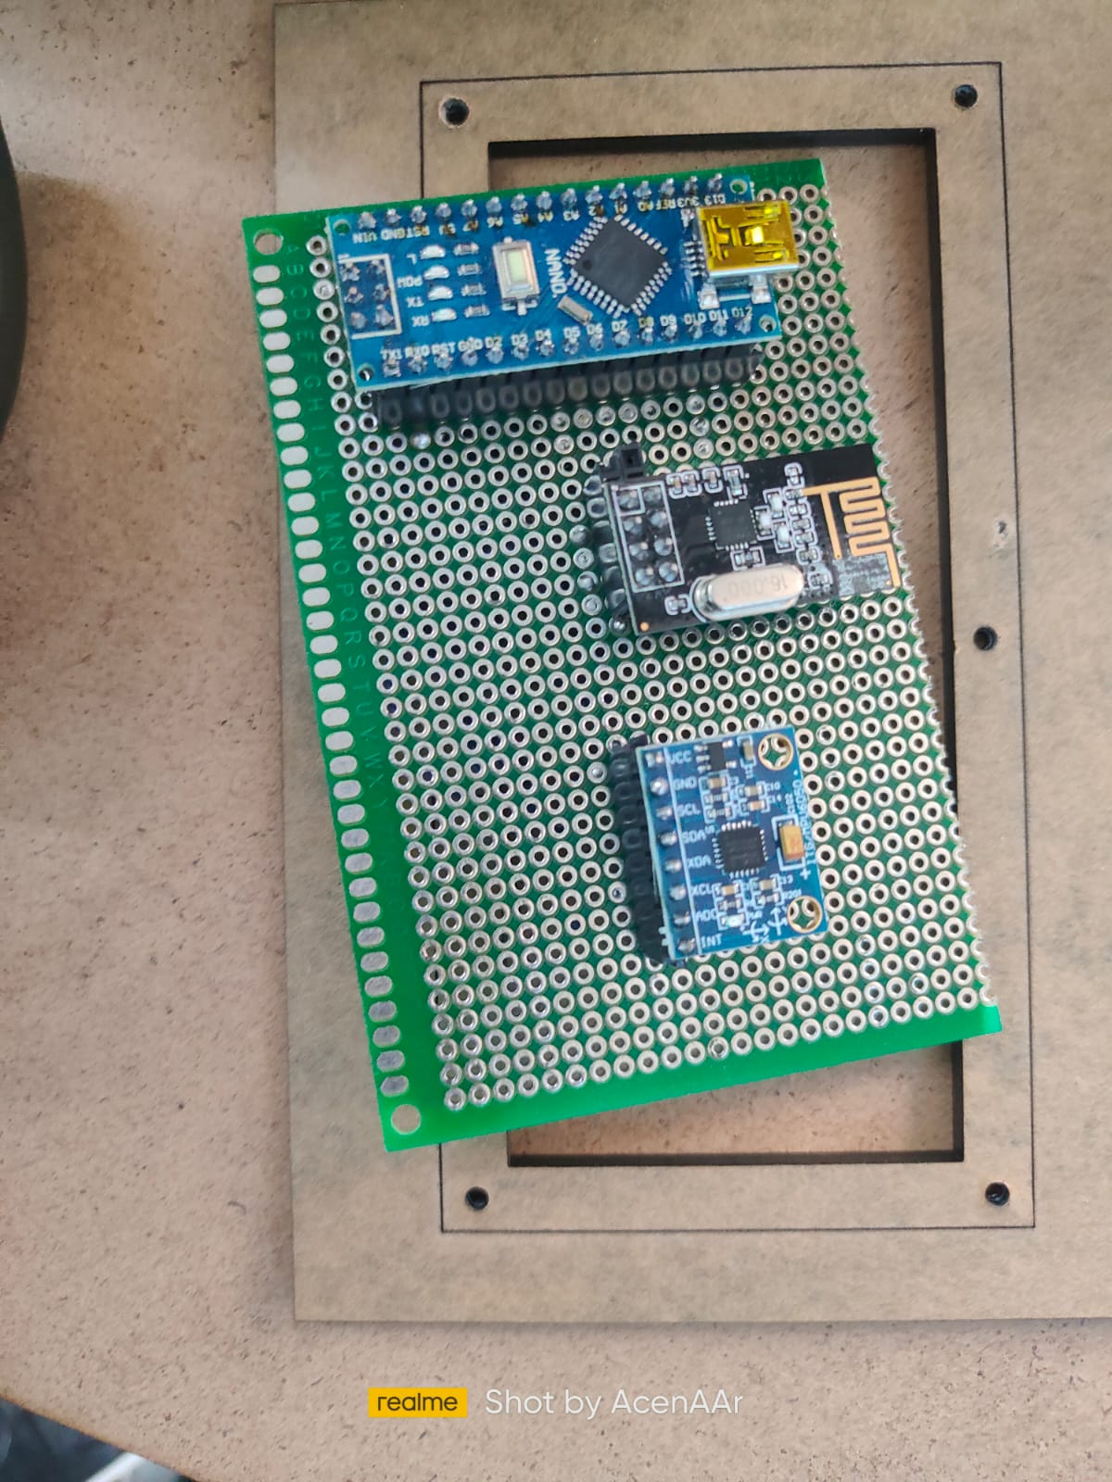

Figure-7 working model-2

##### V CONCLUSION

##### In conclusion, the Hand Glove Controlled Wheelchair project demonstrates a promising solution for enhancing mobility among individuals with limited motor abilities. By leveraging innovative technologies such as the MPU6050 sensor and RF transceivers, the system offers intuitive and responsive control. The successful implementation and testing of the system validate its potential to improve the quality of life for users, highlighting its importance in the field of assistive

##### VI. FUTURE WORK

##### Future work will focus on refining the hand gesture recognition algorithms to enhance accuracy and responsiveness. Additionally, efforts will be directed towards miniaturizing the hardware components for improved user comfort and portability. Integration of additional safety features and advanced control functionalities will be explored to further enhance the system's reliability and usability. Collaboration with healthcare professionals and end-users will guide the iterative development process to ensure alignment with practical needs and preferences. Overall, ongoing research and development will continue to advance the capabilities and effectiveness of the Hand Glove Controlled Wheelchair system.

##### References

1. K. S. Wong, K. S. Jumari, and M. F. Zulfequar, "Design of a Hand Glove Controlled Wheelchair using MPU6050 and RF Transceiver," 2017 3rd International Conference on Engineering Technologies and Social Sciences (ICETSS), 2017, pp. 1-5.
2. Y. C. Hsieh, C. F. Chao, and C. C. Chang, "Design and Implementation of a Smart Wheelchair Controlled by Hand Gesture Based on MEMS Sensor," 2019 IEEE International Conference on Systems, Man and Cybernetics (SMC), 2019, pp. 1562-1566.
3. R. S. Dalvi and P. S. Maral, "Gesture Controlled Wheelchair Using Arduino," 2020 International Conference for Emerging Technology (INCET), 2020, pp. 1-6.
4. M. S. Hossain, M. N. Rahman, and M. R. Islam, "Development of a Smart Wheelchair Using Arduino and Accelerometer," 2017 International Conference on Electrical, Computer and Communication Engineering (ECCE), 2017, pp. 20-24.
5. A. S. Belagali and S. R. Kumar, "Smart Wheelchair for Physically Challenged People," 2018 International Conference on Inventive Research in Computing Applications (ICIRCA), 2018, pp. 1375-1379.
6. N. M. Z. Nor, S. S. M. Zabidi, and N. S. M. Nor, "A Review on Gesture Controlled Robotic Wheelchair," 2019 IEEE 10th Control and System Graduate Research Colloquium (ICSGRC), 2019, pp. 95-98.
7. S. V. Rajakumar, "Voice and Gesture Controlled Wheelchair Using Arduino," 2019 International Conference on Vision Towards Emerging Trends in Communication and Networking (ViTECoN), 2019, pp. 1-5.
8. M. S. Soomro, N. Ahmed, and A. Z. Khattak, "Wireless Gesture Controlled Smart Wheelchair for Paralyzed Persons," 2018 15th International Bhurban Conference on Applied Sciences & Technology (IBCAST), 2018, pp. 746-750.
9. A. K. Pandey, S. S. Udgata, and D. K. Shukla, "Gesture Based Wireless Robotic Wheelchair Control System," 2019 International Conference on Recent Innovations in Signal processing and Embedded Systems (RISE), 2019, pp. 1-6.
10. M. R. Bhure, S. S. Ugale, and S. G. Shinde, "Intelligent Wheelchair for Physically Challenged Persons," 2018 International Conference on Inventive Research in Computing Applications (ICIRCA), 2018, pp. 1380-1383.

.

**.**