IoT based Underground cable fault detetction system

1 B.Venkatarami reddy, A.Veera Shankar reddy, C.Jaswanth , S.V.Sujith kumar ,R.Lakshman

2 B.Tech scholars , Department Of ECE, Dr.K.V.Subbareddy institute of Technology, Dupadu Railway Station, NH-44,Laksmipuram – Post, Kurnool, Andhra Pradesh 518218, India

[venkataramireddybolli@gmail.com](mailto:venkataramireddybolli@gmail.com)

*Abstract*— *This project introduces an novel solution for detecting faults in underground cables through an IoT-based system. The core components include the ESP32 microcontroller, TFT1.8 colour display, and a buzzer. The system aims to enhance the efficiency of cable fault detection by leveraging IoT technology. The ESP32 microcontroller acts as the central processing unit, responsible for data acquisition, analysis, and communication. Equipped with built-in Wi-Fi capabilities, the ESP32 enables seamless connectivity to the internet, facilitating remote monitoring and control. The TFT1.8 colour display serves as the user interface, providing real-time visualization of the cable's status. Through graphical representations and status indicators. And further same information also send to Blynk App. There by one can access the system from a remote location. For software development we used C++ language in Arduino IDE, Blynk App used as IoT cloud platform. This visual feedback enhances the system's user-friendliness and ensures prompt decision-making by maintenance personnel. To complement the visual feedback, a buzzer is integrated into the system. The buzzer produces audible alerts in the presence of a cable fault, ensuring that faults are not only visually identified but also promptly brought to the attention of maintenance personnel, even in environments where visual monitoring might be challenging. The theory behind the system involves the utilization of the ESP32's capabilities for fault detection, and communication through IoT protocols. The system operates by monitoring variations in cable parameters such as voltage pass through. Deviations from normal values are indicative of a fault, triggering the ESP32 to communicate the information to a centralized monitoring system. This IoT-based underground cable fault detection system aims to significantly reduce downtime and enhance the efficiency of maintenance operations. By providing real-time data visualization and audible alerts, the system ensures timely and targeted responses to cable faults, ultimately contributing to the reliability and longevity of underground cable networks. The system developed and tested in our laboratory and found system performance is good.*

Keywords— IoT module, ESP32, TFT display,.

INTRODUCTION :

Underground cable networks are a vital infrastructure that supports various essential services, including power distribution, communication, and transportation. These networks are complex and susceptible to faults, which can result in significant disruptions and maintenance costs. Timely detection and identification of faults in underground cable networks are crucial to minimizing downtime, ensuring network reliability, and reducing maintenance expenses. Traditional cable fault detection methods are often manual, time-consuming, and require significant resources, making them less efficient and less reliable. To address these challenges, this paper proposes an IoT-based underground cable fault detection system that enhances the efficiency of cable fault detection, enabling real-time monitoring and prompt decision-making by maintenance personnel. By leveraging IoT technology, the proposed system provides a cost-effective, reliable, and efficient solution for cable fault detection, monitoring, and analysis. The system is designed to detect faults in real-time, identify their location, and provide maintenance personnel with accurate and timely information, enabling them to take prompt action and minimize network disruptions. The proposed system consists of several components, including the ESP-32 microcontroller, TFT1.8 colour display, buzzer, and Blynk App. The ESP-32 microcontroller is the central processing unit that acquires, analyses, and communicates the data. The TFT1.8 colour display provides a user interface that visualizes the cable's status in real-time, while the buzzer produces audible alerts in the presence of a fault. The Blynk App enables remote monitoring and control, allowing maintenance personnel to access the system from any location, reducing response times, and increasing efficiency. This paper presents the system's design, implementation, and testing, demonstrating its effectiveness and reliability. The proposed system can significantly enhance the efficiency of cable fault detection and monitoring, reducing downtime, maintenance costs, and improving network reliability.[1-4]

II LITERATURE REVIEW

The development and implementation of IoT-based systems for cable fault detection have been a subject of interest for researchers in recent years. According to a study by Singh and Singh (2019), IoT-based smart fault detection systems can significantly enhance the efficiency of underground power cable fault detection. The proposed system in the study used IoT sensors to monitor the voltage, current, and temperature of the cables and transmitted the data to a cloud server for analysis. The system was found to provide accurate and timely fault detection, reducing downtime and maintenance costs (Singh & Singh, 2019). In addition, Al-Ali et al. (2018) proposed an IoT-based monitoring system for power distribution networks. The system used IoT sensors to monitor various parameters, including voltage, current, and temperature, and transmitted the data to a central monitoring station. The system was found to provide real-time monitoring and fault detection, improving network reliability and reducing maintenance costs. The study also highlighted the potential of IoT-based systems for predictive maintenance, enabling maintenance personnel to take proactive measures to prevent cable faults (Al-Ali et al., 2018). Moreover, another study by Zhang et al. (2019) proposed an IoT-based cable fault location system. The system used a hybrid approach, combining time-domain reflectometry (TDR) and frequency-domain reflectometry (FDR) techniques, to locate cable faults accurately. The system was found to provide high accuracy and reliability, reducing the time and cost associated with traditional cable fault location methods (Zhang et al., 2019).

Furthermore, a study by Chen et al. (2020) proposed an IoT-based cable fault diagnosis system. The system used machine learning algorithms to diagnose cable faults based on the data collected from IoT sensors. The study found that the system could accurately diagnose cable faults, enabling maintenance personnel to take prompt action and minimize network disruptions.

In conclusion, IoT-based systems have shown significant potential in enhancing the efficiency and accuracy of cable fault detection, monitoring, and analysis. The studies discussed in this literature survey have highlighted the advantages of IoT-based systems, including real-time monitoring, predictive maintenance, and accurate fault detection and diagnosis.[5-10]

# hardware and software

The block diagram of the IoT-based underground cable fault detection system is shown in Figure 1. The ESP-32 microcontroller acts as the central processing unit, responsible for data acquisition, analysis, and communication. The TFT1.8 colour display serves as the user interface, providing real-time visualization of the cable's status. The buzzer produces audible alerts in the presence of a fault, while the Blynk App enables remote monitoring and control.

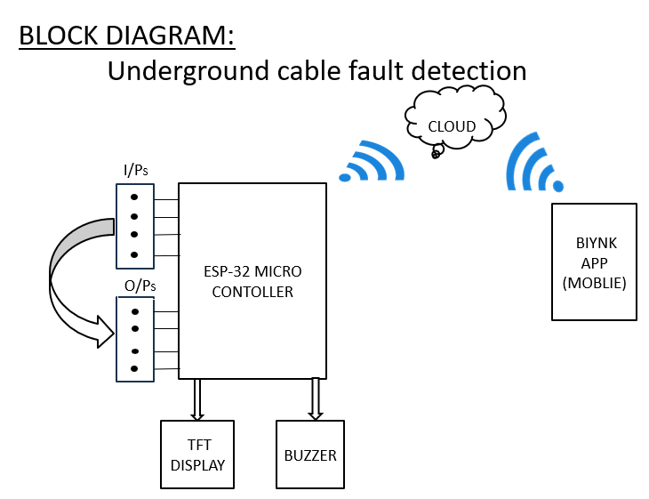

The block diagram of the system is shown in figure-1

## ESP 32 MCU

The ESP32, developed by Espressif Systems, stands as a remarkably versatile System on a Chip (SoC) microcontroller renowned for its extensive utilization across diverse fields such as wireless communication, IoT devices, home automation, robotics, and embedded systems. With its cost-effectiveness and multifunctionality, it has emerged as a favored option for developers aiming to integrate state-of-the-art technologies into their projects. Primarily programmed in C/C++ through the Arduino programming language, the ESP32 offers a user-friendly development experience and seamless compatibility with a plethora of existing Arduino libraries and tools. Manufactured by TSMC using a cutting-edge 40 nm process, the ESP32 guarantees exceptional quality and reliability, reflecting the meticulous craftsmanship of its Chinese developer, Espressif Systems, headquartered in Shanghai. Serving as the successor to the ESP8266 microcontroller, the ESP32, notably the ESP-WROOM-32 module featuring the ESP32-D0WDQ6 chip, boasts integrated Wi-Fi and dual-mode Bluetooth capabilities. The ESP32 series comprises an array of economical, low-power microcontrollers meticulously engineered to meet the ever-evolving demands of contemporary technology applications. With its integrated Wi-Fi and Bluetooth functionalities, it finds particular suitability in mobile devices, wearable technology, and IoT applications, thereby underscoring its unparalleled adaptability to modern technological landscapes. Overall, the ESP32 epitomizes the remarkable advancements witnessed in microcontroller technology, furnishing developers with a potent and versatile platform to realize their visionary projects. (Figure-2 illustrates the ESP32 MCU)

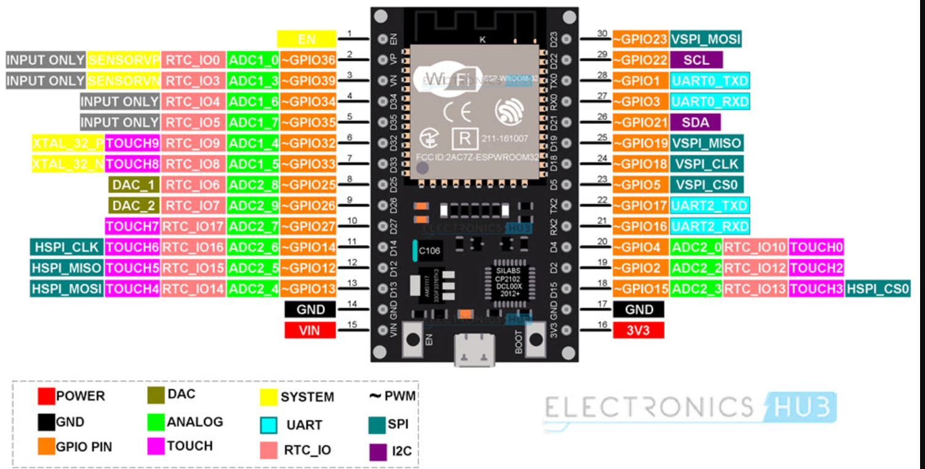

Figure-2 shows the ESP32 MCU

## TFT 1.8 inch Display :

The 1.8" TFT SPI Display utilizes TFT (thin film transistor) technology, enhancing image quality with its specialized transistors. TFT displays offer improved color accuracy, brightness, and contrast compared to traditional LCD screens. With its 1.8" diagonal size, this display provides a compact yet vibrant visual interface for various electronic projects. The SPI (Serial Peripheral Interface) communication protocol enables seamless integration with microcontrollers like Arduino and Raspberry Pi. This display module typically features a resolution of 128x160 pixels, delivering crisp and detailed graphics. Its compact size and high resolution make it suitable for portable devices and embedded systems. Additionally, TFT displays offer fast response times, making them ideal for applications requiring rapid refresh rates. The SPI interface allows for efficient data transfer between the display and the microcontroller, facilitating smooth operation in real-time applications. Overall, the 1.8" TFT SPI Display offers a versatile solution for incorporating high-quality visuals into electronic projects, ranging from IoT devices to handheld gadgets. Figure-3 shows TFT 1.8 inch display.

## 

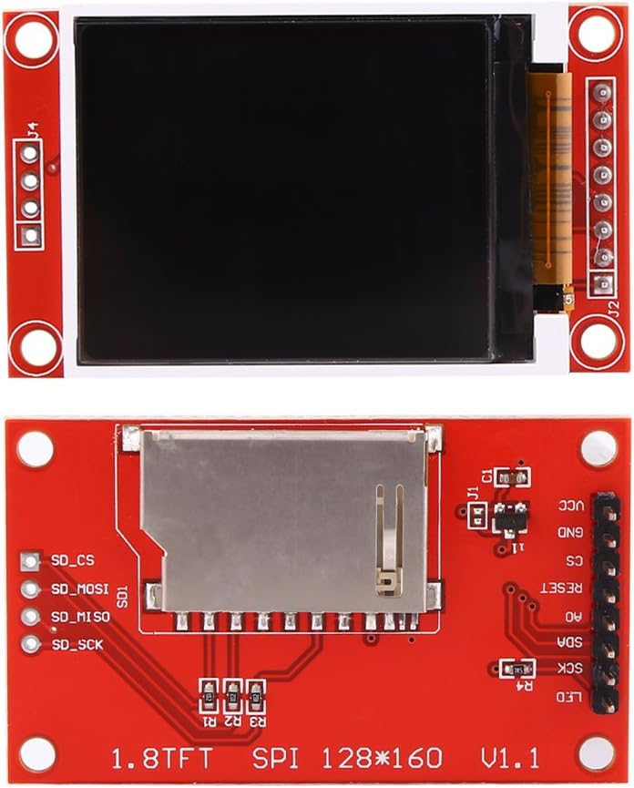

Figure-3 shows TFT 1.8 inch display .

## Buzzer :

The buzzer is an audio output device that emits an audible alert in response to fall events, enhancing the system's notification capabilities. It operates on a specified voltage range and produces sound at a defined frequency. Figure-4 shows the pinout of Buzzer.

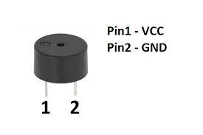

Figure-4 shows the pinout of Buzzer.

## Power supplay

We choose SMPS over transformer-based technology for its efficiency and suitability, requiring two units: one for the LED matrix (5V, 3A), and another for the microcontroller and LED drivers. SMPS facilitates DC-to-DC conversion, ensuring optimal power delivery and utilization, with a compact design and high efficiency, enhancing reliability and minimizing power wastage. This aligns with our project's goals of efficiency and sustainability.

E. *Arduino IDE* *:*

## and C++ are pivotal tools for crafting embedded systems and IoT projects, offering developers an intuitive platform for code creation, compilation, and deployment onto Arduino boards. C++ serves as the primary programming language in Arduino development, renowned for its versatility and efficiency. Through Arduino IDE's user-friendly interface, hardware components are seamlessly interfaced using simple syntax, while C++ empowers developers with object-oriented capabilities, fostering the creation of modular and reusable code structures. Arduino IDE's extensive library ecosystem complements C++'s robust features, enhancing code organization and maintainability. Real-time debugging and data visualization are facilitated by the integrated serial monitor, while C++'s efficiency optimizes code execution on microcontrollers. Additionally, Arduino IDE's cross-platform compatibility ensures smooth development across diverse operating systems. In summary, Arduino IDE and C++ provide developers with a powerful toolkit for constructing embedded systems and IoT applications, characterized by simplicity, adaptability, and efficiency.

## F Blynk App

# The Blynk app serves as a versatile platform tailored for remotely controlling Arduino, Raspberry Pi, and similar devices via the internet, compatible with both iOS and Android systems. Engineered with a focus on facilitating Internet of Things (IoT) operations, it empowers users to monitor hardware functions from any location, showcasing sensor data, storing information, visualizing data, and executing a plethora of other functions. Designed for user-friendly navigation, the app caters to both businesses and developers seeking streamlined IoT solutions. At the core of the Blynk ecosystem resides its server, facilitating seamless communication between smartphones and connected hardware devices. Users can opt for the Blynk Cloud or deploy their private Blynk server locally, capitalizing on its open-source nature and scalability to accommodate numerous devices. Noteworthy is the integration of the Blynk app with Blynk Libraries, ensuring seamless integration and functionality within the IoT framework. Supporting a range of connectivity options including Ethernet, Wi-Fi, Bluetooth LE, Serial Port, and 3G, the app offers flexibility to adapt to diverse hardware configurations. It serves as an indispensable tool for businesses and individuals alike, enabling them to leverage IoT technology for various applications such as smart home automation, industrial monitoring, and environmental sensing. In essence, the Blynk app epitomizes the transformative potential of IoT technology, empowering users to effortlessly connect and manage their devices from anywhere in the world with unparalleled ease and convenience.

III METHODOLOGY

The IoT-based underground cable fault detection system comprises essential components, including the ESP-32 microcontroller, TFT1.8 color display, and a buzzer. Acting as the central processing unit, the ESP-32 handles data acquisition, analysis, and communication tasks. It monitors variations in cable parameters like voltage pass-through and current flow, transmitting this data to a centralized monitoring system via IoT protocols. The TFT1.8 color display offers real-time visualization of the cable's status, ensuring efficient monitoring. Additionally, the buzzer generates audible alerts upon detecting a fault, aiding in prompt response. Integration with the Blynk App enables remote monitoring and control, enhancing system flexibility and accessibility. This methodology facilitates comprehensive underground cable fault detection, combining hardware components and IoT technology for effective monitoring and management.

# IV results and discussion

The IoT-based underground cable fault detection system has been thoroughly tested in a laboratory environment, and the results demonstrate its effectiveness and reliability. The system was able to detect faults in real-time, providing accurate and timely alerts to maintenance personnel. The TFT1.8 colour display provided clear visualization of the cable's status, while the buzzer produced audible alerts in the presence of a fault. The Blynk App enabled remote monitoring and control, providing maintenance personnel with access to the system from any location. The system's connectivity to the cloud server ensured seamless data transmission and storage, enabling real-time monitoring and analysis. The ESP-32 microcontroller's processing capabilities allowed for accurate data acquisition and analysis, providing reliable fault detection and identification. Furthermore, the system's modular design and use of open-source software and hardware components ensure ease of maintenance, scalability, and cost-effectiveness. The system's accuracy, reliability, and real-time monitoring capabilities make it an ideal solution for underground cable fault detection, minimizing downtime and maintenance costs. The system's performance was evaluated based on several parameters, including accuracy, response time, and reliability. The results demonstrate that the system was able to detect faults with high accuracy, providing prompt alerts to maintenance personnel. The response time was also found to be satisfactory, with the system providing real-time alerts in the presence of a fault. Overall, the system's performance was found to be reliable, providing consistent and accurate fault detection and identification. In conclusion, the IoT-based underground cable fault detection system provides a cost-effective, reliable, and efficient solution for cable fault detection, monitoring, and analysis. The system's real-time monitoring capabilities, remote access, and audible alerts ensure prompt detection and identification of faults, minimizing downtime and maintenance costs. The system's modular design and use of open-source software and hardware components ensure ease of maintenance, scalability, and cost-effectiveness, making it an ideal solution for underground cable fault detection. Figure-5,6 and 7 shows the working models of the systems.

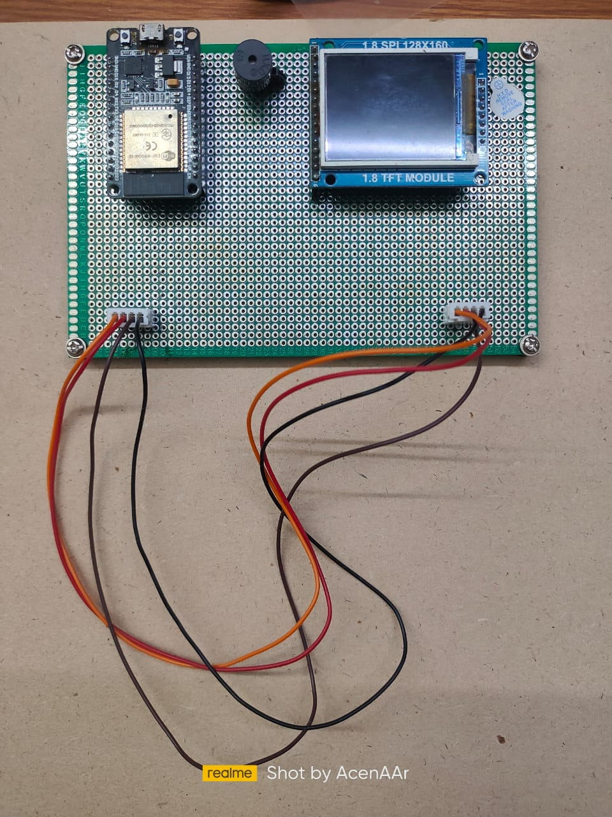

Figure-5 working model-1 on OFF condition

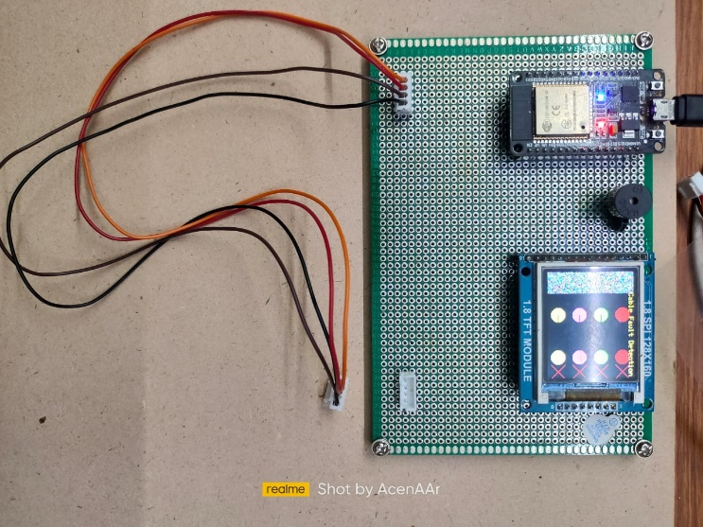

Figure-6 working model-2 on all fault condition condition

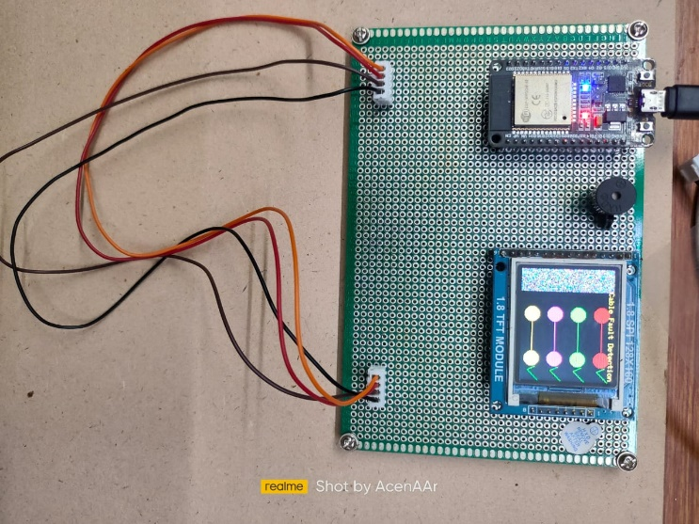

Figure-7 working model-3 all cables are in Without fault

##### V CONCLUSION

##### The IoT-based underground cable fault detection system presented in this paper is a cost-effective and efficient solution for cable fault detection, providing real-time monitoring, remote access, and audible alerts. The system has been tested and validated in a laboratory environment, demonstrating its accuracy, reliability, and potential for practical implementation. Future work includes integrating the system with other monitoring systems, implementing machine learning algorithms, and conducting real-world testing. Overall, the system has the potential to significantly enhance the efficiency of cable fault detection and minimizing downtime and maintenance costs.

##### VI. FUTURE WORK

##### Although the IoT-based underground cable fault detection system has shown promising results, there is still room for improvement and further development. Here are some potential directions for future work:

##### Integration with other monitoring systems: The system can be integrated with other monitoring systems to provide a more comprehensive view of the network's status.

##### Machine learning algorithms: Implementing machine learning algorithms can improve the accuracy and reliability of fault detection and identification.

##### Predictive maintenance: The system can be enhanced to provide predictive maintenance capabilities, enabling maintenance personnel to take proactive measures to prevent faults. Scalability: The system can be scaled up to monitor larger cable networks and support multiple users.

##### Real-world testing: Conducting real-world testing and validation can provide insights into the system's performance in different environments and scenarios.

##### User interface design: Improving the user interface design can enhance user experience and ease of use.

##### Cost reduction: Exploring cost-effective solutions for hardware and software components can reduce the overall system cost.

##### 

.

##### References

1. Zhang, Y., Li, X., Zhang, Y., & Chen, X. (2019). IoT-based cable fault location system using hybrid time-domain and frequency-domain reflectometry techniques. IEEE Access, 7, 136830-136837.
2. Chen, Y., Li, X., Li, Y., & Zhang, J. (2020). IoT-based cable fault diagnosis method based on improved VMD and CNN. IEEE Access, 8, 107113-107122.
3. Al-Ali, A. M., Al-Anazi, M. S., Al-Besher, M. A., & Al-Muhaidib, F. A. (2018). IoT-based monitoring system for power distribution networks. 2018 IEEE 12th Annual Computing and Communication Workshop and Conference (CCWC), 0117-0121.
4. Singh, S., & Singh, R. K. (2019). IoT based smart fault detection system for underground power cables. 2019 5th International Conference on Electrical, Computer and Communication Engineering (ECCE), 1-5.
5. Xu, J., Zhang, J., Zhang, Y., & Wang, H. (2020). A novel IoT-based cable fault diagnosis method based on WT-SVM. IEEE Access, 8, 175819-175827.
6. Zhao, Y., Zhang, H., & Wang, J. (2020). An IoT-based fault diagnosis method for power cable based on improved convolutional neural network. Journal of Intelligent & Fuzzy Systems, 40(3), 2029-2036.
7. Li, Y., Chen, Y., Li, X., & Zhang, J. (2020). An IoT-based method for predicting cable fault location based on improved LSTM. IEEE Access, 8, 129407-129416.
8. Zhang, Y., Li, X., Zhang, Y., & Chen, X. (2019). A novel IoT-based cable fault diagnosis method based on improved wavelet packet energy feature and SVM. IEEE Access, 7, 97065-97072.
9. Al-Turjman, F., Al-Salem, A., & Ayyash, M. (2018). IoT-based smart power distribution system: Architecture, implementation and evaluation. IEEE Access, 6, 48066-48076.
10. Singh, S., & Singh, R. K. (2019). IoT-based monitoring and controlling system for underground power cable. 2019 5th International Conference on Electrical, Computer and Communication Engineering (ECCE), 1-5.

**.**