**Design of Drainage System for Kapurwadi Village**

Jadhav Raviraj, Sase Jaydip, Sayyed Aman, Todmal Gaurav

DVVP College Of Engineering Ahmednagar Maharashtra India

**Abstract**: - The two basic essential amenities for a healthy living are safe water supply and hygienic sanitation facilities. The provision of safe drinking water preceded when talking about providing basic amenities to community. Although, the importance of hygienic sanitation facilities that are effective and low-cost on-site sanitation, cannot be allowed to lag behind. This can be done through practicing and following the conventional sewerage and sewage treatment techniques. A proper knowledge about designing sewerage system is important for high percentage of domestic water coming from village. If this huge quantity of water, that is already polluted and hazardous for human and animal health, is let into open streams without any prior treatment can cause heavy damages to human heath as well as to environment. Hence a proper network for carrying this sewage from its source to a Sewer Treatment Plant where it can treated and then disposed off safely, without harming the environment is very important to be designed. To achieve above objective, the study involving designing of a sewerage network for the Kapurwadi village.

1. **INTRODUCTION**

The underground drainage system has been designed for healthy environment and proper disposal of sewage from the human society. Because of unfriendly nature of human waste, a drainage system should be “out of vision and out of sense”. Most of the drainage systems are concealed from the eyes (underground). It is hence vital that it must be of superior quality and should be able to work a seemingly endless amount of time without leakage or deformities. It becomes nasty and expensive to address such issues that emerge in ordinary underground pipelines unexpectedly, and which may happen because of poor item quality. It is strongly advice for structures where hygiene is an important requirement. This project discusses the development and implementation and an efficient underground drainage system for Kapurwadi village in Maharashtra (India).

Kapurwadi is a village with a population of 4269 peoples. economic zone, no. of temples so, providing an underground drainage system. Underground drainage is the general term given to the systems of pipes and fittings that are installed below ground level to transport foul drainage or rainwater flows to a sewage treatment facility or, in this case of rainwater, a watercourse.. . There are common three types of sanitary sewage namely Domestic Sewage, Industrial Sewage, Storm Sewage. This underground system is a system that carries Domestic Sewage to the treatment plant. Talking about the systems of Sanitation the old conservancy system is way too different from the modern water carrying system.

1. **Methodology:**

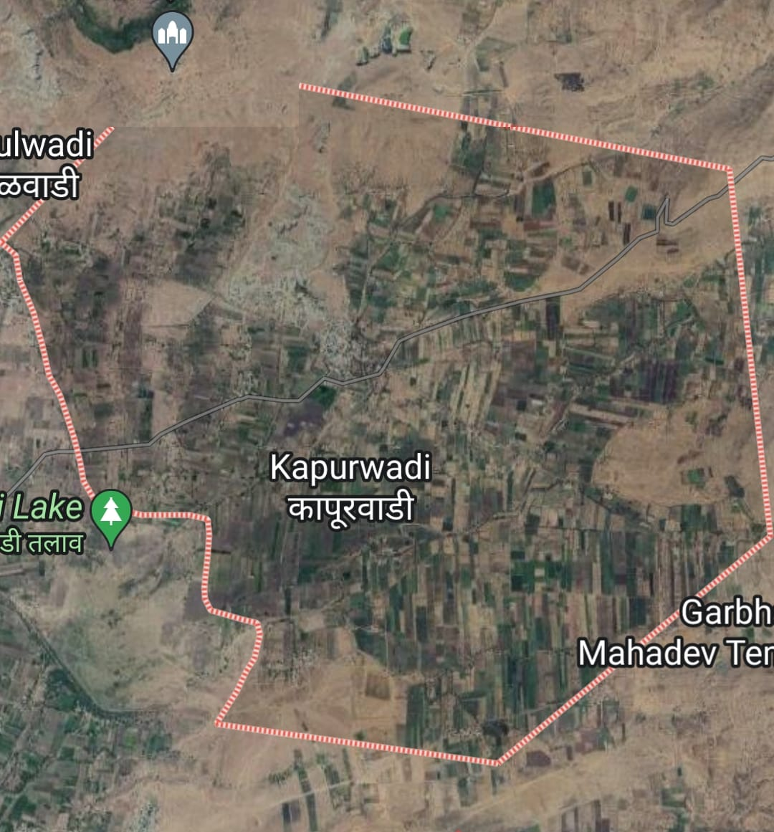 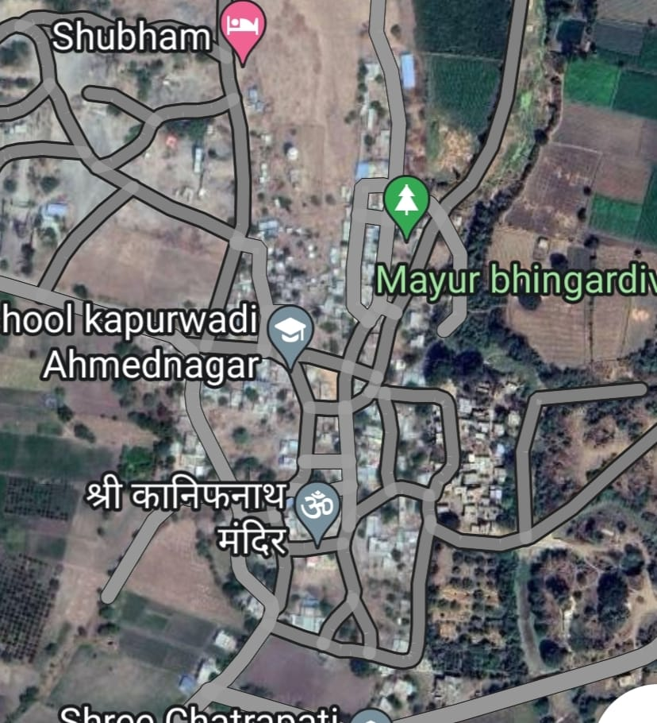

We will adopt following steps:

• Literature Review.

• Set an Objective.

• Defining Problem Statement.

• Action Plan.

• Conclusion

• Report Preparation

• Publishing Paper

**II. OBJECTIVES, ADVANTAGES, DISADVANTAGES AND PRECAUTION:**

a. Objectives of the study:

1)Design underground drainage system for Kapurwadi village.

2)Design are economically, fast deployment.

b. Advantages

• Enhances the appearance of the property.

• Less time of Labour Requirement.

• Reduce Soil Erosion.

• Removes Toxic Substances.

c. Limitations

• Expensive.

• Regular maintenance is required.

• Can contaminate bodies of water.

d. Precautions

• Make sure that the soil is not too roomy while digging the recharge well.

• Make sure to cover the recharge well in right way while construction.

• Make sure to give overflow pipe for the recharge well to prevent water logging around the recharge well in case of overflow.

• Do not create a recharge well if the water table is within five feet from the ground level.

• The Stone packing should be done by skilled people in order to avoid caving or collapse of recharge well.

• Provide required concrete / brick lining and make sure that water is not entering into the recharge well from the sides as this may lead to collapse.

**III. UTILIZATION OF DRAINAGE**

1. Need for artificial drainage:

• Additional water in the crop root zone soil is injurious to plant growth. Crop yields are considerably reduced on poorly drained soils, and, in cases of prolonged waterlogging, plants eventually die due to a lack of oxygen in the root zone.

• Origin of more soil water that result in high water tables include: high precipitation in humid regions; surplus irrigation water and canal seepage in the irrigated lands; and artesian pressure.

b. Secondary drainage treatments:

• Methods of improving the internal drainage of low permeability soils include: subsoiling, deep tillage, mole drainage, and biological practices, viz., cropping with deep rooted legumes (e.g., alfalfa) and crop rotations.

• Deep rooted trees are used to minimise the water table. There are usually no water quality hazards associated with these increase drainage practices.

C. On-farm source control:

• The most suitable method of minimizing environmental problems is to implement source control practices at the farm level. In irrigated parts, this can be achieved by improved irrigation water management.

• Big irrigation efficiencies and lined irrigation conveyance structures will reduce the amount of drainage water which needs to be removed.

d. Re-use of drainage water:

• In many parts where irrigation water is short, drainage water is used to meet crop water requirements. Re-use is only durable if the drainage water is of sufficiently good quality.

• The water quality concerns about drainage water re-use with plants of growing salt tolerance are that: the effluent may be high in salt content (in irrigated lands)

e. Re-use for crop irrigation:

• The major shame factor of re-used waters is the high concentration of ions.

• Waters with less ionic applications provide plants with an adequate supply of many of the essential nutrients, needed.

**IV. REINFORCED CEMENT CONCRETE PIPE DETAILS**

1. Purpose of pipe:

• A drainage pipe is any pipe used to facilitate the transfer of water from one place to another.

• The main purpose is to dispose of wastewater from homes, office buildings.

1. Advantages of pipe:

• The maintenance cost is low.

• The inside surface of pipes can be made smooth.

• The pipes are durable with useful life of about 75 years.

• The pipes can be cast at site work and thus there is reduction in transport charges.

1. Limitations of pipe:

• Affected by acids.

• Repairs are very difficult.

• Transportation and laying cost is high.

• Difficult to make connections.

d. Technical factor affecting the choice of pipe material:

1.Strength: • Since the water flows through the pipes under pressure, hence material should be strong enough to resist the high internal pressure.

2.Resistant to corrosion: • Material of pipe should resist the corrosion internally as well as externally.

3.Hydraulic properties: • The pipe material should be smooth to avoid frictional losses and to produce higher hydraulic efficiency.

4.Maximum permissible diameters: • Maximum permissible diameter may differ with different materials and hence it should be suited for different parts of water distribution.

5. Handling and jointing: • It is quite often found that the pipe materials are suitable in handling and jointing.

e. Pipe details:

• Diameters from 150mm to1220mm

• Lengths of 2.5 meters

• Joint will be Flexible joint.

**V. PROCEDURE FOR DESIGN OF UNDERGROUND DRAINAGE SYSTEM FOR 30 YEARS:**

1) Fix map for required drainage system.

2) Draw the map of drainage pipe line with manholes.

3) find the length and slope of ground.

4) Find the length and slope of the pipes in between two manholes.

5) Find length in kilometres of all pipes and also find diameter of all pipes.

6)Then find the cumulative by addition of length of pipe coming in same manhole.

7)Find the cumulative length in kilometres.

8)Find the cumulative area.

9) Calculation future population by using

Incremental increase method

Pn=Po+nx+{n(n+1)÷2}y

Where,

Pn- future population

Po- last decade Known population

r- geometric average of per decade percentage increase in population.

n- no of decade between present of future

y - arithmatic average of Increment is increase in population

x- arithmetic average of per decade increase in population

10) Discharge of Rainwater

Q = AIR / 360

Where,

Q- Discharge

I- Intensity

R- Rainfall factor

**VI. OBSERVATION**

Design in excel sheet



Determining of slope

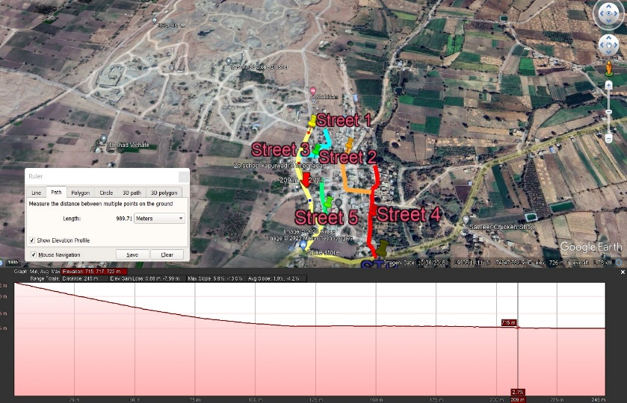

Determining of length

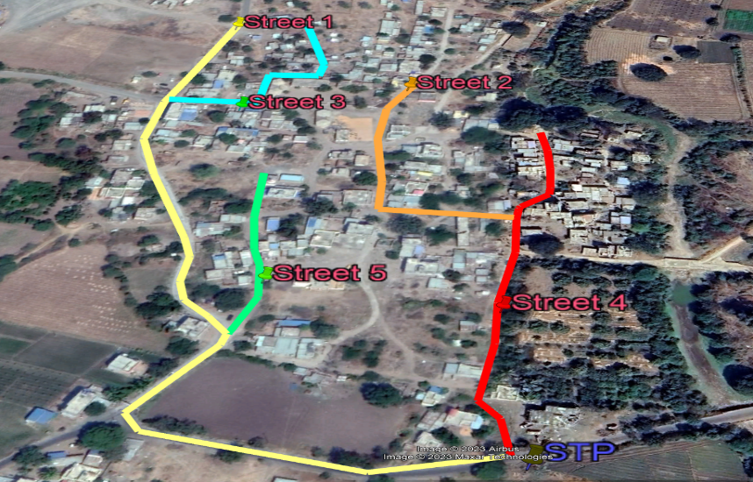

**VII. CONCLUSION**

For Kapurwadi village we designed underground drainage system and conclude as follows:

1) Kapurwadi is the slow developing village.

2) Design and underground system is for 30 years

3) Underground drainage system reduce soil erosion.

4) Enhance the appearance of the village.

**Result** –

Provide –

* 150mm pipe for each house
* 300mm pipe for street 2, 3 & 5
* 450mm pipe for main street ( 1 & 4 )

SCOPE OF FUTURE WORK

• We collected at to all general information from google of Kapurwadi village.

• Then we drawn the map of village. In that map we also drawn pipe laying map, by fixing the manhole.

• And then we started further calculation for underground drainage system.

• In future we can also design sewage treatment plant by taking reference of this project.

• And we can design next for water collected by underground drainage system for agricultural use.

REFERENCE

21 “Design of Under Ground Drainage System for Rural Area” (2), Shraddha Tiwari and Mangesh Bhorkar, International Research Journal of Engineering and Technology (IRJET), Volume 7, Issue No 6, June 2020,

2) “Strom water drainage systems design CPHEEO, MOHUA, “Manual on Storm Water Drainage Systems”, Issue 1 Aug, 2019

3) A Review of Sustainable Urban Drainage Systems Considering the Climate Change and Urbanization Impacts. Chocat, B.; Ashley, R., Marsalek, J.; Matos, M.R.; Rauch, W.; Schilling, W.; Urbonas, B. Toward the sustainable management of urban storm-water. Indoor Built Environ 2007, 16, 273-285

4) A REVIEW OF SUSTAINABILITY OF URBAN DRAINAGE SYSTEM: TRAITS AND CONSEQUENCES Wakjira Takala Dibaba Jimma Institute of Technology, Jimma University Journal of Sedimentary Environments - October 2018

5)Yash Narale, Apurva Jogal, Himani Chaudhary, and S.P Bhosale, "Underground Drainage Monitoring System using IOT", International Journal of Advance Research, Ideas and Innovations in Technology