**PERFORMANCE OF GRID CONNECTED RENEWABLE ENERGY SYSTEMS USING MATLAB/SIMULINK .**

**Dr .L .RAVI SRINIVAS**

D.NANDINI | D.HARIKA | G.UGENDRA KUMAR

**ABSTRACT:**

This analysis investigates how to power a sizable facility with vital equipment by utilizing conventional electrical grid power in addition to solar and wind energy. Utilizing strategies, we make the most of the electricity from various sources despite weather fluctuations. The vital equipment will always have electricity thanks to our control strategy. We simulate the behavior of this system under various circumstances using Matlab-Simulink. Results indicate that our approaches perform effectively and quickly adapt to changes in the weather. Overage power is returned to the grid, which provides support as needed.

**SESSION 1:**

**INTRODUCTION:**

This project explores using solar and wind power together to improve energy reliability and efficiency. We simulate how these systems work and optimize their performance. We also consider their economic and environmental impacts. Another focus is on addressing power quality issues, such as harmonics, which can affect electrical equipment performance and lifespan. We define power quality as the ability of equipment to function without significant loss due to electrical issues. This includes maintaining smooth voltage levels and frequencies. Common power quality problems include voltage variations, interruptions, and harmonic distortion caused by nonlinear loads.

Grid-connected hybrid solar-wind power systems reduce carbon emissions, promote the integration of renewable energy sources, and provide a critical answer to energy-related problems. Studies using simulations are essential for comprehending and improving system behavior. The abundance and complementary nature of solar and wind energy supplies improves system efficiency and dependability. Advanced modeling approaches are necessary for successful integration of challenges such as voltage variations and intermittency. System design and optimization are aided by a variety of techniques and resources, including as software platforms like MATLAB/Simulink and mathematical modeling. To maximize effectiveness and return on investment, studies concentrate on component size, power electronics integration, and economic analysis. Techno-economic performance, grid integration issues, and energy generating characteristics are all covered in performance evaluation and case studies. Future research areas are being shaped by emerging technologies such as hybrid system integration with energy storage and enhanced control systems.To accelerate the shift to a sustainable energy future, research and innovation must continue.

**SESSION 2:**

**SOLAR SYSTEM:**

Decentralized renewable energy generation is necessary to preserve a clean environment in response to the growing demand for electrical energy. The utility grid's interaction with renewable energy sources, such as solar, wind, or hydropower, helps reduce problems with electricity availability, security, and quality. The use of solar electricity is becoming more popular since it is more abundant, efficient, and

environmentally friendly than other conventional power sources like nuclear or fossil fuels. Photovoltaic (PV) systems are expensive initially, but they use free, abundant sunshine to provide extended lifespans with low maintenance. Because photovoltaic technology has no moving components, it is a reliable and ecofriendly method of producing electricity.

# Why Is Solar Energy

Because solar energy may help with pressing problems like pollution and fossil fuels, it is very important. Solar energy is renewable and ecologically benign, lowering pollution and lessening its negative effects on the air, water, and food supplies, in contrast to fossil fuels. Since sunshine, the energy source for photovoltaic (PV) systems, is abundant and free, the long-term advantages of these systems outweigh their initial cost. However, to guarantee a steady supply of electricity, grid integration or hybridization with additional power generating devices are required due to the intermittent nature of solar energy. Sophisticated control systems are necessary for integration with the energy grid, and they can be expensive

From the discovery of the photovoltaic effect in the 19th century to the creation of useful solar cells in the 20th century, solar technology has advanced significantly in spite of obstacles. Innovations in production techniques and marketing approaches have reduced the cost and increased the availability of solar energy, opening the door for its broad use in a variety of applications, including as offshore oil platforms and navigation. The future can be sustainable and cleaner with solar energy if innovation and investment continue.

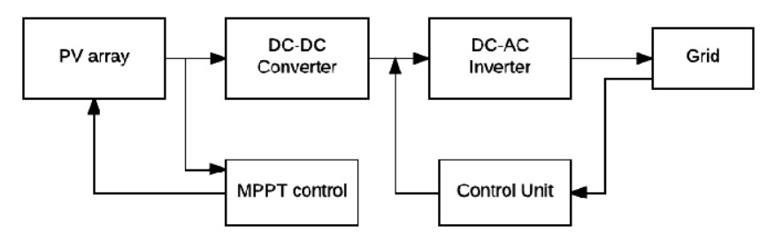

**Block diagram of grid connected solar panel**

**SESSION 3: Proposed methods**

# MPPT P & O ALGORITHM AND DUTY CYCLE REGULATOR

Renewable energy is becoming more and more popular since it's clean and getting cheaper, particularly photovoltaic (PV) systems. PV plants must contend with issues including weather-related nonlinear IV curves. Maximum power point tracking (MPPT) approaches are essential to address this. Numerous techniques exist, ranging from basic perturb and observe (P&O) to more intricate approaches such as fuzzy logic. With the combination of P&O and fractional open-circuit voltage (FOCV), this research presents a hybrid MPPT technique. It effectively records the maximum power point (MPP) with low power loss oscillation using two sensors, even under changing weather conditions. Simulations demonstrate its advantages over alternative methods, such as simple P&O.

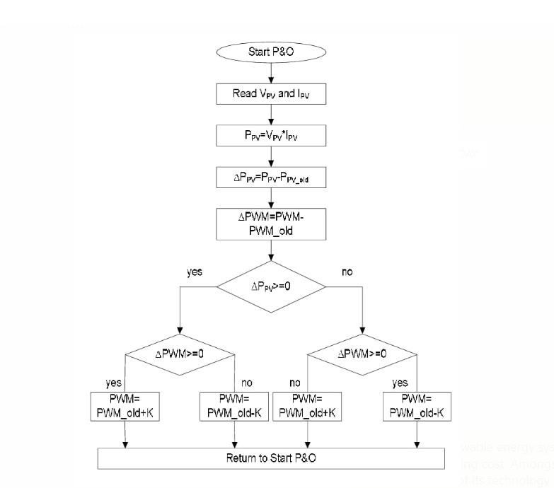

## Flow chart of MPPT P & O Algorithm

**PROPOSED DC-DC CONVERTER:**

As a component of the DC-to-DC conversion process, a boost converter raises the voltage from a power source, which is advantageous for uses such as battery-operated devices. It is necessary for systems, like as LED lights and hybrid cars, that require greater voltages than the power supply can provide. This converter avoids power losses and assures efficiency by quickly switching a semiconductor switch. The introduction of commercial semiconductor switches in the 1950s and the models developed by R. D. Middlebrook in 1977 made the design of such converters easier. Boost converters are be very handy when you need to raise the voltage but there aren't enough cells in the battery stack due to space restrictions. Additionally, they are utilized in low-power circuits such as the "Joule thief," which recovers energy from almost empty batteries that would have been thrown away otherwise. This invention is especially helpful for gadgets that utilize alkaline batteries, which lose voltage with time and become useless for regular loads.

**DESCRIPTION:**

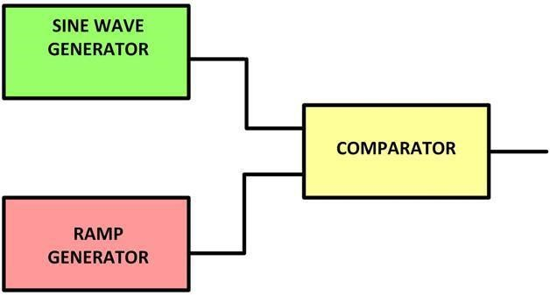

# SPWM block diagram

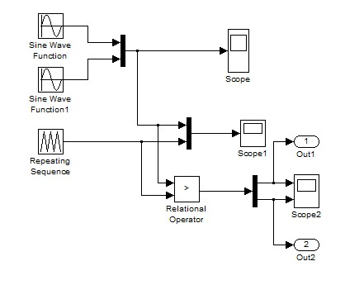

## 4 SPWM SIMULATION DIAGRAM

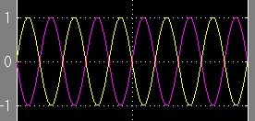 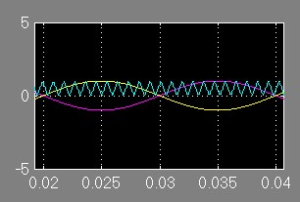

SCOPE view SCOPE 1 view

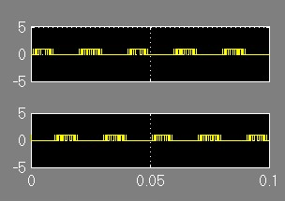

## SCOPE 2 view

PWM modulation consists of keeping the duty cycle constant while adjusting the pulse period based on the amplitude of the modulating signal. Using a comparator to compare the modulating signal with a ramp waveform is a traditional way of producing PWM.

# PROPOSED VOLTAGE SOURCE INVERTER

PWM modulation consists of keeping the duty cycle constant while adjusting the pulse period based on the amplitude of the modulating signal. Thyristors limited the usefulness of HVDC by allowing just on and depending on external AC systems for off. Insulated-gate bipolar transistors (IGBTs) facilitate selfcommutated converters known as voltage-source converters (VSCs) by offering control over turn-on and turn-off. In AC systems, VSCs provide benefits including improved harmonic performance and autonomy from synchronous machines, which makes power transfer to passive loads easier. They are small and ideal for places with limited space, such as offshore platforms. Pulse-width modulation (PWM) is used to rectify square waves produced by two-level converters, the most basic form of VSC. In contrast to LCCs, PWM reduces transmission efficiency by increasing switching losses. Although three-level converters, like as diode-clamped converters, have disadvantages including large switching losses and electromagnetic interference, they improve harmonic When compared to two-level converters, the Modular Multi-Level Converter (MMC), a popular VSC for HVDC, offers superior harmonic performance and reduced power losses. Nevertheless, MMCs need large submodule capacitors and intricate controls. With large-capacity plans like the Trans Bay Cable, MMC HVDC systems are growing. Although they come with distinct tradeoffs in terms of complexity, power losses, and harmonic performance, variants like the full-bridge MMC and the Cascaded Two Level (CTL) converter provide better performance and versatility.

**SESSION 4: Results**

## PROPOSED SIMULATION RESULTS

With support for linear and nonlinear systems in continuous, sampling, or hybrid time, Simulink is software for modeling and analyzing dynamical systems. It provides a graphical user interface (GUI) that enables top-down and bottom-up modeling of block diagrams using mouse actions. Scopes allow the observation of simulation results in real time, facilitating parameter research and adjustments. Within the MATLAB environment, post-processing and visualization are feasible. Simulink investigates a variety of dynamic systems, including shock absorbers and electrical circuits.

Using Simulink for simulation entails first building a graphical model that shows the mathematical connections between inputs, states, and outputs. MATLAB is a high-performance programming language that combines programming, visualization, and calculation. Math, algorithm creation, data collection, modeling, simulation, prototyping, analysis, and visualization are among its applications. Because arrays are the fundamental building blocks of MATLAB, which is interactive, effective problem-solving for as opposed to non-interactive languages like C or FORTRAN, saving time in matrix and vector formulations.

The MATLAB system consists of six main parts:

* Development Environment
* The MATLAB Mathematical Function Library
* The MATLAB Language
* Graphics
* The MATLAB Application Program Interface (API)
* MATLAB Documentation

## COMPONENTS THAT ARE USED IN SIMULATION

* Three phase source block
* VI measurement block
* Scope
* Three-Phase Series RLC Load
* Three-Phase Breaker block
* Integrator
* Breaker
* Three-Phase Programmable Voltage Source
* Trigonometric Function
* Three-Phase Transformer (Two Windings)
* Three-Phase Transformer 12 Terminals
* IGBT/Diode

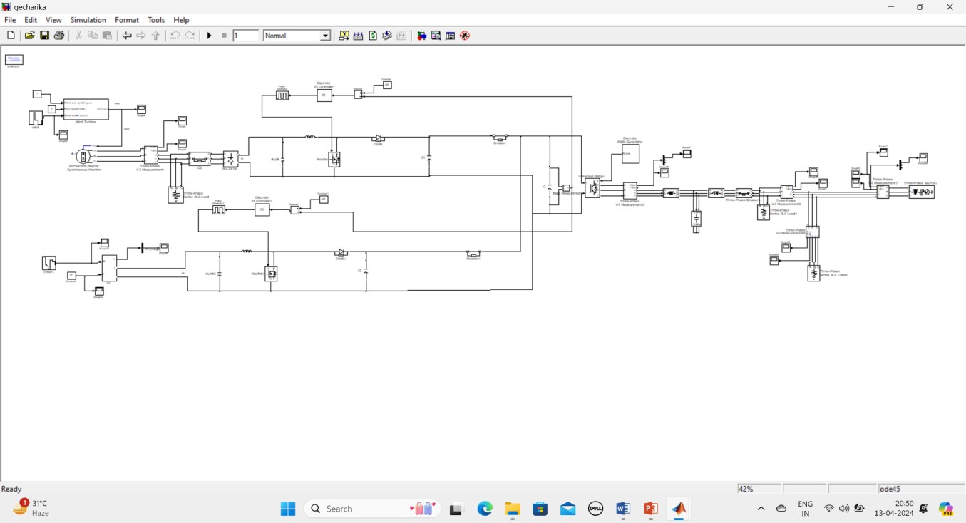

# Simulation circuit

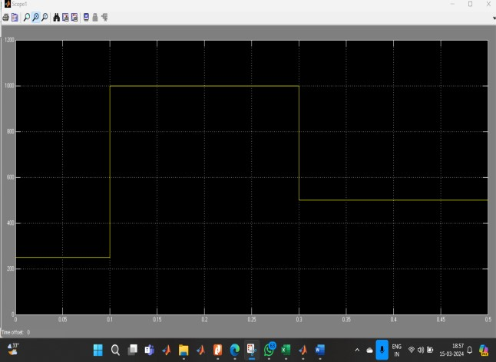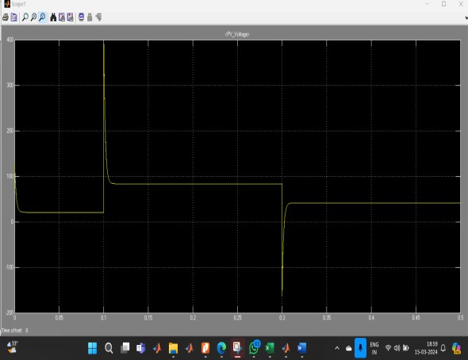

**Solar panel input temp vs time Pv voltage vs time**

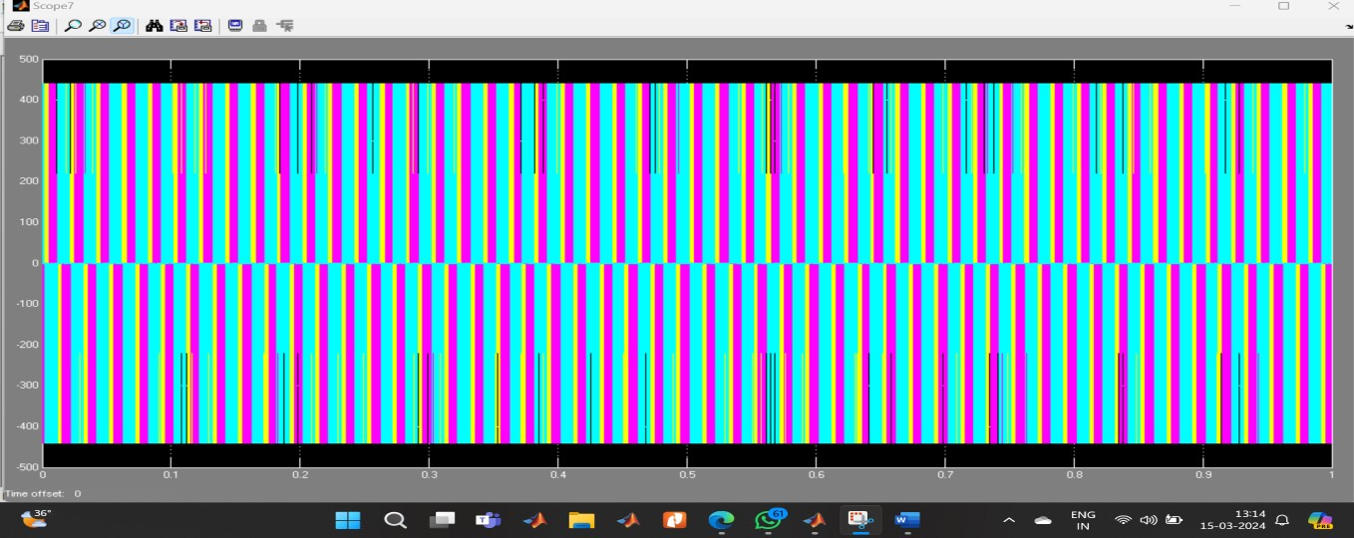

**Inverter output voltage vs time before filtering**

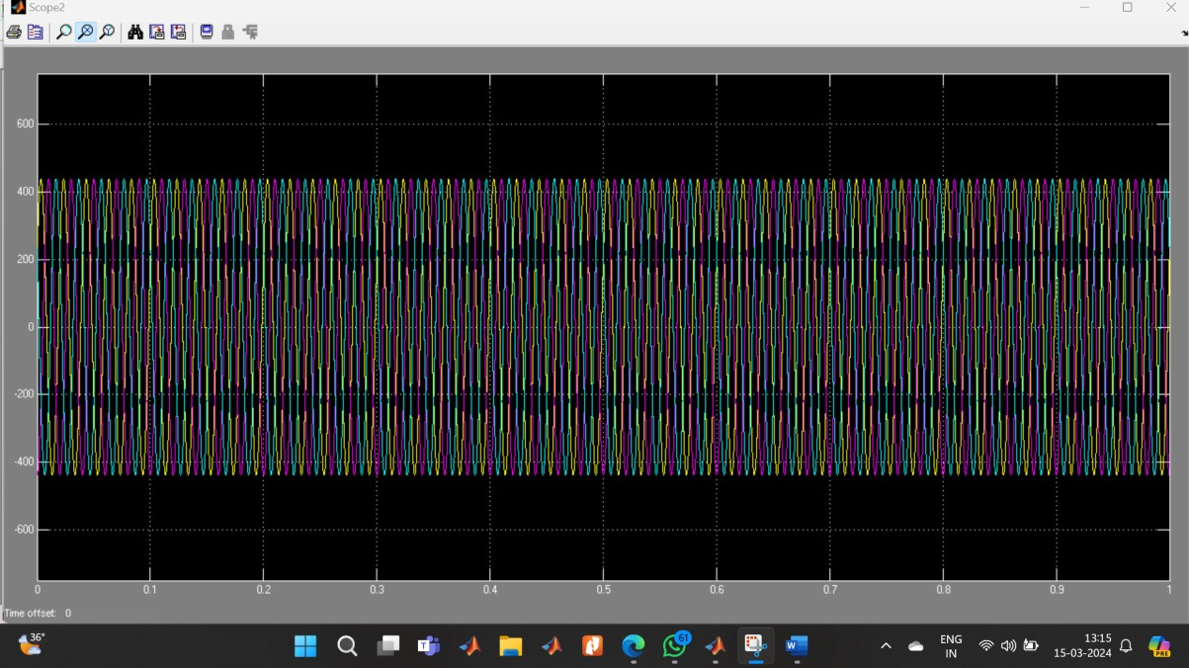

# Inverter output voltage after filtering



## Grid voltage vs time

**REFERENCES:**

1. Khan, M. J., Iqbal, M. T., & Qu, Z. (2010). Microgrids: A review of technologies, key drivers, and outstanding issues. Renewable and Sustainable Energy Reviews, 15(9), 4834-4846.
2. El-Fouly, T. H., Salama, M. M., & Chikhani, A. Y. (2010). Wind energy conversion systems: A technical review. Renewable and Sustainable Energy Reviews, 14(1), 125-152.
3. Hameed, Z., & Hasan, S. M. (2015). Design, Simulation, and Analysis of a Solar-Wind Hybrid Energy System. Procedia Computer Science, 62, 210-217.
4. Pandiarajan, N., Muthu, R., & Manikandan, M. R. (2019). Design and analysis of solar wind hybrid energy system. Materials Today: Proceedings, 18, 4295-4300.
5. Chandel, S. S., Naik, M. N., & Chandel, R. (2015). Review of solar photovoltaic water pumping system technology for irrigation and community drinking water supplies. Renewable and Sustainable Energy Reviews, 49, 1084-1099.
6. Farhat, I. A., Kordab, A. M., & Abdelhadi, F. A. (2018). Comparative study of three topologies for wind energy conversion system with MPPT fuzzy logic control. Ain Shams Engineering Journal, 9(1), 157-166.
7. Ponnalagar, V. P., & Rajasekaran, V. (2019). Simulation and analysis of solar wind hybrid energy system with MPPT techniques using CUK converter. Materials Today: Proceedings, 18, 2327-2334.
8. Wu, J., Hu, Y., & Wang, L. (2017). Coordinated control of a grid-connected solar–wind power system based on fuzzy logic and a back propagation neural network. Energies, 10(5), 710.
9. Moradzadeh, M., & Ehsan, M. (2019). Fuzzy sliding mode control of solar-wind hybrid energy systems with MPPT algorithms. Energy Conversion and Management, 180, 195-204.
10. Li, Y., Chen, B., & He, G. (2015). Neural network based maximum power point tracking control for wind generation system with DFIG. Energy Procedia, 75, 866-871.