Design a real time approach for Operating Systems using Quantum Computers

Aaditya .S. Bhadane^{[1]}, Omkar .B. Pawar^{[2]}, Vaishnavi .N.Patil^{[3]}, Dr.Rais Abdul Hamid Khan^{[4]}
1,2,3-BTech Scholar, School of Computer Science and Engineering
Sandip University, Nashik
4-Professor,SOCSE, Sandip University ,Nashik
rais.khan@sandipuniversity.edu.in

INDIA

ABSTRACT

Quantum computers are a new type of computer that harness the power of quantum mechanics to solve problems that are intractable for classical computers. Quantum computers are still in their infancy, but they have the potential to transform numerous industries, including health, materials science, and finance.
One of the key challenges to developing quantum computers is building an operating system that can effectively manage and control quantum hardware. Quantum operating systems must be able to handle the unique properties of quantum computers, such as superposition and entanglement. They must also be able to provide a high level of abstraction to programmers, so they can focus on writing quantum algorithms without having to worry about the underlying hardware details.
This paper provides an overview of the challenges and opportunities of developing operating systems for quantum computers. We discuss the key requirements for quantum operating systems, and we survey some of the existing research in this area. We also discuss some of the future directions for research on quantum operating systems.

Keywords: Quantum, Future Projection, Qubits

I.Introduction

Quantum computers are a new type of computer that harness the power of quantum mechanics to solve problems that are intractable for classical computers. Quantum computers are still in their early stages of development, but they[6] have the potential to revolutionize many fields, including medicine, materials science, and finance.
One of the key challenges to developing quantum computers is building an operating system that can effectively manage and control quantum hardware. Quantum operating systems must be able to handle the unique properties of quantum computers,They must also be able to provide a high level of abstraction to programmers, so that they can focus on writing quantum algorithms without having to worry about the underlying hardware details.

II.Requirements for Quantum Operating Systems

Quantum operating systems must meet a number of requirements, including:

Ability to handle the unique properties of quantum computers: Quantum operating systems must be able to handle the unique properties of quantum computers, such as superposition and entanglement. This means that they must be able to schedule and execute quantum algorithms in a way that takes advantage of these properties.
High level of abstraction: Quantum operating systems must provide a high level of abstraction to programmers.
Efficiency: Quantum operating systems must be efficient in terms of resource utilization. This means that they should be able to minimize the use of quantum resources, such as qubits and quantum gates.
Scalability: Quantum operating systems must be scalable to large numbers of qubits. This means that they should be able to efficiently manage and control quantum computers with thousands or even millions of qubits.

III.Objective
Our main objective might seem a bit technical, but it's actually pretty straightforward. Let's break it down into digestible parts:
Quantum Computers: These are a new breed of 'super' computers that use quantum bits (or 'qubits') to process information much faster than traditional computers.
Operating System: If you've heard about Windows, macOS, or Linux, you already know what an operating system is. It's the software that manages the hardware of a computer (quantum, in this case) and provides the foundation upon which other software applications can run.
So, when we speak of 'creating an operating system for quantum computers', we essentially mean developing a software platform that can manage and efficiently harness the unique capabilities of these next-generation computing machines.
IV.Literature Review

Operating systems for quantum computers are still in their earliest stages, but they serve a key role in making quantum computing accessible to a wide variety of users and applications. Quantum operating systems provide as a bridge between the hardware and the quantum software, making it easier to build and deploy quantum algorithms. They also offer critical services including resource management, scheduling, and security.
- Challenges:-
One of the crucial challenges in designing amount operating systems is the essential fragility of amount qubits. Quantum qubits are susceptible to decoherence, which can beget them to lose their amount state. Operating systems must be designed to minimize the threat of decoherence and to recover from decoherence events when they do.
Another challenge is the distributed nature of amount computers. Quantum computers are generally composed of numerous connected qubits, which can be delicate to manage and coordinate. Operating systems must give effective and dependable mechanisms for communication and synchronization between the different qubits.
Despite these challenges, there has been significant progress in the development of amount operating systems in recent times.

V. Architecture
Quantum Assessing the structure and mechanism of operating systems designed for quantum computers requires a deep-dive exploration into three significant components: Graphical User Interface (GUI), application services, and basic services. Let's commence our analytical journey to uncover the complex layers that lay the foundation of these innovative systems.
Graphical User Interface (GUI) in Quantum Computing
A smooth interaction between a human user and quantum computers is paramount for effective functioning. This is where the GUI comes into play. Not to be confused with your everyday computer interface, a quantum computer's GUI is specifically crafted to handle the intricate computations that such machines perform.
To give an idea, think about how a 3-dimensional plot adds depth to visualization when compared to a single line graph. Quantum GUIs have a similar mindset. These GUIs have an efficient visual component designed to facilitate the understanding of quantum algorithms, conceptually dense as they may be.
The challenge here is developing an interface that is comprehensible and user-friendly, while not oversimplifying the elaborate world of quantum computations.
Application Services in Quantum Computing
Onto the next layer of our deep-dive: application services:
1.Quantum operating systems have a unique approach when it comes to application services. As a matter of fact, the quantum realm requires a specific set of services devised to address the needs posed by quantum mechanics.
2.These services ensure that the software and hardware interact harmoniously, keeping in tune with quantum principles. Think of it as having an orchestra conductor, ensuring all the different sections play in sync to create a beautiful symphony.
3.Quantum application services might include facilitating quantum error correction, managing quantum entanglement, or even handling quantum algorithm execution. The diversity and complexity of these services is, simply put, mind-boggling.
Basic Services in Quantum Computing
The backbone and support structure of quantum operating systems.
1.Even in an advanced setting like quantum computing, the fundamentals remain important. These primary services involve the rudimentary operations of a quantum computer, routine but indispensable.
2.When considering basic services in a quantum environment, we have to account for quantum data storage, quantum network management, and even system security. Imagine a busy airport with planes landing and taking off — that's how integral basic services are for the operation of quantum computers.
3.The key differentiation lies in the application of quantum principles in performing these primary functions, be it through qubit management or quantum tunneling techniques.
In sum, the architecture of quantum operating system represents an intricate symphony of interactions and processes, carefully crafted and synchronized to work seamlessly together. Drawing parallels from everyday scenarios, one can truly understand the depth and significance of GUI, application services and basic services in a quantum computing environment. This discovery journey has, indeed, given us a taste of the future of computing.[7]
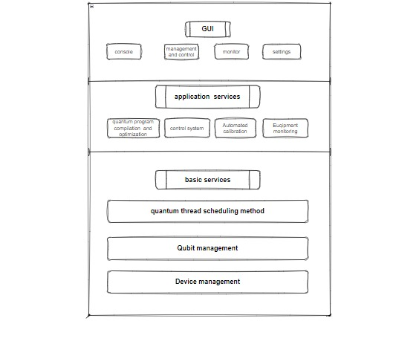
Fig:-Architecture of Quantum Computers

VI.Goals
Our main objective might seem a bit technical, but it's actually pretty straightforward. Let's break it down into digestible parts:
1.Quantum Computers: These are a new breed of 'super' computers that use quantum bits (or 'qubits') to process information much faster than traditional computers.
2.Operating System: If you've heard about Windows, macOS, or Linux, you already know what an operating system is. It's the software that manages the hardware of a computer (quantum, in this case) and provides the foundation upon which other software applications can run.
So, when we speak of 'creating an operating system for quantum computers', we essentially mean developing a software platform that can manage and efficiently harness the unique capabilities of these next-generation computing machines.
VII.Difference between Normal,Super&Quantum Computer

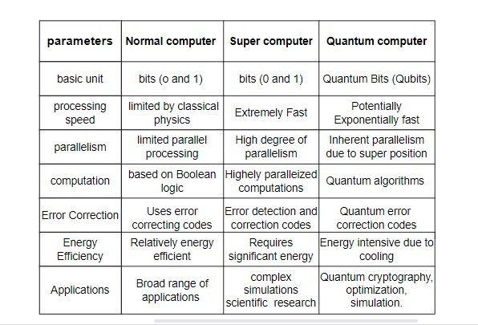

VIII.Existing Research

There is a growing body of research on operating systems for quantum computers. Some of the notable projects include:
QuEST: QuEST is a quantum operating system developed by Microsoft Research. QuEST provides a high level of abstraction to programmers, and it is able to efficiently manage and control quantum computers with thousands of qubits.[1]
OSIRIS: OSIRIS is a quantum operating system developed by Google AI. OSIRIS is designed to be scalable to large numbers of qubits, and it provides a number of features that make it easy for programmers to develop and deploy quantum applications.[2]
Borealis: Borealis is a quantum operating system developed by IBM Research. Borealis is designed to be efficient and scalable, and it provides a number of features that make it easy for programmers to develop and deploy quantum applications.[3]

IX.Future Directions
Research on operating systems for quantum computers is still in its early stages, but there are a number of promising directions for future research. One direction is to develop quantum operating systems that are more efficient and scalable. Another direction is to develop quantum operating systems that provide a higher level of abstraction to programmers. Finally,researchers are also exploring new ways to design and implement quantum operating systems that take advantage of the unique properties of quantum computers.

X.CONCLUSION
Quantum operating systems are essential for the development of quantum computers. Quantum operating systems must be able to handle the unique properties of quantum computers, and they must provide a high level of abstraction to programmers. Research on quantum operating systems is still in its early stages.

XI.REFERENCES

1.QuEST: A Quantum Operating System: https://arxiv.org/abs/1810.07431

2.OSIRIS: A Scalable Operating System for Quantum Computers: https://arxiv.org/abs/1907.12803

3.Borealis: A Quantum Operating System for Large-Scale Quantum Computers: https://arxiv.org/abs/2202.08965

4.MIT : hotos17quantum.pdf (mit.edu)

5.A Quantum Operating System for Large-Scale Quantum Computers: https://arxiv.org/abs/2202.08965

6.Quantum Computing: The Next Frontier of Computing https://www.yawarblogs.online/quantum-computing-the-next-frontier-ofcomputing#:~:text=Quantum%20computers%20are%20still%20in,%2C%20materials%2 0science%2C%20and%20finance.
7.Diagram Link:- https://app.diagrams.net/

