**IOT BASED BANK SECURITY SYSTEM**

**A. Ragavendra Prasad1, B. Harun2, P. Venu Gopal3, S. Aslam Basha4, S. Mahesh5,**

**C. Raja Sekhar6**

**1** Assistant Professor, Department of EEE, Santhiram Engineering College, Nandyal, A. P

**2,3,4,5,6** UG Student Scholar, Department of EEE, Santhiram Engineering College, Nandyal, A. P

raghavendra.eee[@srecnandyal.edu.in](mailto:@srecnandyal.edu.in), boyaharun2002@gmail.com

______________________________________________________________________________________________________________________

**ABSTRACT**

This paper proposed an effective watching and controlling system for bank locker rooms which is completely self-decision. The security system is planned to perceive the unlawful entrance in the bank locker room zones that ordinarily happens in cases of the thefts. The genuine stress with current physically managed security structure is that if the robbery occurs by then the banks are not had the ability to recognize the plunderers due to nonattendance of confirmation. In our investigation we use Microcontrollers with different sensors as observatory to recognize or perceive intruder or unpredictable activities inside the bank and ATM. The structure will focus on the security of the bank locker rooms in an effective course by recognizing and controlling unapproved development. The proposed security system will save the pictures at whatever point the development.

**Keywords:** ESP32, Sensors, IOT, Blynk Application, RFID Cards

__________________________________________________________________________________________________________________________________

**I. INTRODUCTION**

In today's world, where most individuals live in cities, security is of the most extreme significance. There will be would-be burglars who may target homes, businesses, and banks, putting resources there at hazard. A plenty of locks or an alert framework is what most people require to combat a security peril. The industry offers a wide assortment of alert frameworks that make utilize of various sensors[2]. Since it is competent of identifying a wide assortment of natural changes and handling them to send out alarms based on pre-set values, the sensor framework isn't continuously reliable. In this way, this venture will arrange the security framework for the bank locker that makes utilize of RFID and voice control [1]. Much obliged to the utilize of radio recurrence distinguishing proof (RFID) technology and voice control, the framework will give more security compared to competing systems [13]. Through the utilize of radio recurrence distinguishing proof (RFID) and voice commands, as it were authorised people are able to open the locker. Radio wires or coils, handsets (with decoders), and electronically modified RF labels (transponders) make up an RFID framework. On the showcase, you may discover a wide assortment of RFID frameworks. Their recurrence ranges determine how they are classified. Moo recurrence (30–500 kHz), mid recurrence (900–1500 MHz), and tall recurrence (2.4–2.5 GHz) RFID units are among the most prevalent. For included peace of intellect, the security framework makes utilize of voice control and inactive labels [12].

Compared to dynamic labels, inactive labels are more cost-effective and weigh less. With these two codes as a security degree, as it were genuine clients will be able to get stores from a bank vault.modern day, the larger part of people, especially in both urban and country locales, have made security a best need. There will continuously be unscrupulous people who endeavor to take from you or your commerce, putting your cash at chance. Most people will introduce an alert framework or a plenty of locks to combat the security peril. You may discover a wide assortment of caution systems on the showcase, each with its possess special set of sensors[4]. Depending on the esteem you've as of now chosen, the sensor will send out an caution if it identifies a alter in its quick environment[3].

In any case, there are circumstances in which this approach may demonstrate to be lacking. In this work, we give a framework that employments GSM and RFID innovation to protect cash in bank lockers, homes, and workplaces (treasury), which is more secure than existing strategies. As it were authorised people may open the bank locker utilizing GSM innovation, much appreciated to an access-control framework based on radio-frequency recognizable proof (RFID)[1]. Radio wires or coils, transceivers (with decoders), and electronically modified RF labels (transponders) make up an RFID framework. On the showcase, you may discover a wide assortment of RFID frameworks [14].

**II. LITERATURE SURVEY**

**Bank Locker Security System based on RFID and GSM Technology:** The fundamental objective of this paper is to plan and execute a bank locker security system based on RFID and GSM innovation which can be organized in bank, secured workplaces and homes [7]. In this framework as it were true individual can be recouped cash from bank locker. We have actualized a bank locker security framework based on RFID and GSM innovation containing entryway locking framework utilizing RFID and GSM which can actuate, confirm, and validate the client and open the entryway in genuine time for bank locker secure get to [12]. The primary advantage of utilizing detached RFID and GSM is more secure than other frameworks [7]. This framework consists of microcontroller, RFID peruser, GSM modem, console, and LCD, in this framework The RFID peruser peruses the id number from inactive tag and send to the microcontroller [5]. If the id number is substantial at that point microcontroller send the SMS ask to the verified individual mobile number, for the unique secret word to open the bank locker, if the individual send the password to the microcontroller, which will confirm the passwords entered by the key board and gotten from confirmed versatile phone [6]. if these two passwords are coordinated the locker will be opened something else it will be stay in bolted position, This framework is more secure than other frameworks since two passwords required for confirmation. This framework moreover makes a log containing check-in and check-out of each client along with fundamental data of client [8].

**Review of Bank Locker System Using Embedded System:** In this audit paper different bank locker security framework plans are clarified [9]. In today’s high-speed world, security plays critical part. Individuals are presently more concern of their assets like profitable reports, adornments, and numerous more fabric. The most secure put to keep all such profitable is bank. With the progression in innovation there are numerous framework designed to keep bank lockers secure [9].

**A Digital Security System with Door Lock System Using RFID Technology**: RFID, Radio Recurrence Recognizable proof is an cheap innovation, can be implemented for a few applications such as security, resource following, individuals following, inventory location, get to control applications. The fundamental objective of this paper is to plan and actualize a computerized security framework which can send in secured zone where as it were authentic individual can be entered [10] [14]. We actualized a security framework containing entryway locking system utilizing inactive sort of RFID which can actuate, confirm, and approve the client and open the entryway in genuine time for secure get to. The advantage of utilizing detached RFID is that it capacities without a battery and inactive labels are lighter and are less costly than the active labels. A centralized framework oversees the controlling, exchange and operation assignment. The door locking framework capacities in genuine time as the entryway open rapidly when client put their tag in contact of peruser. The framework too makes a log containing check-in and check-out of each user along with fundamental data of client [10].

**Locker Security System Using RFID And GSM Technology:** This paper presents the improvement and execution of “bank locker security framework based on RFID and GSM innovation" which can be organized in bank, secured workplaces and homes. In this framework as it were bona fide individual can be recuperated cash from bank locker [11]. We have executed a bank locker security framework based on RFID and GSM innovation containing entryway locking framework utilizing RFID and GSM which can actuate, authenticate, and approve the client and open the entryway in genuine time for bank locker secure access. The fundamental advantage of utilizing detached RFID and GSM is more secure than other systems [11]. This framework comprises of microcontroller, RFID peruser, GSM modem, console, and LCD, in this framework The RFID peruser peruses the id number from detached tag and send to the microcontroller, if the id number is substantial at that point microcontroller send the SMS ask to the authenticated individual versatile number, for the unique watchword to open the bank locker, if the person send the secret word to the microcontroller, which will confirm the passwords entered by the key board and gotten from confirmed versatile phone. if these two passwords are matched the locker will be opened something else it will be stay in bolted position, This framework is more secure than other frameworks since two passwords required for confirmation. This system moreover makes a log containing check-in and checkout of each client along with fundamental information of utilize [11].

**Existing System**

Security is a defense against dangers which gives an confirmation of security. Presently and some time recently security is one of the major concerns in places like domestic, workplaces, educate, research facilities etc. in arrange to keep our information privately so that no other unauthorized individual may have access on them. In long time past days the security instruments are less in arrange to anticipate unauthorized get to. These days parcel of security instruments have been presented for such places and applications. But along with a wide assortment of security strategies, the methods of theft are too changing and it’s expanding day by day. With the accessible frameworks we can protect domestic and educate to a few degree. But that’s not the case for basic places like military workplaces and logical research facility. These places require exceedingly secure frameworks at each point of time in arrange to ensure the profitable information and cash. Assortments of security frameworks are presently accessible such as watchword secured ones, RFID card technologies, biometric secured frameworks, cryptography based and numerous more. Each framework is pertinent for diverse application zones depending upon their specialized utilization. Moreover there are frameworks that utilize a combination of any two procedures for more security, however they don’t provide a total secure framework as there is as it were single figure confirmation. Moreover these systems can be broken by programmers or burglars. So these frameworks cannot be taken for the critical places that require more security. Here three strategies; RFID.

**Proposed System**

In this paper, the RFID peruser peruses a information from tag and it too send to the microcontroller [1]. If the card is bona fide at that point show appears the eight-digit number of the card studied by the microcontroller [6]meter. At that point the verified individual needs to enter into the locker, or by utilizing the voice prepare the locker will open the entryway. At that point the individual enters into the locker room. This method is straightforward and more solid than other framework.

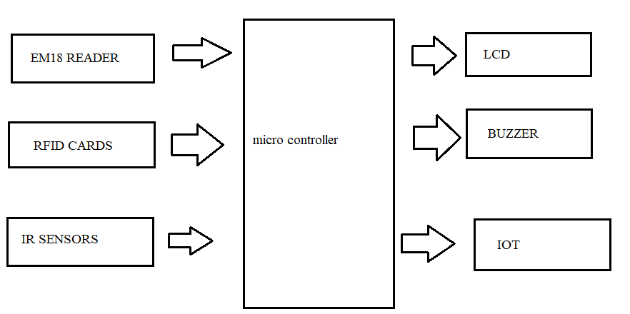

**Figure 1:** Block Diagram

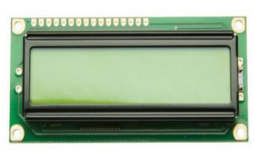**LCD:**After the show is set up and connected accurately, you can utilize commands like "clear show," "move cursor," and "type in character" to transmit content and other data to the show. More complex visualisations are too conceivable since the screen may be set to show user-defined characters or visuals.

**Figure 1:** 16 X2 LCD Display

**Buzzer:**A buzzer is an electronic signalling gadget that regularly produces a buzzing or beeping sound. It comprises of an electromechanical component called a transducer, which changes over electrical vitality into sound waves. When an electrical current passes through the buzzer, it causes the transducer to vibrate, creating the capable of being heard sound.

Buzzers can shift in plan and sound yield, with diverse sorts creating diverse tones, frequencies, and volumes. They can be dynamic (requiring a ceaseless electrical flag to create sound) or inactive (creating sound when a beat of power is connected). Generally, buzzers play a significant part in giving sound-related criticism and signalling in a wide extend of applications.

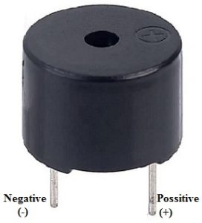

**Figure 2:** Buzzer

**EM18 Reader:** The EM-18 reader module is a device used for reading radio frequency identification (RFID) tags.The EM-18 RFID reader module is a popular RFID (Radio Frequency Identification) reader module widely used in various applications such as access control systems, attendance systems, inventory management, and security systems. The EM-18 module operates at 125 kHz frequency and is capable of reading EM4100 series RFID tags/cards.To use the EM-18 module, you typically connect it to a microcontroller or a computer using the serial interface, and then you can program the microcontroller or computer to interact with the module to read RFID tags/cards. The module sends out the unique 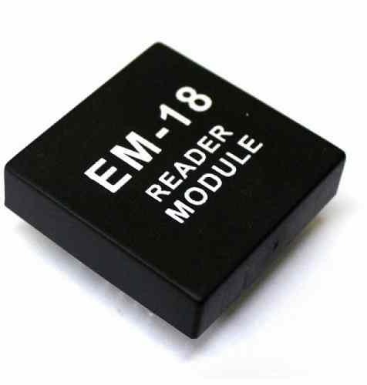identifier of the RFID tags/cards it reads over the serial interface, which can then be processed by the connected device.

**Figure 3:** EM18 Reader

**IR Sensors:** Infrared (IR) sensors are devices that detect or measure infrared radiation in the form of heat emitted by objects. They are commonly used in various applications ranging from remote controls to motion detectors and industrial automation IR sensors work based on the principle of detecting infrared radiation emitted or reflected by objects. They typically consist of an IR emitter (a source of infrared radiation) and an IR detector (which senses the radiation). When an object comes within the range of the sensor, it either emits its own IR radiation or reflects the IR radiation emitted by the sensor. The detector then measures the intensity of IR radiation, which changes with the presence and characteristics of the object.

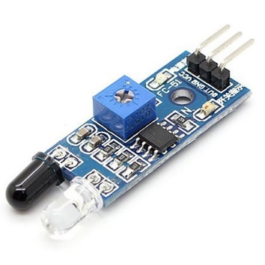

**Figure 4:** IR Sensor

**RFID Cards**: RFID (Radio Frequency Identification) cards are small, portable devices that contain embedded RFID chips. These cards are widely used for various applications such as access control, identification, payment systems, inventory management, and more. The RFID technology enables wireless communication between the card and a reader device using radio frequency signals.

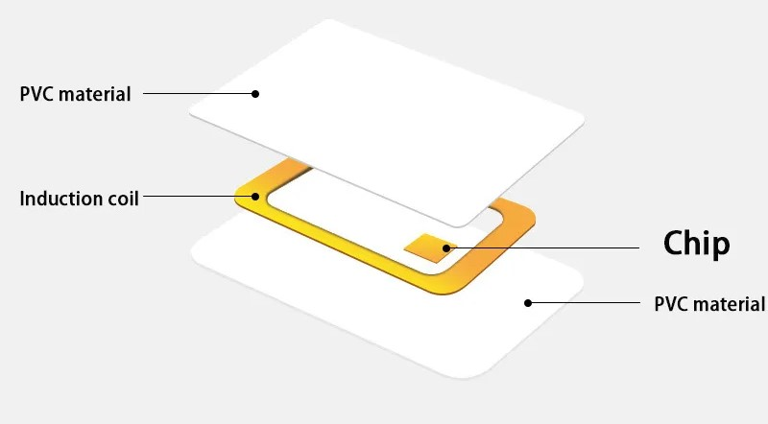

**Figure 5:** RFID Cards

**III. FUNCTIONAL BLOCKS OF PROPOSED SYSTEM**

The ESP32 supports three types of I/O modes with each GPIO Pin: Digital, Analog and Internal Sensors.

**Analog:** Used to send/receive analog data using the following functions:

# examples based on Arduino IDE

analogRead();

analogWrite();

Digital: Used to send/receive digital data using the following functions:

# examples based on Arduino IDE

digitalRead();

digitalWrite();

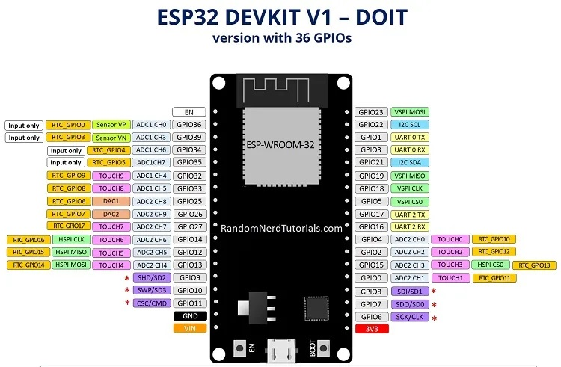

**Figure 7:** Esp32 Board Guide

The ESP32 Dev Kit C is a popular development board for the ESP32 microcontroller. Here's a breakdown of its key pin functionalities:

**Power:** Micro-USB: Gives control and programming interface through USB connection.

5V & 3.3V: These pins permit outside control supply. The onboard controller changes over 5V to 3.3V if needed.

Important Note: The ESP32 chip works at 3.3V. Never apply voltages surpassing 3.3V to any stick, as it can harm the chip.

**General Purpose Input/Output (GPIO) Pins:** 39 advanced pins: Out of these, 34 can be utilized as GPIOs for different functionalities like advanced input, yield, PWM (Beat Width Balance), SPI (Serial Fringe Interface), I2C (Inter-Integrated Circuit), and ADC (Analog-to-Digital Converter).

**D0 - D3, CMD, CLK:** These pins are saved for inside communication between the ESP32 and SPI streak memory. Maintain a strategic distance from utilizing them for outside connections.

**GPIO16 & GPIO17:** Accessibility depends on the particular ESP32 module on the board. They might be saved for inner utilize on ESP32-WROVER modules but are usable for common purposes on ESP32-WROOM and ESP32-SOLO-1 modules.

**Other Notable Pins:** Strapping pins (GPIO 0, 2, 4, 5, 12, 15) These pins are utilized to put the ESP32 into diverse modes like boot or blazing mode. The Dev Pack C ordinarily sets these pins naturally amid operation.

**IV. HARDWARE EXPERIMENTAL RESULT**

**Under Normal Condition**

Under normal condition the all the components are in rest position and when the any activity done at the bank the components are get alert and do their operations. The below figure shows the normal condition of the components

**Under Working Condition**

In working condition when we scan the RFID cards on scanner, the scanner scan the card and open the door.If the card is invalid it does not open the door. At the door opening time and closing time the Buzzer makes sound for alerting. The LCD shows the operation of the locker system is it open or close. The IR sensors sense the motion and sends the signal to the controller. If the person is present in front of sensor then the scanner scan the card other wise it do not scan the card

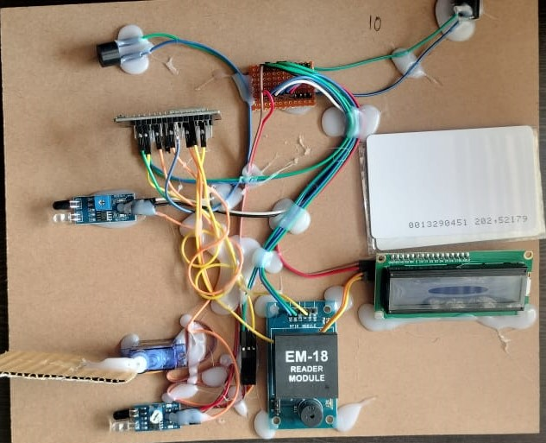 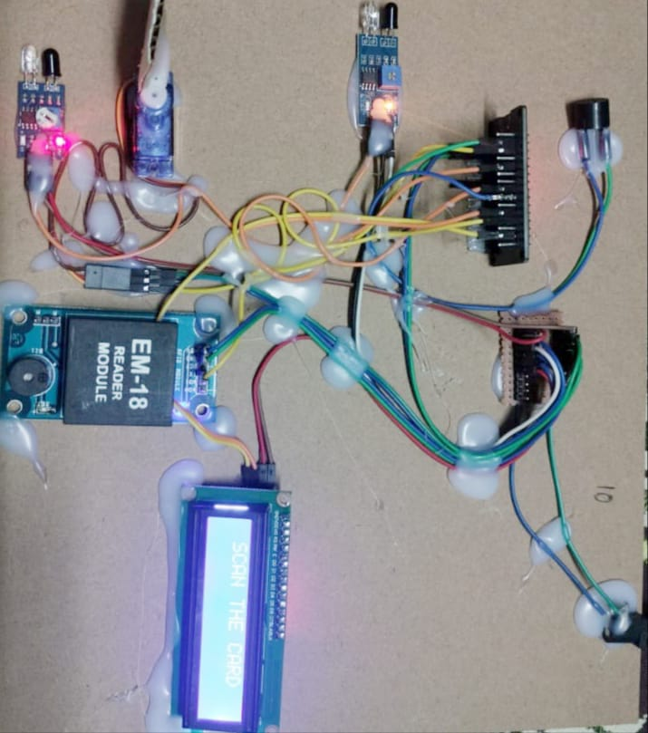

**Figure 8:** Under Normal Condition **Figure 9:** Under Working Condition

**V. BLYNK APPLICATION**

Firstly, install or download Blynk apps for Android or iOS at the Google Play Store or App Store. To interface with Arduino, the user needs to install the Blynk library in the library folder of the Arduino IDE. After finishing the installation, open the apps on the smartphone and create a new account to login for a new project. For this project, the hardware selected is a Node MCU, and the communication type is WiFi ESP8266. There are two modes of display on the screen of the LCD, which also reflects on the screen of the smart phone using the Blynk application. On the screen, it displayed the working of the bank locker door. When the door is open the app shows the IN reading from 0 to 1 and also the green light will blow in IN mark. When the door is closed the app shows OUT reading from 0 to 1 and the ALERT system will blow in Red light.

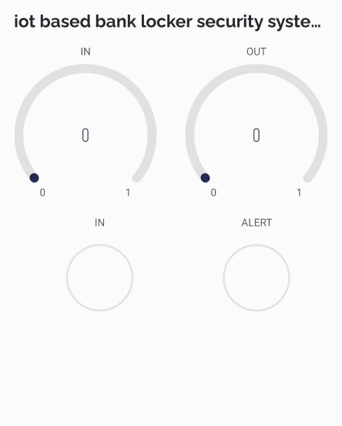

**Figure 16**: Using Blynk App

**VI.CONCLUSION**

In this ponder, a security framework is proposed by utilizing inactive RFID and Voice control. It is a moo fetched, moo in control conception, compact in measure and standalone framework. The microcontroller compares the two passwords entered by PC. If these passwords are redress, the microcontroller gives vital control flag to open the bank locker something else the door remains bolted. The proposed framework can be utilized in other places such as office and library and Banks. Future work of this framework can be made strides by applying the security system based on GSM and secret word for superior security of the individual. The inquire about recommends a security arrangement that combines detached RFID with voice control. This framework is totally self-contained, little, cheap, and vitality productive. At the PC's input, the microcontroller compares the two passwords. Once the microcontroller confirms the passwords, it opens the bank locker; something else, it remains bolted. Workplaces, libraries, and banks are fair a few more potential areas for the recommended framework to discover utilization. To make this framework indeed more secure in the future, it might utilize a GSM and secret word security framework.

**VII. REFERENCES**

[1]. Parvathy A, Venkata Rohit Raj, Venumadhav, Manikanta, “RFID Based Exam Lobby Maintenance System’’, IJCA Uncommon Issue on “Artificial Insights Methods - Novel Approaches & Commonsense Applications” AIT, 2011

[2]A.V.R.Mayuri, M.V.Surbramanyam,” QoS variance Aware Spectrum Sensing and Allocation Strategy for Cognitive Radio Wireless Mesh Networks”, GLOBAL JOURNAL OF COMPUTER SCIENCE AND TECHNOLOGY:E NETWORK.WEB AND SECURITY , Vol.15,No.2,PP.1-6,2015.

[3]P.Raghunath, Dr.M.V.Subramanyam, “Communication coverage in wireless passive sensor networks”, International conference on recent advances in e communication & I technologies.

[4]V.Jyothi, Dr.M. V. Subramanyam “ An Enhanced technique to improve the Network Lifetime of Cognitive Sensor Networks’, International Journal of Wireless Personal Communications’ pp. 12757 – 12763, May-2021 DOI https://doi.org/10.1007/s11277-021-08575-0 [SCI].

[5]**M. Yerri Veeresh** and N.V.S. Prasad, Hardware Implementation of Automatic Power Factor Correction by Using Capacitive Bank and Aurdina Micro Controller, Journal of Emerging Technologies and Innovative Research (JETIR), ISSN: 2349-5162, Volume-6, Issue-5, May-2019. Pg.no: 1950-1955. **(UGC Approved) Impact Factor: 5.87.**

**[6] A. Raghavendra Prasad,M.Y.Veeresh,N.V.S.Prasad,** Hardware Implementation of Automatic Power Factor Correction by Using Capacitive Bank and Aurdina Micro Controller, Journal of Emerging Technologies and Innovative Research (JETIR), ISSN: 2349-5162, Volume-6, Issue-5, May-2019. Pg.no: 1950-1955. **(UGC Approved) Impact Factor: 5.87.**

**[7]A.Raghavendra prasad,Smar Home Atomation System by Using GSM and Arduino Technologies, Journal of Engineering Technologies and Innovative Research(JETIR),ISSN : 2349-5162**,Volume-6, Issue-5, May-2019. Pg.no: 1950-1955. **(UGC Approved) Impact Factor: 5.87.**

[8]. R.Ramani , S. Selvaraju , S.Valarmathy, P.Niranjan , “Bank Locker Security System based on RFID and GSM Technology’’, International Journal of Computer Applications (0975 – 8887)

[9]. Abhilasha A Sayar1 , Dr. Sunil N Pawar2 , “Review of Bank Locker System Using Embedded System” , International Journal of Advanced Research in Computer and Communication Engineering .

[10]. A Digital Security System with Door Lock System Using RFID Technology‖, Gyanendra K Verma, Pawan Tripathi, 2010.

[11]. Locker Security System Using RFID And GSM Technology‖, Aruna. D.Mane1 and Sirkazi Mohd Arif 2, 2013.

[12]. Malik Sikandar Hayat Khiyal, Aihab Khan, and Erum Shehzadi. “SMS Based Remote Home Apparatus Control Framework (HACS) for Robotizing Machines and Security”, Issues in Illuminating Science and Data Innovation. Vol. 9. pp. 887 – 894. 2009.

[13]. Al-Ali, A.R. Rousan, M.A. Mohandes, M. “GSM-Based Remote Domestic Apparatuses Monitoring & Control System”, Procedures of Universal Conference on Data and Communication Advances: From Hypothesis to Applications, pp 237-238, 2004.

[14comp]. Carelin Felix and I. Jacob Raglend, “Home Computerization Utilizing GSM”, Procedures of 2011 Universal Conference on Flag Preparing, Communication, Computing and Networking Innovations, pp. 15-19, 2011.

gsm