**INDUSTRIAL RESEARCH REPORT**

**NIKE VS ADDIDAS COMPETATIVE ANALYSIS**

**Project Report submitted in partial fufilment for the award of the degree ofBACHELOR OF BUSSINESS ADMINISTRATION**

**Submitted by**

***SUDHANSHU KUMAR SINGH***

**NAME OF THE CANDIDATE**

SUDHANSH KUMAR SINGH

21GSOB1060038

**NAME OF THE SCHOOL**

SCHOOL OF BUSSINESS

**Under the Supervision OF**

**DR ANSHU GOEL**



MAY/2024







**BONAFIDE CERTIFICATE**

Certified that this project report **“INDUSTRIAL RESEARCH REPORT”** is the bonafide work of Sudhanshu kumar singhwho carried out the project work under my supervision.

**SIGNATURE SIGNATURE**

**SUPERVISOR**

DR ANSHU GOEL

**Approval Sheet**

This thesis/dissertation/report entitled ‘**Industrial research report** approved By **SUDHANSHU KR SINGH** is for the degree of **BBA**

Supervisor (s)

**Date:**

**Place:**

**Statement of Project Report Preparation**

a. Thesis title: ……………………………………………………………..

1. Degree for which the report is submitted: ……………………………………
2. Project Supervisor was referred to for preparing the report.
3. Specifications regarding thesis format have been closely followed.
4. The contents of the thesis have been organized based on the guidelines.
5. The report has been prepared without resorting to plagiarism.
6. All sources used have been cited appropriately.
7. The report has not been submitted elsewhere for a degree.

(Name of the student)

NAME-SUDHANSHU KR SINGH 21GSOB1060038

|  |
| --- |
| **TABLE OF CONTENT**  **CHAPTER -1**   * INTRODUCTION * **CHAPTER -2 REVIEW AND LITRATURE** * BACKGROUND FACTORS * NECESSITY OF THE PROJECT * SITUATIONAL ANALYSIS * **CHAPTER 3 - OBJECTIVE** * THE GENERAL OBJECTIVE * RESEARCH DESIGN AND METHODOLOGY * SAMPLING DESIGN AND PLAN * **CHAPTER 4- DATA COLLECTION** * ONLINE SURVEY * IN DEPT INTERVIEW * RETAIL OBSERVATION * **CHAPTER 5 – DATA ANALYSIS** * QUALITATIVE ANALYSIS * QUANTATIVE ANALYSIS * DATA INTEGRATION * **CHAPTER 6** * INTERPERTATION * FINDINGS * SUMMARIZE AND GRAPS * **CHAPTER-7** * LIMITATION * CONCLUSION * REFRENCES |

**INTRODUCTION**

Nike and Adidas employ similar strategic frameworks, yet each brand distinguishes itself through unique implementation methods. Both companies place a premium on innovation and technological advancement in their product lines.

Nike predominantly targets the American market, while Adidas directs its focus toward Europe. Nike's operational model eschews manufacturing units, instead prioritizing design, distribution, and marketing, with production outsourced to Asian countries such as Taiwan, Korea, China, Indonesia, and Vietnam. In contrast, Adidas traditionally manufactured all its products in Germany but has recently adopted Nike's outsourcing strategy, leveraging Asian manufacturers.

During the 2010 World Cup, Nike launched the highly successful "Write the Future" advertisement, featuring top players and amassing significant views on platforms like YouTube. In response, Adidas debuted an ad with a Star Wars theme, showcasing celebrities like Snoop Dogg and Daft Punk. Despite officially sponsoring the event and supporting 12 teams compared to Nike's nine, Nike captivated fans by installing an LED display on a Johannesburg skyscraper. This interactive display enabled soccer enthusiasts to share messages via social media platforms like Twitter and Facebook, with Nike highlighting 100 messages each night.

In the domain of athletic footwear, various terms such as trainers, running shoes, sneakers, and tennis shoes are employed based on regional preferences. These footwear categories are tailored for sports and physical activities, emphasizing functionality and performance

**NIKE Inc.**

Nike, a prominent American multinational corporation headquartered near Beaverton, Oregon, within the Portland metropolitan area, is recognized for its creation, production, and global distribution of footwear, apparel, equipment, accessories, and related services. As a leading supplier of athletic shoes and attire worldwide, Nike recorded revenue surpassing US$24.1 billion for its fiscal year ending on May 31, 2012. With a workforce exceeding 44,000 individuals worldwide as of 2012, it holds a significant presence in the sports industry. Valued at $19 billion in 2014, the Nike brand stands out as the most valuable within the sports sector.

Nike's product lineup encompasses a diverse range of sports equipment, initially rooted in track running shoes but expanding over time to include shoes, jerseys, shorts, cleats, and more, catering to various sports such as track and field, baseball, ice hockey, tennis, soccer, lacrosse, basketball, and cricket. Notable among its offerings is the iconic Nike Air Max, first introduced in 1987, alongside subsequent releases like the Air Huarache in 1992. Recent additions include specialized footwear lines such as Nike 6.0, Nike NYX, and Nike SB, designed specifically for skateboarding enthusiasts.

Additionally, Nike has showcased innovation in cricket shoes, exemplified by the Air Zoom Yorker, engineered to be 30% lighter than comparable models. In 2008, the brand unveiled the Air Jordan XX3, a high-performance basketball shoe designed with environmental sustainability in mind.

.

**Adidas**

Established in 1949 by Adolf Dassler, known as Adi Dassler, Adidas stands as a multinational corporation renowned for its production of sportswear, footwear, and accessories on a global scale. The name "Adidas" originates from a combination of "Adi" (short for Adolf) and "Das" (from Dassler).

Adidas has ingrained itself into sports culture, endorsed by a plethora of athletes and celebrities, with its distinctive three-stripe logo serving as a hallmark of the brand. Its product range encompasses sneakers, sport-specific clothing, accessories, and even sporting equipment.

With a notable presence across various sports, Adidas actively sponsors athletes, teams, and major events worldwide, positioning itself in direct competition with industry giants like Nike and Puma. Constant innovation in design, technology, and sustainability remains a focal point for the brand, ensuring it maintains a leading edge in the market.

Beyond sports, Adidas has expanded its reach into lifestyle and fashion sectors, collaborating with designers, artists, and celebrities to craft exclusive and fashionable collections. Moreover, the brand demonstrates a commitment to sustainability through initiatives aimed at reducing environmental impact, including the use of recycled materials and efforts to minimize water consumption during production processes.

# **BACKGROUND FACTORS**

The rivalry between NIKE and ADIDAS is legendary in the global sportswear industry. Both companies boast a storied history, diverse product offerings, and widespread brand recognition, which have solidified their positions as market leaders over many years.

Founded in 1964, NIKE is celebrated for its iconic Swoosh logo and its association with top-tier athletic gear.

The brand's partnerships with elite athletes and groundbreaking technologies like the Air cushioning system have further cemented its reputation for high-performance products. On the other hand, ADIDAS, established in 1949, is recognized for its distinctive Three-Stripe branding, collaborative ventures with fashion designers, and its focus not only on athletic wear but also on lifestyle and casual apparel.

As consumer preferences and industry dynamics continually shift, comprehending the foundational elements that underpin the competitive rivalry between these two industry giants is essential for crafting effective strategies and maintaining a competitive advantage.

**NECESSITY OF THE PROJECT**

Conducting a competitive analysis between Nike and Adidas holds significant importance for several reasons:

**Market Understanding:** It provides insights into the dynamics of the sportswear market, including emerging trends, customer preferences, and the competitive landscape.

Identifying Strengths and Weaknesses: Through a comparative assessment, strengths and weaknesses in areas such as product innovation, marketing strategies, and supply chain management can be pinpointed for both brands.

Strategic Planning: The analysis serves as a foundation for strategic decision-making, enabling the identification of growth opportunities, potential threats, and areas requiring improvement to maintain competitiveness.

**Benchmarking:** Both Nike and Adidas can gauge their performance relative to each other and the broader market, facilitating benchmarking against competitors.

**Customer Insights**: Understanding customer perceptions and interactions with the brands yields valuable insights for product development, marketing initiatives, and brand positioning strategies.

**Investor Relations**: Investors rely on understanding the competitive landscape to evaluate the investment potential of Nike and Adidas, considering factors like market share, revenue growth, and profitability.

Brand Loyalty and Perception: Analyzing brand loyalty and perception aids in comprehending market sentiment and identifying areas for enhancing consumer connections and loyalty.

**Future Planning:** By assessing innovation, market reach, and brand image, both companies can anticipate future trends and market shifts, enabling proactive adjustments to their strategies.

In summary, a competitive analysis between Nike and Adidas is indispensable for staying informed about market trends, identifying opportunities and threats, and sustaining a competitive advantage in the sportswear industry.

# **SITUATIONAL ANALYSIS**

In the fiercely competitive sportswear market, NIKE and ADIDAS contend for market dominance alongside formidable rivals like UNDER ARMOUR, LULULEMON, and PUMA. Both NIKE and ADIDAS have exhibited robust financial performance, driven by innovative product development and compelling marketing initiatives aimed at fostering brand loyalty and driving sales growth.

**Strengths of NIKE:**

Established market leadership and widespread brand recognition.

Pioneering product technologies such as Air, React, and Flyknit.

Strategic athlete endorsements and sponsorships bolster brand appeal.

Successful expansion into lifestyle and casual apparel segments.

Effective utilization of digital marketing channels and robust e-commerce presence.

**Strengths of ADIDAS:**

A versatile product portfolio spanning athletic, lifestyle, and fashion categories.

Successful collaborations with esteemed fashion designers and influential celebrities.

Commitment to sustainability and eco-friendly initiatives throughout operations.

A robust international footprint with a focus on emerging markets.

Proficient use of social media platforms and influencer marketing strategies.

Common Challenges Faced by Both Brands:

Adapting to shifting consumer preferences and the increasing demand for personalized products.

Competing against agile, smaller brands that can swiftly respond to market trends.

Managing supply chain disruptions and optimizing inventory management practices.

Sustaining brand relevance amidst rapid digital transformation in the retail landscape.

In summary, amidst intense competition and evolving market dynamics, NIKE and ADIDAS leverage their respective strengths while navigating shared challenges to maintain their positions as leaders in the sportswear industry.

**QUESTIONS**

* When undertaking a competitive analysis between Nike and Adidas, it's essential to explore the following key questions:
* Market Positioning and Strategy:
* How does each company position itself within the sportswear market?
* What are the primary target markets for Nike and Adidas, and how do they tailor their products and messaging to appeal to these segments?
* What strategic priorities and objectives guide the actions of each brand?
* Product Offering and Innovation:
* What are the core product categories and offerings of Nike and Adidas?
* How do their product portfolios compare in terms of innovation, quality, and variety?
* What recent innovations or product launches have both companies introduced, and how have they been received by consumers?
* Marketing and Branding:
* What are the predominant marketing channels and strategies utilized by Nike and Adidas?
* How do they differentiate their brands in terms of values, messaging, and overall image?
* Which recent marketing campaigns have demonstrated notable success for each brand?
* By delving into these aspects, a comprehensive understanding of the competitive landscape between Nike and Adidas can be attained, informing strategic decisions and fostering sustainable growth within the sportswear industry.

**RESEARCH OBJECTIVE**

**The primary objectives of this competitive analysis are:**

1. To compare and contrast the market positioning, brand image, and product offerings of NIKE and ADIDAS
2. To identify the key competitive advantages and differentiating factors that drive consumer preferences between the two brands
3. To understand the evolving consumer trends and preferences that are shaping the sportswear industry

**1.To compare and contrast the market positioning, brand product offerings of NIKE and ADIDAS**

Nike and Adidas stand as premier contenders in the global sportswear industry, each with distinct market positions, brand images, and product offerings.

**Market Positioning Nike:**

Positioned as a premium brand, Nike places a strong emphasis on innovation, performance, and athleticism, targeting athletes and sports enthusiasts across various disciplines.

Highlighting cutting-edge technology like Nike Air cushioning and Flyknit materials, the brand aims to enhance performance and comfort.

Nike's marketing endeavour often spotlight top athletes and celebrities, reinforcing its association with excellence and achievement.

Adidas:

While also targeting athletes and sports enthusiasts, Adidas positions itself as a more inclusive and lifestyle-oriented brand in comparison to Nike.

Balancing performance and innovation with style and fashion, Adidas appeals to a broader audience beyond the realm of athletics.

Notably, Adidas showcases a commitment to sustainability and social responsibility, evident in initiatives such as utilizing recycled materials and reducing carbon emissions in its supply chain.

**Brand Image: Nike:**

Renowned for its iconic "Swoosh" logo and the slogan "Just Do It," Nike embodies a spirit of determination, perseverance, and excellence.

The brand is recognized for its propensity to push boundaries and challenge conventions, often sparking debate with its daring marketing campaigns and sponsorships.

Nike's association with prominent athletes like Michael Jordan, LeBron James, and Cristiano Ronaldo further solidifies its image of athleticism and success.

Adidas:

Identified by its distinctive three-stripe logo, Adidas prioritizes heritage and authenticity in its brand image. Its roots in sports and iconic designs have made it synonymous with streetwear culture.

Cultivating a relaxed and approachable image, Adidas appeals to consumers interested in both style and performance.

Collaborations with fashion icons and celebrities such as Kanye West andBeyoncé have expanded Adidas' influence and reinforced its status as a trendsetter.

Product Offerings: Nike:

Offering a comprehensive array of sports apparel, footwear, and equipment across various categories and activities, Nike consistently introduces cutting-edge technologies and innovations.

Collaborations with athletes and designers result in signature collections and limited-edition releases, further enhancing the appeal of Nike's product lineup.

Adidas:

Presenting a diverse portfolio of sportswear encompassing footwear, apparel, and accessories across categories like soccer, basketball, running, and lifestyle, Adidas parallels Nike in prioritizing innovation.

Lifestyle-oriented collections like Originals celebrate Adidas' heritage and iconic designs, complementing its performance-driven offerings.

In essence, while Nike and Adidas share similarities in their pursuits of excellence and innovation, their unique positioning, brand image, and product strategies set them apart in the competitive sportswear landscape.

**2.To identify the key competitive advantages and differentiating factors that drive consumer preferences between the two brands**

The competitive advantages and factors driving consumer preferences between Nike and Adidas encompass several key dimensions, ranging from product innovation to brand image and marketing strategies:

**Innovation and Technology:**

Nike: Renowned for its relentless pursuit of innovation, Nike consistently introduces cutting-edge technologies and materials in its products. Innovations like Nike Air cushioning, Flyknit, and React foam are synonymous with performance and comfort, appealing to athletes and fitness enthusiasts seeking top-tier gear.

Brand Image and Marketing:

Nike: Rooted in athleticism, excellence, and empowerment, Nike's brand image is exemplified by its iconic "Swoosh" logo and the "Just Do It" slogan, embodying determination and achievement. High-profile marketing campaigns featuring elite athletes reinforce Nike's association with top performance and inspire consumers to strive for greatness.

**Product Diversification and Target Audience:**

Nike: Offering a diverse range of products across multiple sports categories, Nike caters to athletes and enthusiasts of all ages and skill levels. From performance-oriented footwear and apparel to casual lifestyle collections, Nike's extensive lineup ensures broad appeal. The brand's focus on individual sports and prominent athlete endorsements reinforces its connection with specific consumer segments.

**Retail Experience and Community Engagement:**

Adidas: Prioritizing meaningful connections with consumers, Adidas emphasizes innovative retail concepts and community-driven initiatives. Flagship stores showcase the latest innovations, while local activations promote grassroots sports and sustainability efforts. By fostering a sense of belonging and shared values, Adidas cultivates a loyal fan base that extends beyond product preferences.

In essence, while both Nike and Adidas excel in various aspects of their offerings and engagement strategies, their distinct approaches to innovation, branding, and consumer connections contribute to their competitive advantage and influence consumer preferences in the sportswear market

**3.To understand the evolving consumer trends and preferences that are shaping the sportswear industry**

**Sustainability** Consumer Trend The burgeoning demand for sustainable and eco-friendly products pervades various industries, including sportswear. Consumers are increasingly mindful of the environmental consequences of their purchases, prompting brands to prioritize sustainability throughout their manufacturing processes and supply chains. Nike: Nike has taken proactive steps to address sustainability concerns by integrating recycled materials, minimizing waste, and adopting eco-friendly practices in production. Initiatives like Nike's "Move to Zero" campaign exemplify the brand's commitment to achieving zero carbon and zero waste, resonating with environmentally conscious consumers.

**Adidas:** Similarly, Adidas has made significant strides in sustainability, exemplified by initiatives such as "Futurecraft.Loop," which aims to develop fully recyclable running shoes. Collaborations with environmental organizations and investments in eco-friendly materials like recycled polyester and ocean plastic underscore Adidas' dedication to sustainability, appealing to consumers seeking ethically produced sportswear.

**Athleisure and Lifestyle Integration:** Consumer Trend: The ascendance of athleisure wear has blurred the boundaries between sports apparel and everyday fashion. Consumers seek versatile clothing and footwear that seamlessly blend style and functionality, enabling effortless transitions between workouts and daily activities. Nike: Nike's diverse product range caters to both athletic performance and lifestyle wear, positioning it as a preferred choice for consumers seeking fashionable yet functional sportswear. Collaborations with fashion luminaries and celebrities further bolster Nike's presence in the lifestyle market, appealing to trend-conscious consumers. Adidas: With its Originals line, Adidas celebrates its heritage and streetwear ethos, offering retro-inspired designs infused with contemporary flair. By tapping into fashion trends and partnering with influencers, musicians, and artists, Adidas positions itself as a lifestyle brand transcending sports, captivating consumers in search of casual and stylish apparel and footwear.

**Digitalization and Personalization**: Consumer Trend: The advent of e-commerce and digital technologies has spurred consumer expectations for personalized shopping experiences and seamless online interactions with brands. Customization features, virtual try-on tools, and AI-driven recommendations have become increasingly popular among tech-savvy consumers.

**RESEARCH DESIGN AND METHODOLOGY**

* This competitive analysis will employ a mixed-methods approach, combining quantitative and qualitative research techniques to gather comprehensive insights:

#### **Secondary Research**

* + Extensive review of industry reports, market trends, and financial data - Analysis of NIKE and ADIDAS' product portfolios, marketing strategies, and brand positioning - Examination of consumer sentiment and reviews through online channels
  + Conducting in-depth interviews with a diverse sample of sportswear consumers - Implementing online surveys to gather data on brand preferences, purchasing behaviour and customer satisfaction - Observing and analysing consumer behaviour in brick-and-mortar retail stores

#### **Data Integration and Analysis**

* + Synthesizing quantitative and qualitative data to identify key trends, patterns, and insights - Employing statistical analysis and data visualization techniques to uncover meaningful insights - Interpreting the findings to develop strategic recommendations for NIKE and ADIDAS

**SAMPLING DESIGN AND PLAN**

The sampling design for this competitive analysis blends probability and non-probability sampling techniques to ensure a comprehensive and diverse representation:

**Random Sampling**: A selection of participants chosen randomly from a database of sportswear consumers ensures statistical validity and broad generalizability.

Purposive Sampling: Targeted recruitment of consumers based on specific demographic, psychographic, and behavioural criteria aims to capture insights from various consumer segments, enriching the dataset.

**Snowball Sampling:** Utilizing referrals from initial participants to identify and recruit additional respondents, particularly for in-depth interviews, enhances the diversity of perspectives and insights gathered.

The target sample size for the online survey is set at 1,000 respondents, while in-depth interviews will involve 50 consumers. This sample size allows for robust data collection and comprehensive analysis to meet the research objectives effectively.

Distribution Strategies: Nike employs distribution strategies akin to Adidas, expanding into new and emerging markets globally while establishing retail outlets across various countries. Its distribution network encompasses independent distributors, subsidiaries, and licensed partners, ensuring widespread availability. Nike also offers online shopping options, enhancing consumer accessibility and convenience.

**Market Growth and E-commerce**: Despite fierce competition, both Adidas and Nike have experienced significant growth over the past two decades, largely attributed to the rise of e-commerce and internet technologies. Online retailing not only drives sales growth but also enhances operational efficiency by reducing costs.

Promotional Efforts: Promotional activities by both companies primarily focus on product showcases through endorsements and advertising across various channels. Adidas and Nike maintain distinct brand identities, with Adidas renowned for its lightweight sporting shoes, particularly favored by basketball players. This preference is rooted in the unique designs and lightweight characteristics of Adidas footwear, aligning with the demands of basketball athletes.

* Top of Form

Top of Form

**DATA COLLECTION**

The data collection process for this competitive analysis will involve both online and offline methods to ensure a well-rounded and holistic understanding of the NIKE and ADIDAS competitive landscape:

#### **Online Survey**

The online survey will be distributed through various digital channels, including social media platforms, email lists, and specialized consumer panels. The survey will gather quantitative data on brand perceptions, purchasing behaviours, product preferences, and customer satisfaction.

#### **In-Depth Interviews**

Face-to-face and virtual in-depth interviews will be conducted with a diverse sample of sportswear consumers. These qualitative interviews will provide deeper insights into consumer motivations, decision-making processes, and personal experiences with NIKE and ADIDAS products and services.

#### **Retail Observations**

The research team will visit select NIKE and ADIDAS retail stores to observe consumer behaviour, product display and merchandising, and the overall in-store experience. This on-site data collection will complement the online and interview data, providing a more comprehensive understanding of the competitive landscape.

Top of Form

**DATA ANALYSIS**

* The data collected through the online survey, in-depth interviews, and retail observations will undergo a rigorous analysis process to uncover meaningful insights and actionable recommendations for NIKE and ADIDAS:

#### **Quantitative Analysis**

* + The survey data will undergo analysis utilizing statistical methodologies including descriptive statistics, regression analysis, and hypothesis testing. Through these techniques, patterns, trends, and correlations in consumer preferences, purchasing behaviors, and brand perceptions between NIKE and ADIDAS will be identified, enabling a comprehensive understanding of the competitive landscape.

#### **Qualitative Analysis**

* + The interview transcripts and observation notes will undergo thematic analysis and coding to uncover common themes, pain points, and insights. This qualitative approach aims to delve deeper into the underlying motivations and decision-making processes of sportswear consumers, enriching our understanding of their preferences and behaviors.

#### **Data Integration**

* + The quantitative and qualitative findings will be amalgamated to form a comprehensive and holistic understanding of the competitive landscape. Through this integration, the research team will pinpoint areas of convergence and divergence between NIKE and ADIDAS, revealing strategic opportunities for differentiation and growth. The culmination of this analysis will be presented in a detailed report, supplemented with visual aids like charts and graphs, to effectively convey the research outcomes. This report will not only communicate the findings but also offer actionable recommendations tailored for both NIKE and ADIDAS.

Top of Form

**INTERPRETATION**

**Data Collection Methods**: This research primarily utilized questionnaires as the primary data collection method to understand the factors influencing customer perceptions. Questionnaires are commonly employed for data collection, alongside observation, case studies, and projective techniques. Secondary data from reputable sources such as publications, case studies, and research papers were also utilized to gain insights into industry and company profiles.

**Sampling: Population:** The population consists of all Indian customers sharing common characteristics, with its size determined by the number of elements within it. Sample Size: The sample, a subset of the population, comprises target customers of Adidas and Nike in India. Due to time and resource constraints, the sample size for this study consisted of 217 respondents. To mitigate sampling errors, questionnaires were distributed electronically via email and various social media platforms, allowing respondents sufficient time to complete them. Sampling Technique:

Two main sampling techniques are probability and nonprobability sampling. Probability sampling involves selecting samples based on the theory of probability, using methods like simple random, systematic, stratified, and cluster sampling. Nonprobability sampling relies on the researcher's judgment, including convenience, quota, judgment, and snowball sampling. This study employed convenience sampling, a nonprobability technique chosen for its efficiency in collecting timely data and avoiding low response rates.

Top of Form

**FINDINGS**

A competitive analysis between Nike and Adidas typically encompasses various facets of their operations, encompassing brand positioning, product offerings, marketing strategies, financial performance, and more. Key findings often include:

**Brand Positioning:** Nike emphasizes innovation and performance, targeting athletes and active individuals, while Adidas focuses on lifestyle and fashion, appealing to a broader audience beyond sports enthusiasts.

**Product Range**: Both companies offer diverse product lines including footwear, apparel, and accessories. Nike dominates in performance sports like basketball and running, whereas Adidas excels in lifestyle segments such as streetwear and fashion collaborations.

**Market Share:** Nike generally holds a larger global market share, particularly in the United States, while Adidas has made significant gains in markets like Europe and China.

**Innovation:** Nike is renowned for pushing boundaries in product design and technology, while Adidas also invests in innovation but may not always be seen as leading the pack.

**Marketing Strategies:** Nike emphasizes high-profile endorsements and emotionally resonant advertising campaigns, while Adidas focuses on grassroots marketing and collaborations with influencers and designers.

**Financial Performance**: Nike typically boasts higher revenues and profits, but both companies have experienced growth, driven by factors like e-commerce expansion and international sales.

**Retail Presence**: Nike and Adidas operate a mix of company-owned stores and third-party distribution. Nike has been prioritizing direct-to-consumer channels, including online sales and branded retail locations.

**Sustainability Initiatives**: Both Nike and Adidas are committed to sustainability, aiming to reduce their environmental impact, which can influence consumer perceptions and purchase decisions.

**Global Expansion**: Both companies are focused on expanding their presence in emerging markets, particularly in Asia, where significant growth potential exists.

**E-commerce and Digital Strategy:** Nike and Adidas are investing in their online presence and digital marketing efforts to tap into the growing e-commerce market and engage with consumers directly.

**SUMMARIZE AND GRAPH**

Here's a summarized competitive analysis between Nike and Adidas, along with a comparative graph:

**Brand Positioning:**

**Nike:** Emphasizes innovation and performance, targeting athletes and active individuals.

**Adidas**: Centers on lifestyle and fashion, appealing to a wider audience beyond sports enthusiasts.

Product Range:

**Nike:** Strongly positioned in performance sports like basketball and running.

**Adidas:** Noteworthy presence in lifestyle segments such as streetwear and fashion collaborations.

Market Share:

**Nike:** Generally holds a larger global market share, particularly dominant in the United States.

**Adidas**: Experiencing growth, particularly notable in Europe and China.

Innovation:

**Nike**: Renowned for pioneering new materials and manufacturing techniques.

**Adidas:** Also invests in innovation but may not always lead in this regard.

Marketing Strategies:

**Nike:** Leverages high-profile athlete endorsements and emotionally resonant advertising

campaigns.

**Adidas**: Prioritizes grassroots marketing and partnerships with influencers and designers.

Financial Performance:

**Nike**: Enjoys higher revenues and profits compared to Adidas.

**Adidas**: Demonstrating growth, propelled by expansions in e-commerce and international markets.

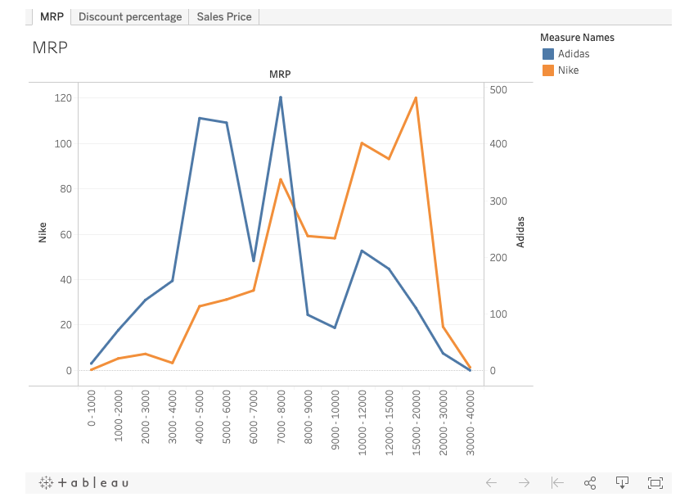

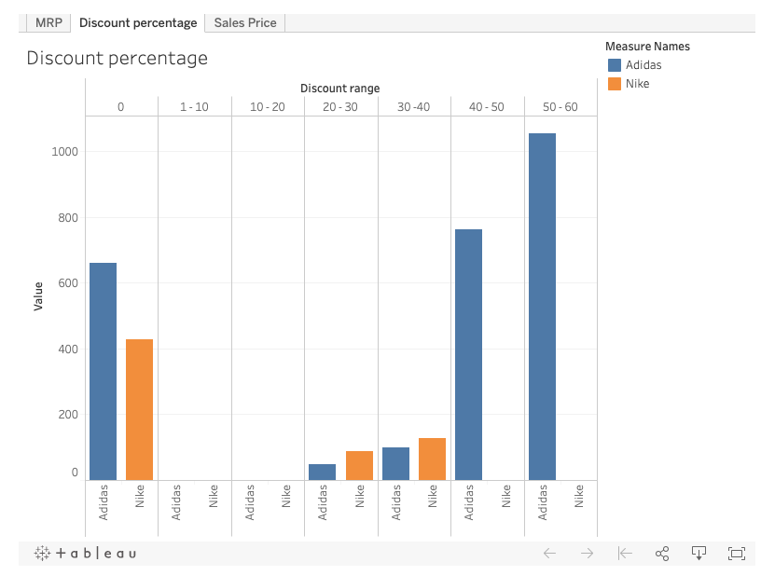

The discount percentage of Addidas is slightly more in comparison of Nike and it is showing the graph is showing that Nike follow less discount percentage strategies if we see in the following bar graph adidas is moving towards more MRP discounts

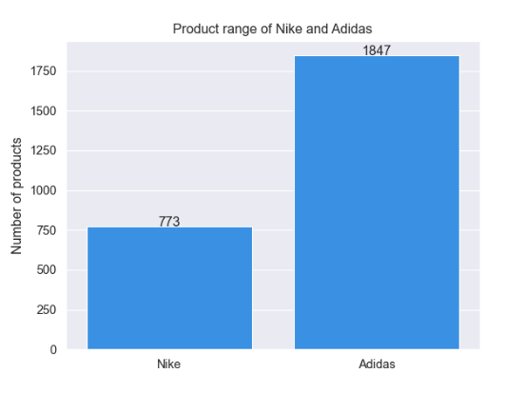

In this graph we can see that Product Range of Nike is less and Adidas has more and the difference is also high in numbers total number of products which Adidas has is on the higher side because adidas has more diversified buyers.

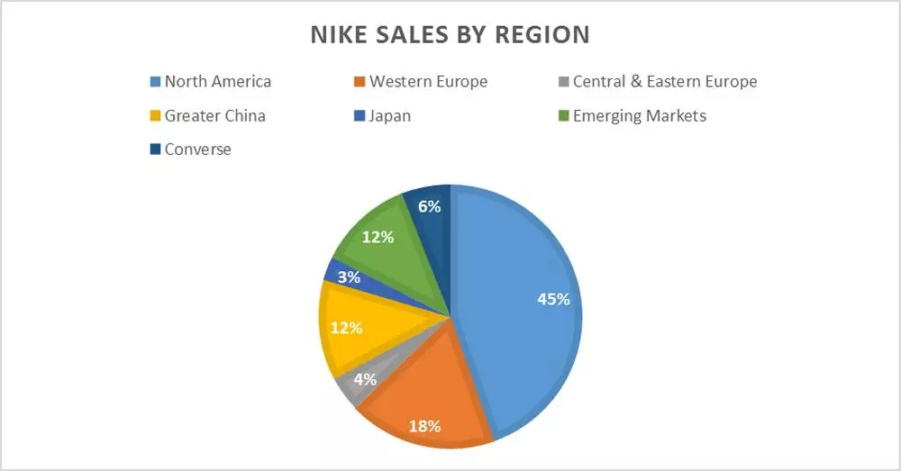

Nike has its highest sales in North America and also it is a brand of north America if we see the lowest number of sales that is shown in Central and Eastern Europe.

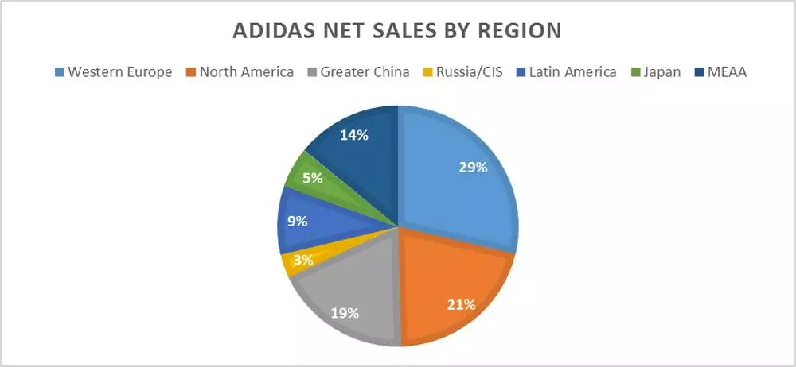

In this Pie chart we can see net sales of Addidas by region and also we can understand that this pie chart is showing highest sales of adidas is located in western Europe region and if we look after the lowest sales that is shown in Russia/cis region.

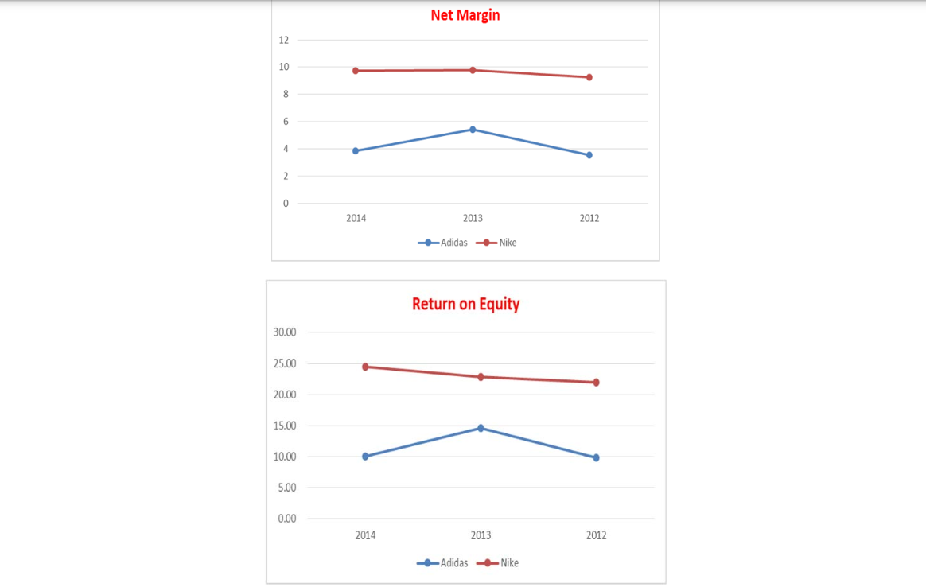

In this Line chart we can understand that the Net margin of Nike is Not expanding and in Addidas it is expanding and showing more Growth in terms of net margin Addidas is making more net margin.

Now if we see return on equity in both Nike and Addidas then we can clearly understand that Addidas has higher return as compared to Nike and also Addidas is moving upwards.

Adidas has higher financial leverage than Adidas, which indicates that Adidas depends in debts more than Nike. Nike depends on Internal funding more than external funding. The chart below summarize the comparison of three years ( FactSet Fundamentals, 2014).

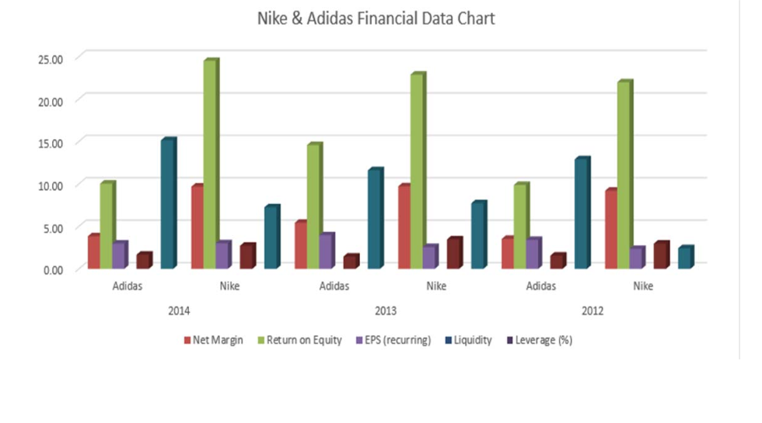

**DATA COLLECTION BASED ON ONLINE SURVEY**

In this Pie chart the survey report shows that most of the Shoes buyers of Nike and Addidas are above age 20 and are Adults.

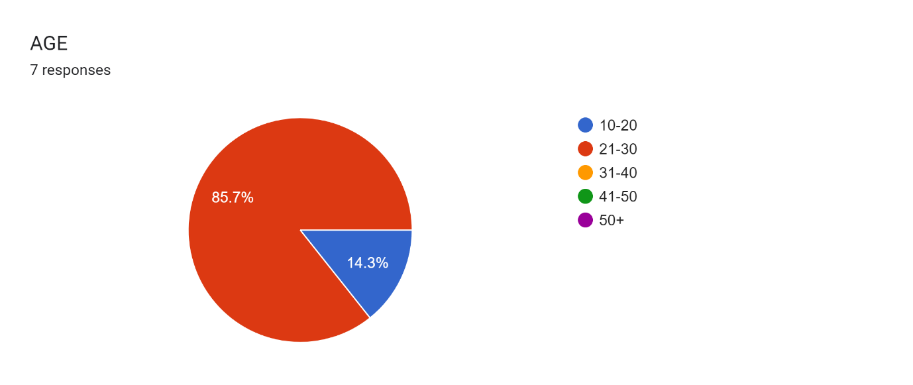

Top of Form

Forms response chart. Question title: MONTHLY INCOME
                      . Number of responses: 7 responses.Now if we talk about monthly income as per the survey report which is shown in this pie chart is below 1 lakh because the survey includes people who are mostly students.

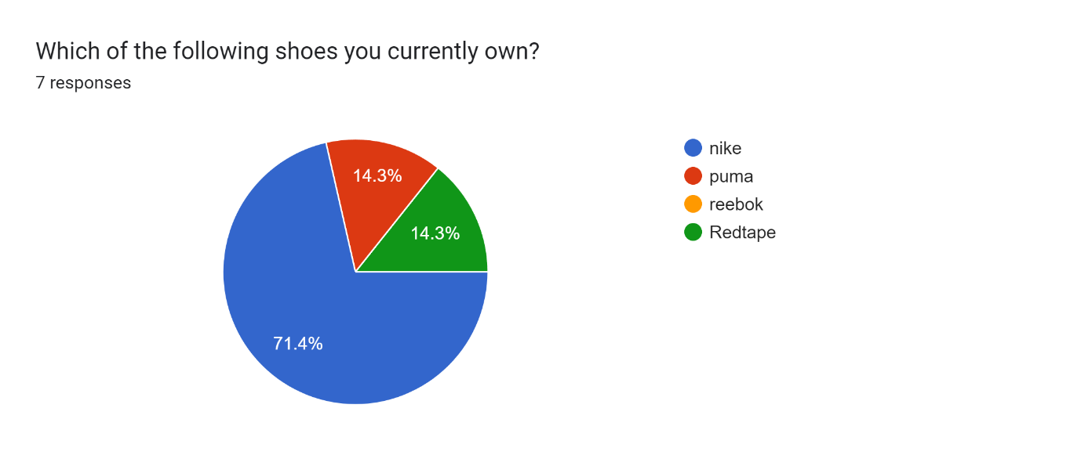Most the people own Nike shoes as the survey results shows are this includes people of different age groups while puma and Redtape has equal users.

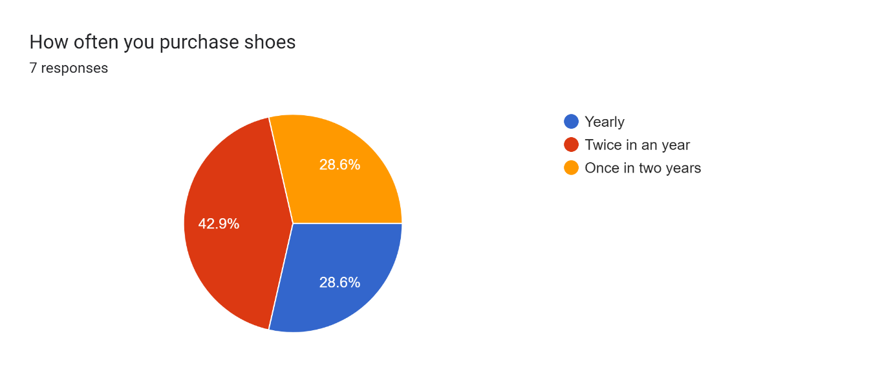This pie chart shows most people purchased shoes twice a year and less people purchase shoes yearly and also this survey includes peoples of different age groups.

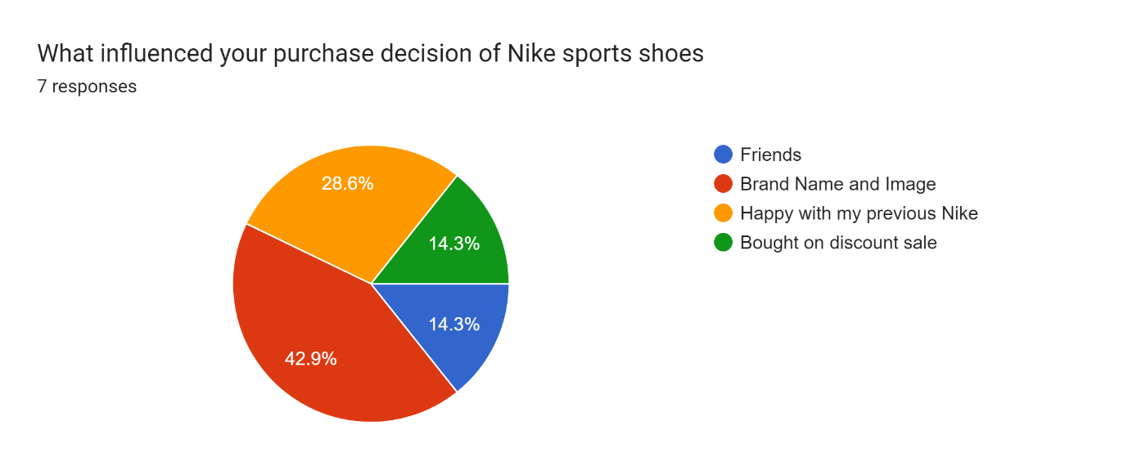If we talk about what influenced buyers to make purchase then if shows in above pie chart that brand name and its image has an impact on people to purchase shoes. **LIMITATION**

While conducting a competitive analysis between Nike and Adidas yields valuable insights, it's crucial to recognize certain limitations:

**Data Availability**: The accuracy and depth of the analysis heavily depend on the availability of reliable data. Information regarding internal strategies or performance metrics may not always be publicly accessible, potentially limiting the analysis.

**Dynamic Market Conditions:** The sportswear industry's competitive landscape is constantly evolving due to factors like shifting consumer preferences, economic fluctuations, and technological advancements. Any analysis represents a snapshot in time and may not capture ongoing changes or future trends.

**Geographic Variations**: Competitive dynamics between Nike and Adidas can vary significantly across different regions and markets. Cultural preferences, regulatory environments, and competitive pressures may influence their relative positions differently in each market.

**Subjectivity in Perception:** Assessments of brand image, marketing effectiveness, and consumer preferences are subjective and may vary based on individual perspectives or biases. While market research can provide insights, interpretations of brand perception may not always align with objective reality.

**Incomplete Scope**: Competitive analyses often focus on specific dimensions like product offerings, marketing strategies, or financial performance, potentially overlooking other critical factors such as supply chain management, corporate culture, or strategic partnerships that could impact competitiveness.

**Future Uncertainty**: Predicting future developments and market outcomes with certainty is inherently challenging. While competitive analyses can identify current strengths, weaknesses, opportunities, and threats, they may not accurately forecast how external factors or strategic decisions will unfold over time.

**CONCLUSION**

* Top of Form

In conclusion, the comparative market strategy analysis highlights the success of Nike and Adidas in achieving high sales through effective marketing strategies. Manufacturers in the sports goods industry must diligently promote their products amidst market growth, employing unique marketing techniques in this competitive landscape. Research indicates the utilization of an integrated marketing strategy by global players, combining various approaches like direct marketing, personal selling, public relations, and advertising, with communication facilitated through social media, radio, and television channels.

Both Nike and Adidas adhere to a Value-for-Money philosophy, recognizing it as a crucial driver of success. Understanding and harnessing this principle is imperative for sustained growth amid global challenges. Insights gleaned from the research underscore several key points:

Male consumers exhibit a stronger preference for Nike and Adidas compared to female consumers.

When selecting sport shoes, males prioritize style, whereas females prioritize price, comfort, and durability.

Nike is preferred as a gift over Adidas.

These findings suggest areas where Nike and Adidas can refine their marketing strategies to enhance customer satisfaction and competitive positioning. By adapting to these insights, both companies can effectively differentiate themselves and better compete not only with other firms but also with each other, thus maintaining their prominence in the dynamic sports goods market.

**REFRENCES**

**WEBSITE-**

<https://www.michael84.co.uk/adidas-vs-nike-which-is-the-best-heres-everything-you-need-to-know/>

<https://www.forbesindia.com/article/lifes/nike-vs-adidas-which-sports-brand-will-win-the-battle-for-designer-fashion/76595/1>

<https://www.economist.com/business/2023/03/23/can-adidas-ever-catch-up-with-nike>

**SEARCH ENGINE**-

[**https://www.google.co.in/**](https://www.google.co.in/)

[**https://in.search.yahoo.com/?fr2=inr**](https://in.search.yahoo.com/?fr2=inr)

