**AI ASSISTANT FOR VISUALLY IMPAIRED PEOPLE**

**Vishal Khedkar1, Aditya Khomane2, Sushant Pawar3, D.Poul4**

1,2,3UG Student, Department of Electronics and Telecommunications, Imperial College of Engineering and Research, Pune, India.

4Proffesor, Department of Electronics and Telecommunications, Imperial College of Engineering and Research, Pune, India.

**ABSTRACT**

In today's advanced hi-tech world, the need of independent living is recognized in case of visually impaired people who are facing main problem of social restrictiveness. This study presents the design and implementation of an AI assistant tailored specifically for visually impaired individuals, aimed at enhancing their autonomy and accessibility in various aspects of daily life. With the recent advances in inclusive technology, it is possible to extend the support given to people with visual impairment. This project is proposed to help those people who are blind or visually impaired using Artificial Intelligence, text-to-speech conversion, Text Recognition, voice-activated commands and personalized assistance. The idea is implemented through Android mobile app that focuses on voice assistant, WhatsApp Phone Call, Video Call, Send Text Message, chat bot etc. The app is capable to assist using voice command to recognize objects in the surrounding, do text analysis to recognize the text in the hard copy document. It will be an efficient way in which blind people can also interact with the environment with the help of technology and utilize the facilities of the technology.

**Keywords –** AI Assistant, Voice Command , NLP, Speech Recognition, Text to Speech, Personalization..

# INTRODUCTION

The Visual impairment is a major disability faced by the visually challenge people. A person who cannot see can never feel the emotion that a person feels who can see the world. This visibility problem is a black dot faced by billions of people around the entire world. Our aim is to remove this black dot with the help Artificial Intelligence.

Imagine a world where navigating daily tasks, accessing information, and staying independent isn't limited by vision. For millions of visually impaired individuals, this is the promise of Artificial Intelligence (AI) assistants. These innovative tools are revolutionizing the way people with visual impairments experience the world, offering a new level of autonomy and empowerment.

# PROBLEM STATEMENT

To Design and implement Application of AI Assistant for Visually Impaired People.

# METHEDOLOGY

Requirement Analysis:

* Understand the purpose, scope, and target users of the AI assistant.
* Define the primary functions and capabilities required.

Design Thinking:

* Employ design thinking techniques to ensure the AI assistant meets user needs and provides an excellent user experience.
* Use prototyping to visualize and refine the user interface and user experience.

Natural Language Processing (NLP) Development:

* Implement NLP techniques to understand and respond to natural language inputs.
* Use libraries such as NLTK, SpaCy, or Hugging Face Transformers for NLP tasks.

Data Collection and Annotation:

* Collect and annotate a diverse dataset to train and test the NLP and ML models.
* Ensure the dataset is representative of the user base and use case scenarios.

# BLOCK DIAGRAM

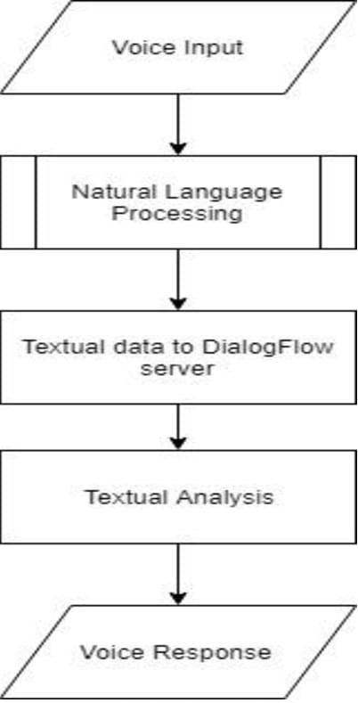

**FIG 1 AI Assistant ChatBot Flowchart**

**ALGORITHM**

**1. Speech Recognition:**

- Algorithm: HMM or CNN

- Steps: Preprocessing, Training, Decoding

**2. Natural Language Understanding (NLU):**

- Algorithm: NLP combined with ML

- Steps: Tokenization, Parsing, NER, Sentiment Analysis, Intent Recognition, Contextual Understanding

**3. Dialog Management:**

- Algorithm: FSM, Rule-Based Systems, or Reinforcement Learning

- Steps: Define States, Implement Rules, Reinforcement Learning

**4.** **Knowledge Graphs:**

- Algorithm: Graph databases

- Steps: Create Graph, Implement Algorithms, Continuous Update

**5. Text-to-Speech (TTS) and Speech-to-Text (STT):**

- Algorithm: Concatenative Synthesis or Parametric Synthesis for TTS; DNN for STT

- Steps: TTS: Preprocessing, Synthesis; STT: Feature Extraction, Acoustic Model, Language Model

RESULTS

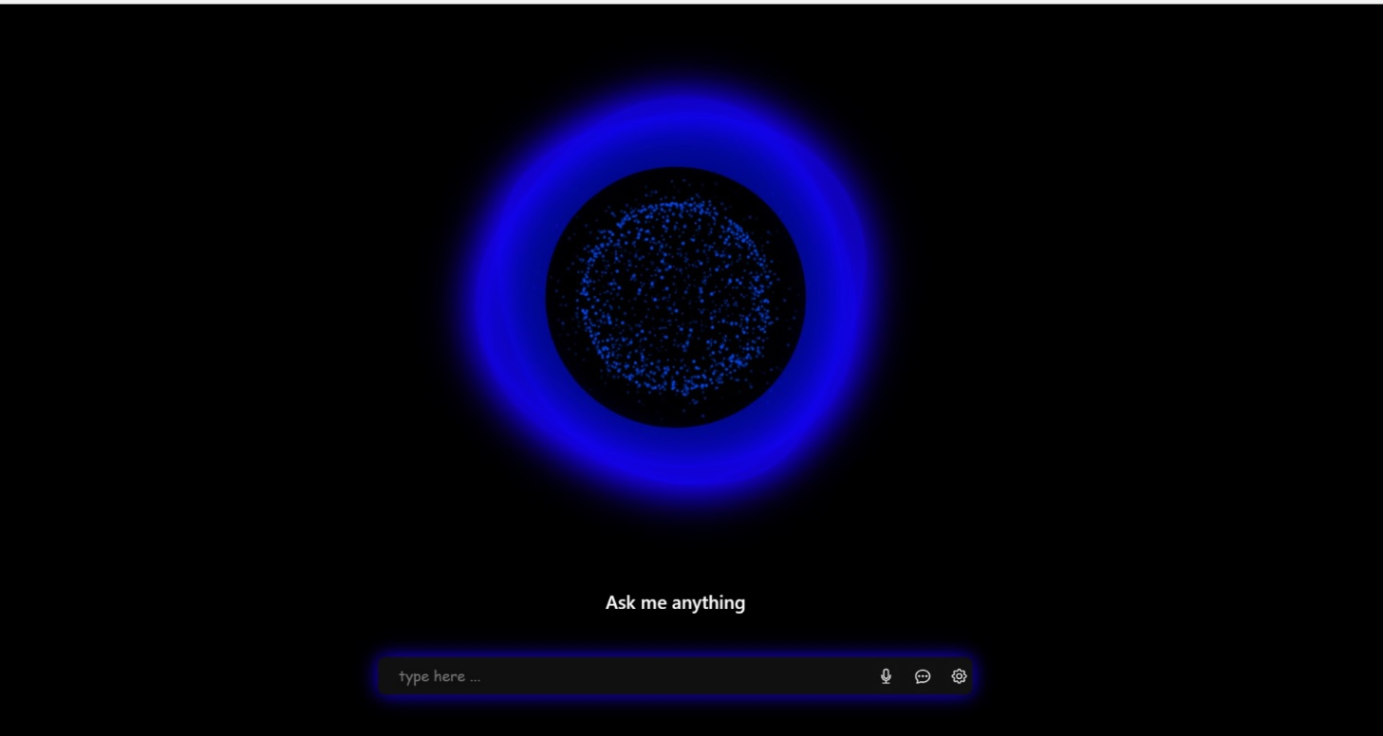

**Figure 2.** Home Page

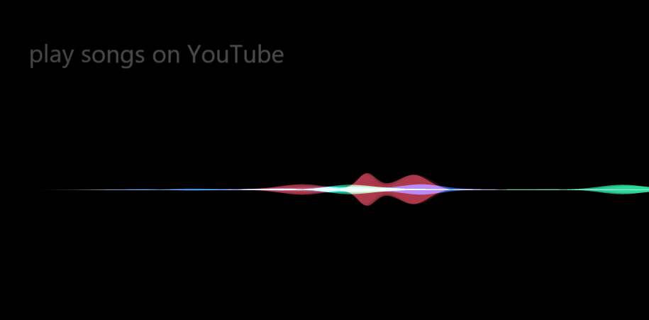

**Figure 2.** AI Assistant App.

# CONCLUSION

The Artificial Intelligence is one of the most growing technology. These technologies are the playing important role in the development of the IT sector. Here we have tried to use these technologies for the visually challenged people so that they can also live an independent and normal life. The friendly chat with the bot Image recognition of the objects and surroundings. Voice Command recognition to help in the easy to Phone Call, Video Call and Send Messages. Text recognition and reading of the analyzed text. The development of the proposed system if is completed, it can serve the visually challenged people with a better assistant.

In coming days our proposed system can be applied in multilingual application so that a person can use the application in their language without any trouble. In future our proposed system will be able interpret the textual description in a much better way. The Voice recognition can be enhanced with much more details about the voice captured through the mike. Enhancement to this system can be done by adding the features of voice command recognition. The existing methodology for voice command through phone call can be done with more accuracy.

# REFERENCES

1. A. K. Nair, R. Pradhan, and M. V. P. Siva Kumar, "A Survey on Artificial Intelligence-Based Solutions for Visually Impaired People," 2021 International Conference on Artificial Intelligence and Applications (ICAIA), Chennai, India, 2021.
2. M. A. Ahmed, M. A. Almansob, and S. J. Hussain, "An Artificial Intelligence-Based System for Visually Impaired People," 2021 International Conference on Advanced Science and Engineering (ICOASE), Sana'a, Yemen, 2021.
3. R. Bharti, A. K. Singh, and S. K. Singh, "An Artificial Intelligence-Based System for Visually Impaired People," 2019 IEEE 2nd International Conference on Advanced Computational and Communication Paradigms (ICACCP), Gangtok, India, 2019.
4. A. Almomani, R. Almomani, and K. Y. Quwaider, "A Review on Computer Vision-Based Assistive Technology for Visually Impaired People," International Journal of Advanced Computer Science and Applications, 2019.
5. S. K. Gupta, A. H. J. J. Prasad, and P. K. Sahu, "Smart Phone Based System for the Visually Impaired People using Artificial Intelligence," 2020 8th International Conference on Reliability, Infocom Technologies and Optimization (Trends and Future Directions) (ICRITO) (UP section), Noida, India, 2020.
6. V. K. Meena, S. K. Singh, and R. Bharti, "An Artificial Intelligence-Based System for the Assistance of Visually Impaired People," 2020 11th International Conference on Computing, Communication and Networking Technologies (ICCCNT), Kharagpur, India, 2020.
7. A. K. Pandey and S. Mishra, "A Comprehensive Review on Artificial Intelligence-Based Assistive Technology for Visually Impaired People," 2021 3rd International Conference on Communication, Computing and Electronics Systems (ICCCES), Gwalior, India, 2021.
8. S. B. Raghavendra and S. K. Gupta, "Assistive Devices for Visually Impaired using Artificial Intelligence: A Review," 2021 8th International Conference on Computing for Sustainable Global Development (INDIACom), New Delhi, India, 2021.
9. S. B. Raghavendra and S. K. Gupta, "Assistive Devices for Visually Impaired using Artificial Intelligence: A Review," 2021 8th International Conference on Computing for Sustainable Global Development (INDIACom), New Delhi, India, 2021.